LOAN MANAGEMENT SYSTEM FLOW
===============================

Step-1: Register user

http://localhost:8080/api/auth/register

What Happens Internally
- Password is encrypted using BCrypt
- User is created
- Default role assigned → ROLE_USER

Tables Affected
users
user_roles

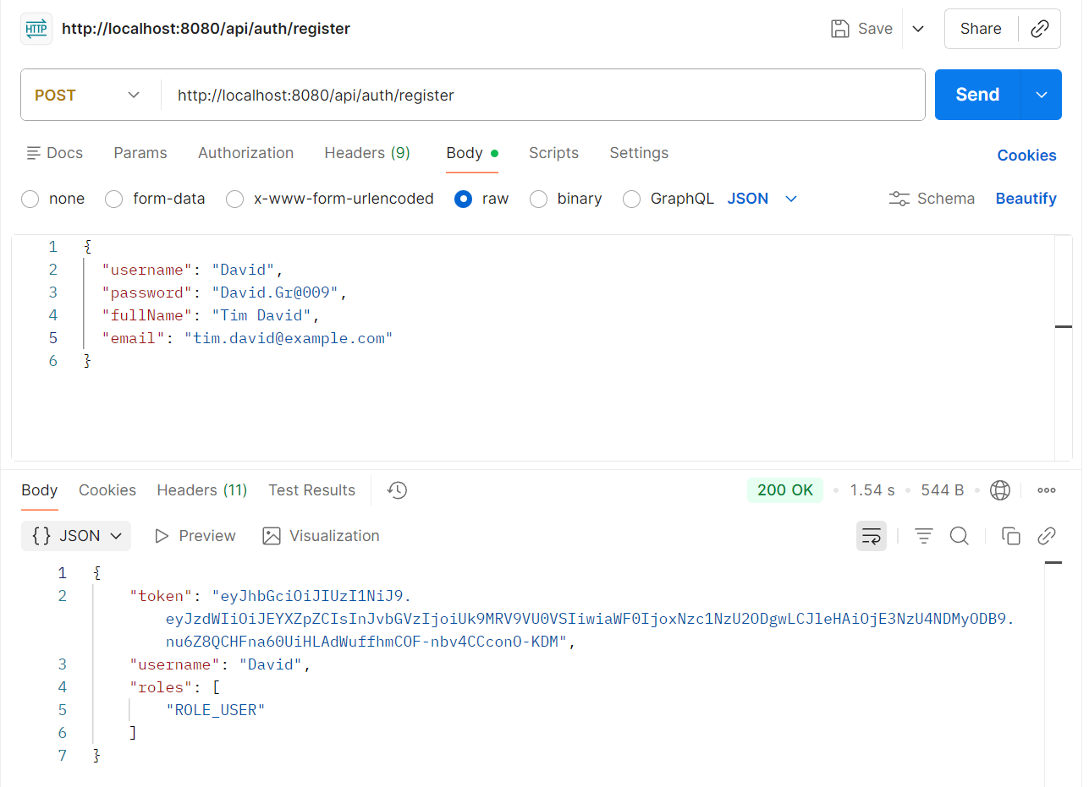

Users table screenshot:
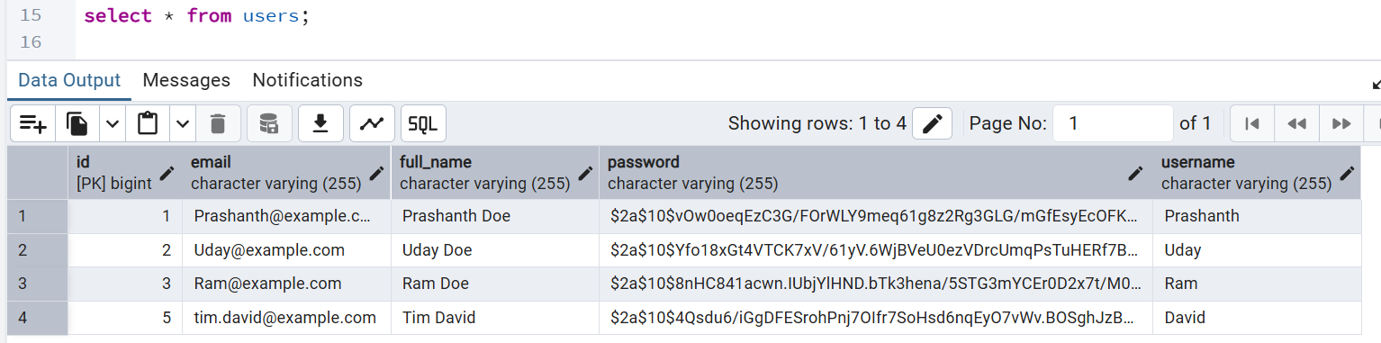
user_roles table screenshot
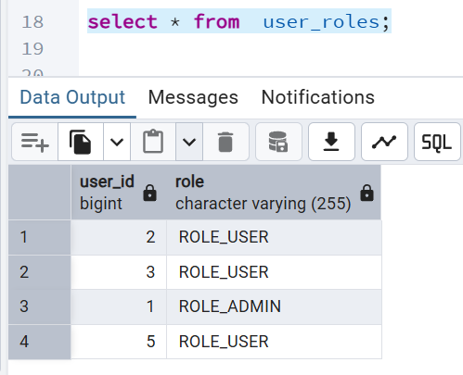

STEP 2: User Login (Authentication)
http://localhost:8080/api/auth/login

What Happens Internally
- Email lookup in users
- Password verified against encrypted hash
- User roles fetched from user_roles
- JWT token generated

Tables Read
users
user_roles

Note: No database will go any table.
Response attached below.

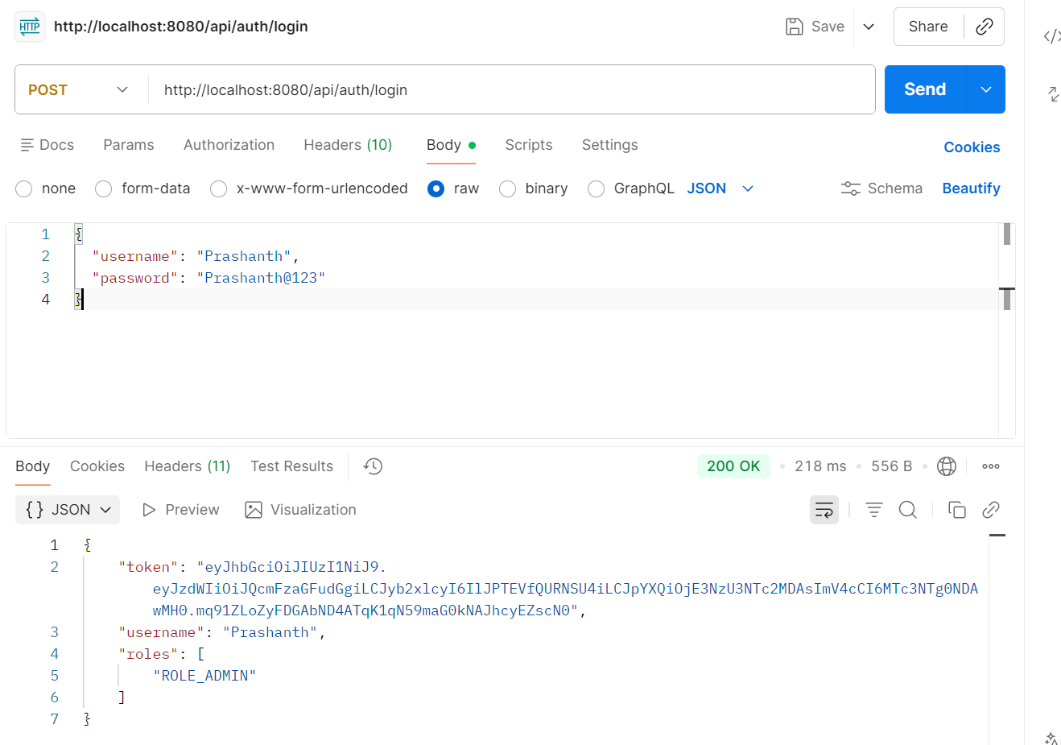

STEP 3: EMI Calculation (Before Applying Loan)
http://localhost:8080/api/loans/emi

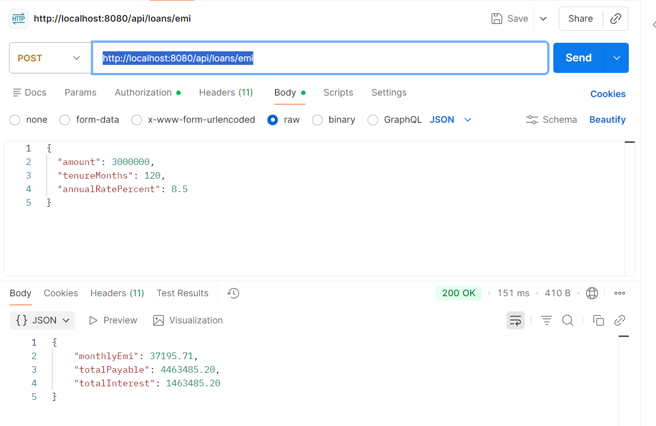

What Happens Internally
- EMI calculated using standard formula
- No DB write
- Pure business logic execution

STEP 4: View Loan Products
http://localhost:8080/api/products

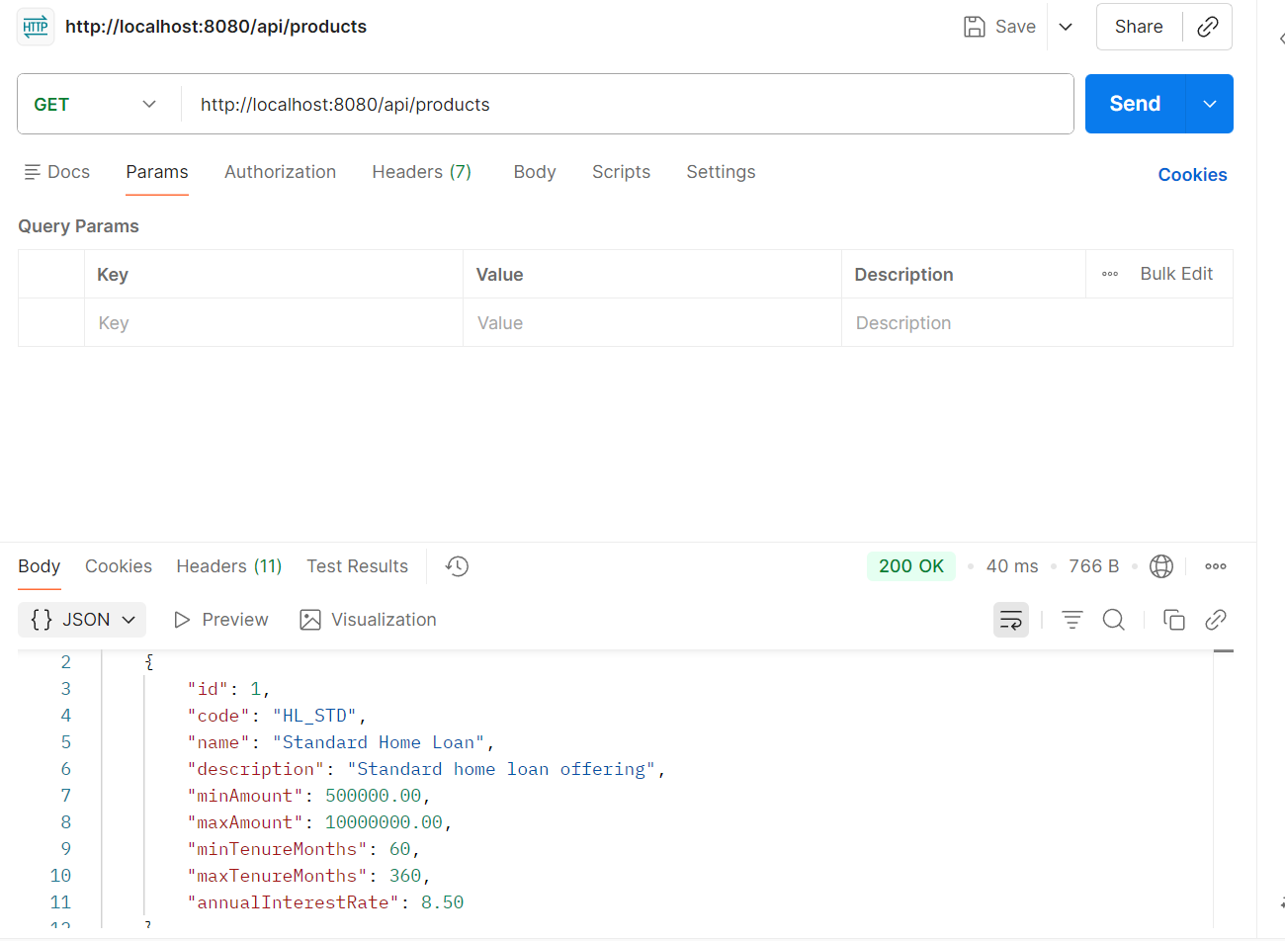

STEP 5: Apply for New Home Loan
http://localhost:8080/api/loans/apply

What Happens Internally
- JWT user identified
- Loan product validated
- EMI calculated
- Loan account number generated
- Status set → PENDING_APPROVAL

Tables Written
Loan

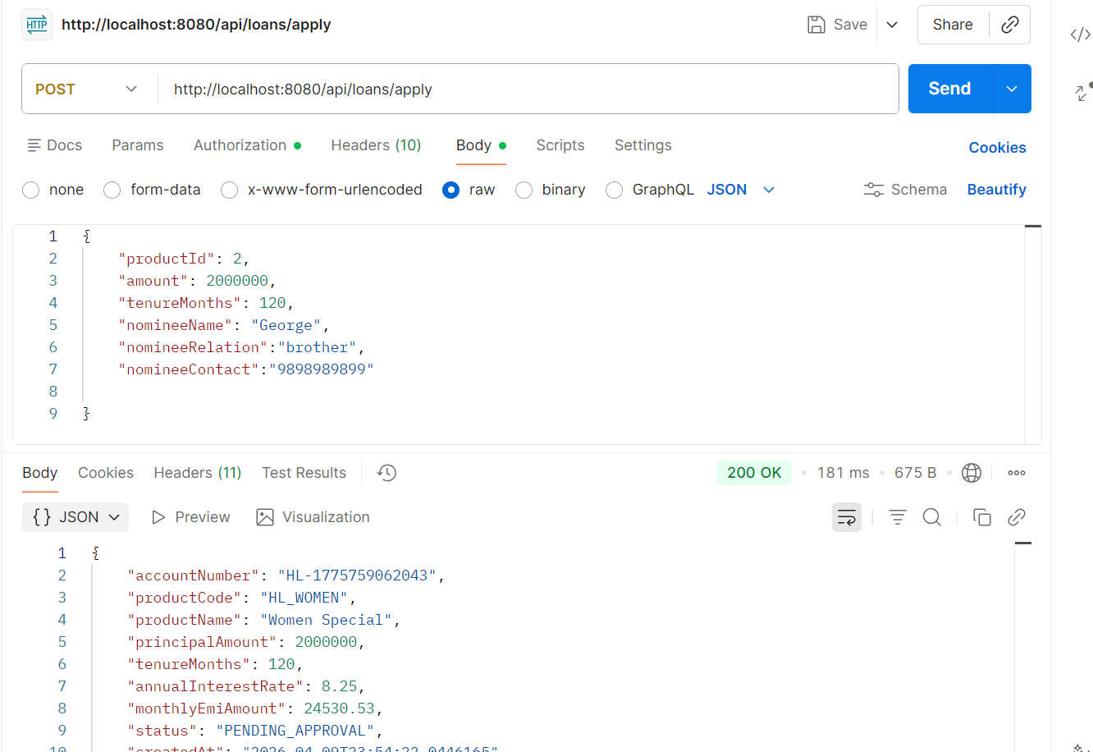

STEP 6: View Loans – ROLE_USER
http://localhost:8080/api/loans/

Tables Read
Loan

What Happens
- Only loans where user_id = logged in user
- Ownership filter applied

STEP 7: View Loans – ROLE_ADMIN

http://localhost:8080/api/loans

Tables Read
Loan
✅ Admin sees all loans

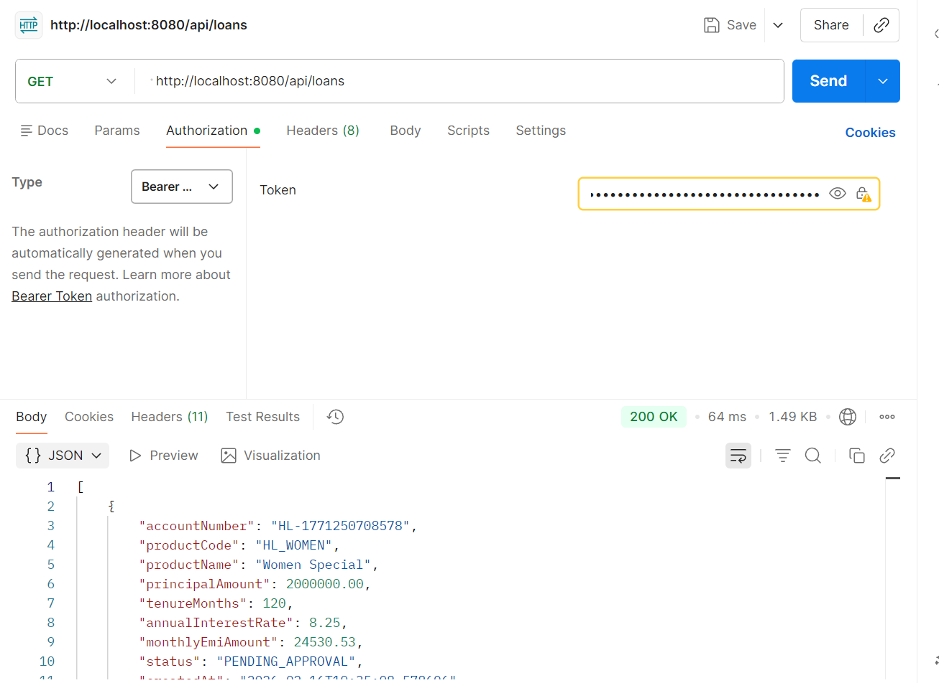

STEP 8: View Loan by Loan Number
http://localhost:8080/api/loans/HL-1771250526916

Tables Read
✅ loan

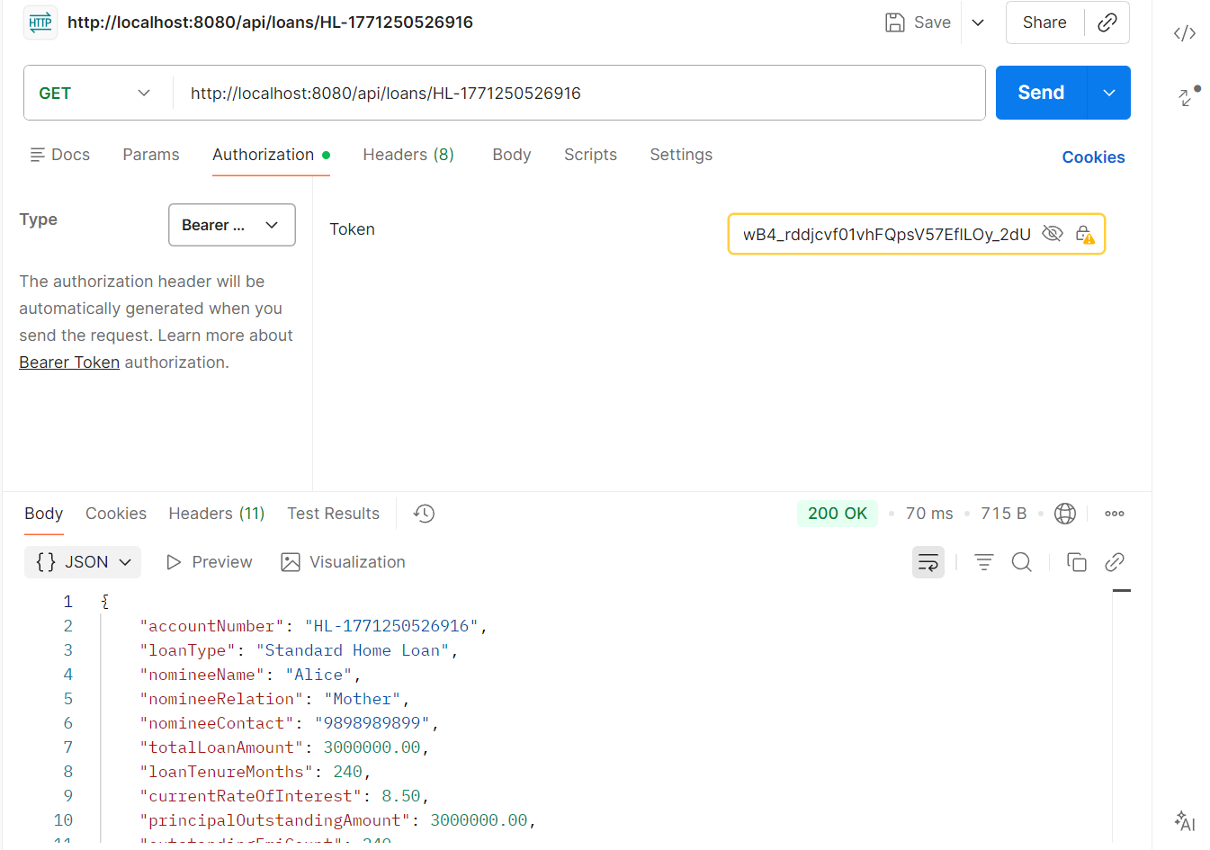

STEP: 9 Activate Home Loan (Admin Only)
http://localhost:8080/api/loans/admin/HL-1771250526916/activate

Purpose
This API is used to activate a home loan that is currently in a PENDING_APPROVAL state.
The endpoint is restricted to users with ADMIN role, ensuring that only authorized administrators can approve and activate customer loans.

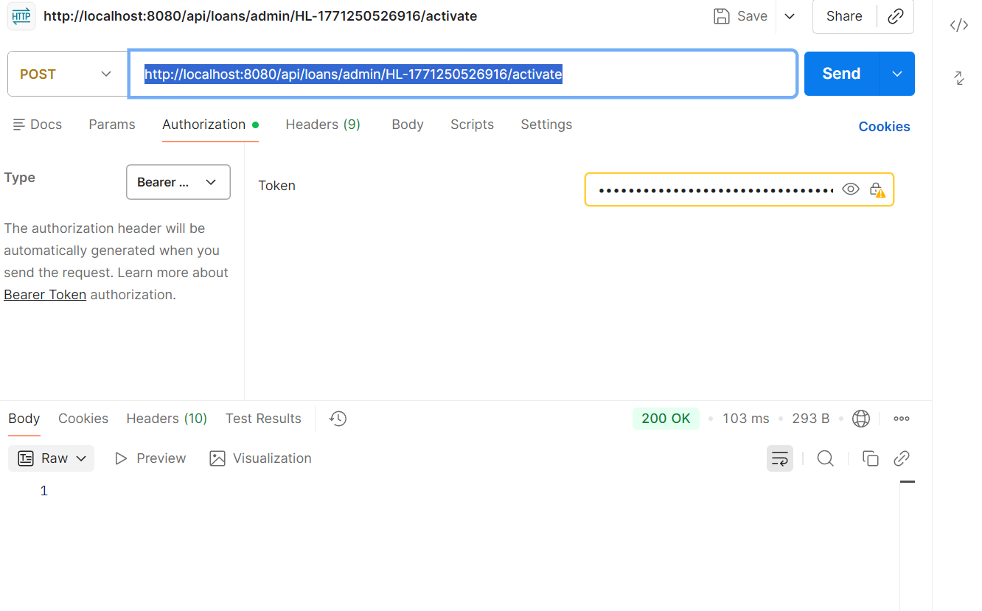

Processing Logic (Internal Flow)
- JWT token is validated
- User role is verified (ROLE_ADMIN)
- Loan details are fetched using loanAccountNumber
- Current loan status is validated
  - Loan must be in PENDING_APPROVAL state
- Loan status is updated to ACTIVE
- Loan record is saved back to the database

