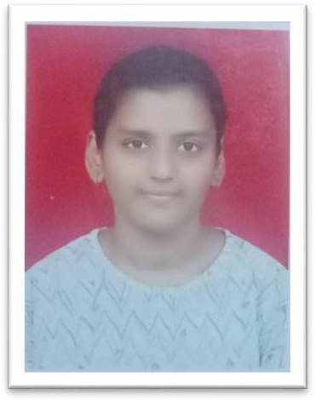Aishwarya Shrinivas Karampuri

**Mobile -** 8208475724

**Address -** 91, Kota Nagar, Old vidi gharkul, Solapur.

**Email -** [aishusk2001@gmail.com](mailto:aishusk2001@gmail.com)

**LinkedIn -** [linkedin.com/in/aishwarya-karampuri](https://www.linkedin.com/in/aishwarya-karampuri)

# Career objective

* Seeking a position to utilize my skills and abilities in the Information Technology that offers professional growth while being resourceful, innovative, and flexible.

# Education

|  |  |  |  |  |
| --- | --- | --- | --- | --- |
| Course | Institute  name | Board | Year of  Passing | Percentage |
| BTECH  (Computer Engineering) | MIT  Academy Of Engineering | SPPU | Pursuing Third year | - |
| BTECH  (2nd year - Computer Engineering) | MIT  Academy Of Engineering | SPPU | 2020 | 87.6% |
| DIPLOMA  (Computer Technology) | S.E.S.  Polytechnic | MSBTE | 2019 | 86.82% |
| SSC | Sambhajirao Shinde  Prashala | Pune Board | 2016 | 79.60% |

**TECHNICAL SKILLS**

* Database – php MySQL, Oracle
* Servers – Apache, Tomcat
* Languages – C, C++, Java, php, SQL
* Web design – HTML, CSS, Java script

# Areas of interest

* Database management systems
* Data science
* Cloud computing
* Web designing

# Certification courses

* Programming for Everybody (Getting Started with Python)
* Python 101 for data science

# Extra curriculum Activities

* Participated in Electrom challenge project competition held at SVERI College of engineering, Pandharpur.

# Strengths

* Punctuality
* Adaptability
* Teamwork
* Time management

# Personal snippets

* Date of birth – 22nd march 2001
* Languages Known – English, Hindi, Marathi, Telugu

# Declaration

I solemnly declare that all the above information is correct to the best of my knowledge and belief.

**Place: Signature:**

Solapur