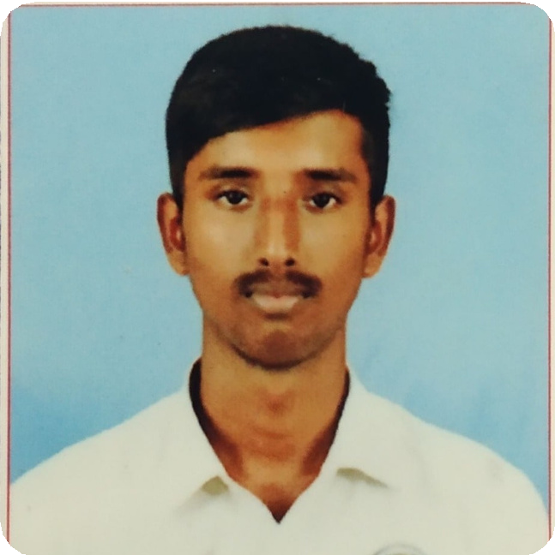

[**JANESH M**](mailto:janeshm0907@gmail.com)

[D A T A A N A L Y S T](mailto:janeshm0907@gmail.com)

[**6379157969**](mailto:janeshm0907@gmail.com)

[**janeshm0907@gmail.com**](mailto:janeshm0907@gmail.com)

[**https://github.com/janesh09**](mailto:janeshm0907@gmail.com)

[**https://janesh-354fc.web.app/**](mailto:janeshm0907@gmail.com)

[**CAREER GOALS**](mailto:janeshm0907@gmail.com)

[To make use of my interpersonal skills to achieve goals in the company and capable of handling multiple projects at a time with minimum supervision.](mailto:janeshm0907@gmail.com)

[**TECHINICAL SKILL**](mailto:janeshm0907@gmail.com)

[programing language:](mailto:janeshm0907@gmail.com)

[**PytThon**](mailto:janeshm0907@gmail.com)

[**C**](mailto:janeshm0907@gmail.com)

[Tools:](mailto:janeshm0907@gmail.com)

[**Anaconda Navigator**](mailto:janeshm0907@gmail.com)

[**Google Colab**](mailto:janeshm0907@gmail.com)

**EDUCATIONAL QUALIFICATION**

## Bachelor of Computer Science and Engineering

#### KONGUNADU COLLEGE OF ENGINEERING TECHNOLOGY, TRICHY,

YEAR OF PASSING – 2022

MARKS OBTAINED – 7.85(PURSUING)

## Higher Secondary

#### SVG MATRIC. HR. SEC. SCHOOL, KARAMADAI

YEAR OF PASSING – 2018 MARKS OBTAINED –62.3%

## Secondary

#### METRO MATRIC. HR. SEC. SCHOOL, METTUPALAYAM

YEAR OF PASSING – 2016 MARKS OBTAINED –82.3%

**AREA OF INTERESTS**

 **Machine learning**

**PROJECT DETAILS**

**Title:** Crop Yield Prediction Using Machine Learning Algorithm

**DESCRIPTION:** This project focuses on predicting the crop yield based on the existing data by using a Machine learning algorithm. Real data of Tamil Nadu were used for building the models and the models were tested with samples.

### **Title:** Number Plate Detection Using OpenCV

#### **DESCRIPTION:** It will predict the number plate of the vehicle .the main motto of this project is to note entry and exit the bus time in our college using

this project

[**PERSONAL DETAILS**](mailto:janeshm0907@gmail.com)

[Date of Birth : 09.09.2000 Gender : Male](mailto:janeshm0907@gmail.com)

[Nationality : Indian](mailto:janeshm0907@gmail.com)

[**HOBBIES**](mailto:janeshm0907@gmail.com)

[-Watching English Movies,](mailto:janeshm0907@gmail.com)

[-English series,](mailto:janeshm0907@gmail.com)

[-Playing Games.](mailto:janeshm0907@gmail.com)

[**PERSONAL TRAITS**](mailto:janeshm0907@gmail.com)

[-Flexibility](mailto:janeshm0907@gmail.com)

[-Active listner](mailto:janeshm0907@gmail.com)

[-Creativity](mailto:janeshm0907@gmail.com)

[-Self Motivator and Self Learner](mailto:janeshm0907@gmail.com)

[-Good Team Worker and Leadership Sklls](mailto:janeshm0907@gmail.com)

[**CONTACT DETAILS**](mailto:janeshm0907@gmail.com)

[81E4 Devaraj Villa KRG layout Bharathi Nagar Mettupalayam (Coimbatore) Tamil Nadu](mailto:janeshm0907@gmail.com)

[Place:](mailto:janeshm0907@gmail.com)

[Date:](mailto:janeshm0907@gmail.com)

**CO-CURRICULAR ACTIVITIES**

-ATTENDED “MACHINE LEARNING WORKSHOP” ORGANIZED BY NATIONAL INSTITUTE OF TECHNOLOGY

-PRESENTED A PAPER TITLED “MACHINE LEARNING” ORGANIZED BY VSB COLLEGE OF ENGINEERING AND TECHNOLOGY

-PRESENTED A PAPER TITLED "AUGMENTED REALITY" ORGANIZED BY VSB COLLEGE OF ENGINEERING AND TECHNOLOGY

- PRESENTED A PAPER TITLED "5G NETWORK" HELD ON CARE COLLEGE OF ENGINEERING AND TECHNOLOGY

**INTERNSHIP**

-CROP YIELD PREDICTION USING MACHINE LEARNING ALGORITHM AT CMR ENGINEERING COLLEGE

-INTERNSHIP IN REACTJS AND ITS APPLICATION IN INFORM SOLUTIONS AT NAMAKKAL

**ACHIVEMENT**

-WON FIRST PRIZE IN PAPER PRESENTATION AND AT CARE COLLEGE OF ENGINEERING

-TWO DAYS STATE LEVEL CSI STUDENT CONVENTION WON FIRST IN TECHNICAL QUIZ KARPAGAM COLLEGE OF ENGINEERING

-WON THIRD PRIZE IN THE BASKETBALL ZONAL MATCH PAVAI

COLLEGE OF ENGINEERING AND TECHNOLOGY

-WON FIRST PRIZE IN AGNITIOZ 2020(HACKATHON) AND SECOND PRIZE IN AGNITIOZ 2021(HACKATHON) HELD AT KONGUNADU COLLEGE OF ENGINEERING AND TECHNOLOGY

**LANGUAGES KNOWN**

# -Kannada

* English

# Tamil

(JANESH. M)