CMS Inventory





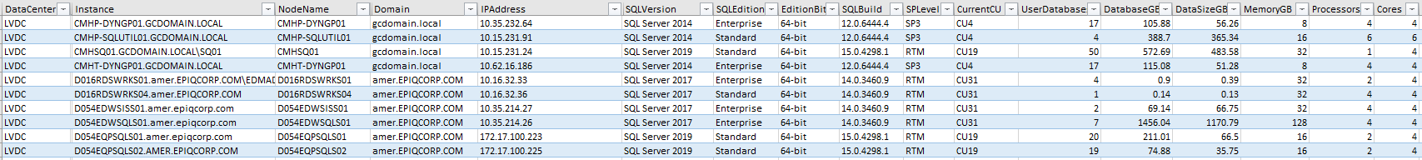

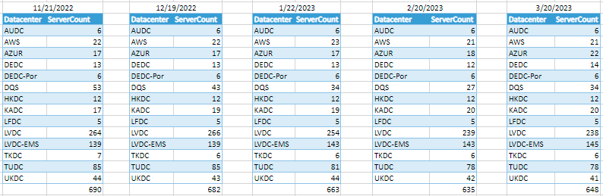

* New framework for capacity report.
* CMS is the source of truth.
* Data integration is done through linked servers, connected to each management box on respective data center.
* Captures data from various data centres includes Azure and AWS environments.
* Joined with SAM table to pull Application owners and Server type.
* Stores in centralised master table.
* Data refreshes every week.
* Archived to a table monthly to double check missing servers (Decoms and new server builds).

Database settings:

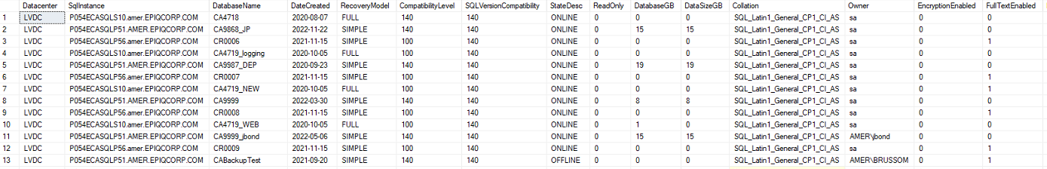

* Collection of databases from various DCs.
* Table contains info like Recovery model, status, compacity level, size, Full text enabled, etc... for each database.
* Filter based on condition.

DBCC report:

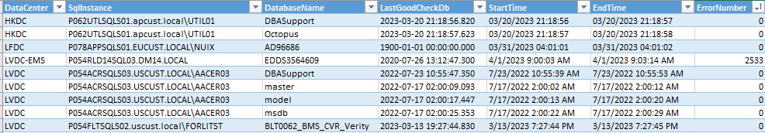

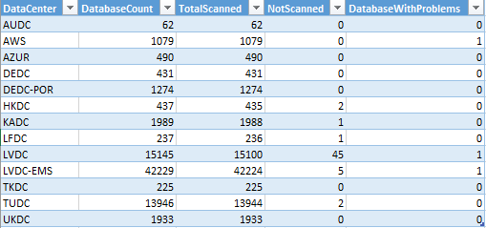

* Contains details of the databases that have not been processed integrity checks over the days (capped to 2 weeks)
* Also has the details to find those databases that have errors encountered
* The summary is grouped by DC
* Actively monitoring by Devender

SQLLogins:

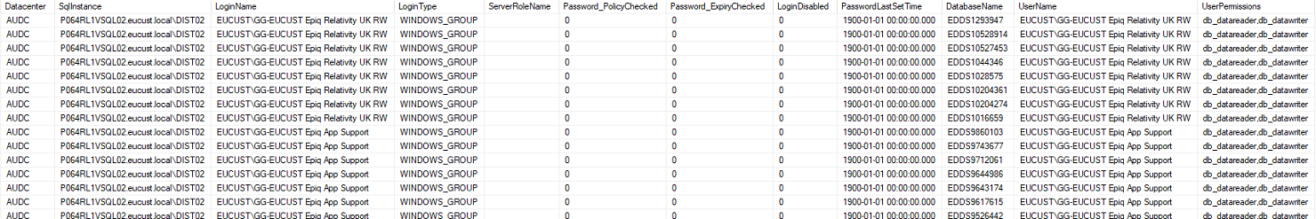

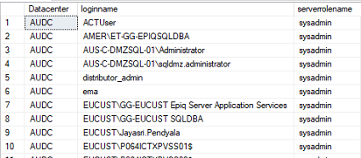

* Ability to find user permissions for databases.
* Validate sysadmin role for SQL logins.
* Ensure password_policy check and password expiry check.