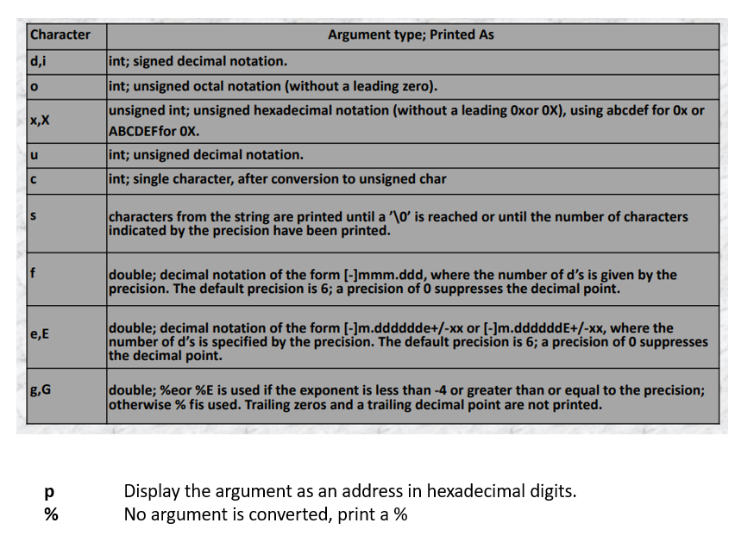

sample_1.c

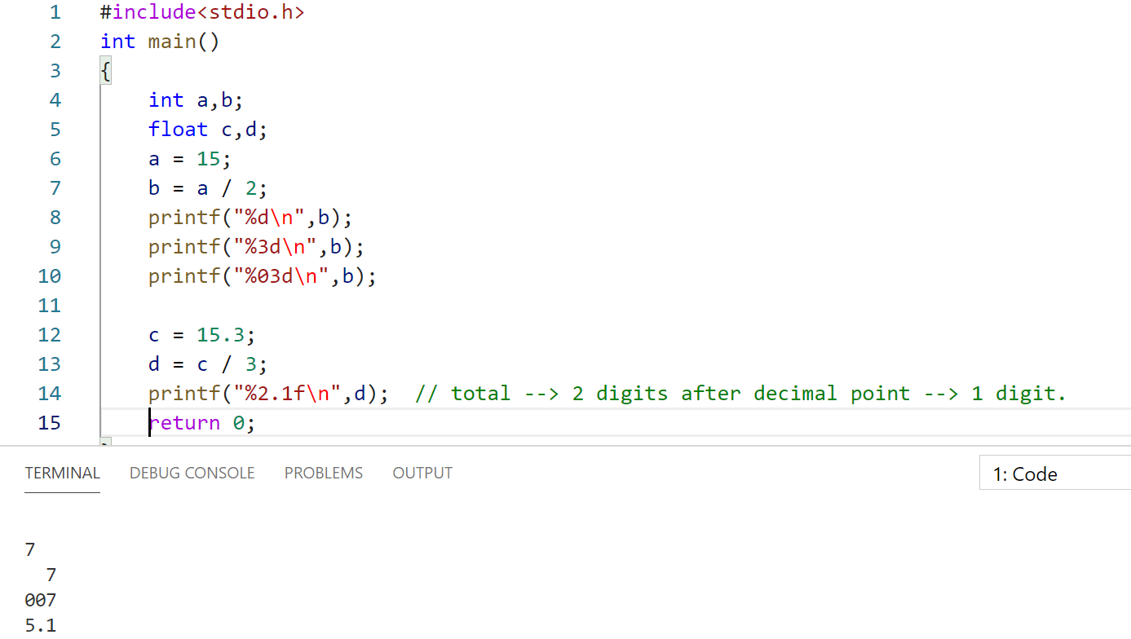

sample_2.c

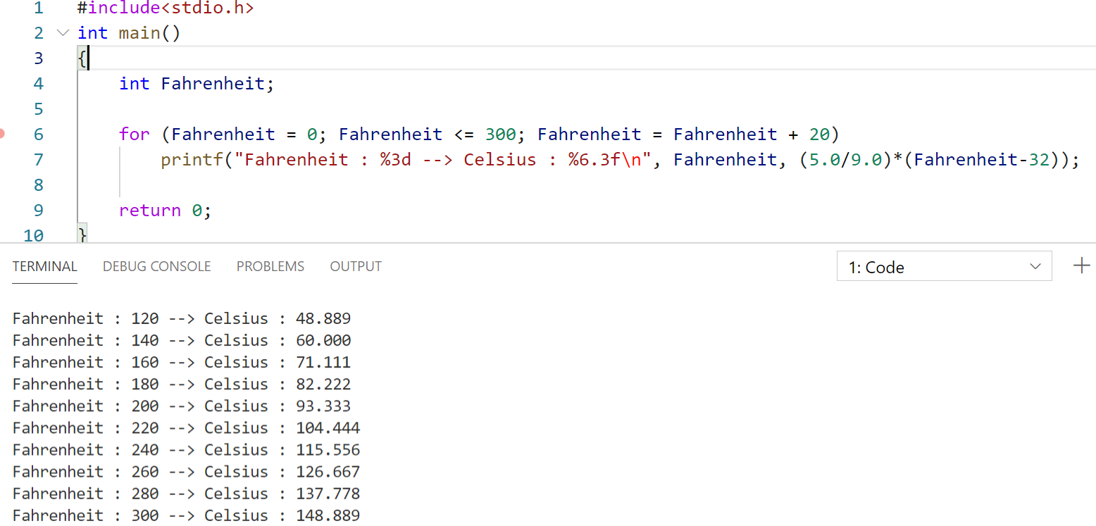

%3d 🡪 3 decimal digits.  
%6.3f 🡪 Totally 6 digits, After decimal point only 3 digits.

Refer sample_3.c

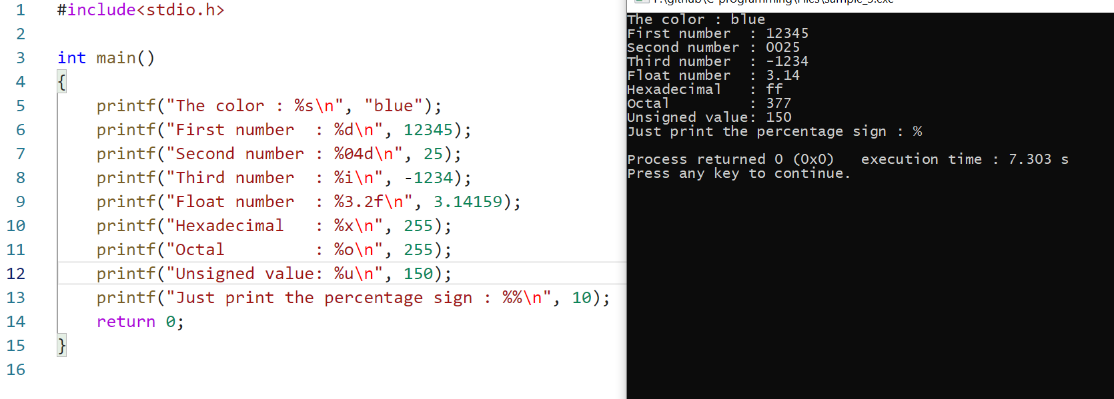

Refer sample_4.c

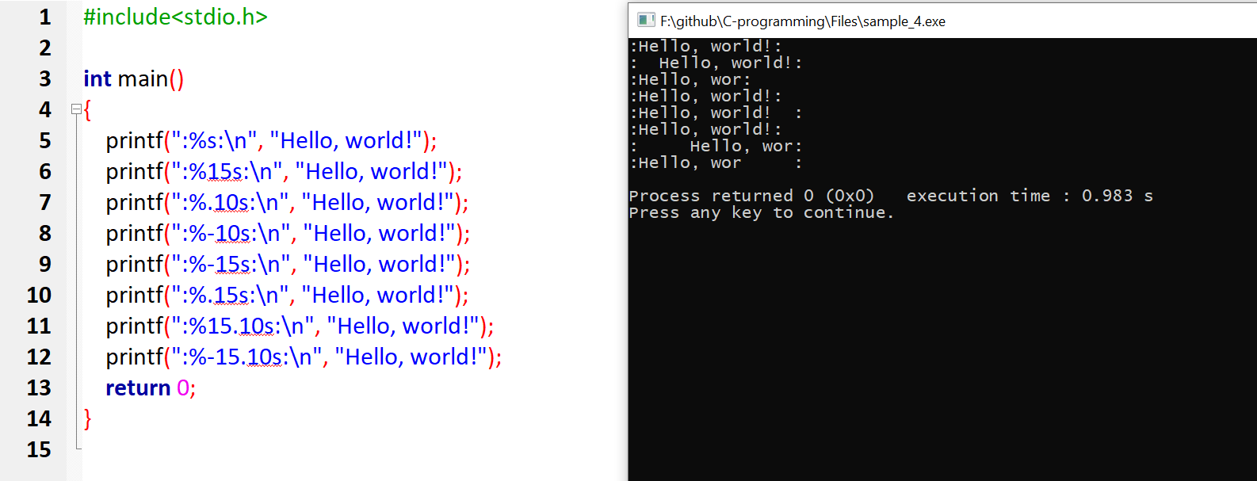

Return type of printf() and scanf() 🡪 int

scanf() 🡪 will return how many inputs it takes

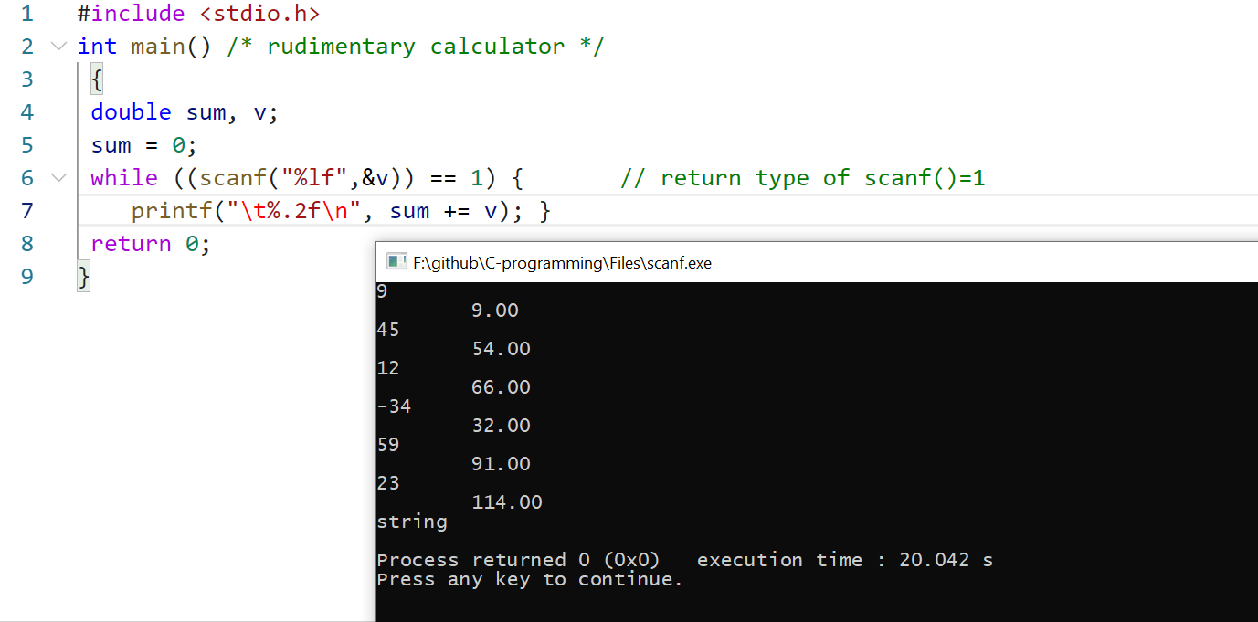

When scanf() fails its return type will not be equal to 1, so loop fails  
until we give numerical value, its return value=1.   
As soon as we give string, its return value!=1.

Modes in File handling.

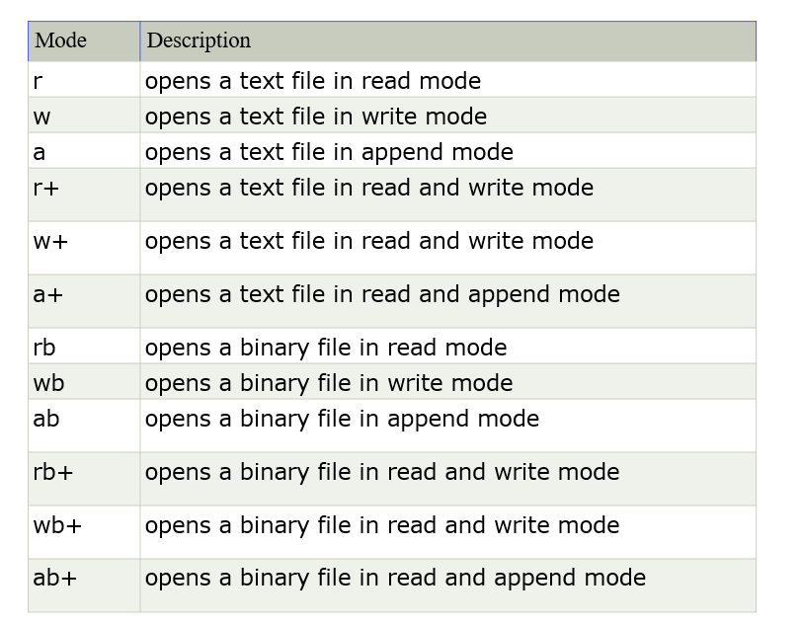

Reading the program itself

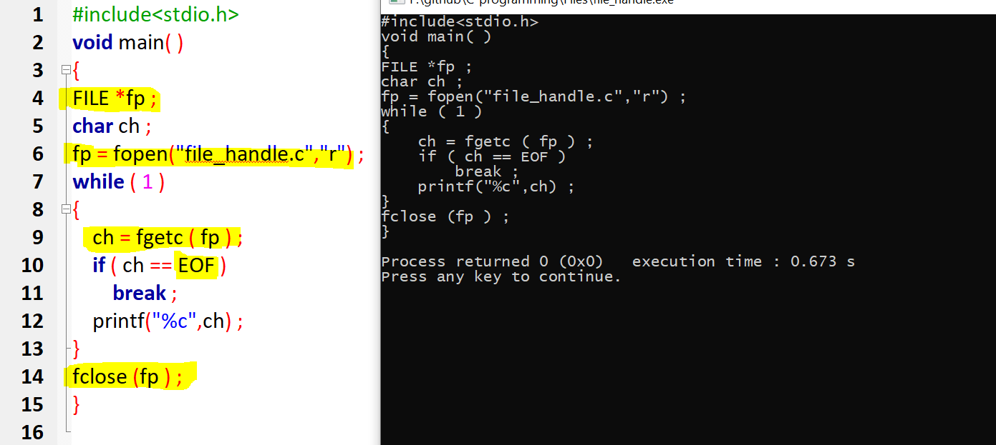

Writing and reading from a file(string)

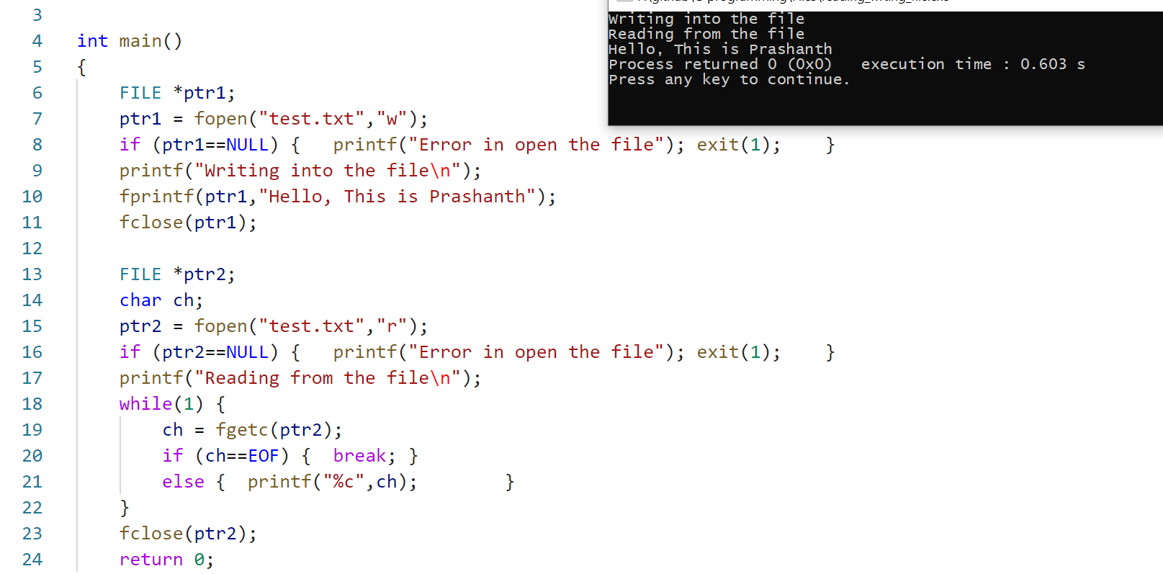

Writing and reading from a file(character)

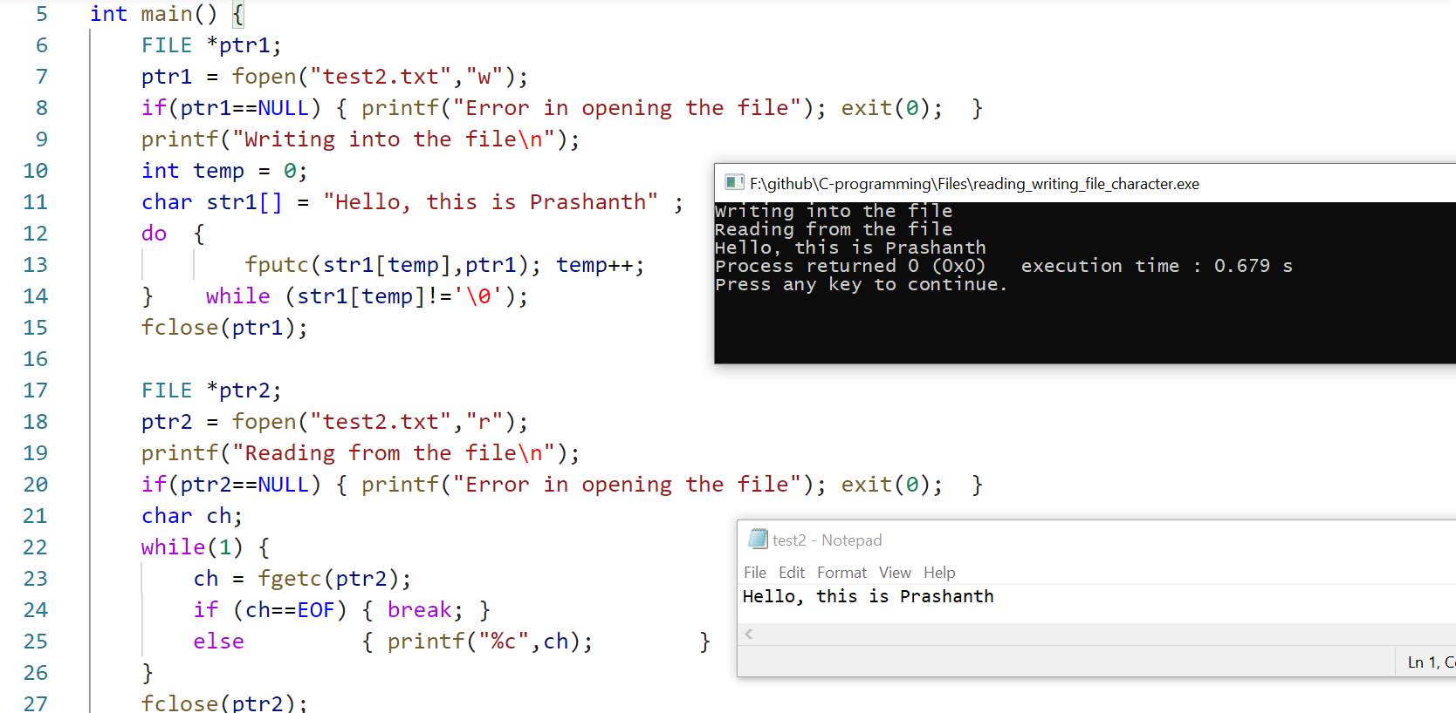

Writing and reading from a file fputs() and fgets()

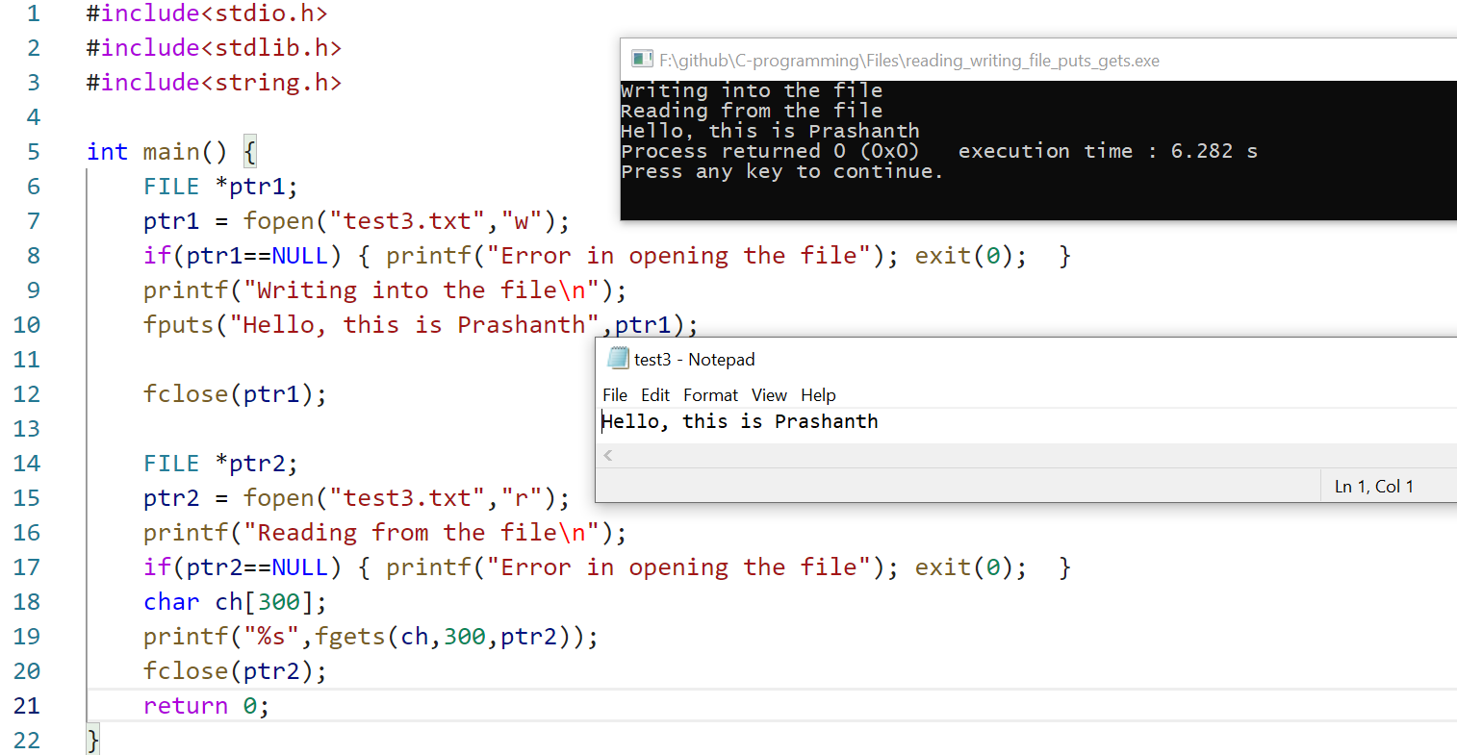

Refer perror_stderr_errno.c

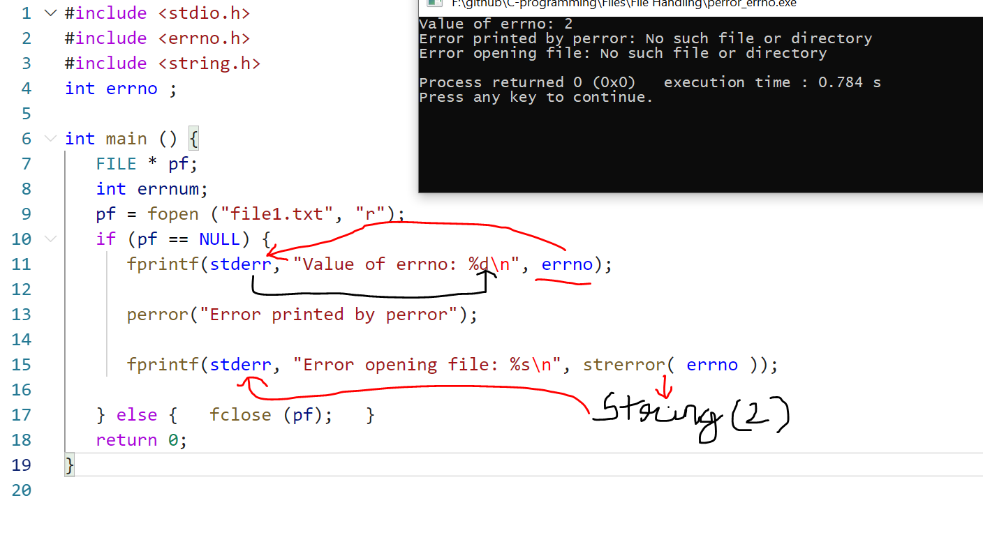

# ferror

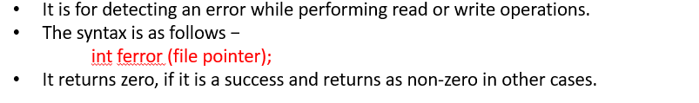

Refer ferror.c  
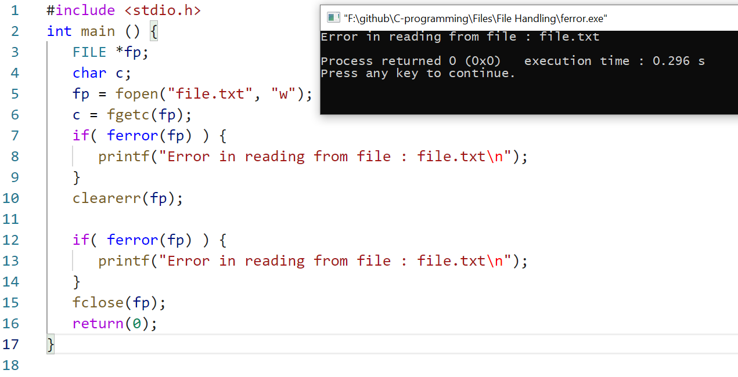

# feof

