Declaring the 2D array in a single row.

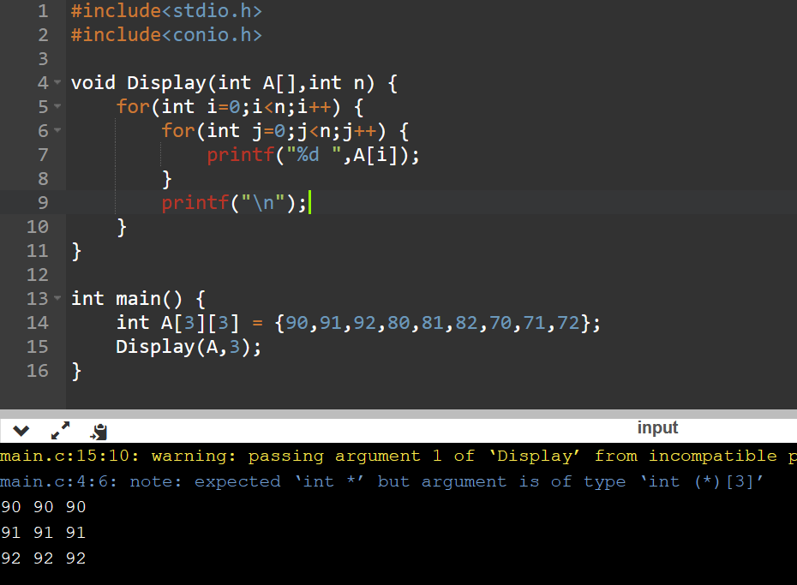

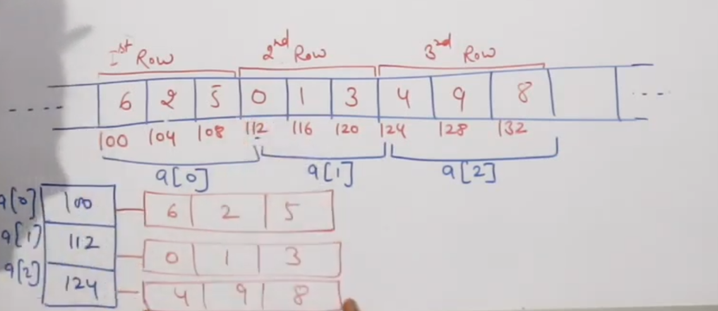

Representation of 2D array

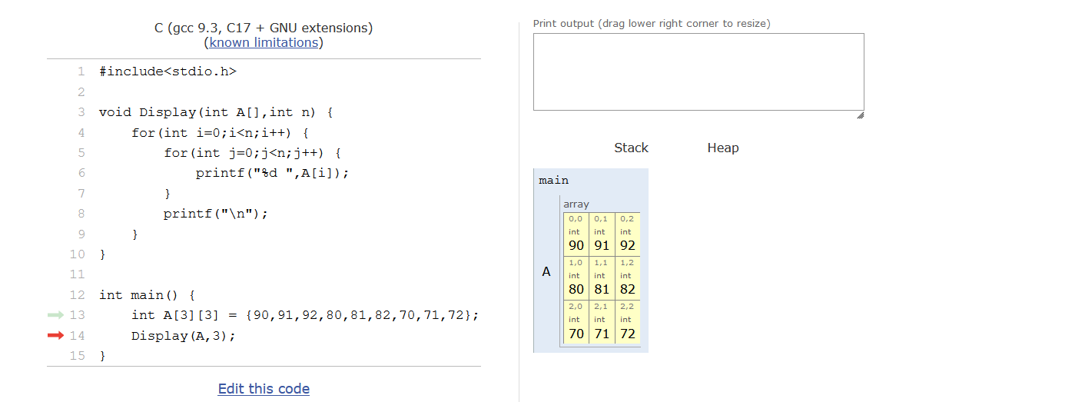

This 2D array is having three 1D array

**Pointing the 1st 1D array**

int *p;  
p = &arr1[0][0]; (or) p = arr1[0];



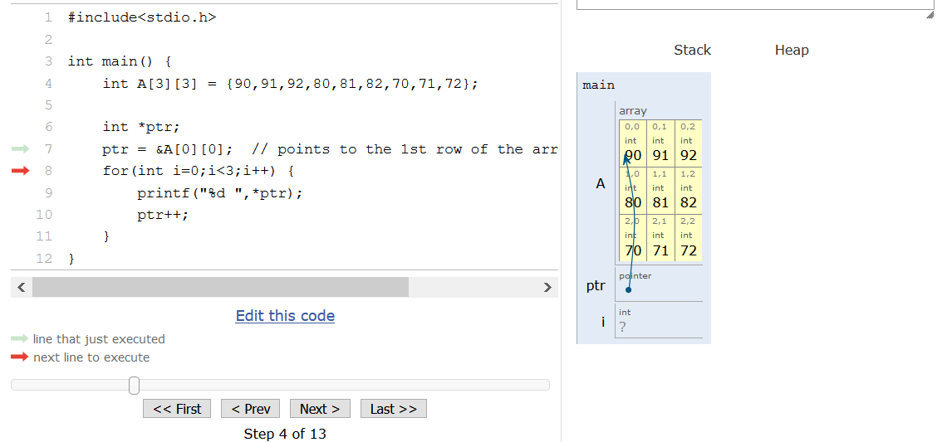

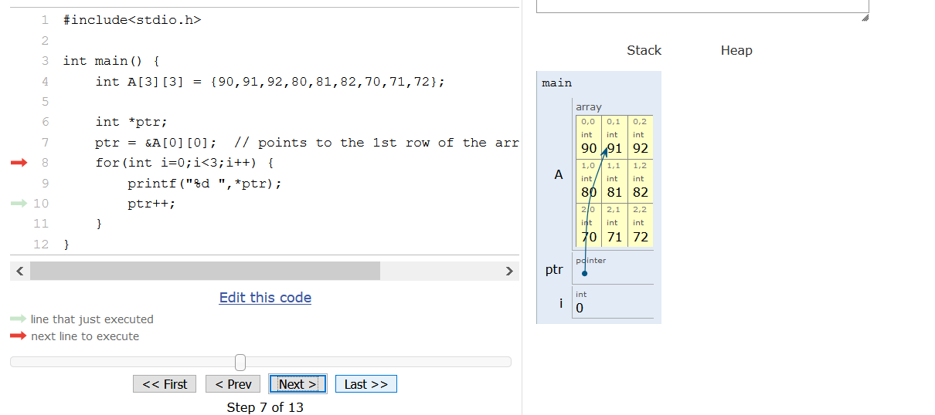

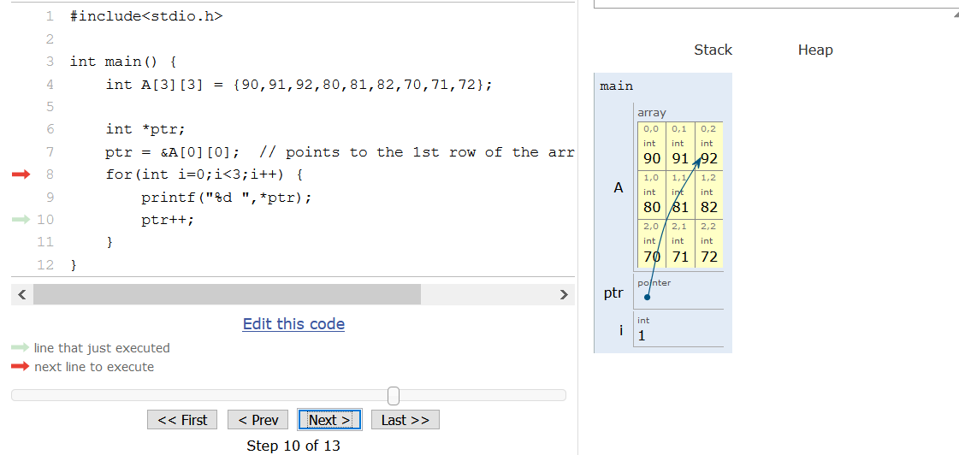

arr1 --> pointer to the first element in that arr1 array.  
&arr1 --> base address of the complete array.

So both are same