# Refer add_two_distances.c

# Array of Structures

# Nested Structures

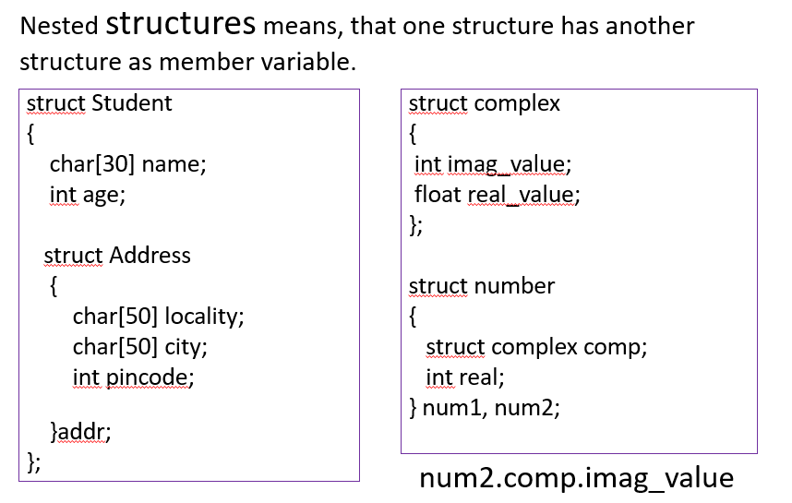

# Structures as Function Arguments