# **Method-1**

compile --> gcc <name of the source code.c>  
run --> source code  
Executable file will be in a.exe

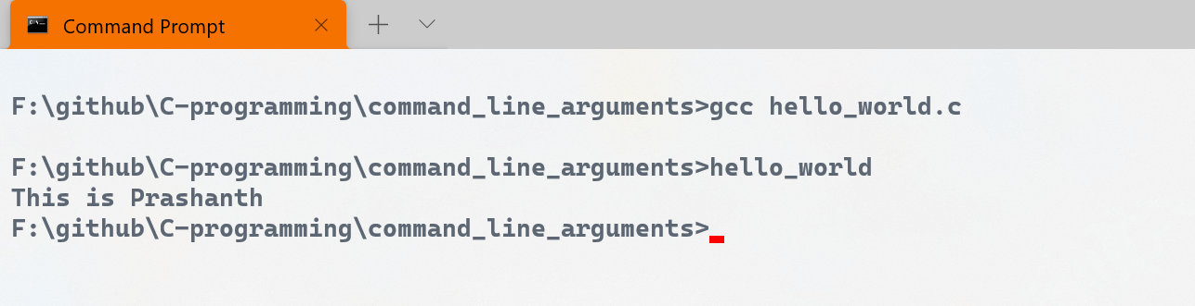

# **Method-2**

compile --> gcc -o <name of the executable file><name of the source code.c>  
run --> "program_name"  
executable file will be in the form “executable file”.exe

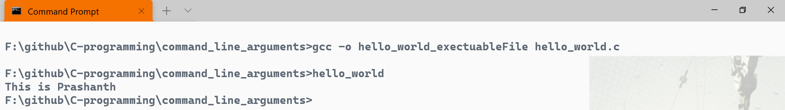  


# **Refer basic_1.c**

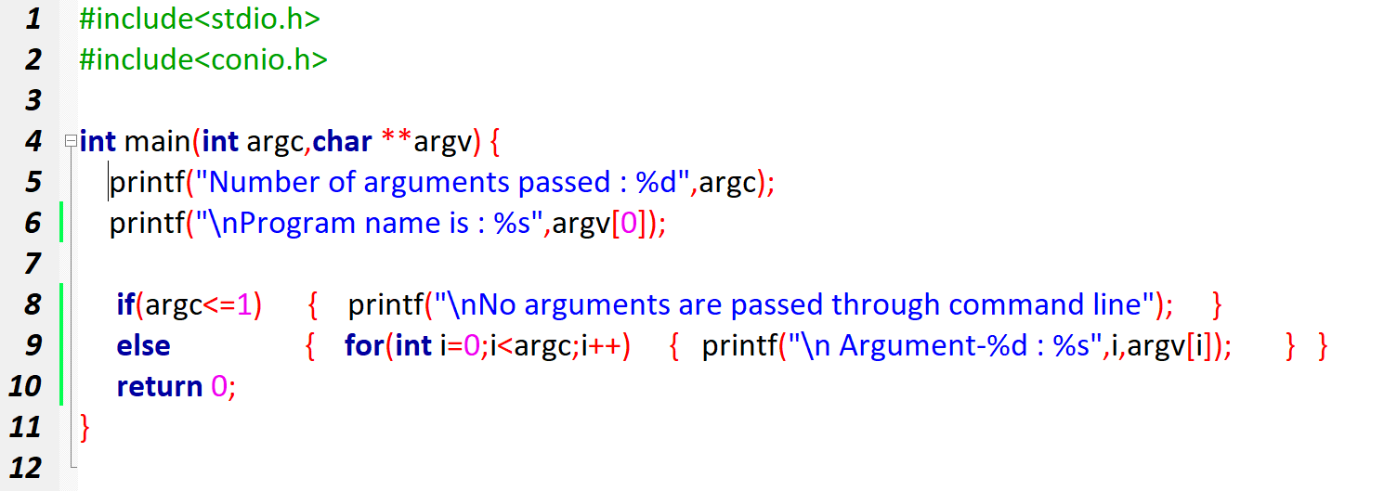  
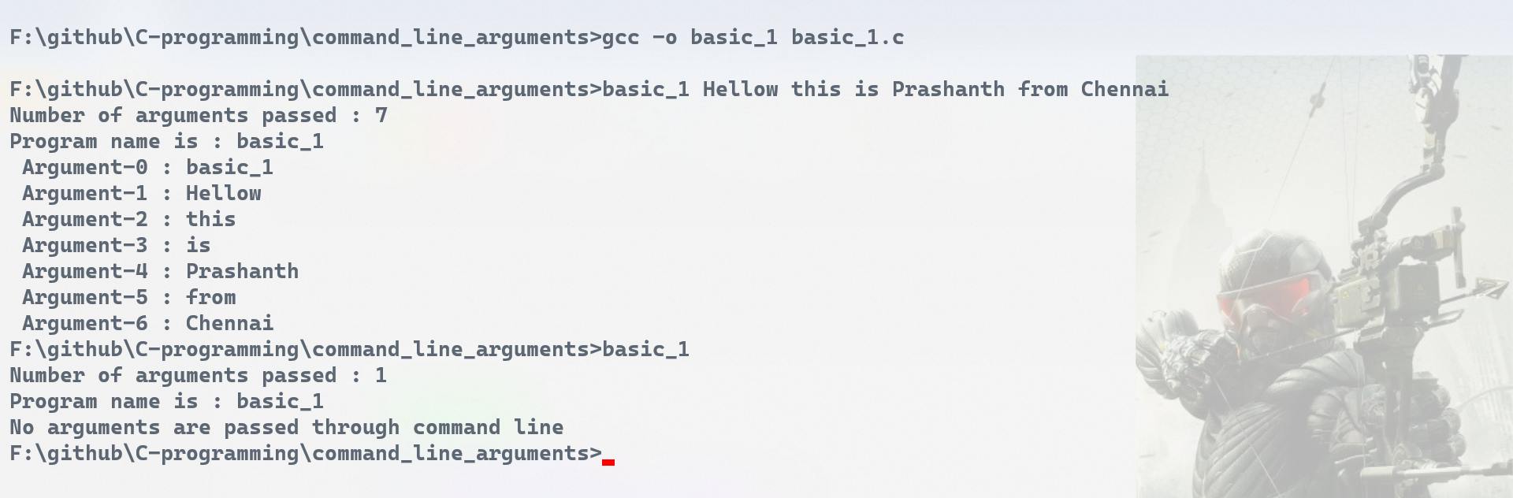

# **Refer odd_even.c**

# **Refer circle_area.c**

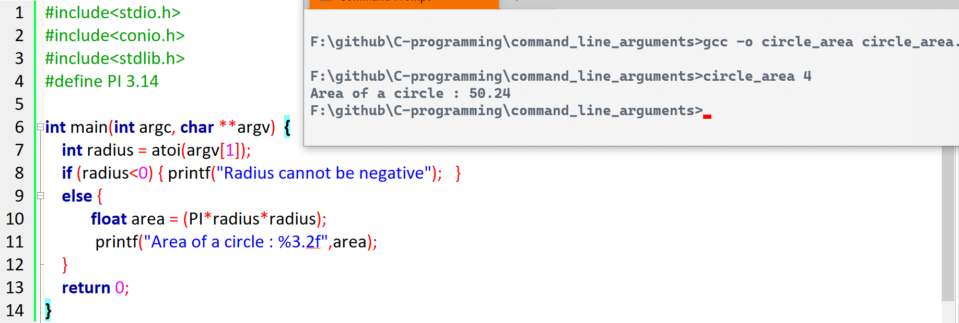

# **Refer string_palindrome.c**

Reference Links  
<https://randerson112358.medium.com/how-to-run-c-program-in-command-prompt-e435186cd162>