# **Refer basic_1.c**

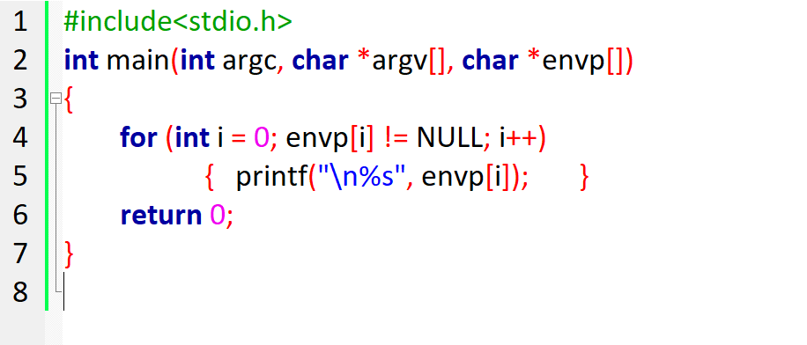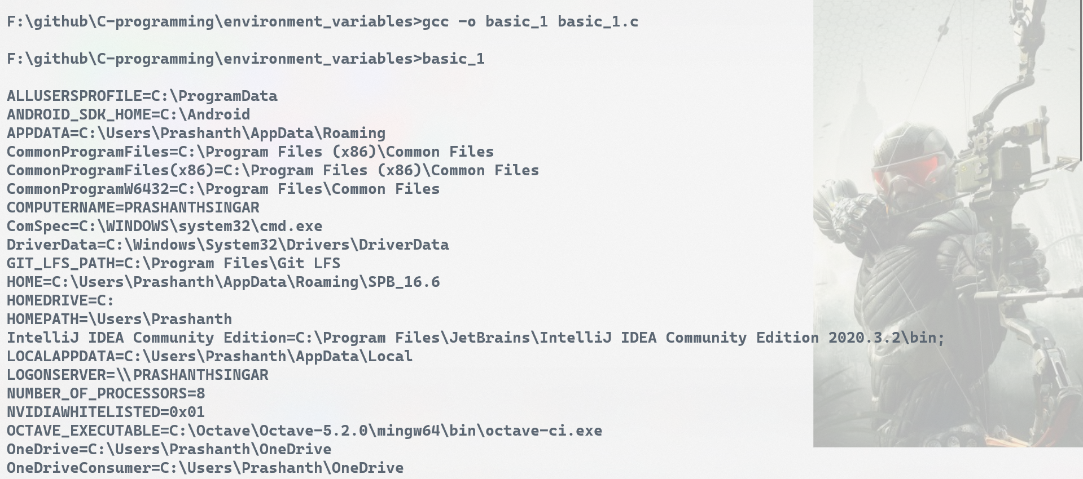  
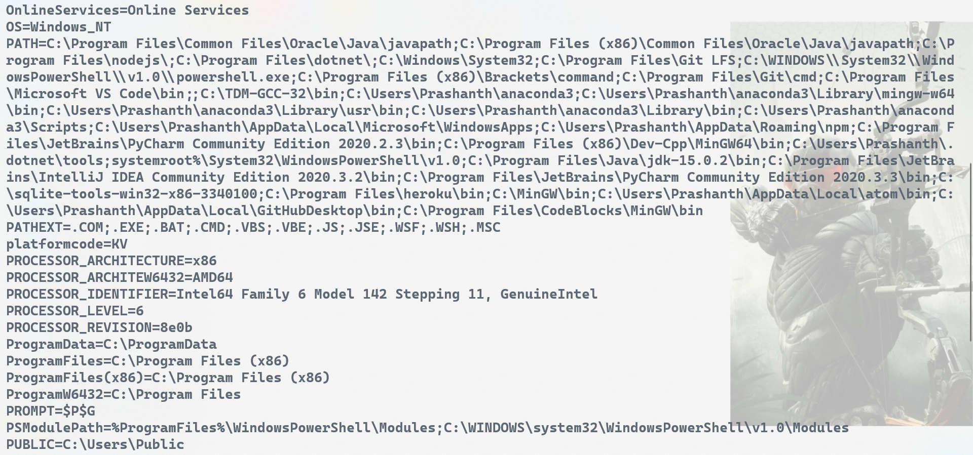

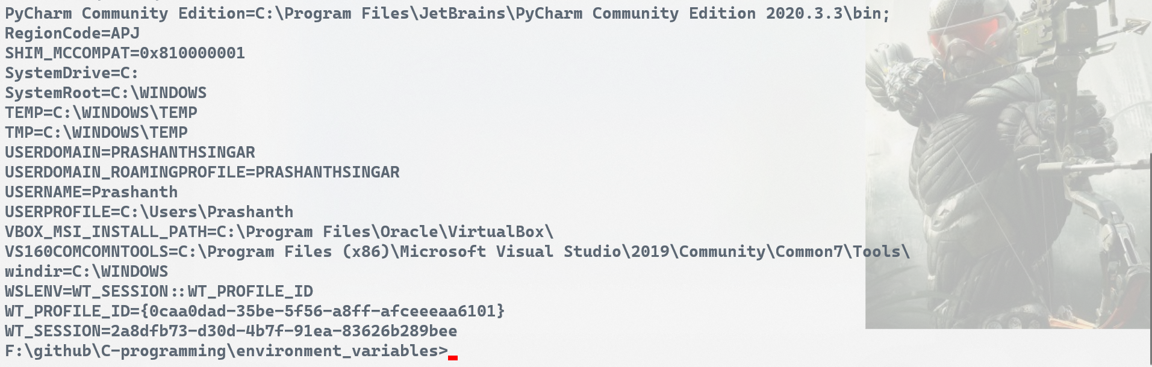

**But most of the compilers also support a third declaration of main that accepts third argument. The third argument stores all environment variables.**

# **getenv()**

The **getenv**() function obtains the current value of the environment variable, *name*. The application should not modify the string pointed to by the **getenv**() function.

