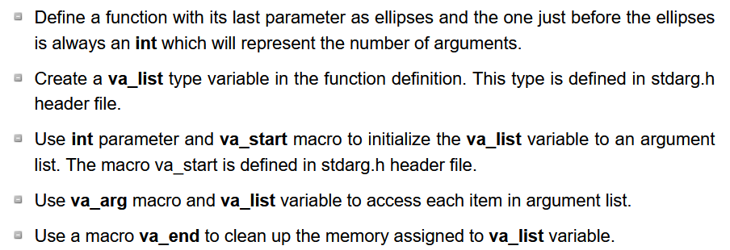

Accessing the va_list array

## **Refer Varying arguments_1c**

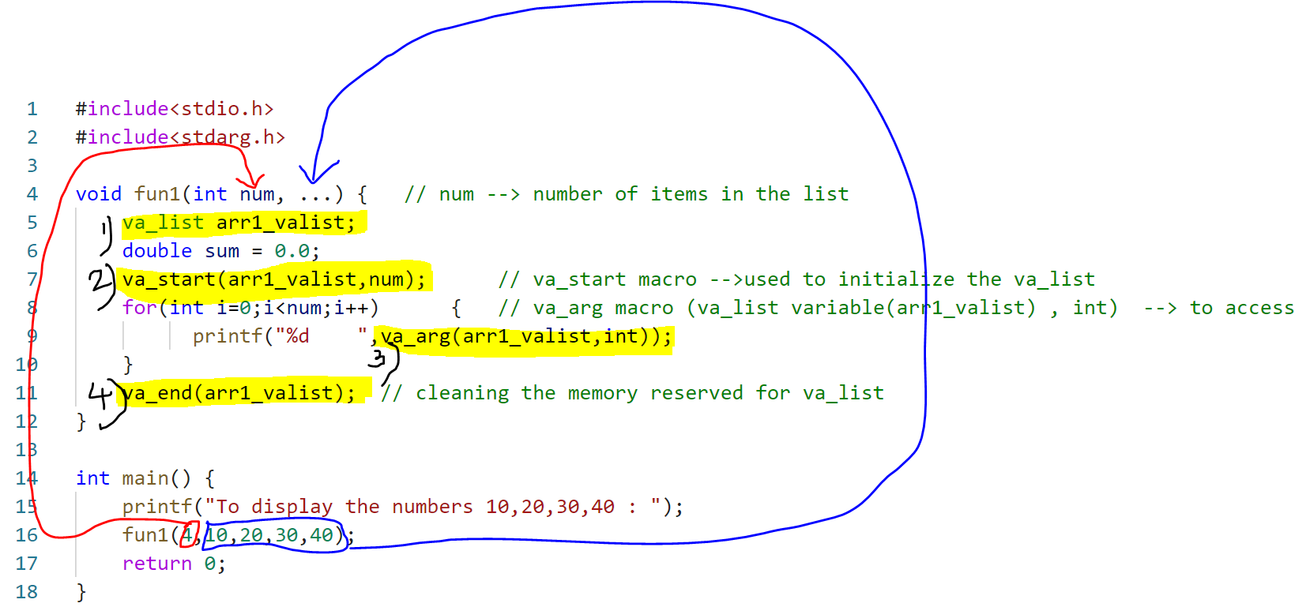



Output

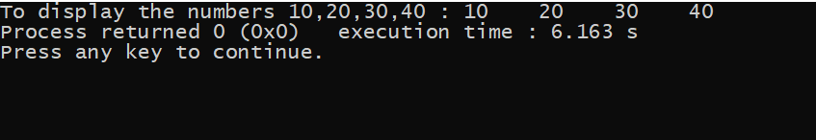

## **Refer Varying arguments_average.c**

Code:

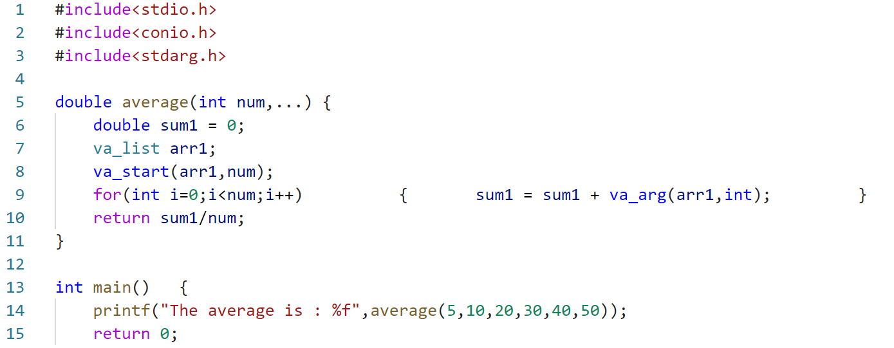

Output:

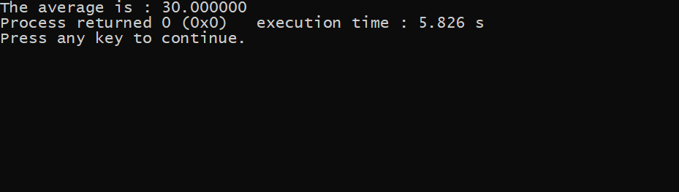

# Bitfields

## **Refer bit_fields_1.c**

Code

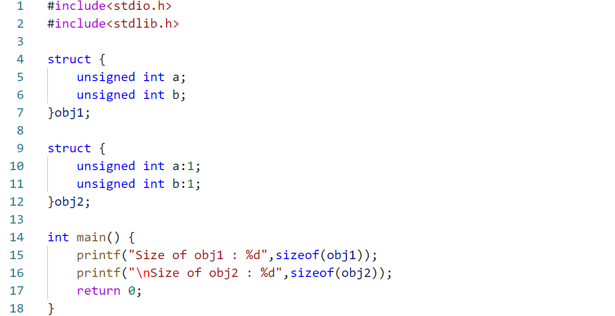

Output  
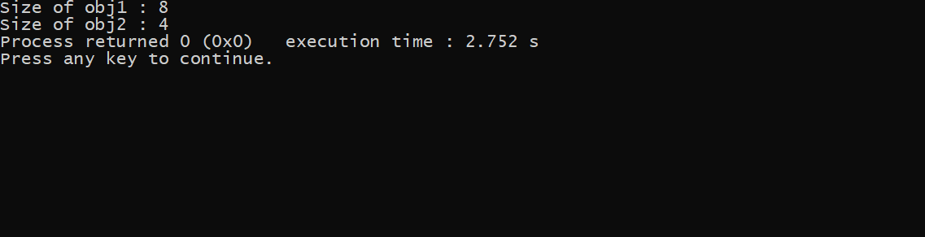

## **Refer bit_fields_2.c**

