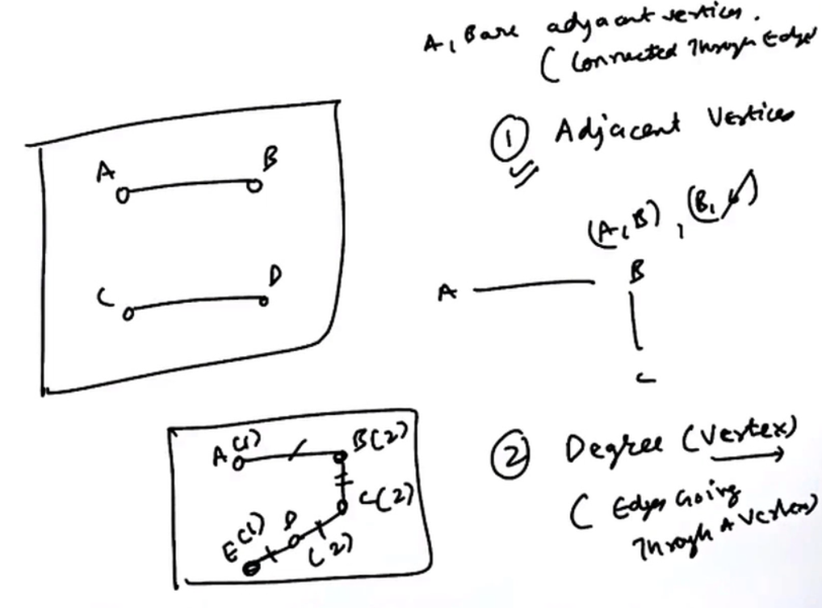

1)Adjacent vertex 🡪 Two vertices are adjacent if they are connected via an edge.  
2)Degree of a vertex 🡪 Number of edges passing through a vertex.

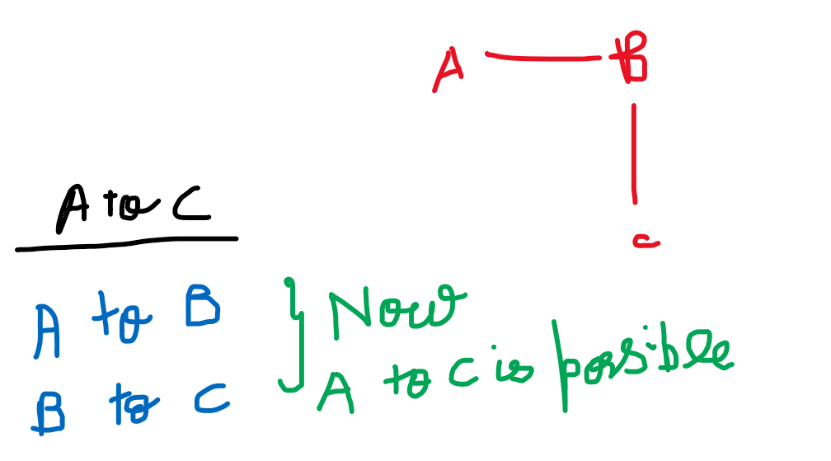

3)Path 🡪 A path in a graph is a finite/infinite sequence of edges which joins a sequence of vertices.  
Though A and C are not adjacent to each-other, with paths we can reach from A to C.

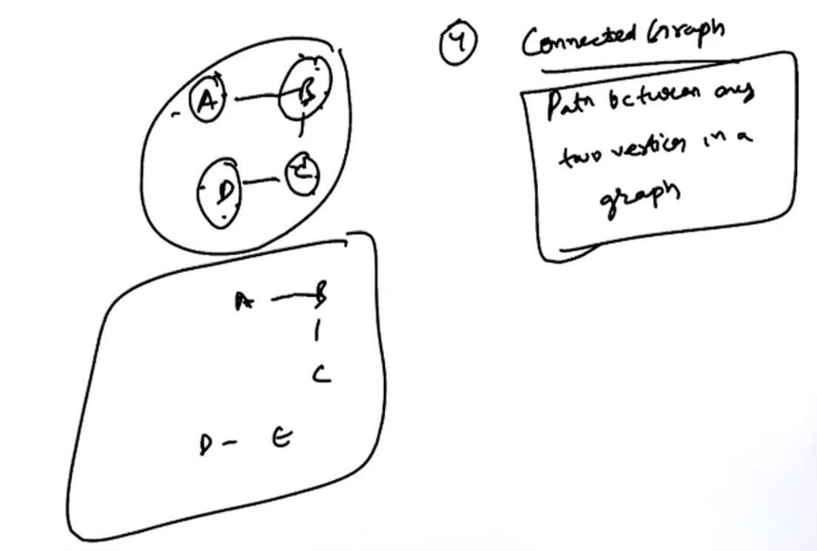



4) Connected Graph 🡪 If there is a path between any two vertices in a graph.

5) Connected component 🡪 A sub-graph of a graph which is connected.

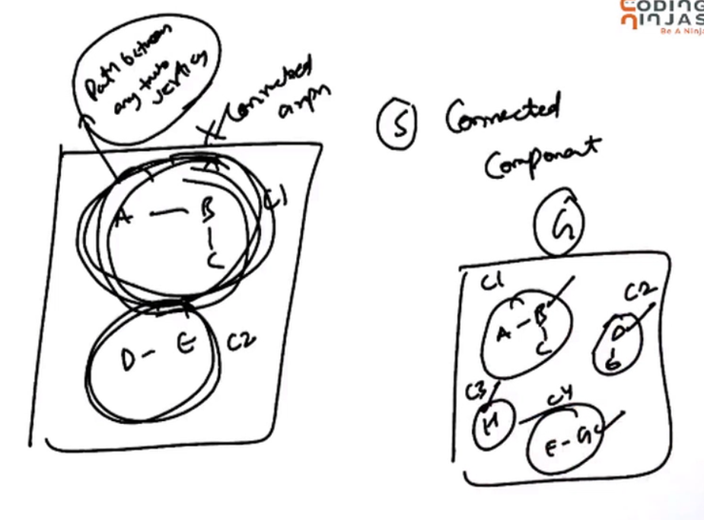

The graph G which has 4 connected components (C1,C2,C3 and C4)

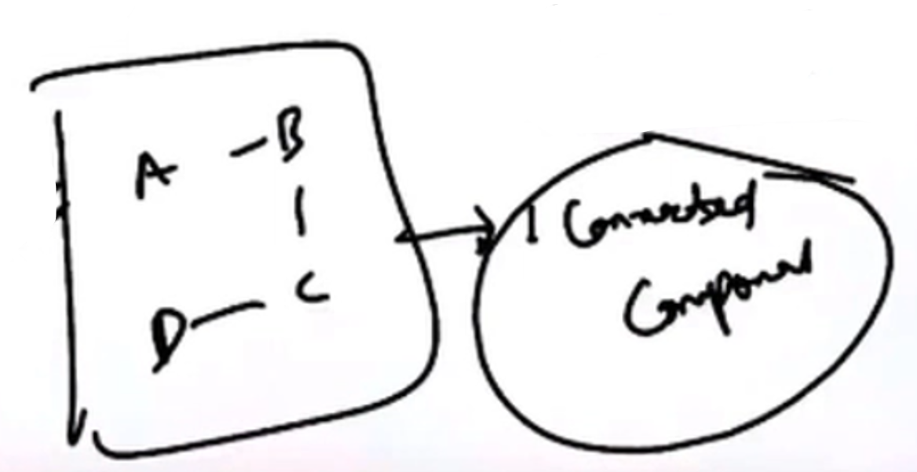

Connected graph will have only 1 connected component.

6) Tree 🡪 A tree is also a graph, but tree have some special property.  
A tree is always a connected graph. A tree cannot be a dis-connected graph.  
There will be a no cycle in a tree, but there will be a cycle in a graph.

So a graph will be a tree, there should not be a cycle in a graph, the graphs must be connected.

Minimum edges in a connected graph 🡪 In a graph, there will be minimum (n-1)edges for n vertices.

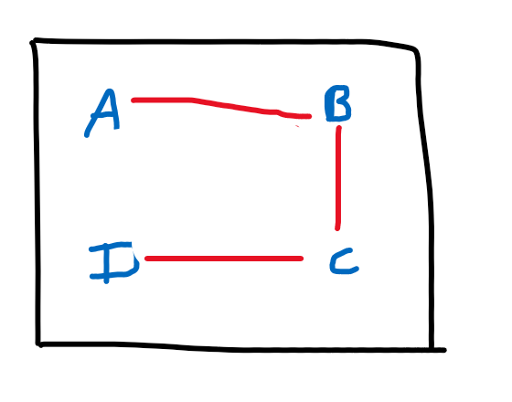  
Maximum edges in a connected graph 🡪 There must be an edge between any two vertices.

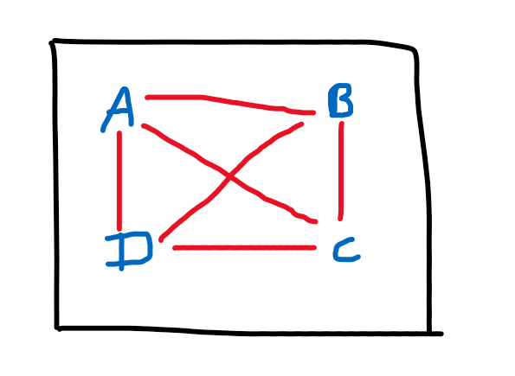

From A we can reach B,C,D. From B we can reach A,C,D. From C we can reach B,A,D.

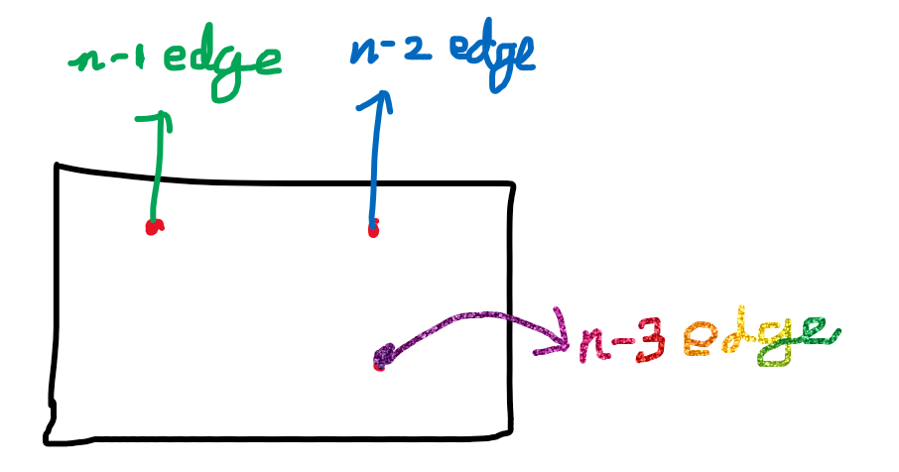

**n-1 + n-2 + n-3 + …. + 1 🡪 n(n-1)/2 🡪 O(n^2)**

# **Implementing a graph**

## **Brute force method (Using edge list)**

## **Adjacency List**

## **Adjacency Matrix**

If the edges are less 🡪 Adjacency list  
If the edges are more 🡪 Adjacency matrix