# **Data Models**

## **Model View Controller**

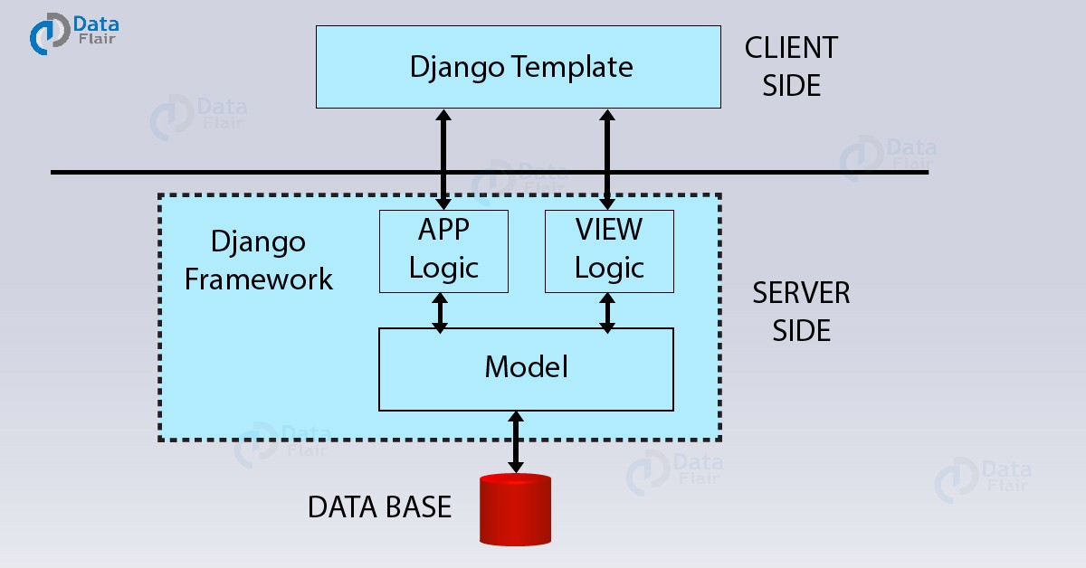

## **Django Data Model**

