# **Create a virtual environment**

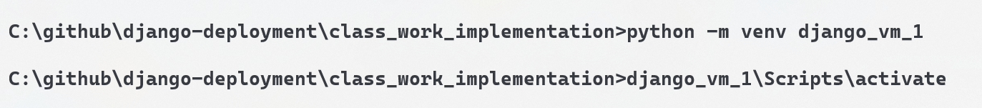

# **Install Django**

# **Creating a Django Application**

1. Go inside the project

# **Working with a Django Application**

