# **Before Generics**

Class Object 🡪 this the built-in-class / mother classes for all the JAVA classes.  
Every class is directly/indirectly from object class.

With the reference of an object of the object [parent class] class we can assign to any class [child class]   
Object obj = new String(“Hi”); [ Generalization ]

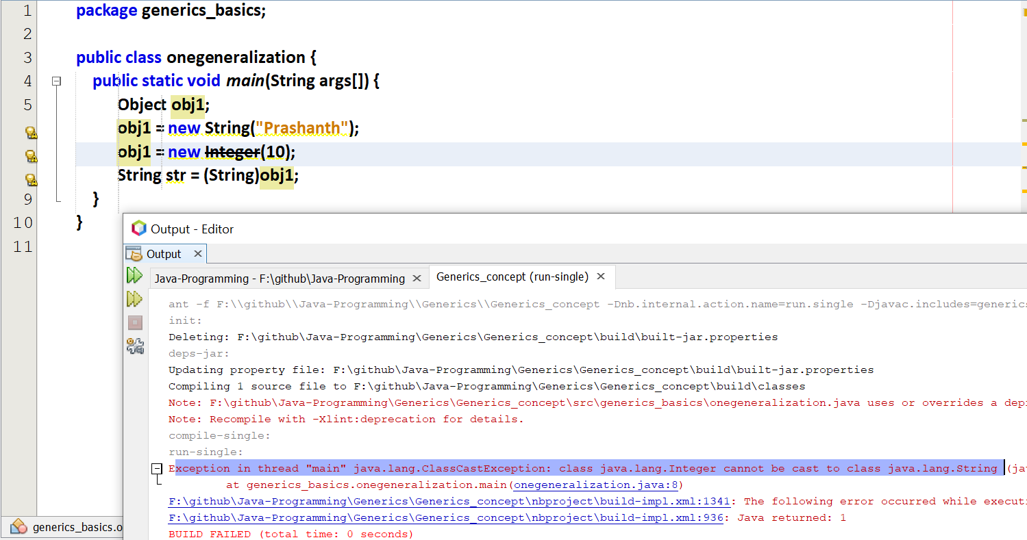

At compile time, it is accepting without any prompt. But the error is raised only at the run-time.  
[integer object cannot be converted into string]

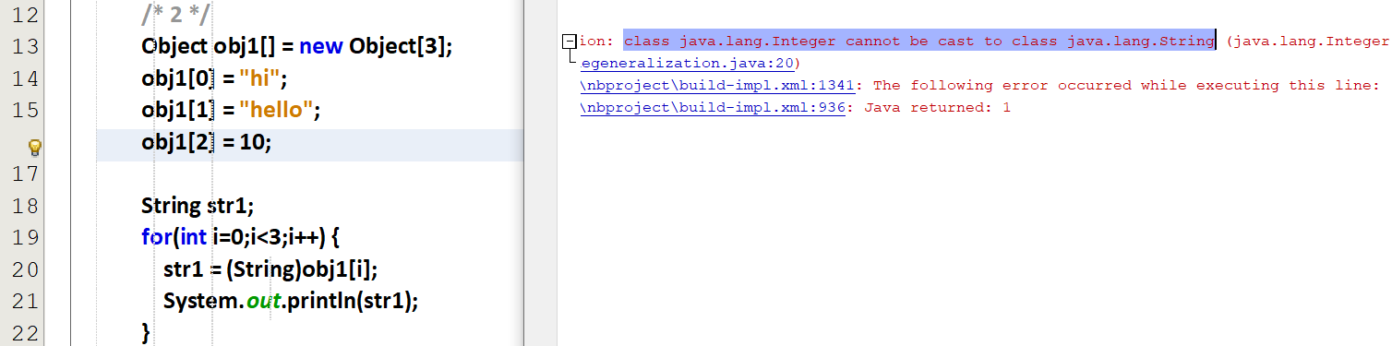

Here the 0th and 1st index 🡪 string  
2nd index 🡪 int  
But the main draw-back is, the error is raised only at the run-time.

Therefore we want an array to store only integers. If the 0th index is integer, then the complete array must be filled with integers.  
Therefore we want an array to store only string. If the 0th index is string , then the complete array must be filled with string.

But the array must be capable of storing any data-type. Before using that array mention that data-type.

This can be done by using generics

# **Generics**

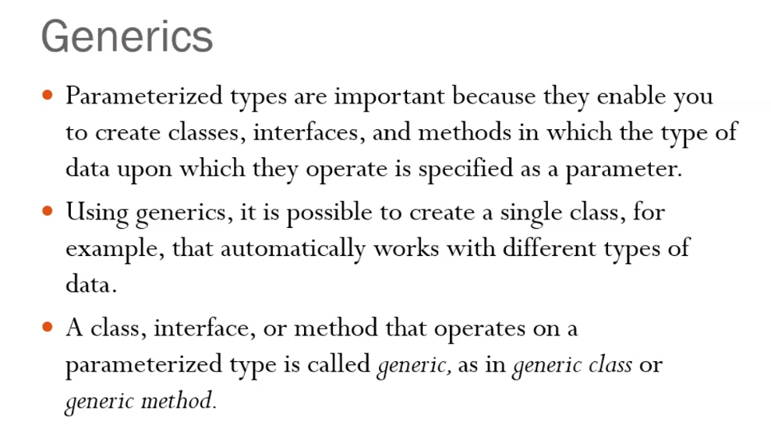

Templates in C++ 🡪 primitive data-types  
Generics in JAVA 🡪 objects

## **Refer Basic_1.java**

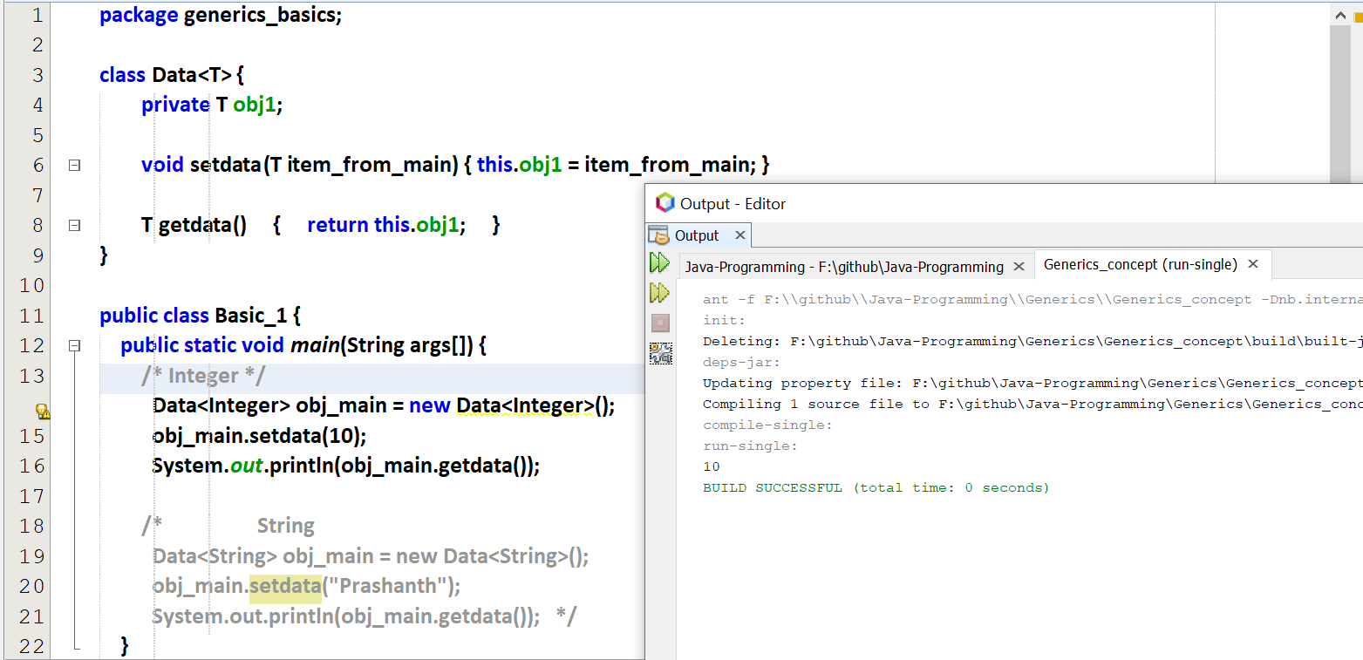

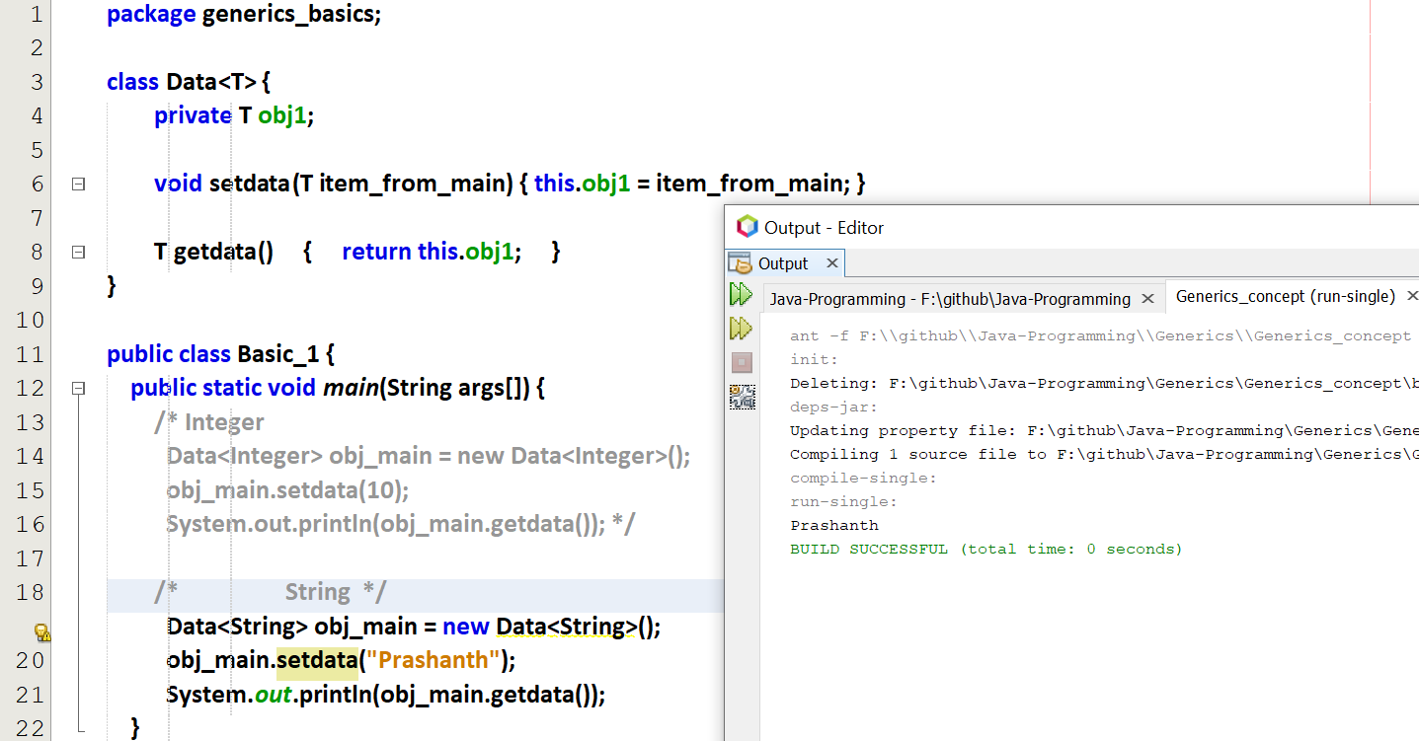

## **Refer Basic_2.java**

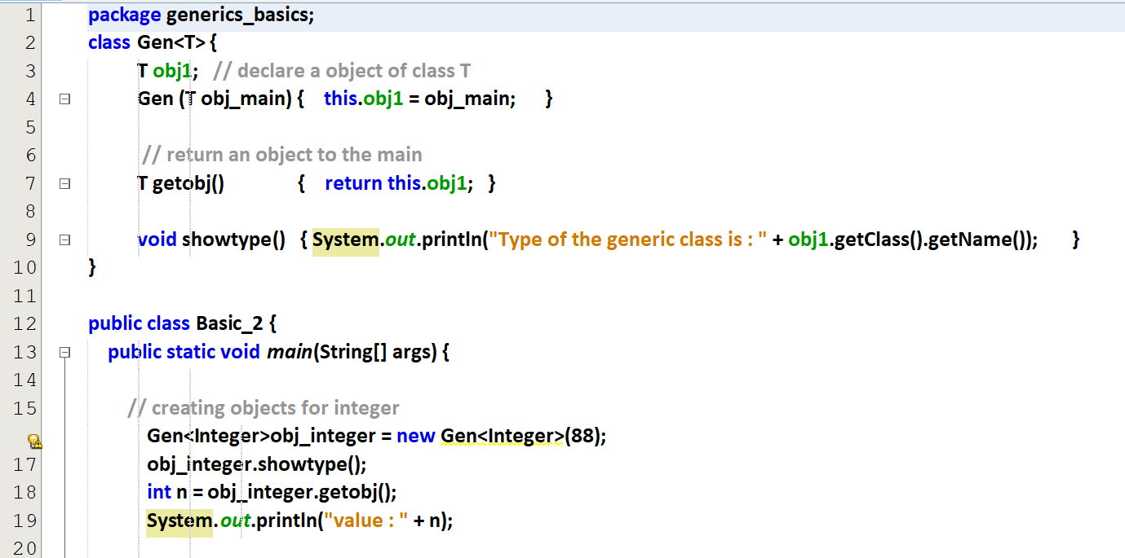  
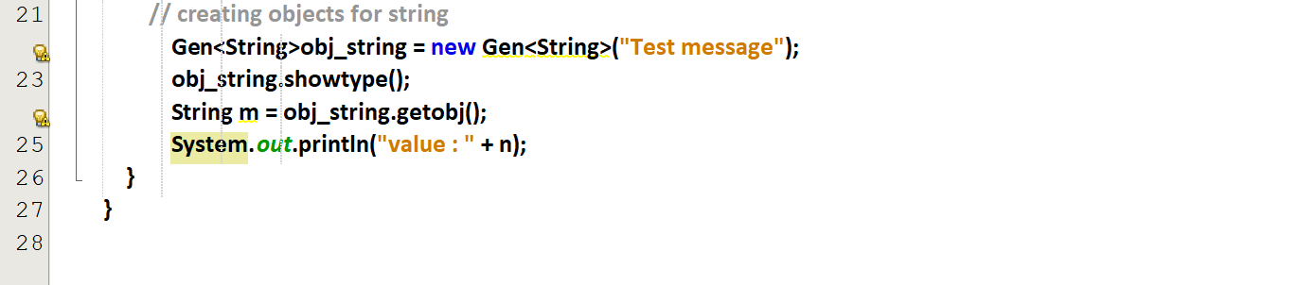

Output

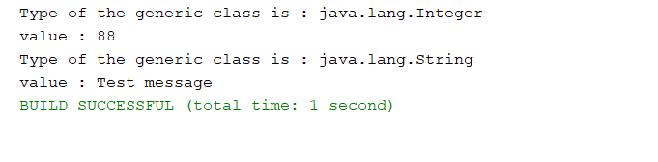

## **Refer Basic_3.java**

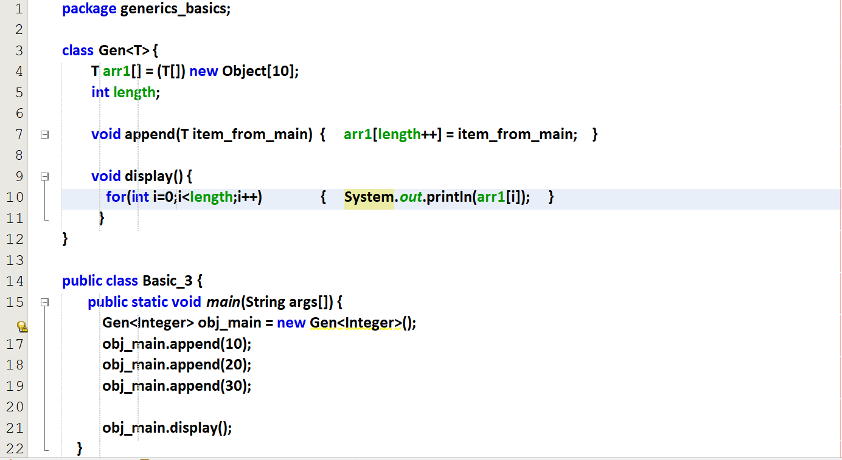

Output

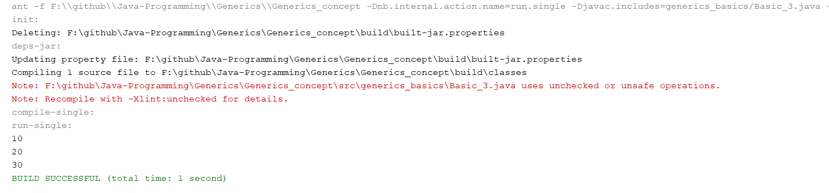

Reason for warning 🡪 Here the object is converted into Generic, we can avoid this by using   
@SuppressWarnings(“unchecked”)

With integer

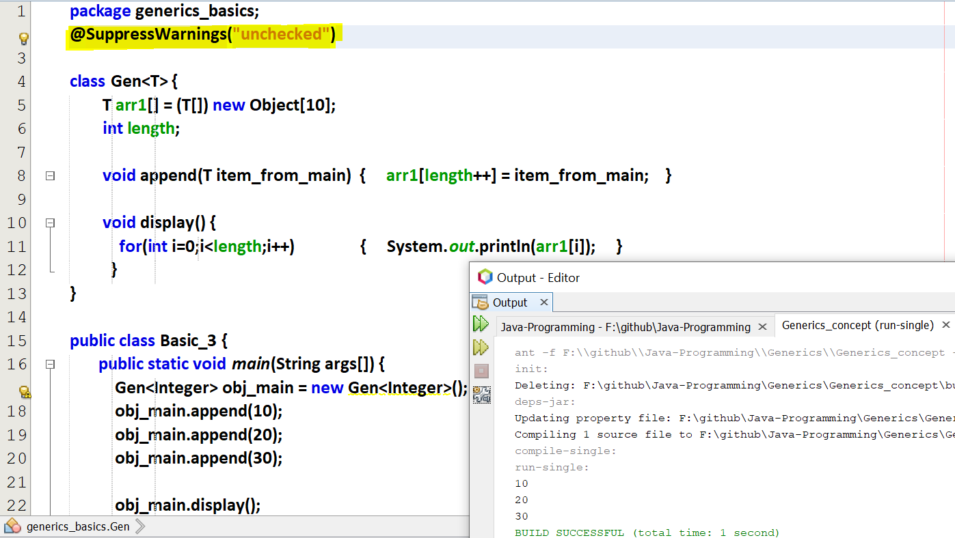

With strings

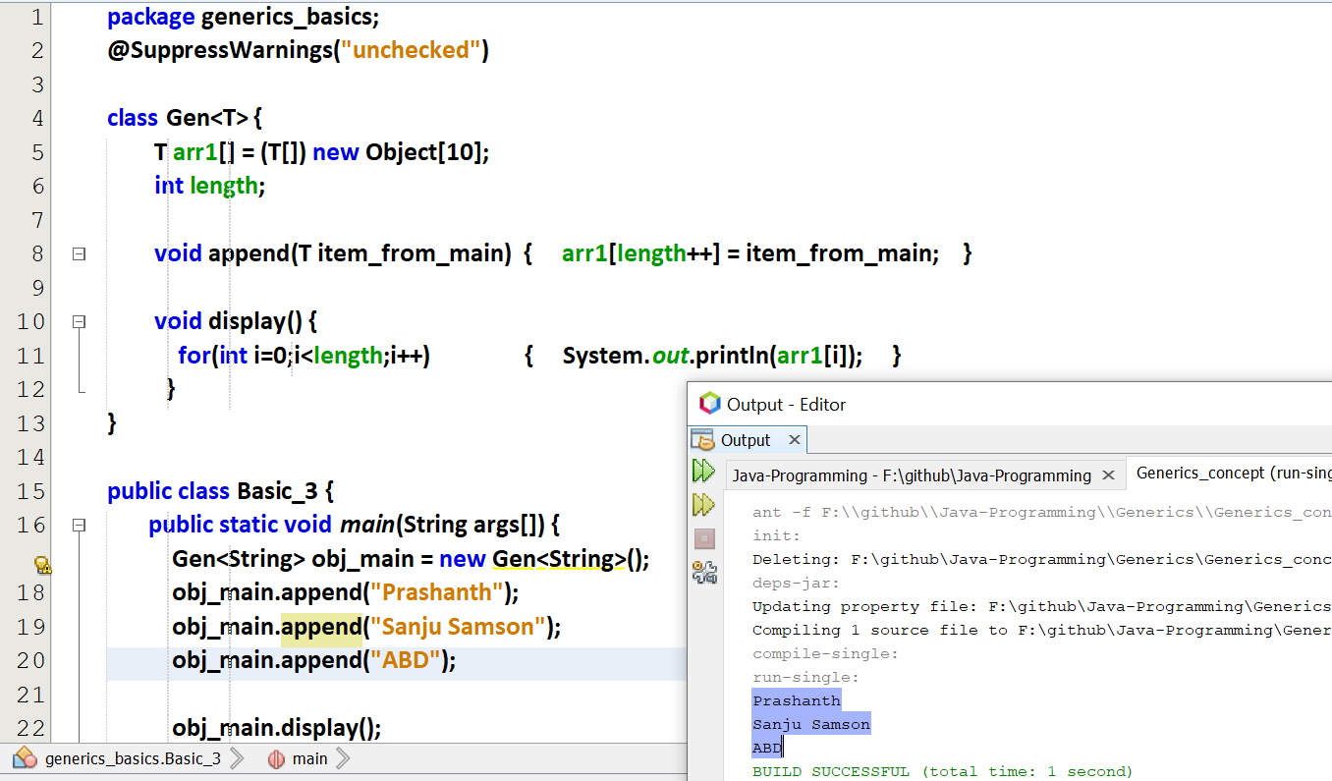

## **Refer Basic_4.java Array as a Parameter in generic class**

## **Refer Basic_5.java Array**

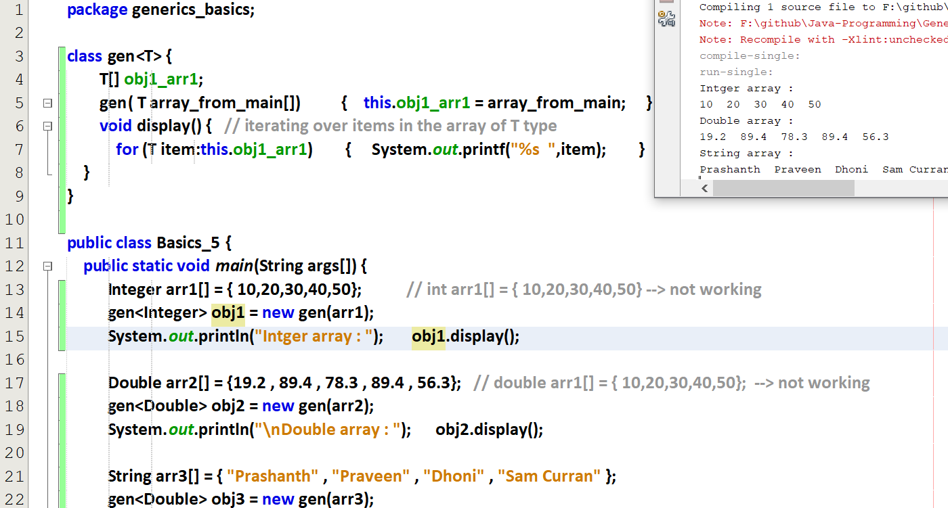

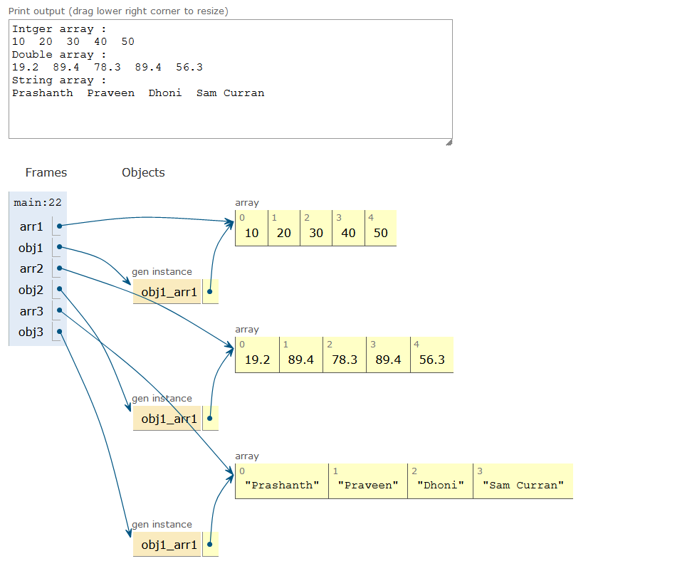

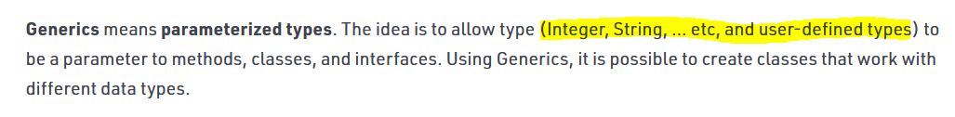

## **Two Type Parameters**

Refer two type parameter.java

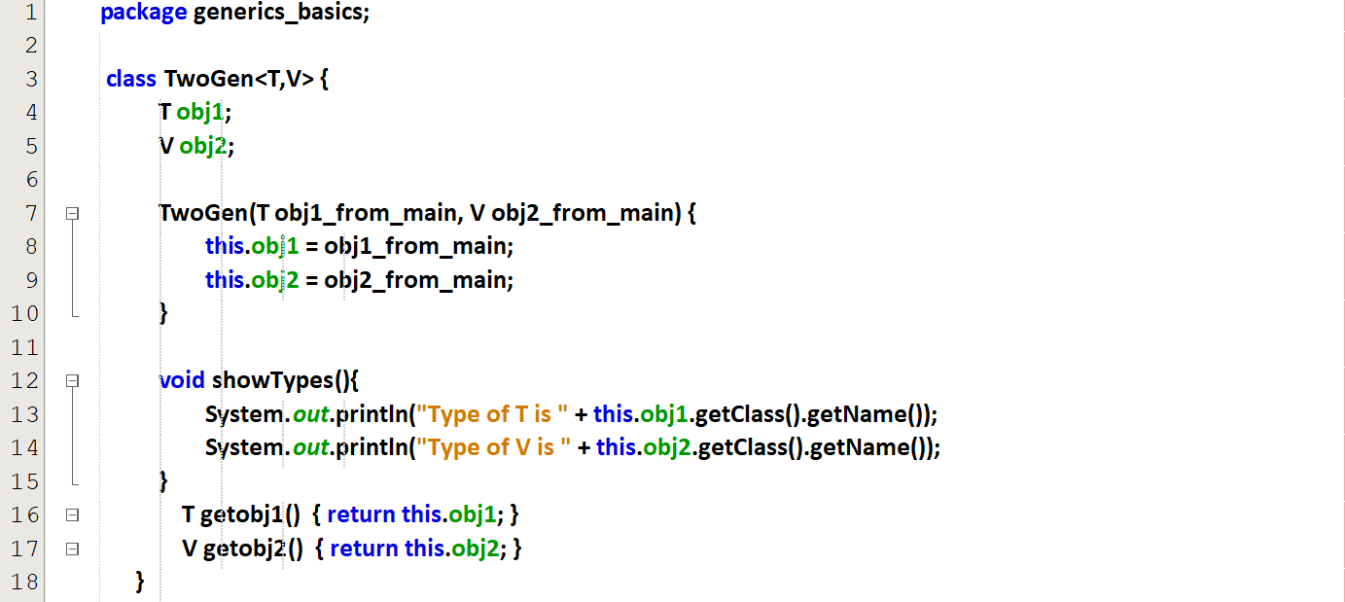  
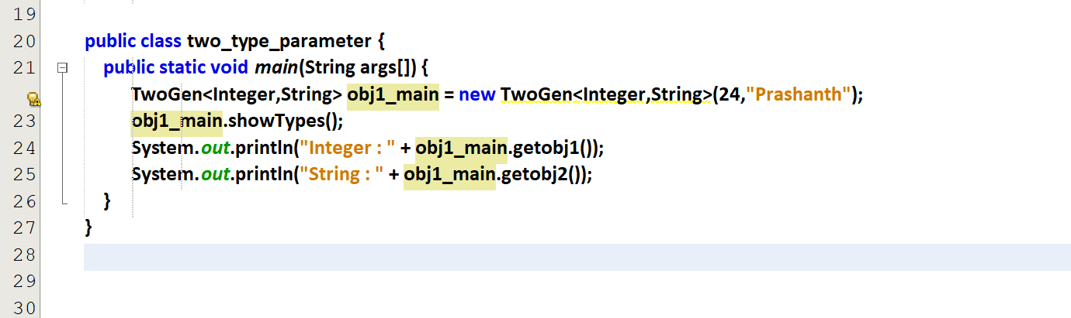

Output

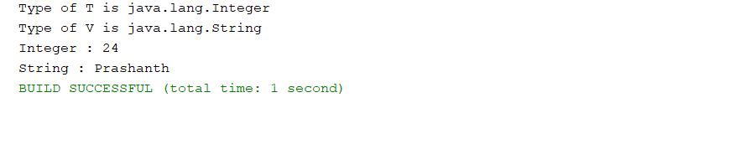

# **Bounds on Generics**

## **No Parameters**

Refer no_parameters.java

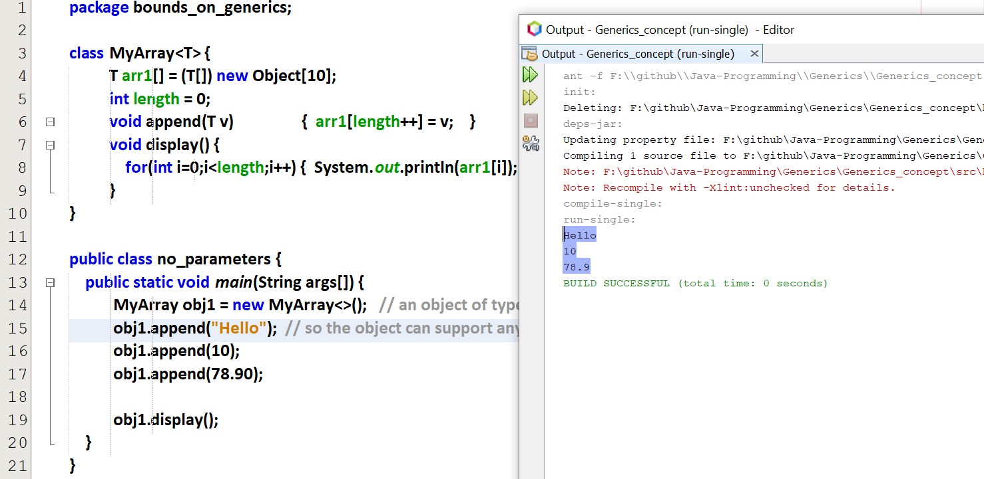

obj1 🡪 an object of type generic, since parameters are not given.  
Since the class is also Generic, it supports any type of object.

## **Multiple Parameters**

## **Subtypes**

A normal class cannot able to inherit Generic classes.  
A generic class only can able to inherit Generic classes.

### **Refer subtypes_1.java**

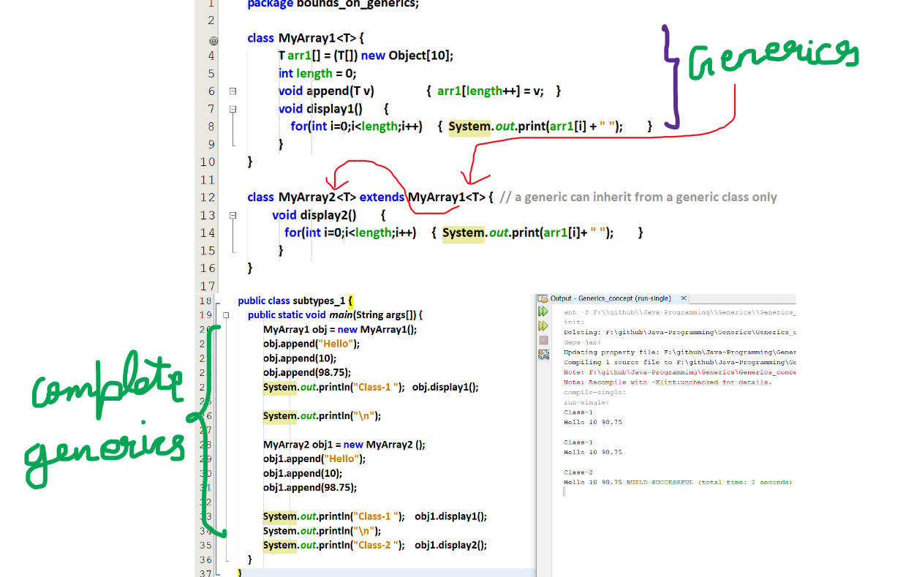

Both the classes are generic

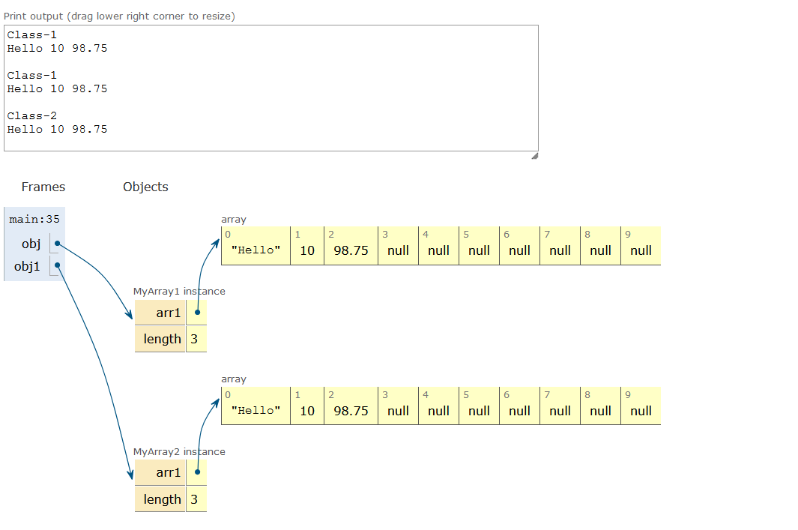

### **Refer subtypes_2.java**

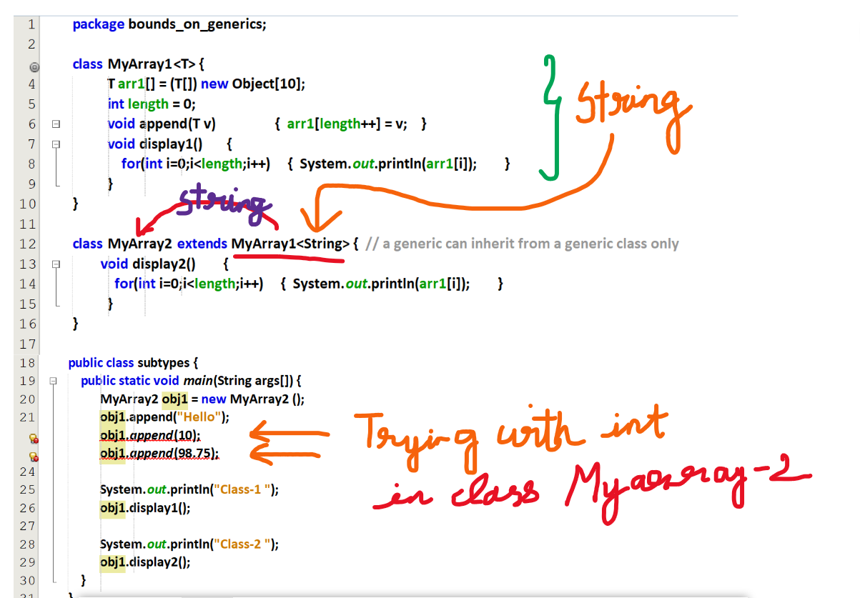

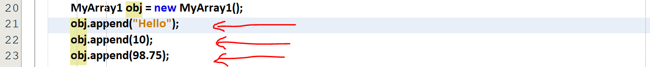

Myarray1 🡪 Generic   
object for Myarray1 🡪 Generic

Myarray2 extends Myarray1<String>  
Myarray2 🡪 String  
object for Myarray2 🡪 String

## **Bounded Types**

### **Refer bound_types_1.java**

### **Refer bound_types_2.java**

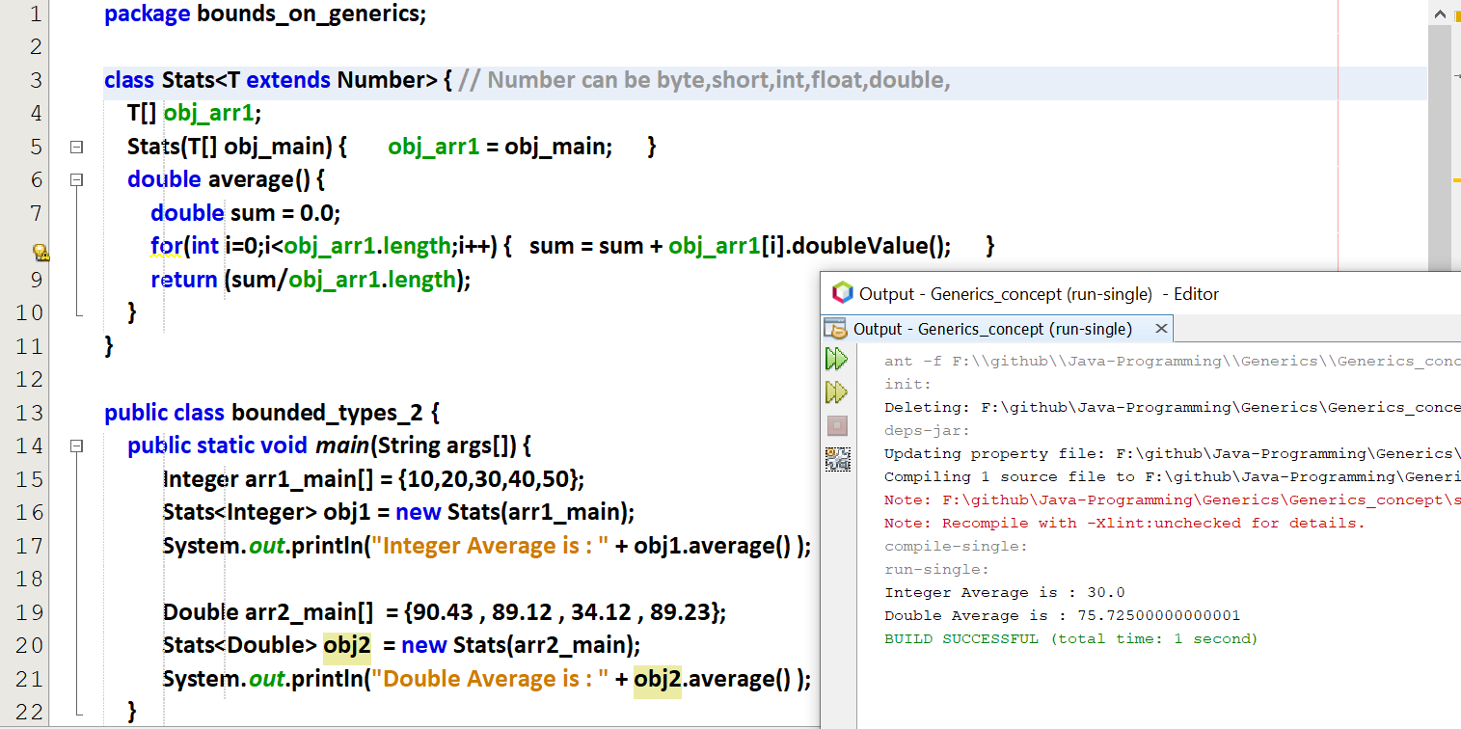

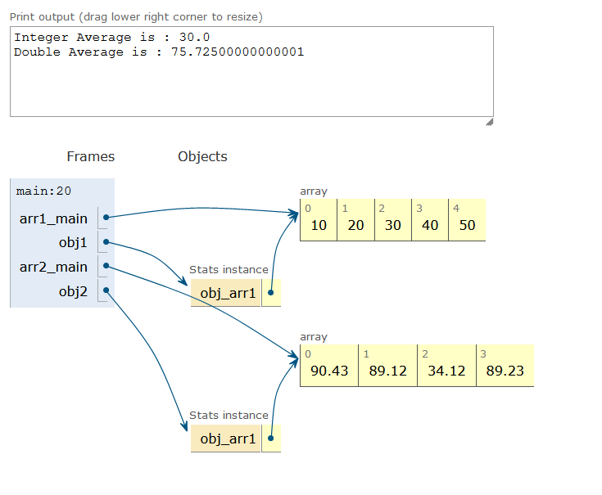

Forcefully we are making the generic class to be of Number

# **Need for wild card**

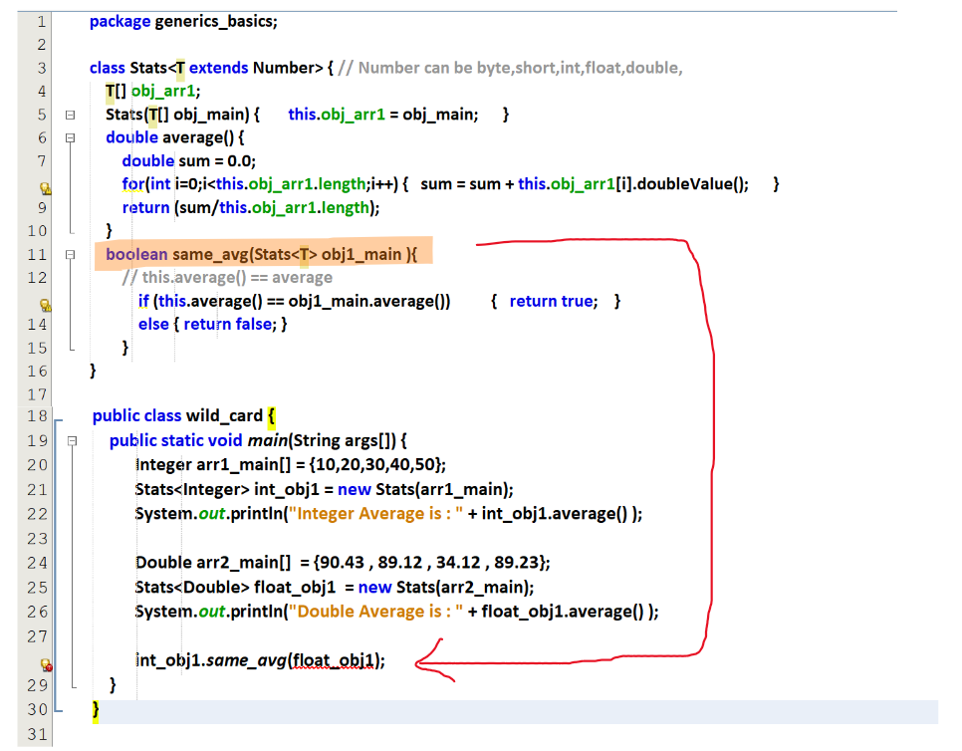

After putting ?

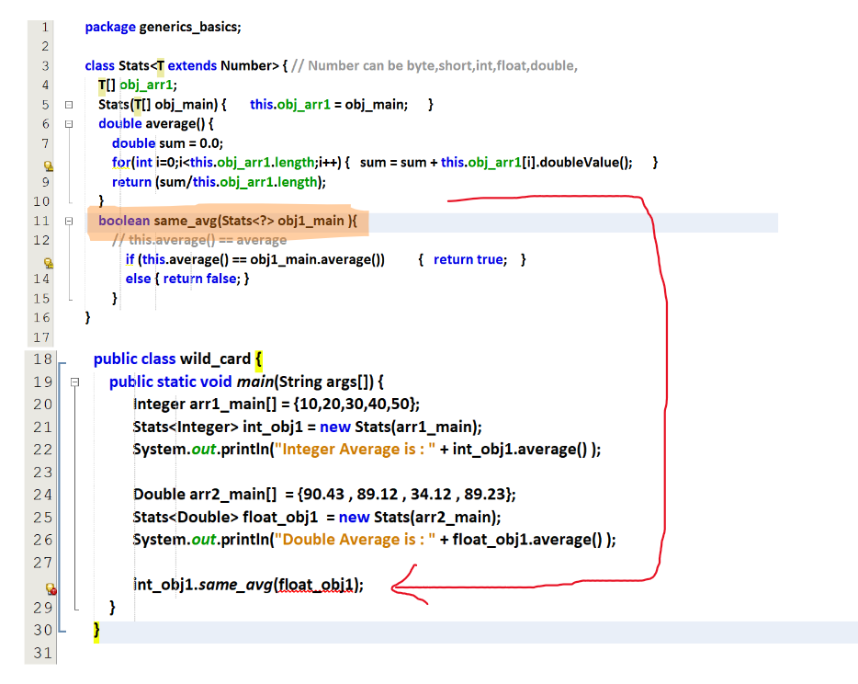

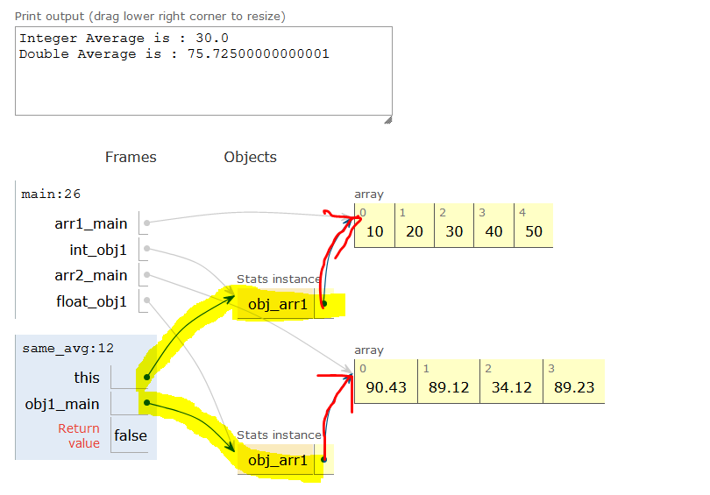

# **Generic Methods**

