# Synchronization

All threads will have their individual stack. But object is created in heap.

## **Resource sharing**

## **Critical Section**

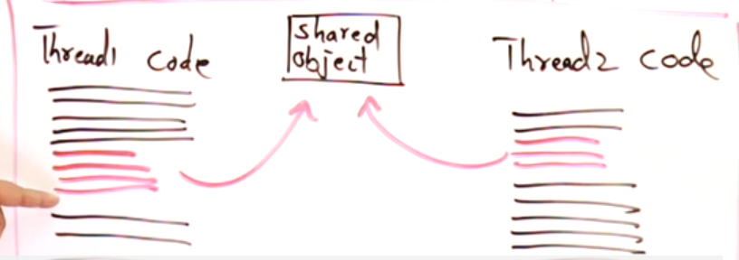

Red lines are the critical section part of their respective codes.

## **Mutual Exclusion**

Will not allow two threads to access the same resource simultaneously. This is known as Mutual exclusion. Preventing any other thread to access the same object is known as mutual exclusion.  
There should be some co-ordination between threads so that one thread can access the shared object at that instant.

Happening of one prevents the happening of other.  
Thread-1 accessing a resource will prevent thread-2 to access.

1. There should be some system which should take care of the shared resources by allowing only 1 thread at a time 🡪 Locking/mutex || semaphores || monitor.  
   Locking/mutex ( mutex will take care)  
   Semaphores (OS will take care)  
   Monitor (objects will take care)
2. Apart from the system there must be some co-ordination between threads (i.e t-1 and t-2 should communicate with each-other to access the shared resource. 🡪 Race condition || Inter-thread communication.

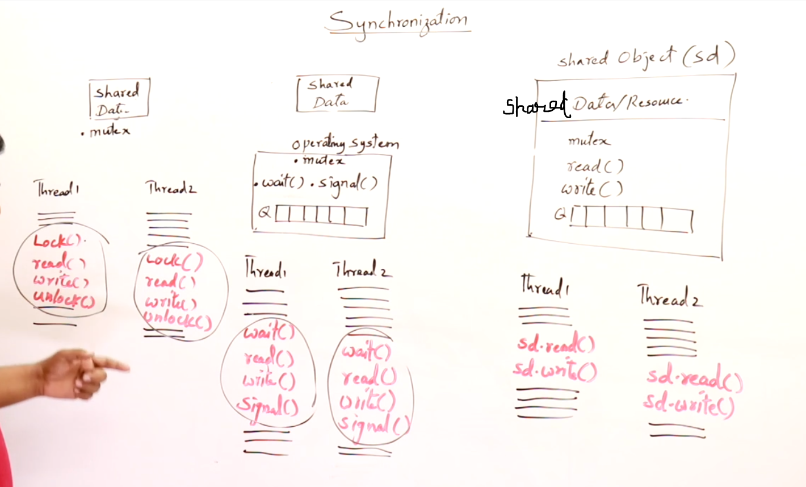

Locking/Mutex Semaphore Monitor

## Locking/Mutex

Here threads will lock() , read() , write() , unlock() automatically. Two / more threads will communicate with each-other and provide mutual exclusion.

## **Semaphore**

Threads knows how to read and write, OS will take care of locking [i.e wait()] and unlock [i.e signal()]. Operating System will achieve mutual exclusion.

## **Monitor**

Thread doesn’t know how to read and write. But it can perform by calling the methods. Objects in Object Oriented Programming(OOPS) will contain data and methods() and these objects provides mutual exclusion.

Eg: Barber Shop, Customers wants hair-cut, trim bears but customers don’t know how to do??  
So they simply calls the methods which they want, and stylists will make the customers sit in the queue and allow one-by-one when their turn comes.

### **Multi-threading using Monitor**

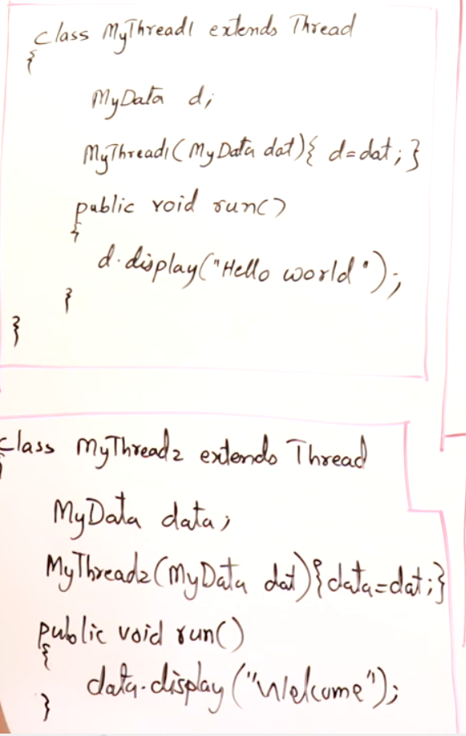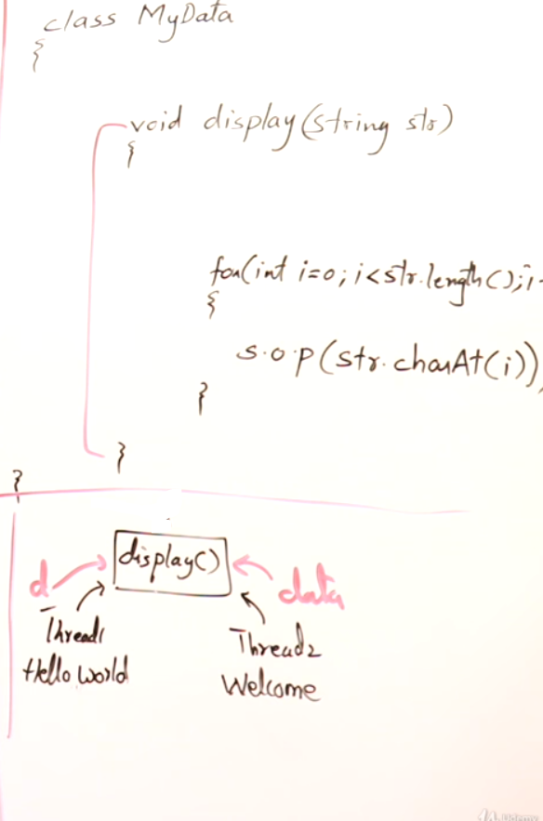

Main method

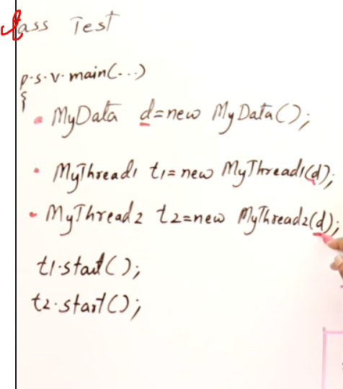

Here d is the shared object to all the threads.

Method-1

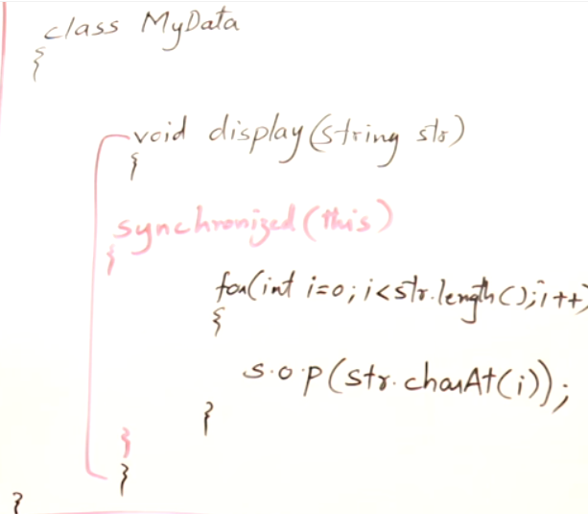

Method-2

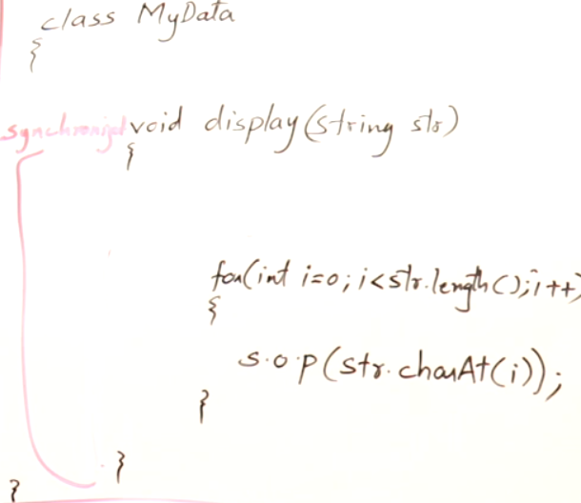

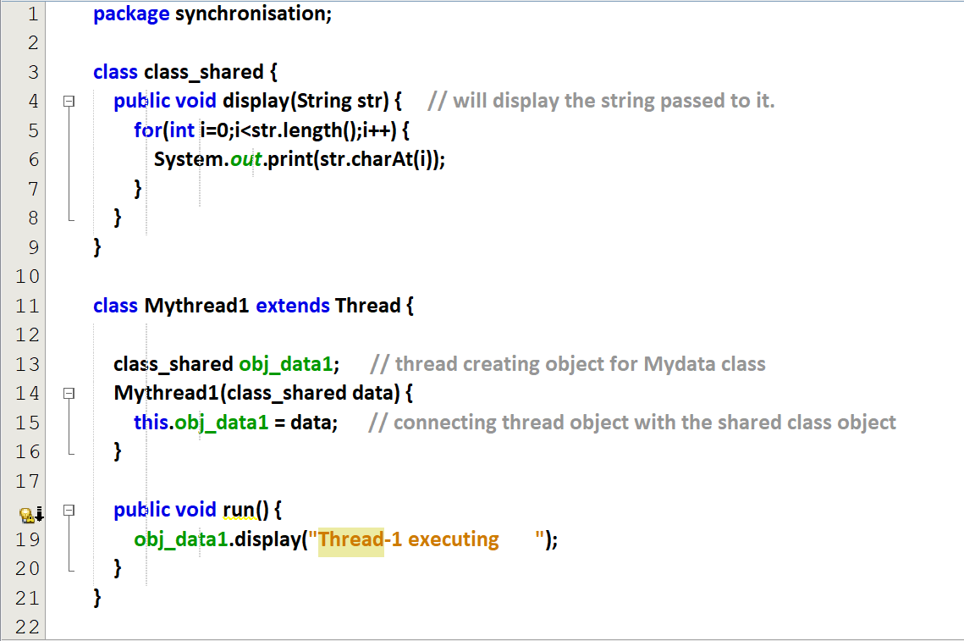  
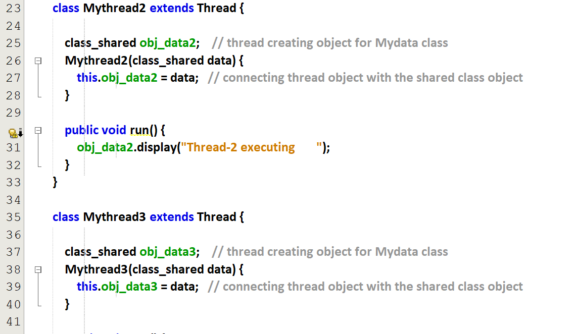

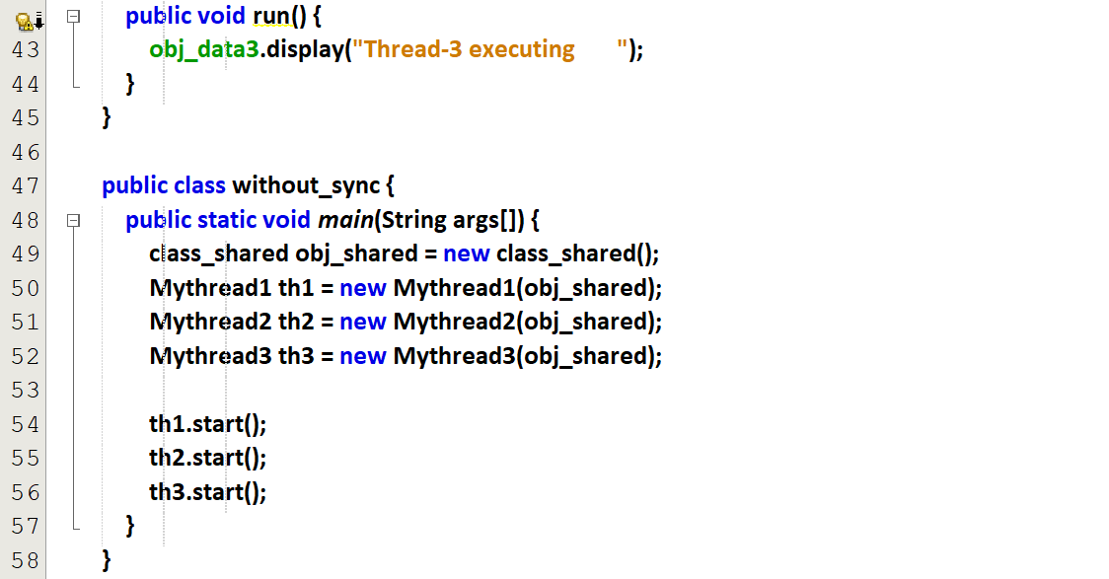

Output

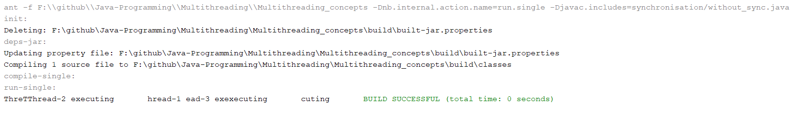

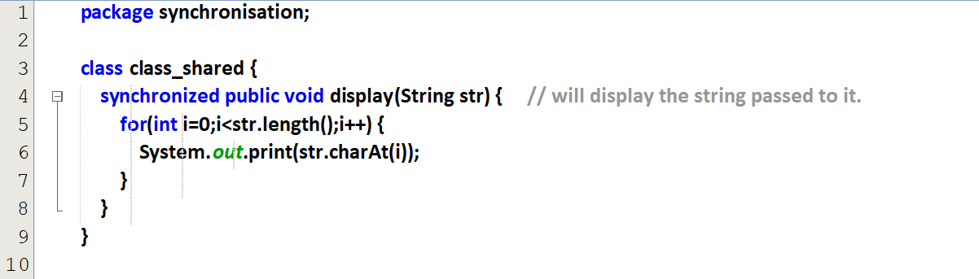



Without sleep

Output

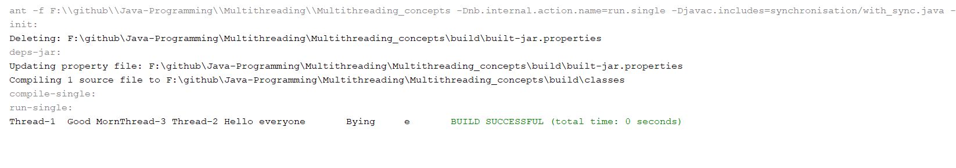

First 🡪 thread-1, Second 🡪 thread-3, Third 🡪 thread-2

#### **With synchronisation**

##### **With sleep**

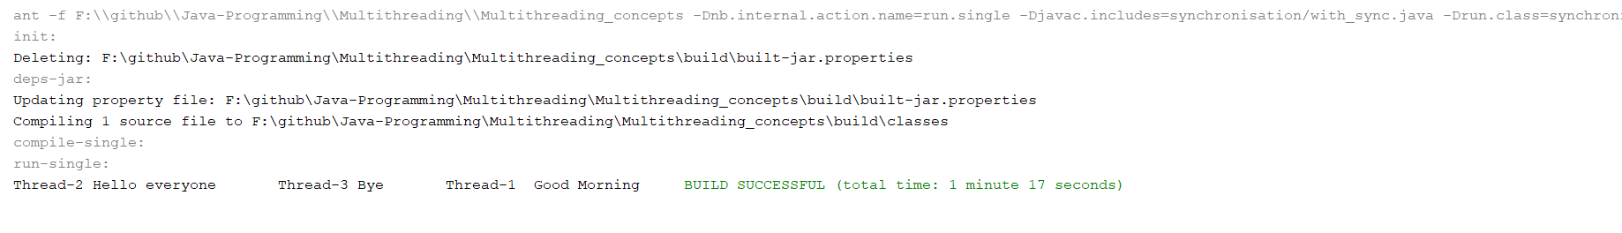

Once a thread starts, it will continue running. It will not interrupt itself. The typing will be slow.

##### **Without sleep**

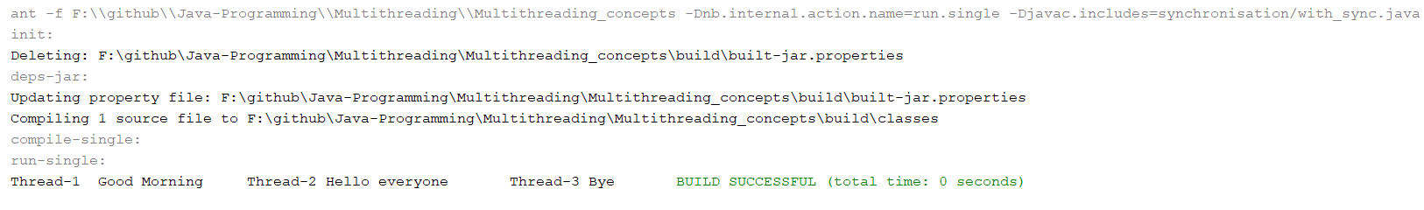

Once a thread starts, it will continue running. It will not interrupt itself.

#### **Without synchronisation**

##### **With sleep**

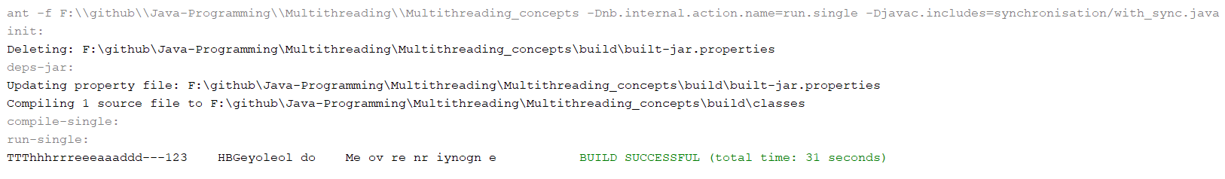

##### **Without sleep**

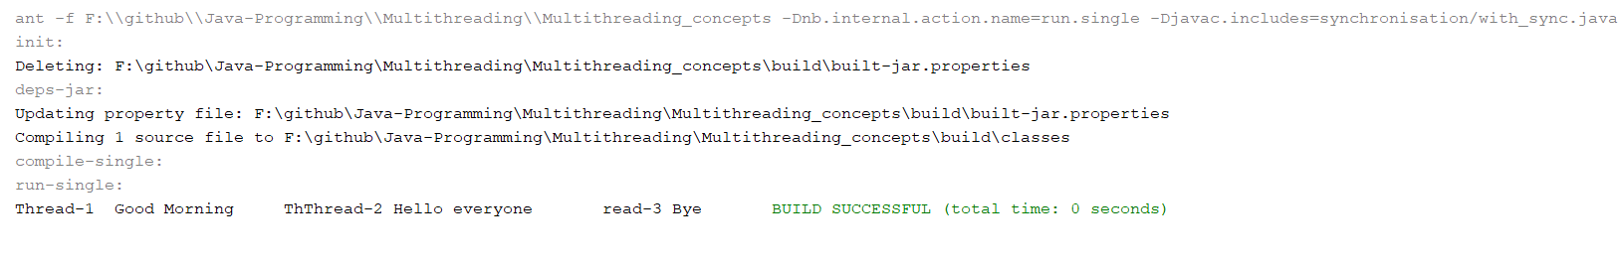

Here the threads starts and will not interrupt often.

Once a thread starts, it will continue to run. It will interrupt frequently because of sleep.

### **Students challenge ATM**

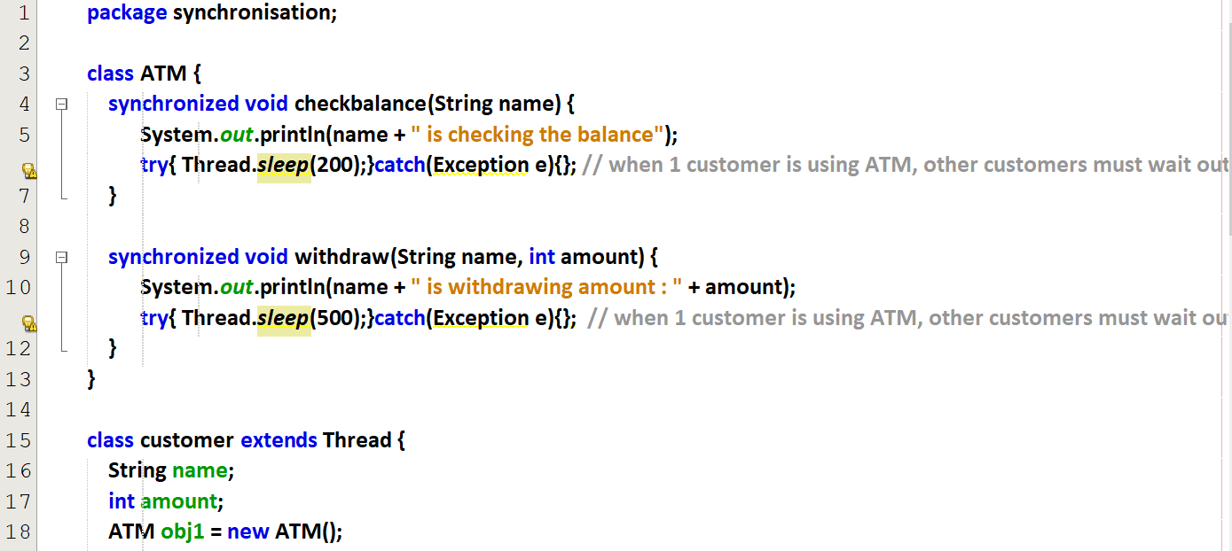  
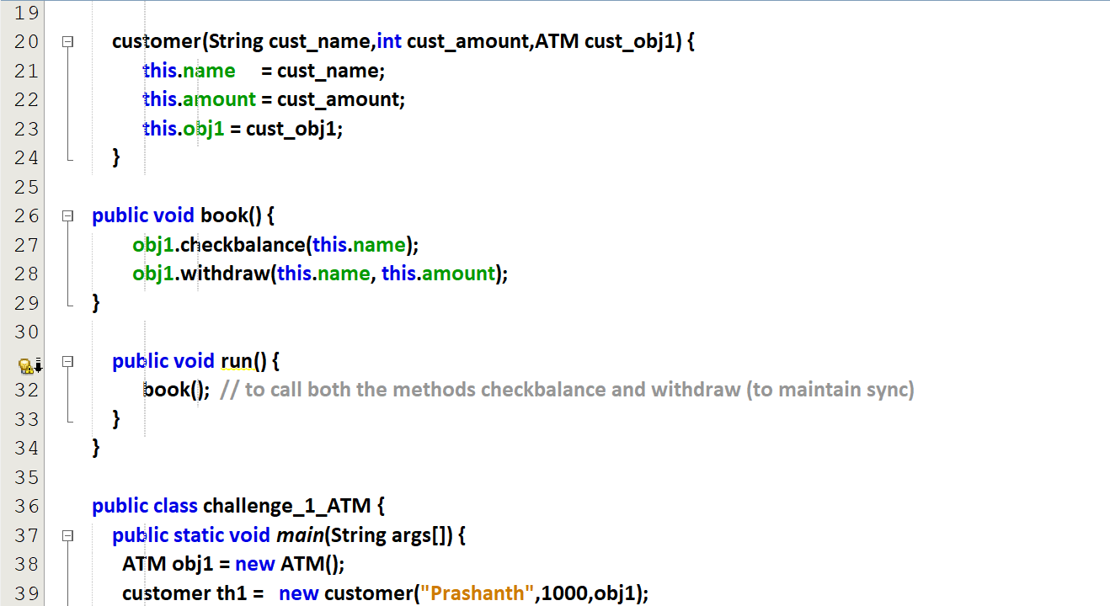  
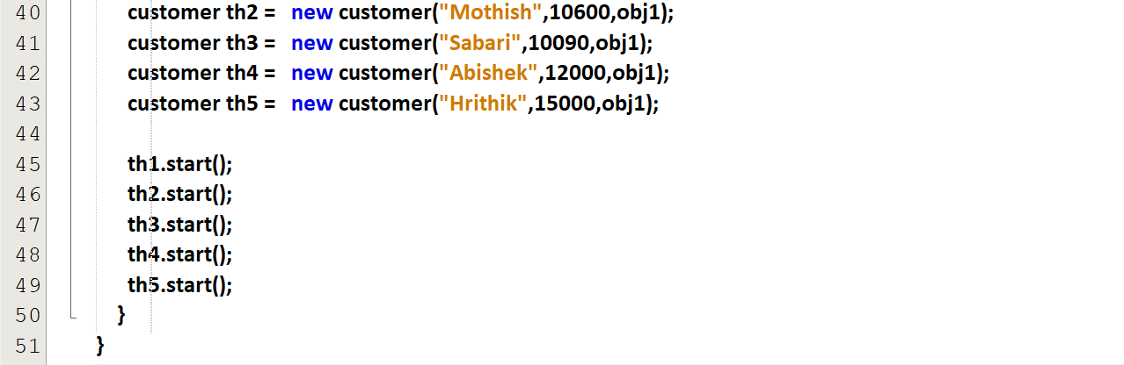

Output

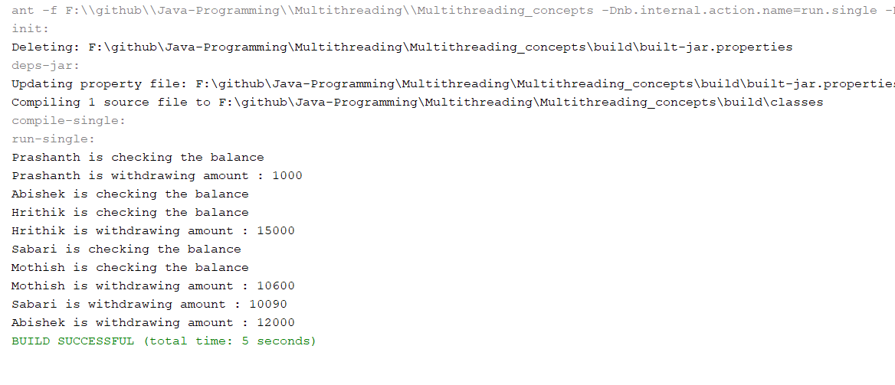

## **Race Condition**

## **Inter-thread communication**

Similar to inter-process communication in OS, here in JAVA it is inter-thread communication..  
Before this JAVA achieved synchronisation, Now the programmer has to achieve inter-thread communication.

producer will write the value using set().  
consumer will read the value using get().

flag = true (Producer’s turn)  
flag = false (Consumer’s turn)

notify() 🡪 will wake up only one blocked thread  
notify_all() 🡪 will wake up all the blocked threads

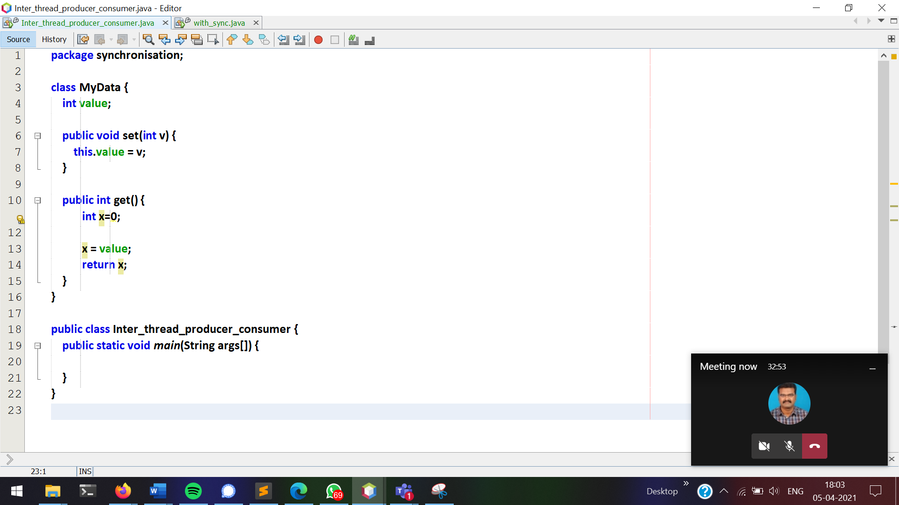

Without synchronisation

Producer produces items, but consumer consumes already consumed items.

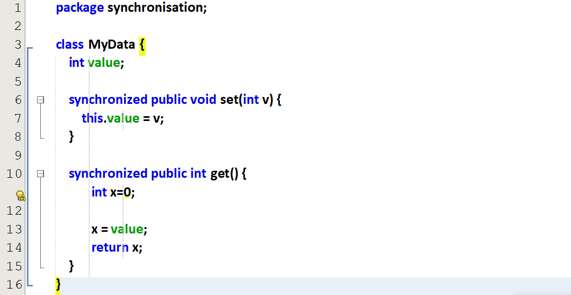  
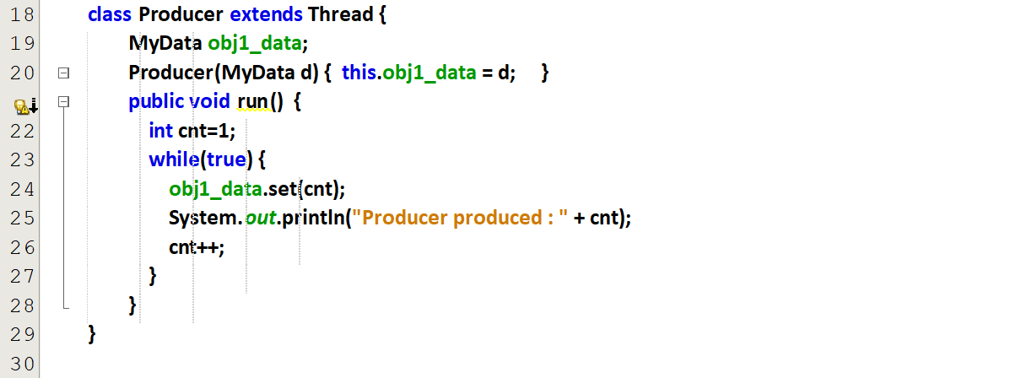

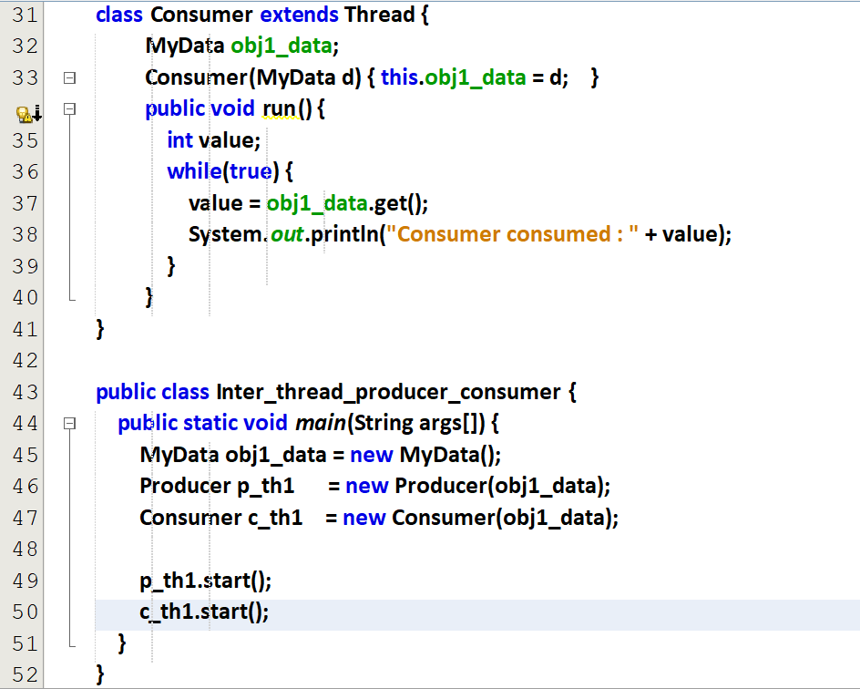

**Output**

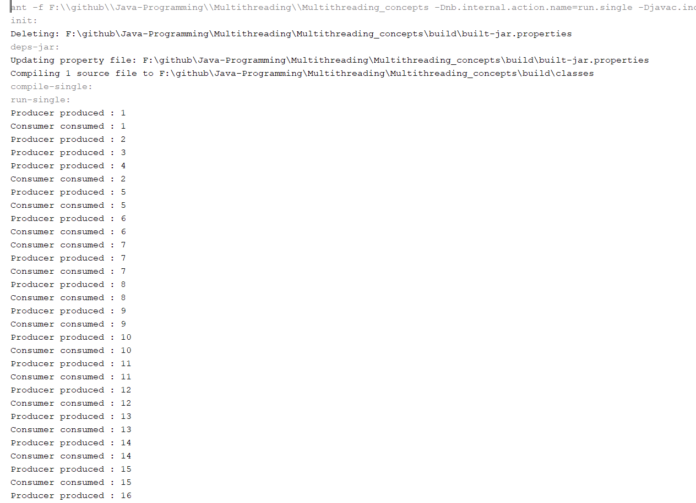

Even-though synchronisation is there for both set() and get(), these are 2 independent methods, so we cannot find the sync.

With synchronisation