# **Inheritance**

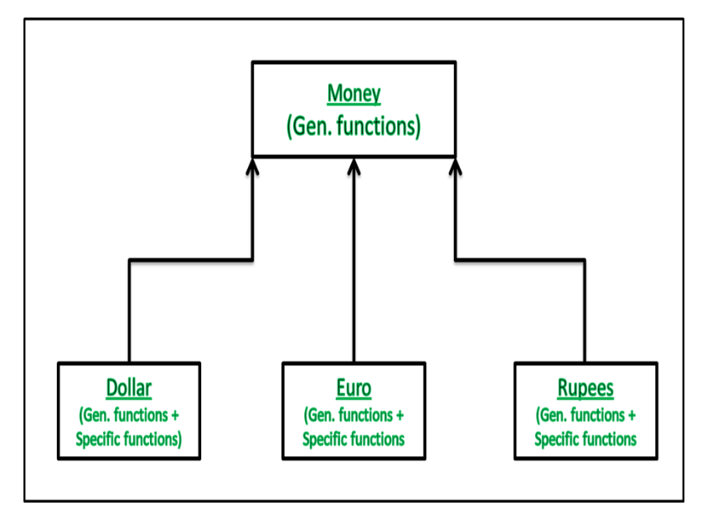  
**Relatively General Class:** Money

**Relatively Specific Class:** Dollar, Euro, Rupees

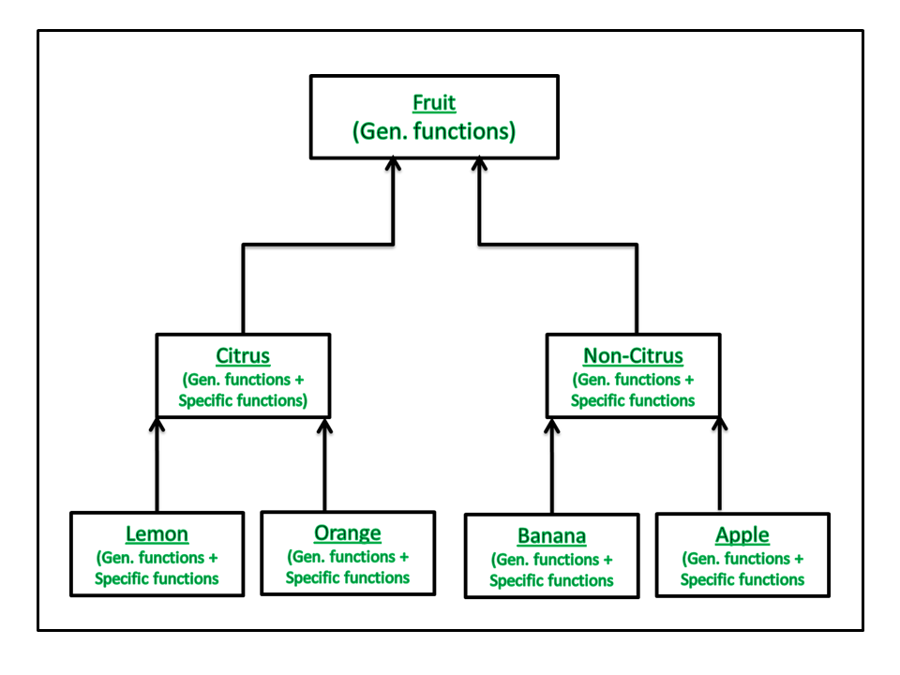

**Lemon, Orange are more Specific than Citrus**

**Banana, Apple are more Specific than Non-Citrus**

**Citrus, Non-Citrus are more Specific than Fruit**

**Fruit is most general class**

**Generalization 🡪 bottom-up  
Specialization 🡪 top-down**

