# **String method**

## **.compareTo()**

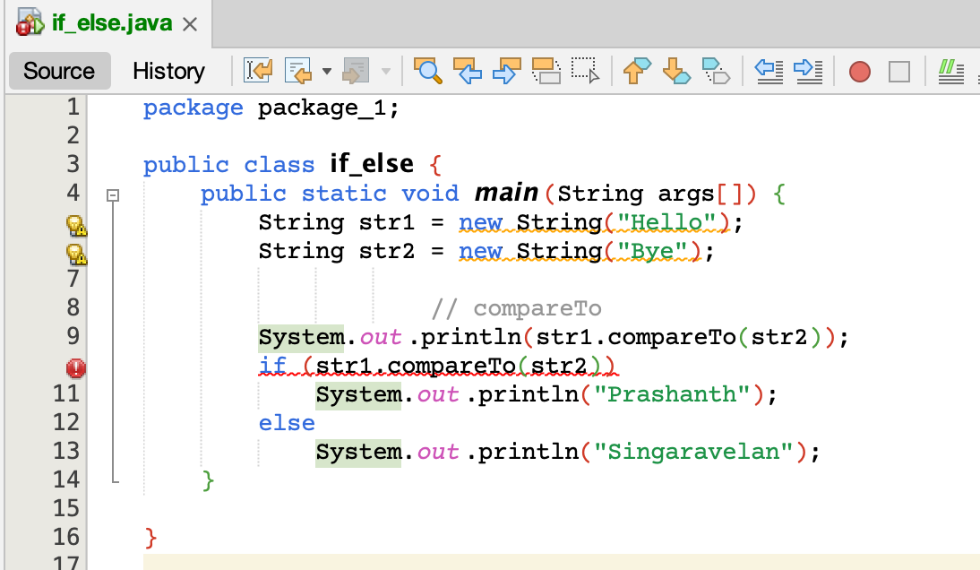

## **.equals()**

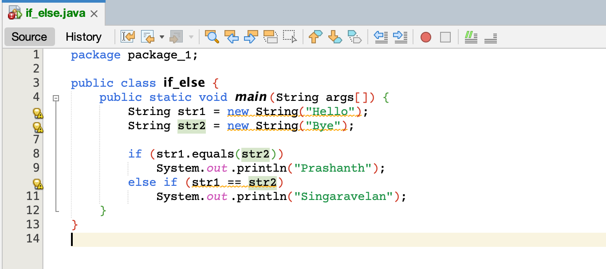

# **Switch Statement**

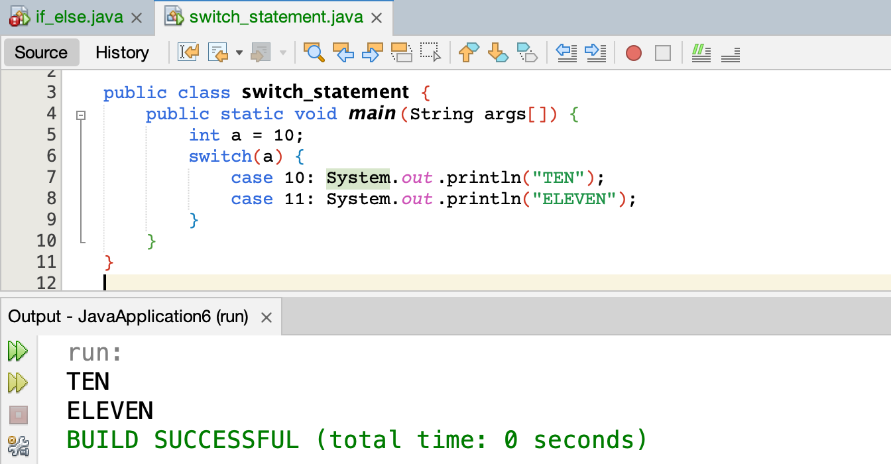

Break statement is not present in Switch syntax.

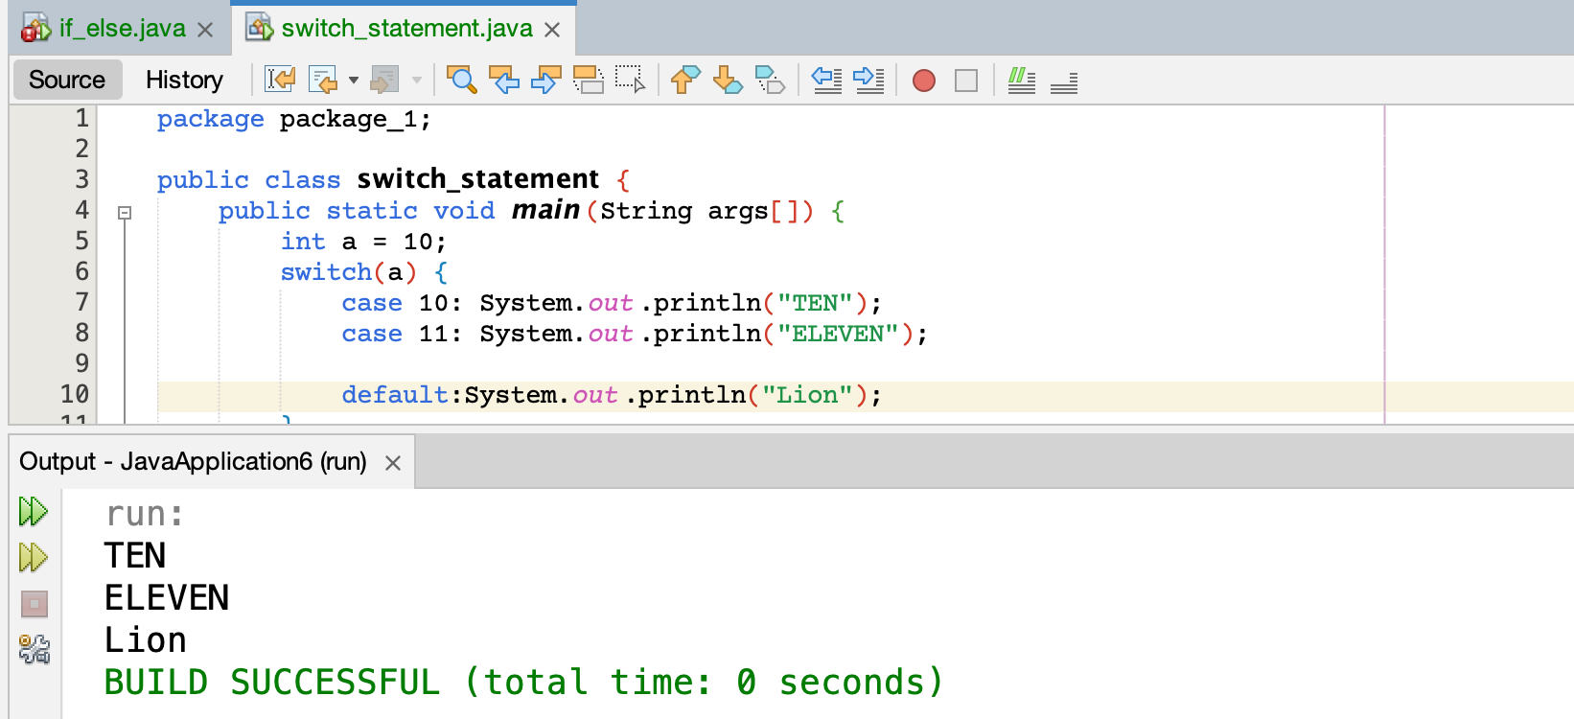

If any one of the case passes also, **default** will execute.

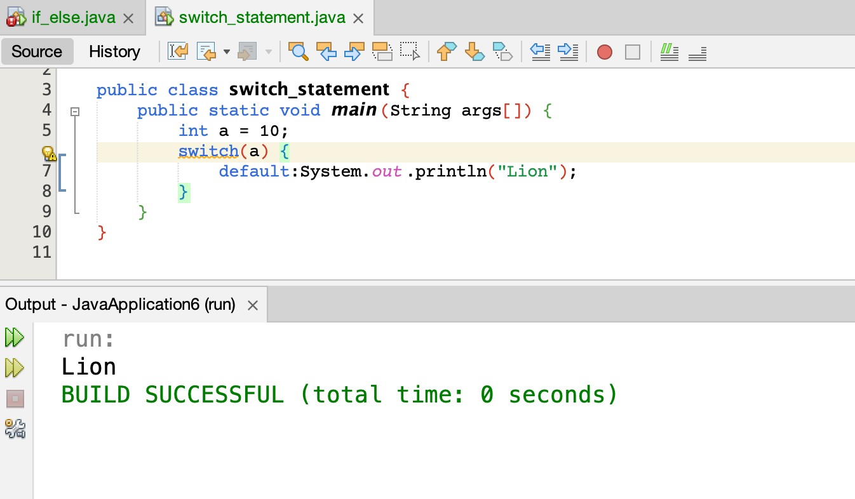

If there are no cases also, **default** will execute.

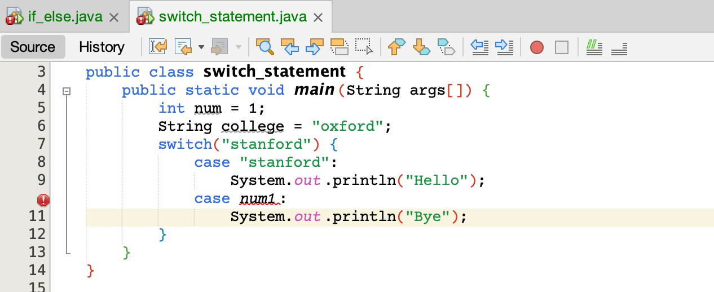

Only “Stanford” must be given in the case.

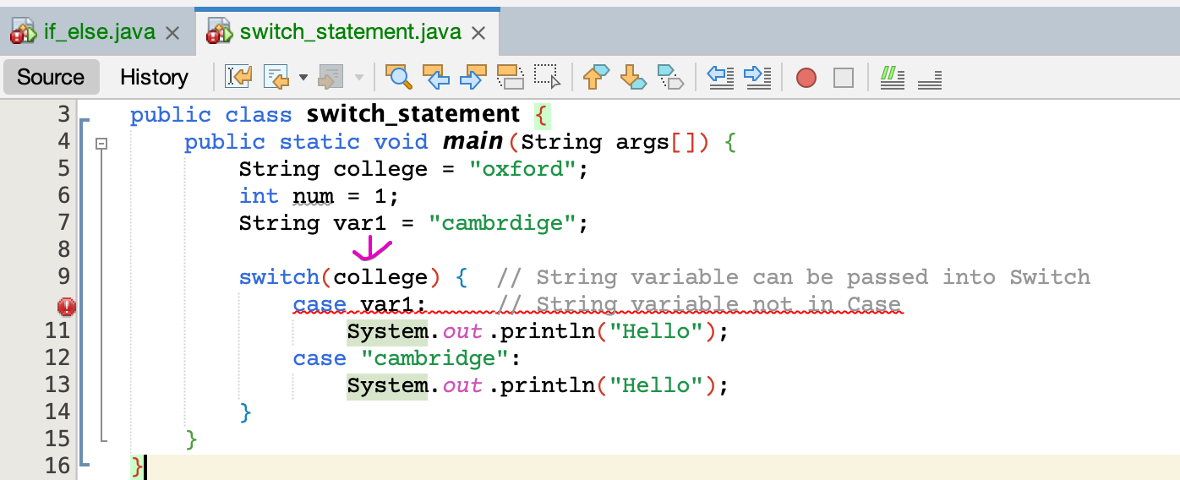

Variable name not in Case. Straightly write the values in Case.

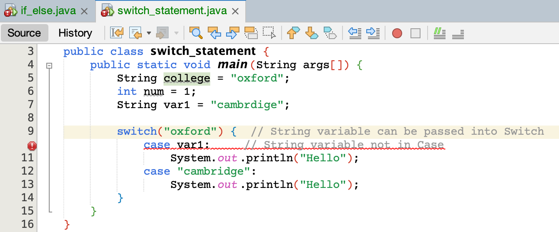

What-ever (variable/value) type in Switch(), that corresponding type value must be given in case.

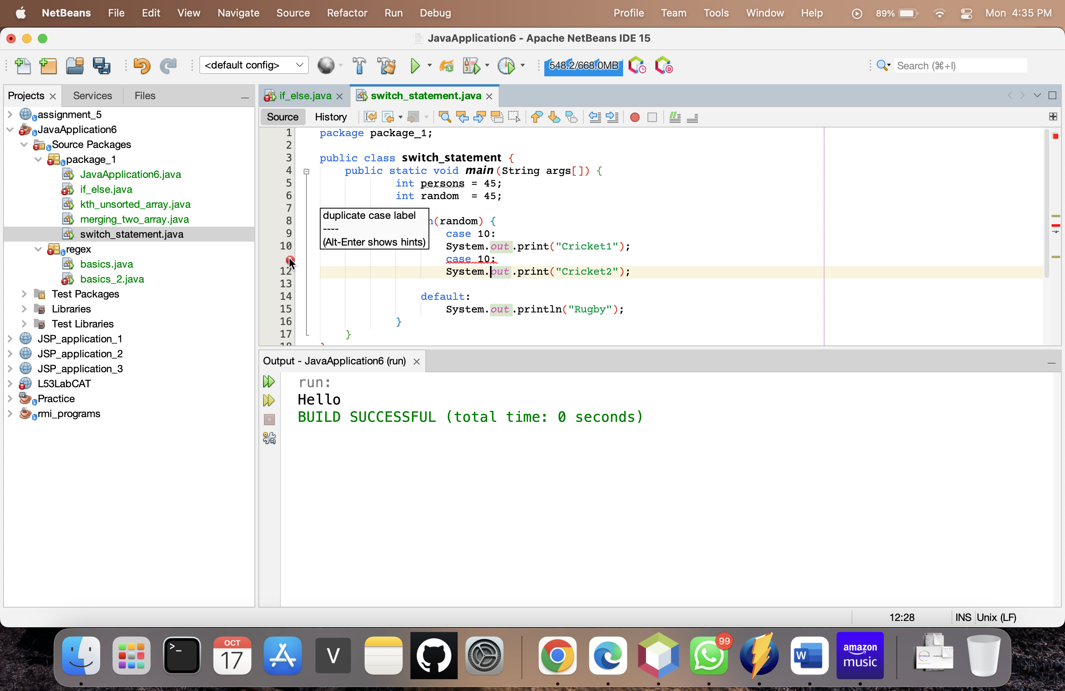

No two cases must have same case number

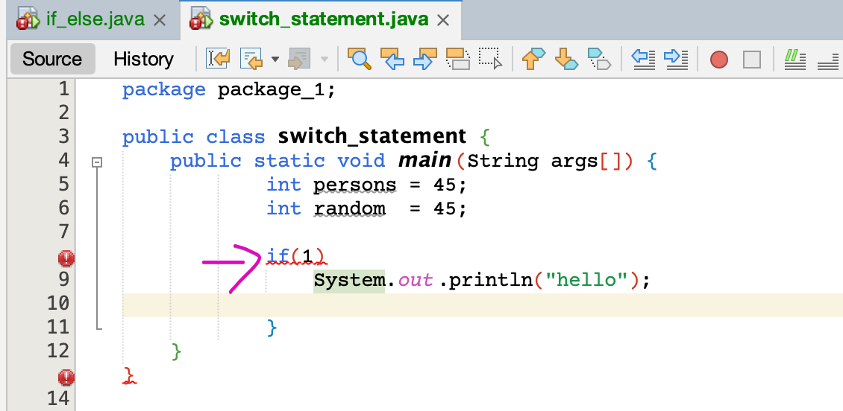

Only Boolean must be given.