# **Entropy**

## **Problem-1**

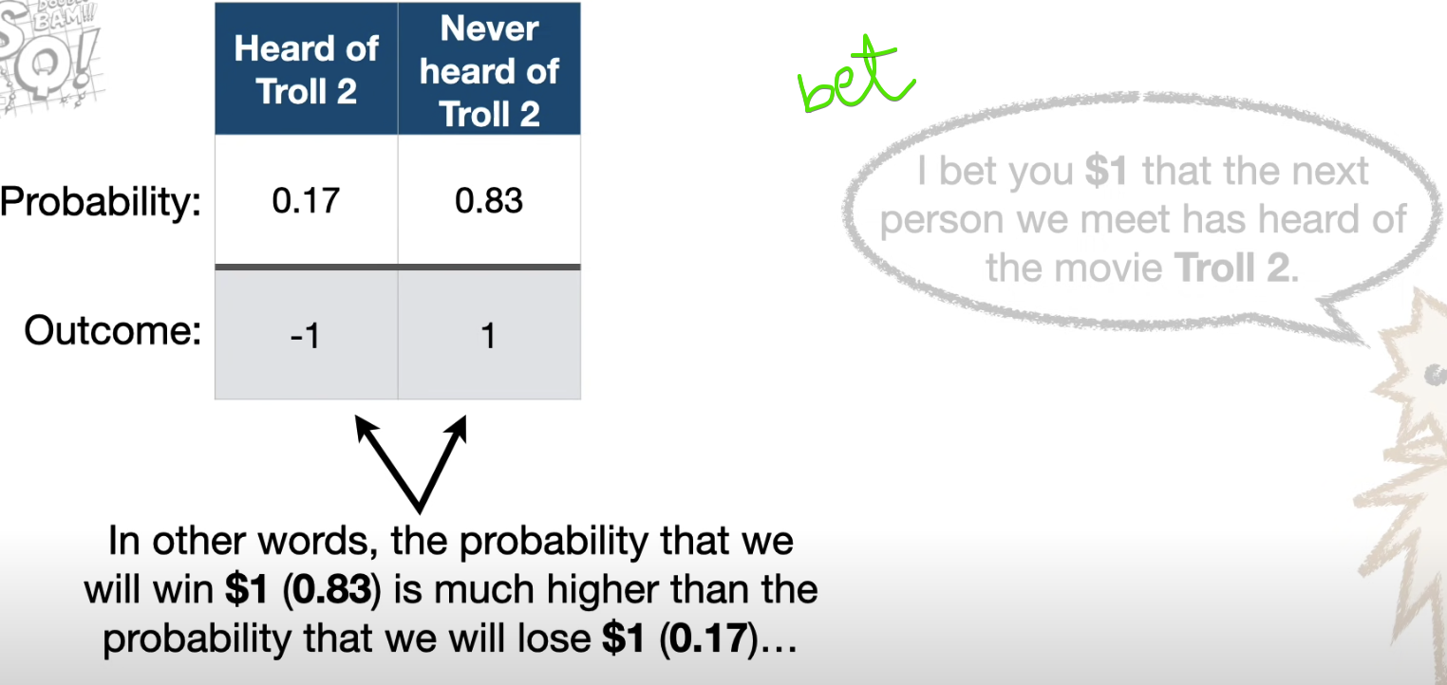

So we will be confident enough to challenge for the bet.

However, even though there is a high probability that we will win the bet (0.82), there is also still a low probability that will lose (0.17).

Lets repeat this $1bit for 100 times.

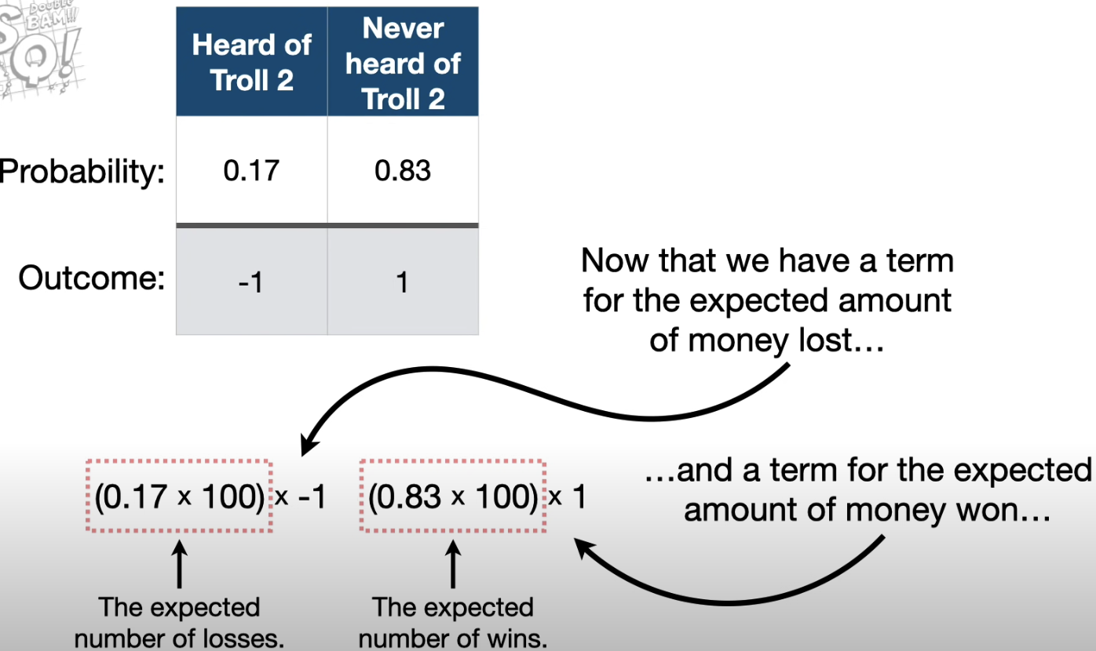

We can add up these two terms to find out the total of how much we except to win/lose.

Amount earned after 100 bets 🡪 $66  
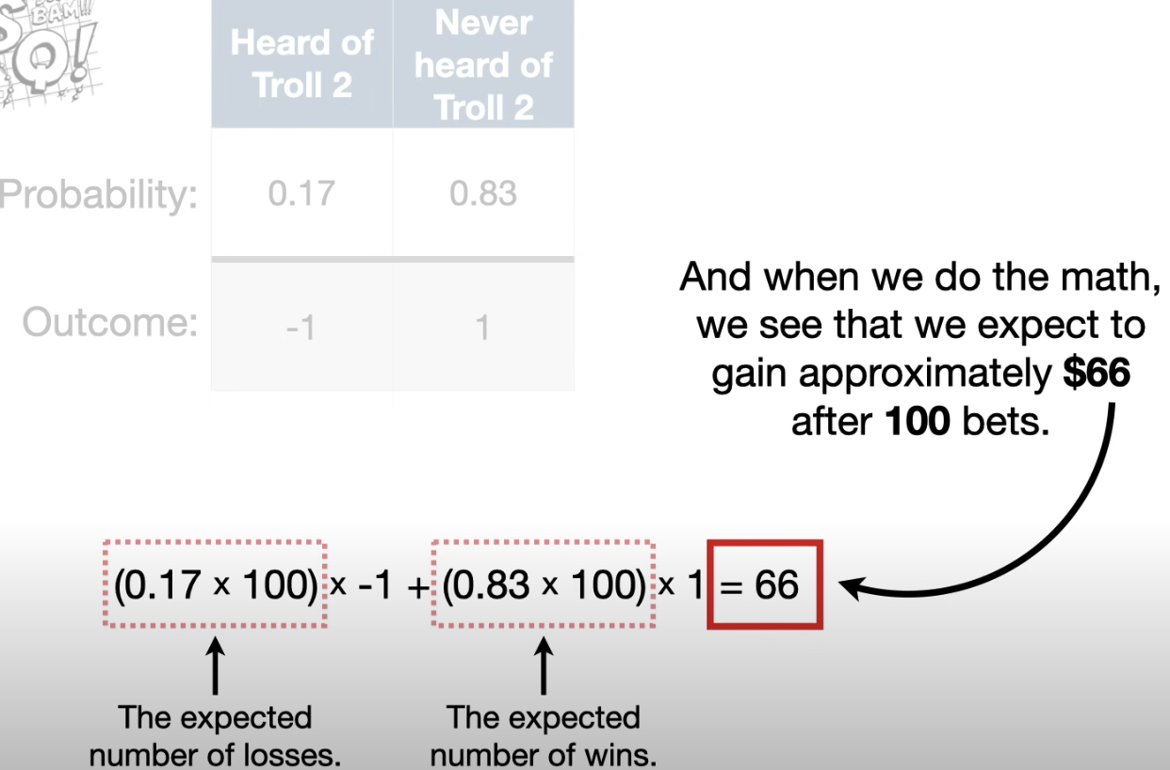

Average amount earned per bet 🡪 $ 0.66

Even-though I win or lose $1 each time I bet. On an average I expected to gain 66 cents each time.

0.66 🡪 Expected cents is the expected value for the bet.

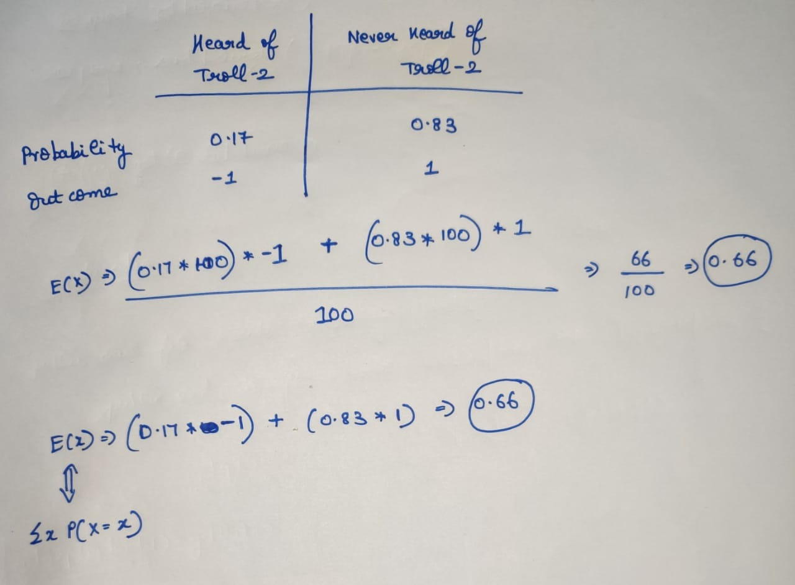

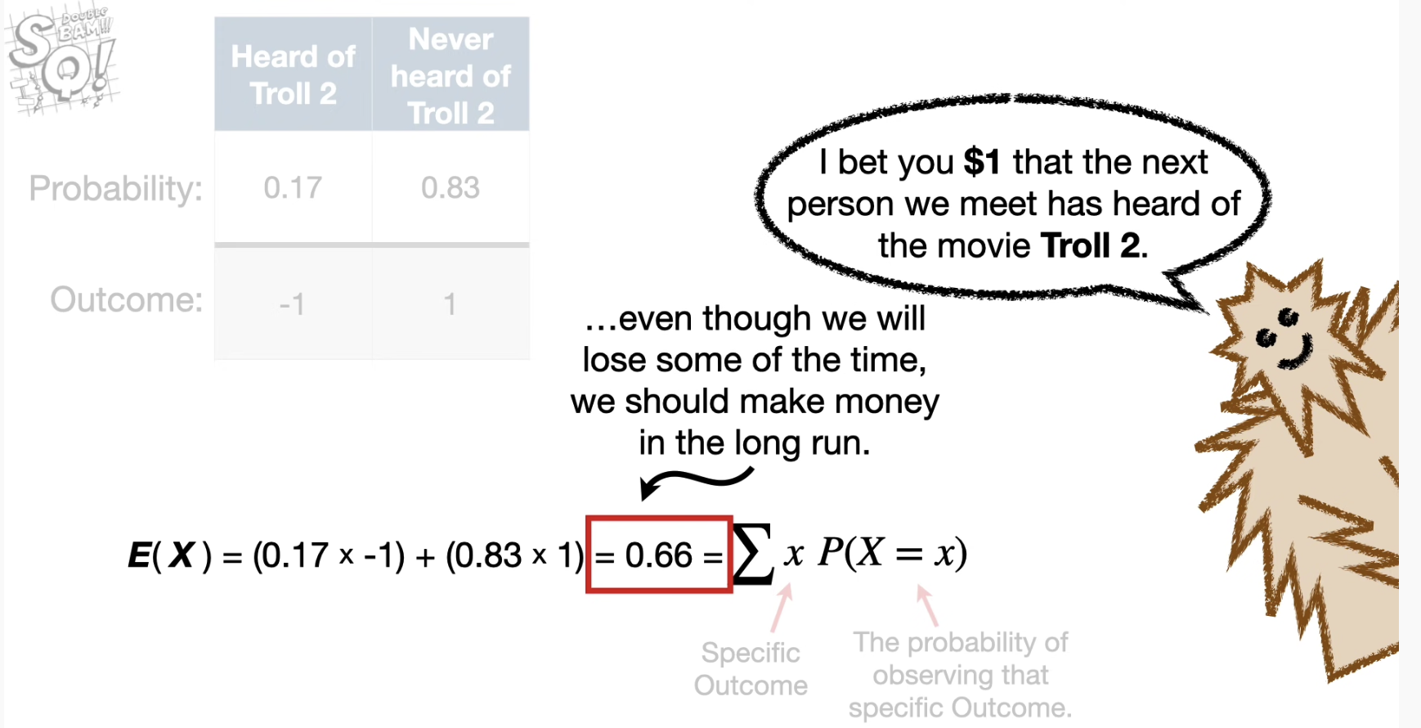

## **Dive into complex problem-2**

Till now we covered to calculate the Expected value for discrete variables.