How to open a php program in a web-browser

1. Open mamp server, and then on it.
2. Put the files to be executed in the htdocs folder.
3. Type localhost/<folder_name>/<file_name>.php

**Getting input from the user**

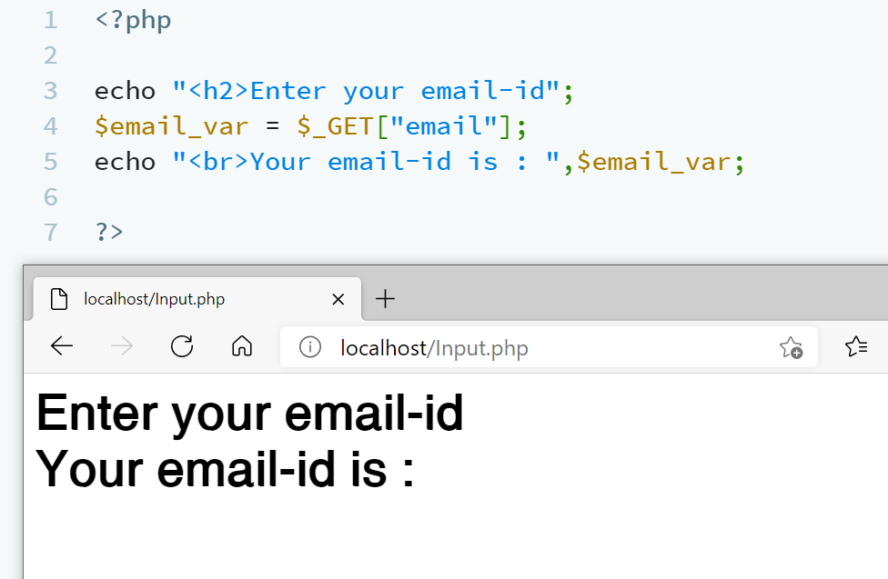

**Method-1**  
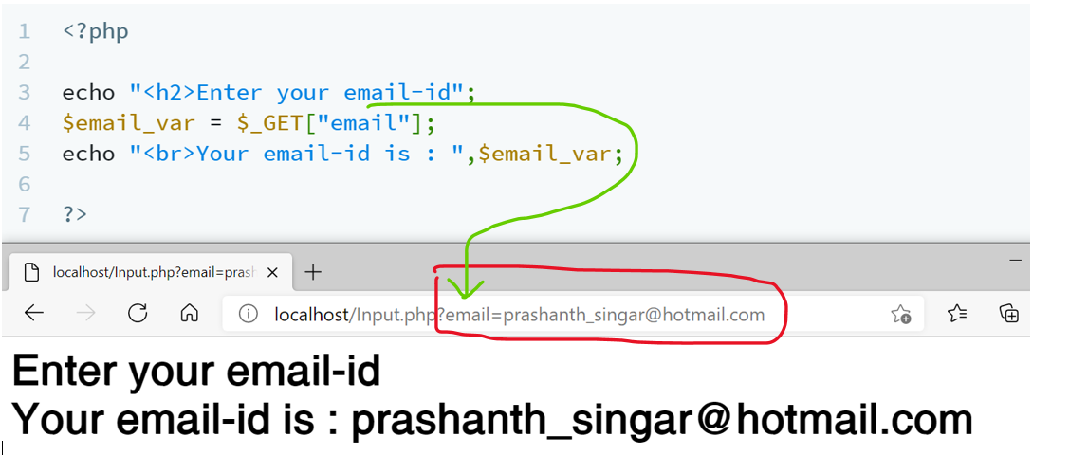  
localhost:<file_name>.php?<parameter_name>=<parameter_value>

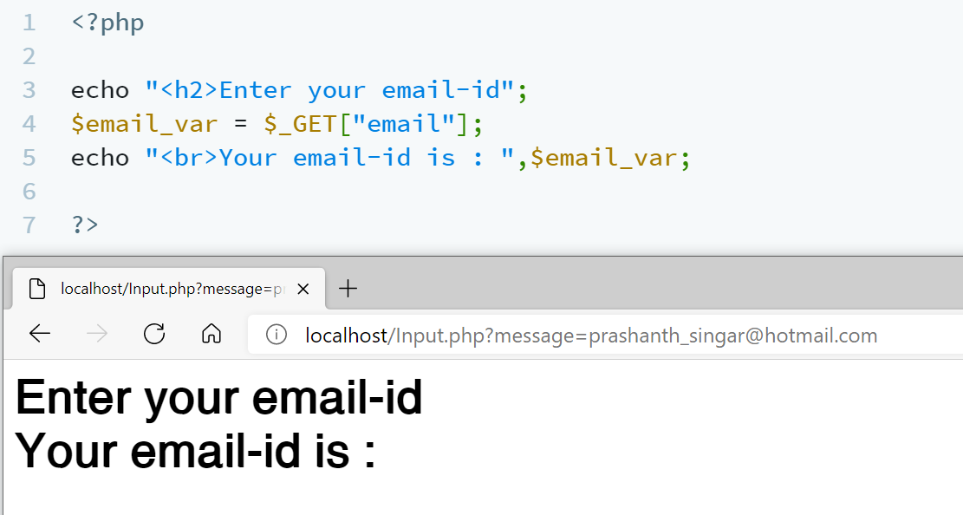

The parameter message is not present, hence it will not

**Method-2**  
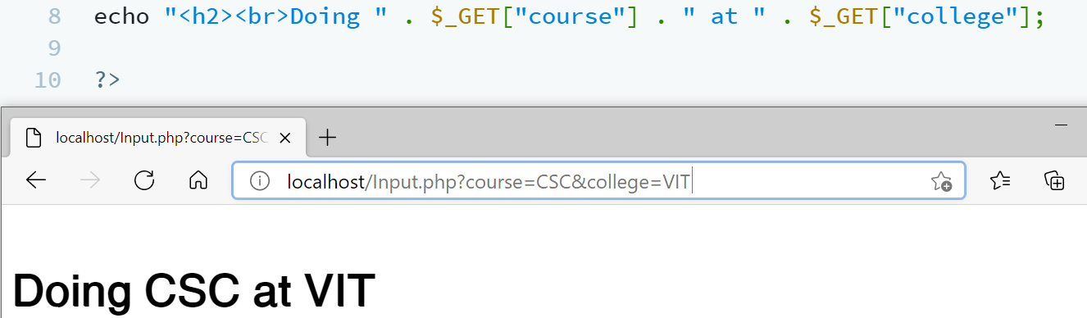

If condition



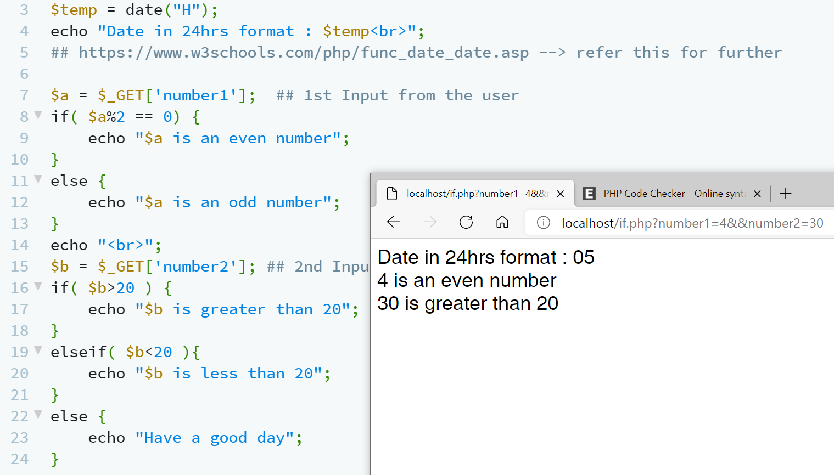



Switch statements

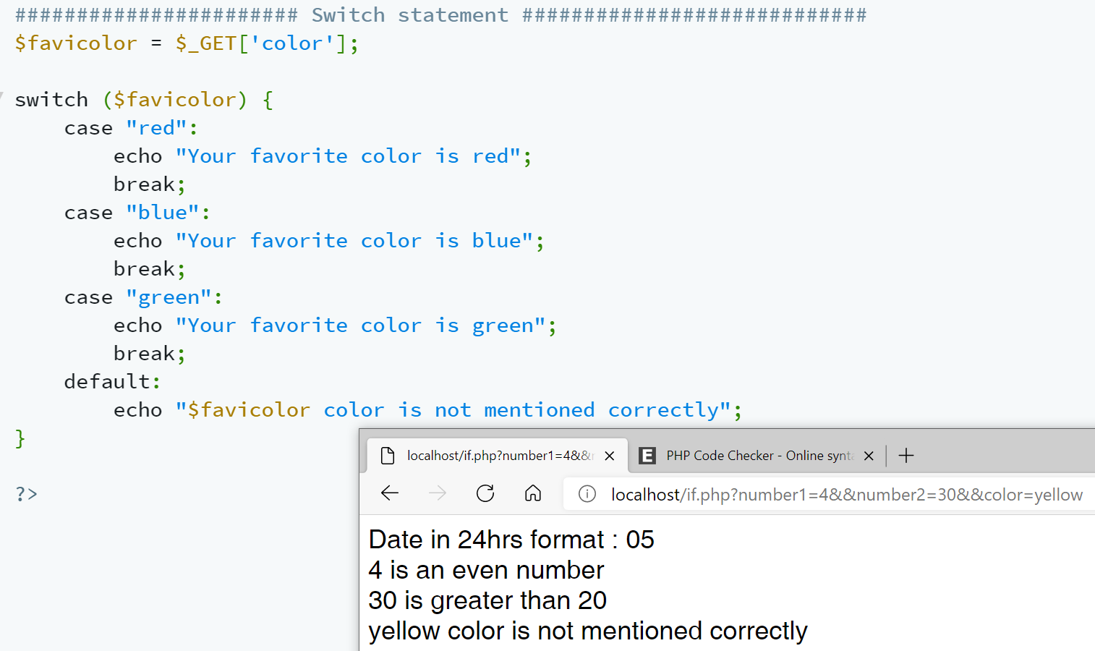

**Creating Data-bases using Mamp server**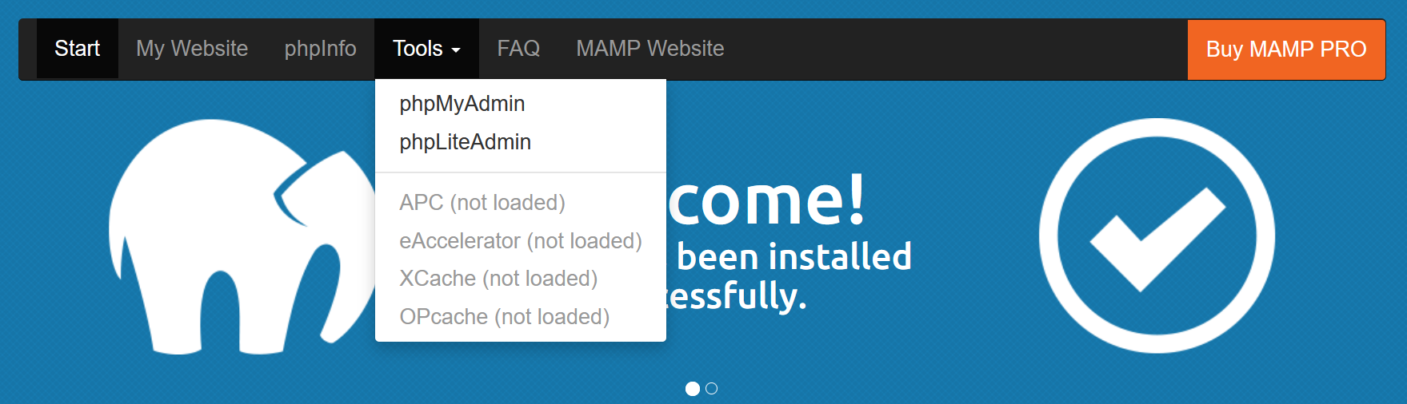  
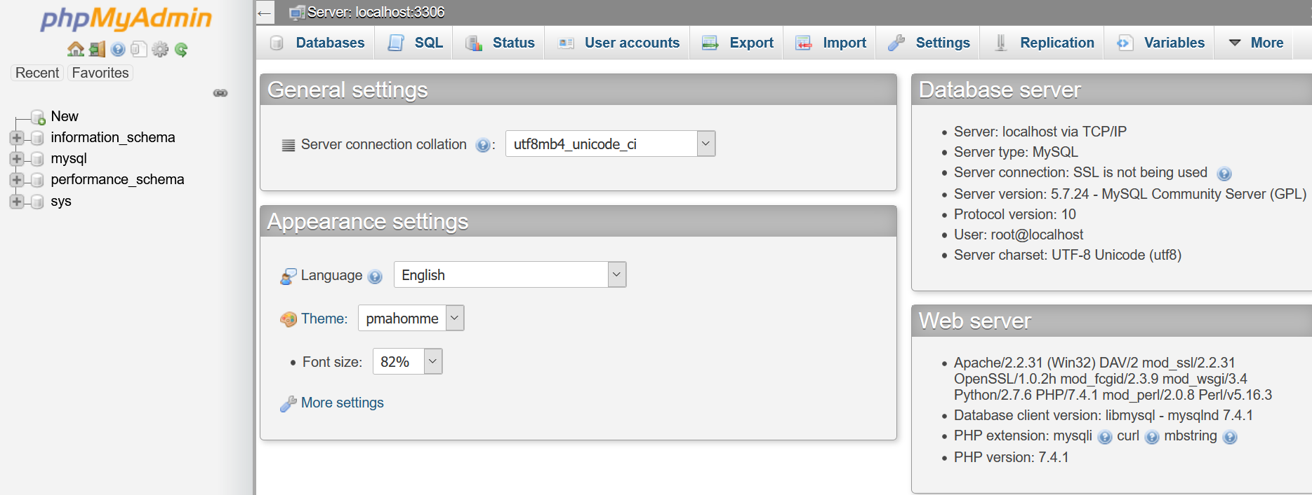



**2) Creating the table (i.e userinfo) of the data-base**

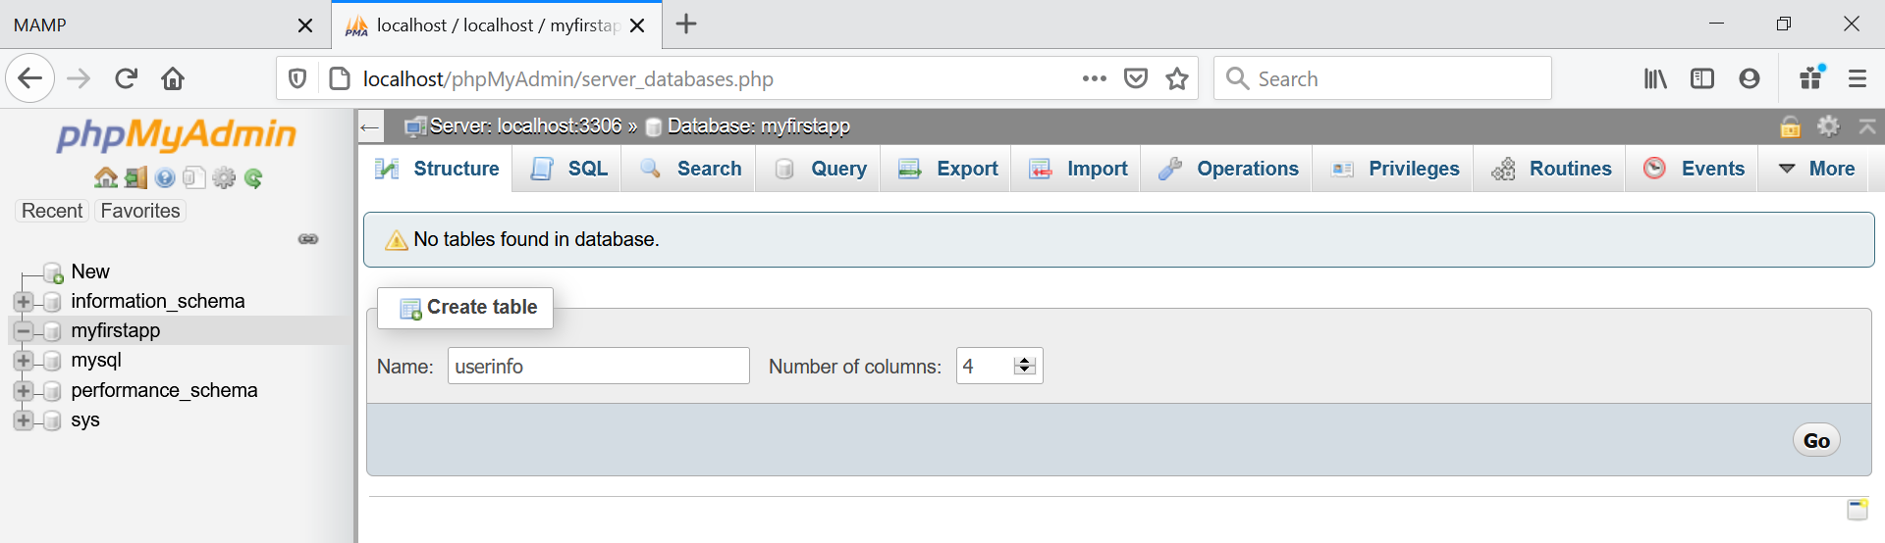  
click go.  
**3) Giving the attribute name of the table (i.e userinfo)**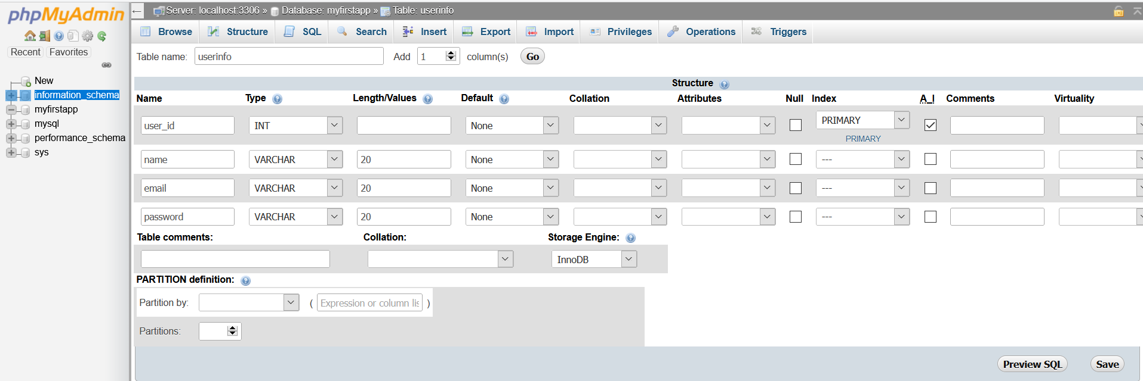click save

User_id is given the flag AI(auto increment)

This is the structure of the table   
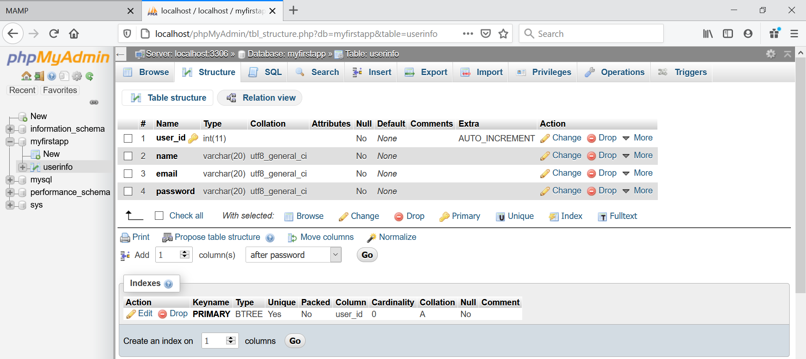

Under **Browse** 🡪 the query will be displayed

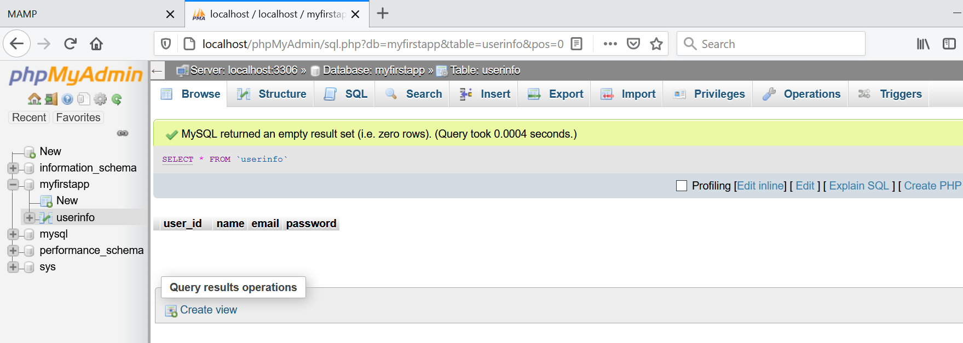

Entering the records

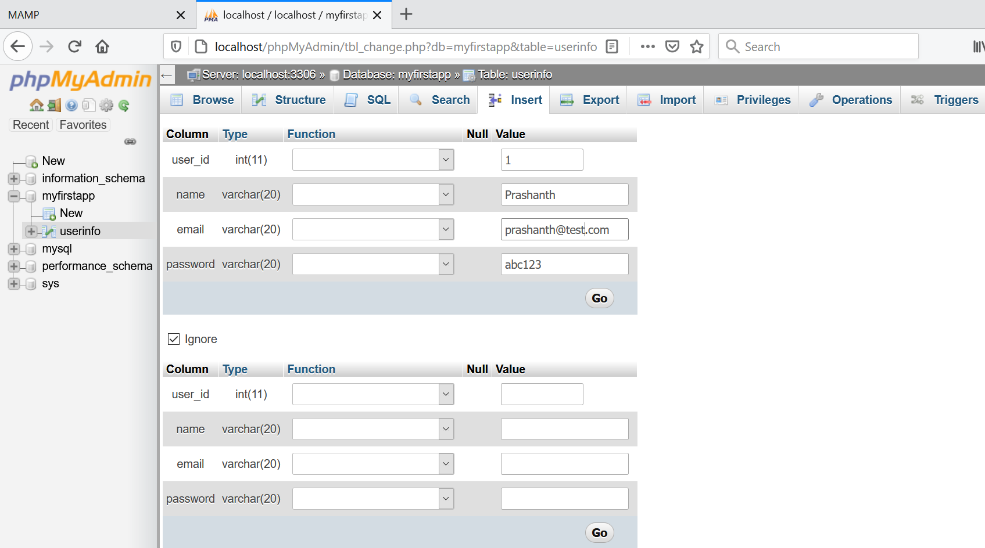  
click GO

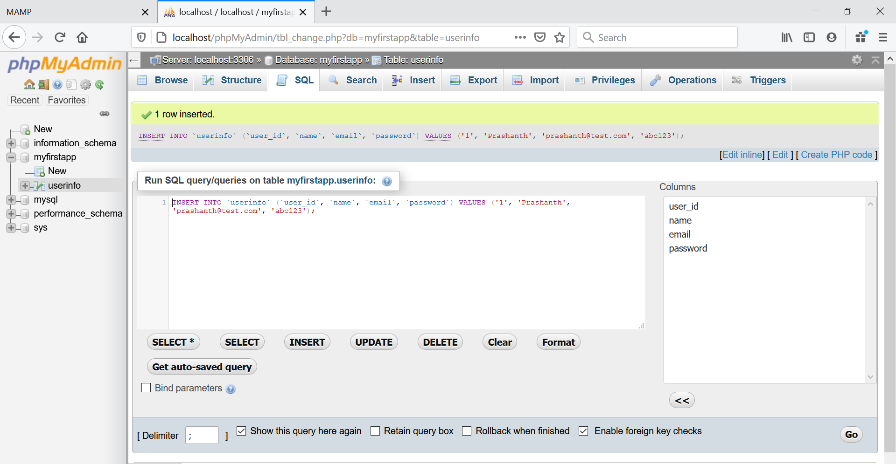

Actually at the backend this is the query executing.

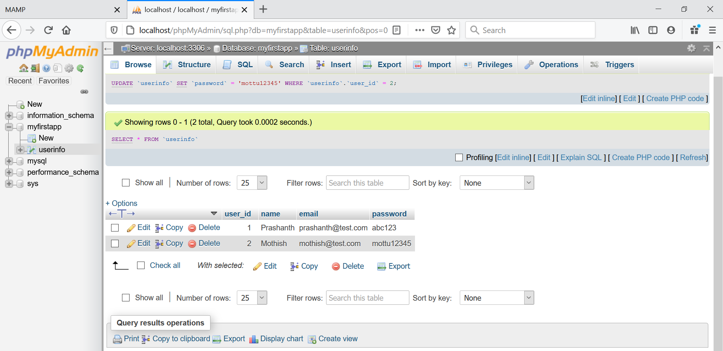

Changed the password of Mothish

Creating the records using Query

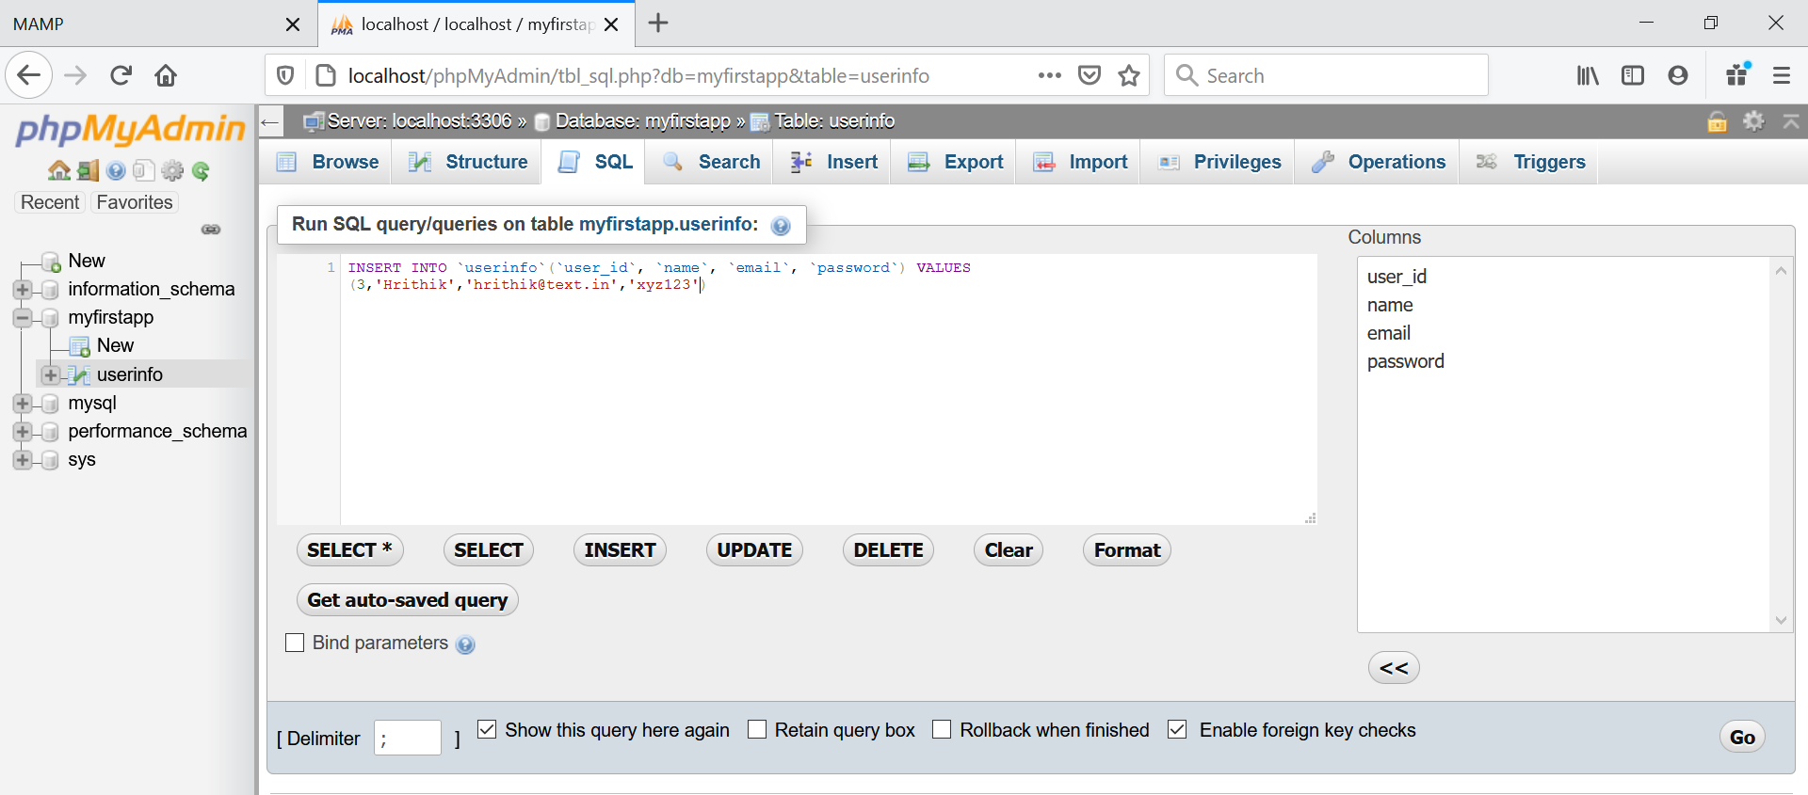

After typing the query, click go

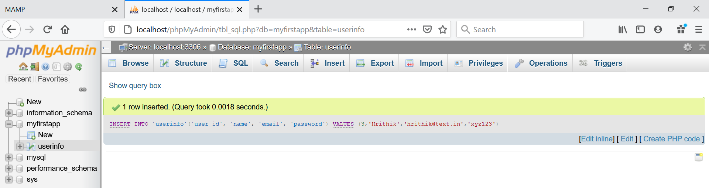

Connecting the php to the data-base.

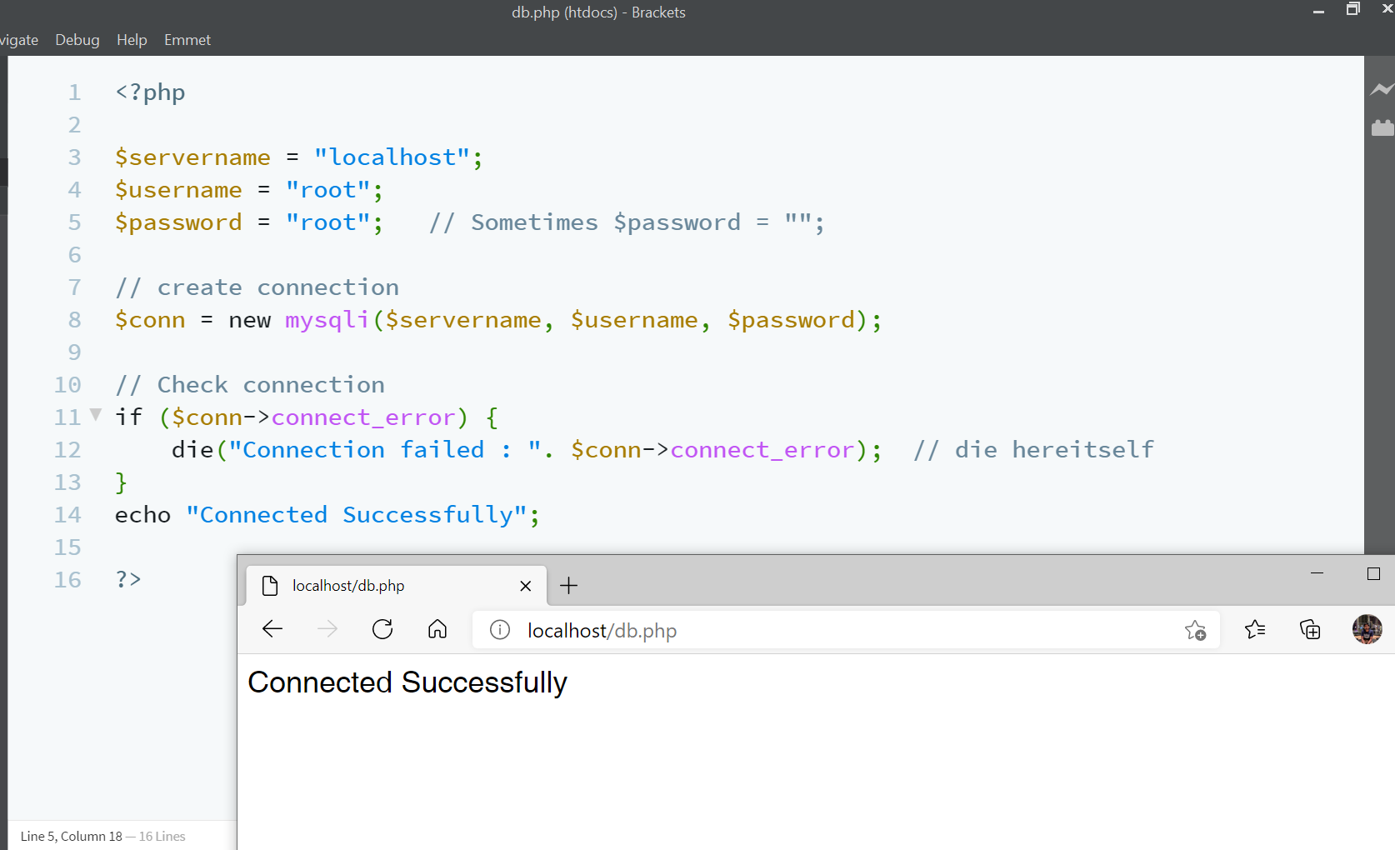

Checking for login

Directly from the data-base

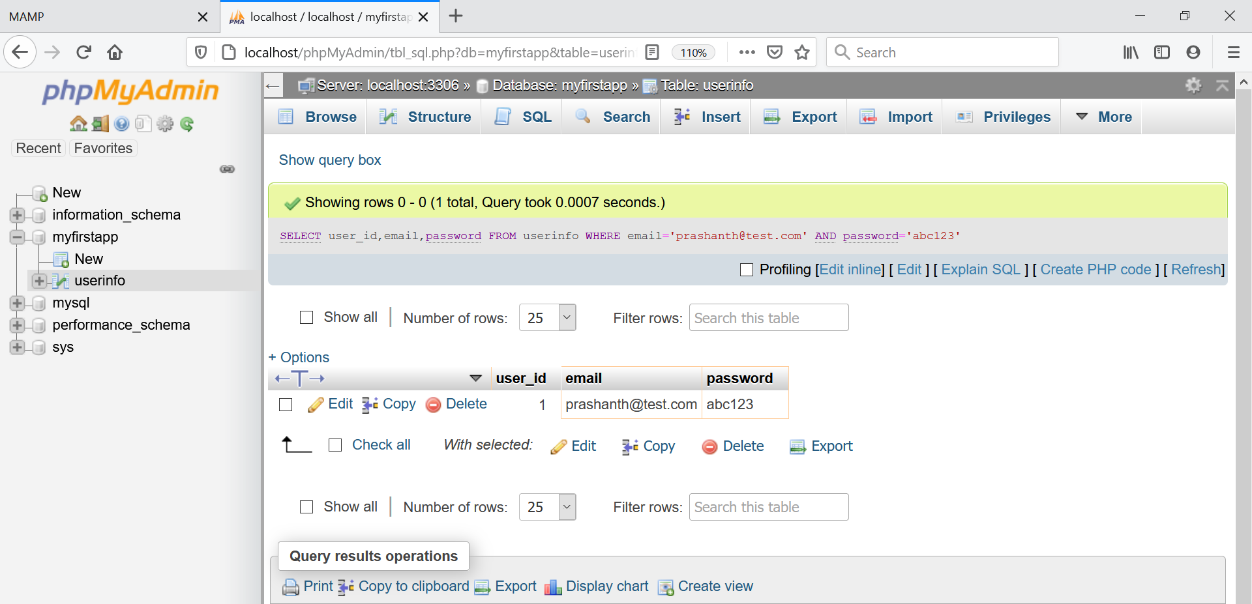



From app to php and then php to data-base

