Show “Button Got Clicked” on my _label when the button gets clicked

Widgets

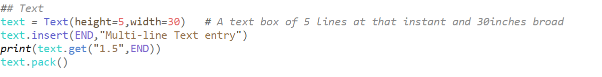  
1.5  
1 🡪 input should be read from the first line  
.5 🡪 5th character   
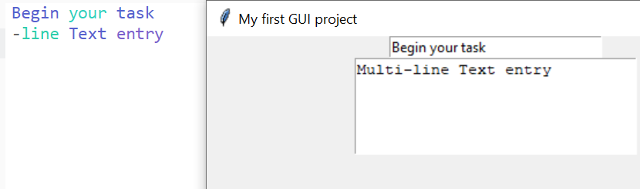

All the conditions are applied on the python output console rather than the GUI window.

**Spin box**

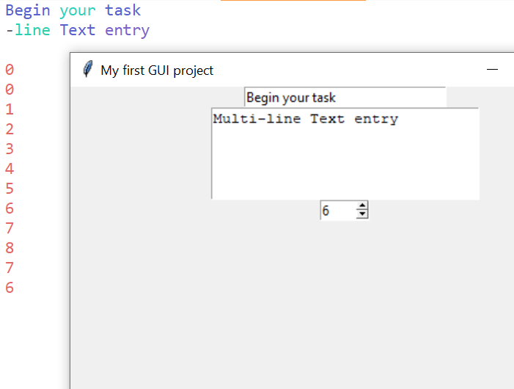

**Scale**

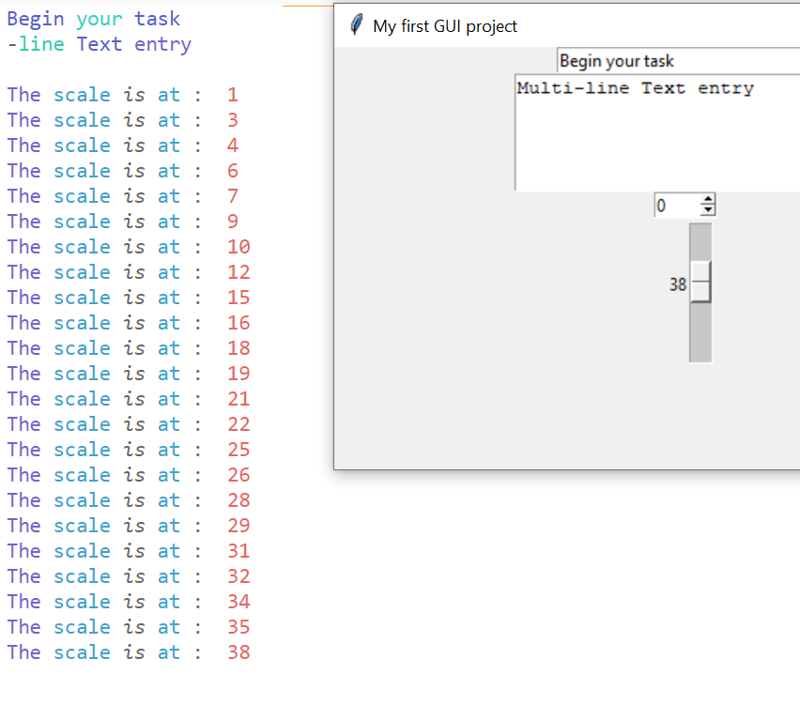

**Radio-button**

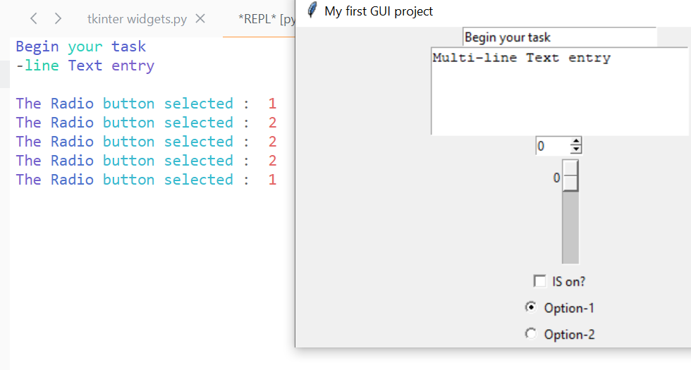

These is no precise positioning in the pack() [i.e we cannot able to keep one widget above and another widget below] , but there is a precise position in place()

**place**

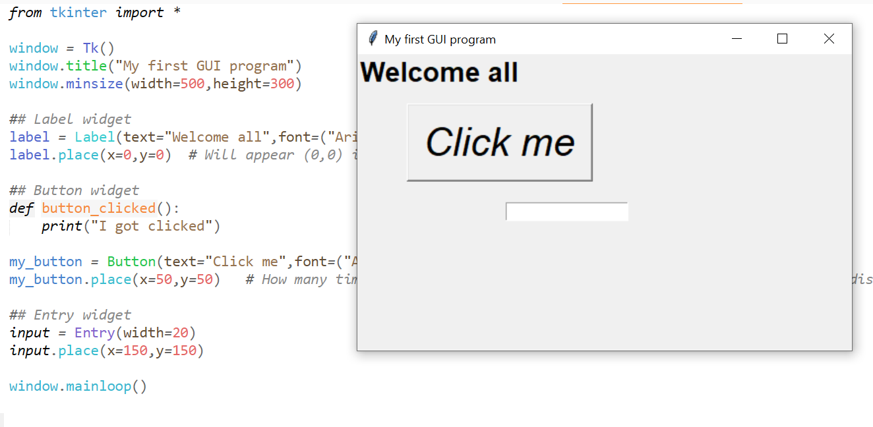

In place, we have to mention the dimensions which is in the matrix format. This is so tedious.  
So grids are useful

**Grids**

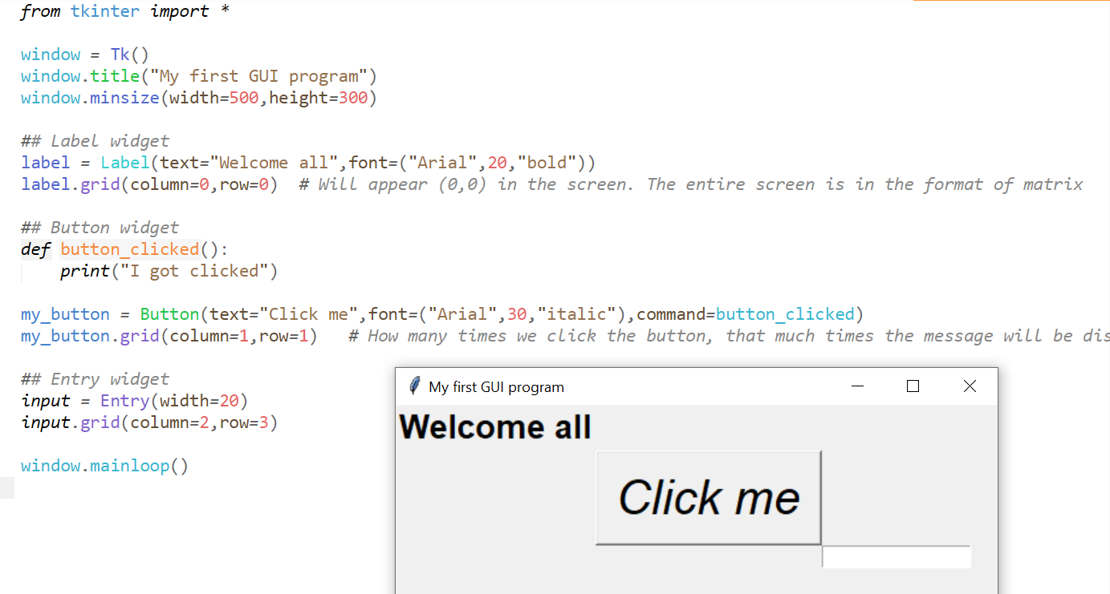

grid challenge

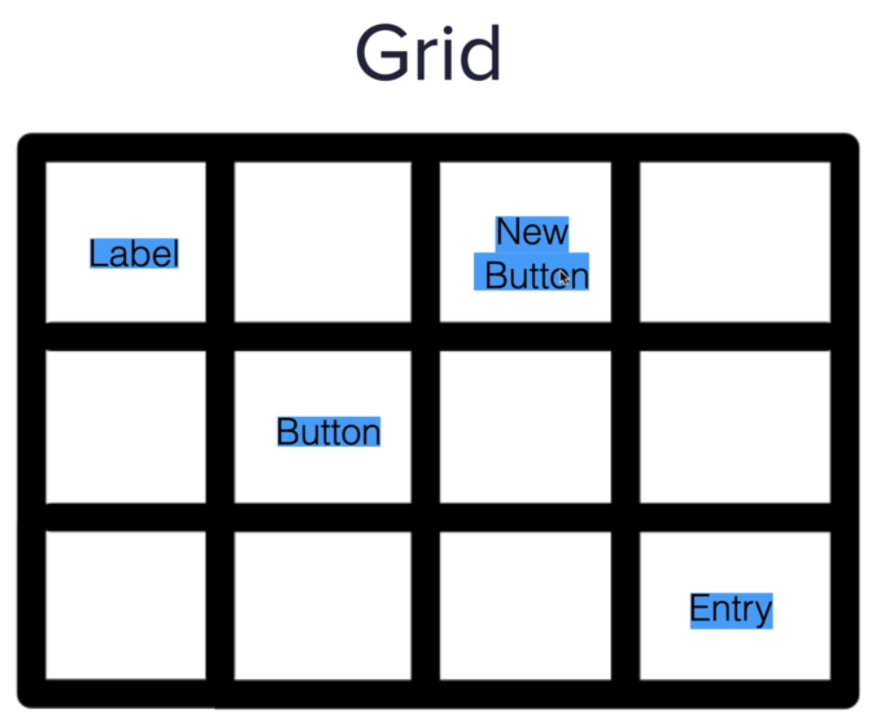

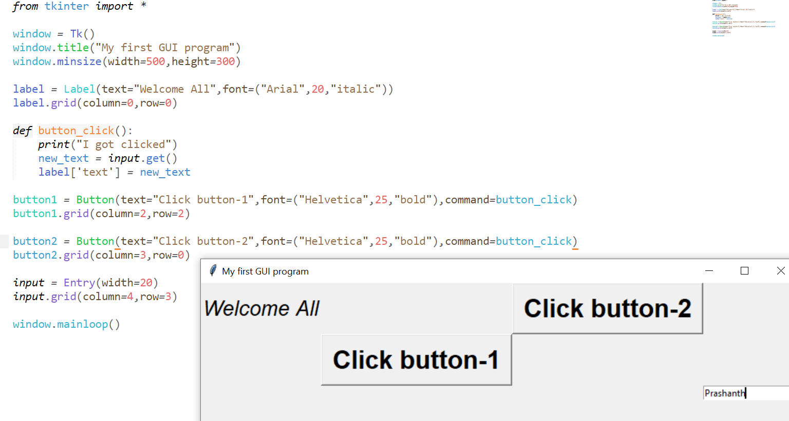

Padding with grids

