**Postman 🡪 a tool to work with API, not used in real-world production.**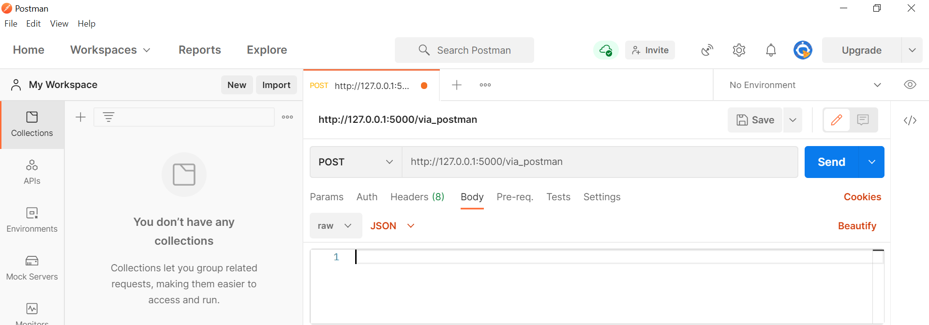

Select POST methods

1) Want to send the data in the body, so click Body  
2) Input in JSON format, so click raw and select JSON

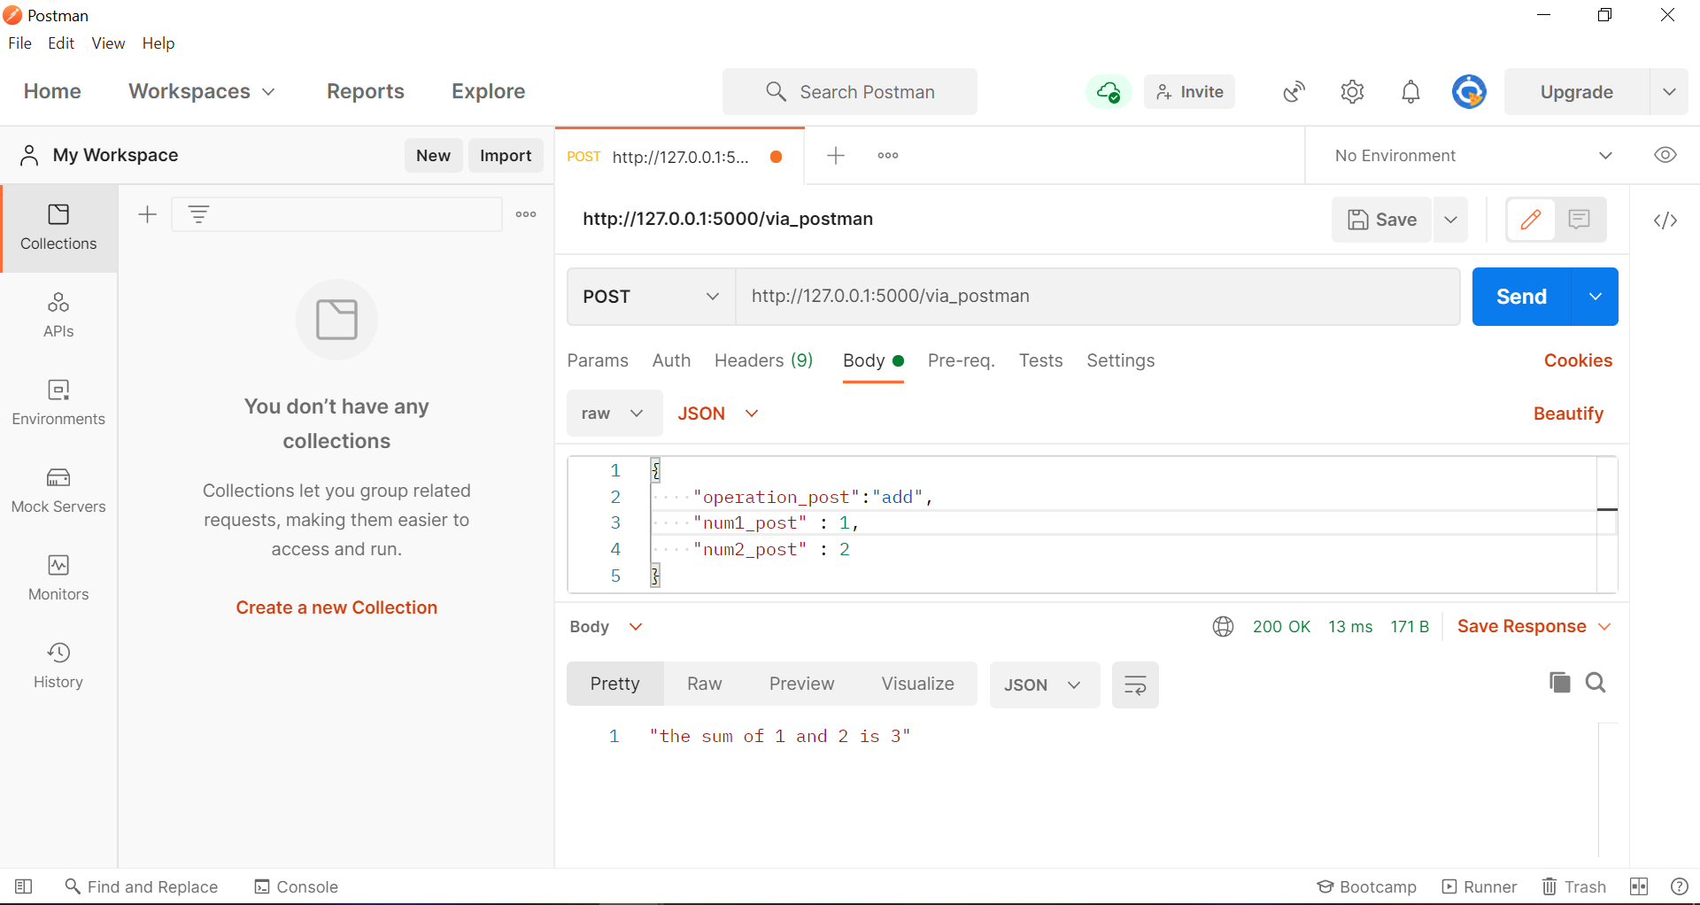  
Giving the data in JSON format. 