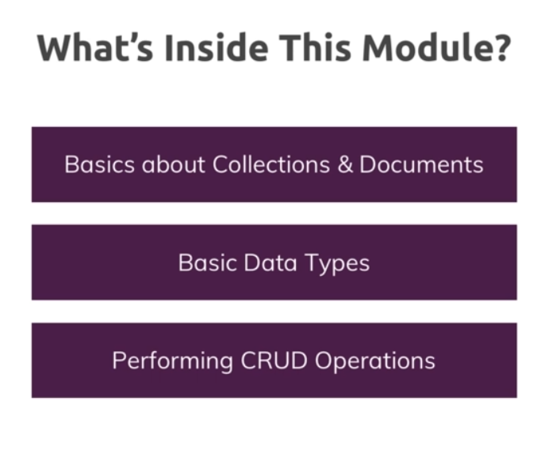

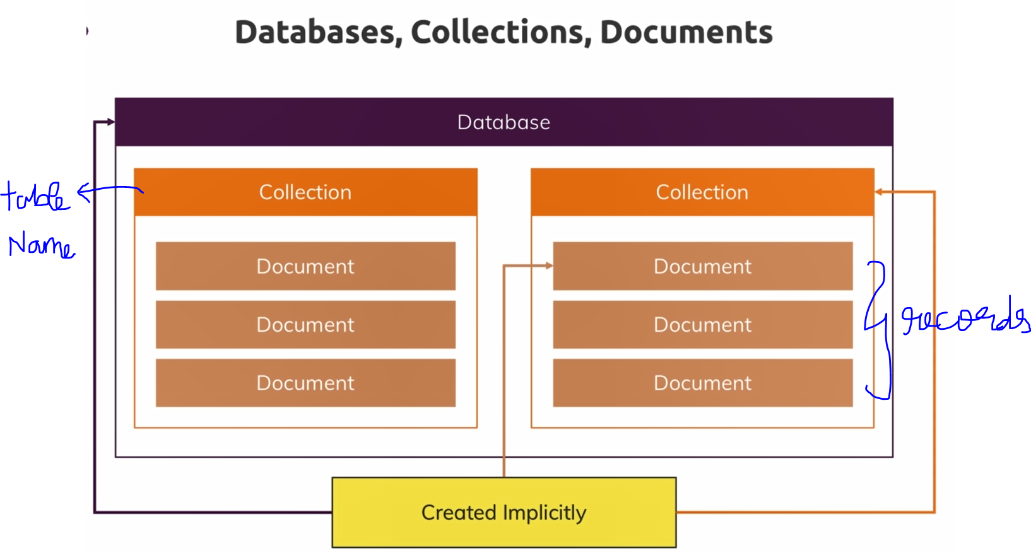

These are created implicitly.

# **MongoDB URI Uniform Resource Identifier**

URI string 🡪 

**mongo+srv://** 🡪 Address of the SRV record  
**<host> 🡪** host name of the SRV record for the Mongo db cluster that we want to connect. It is pointing to the data-base server. It only holds the SRV records.

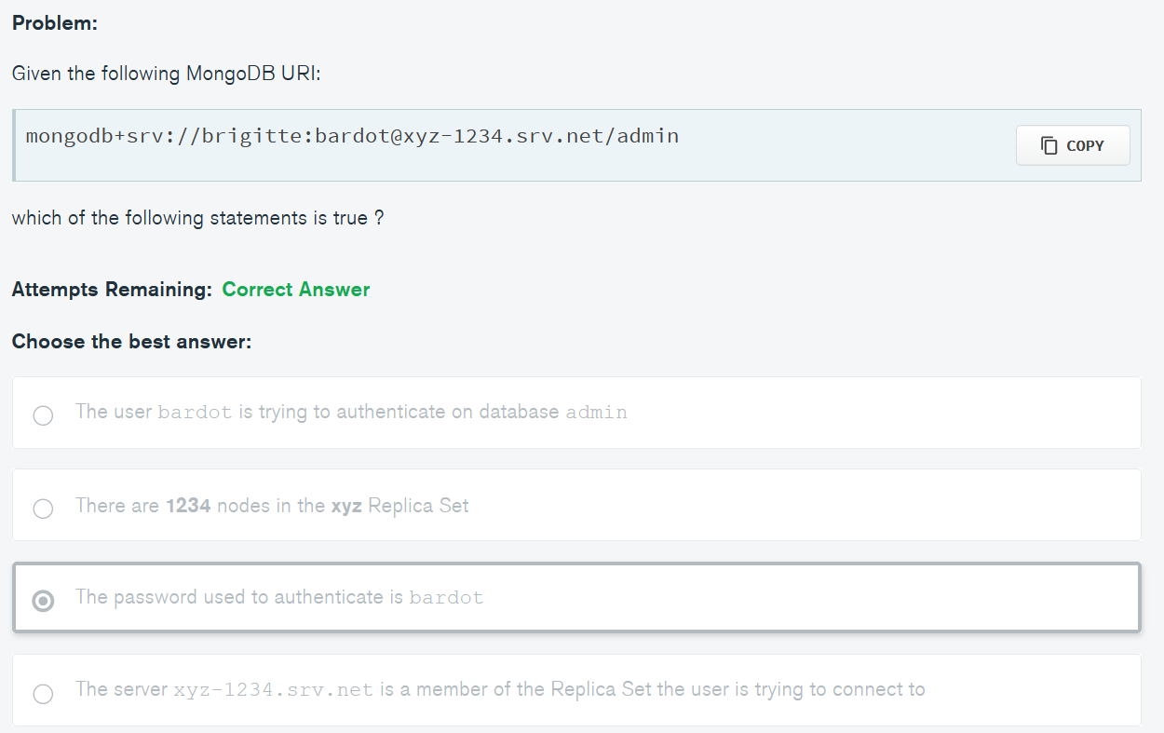

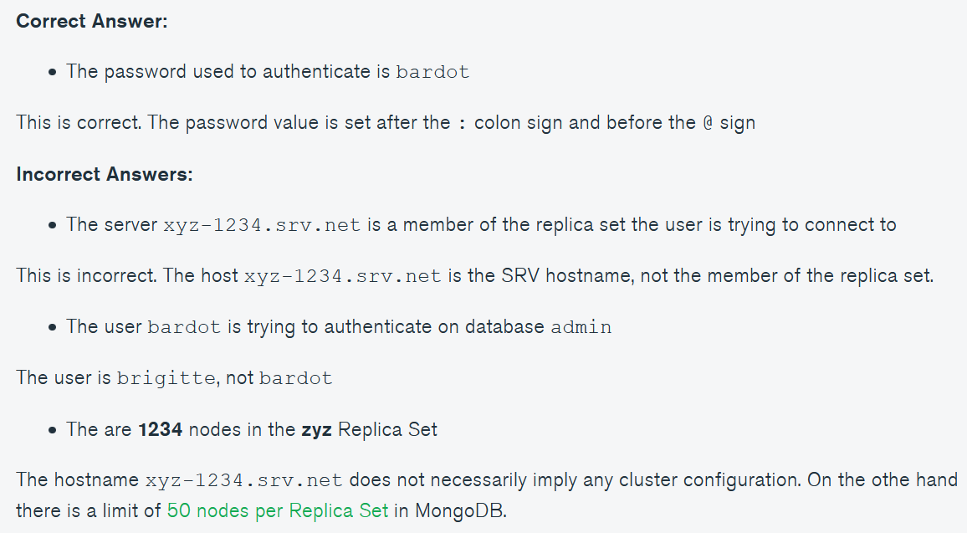

  
If a connection error arises, it will retry