# **SURANA COLLEGE**

# **AUTONOMOUS**

Re-Accredited by NAAC with A+ Grade #16, South End Road, Basavanagudi, Bengaluru-560004



# **A Project Report**

**on**

**Video Craft Vault Asset Store**

submitted to **Surana College Autonomous** as a partial requirement for the award of the degree

Bachelor of Computer Applications

Submitted by

**Sathvik Adiga**

**U03ME22S0029  
  
Prashantha K  
  
U03ME22S0046**

# **under the Guidance of**

**Prof. Vidya A,**

**Head Of The Department, Department of Computer Science**

**2023-2024**

**SURANA COLLEGE AUTONOMOUS**

Re-Accredited by NAAC with A+ Grade #16, South End Road, Basavanagudi, Bengaluru-560004



***Certificate of Completion***

This is to certify that the project work entitled “**Video Craft Vault Asset Store**” is a bonafide work carried out by **Sathvik Adiga**

**And Prashantha K** bearing Register No. **U03ME22S0029 and U03ME22S0046** respectively , under the guidance of **Ms.Vidya A**in partial fulfillment for the award of **Bachelor of Computer Applications** of SURANA COLLEGE AUTONOMOUS**,** during the year **2023-24**.

This project report has not been submitted earlier to any other university.

Signature of the Guide Signature of the HOD

# **DECLARATION**

for the fulfillment of the requirements of any course of study.

**We Sathvik Adiga and Prashantha K** Bearing Register Numbers **U03ME22S0029 and U03ME22S0046 respectively**, student of IV semester BCA, SURANA COLLEGE AUTONOMOUS, Bangalore, hereby declare that the project work entitled **Video Craft Vault Asset Store** submitted to SURANA COLLEGE AUTONOMOUS during the academic year 2023-2024, is a record of original work done by us under the guidance of **Prof.Vidya A** , Head Of The Department, Department of Computer Applications, SURANA COLLEGE AUTONOMOUS, Bangalore.

This project work is submitted in partial fulfillment of the requirements for the award of the degree of Bachelor of Computer Applications. The matter in this project is genuine work done by me and has not been submitted whether to this University or to any other University/Institute

Date: **Sathvik Adiga**

**U03ME22S0029**

**Prashantha K**

**U03ME22S0046**

Place: Bengaluru

# **ACKNOWLEDGEMENT**

This project would not have been possible without the support and guidance of several individuals and resources. I would like to take this opportunity to express my gratitude to all those who have contributed to the successful completion of this web project.

**Academic Guidance**

First and foremost, I would like to thank my professor, **Ms. Vidya A** for providing the necessary guidance and support throughout this project. Your insights and constructive feedback have been invaluable in shaping this project from its inception to its completion.

**Peer Support**

I would also like to acknowledge my classmate **Prashantha K**, for his collaborative spirit and for being a source of motivation and support. The group discussions and coding sessions we had together have been a significant part of this learning journey.

**Online Resources**

This project has greatly benefited from numerous online resources. I would like to mention a few that were particularly helpful:

W3Schools and YouTube: For its extensive library of tutorials and examples.

Stack Overflow: For the community-driven support that helped resolve many technical issues.

**Tools**

Visual Studio Code: For being an excellent code editor with a plenty of useful extensions.

**TABLE OF CONTENTS**

**Table of Contents**

|  |  |  |
| --- | --- | --- |
| Sl. No. | Content | Page No |
| 1. | Problem Statement | 6 |
| 2. | Introduction | 6 |
| 3. | Objectives | 6 – 7 |
| 4. | Technologies Used | 7 |
| 5. | Source Code | 8 - 30 |
| 6. | Sample Screens | 31 - 33 |
| 7. | Future Recommendations | 34 - 35 |
| 8. | References | 35 |

**Introduction**

The entertainment industry thrives on creativity and innovation, driven by the essential assets that bring visions to life. As the demand for high-quality content continues to soar, the necessity for skilled editors and artists grows exponentially.

Industries are currently grappling with a shortage of creative professionals, a challenge exacerbated by outdated educational frameworks and pervasive misconceptions about creative careers. This shortage is particularly pronounced in fields such as video editing, sound design, and graphic design, where the need for talent is at an all-time high.

Creating original content from scratch is not only time-consuming but often impractical, especially in a fast-paced industry where time is a critical resource. This is where asset stores come into play. By providing a vast array of pre-made, cost-effective assets, these stores enable artists to focus on the creative aspects of their projects rather than the tedious process of building everything from the ground up.

Utilizing asset stores can save thousands of hours of labour, significantly boosting efficiency and productivity.

**Objectives**

**Primary Objectives of Video Craft Vault are:**

* **Enhance Efficiency:** Streamline the creative process by providing readily available, high-quality assets to artists. Reduce the time and effort required to produce content by leveraging pre-made assets, enabling artists to focus on creative tasks.
* **Promote Cost-Effectiveness:** Offer cost-effective solutions for acquiring essential assets, reducing the financial burden on both aspiring and professional artists. Optimize budget allocation by minimizing the need for extensive in-house production.
* **Improve Content Quality:** Ensure that artists have access to top-tier assets that can enhance the overall quality of their projects.

Facilitate the creation of polished, professional content that meets industry standards and audience expectations.

* **Bridge Educational Gaps:** Supplement traditional education with practical tools and assets that align with current industry demands.

Provide resources that help emerging artists overcome misconceptions and challenges associated with pursuing creative careers.

* **Facilitate Industry Collaboration:** Promote collaboration and knowledge sharing among artists by providing a common platform for accessing and utilizing assets.

Enhance teamwork and project efficiency through the use of standardized, high-quality assets.

* **Adapt to Market Needs:** Continuously update and expand the asset store offerings to reflect the evolving trends and requirements of the entertainment industry. Ensure that the asset store remains a relevant and valuable resource for artists across various mediums and disciplines.

**Technologies Used**

**HTML (Hyper Text Markup Language):**

Used for structuring the content of the website. Provides the basic framework and semantic structure for web pages.

**CSS (Cascading Style Sheets):**

Used for styling the website and ensuring a consistent look and feel across all pages. Includes responsive design techniques to ensure the website functions well on various devices and screen sizes.

**JavaScript**:

Used for adding interactivity and cart system to the website.

Enhances user experience by enabling features such as real-time form validation, dynamic content updates, and interactive elements.

**Source Code**

***LANDING PAGE:***

<!DOCTYPE html>

<html lang="en">

<head> <meta charset="UTF-8">

<meta name="viewport" content="width=device-width, initial-scale=1.0">

<title>MAIN PAGE</title>

<link rel="stylesheet" href="style.css">

</head>

<body>

<div class="main">

<div class="navbar">

<div class="icon">

<img src="logos/Video_Craft-removebg-preview.png" class="logo">

</div> <div class="menu">

<ul>

<li><a href="Home.html">HOME</a></li>

<li><a href="us.html">ABOUT</a></li>

<li class="dropdown">

<a href="#" class="dropbtn">SOFTWARES</a>

<div class="dropdown-content">

<a href="davinci.html">Davinci Resolve</a>

<a href="ae.html">After Effects</a>

<a href="pr.html">Premiere Pro</a>

</div>

</li>

<li class="dropdown">

<a href="#" class="dropbtn">ASSETS</a>

<div class="dropdown-content">

<a href="video.html">Videos</a>

<a href="templates.html">Templates</a>

<a href="gfx.html">GFX Pack</a>

<a href="vfx.html">VFX Pack</a>

</div>

</li>

<li><a href="us.html">CONTACT</a></li>

</ul>

</div>

<div class="search">

<input class="srch" type="search" name="searchInput" id="searchInput" placeholder="Search your asset..">

<button class="btn" onclick="searchAssets()">Search</button>

</div> </div>

<div class="content">

<h1>Video Editing & <br><span>MultiMedia</span> <br>Assets Store</h1>

<p class="par">Welcome to Video Craft Vault, your ultimate destination for unlocking boundless creativity! <br/> Delve into our vast repository of meticulously crafted editing assets and templates,<br/> meticulously designed to cater to the diverse needs of creators across various software platforms. <br/>From sleek templates to awe-inspiring assets, our curated collection empowers <br/> professionals and enthusiasts alike to effortlessly elevate their projects to new heights of excellence. <br/>Explore, create, and transform your visions into reality with <br/> Video Craft Vault!</p

<button class="cn"><a href="Login.html">JOIN US</a></button>

<div class="form" id="loginForm">

<h2>Login Here</h2>

<input type="email" name="email" placeholder="Enter Email Here">

<input type="password" name="" placeholder="Enter Password Here">

<button class="btnn" onclick="login()">Login</button>

<p class="link">Don't have an account<br>

<a href="login.html">Sign up </a> here</a></p>

<p class="liw">Log in with</p>

<div class="icons">

<a href="login.html"><ion-icon name="logo-facebook"></ion-icon></a>

<a href="login.html"><ion-icon name="logo-instagram"></ion-icon></a>

<a href="login.html"><ion-icon name="logo-twitter"></ion-icon></a>

<a href="login.html"><ion-icon name="logo-google"></ion-icon></a>

<a href="login.html"><ion-icon name="logo-skype"></ion-icon></a>

</div>

</div>

<div id="afterLogin" style="display: none;">

</div>

</div>

</div>

<script src="https://unpkg.com/ionicons@5.4.0/dist/ionicons.js"></script>

<script src="search.js"></script>

</body>

</html>

**JAVA SCRIPT (Cart System):**

const product = [

{ id: 0,

image: 'https://i.pinimg.com/564x/2c/25/5a/2c255ad0febb36a04b0b0d7a96db381c.jpg',

title: 'VIDEO EDITING TEMPLATES',

price: 149,

},

{ id: 1,

image: 'https://i.pinimg.com/564x/b6/ad/d9/b6add9f4ac91c4534b0b6a08879ad29b.jpg',

title: 'MOGRT PACK PREMIERE PRO',

price: 199,

},

{ id: 2,

image: 'https://i.pinimg.com/564x/b1/1b/c6/b11bc6765e37dc5a796c9b5d2b11815a.jpg',

title: 'DRAG AND DROP CC PACK',

price: 99,

},

{ id: 3,

image: 'https://i.pinimg.com/564x/63/dc/39/63dc3931ab90d97f128828416a8214d8.jpg',

title: 'COMPLETE VIDEO EDITING BUNDLE',

price: 499,

}

];

const categories = [...new Set(product.map((item)=>

{return item}))]

let i=0;

document.getElementById('root').innerHTML = categories.map((item)=>

{

var {image, title, price} = item;

return(

`<div class='box'>

<div class='img-box'>

<img class='images' src=${image}></img>

</div>

<div class='bottom'>

<p>${title}</p>

<h2>$ ${price}.00</h2>`+

"<button onclick='addtocart("+(i++)+")'>Add to cart</button>"+

`</div>

</div>`

)

}).join('')

var cart =[];

function addtocart(a){

cart.push({...categories[a]});

displaycart();

}

function delElement(a){

cart.splice(a, 1);

displaycart();

}function displaycart(){

let j = 0, total=0;

document.getElementById("count").innerHTML=cart.length;

if(cart.length==0){

document.getElementById('cartItem').innerHTML = "Your cart is empty";

document.getElementById("total").innerHTML = "$ "+0+".00";

}

else{

document.getElementById("cartItem").innerHTML = cart.map((items)=>

{ var {image, title, price} = items;

total=total+price;

document.getElementById("total").innerHTML = "$ "+total+".00";

return(

`<div class='cart-item'>

<div class='row-img'>

<img class='rowimg' src=${image}>

</div>

<p style='font-size:12px;'>${title}</p>

<h2 style='font-size: 15px;'>$ ${price}.00</h2>`+

"<i class='fa-solid fa-trash' onclick='delElement("+ (j++) +")'></i></div>"

); }).join('');

}

}

**CSS (Landing Page):**\*{

margin: 0;

padding: 0;

}

.main{

width: 100%;

background: linear-gradient(to top, rgb(41, 45, 144)30%,rgb(104, 111, 178)70%), url(1.jpg);

background-position: center;

background-size: cover;

height: 100vh;

}

.navbar{

width: 1200px;

height: 75px;

margin: auto;

}

.icon{

width: 200px;

float: left;

height: 70px;

}

.logo{

width: 100px; /* Adjust width */

float: left;

margin-top: 5px; /* Remove padding-top */

}

.menu{

width: 400px;

float: left;

height: 70px;

}

ul{

float: left;

display: flex;

justify-content: center;

align-items: center;

}

ul li{

list-style: none;

margin-left: 62px;

margin-top: 27px;

font-size: 14px;

}

ul li a{

text-decoration: none;

color: #fff;

font-family: Arial;

font-weight: bold;

transition: 0.4s ease-in-out;

}

ul li a:hover{

color: #4cbaf6;

}

.search{

width: 330px;

float: left;

margin-left: 270px;

}

.srch{

font-family: 'Times New Roman';

width: 200px;

height: 40px;

background: transparent;

border: 1px solid #ffffff;

margin-top: 13px;

color: #fff;

border-right: none;

font-size: 16px;

float: left;

padding: 10px;

border-bottom-left-radius: 5px;

border-top-left-radius: 5px;

}

.btn{

width: 100px;

height: 40px;

background: #115a96;

border: 2px solid #c8e2fb;

margin-top: 13px;

color: #fff;

font-size: 15px;

border-bottom-right-radius: 5px;

border-bottom-right-radius: 5px;

transition: 0.2s ease;

cursor: pointer;

}

.btn:hover{

color: #000;

}

.btn:focus{ outline: none;

}

.srch:focus{

outline: none;

}

.content{

width: 1200px;

height: auto;

margin: auto;

color: #fff;

position: relative;

}

.content .par{

padding-left: 20px;

padding-bottom: 25px;

font-family: Arial;

letter-spacing: 1.2px;

line-height: 30px;

}

.content h1{

font-family: 'Times New Roman';

font-size: 50px;

padding-left: 20px;

margin-top: 9%;

letter-spacing: 2px;

}

.content .cn{

width: 160px;

height: 40px;

background: #69b3f8;

border: none;

margin-bottom: 10px;

margin-left: 20px;

font-size: 18px;

border-radius: 10px;

cursor: pointer;

transition: .4s ease;

}

.content .cn a{

text-decoration: none;

color: #000;

transition: .3s ease;

}

.cn:hover{

background-color: #fff;

}

.content span{

color: #2498f7;

font-size: 65px

}

.form{

width: 250px;

height: 380px;

background: linear-gradient(to top, rgba(0,0,0,0.8)50%,rgba(0,0,0,0.8)50%);

position: absolute;

top: -20px;

left: 870px;

transform: translate(0%,-5%);

border-radius: 10px;

padding: 25px;

}

.form h2{

width: 220px;

font-family: sans-serif;

text-align: center;

color: #0059ff;

font-size: 22px;

background-color: #fff;

border-radius: 10px;

margin: 2px;

padding: 8px;

}

.form input{

width: 240px;

height: 35px;

background: transparent;

border-bottom: 1px solid #2688ff;

border-top: none;

border-right: none;

border-left: none;

color: #fff;

font-size: 15px;

letter-spacing: 1px;

margin-top: 30px;

font-family: sans-serif;

}

.form input:focus{

outline: none;

}

::placeholder{

color: #fff;

font-family: Arial;

}

.btnn{ width: 240px;

height: 40px;

background: #316ef2;

border: none;

margin-top: 30px;

font-size: 18px;

border-radius: 10px;

cursor: pointer;

color: #fff;

transition: 0.4s ease;

}

.btnn:hover{ background: #fff;

color: #32b8f7;

}

.btnn a{ text-decoration: none;

color: #fdf2f2;

font-weight: bold;

}

.form .link{ font-family: Arial, Helvetica, sans-serif;

font-size: 17px;

padding-top: 20px;

text-align: center;

}

.form .link a{

text-decoration: none;

color: #657dff;

}

.liw{ padding-top: 15px;

padding-bottom: 10px;

text-align: center;

}

.icons a{

text-decoration: none;

color: #fff;

}

.icons ion-icon{

color: #fff;

font-size: 30px;

padding-left: 14px;

padding-top: 5px;

transition: 0.3s ease;

}

.icons ion-icon:hover{

color: #0084f0;

}

.dropdown {

position: relative;

display: inline-block;

}

.dropdown-content {

display: none;

position: absolute;

background-color: #f9f9f9;

min-width: 160px;

box-shadow: 0px 8px 16px 0px rgba(0, 0, 0, 0.2);

z-index: 1;

}

.dropdown-content a {

color: black;

padding: 12px 16px;

text-decoration: none;

display: block;

}

.dropdown-content a:hover {

background-color: #f1f1f1;

}

.dropdown:hover .dropdown-content {

display: block;

}

**Products Page:  
(HTML)**

<!DOCTYPE html>

<html lang="en">

<head>

<meta charset="UTF-8">

<meta http-equiv="X-UA-Compatible" content="IE=edge">

<meta name="viewport" content="width=device-width, initial-scale=1.0">

<!-- font awesome cdn link -->

<link rel="stylesheet" href="https://cdnjs.cloudflare.com/ajax/libs/font-awesome/5.15.4/css/all.min.css">

<!-- custom css file link -->

<link rel="stylesheet" href="products.css">

<!-- custom js file link -->

<script src="products.js" defer></script>

</head>

<body>

<div class="container">

<h3 class="title"> VIDEO ELEMENTS </h3>

<div class="products-container">

<div class="product" data-name="p-1">

<img src="https://i.pinimg.com/originals/62/9b/69/629b69b9c221f840c36a8fddb15c3aec.gif" alt="Gameplay">

<h3>Gaming Clips</h3>

<div class="price">$39.00</div>

</div>

<div class="product" data-name="p-2">

<img src="https://i.pinimg.com/originals/97/5d/2b/975d2b47b63de2f19f9d66d3dda3e80c.gif" alt="space">

<h3>Space n Sky Pack</h3>

<div class="price">$70.00</div>

</div>

<div class="product" data-name="p-3">

<img src="https://i.pinimg.com/originals/6b/2f/92/6b2f92b18146651897ea4e4df4bf39be.gif" alt="Animations">

<h3>Animation Pack</h3>

<div class="price">$75.00</div>

</div>

<div class="product" data-name="p-4">

<img src="https://i.pinimg.com/originals/54/19/c9/5419c9ce3ffade43b2837daa2c96b1d9.gif" alt="Meme">

<h3>Memes Pack</h3>

<div class="price">$49.00</div>

</div>

<div class="product" data-name="p-5">

<img src="https://i.pinimg.com/originals/5e/c6/5a/5ec65a4b3b937130fc36e1340bd52e14.gif" alt="Lights">

<h3>Explosion Pack</h3>

<div class="price">$49.00</div>

</div>

<div class="product" data-name="p-6">

<img src="https://i.pinimg.com/originals/b3/7b/a2/b37ba2706030a7862df2b00645458c7f.gif" alt="Void">

<h3>Vfx Video Elements</h3>

<div class="price">$299.00</div>

</div>

</div>

</div>

<div class="products-preview">

<div class="preview" data-target="p-1">

<i class="fas fa-times"></i>

<img src="https://i.pinimg.com/originals/62/9b/69/629b69b9c221f840c36a8fddb15c3aec.gif" alt="Gameplay">

<h3>Gaming Clips</h3>

<div class="stars">

<i class="fas fa-star"></i>

<i class="fas fa-star"></i>

<i class="fas fa-star"></i>

<i class="fas fa-star"></i>

<i class="fas fa-star-half-alt"></i>

<span>( 250 )</span>

</div>

<p>Free Gaming FX presets Inside!</p>

<div class="price">$39.00</div>

<div class="buttons" align="Center">

<a href="payment.html" class="buy">buy now</a>

</div>

</div>

<div class="preview" data-target="p-2">

<i class="fas fa-times"></i>

<img src="https://i.pinimg.com/originals/97/5d/2b/975d2b47b63de2f19f9d66d3dda3e80c.gif" alt="space">

<h3>Space n Sky Pack</h3>

<div class="stars">

<i class="fas fa-star"></i>

<i class="fas fa-star"></i>

<i class="fas fa-star"></i>

<i class="fas fa-star"></i>

<i class="fas fa-star-half-alt"></i>

<span>( 250 )</span>

</div>

<p>SKY pack here!</p>

<div class="price">$70.00</div>

<div class="buttons" align="Center">

<a href="payment.html" class="buy">buy now</a>

</div>

</div>

<div class="preview" data-target="p-3">

<i class="fas fa-times"></i>

<img src="https://i.pinimg.com/originals/6b/2f/92/6b2f92b18146651897ea4e4df4bf39be.gif" alt="Animations">

<h3>Memes Pack</h3>

<div class="stars">

<i class="fas fa-star"></i>

<i class="fas fa-star"></i>

<i class="fas fa-star"></i>

<i class="fas fa-star"></i>

<i class="fas fa-star-half-alt"></i>

<span>( 250 )</span>

</div>

<p>Free Ae Animator Inside!.</p>

<div class="price">$49.00</div>

<div class="buttons" align="Center">

<a href="payment.html" class="buy">buy now</a>

</div>

</div>

<div class="preview" data-target="p-4">

<i class="fas fa-times"></i>

<img src="https://i.pinimg.com/originals/54/19/c9/5419c9ce3ffade43b2837daa2c96b1d9.gif" alt="Lights">

<h3>Memes Pack</h3>

<div class="stars">

<i class="fas fa-star"></i>

<i class="fas fa-star"></i>

<i class="fas fa-star"></i>

<i class="fas fa-star"></i>

<i class="fas fa-star-half-alt"></i>

<span>( 250 )</span>

</div>

<p>Elevate your 2D animation journey with this cool 2D pack.</p>

<div class="price">$49.00</div>

<div class="buttons" align="Center">

<a href="payment.html" class="buy">buy now</a>

</div>

</div>

<div class="preview" data-target="p-5">

<i class="fas fa-times"></i>

<img src="https://i.pinimg.com/originals/5e/c6/5a/5ec65a4b3b937130fc36e1340bd52e14.gif" alt="exp">

<h3>Explosion Pack</h3>

<div class="stars">

<i class="fas fa-star"></i>

<i class="fas fa-star"></i>

<i class="fas fa-star"></i>

<i class="fas fa-star"></i>

<i class="fas fa-star-half-alt"></i>

<span>( 250 )</span>

</div>

<p>CREATE STUNNING FX USING EXPLOSIVE PLUGINS!</p>

<div class="price">$99.00</div>

<div class="buttons" align="Center">

<a href="payment.html" class="buy">buy now</a>

</div>

</div>

<div class="preview" data-target="p-6">

<i class="fas fa-times"></i>

<img src="https://i.pinimg.com/originals/b3/7b/a2/b37ba2706030a7862df2b00645458c7f.gif" alt="Void">

<h3>Vfx Video Elements</h3>

<div class="stars"> <i class="fas fa-star"></i>

<i class="fas fa-star"></i>

<i class="fas fa-star"></i>

<i class="fas fa-star"></i>

<i class="fas fa-star-half-alt"></i>

<span>( 250 )</span>

</div> <p>Most Void Pack!.</p>

<div class="price">$299.00</div>

<div class="buttons" align="Center">

<a href="payment.html" class="buy">buy now</a>

</div> </div>

</div> </body>

</html>

**Results**

Sample Assets Page:

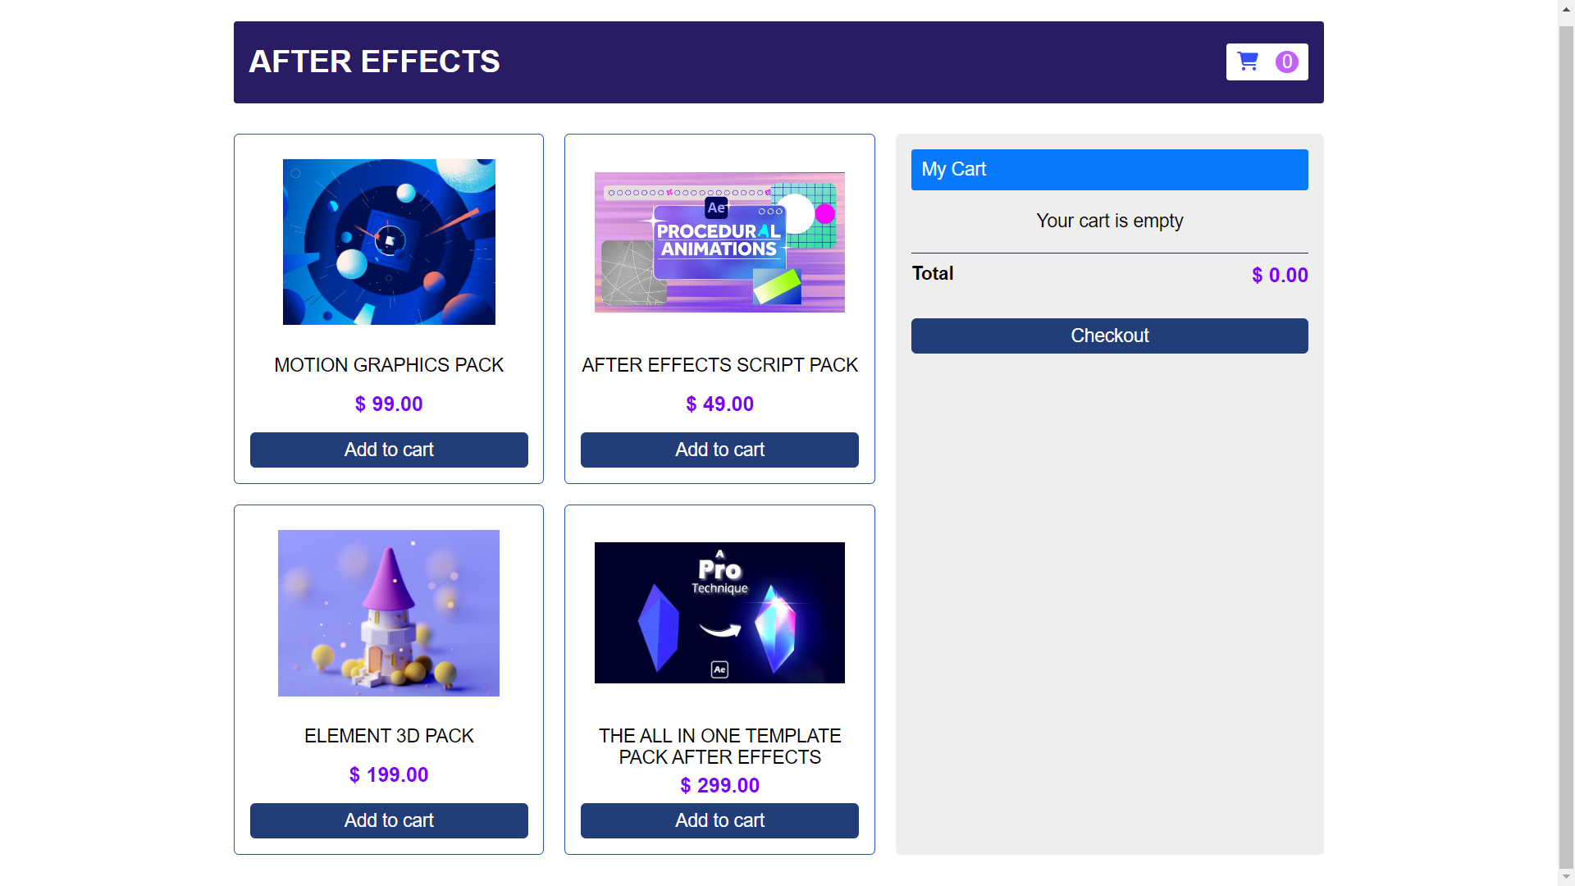

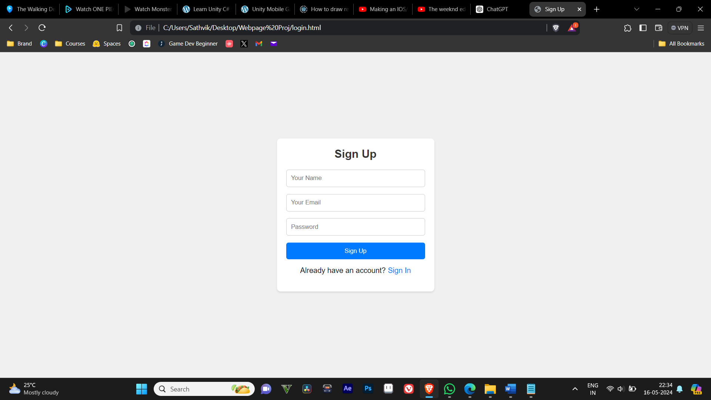

**Assets page:**

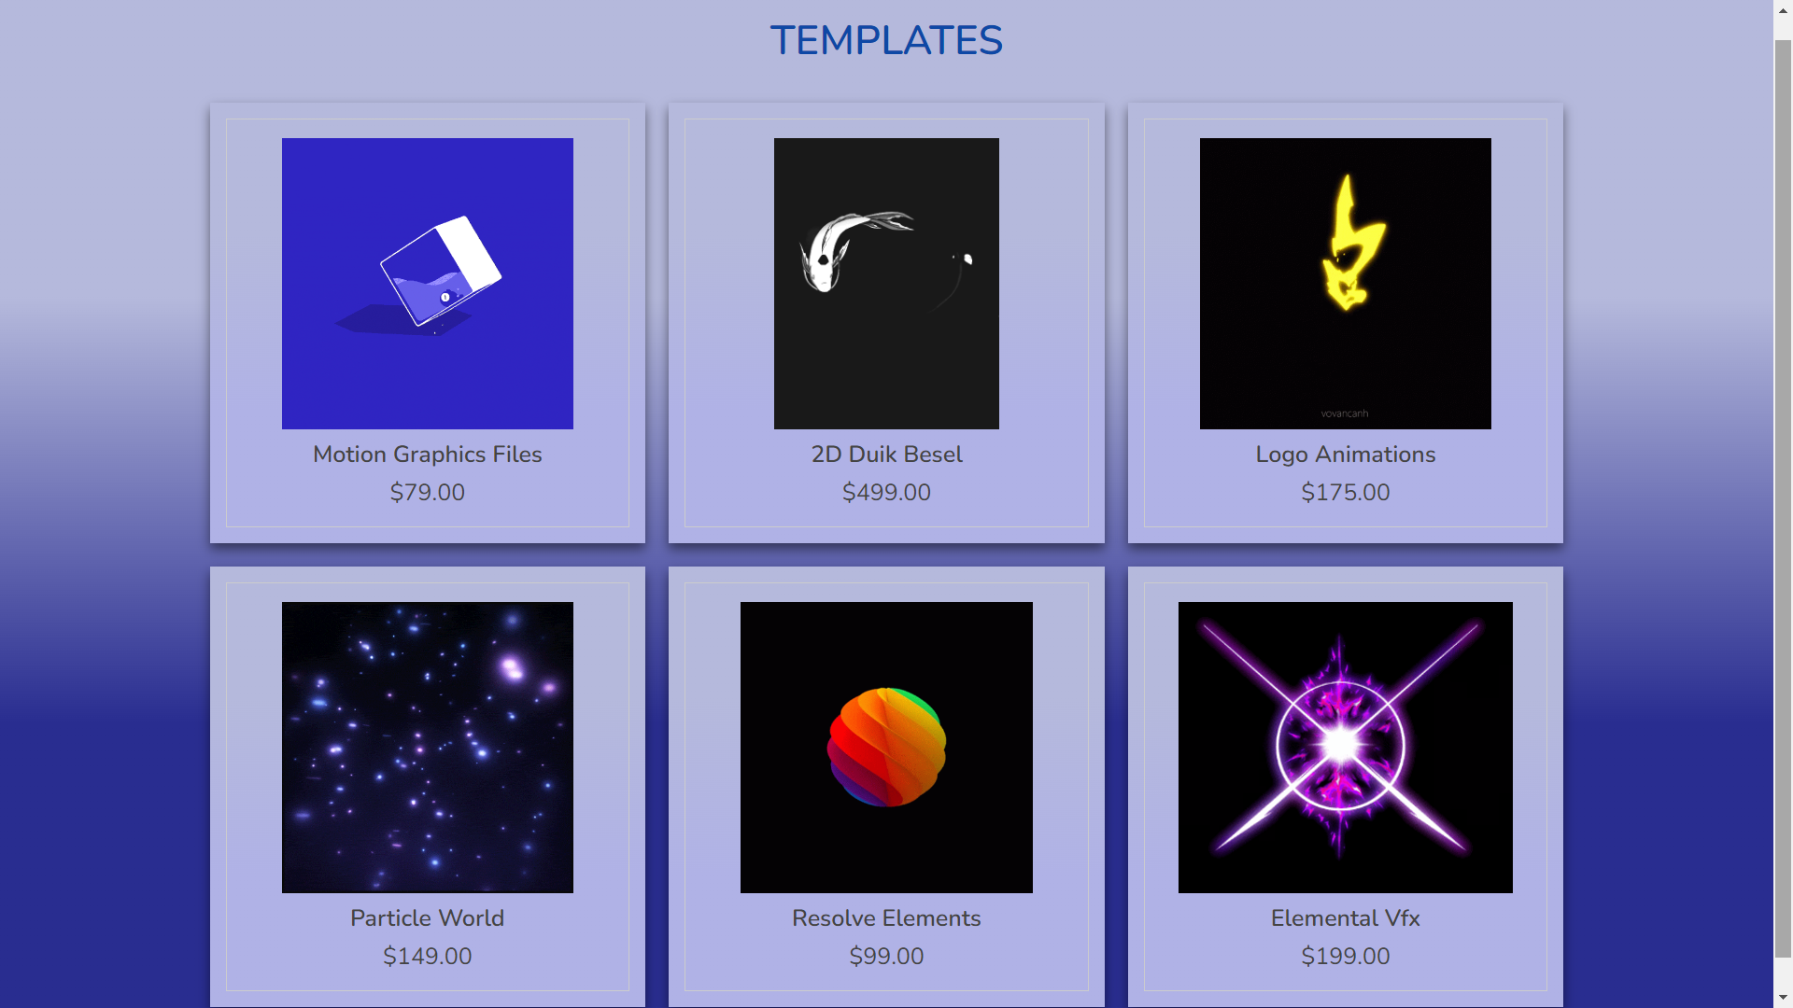

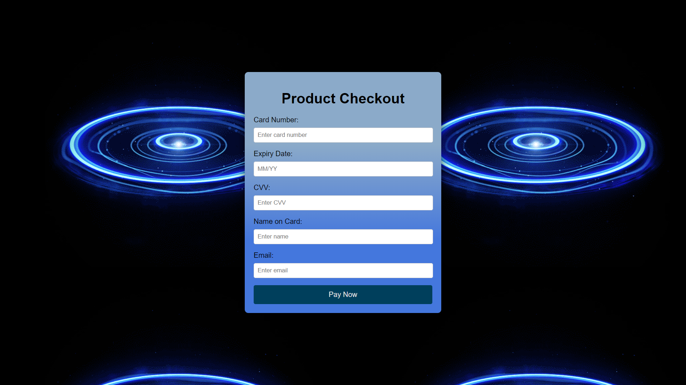

**Payment Form:** 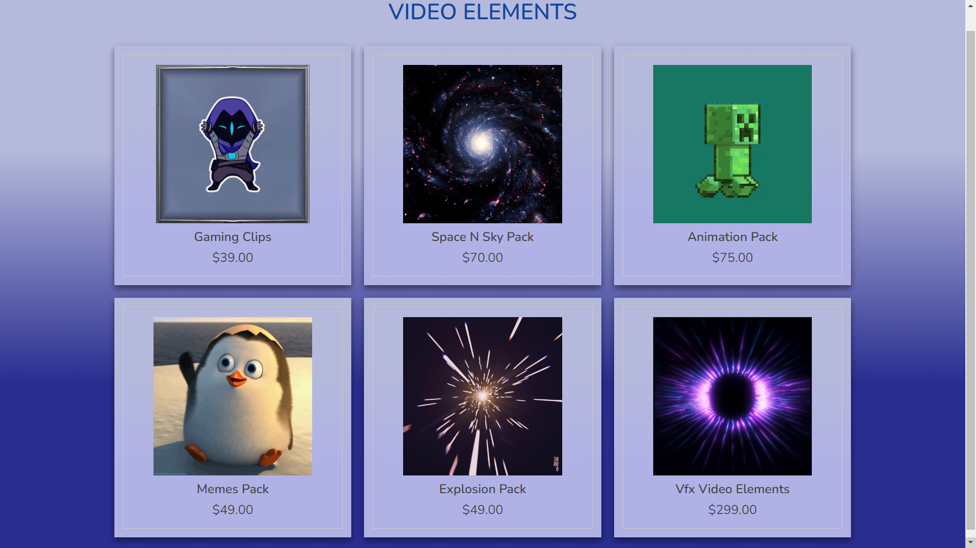

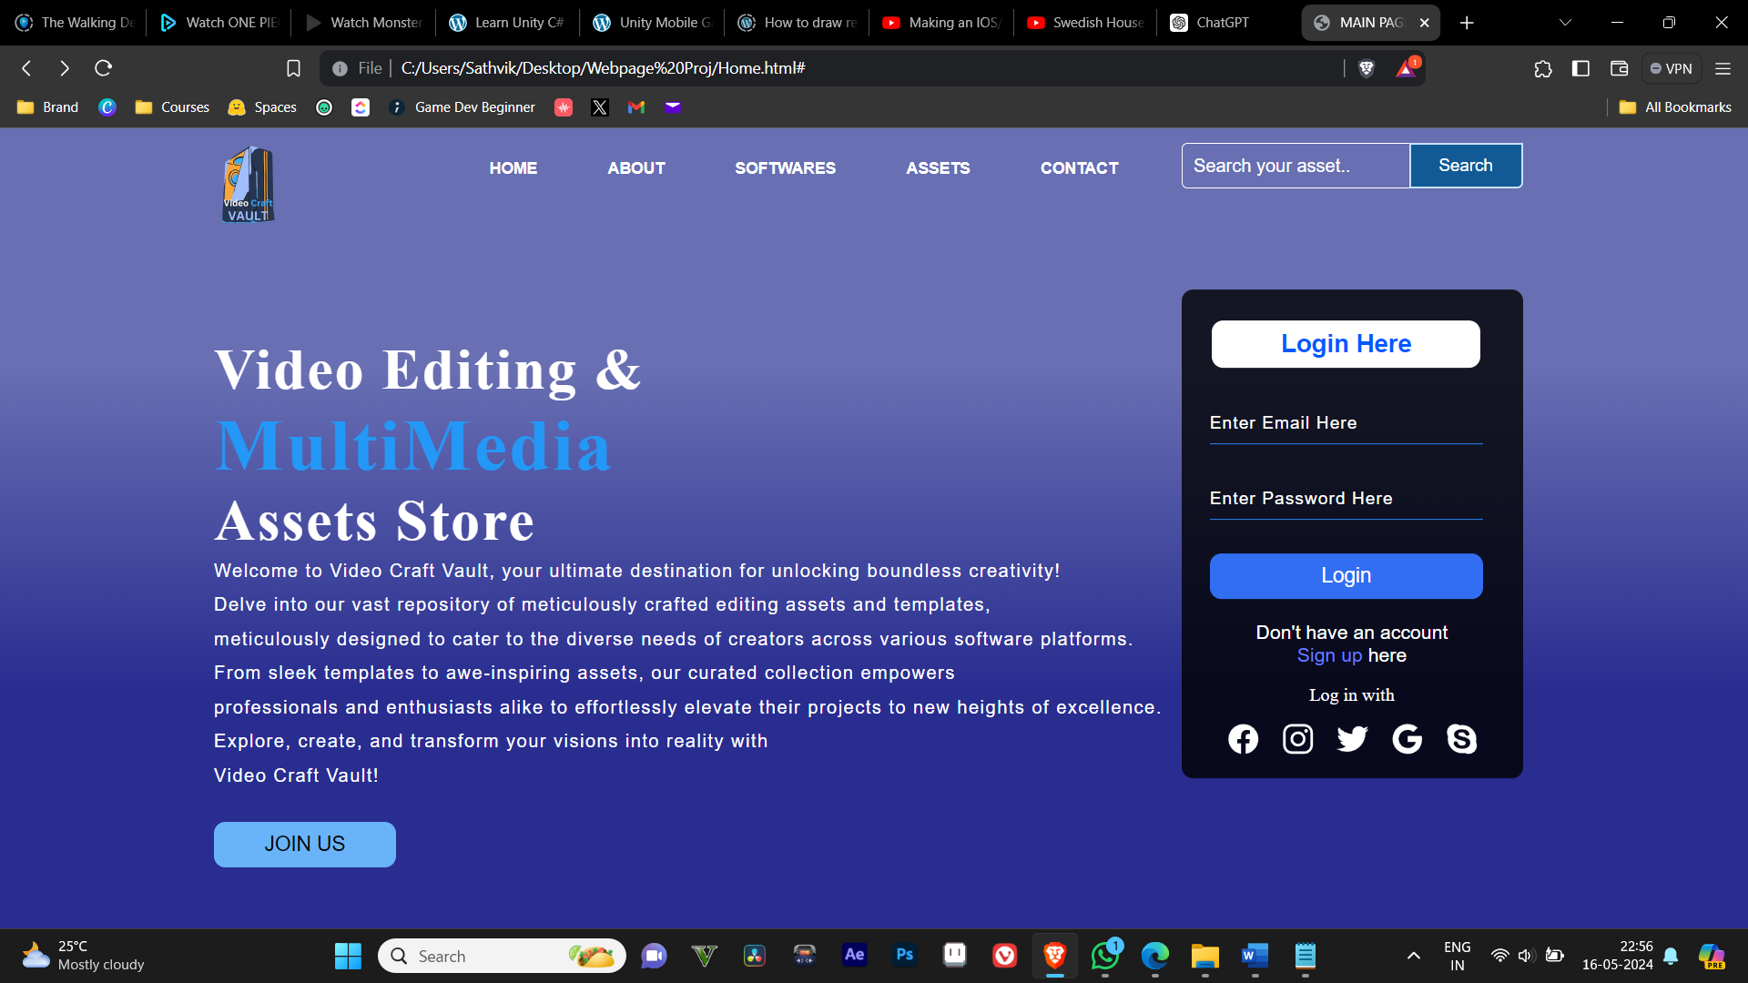

**Future Recommendations**

* **Artificial Intelligence and Machine Learning Integration and Recommendation system:**

AI-driven recommendation systems to personalize asset suggestions based on user behaviours and preferences.

* **Automated Tagging and Categorization:**

Using machine learning to automatically tag and categorize new assets, improving searchability and organization.

* **Content Creation Assistance:**

Developing AI tools to assist artists in creating custom assets or modifying existing ones, enhancing creativity and productivity.

* **Virtual and Augmented Reality Support and Compatibility:**

Ensure the asset store includes assets optimized for virtual and augmented reality applications, catering to the growing demand in gaming and immersive experiences.

* **Interactive Previews**:

Provide interactive 3D previews of assets to help users better understand how they will appear and function in VR/AR environments.

* **Blockchain for Digital Rights Management & Ownership Tracking:**

Utilize blockchain technology to track and verify asset ownership, ensuring that artists are properly credited and compensated for their work.

* **Secure Transactions:**

Implement blockchain-based payment systems to enhance security and transparency in transactions.

* **Enhanced Collaboration Tools:**

Real-Time Collaboration: Introduce features that allow multiple users to collaborate in real-time on asset customization and project development**.**

* **Feedback and Review System**:

Create a robust system for users to leave feedback and reviews on assets, fostering a community-driven quality control mechanism.

* **Audio Libraries:**

Expand the library to include more diverse and high-quality audio assets, such as sound effects, music tracks, and voiceovers.

* **Motion Graphics and Animation:**

Increase the availability of pre-made motion graphics and animation assets, which are in high demand for video content creation.

* **Templates and Presets:**

Offer a wide range of templates and presets for various software applications (e.g., Adobe After Effects, Photoshop, Premiere Pro) to help users streamline their workflows.

* **Advanced Search and Filters:**

Enhance the search functionality with more advanced filters and search options to help users quickly find the specific assets they need.

* **User-Friendly Interface:**

Continuously update and improve the user interface to ensure it remains intuitive and easy to navigate**.**

* **Regular Updates and Innovation:**

Regularly update the platform with new features, security patches, and performance enhancements based on user feedback and technological advancements**.**

**References**

**Web Design and Development Resources**

W3Schools. (n.d.). HTML Tutorial. Retrieved from <https://www.w3schools.com/html/>

W3Schools. (n.d.). CSS Tutorial. Retrieved from <https://www.w3schools.com/css/>

W3Schools. (n.d.). JavaScript Tutorial. Retrieved from <https://www.w3schools.com/js/>

Login forms CSS Retrieved From  
https://freefrontend.com/css-login-forms/