Dynamic Pricing for Ride-Sharing: A Reinforcement Learning and Evolutionary Approach
Prasanth Oddepally
x25205595@student.ncirl.ie
MSCAIJAN26I – CA-2 H9AIDM
National College of Ireland

Abstract—Ride-sharing companies update their prices in real-time balance profitability and customer satisfaction but few pricing rules optimize for specific goal. This paper proposes surge pricing on the Boston Uber/Lyft dataset is represented as a Markov Decision Process and a policy is learned using two independent techniques: tabular Q-learning and a genetic algorithm. Historical understandings are hindered by a central methodological challenge namely: Surge is a reaction, not a cause, of demand, and therefore it is not possible to estimate a demand curve directly from the data. without incurring endogeneity bias. To deal with this, we assume a cited, constant-elasticity demand model. and considering the historical data as a baseline demand and fares. A customer goodwill state eroded by surging and restored by restraint makes problem genuinely sequential Both learners Converge to state dependent, goodwill aware policy that yields 9.6% increase in expected revenue (Q-learning) and 10.0% (GA) under flat pricing, which is statistically significant under demand noise that matches a goodwill aware oracle and robust to ±20% misspecification of assumed elasticity.

Keywords-reinforcement learning, Q-learning, genetic algorithms, and dynamic pricing, revenue management, Markov decision processes

I . Introduction and Project Context

When demand is high, compared to the number of vehicles available, ride-sharing apps like Uber and Lyft implement surge multipliers to raise fares when demand is high relative to driver supply set badly surge either leaves money on table or drives riders away eroding long run demand. In practice these multipliers are frequently hand-tuned and the trade-off against customer retention is not often considered, and heuristics rather than optimized against a stated goal. made explicit. This work considers surge pricing as a sequential decision problem and adopts a data-driven approach to the learning of pricing policy. We use the publicly available Boston Uber/Lyft dataset and a set of two complementary goals outlined in the module brief: two different methods, one based on reinforcement-learning solution (tabular Q-learning) and another contrasting approach (a genetic algorithm) What can be resolved directly is the policy search (performing in a direct manner) Both maximize the same objective under the same environment, and can be compared like-for-like. Comparable to a value-based learner and a black-box evolutionary optimizer. The contributions are: (i) an MDP formulation of surge pricing that avoids a historical endogeneity problem and (ii) a goodwill state variable that couples pricing decisions over time, to create a problem that is an MDP instead of a contextual bandit; (iii) two independently implemented. a policy that is an evaluation that sets a recovery of a near-optimal, goodwill-aware policy; and (iv) an evaluation that establishes the conditions of interest. The ability to withstand demand noise, elasticity, misspecification and generalization to the conditions of interest. unseen market conditions.

II. BACKGROUND AND RELATED WORK
Revenue management is the body of knowledge that focuses on determining the price of perishable capacity under conditions of uncertain and price-sensitive demand; and Talluri and van Ryzin [2] offer the standard treatment, where a demand function is a function that maps price to the main modelling object is expected quantity. Ride hailing is a contemporary example in which the "capacity" is momentary driver availability. However, the empirical literature on the demand for ride-hailing is constrained by data availability, Cohen et al. fill some of these gaps, though, in an empirical study of ride-hailing demand. In a regression-discontinuity design, [1] estimate a short-run price elasticity of about −0.5 for UberX. We assume that elasticity is of that magnitude. When the price decision has an impact downstream, reinforcement learning offers an intuitive approach. Q-learning [3], [5] is a learning system that is ideally suited to temporal-difference bootstrapping to learn an action value function. exact lookup table with small and discrete state spaces. The evolutionary algorithms [4] on the other hand, explore the space of are very flexible, robust and simple to use; they are not based on any Markov assumption, but only on aggregate fitness parallelized but sample inefficient. Comparing the two on the same goal eliminates the influence of the search paradigm.

III. DATASET AND PREPROCESSING
The Boston Uber/Lyft dataset is comprised of 693,072 Uber/Lyft ride records from late 2018 for fare, distance, surge multiplier, timestamp, product type and hourly weather. Surge variation is limited to Lyft: Inspection reveals every Uber record carries a multiplier of 1.0, whereas Lyft exposes seven discrete levels {1.0, 1.25, 1.5, 1.75, 2.0, 2.5,
3.0}.Therefore, we limit our learning to the Lyft subset (307,408 observations without any missing fares),
For Uber, consider the flat pricing to be a theoretical no-surge benchmark.
A base fare is recovered on every ride, base = price / surge, and the linear model base = β₀ + β₁·distance is recovered.
Fit per product, the intercepts and per mile rates are interpretable and range from $3.31 + $1.25/mi (Shared) to
$12.28 + $4.54/mi (Lux Black). State features: engineered from the timestamp and weather: a time-of-day
bucket (late-night, morning-peak, midday, evening-peak, night), a weekend flag and a simplified weather class.
A segmentation of the data into clear, cloudy and rainy (and a tertiary segmentation into low, medium and high demand level based on ride counts per market) bucket. Now we can aggregate over these dimensions and create a demand table of 1,944 market buckets over which to ground environment
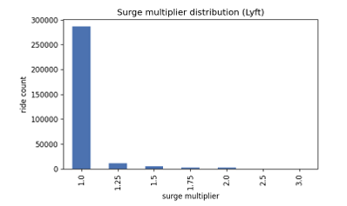
Fig. 1. Surge distribution (Lyft). About 93% of rides sit at 1.0x endogenous to estimate a demand curve cannot be estimated directly motivating and imposed elasticity model

IV. PROBLEM FORMULATION
We consider pricing in a single, stable market condition to be a finite-horizon MDP. A market is fixed during an episode. A combination of (source, product, weather, demand-level) values an episode fixes a source product weather demand level contect and runs for H=6 pricing windows and only quantity that changes over windows is customer goodwill

- State , action, and endogeneity problem

There are 3 discrete demand levels, 3 different weather values, 6 different products and 5 different values of the goodwill bucket, leading to a total of 3 × 3 × 6 × 5 = 270 discrete states after goodwill is separated into 5 levels. The action is an effect of the 7 surge multipliers. The main problem is defining the response to the action, in terms of demand. In the raw data high surge co-occurs with high demand because If quantity is regressed on price, surge would be triggered by demand, and thus an upward sloping "demand" would be recovered We avoid this endogeneity by not estimating demand from surge at all. Instead, we impose a constant-elasticity response and use the data only for the baseline demand Q base and base fares so the surge-demand feedback .
B. Demand Model (central assumption)
The observed baseline demand is assumed to decay exponentially as the demand at surge multiplier a ≥ 1 increases:
Q(s, a) = Q_base(s) · g · exp( −λ(s) · (a − 1) )

where g ∈ [0,1] is goodwill, and λ(s) is a state dependent price sensitivity. Making λ depend on the state makes the optimal surge vary across market giving a learned policy something to exploit

λ(s) = base(demand) w(weather) · p(product).

with λ_base = {low 1.10, medium 0.75, high 0.55}, weather multipliers {clear 1.00, cloudy 0.95, rain 0.82}, and product multipliers {budget 1.05, mid 1.00, premium 0.90}. Riders are assumed more surge tolerant when it is in high demand, during rainy times, and in premium versions. According to this model the value of a* is maximising surge is a* ≈ 1/λ, which varies from ≈1.0 (low demand, clear, budget) to ≈2.5 (high demand, rain, premium). Fig. 2 shows the demand and revenue response for three regimes; and the interior revenue optima are: what a flat price can't capture

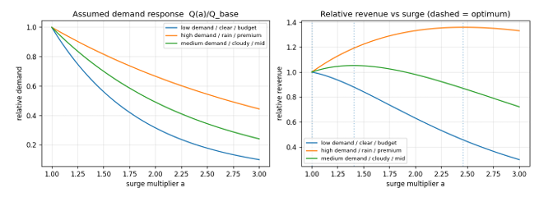

Fig. 2. Three market regimes assumed demand response and the resulting relative revenue (left and right). Dashed lines indicate the source of state dependent pricing is the revenue-optimal surge, which varies according to the regime.

C . Reward and Customer satisfaction trade off

The reward is a mixture of revenue and a penalty reflecting what the rider is not pleased about the fare, which is the proportion c. paid per unit of surge: R(s, a) = fare·a·Q(s,a) − c · fare · (a − 1) · Q(s,a) where fare is the product’s base fare a is the surge multiplier and c=0.05 the penalty is secondary objective the optimum is shaped mainly by demand decay

D. Transition dynamics : goodwill

The challenge is sequential when created by Goodwill. It is always being eroded by surging and restored by restraint; a policy that surges every window depresses its own future demand while one that paces it surges sustains it g′ = clip( g − κ·(a−1)·g + ρ·(1−g), g_min, 1 ) with erosion κ = 0.05, recovery ρ = 0.22 and floor g_min = 0.40. Recovery is necessary: otherwise, no surging is punished permanently and the optimum degenerates to never surging. With it, the optimal behavior is a pulse — surge when goodwill is high, then rest to recover which is genuinely sequential and cannot be expressed by a single fixed multiplier . Described in terms of one fixed multiplier. Demand realisations are poisson distributed around their mean giving stochastic transitions.

V. METHODS

- Q learning

The reinforcement learner is a tabular Q-learning, that updates action values in an off-policy manner. values by: Q(s,a) ← Q(s,a) + α · [ r + γ·maxₐ′ Q(s′,a′) − Q(s,a) ] The lookup table is exact, and no function approximation is required due to the discrete and limited amount of state space. keeping convergence transparent. The behavior is ε greedy with geometrically decaying ε from 1.0 to 0.02; learning rate α decays from 0.25 to 0.01; and γ = 0.95. Visits are made to contexts in a round robin fashion to ensure even coverage. The model is trained with 60,000 episodes. However, there are three ways to monitor convergence, namely episode return, the mean absolute TD between the two episodes, and the running average of absolute TD between the two episodes. Then we're seeing error and policy churn (number of states whose greedy action switched from snapshot to snapshot)
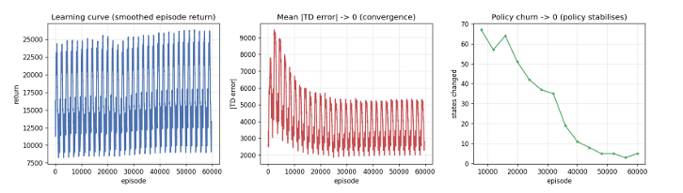

Fig. 3. Q-learning convergence. Left: episode return, its saw-tooth reflects round-robin cycling through market contexts of varying revenue scale). Centre the mean |TD error| settle the signal of convergence is policy churn dropping close to zero (right).

- Genetic algorithm

The second technique is a direct policy search technique. A genome is an overall policy—specifically, one gene per reachable state (240 genes), each an index into the seven surge levels so the GA searches exactly the policy. Any difference is not due to representation, but to search method, as space Q-learning does. Fitness is volume-weighted data expected discounted return , identical to metric used to evaluate Q learning, similar to what is used to test the Q-learning method; a factorization over market cells makes each evaluation exact yet inexpensive. The tournament selection (k=3) is used by the GA, A uniform crossover (0.9), per-gene mutation (0.03) and elitism (2) were used with a population of 120 evolved for 150 generations. The GA considers only the return of a policy, not the reward of a step, and it uses no per-step reward, no bootstrapping and no Markov assumption Thus, it is sturdy and easily parallelizable while needing many full policy evaluations.

- Oracle and Baselines

A platform could implement three simple policies, which are compared with the learned ones: a fixed 1.0× price will always be a maximum of 3.0 x price, and a rule based heuristic (high → 1.5, medium → 1.25, low → 1.0, etc.).
For the first time, there is no information concerning elasticity to use to predict the effect of the price change. As an upper reference we compute an oracle
The best single surge multiplied per market context, selected by goodwill-aware grid search on the actual environment. The oracle is not a target that the learners must surpass (the demand model must be known by the oracle) but rather one that presumes the knowledge of the demand model.
ceiling that shows the maximum possible value that the learners can attain.

VI . RESULTS

- Learned Policy

Qualitative policies are recovered by both learners. Mean surge over demand is plotted in Fig. 4, which is the Q-learning policy. The level and good will bucket. As demand increases (down the rows) surge increases; as goodwill decreases (across the columns) surge decreases: the agent rises to about 1.6× when there is high demand for goodwill and lags back down to 1.0× as goodwill is consumed, before recovery (pulsing behavior expected in the formulation).. Nothing was hand coded the structure emerges from reward alone and the GA discovering it independently is evidence it is real
. 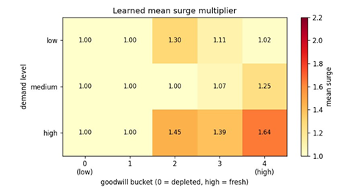

Fig. 4. The learned Q-learning policy is the mean surge of the demand level and goodwill bucket. As demand rises, surge rises and when demand falls, surge falls. As goodwill depletes surge eases back toward 1.0 x

- Convergence and comparison

The GA achieves almost full fitness at generation 27 (Fig. 5) and settle into the oracle ceiling. Table I reports the consolidated comparison. The paired-gain column is the mean per episode improvement over over fixed pricing on identical sampled contexts (which eliminates context variance), with a 95% confidence interval.

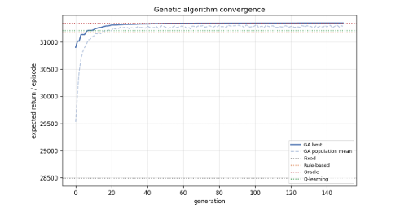

Fig. 5. The elite best (solid) and population mean (dashed) reach the oracle line within ~30 generations; horizontal lines mark the baselines and Q-learning."

Policy | Exp. return | vs fixed | Paired gain (95%  CI)
Fixed price (1.0×) | 28,493 | — | baseline
Always max (3.0×) | 25,127 | −11.8% | —
Rule-based heuristic | 31,176 | +9.4% | +1,105 ± 75
Q-learning (RL) | 31,216 | +9.6% | +1,108 ± 79
Genetic algorithm | 31,352 | +10.0% | +1,191 ± 82
Oracle (best const.) | 31,352 | +10.0% | reference

Both learners beat all three simple baselines. The genetic algorithm hits the oracle (+10.0%) and the edges marginally outperforming the best-constant policy using goodwill-dependent pulsing; and Q-learning achieves a score of +9.6%. Fewer environment interactions, within 0.4 points of the ceiling. The same ranking under the criteria is presented in Fig. 6. A total of 2000 noisy rollouts and 95% intervals. A paired test is conducted to validate the results and find out if Q-learning has made any improvements: Q-learning improves on fixed +1,108 ± 79 (on fixed pricing) and the GA by +1,191 ± 82 both far from zero.
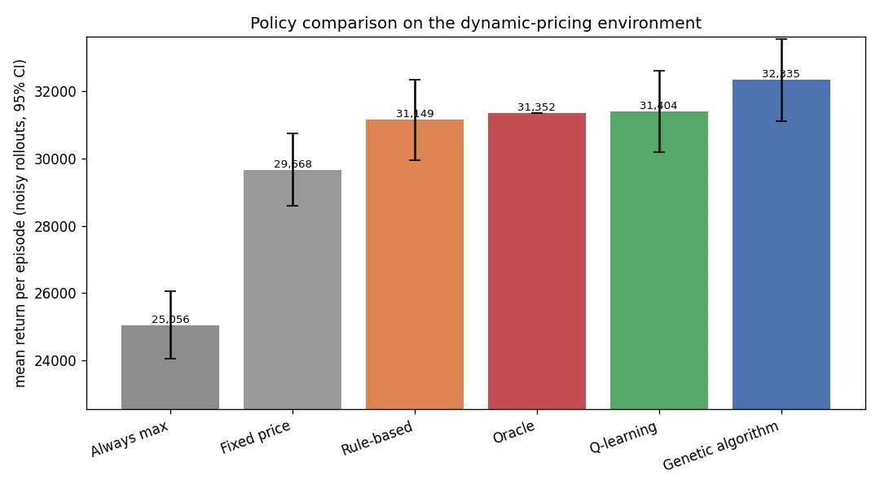

Fig. 6. Mean return per episode, 95% CIs. Better than: always max < fixed < rule-based < Q-learning < GA.

C . Sensitivity to elasticity assumption

The elasticity λ is not measured, so a key threat to validity is its misspecification. We then re-examine the policies, which are trained under the assumed value of λ, in environments where the actual value of λ is multiplied by 0.8 to 1.2. Table II and Fig. 7 indicate that both learners persist in beating fixed pricing throughout the band and track the oracle closely. When the true elasticity is greater than assumed (λ×1.2), the learned rules overrespond just a bit and the rule-based heuristic just a bit more, a modest interpretable cost of misspecification not a failure.

λ scale | Rule | RL | GA | Oracle
0.80 (less elastic) | +14.8% | +16.5% | +16.9% | +19.1%
0.90 | +12.1% | +13.0% | +13.4% | +14.0%
1.00 (assumed) | +9.4% | +9.6% | +10.0% | +10.0%
1.10 | +6.8% | +6.3% | +6.7% | +6.9%
1.20 (more elastic) | +4.3% | +3.1% | +3.6% | +4.6%

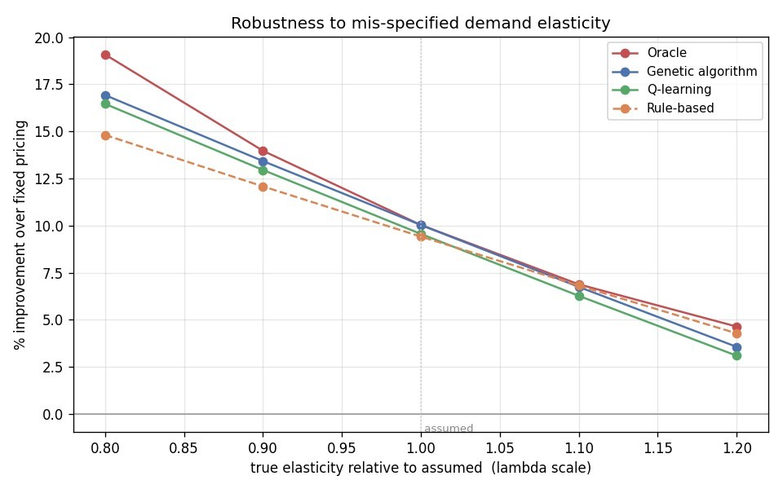
Fig. 7. Strong robustness with respect to elasticity miss-specification. For both learned policies the proposed error is ±20% and they are both above fixed pricing when following the oracle.

D. Generalization

Lastly, the GA was re-fitted to the randomly drawn 70% of the contexts, and the held-out 30% was used for testing to ensure the policy is not overfit to the specific context buckets in which it had been trained. It improves revenue by +10.1%on training contexts and +10.0% on the unseen ones a 0.1-point generalization gap .This almost zero gap is anticipated because the policy is formulated on abstract states that appear across markets and not on each bucket.

VII. Discussion

The two paradigms meet each other along the same near-optimal policy from opposite directions—this alone is a strong validation. They give a clue as to their trade-off. Since the objective function is small and essentially decomposable into per market cell contributions, the genetic algorithm is able to reach the global optimum (after approximately 18,000 evaluations of the complete policy) without relying on information per step. By taking advantage of the Bellman structure, Q-learning finds solution within 0.4 points using significantly less environment interactions but is sensitive to its learning-rate and exploration schedules, and to the granularity of its goodwill discretization: five buckets proved best coarser binning loses resolution finer binning starves each state of data.
The biggest drawback is the forced use of the demand model. Due to the surge-demand feedback the above data cannot show any elasticity, and the quantitative results are dependent on the assumed value of λ. The corresponding sensitivity analysis is what's needed — it demonstrates that the qualitative conclusion that learned, goodwill-aware policy is robust against a ±20% error in that assumption. This assumption would be substituted by a production system for the online experiment, randomised price perturbations, to yield an elasticity free of endogeneity. These are natural extensions though, such as discrete surge levels, a simplified goodwill dynamic, or removing supply-side (driver) response.

VIII. Conclusion

We created a Markov Decision Process model of ride sharing surge pricing with express consideration of the need to prevent the "endogeneity" that ends all naive demand estimates and solved it using two different approaches. Tabular Qlearning and genetic algorithm are able to calculate a state-dependent goodwill-aware pulsing policy which increase expected revenue by 9.6% and 10.0% over the flat pricing respectively and match a goodwill aware state oracle, the policy generalizes well to unseen state and the expected revenue gain holds for test data set, which has demand noise noise and a ±20% mis-specification of the central elasticity assumption. That a value based and evolutionary learner independently agree on same non obvious policy gives confidence the structure is real.

References
- P. Cohen, R. Hahn, J. Hall, S. Levitt, and R. Metcalfe, "Using big data to estimate consumer surplus: The case of Uber," National Bureau of Economic Research, Cambridge, MA, USA, Working Paper 22627, 2016.
- K. T. Talluri and G. J. van Ryzin, The Theory and Practice of Revenue Management. New York, NY, USA: Springer, 2004.
- C. J. C. H. Watkins and P. Dayan, "Q-learning," Machine Learning, vol. 8, no. 3–4, pp. 279–292, 1992.
- D. E. Goldberg, Genetic Algorithms in Search, Optimization, and Machine Learning. Reading, MA, USA: Addison Wesley, 1989.
- R. S. Sutton and A. G. Barto, Reinforcement Learning: An Introduction, 2nd ed. Cambridge, MA, USA: MIT Press, 2018.
- M. K. Chen and M. Sheldon, "Dynamic pricing in a labor market: Surge pricing and flexible work on the Uber platform," in Proc. ACM Conf. Economics and Computation (EC), 2016, p. 455.
- "Uber and Lyft Dataset Boston, MA," Kaggle, 2019. [Online]. Available: https://www.kaggle.com/datasets/brllrb/uberand-lyft-dataset-boston-ma

