

Graph Theory and Its Applications

Assignment - 5

Body Mass Index in Human Walking on Different Types of Soil Using Graph Theory

TEAM MEMBERS >

AKURATHI PRASHANTH SAI [PES1UG20CS525]

PRATEEK KESHRI [PES1UG20CS526]

**ABSTRACT :**

This paper states an experimental research that establishes a relationship between the body mass index (BMI) and human walking. Its mathematical formulation employs bio-mechanical anthropometry concepts. To validate the results in a realistic scenario, a novel algorithm that uses graph theory is proposed. This allows us to obtain the optimal route of escape. The model takes into account physical infrastructure, human physiology, and soil nature, then human walking speed is determined. Finally, the evacuation time as a function of BMI is presented. The proposed approach has the potential to be employed in different areas of civil security.

**INDEX** **TERMS** :

Body mass index, graph theory, human walking model, simulation

1. **INTRODUCTION :**

Human walking is a locomotion mode in which the lower limbs alternated to cause motion. It is characterized in two different succession: 1. Bipedal, in which the human body never leaves the ground, e.g. gait action. 2. Double, in which human body is suspended for a moment, e.g. jumping race [1]. Walking speed depends on human physiology such as weight, sex, etc. Nevertheless, another factor that has a strong impact on it, are the ones related to the contact surface in which the action is executed, i.e. the slope of the surface, type of soils, etc. [2]. The scenario selected for this research is a human body that follows a bipedal succession that moves in a flat ground. In addition, different types of soil are also considered in the analysis. To gait causes an energy expenditure which mainly depends on the physiology of the human body. For this reason, each person tends to adopt the most efficient way to do it depending on its Body Mass Index (BMI) [1]. During a gait, your body center of gravity follows a non-rectilinear movement, that is, it describes vertical and horizontal displacements that lead to a greater metabolic expenditure; nevertheless, the human body has developed various mechanisms that improve its performance, through energy transfers [3] and the reduction of the displacement of the center of gravity [4]. The speed acquired during a gait primarily depends on its initial speed. A low gait supposes a low initial speed and it is like to starting to walk with every step performed. While the person tries to increase the speed, it diminishes the energetic expense until arriving at a normal gait speed, around the 4.5 km/h. A slow gait supposes a greater energetic expense than a fast gait. Another factor to consider is the age. Each person tends to adopt an adequate speed based on it, for instance, the gait speed of elderly and children are lower than adults [5]. Therefore, the development of biomechanical studies requires more realism and customization, as in the case where there is a natural disaster and there is a need to find the optimal route of escape. Methods for such analysis are numerous, e.g., models made through programs that simulate movements under certain conditions using markers in different body parts [6], path tracking using kinetic movement [7], using force platform for measuring the reaction soil and torque [8] and more [9]. Nonetheless, these methods require the implementation of expensive smartdevices, leading sometimes to a non-affordable option. This paper presents the relationship between the BMI with the human walking under an emergency scenario (specifically in case of an earthquake). The model employs Dijkstra graph theory [10], [11] to simulate the case study. The user must go through different nodes, which physically represent soil types that the person needs to pass through in order to reach the exit

The study incorporates the physiology of the person [12], allowing to observe the output timing based on height and weight. The analysis is based on a maximum time proposed by the moles of Mexico in case of earthquake occurs [13]. As a result, the optimal exit route and the evacuation time as a function of BMI are determined in order to generate evacuation routes in buildings that save a greater amount of living beings in a short time. The rest of the paper is structured as follows: Section II describes the mathematical model and the experimental data used for the simulation. Section III describes the algorithm employed to calculate the exit time divided in two cases: normal and fast speed. Section IV shows an analysis of the results regarding the evacuation of a person. Finally, Section V presents the conclusions and future research.



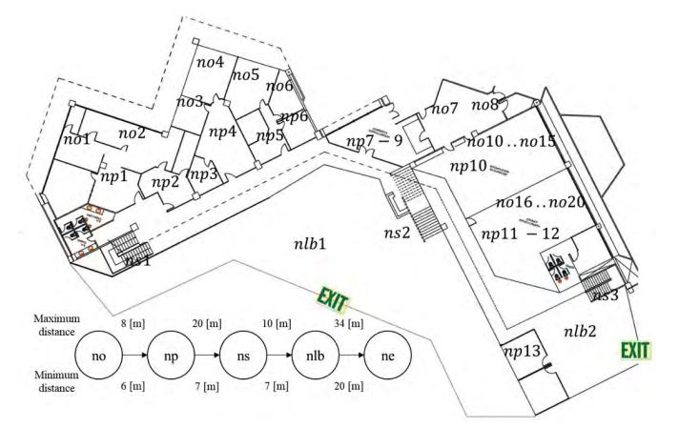

1. **SIMULATION ENVIRONMENT**:

This section presents various aspects of the development and implementation of the simulation; e.g., the use of anthropometry for calculating the center of mass of the human body, the relationship between body mass index (BMI) and the speed of the human being, as well, the mathematical foundations, assumptions and hypotheses, which they were proposed to be configured for a simulation environment.

1. ***ANTHROPOMETRY IN BIOMECHANICS :***

Anthropometry is the quantitative study of the physical characteristics of a person, both in safety and ergonomics [14]. When the body is in a fixed position, the study contemplates a static anthropometry, while functional anthropometry is employed to measure the dimensions of certain activities associated with the movement [15]. The variables that define the anthropometry depends on human physiology, as follows i.e. the height, weight, sex, among others. These measures are obtained on bare individuals; therefore, it is recommended to provide a tolerance in some dimensions to compensate for clothing, footwear, etc. Anthropometric measurements vary from one population to another, for instance: • Sex - It differentiates in virtually all body dimensions. The longitudinal dimensions of the male are larger than women of the same group, which can represent up to 20% different. • Race - The physical characteristics and differences between different ethnic groups are determined by genetic, nutritional, and environmental aspects among others. • Age - Its effects are related to one’s own human physiology. • Nutrition - It has been proven that a healthy diet contributes to the development of the body [16]. On the other hand, biomechanics studies the mechanics of human body movement. It is a science that explains how and why the human body moves. This includes the interaction between the person performing the movement and equipment or the environment [17], [18]. The five major components of biomechanics are: • Movement refers to the motion of the body or object through space. Speed and acceleration are key are involved in this component. • Strength refers to pushing or pulling causing a person or an object to accelerate, slow down, stop or change direction. • Moment refers to the product of the force times the distance. • Levers arms and legs work like levers; a lever consists of three components: the resistance arm, the point of support and axis of rotation. • Balance refers to stability. An important principle of balance is the alignment of the center of gravity of the support base. The Anthropometry in Biomechanics allows calculation of the mass and the position of the center of mass of each one of the segments of the body. In this way, it is possible to perform static or dynamic analysis with greater precision. To get the center of mass (CM) of the human body based on the sex and height, in [19] proposes the following formulation: L = kH; k = ( 0.565 for men 0.550 for women (1) where is the CM of the human body measured from the feet, is a constant that depends on the sex, and is the height of the person given in cm.

1. **BMI CLASSIFICATION :**

To assess the nutritional status of a person, the World Health Organization (WHO) recommends the use of the BMI [20]. This parameter should not be applied with the same values to children and adolescents due to growth and body development variables, therefore a BMI is obtained based on a person’s weight and height as shown in 2 [21]. BMI = weight/height2 (Kg/m 2 ) (2) Nevertheless, to determine the BMI for people who are over 20 years old, Table 1 can be used [22]. C. HUMAN WALKING SPEED To develop the human walking mathematical model, the following assumptions are adopted: • When a person moves, and has reached his limit speed (acceleration equal to zero), each leg is stiff during the time of its contact with the ground, like the spokes of a wheel, which thereby rotates without the benefit of a rim. Thus, each foot leaves contact with the ground at the instant the other touches the ground. The flexing of the knee of the free leg serves only to keep that foot from contacting the ground as its leg swings forward, and such flexure doesn’t consume significant energy or change the natural period of oscillation of the leg. • The legs swing with their natural period as a function of the gravity g, assumed to be given by [23]: T = 2π p 2L/3g (3) • Energy is consumed in raising the center of mass of the body once per step, and this energy is not recovered when the center of mass is lowered again. Under these assumptions, it is straightforward to calculate the power (energy per unit time) expended in walking [24]: a = (mg/π) p 3gL/2; b = π 2 /6gL Pw = Re(a(1 − q 1 − bv2 h )) (4) Then, human walking speed can be expressed as: vh = Re( s 1 − (1 − Pw/a) 2 b ) (5)

**CONTACT SURFACE AND FRICTION :**

It has been observed that foot impacts on the ground increase when walking on hard pavements such as asphalt, while softening when the subject walks on natural soils such as wood, grass or sand [25]. Human walking speed varies according to the type of soil on which he/she moves. This fact is due to the static frictional coefficient between the shoes (leather) and soil. Table 2 shows the static frictional coefficient needed for this research. From the collected data in [12], it is possible to establish a relationship between the static frictional coefficient material and walking speed. These are given for normal and fast speeds



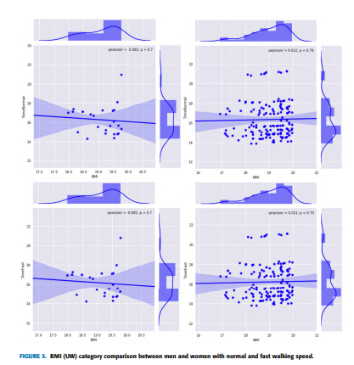

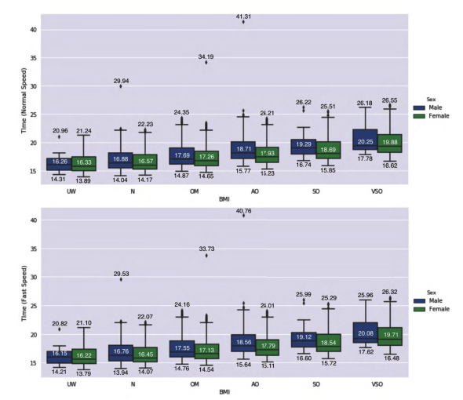



**E .WALKING TIME CALCULATION :**

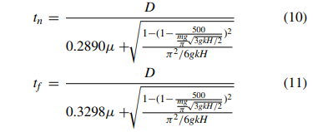Assuming that a person walks a distance D with a constant speed v¯, then the time required for the movement is [26]: t = D/v¯; replacing the previous equations and considering that a person requires 500 watts to walk (Pw) [23], the results are:

The units of H, m and g must follow the International System of units [26].

**F. WALKING ROUTES :**

The infrastructure features are as shown in Fig. 1. To reach the exit, a person needs to pass through different environments. These are represented by nodes, which are presented in Fig. 2 and described in Table 3. If a person is in an office no(1, 2, 3, .., n), he/she will have to walk over various nodes np to get out of the building, through the nearest stair ns(1, 2, 3), then the lobby nbl1 or nbl2 and finally, any exit ne(1, 2, 3), always the nearest.

**G. EXPERIMENTAL DATA :**

The experiment was carried out with a dataset containing a sample of 4,232 people [27]; 2,284 women and 1,948 men, with different values of height and weight. The simulation is designed to determine the optimal exit route according to the initial position of the person, i.e., if someone’s initial location is in office, he/she should go through np1 → ns1 → nbl1 → ne1 nodes. In addition, Table 4 shows the number of people (Men and Women) classified by its BMI

1. **PROPOSED ALGORITHM**

This section presents the proposed algorithm for the simulation at different walking speeds. The main function receives certain parameters described in Table 5. The assumptions are the following: • Graph - refers to a variable that contains the graph of the floor, that is nodes and edges (distances between nodes). • Floor - refers to the floor in which the person is located. • Office - refers to a function that gets the initial location of the person inside the building. • BMI - refers to a Body Mass Index and the people are classified based on it. • Path - refers to the optimal evacuation route using Dijkstra graph theory. • Length - refers to the total distance that a person walks to reach the exit. With Algorithm 1, a repetition statement is developed, and it analyzes each person, from their initial position until they get out of the building.

1. **ANALYSIS AND DISCUSSION**
2. **CORRELATION BETWEEN BMI AND WALKING SPEED**

There are specific locations (no1 to no19) inside the building. The number of people for each location is as follows: [202, 184, 220, 215, 196, 252, 202, 206, 226, 207, 215, 216, 205, 193, 228, 206, 208, 228, 211, 212]. Every person in the experiment has a feature called field, which is classified as shown in Table 5. Those values are used to obtain the results, which are classified according to BMI. In addition, there is a defined a limit time, Ts = 17s [13], which is employed as a control parameter concerning the time spent escaping the building. If the person achieves leaving the building at a time less than Ts , the person survives, otherwise, he does not. This is tagged as (0: trapped inside the building; 1: Evacuate the building) and is used to determine how many people evacuate the building in the designated time. As a result, Fig. 3 shows the Pearson correlation (p) between the BMI (UW) and the fast and normal speed evacuation time for men and women. For the case of men, p = −0.081, which leads to a reverse correlation, while for the case of women the correlation is direct since p = 0.022. Nevertheless, this correlation is not the same for all other cases, as given in Table 6. In addition, people with VSO present the lowest probability of evacuating the building, while people with UW have the highest one. This fact is inferred due to the average time presented in Fig. 4.

1. **SOIL TYPE AND WALKING SPEED :**

Table 7 shows the average time that it takes to walk through different types of soils. It can be appreciated that Tn and Tf for men and women vary in just ±0.01 s. Regarding the surfaces inside the building (wood, ceramics and marble), marble and wood present the lowest and highest displacement time, respectively. Notice that this fact is independent of the BMI and sex.

**C. SURVIVAL FLAG :**

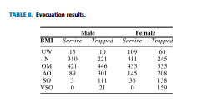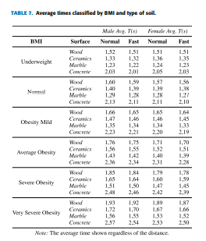The results shown in Table 8 indicates that women have more probabilities to evacuate the building than men in a relation of 1.16 : 1.00. Concerning the BMI, those who have a BMI less than 30 are more likely to evacuate the building.

**V. CONCLUSION :**

This paper presents the impact of BMI on the human walking speed. The study incorporates the human physiology and building infrastructure, leading to a more realistic and accurate results than traditional studies on the field. The results show that people who have obesity present a low probability of evacuating the building. Furthermore, the type of soil represents a barrier in these situations, and it is recommended to avoid the use of wood inside the building floor since it causes unstable gait. The proposed approach presents a pathway to develop a realistic model for civil safety as shown in the presented case study. The formulation can be extended considering other metrics such as the acceleration of the person, ground with slopes, leg positions at different angles (walking uphill, downstairs, etc.)

**REFERENCES :**

[1] C. Sanz, ‘‘Cinesiología de la marcha humana normal,’’ Links, pp. 1–14, 2006.

[2] J. Romkes and K. Bracht-Schweizer, ‘‘The effects of walking speed on upper body kinematics during gait in healthy subjects,’’ Gait Posture, vol. 54, pp. 304–310, May 2017.

[3] S. H. Collins, M. B. Wiggin, and G. S. Sawicki, ‘‘Reducing the energy cost of human walking using an unpowered exoskeleton,’’ Nature, vol. 522, no. 7555, p. 212, 2015.

[4] G. Cavagna, ‘‘Walking,’’ in Physiological Aspects of Legged Terrestrial Locomotion. Springer, 2017, pp. 139–165.

[5] G. J. Jerome, S.-U. Ko, D. Kauffman, S. A. Studenski, L. Ferrucci, and E. M. Simonsick, ‘‘Gait characteristics associated with walking speed decline in older adults: Results from the baltimore longitudinal study of aging,’’ Arch. Gerontol. Geriatrics, vol. 60, no. 2, pp. 239–243, 2015.

[6] R. Rosales and S. Sclaroff, ‘‘Inferring body pose without tracking body parts,’’ in Proc. IEEE Conf. Comput. Vis. Pattern Recognit., vol. 2. Jun. 2000, pp. 721–727.

[7] D. Berdy, D. Valentino, and D. Peroulis, ‘‘Kinetic energy harvesting from human walking and running using a magnetic levitation energy harvester,’’ Sens. Actuators A, Phys., vol. 222, pp. 262–271, Feb. 2015.

[8] I. H. López-Nava and A. Muñoz-Meléndez, ‘‘Wearable inertial sensors for human motion analysis: A review,’’ IEEE Sensors J., vol. 16, no. 22, pp. 7821–7834, Nov. 2016.

[9] J. K. Aggarwal and Q. Cai, ‘‘Human motion analysis: A review,’’ in Proc. IEEE Nonrigid Articulated Motion Workshop, Jun. 1997, pp. 90–102.

[10] A. Munoz-Arcentales, W. Yánez-Pazmino, and W. V. Vargas, ‘‘Proposal of a communication structure model for activating reactive signaling in an emergency evacuation systems,’’ in Proc. IEEE 7th Annu. Comput. Commun. Workshop Conf. (CCWC), Jan. 2017, pp. 1–5.

[11] W. Velásquez Vargas, A. Muñoz-Arcentales, and J. Salvachúa-Rodríguez, ‘‘A distributed system model for managing data ingestion in a wireless sensor network,’’ in Proc. CCWC, 2017, pp. 1–5.

[12] W. Velásquez, A. Muñoz-Arcentales, and J. Salvachúa-Rodríguez, ‘‘Relation between BMI and exit time of a building in an emergency situation: Earthquake,’’ Eng. Lett., vol. 25, no. 4, pp. 13–28, 2017.

[13] F. Ruiz. (2017). En Caso de Sismo Me Salgo o Me Quedo? Esta es la Respuesta de Los Topos. [Online]. Available: http://somoscultura.mx/encaso-sismo-me-salgo-me-quedo-en-edificio/

[14] V. D. Bhise, Ergonomics in the Automotive Design Process. Boca Raton, FL, USA: CRC Press, 2016.

[15] E. V. Cabello, Antropometría. 6. Tablas Antropometricas. España: Instituto Nacional de Seguridad e Higiene en el Trabajo, Centro de Nuevas Tecnologias, 2008.

[16] A. K. Yousafzai, M. A. Rasheed, A. Rizvi, R. Armstrong, and Z. A. Bhutta, ‘‘Effect of integrated responsive stimulation and nutrition interventions in the lady health worker programme in pakistan on child development, growth, and health outcomes: A cluster-randomised factorial effectiveness trial,’’ Lancet, vol. 384, no. 9950, pp. 1282–1293, 2014.

[17] D. A. Winter, Biomechanics and Motor Control of Human Movement. Hoboken, NJ, USA: Wiley, 2009.

[18] F. E. Zajac, R. R. Neptune, and S. A. Kautz, ‘‘Biomechanics and muscle coordination of human walking: Part I: Introduction to concepts, power transfer, dynamics and simulations,’’ Gait Posture, vol. 16, no. 3, pp. 215–232, 2002.

[19] M. G. del Castillo and D. L. Girela, Bases Biológicas y Fisiológicas del Movimiento Humano. Medica Panamericana, 2002.

[20] R. Burrows, N. Díaz, and S. Muzzo, ‘‘Variaciones del índice de masa corporal (IMC) de acuerdo al grado de desarrollo puberal alcanzado,’’ Revista Médica Chile, vol. 132, no. 11, pp. 1363–1368, 2004.

[21] R. Chamorro and M. G. Lorenzo, ‘‘Indice de masa corporal y composición corporal: Un estudio antropométrico de 2500 deportistas de alto nivel,’’ Lecturas, Educación física Deportes, vol. 76, 2004.

[22] Z. Pataky, S. Armand, S. Müller-Pinget, A. Golay, and L. Allet, ‘‘Effects of obesity on functional capacity,’’ Obesity, vol. 22, no. 1, pp. 56–62, 2014.

[23] L. Bencsik and A. Zelei, ‘‘Effects of human running cadence and experimental validation of the bouncing ball model,’’ Mech. Syst. Signal Process., vol. 89, pp. 78–87, May 2017.

[24] J. Sprott, Energetics of Walking and Running. Madison, WI, USA: Univ. Wisconsin-Madison, 2016.

[25] S. C. Vázquez, F. P. Gómez, A. Álvadillo, and L. P. R. Rodríguez, ‘‘Análisis de la marcha. Factores moduladores,’’ in Revista de la Facultad de Ciencias de la Salud, vol. 1. 2003.

[26] H. D. Young, Sears and Zemansky’s University Physics. London, U.K.: Pearson, 2008, vol. 1.

[27] C. Dobking. (2018). Dataset Health Medicine. [Online]. Available: https://people.ucsc.edu/~cdobkin/NHIS_2007_data.csv