
Session 2

–

Introduction

to
Working with R

Assignment
-

2

Contents

Introduction ..................................................................................................................................................... 2
Objective .......................................................................................................................................................... 2
Prerequisites .................................................................................................................................................... 2
Associated Data Files ....................................................................................................................................... 2
Problem Statement ......................................................................................................................................... 2
Expected Output .............................................................................................................................................. 3

Introduction
This assignment will help you to understand the key concepts learnt in this session.

Objective
This assignment will test your skills on the basics of R.

Prerequisites
Not Applicable

Associated Data Files
Not Applicable

Problem Statement
1. Read multiple JSON files into a directory to convert into a dataset.
I have files text1, text2, text3 in the directory JSON.

ANSWER:

Read the JSON File
The JSON file is read by R using the function from JSON(). It is stored as a list in R.
# Load the package required to read JSON files.
library("rjson")

# Give the input file name to the function.
result <- fromJSON(file = "input.json")

# Print the result.
print(result)
When we execute the above code, it produces the following result −
$ID
[1] "1" "2" "3" "4" "5" "6" "7" "8"

$Name
[1] "Rick" "Dan" "Michelle" "Ryan" "Gary" "Nina" "Simon" "Guru"

$Salary
[1] "623.3" "515.2" "611" "729" "843.25" "578" "632.8" "722.5"

$StartDate
[1] "1/1/2012" "9/23/2013" "11/15/2014" "5/11/2014" "3/27/2015" "5/21/2013"
"7/30/2013" "6/17/2014"

$Dept
[1] "IT" "Operations" "IT" "HR" "Finance" "IT"
"Operations" "Finance"

Convert JSON to a Data Frame
We can convert the extracted data above to a R data frame for further analysis using the as.data.frame() function.
# Load the package required to read JSON files.
library("rjson")

# Give the input file name to the function.
result <- fromJSON(file = "input.json")

# Convert JSON file to a data frame.
json_data_frame <- as.data.frame(result)

print(json_data_frame)
When we execute the above code, it produces the following result −
id, name, salary, start_date, dept
1 1 Rick 623.30 2012-01-01 IT
2 2 Dan 515.20 2013-09-23 Operations
3 3 Michelle 611.00 2014-11-15 IT
4 4 Ryan 729.00 2014-05-11 HR
5 NA Gary 843.25 2015-03-27 Finance
6 6 Nina 578.00 2013-05-21 IT
7 7 Simon 632.80 2013-07-30 Operations
8 8 Guru 722.50 2014-06-17 Finance

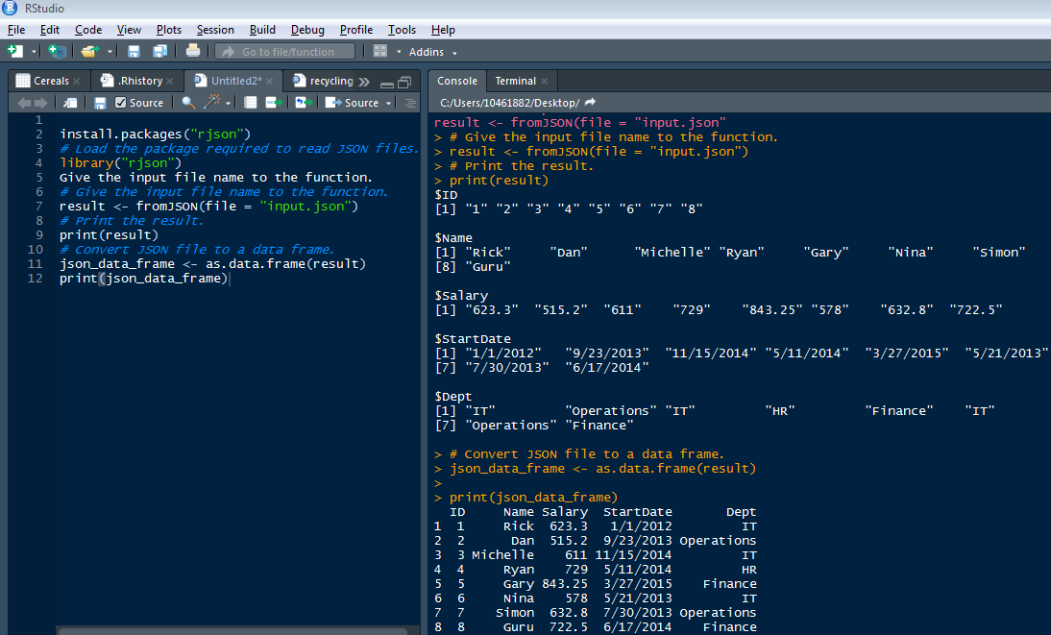

- Parse the following JSON into a data frame. js<-'{
"name": null, "release_date_local": null, "title": "3 (2011)",
"opening_weekend_take": 1234, "year": 2011,
"release_date_wide": "2011-09-16", "gross": 59954
}'
ANSWER:
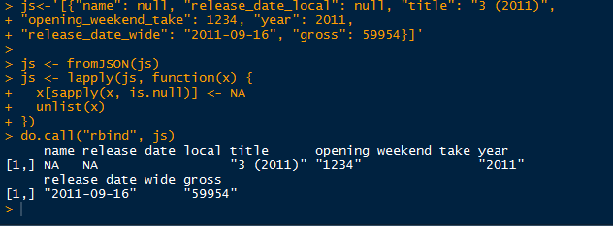
- Write a script for Variable Binning using R.
ANSWER:
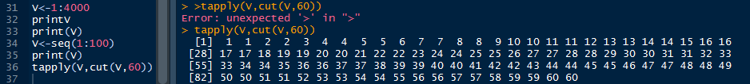

Expected Output
Not Applicable

