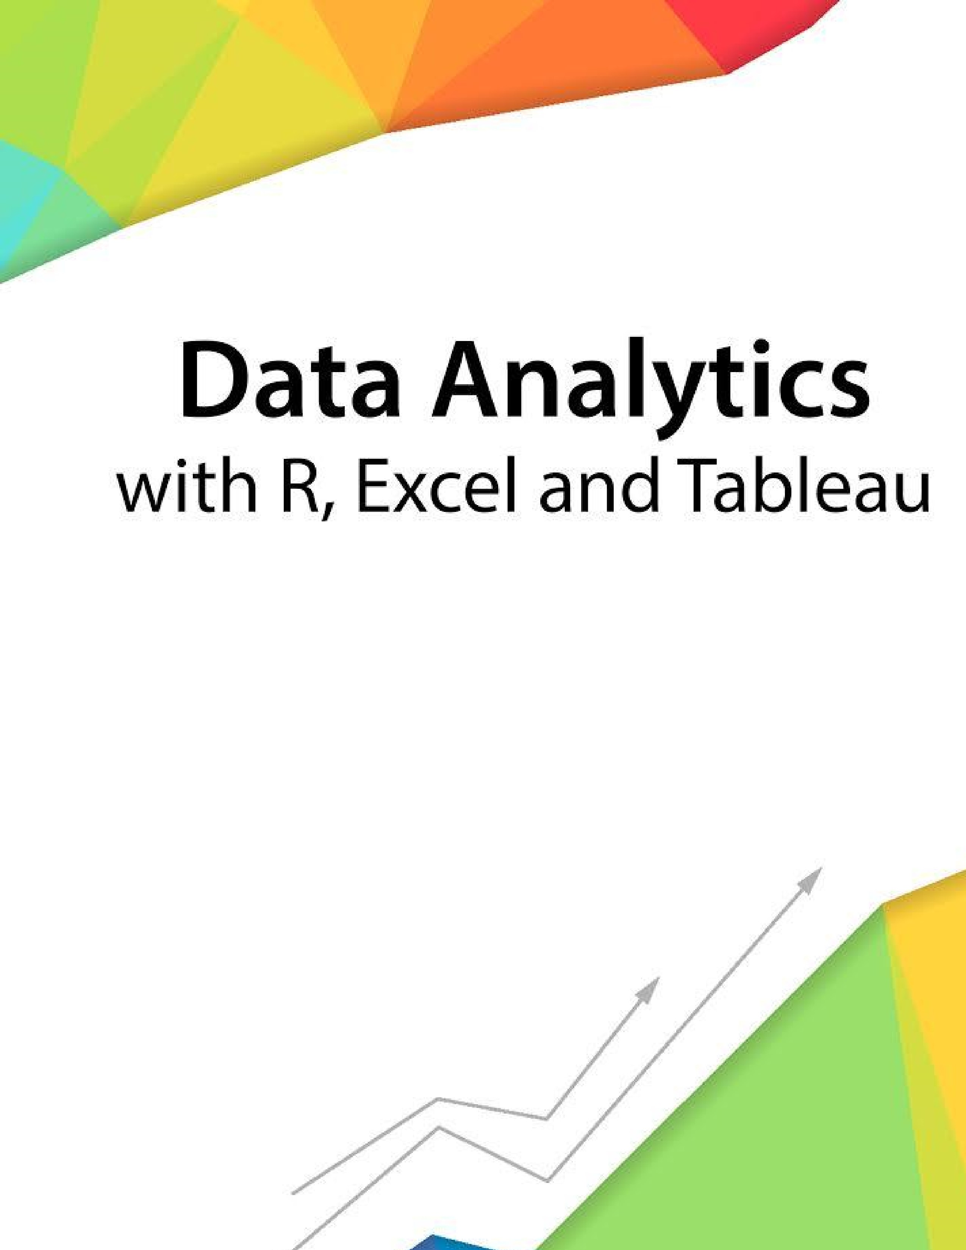
Session 1
–

Introduction

to
Working with R

Assignment
-

2

Contents

- Introduction ..................................................................................................................................................... 2
- Objective .......................................................................................................................................................... 2
- Prerequisites .................................................................................................................................................... 2
- Associated Data Files ....................................................................................................................................... 2
- Problem Statement ......................................................................................................................................... 2
- Expected Output .............................................................................................................................................. 2

Introduction
This assignment will help you to understand the key concepts learnt in this session.
Objective
This assignment will test your skills on the basics of R.
Prerequisites
Not Applicable
Associated Data Files
Not Applicable

Problem Statement
1. What should be the output of the following Script?
v <- c( 2,5.5,6) t <- c(8, 3, 4) print(v%/%t)
Answer: > v<- c(2,5,5,6)
> t< - c(8,3,4)
> print(v%%t)
[1] 0 1 1 0

- You have 25 excel files with names as xx_1.xlsx, xx_2.xlsx,……..xx_25.xlsx in a dir.
Write a program to extract the contents of each excel sheet and make it one df.
Answer: Library(readxl)
File.list<-list.files(pattern=’*.xlsx)
df.list<-lapply(file.list,read_excel)

If the above 25 files were csv files, what would be your script to read?
Answer:
Temp = list.files(pattern=”*.csv”)
Myfiles = lapply(Temp,read.delim)

Expected Output
Not Applicable

The Approximate time to complete this task is 20 Minutes.

