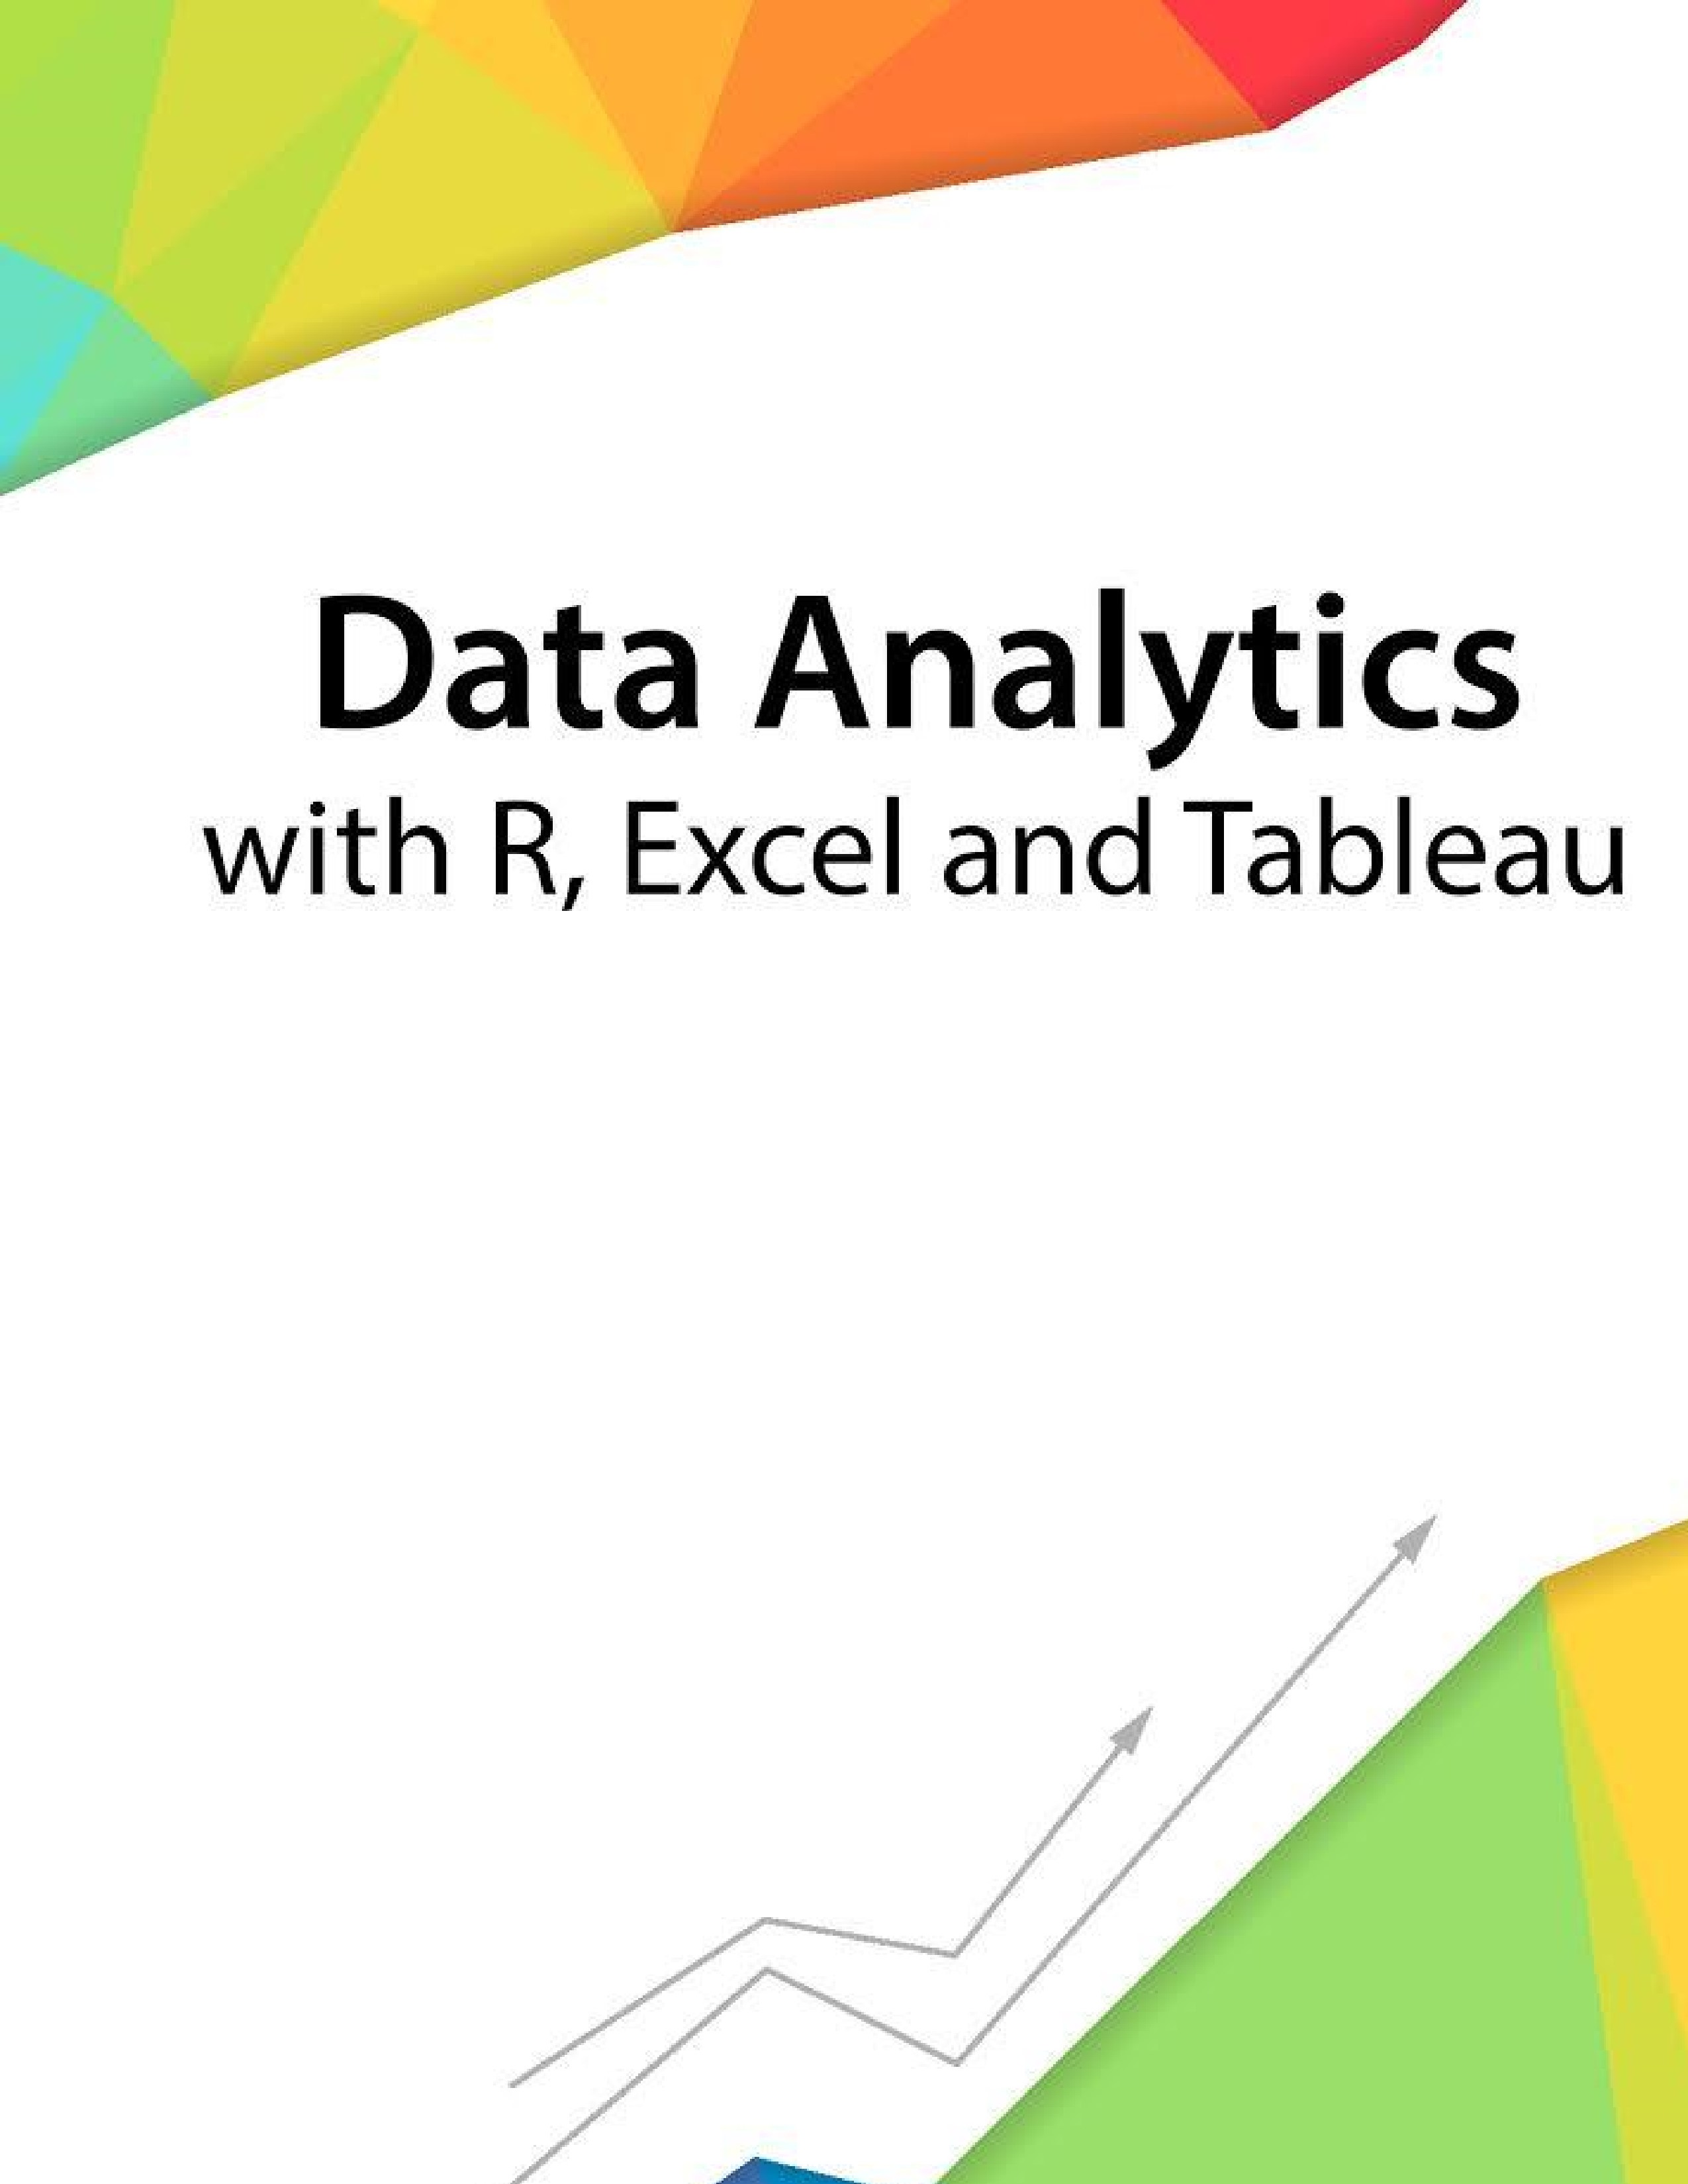
Session 1
-

Introduction

Assignment
-

1


––

Contents

- Introduction ..................................................................................................................................................... 2
- Objective .......................................................................................................................................................... 2
- Prerequisites .................................................................................................................................................... 2
- Associated Data Files ....................................................................................................................................... 2
- Problem Statement ......................................................................................................................................... 2
- Expected Output .............................................................................................................................................. 2

Copyrights© 2017, AcadGild. All Rights Reserved
1

Introduction
This assignment will help you to understand the key concepts learnt in this session.
Objective
This assignment will test your skills on the basics of Data Analytics
Prerequisites
Not Applicable
Associated Data Files
Not Applicable

Problem Statement
1. Say True or False for the below statements:
- Prescriptive Analytics used to predict the future outcomes?
Answer: TRUE
Prescriptive (optimization and simulation) Analytics is used to determine the possible outcomes on “What should we do?” rather “What has happened?” which is done in Predictive Analysis
- Base R packages installed automatically?
Answer: FALSE
The base R packages are always installed depending on the operative system but not automatically loaded when you Launch R
- What is Recycling of elements in a vector?
Answer: Not covered in session 1
- Give an example of recycling of elements.
Answer: Not covered in session 1

Expected Output
Not Applicable

Copyrights© 2017, AcadGild. All Rights Reserved
2

