Amazon Documentation

Step-1: Importing libraries

- Mount drive: importing drive files for colab to access the file.
- Import pandas: imports pandas library, pandas is a package that offers functions and data structures for quickly and effectively transforming and analyzing data.
- Import numpy:imports numpy library, numpy offer support for arrays, matrices, and a number of mathematical operations.
- Import matplotlib.pyplot: imports matplotlib library, it is a popular Python library for producing static, animated, and interactive info-graphics.
- Import seaborn: imports seaborn library,a high-level interface is provided by Seaborn, which is developed on top of Matplotlib, for producing appealing statistical visuals.
- Import warnings: if any warning occurs in the data it will ignore it.

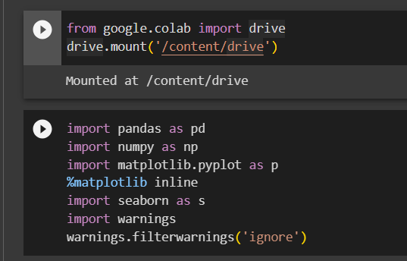

Step-2:

using the Pandas library. The data from the CSV file is loaded into a Dataframe. By giving variable name it display the contents of the dataframe, showing the data and its structure to the user.
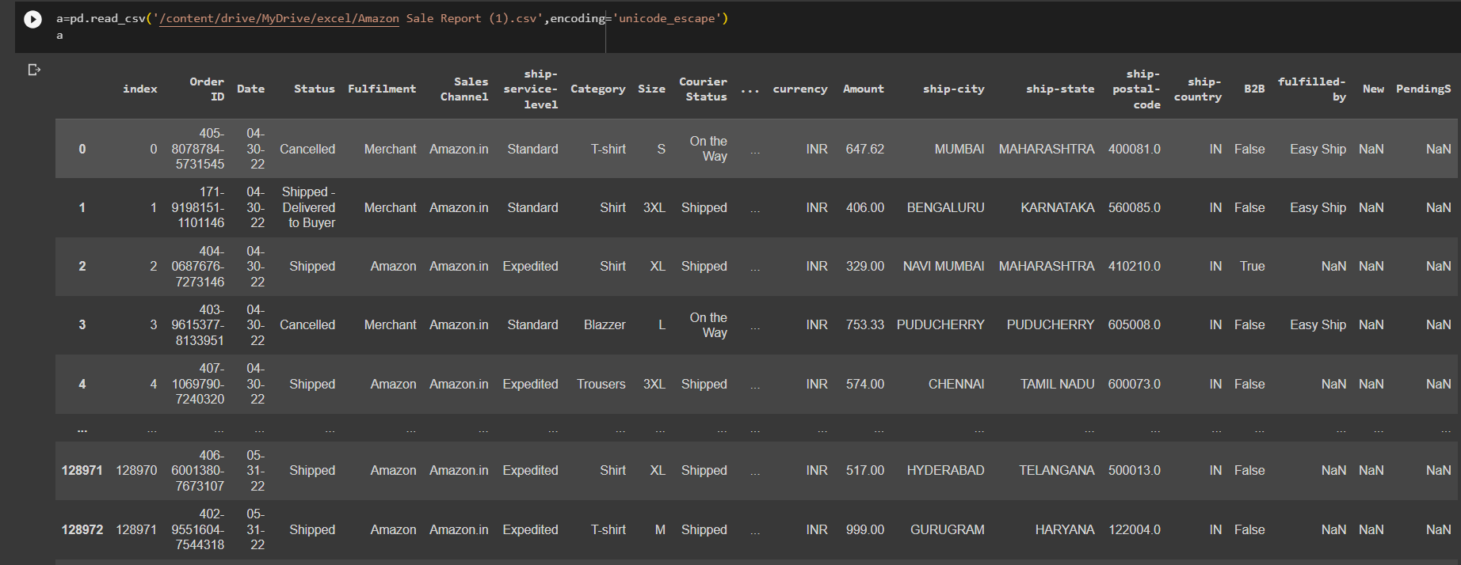

Step-3:

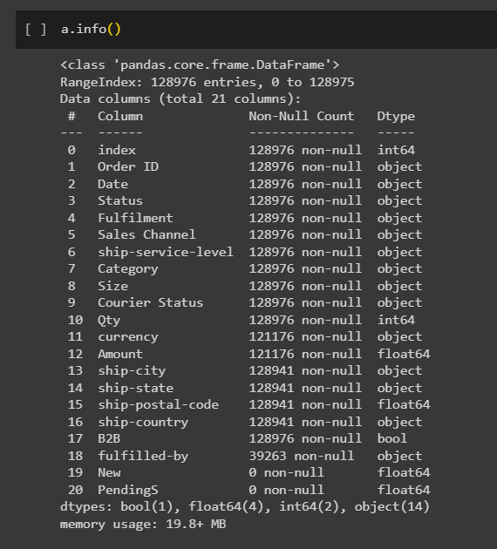

The a.info() command provides a summary of the Dataframe,It displays information about the data type, nonzero amount, and memory usage for each column. For detecting missing values, and for evaluating data sets in different columns.

Step-4:

a.shape()It gives number of rows and columns present in the dataframe, a.columns gives name of every columns that are present in the dataframe.

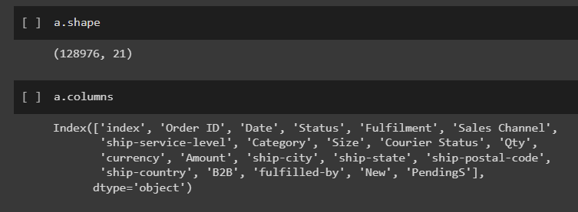

Step-5:

By the info we can see that New and Pendings as zero values so we will drop that columns using drop function it will modify the dataframe directly and checking whether it is dropped are not.

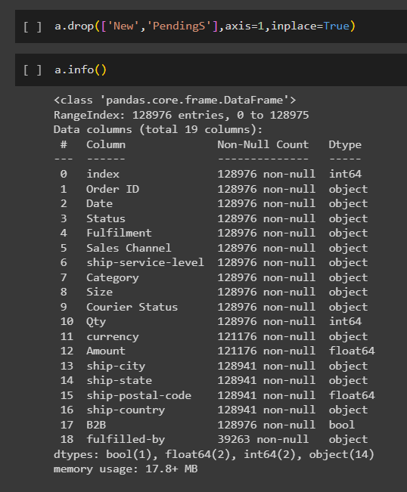

Step-6:

a.isnull().sum() is used with the Pandas library to figure out and show how many columns in a dataframe have null values.It helps to identify how much data is missing in each column.

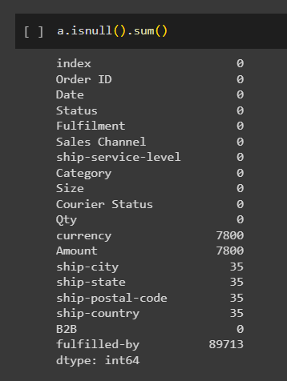

Step-7:

Here we obtain the unique values of the currency than filling the null values with mode value, this is a common method of imputing missing values that contain a common value in a categorical column.

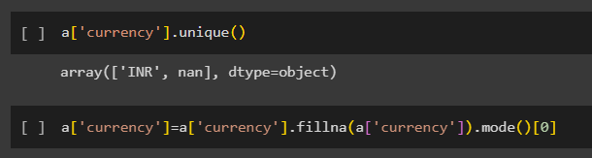

Step-8:

Here we obtain the unique values of the Amount and it returns a list of specific objects found in the column. Then we are seeing the value count of the column than we are changing the null values, null values will be replaced by mean value of that column.

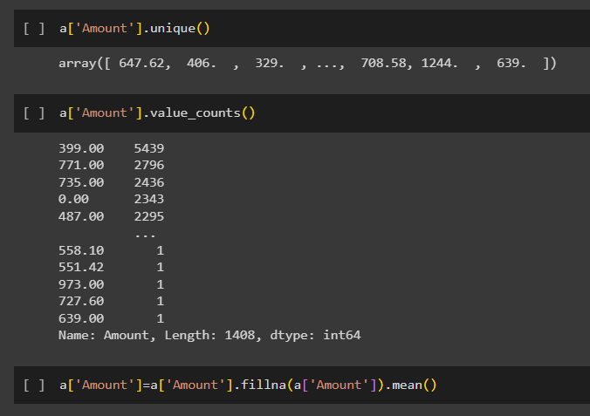

Step-9:

Here we obtain the unique values of the fullfilled-by than replacing null values with mode value ,checking unique values of ship-country and replacing null values, and repeating same for ship-city.

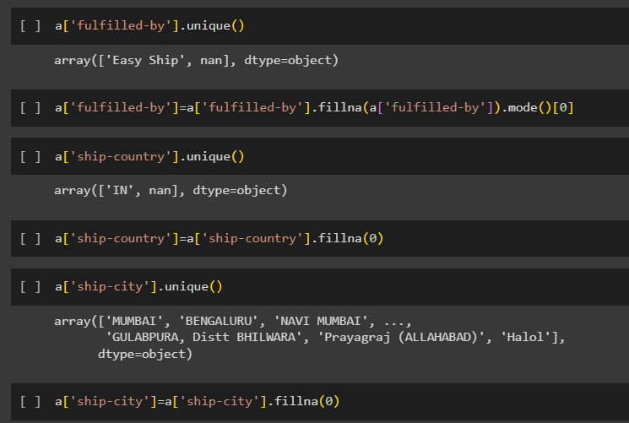

Step-9:

Here we obtain the unique values of the ship-state than replacing null values same for ship-postal-code, we replaced null values with zero.

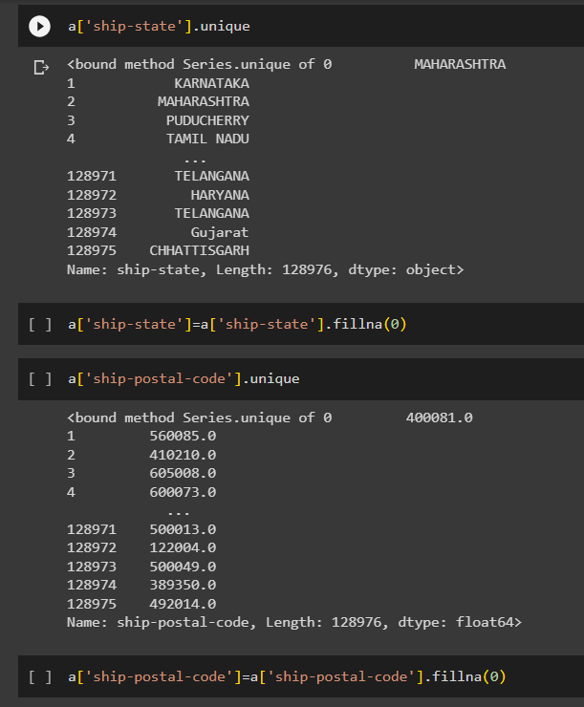

Step-10:

The a.dtypes command returns a Series of data types for each column in the Dataframe a.It provides information about datatype of each column contains in the dataframe.

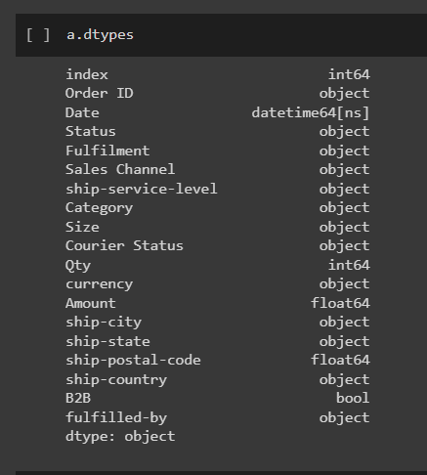

Step-11:

Changing datatype of datetime and ship-postal-code using astype function.

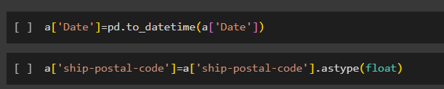

Step-11:

a.describe() give count, mean, std, min, max etc data of the data frame .
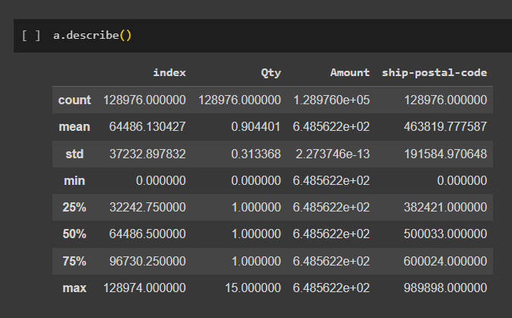

Step-12:

Using seborn we are plotting count plot function to create the plot.The x-axis represents the ‘Size’ categories, and the y-axis represents count.

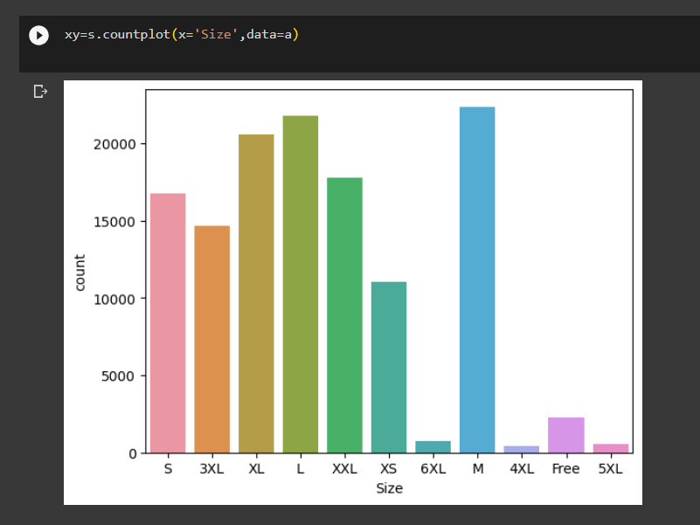
Step-13:

The code creates a statistical plot using Seaborn and The x-axis represents the ‘Size’ categories, and the y-axis represents count then it adds a value label above each bar, indicating the number of events for each size.

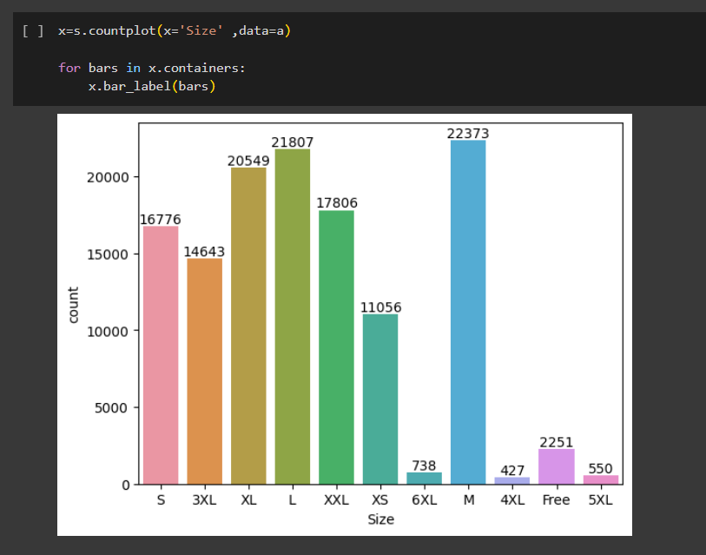

Step-14:

Using groupby function we are grouping size and Qty together then we are summing the Qty to get sum of all the sizes and to get data from high to low we are using ascending function.

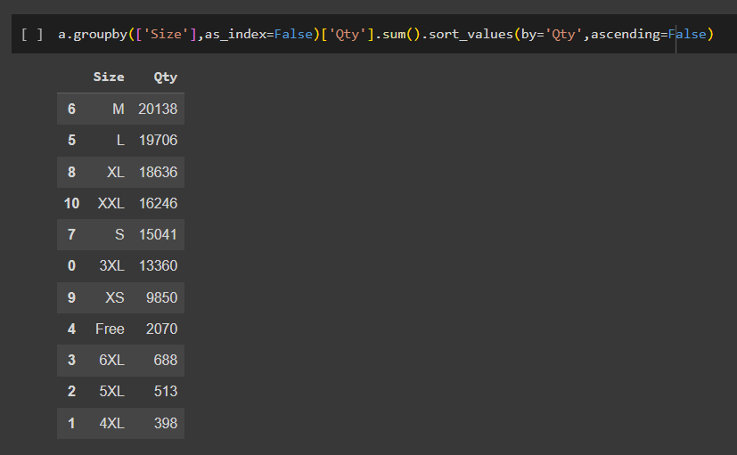

Step-15:

Here calculates the combined quantity for each different Size range using the groupby function and stores the result in a dataframe then uses Seaborn's barplot to create a bar plot, where the x-axis represents the 'Size' groups and the y-axis shows the total of the corresponding quantities This image visually represents all quantities associated of each size category

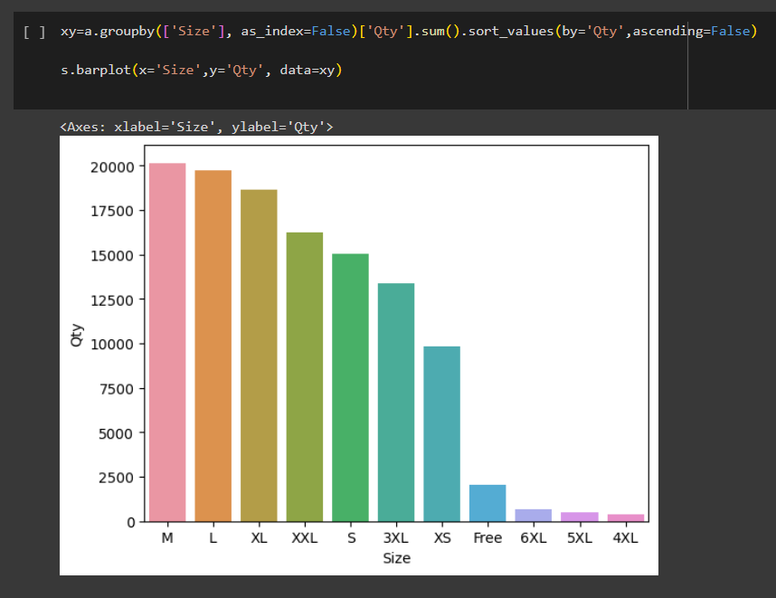

Step-16:

Using Seaborn countplot to create a stacked bar plot. The x-axis represents 'Courier Status', while using the hue parameter differentiates the bands by 'Status' values allows you to find out how two variables are related in a data set.

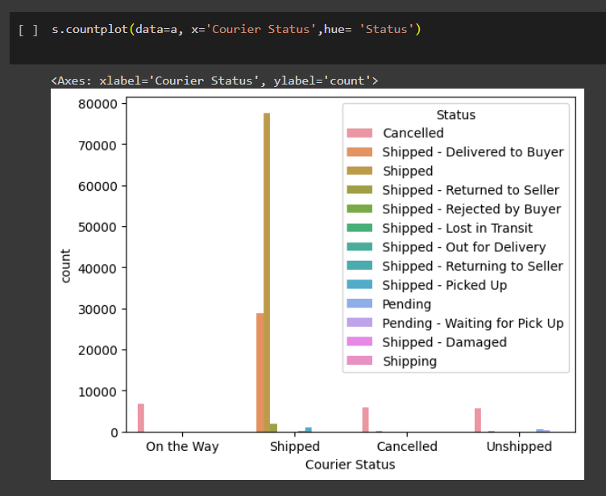

Step-17:

It counts the unique value of the 'B2B' column and stores the result in another variable b, it contains the index of the unique value, and the value of the corresponding figure. using Matplotlib pie function to create a pie chart.The Labels parameter specifies the labels for each slice in pie chart. plt.show(): This line shows the histogram plot.
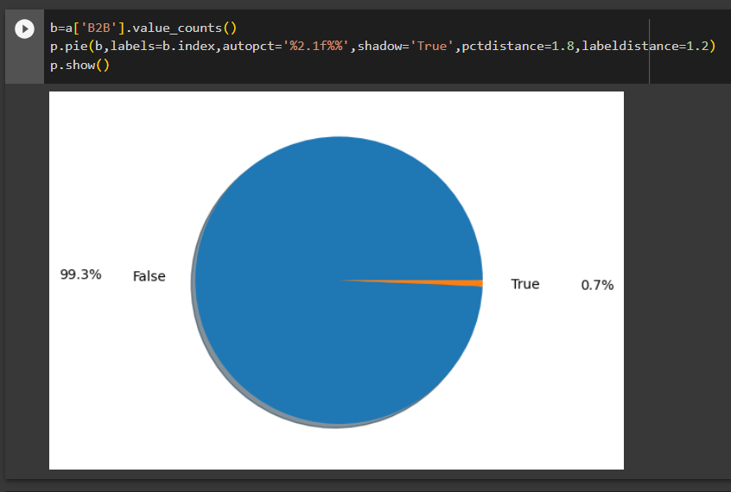

Step-18:

This code snippet provided is a pie chart based on the calculation of the unique values of the Fulfillment column that present in dataframe.The chart shows the distribution of the complete elements, adds percentage labels to slices

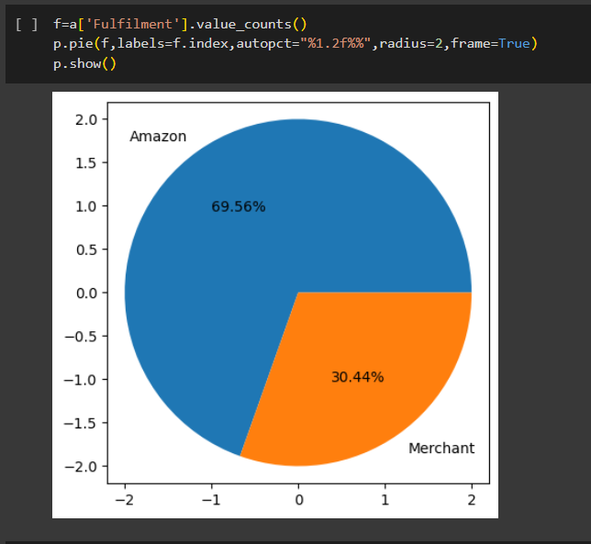

Step-19:

Here using horizontal bar plot that uses the Seaborn countplot function to plot the distribution of the state in the ship-state column in the dataframe than adding labels and titles have been added to the plot.The x-axis represents the conditions, and the y-axis represents the number of events.

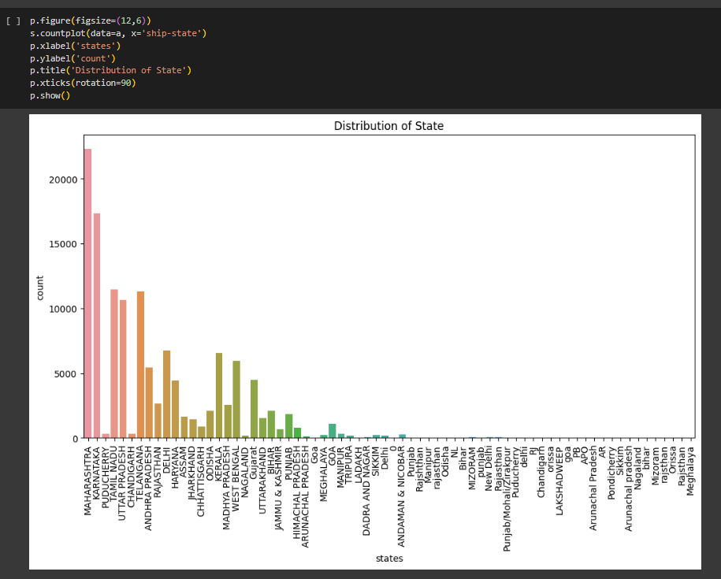

Step-20:

It counts the counts for each unique state in the 'ship-state' column and then selects the top 10 most common states. The results are stored in the top10 series. creates a count plot using the Seaborn countplot function. It uses the 'top10' series to filter the dataframe,and rotated 90 degrees to improve readability.

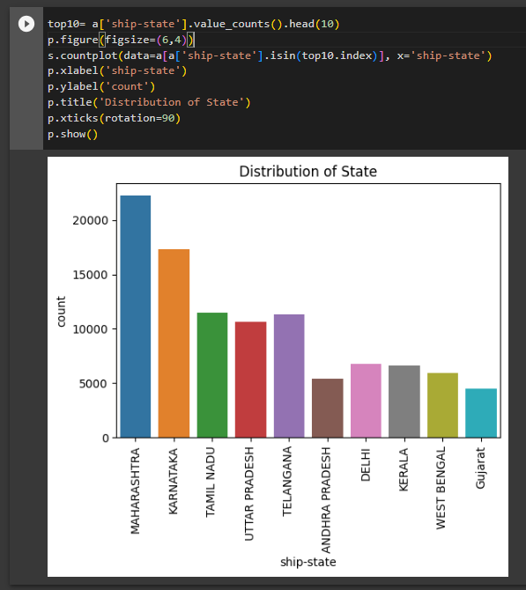

Step-21:

It counts the counts for each unique state in the 'ship-state' column and then selects the minimum 10 states. The results are stored in the ‘last10’ series.shows the distribution of these simple 'ship-state' values.
