REAL-TIME DRIVER DROWSINESS DETECTION
Prem kumar L¹, Sadir Irfan², Prashanth V³, Karthik Rathod⁴.
Guide: Shruthi M.L.J⁵
Teaching Asst.: Deeksha H Kulal⁶
Electronics and Communication Engineering,
PES University, Bangalore, Karnataka, India.
Premmsagar1210@gmail.com

Abstract:
The drowsiness of the drivers is leading to many road accidents these days. These are the significant causes of the road accidents. For every year this type of accidents, deaths, and injuries increases globally. About 4,50,000 accidents takes place in India annually, in which 1,40,000 people die and 3,10,000 people were injured, the annual report of the National Crime Records Bureau (NCRB) showed. Dangerous or careless driving contributed to 24.3% of road accidents which led to 35,000 deaths and 73,476 injured. From the past many years, the researchers have been told that overtiredness of the driver, drowsiness, distraction of the driver is the cause of many road accidents. In this paper a model is designed for detecting the driver is drowsy or not, to reduce accidents caused by this problem by which it increases the transport safety of the driver. Here our project is used to solve these problems by observing if the driver is feeling sleepy or not. If the driver is feeling drowsy, an audio is activated to alert the driver.

Keywords: Eye Aspect Ratio, Eye Mouth Aspect ratio, Drowsy, Landmarks, Threshold.

- INTRODUCTION

Road accidents are very common on Indian roads. A majority of these road accidents are mainly caused by distractions to the driver, daydreaming, reckless driving, drowsiness and over tiredness of the driver. One simple way of keeping a driver awake and alert is to engage them in frequent conversations. A report produced by the Ministry of Road and Highway in the year 2016 stated that at least 4,80,652 road accidents were reported in the country. In our project, we have proposed an approach that makes use of vision based technology to detect the drowsiness of the driver. The major goals of our proposed system are (a) yawn detection, (b) creating a real-time response system, (c) detection of the eye (d) detection of the face, under a variety of conditions like with/without spectacles, with/without a face mask and under dim lighting, etc. The main focus of our project is to create a live drowsy or dozing detection system that will be able to accurately and quickly tell if a person is half sleep or not. Detection of half sleep or drowsy depends on the state of eyes and yawn.

- LITERATURE REVIEW

Paper[1]: Drowsiness detection based on facial landmarks using dlib with opencv and python. The video is captured and divided into frames, Face is detected especially mouth (for yawning) and eyes are detected. The system alerts the user if he's drowsy and if the eyes are closed it stops the car engine.
Paper[2]: classify eyes and eye closure levels based on the concept of viola Jones method It detects the face of the person and after detecting perclos is used to find eye closure
making it to 3 states as open, partially opened and closed. Gives a warning signal to
driver if eye is closed. HMM and SVM models are used.
Paper[3]: Adding face recognition which
makes the system accessible for multiple
drivers.The system continuously monitors the driver’s states such as sleepiness, yawning and if the driver falls asleep or
yawns more than 4 seconds, the system alert the driver to switch back to normal state. After the driver’s journey is completed, he can exit from the system
Paper[4]: In this paper, Drowsiness is estimated using multiple regression analysis using the statistical values of velocity, acceleration, and distance to the white line obtained from the drive recorder as explanatory variables. As the objective variable, the drowsiness facial expression rating value that classifies drowsiness from the driver’s facial expression.
Paper[5]: In the proposed work, pre-existing features for facial landmark detection is implemented to identify the state of drowsiness and fatigue. 68- facial landmark predefined landmark helps in shape prediction to clearly identify the various regions of the face like eye brows, eye, mouth region etc. Various change in parameters of these distinguished points reports various expression of the person.
Paper[6]: Implement a system to detect symptoms of driver drowsiness based on an infrared camera. By exploiting the
phenomenon of bright pupils, an algorithm for detecting and tracking the driver's eyes has been developed. When
drowsiness is detected, the system warns the driver with an alarm message . Use the Otsu thresholding to extract the face region. Morphological operation and K-means is used for accurate eye segmentation. Then a set of shape features are calculated and trained using non-linear SVM to get the status of the eye.
Paper[7]:Presents the output by detecting the drowsiness of the driver and gives the possible accidents caused by the lack of sleepiness as it will perform the analysis of the detection of the drowsiness by the computer vision and it will be focussing on the facial landmarks of the face and then makes the analysis of the speed, tiredness and the blinking of the eyes
Paper[8]: In this paper some observable as eye blinking and head movements are tracked using a camera, for this the eye closure is done as analysed by the logistic regression models. For this the dataset of 71 subjects taken from driving from the vehicle so in this the eye blink and head rotations are taken. This is designed as the logistic regression classifiers and combined them using one to one binarization technique. This approach achieves a global balanced validation accuracy up to 72.7 Percentage on a awake, drowsy, and yawning conditions.

- METHODOLOGY

A live video of the driver is taken using a camera, from which the vehicle driver’s head, shoulder, chest portion is taken. Then the face portion is detection is done. Once the face is detected, the eye region is extracted along with the mouth region. After the extraction of the eye and mouth regions, the Eye and Mouth Aspect Ratio (EMAR) is calculated, and then this calculation is compared with the threshold set and the user is classified as ‘Drowsy’ or ‘Non-Drowsy’. If the threshold is crossed, the driver is said to be in the ‘Drowsy’ state, and if the threshold is not crossed, the driver is in the ‘awake’ state. If the driver is found to be ‘Drowsy’, audio and visual alerts will be sent to the driver to alert him/her.
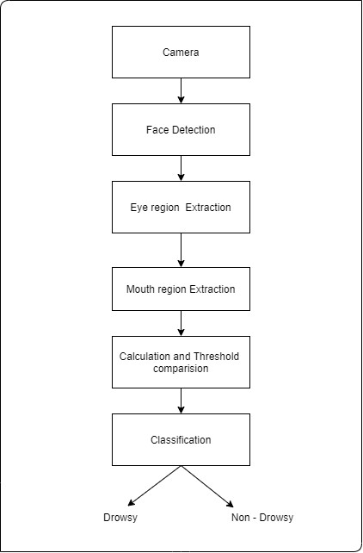
Figure 3.a: Proposed System
The different modules implemented in the application are:
3.1). Input Acquiring Module
3.2). Processing Modules
3.3). User Alert Module

The project has 3 main modules, the input acquiring module, the processing module, and
the User alert module. The processing module is divided into 3 sub modules, the module to extract frames from the live video, the Module to extract data points/landmarks from each individual frame using the DLIB library, and the module for analysing the data points along with calculation and comparison. The Input acquiring module is used to acquire the video of the user is collected from the device, which is then sent for pre-processing. The 1st processing module fetches the video as the input from the input acquiring module, and this video is converted into frames. Each of the frames is then sent to the next module. On getting the frames, the 2nd processing module, with the help of the DLIB library, the landmarks get plotted. After this, the eye and mouth landmarks are extracted. In the final processing module, the analysis and calculation of the data points are done. The eye and mouth aspect ratio is calculated and this calculation is compared with the threshold set to check if the driver is awake or not. The final module is the user alert module, where if the driver is found drowsy, a warning is triggered in audio and visual form, which will be sent to alert the driver.
The general procedure of the real-time drowsiness/sleepiness detection algorithm in our project is fairly straightforward.
Initially, the camera is set-up which takes in the video frames as the input which includes the region of interest, the face.
Once the face is found, the algorithm applies 68 landmarks on the facial region and the eye and mouth landmarks are extracted. For the detection of facial landmarks, the Dlib library is used.
With the mouth and eyes landmarks found, the eyes and mouth aspect ratio is calculated to check if the eyes and mouth are opened or closed.
If the ratio calculation specifies as the eyes of the driver have been closed for specified time interval or if the driver is yawning for a long duration, an alarm is triggered to alert the driver.
If the eyes of the driver are closed for a long period of time, the ratio calculated will endure as it is. When the eyes are open, the ratio increases and vice-versa.

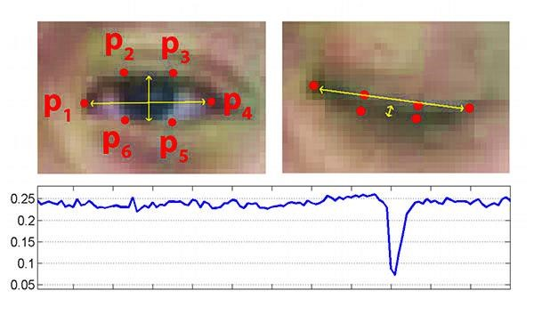
Figure 3.b: Eye landmarks and Eye Aspect Ratio Graph

The first image of Fig 3.3 shows an image of eye that is fully open with facial landmarks plotted on it. The second image of Fig 3.2 shows an image of eye that is closed. The third image of Fig 3.3 which is present in the bottom represents the graph of EAR when the eye is open and closed, we can observe that EAR is constant at the beginning (showing that the eye is open), then suddenly drops below threshold and comes up again showing that the user has blinked. In our project, we will continuously monitor value of EAR, if the EAR value drops below a certain threshold and does not rise back within 2 seconds then we classify the user to be drowsy and trigger an alert.
Out of the 68 landmarks mapped on the entire face, 6 landmarks are mapped for each eye. The left eye has landmarks 43-48, and the right eye has landmarks 37-42 assigned to them. The mouth has 20 landmarks mapped to it, which are landmarks 49-68.
The threshold of ratio for the closed eye is around 0.145, and for better results, the threshold of ratio in this methodology is set to 0.2. The formula for calculating the Eye Aspect Ratio (EAR) is,

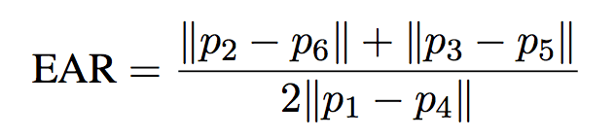

Where, x represents the length between the lower and the upper eyelids, that is, average distance for points (p₂,p₆) and (p₃,p₅), and y is the horizontal distance between points p₁ and p_{4.} This can be seen in figure 3.3.
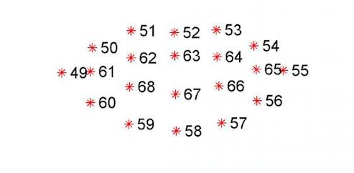
Figure 3.c: Landmarks plotted on mouth

For the mouth, landmarks 63 and 67 are taken into consideration. The distance between points 63 and 67 is calculated using the formula,
𝐷𝑖𝑠𝑡𝑎𝑛𝑐𝑒 = 𝑦2 − 𝑦1
Where y2 is landmark 63 from the upper lip, and y1 is landmark 67 from the lower lip.
When the Eye Aspect Ratio (EAR) crosses a set threshold for more than 10 frames, the user is considered to be ‘Sleeping’. If the distance between the lower lip and upper lip increases greater than 20 units, for more than 20 frames, the user is then considered to be ‘Drowsy’. The reaction time for the system is about 0.33 seconds.
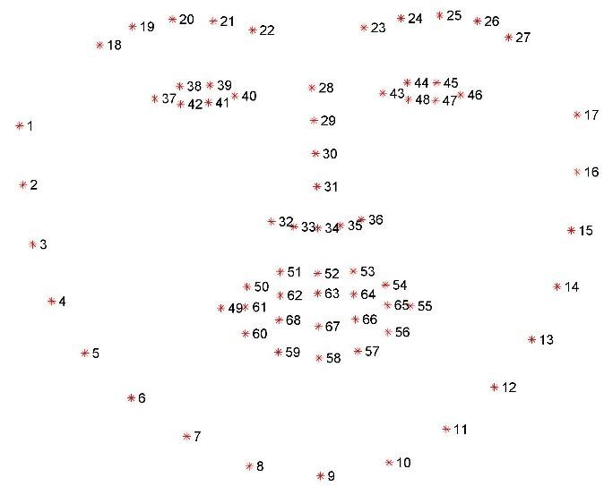
Figure 3.d: The 68 Landmarks plotted on the entire face

- RESULTS:

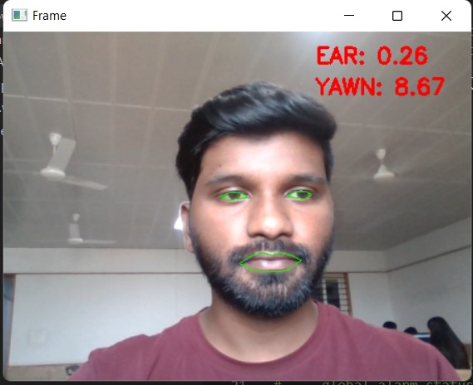

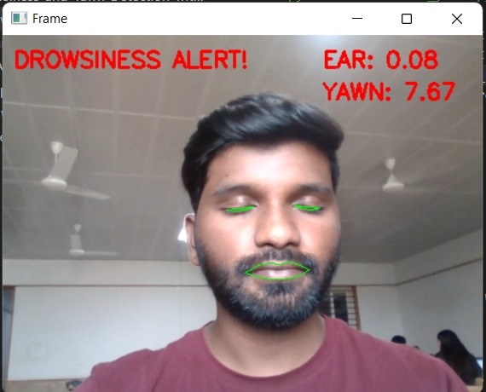

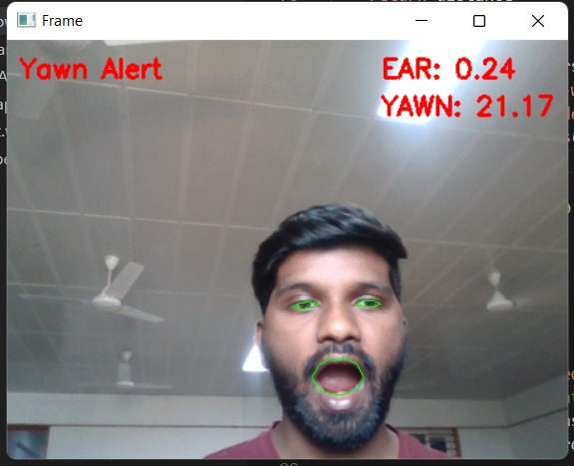

- CONCLUSION

World Health Organization (WHO) claims that death occurring as a result of road accidents fall under the top 10 categories of causes of death. Driver sleepiness/ drowsiness detection plays an important role in safe and cautious driving. Driver sleepiness/ drowsiness detection is a cutting-edge technology that helps in preventing road accidents, which occur when the driver feels sleepy or drowsy. Reports and studies have found that 20 percent of the overall road accidents are due to drivers being fatigued or drowsy. We have proposed a system that will be able to alert drivers when he dowses off, which in turn will avoid accidents. The system detects the motorist's face, and depending on the motorist’s facial state, the motorist is classified as drowsy or non-drowsy. If the driver or motorist is found drowsy, an alert is triggered in audio and visual form.

REFERENCES

[1]. A. M. Al-madani, A. T. Gaikwad, V. Mahale, Z. A. T. Ahmed and A. A. A. Shareef, "Real-time Driver Drowsiness Detection based on Eye Movement and Yawning using Facial Landmark," 2021 International Conference on Computer Communication and Informatics (ICCCI), 2021, doi:10.1109/ICCCI50826.2021.9457005.
[2]. K. S. Sankaran, N. Vasudevan and V. Nagarajan, "Driver Drowsiness Detection using Percentage Eye Closure Method," 2020 International Conference on Communication and Signal Processing (ICCSP), 2020, pp. 1422-1425, doi: 10.1109/ICCSP48568.2020.9182059.
[3]. J. Baikerikar, V. Kavathekar, R. John, L. Peeyus, P. Dharmadhikari and N. Ghavate, "Drowsiness Detection for Drivers," 2021 International Conference on Advances in Computing, Communication, and Control (ICAC3), 2021, pp. 1-5, doi: 10.1109/ICAC353642.2021.9697257
.[4]. H. Oishi, H. Kawanaka and K. Oguri, "Effectiveness of Data Screening for Driver Drowsiness Estimation Using Drive Recorder," 2021 IEEE 10th Global Conference on Consumer Electronics (GCCE), 2021, pp. 766-769, doi: 10.1109/GCCE53005.2021.9622071.
[5]. H. Garg, "Drowsiness Detection of a Driver using Conventional Computer Vision Application," 2020 International Conference on Power Electronics & IoT Applications in Renewable Energy and its Control (PARC), 2020, pp. 50-53, doi: 10.1109/PARC49193.2020.236556.
[6]. I. Girish, A. Kumar, A. Kumar and A. M, "Driver Fatigue Detection," 2020 IEEE 17th India Council International Conference (INDICON), 2020, pp. 1-6, doi: 10.1109/INDICON49873.2020.9342456.
[7]. L. D. S. Cueva and J. Cordero, "Advanced Driver Assistance System for the drowsiness detection using facial landmarks," 2020 15th Iberian Conference on Information Systems and Technologies (CISTI), 2020, pp. 1-4, doi: 10.23919/CISTI49556.2020.9140893.
[8]. M. Hedi Baccour, F. Driewer, T. Schäck and E. Kasneci, "Camera-based Driver Drowsiness State Classification Using Logistic Regression Models," 2020 IEEE International Conference on Systems, Man, and Cybernetics (SMC), 2020, pp. 1-8, doi: 10.1109/SMC42975.2020.9282918.

