SplitSync – Smart Bill Splitter & Expense Management System

A Project Report

Submitted in partial fulfillment of the
Requirements for the award of the Degree of

BACHELOR OF SCIENCE
(INFORMATION TECHNOLOGY)

By
Pol Sayali Vijay
259718

Under the guidance of
Mr. Siddhesh Gotekar
Assistant Professor



SCHOOL OF COMPUTING & TECHNOLOGY PARLE TILAK VIDYALAYA ASSOCIATION’S MULUND COLLEGE OF COMMERCE (AUTONOMOUS)
(Affiliated to University of Mumbai)
MULUND – 400 080 MAHARASHTRA 2025-26

COLLEGE CERTIFICATE (Will be provided by the College)

ACKNOWLEDGEMENT

I like to extend my gratitude to the Principal, Dr. Shivaji Pawar and all staff of Mulund College of Commerce (Autonomous) for providing us moral support, the required infrastructure and resource to enable the completion and enrichment of my project.

I also take this opportunity to thank the School of Computing & Technology Coordinator, Dr. Reena Nagda, Program Coordinator, Dr. Jyotika Chheda and all the faculty of School of Computing & Technology for giving us the most needed guidance and continuous encouragement throughout the duration of the Program.

I wish to extend my deepest gratitude and special thanks to my project guide Mr. Siddhesh Gotekar, for the guidance and the inspiration to complete this project on time. I perceive the skills and knowledge which I have gained throughout my project work as a very valuable component in my future career development.

I am also extremely grateful to the University of Mumbai for having prescribed this project work to me as a part of the academic requirement.

Finally, I thank all my friends and family members who have directly or indirectly helped me in completing my project.

Project Declaration

1. | Student Name | Pol Sayali Vijay
2. | Roll No | 259718
3. | Class | TYBSc. Information Technology
4. | Department | Information Technology
5. | APAAR ID | 920273992389
I hereby declare that the project entitled, “SplitSync – Smart Bill Splitter & Expense Management System”, is my own work, based on my personal study and/or research and that I have acknowledged all material and sources used in its preparation, whether they be books, articles, reports, lecture notes, and any other kind of document, electronic or personal communication.

I certify that I have not copied, in part or whole, nor otherwise plagiarised the work of any other person.

The project is done in partial fulfilment of the requirements for the award of degree of BACHELOR OF SCIENCE (INFORMATION TECHNOLOGY) to be submitted as Semester VI project as part of our curriculum.

Student’s Signature

ABSTRACT

Shared expenses arise naturally in daily life, especially when people live, work, travel, or collaborate together. However, traditional methods of managing these expenses—such as writing in notebooks, using mobile notes, or relying on group chats—are often unorganized, time-consuming, and prone to errors. These challenges lead to confusion, unfair distribution of costs, delayed settlements, and unnecessary tension among group members. To address these issues, this project introduces SplitSync, a web-based smart expense management system designed to simplify and automate group expense handling.
SplitSync provides a centralized digital platform where users can create groups, add members, record expenses, categorize transactions, and automatically split amounts equally or based on customized shares. The system ensures accuracy and fairness by calculating individual contributions using standardized formulas, reducing the possibility of miscalculations. It also eliminates the discomfort of reminding others about pending payments through automated notifications and transparent balance visibility.
Technically, the system is developed using React.js for an interactive and responsive frontend, Node.js and Express.js for backend API handling, and MySQL for secure and scalable data storage. Features such as user authentication, structured record-keeping, real-time updates, and detailed financial summaries make the application reliable and user-friendly. SplitSync maintains long-term expense history, allowing individuals to track contributions over extended periods, such as monthly household budgets, student projects, office events, or travel plans.
This project not only solves a widespread real-world problem but also showcases the effective integration of modern web technologies. By improving accuracy, transparency, and communication in shared financial activities, SplitSync offers a practical and socially relevant solution that enhances convenience and trust among users. The system demonstrates how digital tools can simplify everyday financial coordination and promote fair expense sharing in various group settings.

Contents
CHAPTER 1 – INTRODUCTION 1
1.1 Background 1
1.2 Objectives 4
1.3 Purpose, Scope, and Applicability 5
1.3.1 Purpose 5
1.3.2 Scope 6
1.3.3 Applicability 7
1.4 Organization of the Report 9
CHAPTER 2: SURVEY OF TECHNOLOGIES 12
CHAPTER 3: REQUIREMENTS AND ANALYSIS 29
3.1 Problem Definition 29
3.2 Requirements Specification 31
3.2.1 Functional Requirements 31
3.2.2 Non-Functional Requirements 32
3.3 Planning and Scheduling 33
3.3.1 planning 33
3.3.2 Scheduling 34
3.4 Software and Hardware Requirements 36
3.4.1 Software Requirements 36
3.4.2 Hardware Requirements 38
3.5 Preliminary Product Description 38
CHAPTER 4: SYSTEM DESIGN 41
4.1 UML Diagrams 41
4.1.1 Use Case Diagram 41
4.1.2 Sequence Diagram 42
4.1.3 Activity Diagram 43
4.1.4 Class Diagram 44
4.1.5 State Machine Diagram 46
4.1.6 Component Diagram 46
4.2 MODULE DESIGN 47
4.2.1 USER REGISTRATION MODULE 48
4.2.2 USER AUTHENTICATION MODULE 49
4.2.3 DASHBOARD MODULE 49
4.2.4 GROUP CREATION AND MANAGEMENT MODULE 50
4.2.5 MEMBER MANAGEMENT MODULE 50
4.2.6 EXPENSE MANAGEMENT MODULE 51
4.2.7 EXPENSE SPLITTING MODULE 51
4.2.8 BALANCE CALCULATION MODULE 51
4.2.9 EXPENSE HISTORY MODULE 51
4.3 Database Design 52
4.3.1 Overview of Database Design 55
4.3.2 Role of Database in SplitSync 56
4.3.3 Database Environment and Platform 56
4.3.4 Database Architecture 56
4.3.5 Entity Identification 56
4.3.6 Attribute Description 57
4.3.7 Table Design Explanation 57
4.3.8 Data Flow between Application and Database 57
4.3.9 Normalization and Redundancy Control 57
4.3.10 Data Validation and Integrity Constraints 57
4.3.11 Security and Access Control 58
4.3.12 Advantages of Using a Database 58
CHAPTER 5: IMPLEMENTATION AND TESTING 59
5.1 Overview of the Implementation 59
5.2 Development Tools and Technology Stack 60
5.2.1 Frontend Technologies 60
5.2.2 Backend Technologies 61
5.2.3 Database Technology 62
5.2.4 Development and Testing Tools 62
5.3 System Architecture 62
5.3.1 Presentation Layer (Frontend) 63
5.3.2 Application Layer (Backend) 63
5.3.3 Data Layer (Database) 64
5.3.4 Data Flow Architecture 64
5.3.5 Advantages of the Architecture 65
5.4 Module-wise Implementation 65
5.4.1 User Interface Design 65
5.4.2 Functional Modules 66
5.4.3 Database Integration 68
5.4.4 Input / Output Handling 72
5.5 Challenges Faced and Solutions Implemented 83
5.6 Testing Strategy and Methodology 85
5.6.1 Unit Testing 85
5.6.2 Integration Testing 85
5.6.3 System Testing 86
5.6.4 Test Cases with Expected and Actual Results 86
5.6.5 Bug Tracking and Fixes 88
5.6.7 Tools Used for Testing 88
CHAPTER 6: RESULTS 90
6.1 Test Reports 90
6.2 User Documentation 93
CHAPTER 7: CONCLUSION 95
7.1 Significance of the System 95
7.2 Limitations of the System 96
7.3 Future Scope of the Project 96
CHAPTER 8 : REFERENCES / BIBLIOGRAPHY 98
CHAPTER 9 – ANNEXURE 100
9.1 List of Tables 100
9.2 List of Figures 100
9.3 List of Screenshots 100

CHAPTER 1 – INTRODUCTION

1.1 Background
Managing shared expenses has always been an integral part of daily life. In situations where people work, live, travel, or collaborate together, financial responsibilities naturally arise. These situations include college students organizing group projects, friends going on trips, families sharing household expenses, and colleagues arranging team events. While splitting expenses might appear simple at first glance, real-life scenarios reveal its hidden complexity. Every individual contributes at different times and for different purposes, making it difficult to remember who paid what and how much each person owes. For instance, in a week-long trip among friends, one person may pay for hotel bookings, another for groceries, another for transportation, and yet another for entertainment tickets. Keeping track of these contributions manually can be exhausting and prone to errors. When multiple transactions occur over days or weeks, the situation becomes even more complicated. Without a systematic method, confusion and disagreements often arise.
People usually attempt to track expenses manually using paper, mobile notes, or group chat discussions. These methods are unorganized, inconsistent, and prone to mistakes. For example, in group chats, messages can get buried or missed, and individuals may have different recollections of amounts paid. When it is time to settle the expenses, disputes often occur because everyone recalls the details differently. This leads to delays, misunderstandings, and even strain in relationships.
In academic environments, such as colleges and universities, expense management becomes even more frequent and complex. Students living in hostels, paying shared utility bills, contributing to project materials, organizing events, or participating in trips often face confusion while settling expenses. During group projects, one student may buy stationery, another may cover printing costs, and a third may pay for refreshments. As the number of transactions increases, it becomes difficult to determine each person’s fair share. Even when all members intend to be fair, this lack of clarity can create tension. Similar challenges occur in professional environments. Colleagues sharing team expenses for lunches, office events, or travel arrangements often face similar difficulties. Families managing monthly household budgets may also encounter problems when multiple members contribute to different bills without proper records. These repeated challenges demonstrate that manual methods are inadequate for managing shared expenses efficiently.
To address these real-world difficulties, SplitSync has been developed as a smart, webbased solution for managing shared expenses. SplitSync is designed to automate the process of expense tracking, splitting, and settlement, reducing confusion and errors. It leverages modern web technologies such as React.js for frontend, Node.js with Express for backend, and MySQL for the database to provide a complete, accurate, and userfriendly solution. By digitizing the process, SplitSync ensures fairness, accuracy, transparency, and permanent record-keeping. Although digital payment apps like PayPal, Google Pay, and PhonePe make money transfers easy, they do not solve the problem of splitting complex group expenses or maintaining long-term financial records. For example, if a student group goes on a trip and makes multiple payments for accommodation, food, and transportation, even using these apps, individuals must calculate shares manually. Digital payments allow transactions but do not provide clarity on overall contributions, balances, or settlements. This limitation highlights the need for a system like SplitSync, specifically designed for shared expense management.
The idea for SplitSync emerged from observing repeated issues in daily life. Students, families, friends, and office teams often face the same difficulties. There was a clear need for a system that is automated, transparent, and easy to use, capable of handling expense sharing efficiently. SplitSync offers a centralized platform where users can record expenses in realtime, categorize them by type, automatically split amounts based on participation, view realtime summaries of balances and payments, and send automated reminders for pending settlements. These features ensure everyone involved has access to the same information, reducing confusion and promoting fairness. SplitSync also reduces the emotional discomfort associated with requesting pending payments.
Many people hesitate to ask friends or colleagues for money, which often leads to delays in settlements. By introducing automated reminders and clear balance visibility, SplitSync allows users to communicate systematically and neutrally. Users can see their outstanding balances without personal confrontation, preserving relationships and reducing stress. Moreover, SplitSync promotes trust and transparency. Every user has access to the same financial information, preventing misunderstandings or accusations of unfairness. This is especially important in collaborative environments like student groups, office teams, and families, where cooperation and trust are crucial.
SplitSync represents an opportunity to apply modern web technologies. The frontend, developed using React.js, provides a responsive and interactive user interface, allowing users to easily add expenses, view balances, and track payments. Dynamic dashboards show realtime summaries and graphical reports. The backend, built with Node.js and Express, handles requests between the frontend and the database, manages user authentication, expense calculations, and notifications, and
scalability for multiple users and groups. MySQL is used as the database to store expense records, user information, and transaction histories, ensuring data integrity, security, and easy retrieval for reports. The system also includes automated calculations and reminders to save users from manual effort. Security and privacy are maintained by storing sensitive financial data securely, and only authorized users can access group expenses.
The societal impact of such a platform is notable. As digital finance becomes ubiquitous, people increasingly expect tools that simplify routine tasks while maintaining accuracy and fairness. SplitSync contributes to this trend by addressing the practical and emotional challenges of shared expenses. It empowers individuals to participate confidently in group activities, knowing that financial responsibilities are clear, fairly allocated, and efficiently managed. Additionally, it reduces conflicts and misunderstandings that can arise from informal or ad hoc tracking methods, ultimately saving time and strengthening relationships.
SplitSync is not only a practical tool but also an academically valuable project. Students working on this system gain hands-on experience with full-stack development, RESTful API creation, database management, responsive design, and user interface development. This project bridges the gap between theoretical knowledge and practical implementation, giving students experience in solving real-world problems using modern technologies. SplitSync has multiple benefits. It reduces manual effort in calculating and tracking shared expenses, promotes fairness, transparency, and accountability, enhances social comfort by automating reminders and notifications, and supports long-term record-keeping for future references. Future enhancements could include mobile application integration, payment gateway integration for direct settlements, advanced analytics for spending patterns and budgeting suggestions, multicurrency support for international collaborations, and AI-powered insights to suggest fair splits or detect unusual expenses.
SplitSync is designed to accommodate the wide range of group dynamics that emerge when individuals share expenses. In real-life scenarios, financial responsibilities are rarely uniform. Group members often contribute differently based on participation levels, varying durations of involvement, resource consumption, or personal financial capacities. For instance, during a multi-day vacation, one member may arrive late, another may leave early, and others may participate in only selected activities. In such cases, applying equal expense sharing would be inaccurate and unfair. SplitSync addresses this challenge through its flexible expense-splitting engine, which supports a variety of allocation models including equal division, percentage-based contributions, weighted shares, and fully customized distributions. This flexibility ensures that every scenario—from daily household spending to complex international trips—is handled with precision and fairness.

Beyond splitting expenses, SplitSync introduces a structured and intuitive workflow for managing group finances. Users can record transactions in real time, attach notes or images of receipts, and assign them to specific categories such as food, accommodation, utilities, transportation, entertainment, or miscellaneous expenses. Categorizing expenses enhances organization and allows individuals to analyze their financial behaviors, not only at the group level but also across specific spending domains. Over time, this data creates a financial footprint that helps users recognize patterns, such as overspending during certain activities or the uneven distribution of costs among members.

To support informed decision-making, SplitSync also integrates advanced reporting and visualization tools. These include pie charts that illustrate category-wise spending distribution, bar graphs comparing individual contributions, and timeline-based charts tracking expenses over a given period. Such visual insights can reveal trends—like which categories dominate the budget or which participants consistently contribute more—ensuring transparency and accountability. These tools are particularly helpful for groups that frequently collaborate on events or trips, as the data enables better planning and budgeting for future activities.

Another significant feature of SplitSync is the automation of recurring and predictable expenses. Many groups, especially households or roommates, share monthly costs such as rent, internet bills, streaming subscriptions, or maintenance fees. SplitSync’s recurring expense module allows users to schedule these transactions so they are automatically added and allocated at predefined intervals. This reduces the burden of manual entry, minimizes the risk of omitted expenses, and promotes consistent financial tracking.

The technical foundation of SplitSync is built to support scalability, accuracy, and user convenience. The system can integrate synchronization features, enabling multiple users to collaboratively update expenses in real time. Smart conflict resolution mechanisms ensure that simultaneous edits do not result in data inconsistencies. Additionally, the platform can be extended with cloud storage, enabling secure backup, multi-device access, and long-term retention of financial records. The ability to integrate with external APIs—such as currency converters, payment gateways, or travel data systems—further expands SplitSync’s potential applications, making it adaptable to both local and international contexts.

From a social perspective, SplitSync addresses a long-standing issue: the discomfort and misunderstandings that often arise in shared financial arrangements. Manual calculations, verbal agreements, and informal record-keeping frequently lead to confusion, forgotten debts, or perceived unfairness. The platform reduces these conflicts by offering transparent, objective, and easily verifiable records of every expense and contribution. This transparency fosters trust among group members, strengthens collaborative relationships, and removes the emotional stress associated with settling shared expenses.

In conclusion, the background of SplitSync is rooted in practical human challenges, the necessity for fairness in shared financial responsibilities, and the growing expectation for digital tools that streamline complex tasks. By combining robust functionality, userfriendly design, and advanced technical capabilities, SplitSync emerges as a comprehensive solution to the everyday problem of managing shared expenses. Its adaptability to diverse situations—ranging from small daily purchases to large-scale collaborative events—along with its emphasis on accuracy, transparency, and ease of use, positions it as an essential tool for modern, digitally connected users. Ultimately, SplitSync not only simplifies financial coordination but also enhances social harmony by ensuring that every individual’s contributions are recognized, validated, and fairly accounted for.

1.2 Objectives
- To build a web-based application capable of managing group expenses efficiently.
- To automate expense splitting calculations and reduce human errors.
- To provide users with accurate “who owes whom” summaries.
- To simplify creation and management of groups with multiple participants.
- To maintain clear financial records and enable transparency.
- To provide secure authentication for users and protect financial data.
- To generate user-friendly dashboards showing insights and statistics.

1.3 Purpose, Scope, and Applicability

1.3.1 Purpose
The primary purpose of this project is to create a dependable, structured, and intelligent system that simplifies the process of managing and sharing expenses among groups of people. Shared financial responsibilities occur frequently in day-to-day life, whether among family members, roommates, friends, or colleagues. Despite this, due to the absence of a dedicated platform, most people continue using traditional methods like remembering expenses, writing them in notebooks, maintaining spreadsheets, or discussing them casually in group chats. These approaches are not only inefficient but also prone to mistakes and miscalculations, especially when the number of transactions increases over time. Errors in manual calculations, forgotten contributions, or miscommunication about who paid for what can create confusion and disagreements within the group. The purpose of SplitSync is to replace these outdated practices with a modern, digital system that ensures accuracy, consistency, and clarity. By centralizing all financial interactions in one platform, SplitSync makes the process of recording, splitting, and settling expenses organized and systematic, eliminating the common errors associated with manual tracking.
Furthermore, the purpose of the project extends to promoting fairness in financial interactions. In many real-life scenarios, people unintentionally end up paying more or less than their fair share due to human error in manual calculations. For example, during a group trip, one person may cover transportation costs while another pays for food or accommodation. Without precise tracking, it is difficult to ensure that each individual contributes proportionally. SplitSync aims to remove this inequality by automatically calculating each person’s share using standardized formulas and clearly presenting how the calculations were made. By providing detailed explanations and summaries, the system ensures that all members understand their financial responsibilities, fostering transparency, trust, and a sense of fairness. This approach reduces misunderstandings, strengthens relationships, and promotes an equitable environment in shared financial arrangements.
Another important purpose of this system is to reduce hesitation and discomfort in requesting money from others. Many individuals feel uneasy, embarrassed, or anxious when reminding friends, roommates, or colleagues about pending payments. This emotional barrier often results in delayed settlements, financial tension, and strain on personal or professional relationships. SplitSync is designed to address this challenge by managing communication on behalf of the users. Automated reminders, notifications, and clear balance statements remove the need for direct confrontation, making financial interactions neutral, respectful, and efficient. Users can focus on their activities and shared experiences without worrying about uncomfortable money discussions, which greatly enhances group harmony and ensures timely settlement of expenses.
The system also serves the purpose of maintaining long-term financial records. Many situations—such as monthly household bills, hostel living expenses, extended trips, or recurring group projects—require continuous and accurate tracking over weeks, months, or even years. Manual methods are prone to data loss, misplacement, or incomplete entries, which makes it difficult to refer back to previous contributions or settle disputes about past expenses. SplitSync ensures that all records are stored systematically, providing a reliable history of transactions that can be accessed at any time. This long-term record maintenance allows users to monitor trends, review past spending, track contributions over time, and even analyze financial habits within the group. The purpose is not only to manage expenses in real time but also to offer a dependable source of historical financial data, ensuring accountability, organization, and peace of mind for all participants.
Overall, the purpose of SplitSync is multifaceted: to create a precise and structured method for handling shared expenses, to promote fairness and transparency among group members, to reduce emotional discomfort in financial interactions, and to maintain comprehensive records for present and future reference. By addressing these needs, SplitSync provides a practical and socially relevant solution that transforms the way people manage collective finances, making expense sharing accurate, stress-free, and highly organized.

1.3.2 Scope
The scope of the SplitSync project encompasses the development of a fully functional, webbased application designed to manage shared expenses efficiently for a wide variety of groups. This includes small groups of friends, student project teams, families, office colleagues, travel groups, and other collaborative communities. The system will enable users to register and log in securely, ensuring that every individual’s data remains protected. Once logged in, users will have the capability to create groups for specific events, activities, or purposes, and add members to each group based on their participation. For example, a group could be created for a weekend trip, a hostel shared living arrangement, or a college project, with members added according to their involvement. Once the group is established, users can add detailed expenses, specifying information such as the amount spent, the payer, the purpose of the expense, the relevant category, and the date of the transaction. The system will automatically calculate each member’s share and provide both equal splitting and customizable splitting options, allowing flexibility for situations where participants contribute unequally or share costs based on usage or participation.
The scope of SplitSync further includes the structured storage, management, and retrieval of all related data. All expenses, group details, member information, and settlements will be securely stored in a database, ensuring that records are accurate, consistent, and retrievable at any time. Users will be able to access historical data to review past transactions, filter expenses by category, date, or member, and generate summaries for individual or group expenses. This capability ensures that older records remain accessible even as new data is added, supporting long-term scalability and maintaining a complete financial history. For instance, a student group could easily review expenses from previous semesters, or a family could track utility and grocery contributions over multiple months.
Another important aspect within the scope of SplitSync is the development of an interactive and user-friendly dashboard. This dashboard will provide essential financial information at a glance, including total group expenses, individual contributions, remaining balances, and settlement status. By displaying these details visually and clearly, the system eliminates the need for manual calculations, making it easy for all members to understand the financial distribution within the group. Real-time updates are included in the scope as well, ensuring that any changes made by one member, such as adding a new expense or settling a debt, are immediately reflected for all other members in the group. This ensures accuracy, transparency, and up-to-date financial tracking for everyone involved.
Additionally, the project scope encompasses system security and privacy measures. Since users will be entering sensitive financial information, SplitSync will implement authentication mechanisms, secure session management, data encryption, and proper input validation to safeguard all data. Only authorized and authenticated users will have access to view or modify group expenses, ensuring privacy within each group and protecting against unauthorized access. These security measures are essential for maintaining trust and reliability in the system, particularly when used in professional environments or for groups handling substantial expenses.
The scope of SplitSync also extends to usability and accessibility features, ensuring that the platform can be used easily by individuals with varying levels of technical expertise. The system will be designed to be intuitive, with simple navigation, clear forms, and step-by-step guidance for adding groups, expenses, and members. Users will be able to generate reports, view summaries, and receive notifications without requiring specialized technical knowledge. This wide-ranging scope ensures that SplitSync is not only functional and secure but also practical and user-friendly for a broad audience.
In summary, the scope of the SplitSync project includes secure user registration and login, creation and management of groups, addition and splitting of expenses with flexibility, structured storage and retrieval of records, an interactive real-time dashboard, system security measures, and usability enhancements. By addressing all these aspects, SplitSync aims to provide a comprehensive, scalable, and practical solution for managing shared expenses across a wide variety of real-life scenarios, making financial coordination accurate, transparent, and stress-free for all users.

1.3.3 Applicability
SplitSync is applicable in a wide variety of real-world scenarios. Students living in hostels can use it to manage room rent, groceries, electricity bills, and shared meals. College project teams can use it to track expenses for materials, printing, research, and presentations. Families can utilize the system to divide household expenses such as groceries, utilities, and maintenance. Friends who travel together can use it to manage trip spending, including food, transport, stays, and activities. Office teams can apply it for event planning, buying shared resources, or team outings.
The system is useful in any situation where multiple individuals contribute to shared costs and need a clear, organized, and transparent method for settling expenses. Since the system is webbased, it can be accessed from any device, making it suitable for dayto-day use. Its flexibility makes it applicable for short-term events like trips as well as long-term scenarios like monthly household budgeting.
SplitSync can be used in various real-world situations:

1. Student Use Cases
- Splitting college project expenses
- Managing study tour budgets
- Sharing cafe bills among friends

2. Family Usage
- Dividing grocery expenses
- Tracking festival and event costs
- Managing household budgets

3. Travel Groups
- Splitting trip expenses
- Tracking hotel, food, fuel costs

4. Corporate Teams
- Splitting team lunch bills
- Funding office events
- Organizing team outings

5. Roommates
- Splitting monthly rent
- Managing electricity/water bills
- Sharing Wi-Fi and maintenance charges
SplitSync is highly applicable across sectors because group expenses are universal.

1.4 Organization of the Report

1. CHAPTER 1: INTRODUCTION

This chapter provides an overall introduction to the project and explains the background of shared expense management in today’s digital world. It presents the real-life problems people face when handling group expenses manually and highlights the need for an automated solution. The chapter introduces SplitSync as a modern web-based system designed to solve these practical challenges by providing fairness, transparency, and accuracy. It discusses the problem statement, objectives, the purpose of developing the system, the scope of the platform, and its applicability in different environments such as student groups, families, offices, and travel groups. The introduction also explains how digital tools have influenced financial interactions and why shared expense management deserves a dedicated solution. This chapter further outlines the motivation behind choosing this topic and the benefits it offers socially, academically, and technologically. By the end of the chapter, readers gain a clear understanding of the project’s foundation and why SplitSync is an important and relevant solution.

2. CHAPTER 2: SURVEY OF TECHNOLOGIES

This chapter presents a detailed survey of the technologies used in developing SplitSync along with a review of existing research papers, systems, and tools related to shared expense management. It highlights technologies such as React.js, Node.js, Express.js, and MySQL, explaining why each was selected and how they contribute to system functionality. The chapter also discusses cloud deployment, API handling, UI frameworks, authentication methods, and database structures based on the reviewed literature. It compares traditional expense management techniques with modern digital systems and identifies gaps that SplitSync aims to fill. The survey provides insights into previous studies on automation, financial sharing, group collaboration tools, and digital record-keeping. Each surveyed paper or technology helps establish the relevance, feasibility, and uniqueness of the proposed solution. By analyzing existing systems, the chapter clearly shows how SplitSync improves upon earlier methods and offers a more user-friendly, scalable, and efficient model.

3. CHAPTER 3: REQUIREMENTS AND ANALYSIS

This chapter focuses on gathering, analyzing, and defining the functional and nonfunctional requirements of the SplitSync system. It includes user requirements, system behavior, process flows, and expectations from the platform. Functional requirements describe features such as user authentication, group creation, adding expenses, splitting logic, dashboards, notifications, and record retrieval. Non-functional requirements cover performance, reliability, scalability, usability, and security. The chapter also includes detailed system analysis using techniques like use case diagrams, data flow diagrams, process descriptions, and identification of actors. It explains how users interact with the system and how the application processes data to produce accurate results. Constraints, assumptions, risks, and dependency analysis are also discussed. This chapter provides a strong foundation for system design by ensuring that all user needs and technical requirements are clearly understood and documented.

4. CHAPTER 4: SYSTEM DESIGN

This chapter describes the complete architecture and design of the SplitSync system in detail. It includes high-level and low-level system designs to illustrate how different components interact. The chapter presents system architecture diagrams, ER diagrams, class diagrams, sequence diagrams, and flowcharts. It also explains database schema design, table structures, relationships, and data storage mechanisms. The design chapter outlines frontend design structures, backend API routes, user interface layouts, and navigation flows. It highlights how the application ensures data accuracy, security, and scalability through well-structured design patterns. This chapter also explains how the system supports modular development, making it easier to maintain and extend. Additionally, technical choices such as REST API architecture, state management, and UI responsiveness are explained. By the end of this chapter, readers gain a complete understanding of how SplitSync is structured internally.

5. CHAPTER 5: IMPLEMENTATION AND TESTING

This chapter covers the actual coding, development process, and testing of the SplitSync system. It explains how the frontend was implemented using React.js and how the backend APIs were developed using Node.js and Express. The chapter details the steps involved in creating modules such as user login, group management, expense addition, splitting logic, dashboards, and notifications. Code snippets, screenshots, and explanations illustrate how various features were implemented. The testing section includes unit testing, integration testing, system testing, and user acceptance testing. Different test cases, input/output validations, error handling, and bug fixes are documented. The chapter also explains performance testing, database testing, and security testing. Deployment steps, environment setup, and tool configurations are included. This chapter demonstrates how the theoretical design was transformed into a working system and verifies that it performs correctly in all scenarios.

6. CHAPTER 6: RESULTS

This chapter presents the outputs generated by the system after implementation. It includes screenshots of user registration, group creation, expense entries, automatic sharing results, dashboards, and settlement summaries. Each screenshot is explained clearly to show how the system behaves in real-world scenarios. The chapter demonstrates how SplitSync improves accuracy, transparency, and convenience compared to manual expense management. It highlights the real-time updates, ease of use, and quality of results produced by the system. Comparisons between expected and actual results are discussed to showcase the reliability of the developed features. The chapter also emphasizes user feedback, system performance results, and overall system efficiency. The results illustrate that the project has successfully met its objectives and provides a functional solution to the problem of shared expense management.

7. CHAPTER 7: CONCLUSION

This chapter provides the final summary of the entire project and highlights key learnings, achievements, and outcomes. It explains how SplitSync successfully addresses real-life challenges in managing shared expenses by offering a modern, digital, and automated solution. The conclusion discusses the impact of the system in terms of fairness, transparency, ease of use, and long-term record maintenance. It also reflects on the technical knowledge gained during the project, including full-stack development, database management, authentication, and system integration. Challenges faced during development and how they were resolved are also mentioned. Additionally, the chapter suggests future scope, such as adding mobile app support, payment gateway integration, AI-based recommendations, and advanced analytics. The conclusion reinforces that SplitSync is not just a technical achievement but a practical tool that provides real value to users.

CHAPTER 2: SURVEY OF TECHNOLOGIES
(Bushra Shaikh et al., 2025) The rapid expansion of mobile technologies and digital financial tools has transformed how individuals manage shared expenses, especially in group scenarios where transparency, accuracy, and coordination are critical. The paper “A Study on the Advancement of Bill Splitting and Expense Management Applications” by Shaikh et al. (2025) explores the evolution of digital expense-sharing systems, highlighting the functional gaps in existing mobile applications and the potential enhancements that could strengthen user experience and financial reliability. Much like the debates surrounding early programming education mentioned in your friend’s sample, the domain of bill-splitting technologies also reflects contrasting opinions—some celebrating its convenience while others criticize usability challenges, security risks, and data inconsistencies. This literature review synthesizes the core arguments, evaluates existing initiatives, and identifies the essential criteria required for effective bill-splitting solutions.
The paper begins by acknowledging the limitations of traditional expense management approaches such as manual calculations, physical ledgers, and spreadsheet-based tracking. These legacy systems are prone to human error and lack real-time synchronization, making them unsuitable for dynamic group environments like travel planning, dining, or shared accommodations. Digital solutions attempt to bridge these gaps by offering automated calculations, push notifications, and central repositories for financial records. However, despite the ubiquity of mobile applications, the authors argue that many existing tools suffer from inadequate design, lack stability, or fail to address core issues such as data consistency and privacy. This parallels criticisms in the programming-education debate, where technological access alone does not guarantee meaningful outcomes unless paired with thoughtful design and contextual understanding.
A key advancement highlighted in the paper is the integration of Optical Character Recognition (OCR) technology, particularly through Tesseract-based algorithms. OCR allows users to capture images of receipts and automatically extract expense details, reducing the burden of manual entry. Applications like Snap and Split have effectively demonstrated the convenience of OCR-driven automation. However, the paper notes that OCR accuracy varies depending on lighting, font, and receipt quality, implying that such systems still require verification and are not yet capable of fully replacing human oversight. Thus, while OCR enhances efficiency, it introduces new challenges related to error detection, data validation, and the need for fallback mechanisms. This situation mirrors the “ILEs for coding education” in your friend’s sample, where innovation alone does not eliminate conceptual or procedural challenges.
The paper also reviews the design and implementation strategies of several Android-based expense applications, comparing their interfaces, splitting mechanisms, and backend technologies. Many tools offer customizable splitting logic—equal division, percentage-sharing, and itemized cost allocation—which supports diverse user needs. Systems that incorporate real-time updates, in-app communication, and secure payment integration are viewed as superior in terms of user engagement. Yet, even advanced applications face obstacles such as application crashes, synchronization delays, and inconsistent data across devices. These issues highlight the importance of robust backend engineering, including data redundancy, conflict resolution, and crash resilience.User privacy and data security emerge as central concerns throughout the paper. Expense apps typically handle sensitive financial information, store user identities, and maintain records of transactions that could reveal behavioral patterns. The authors emphasize that inadequate encryption, insecure APIs, or poorly designed authentication protocols expose users to significant risks. Thus, the development of bill-splitting technology must include strong security frameworks, secure database management, and reliable authentication strategies such as token-based systems or secure hashing. The need for long-term user trust parallels the need for sustained coding education pathways discussed in your friend’s example, where early exposure must be supported by safe, reliable environments to truly benefit learners.
The paper further evaluates user requirements and behavioral patterns. Many individuals seek simplicity and minimal cognitive load when managing expenses, preferring applications that reduce the effort associated with tracking and settling debts. Features such as automated reminders, integrated payment gateways, and graphical summaries improve usability by presenting complex financial information in accessible formats. Additionally, the authors highlight the importance of cross-platform compatibility, offline support, and multilingual interfaces to make these tools inclusive across different demographics and contexts.
A significant contribution of this research lies in identifying potential areas for future development. The authors suggest integrating predictive analytics to forecast spending patterns, flag unusual expenses, or suggest optimal settlement strategies. Advanced systems could utilize machine learning algorithms to categorize expenses automatically, detect anomalies, or optimize payments based on user behavior. Furthermore, integrating blockchain technology could provide transparent and immutable transaction logs, which would enhance trust in multi-party settlements. These emerging possibilities parallel the “criteria for effective ILEs” from your friend’s literature review, emphasizing scalability, engagement, and continuity.
The study concludes by outlining the essential characteristics of an effective billsplitting application: accuracy, security, stability, usability, and intelligent automation. While current tools have made meaningful improvements in simplifying group expense management, significant opportunities remain for enhancing system robustness, predictive capabilities, and multi-device consistency. By addressing these gaps, next-generation applications could evolve into comprehensive financial management platforms that combine ease of use with advanced analytics and secure infrastructure.
Overall, the paper provides a comprehensive examination of the state of digital billsplitting technologies, offering valuable insights into both their strengths and limitations. It effectively highlights the interplay between user expectations, technological capabilities, and design considerations. This literature review reflects the paper’s core argument that, although digital solutions have advanced considerably, thoughtful innovation rooted in user-centered design is essential for the future of expense management systems.

(Arshi Khan et al., 2025) The paper “Group Expense Tracking, Analysis, and Settlement using a Web-based Application” by Shaikh et al. (2025) addresses the growing need for efficient, accurate, and transparent systems to manage shared expenses in social, domestic, and professional environments. The authors argue that traditional methods such as spreadsheets, messaging platforms, or verbal arrangements are no longer sufficient in an increasingly digital and interconnected society. These methods are error-prone, lack real-time synchronization, and often lead to misunderstandings, duplicated settlements, or interpersonal conflicts. Similar to how debates around coding education revolve around the need for structured, meaningful learning environments rather than simply introducing tools, this paper emphasizes that digitizing expense-sharing must be accompanied by systematic design, user-centric features, and robust architectural decisions to truly improve financial coordination.
The authors present a web-based solution that automates and simplifies the process of recording expenses, splitting costs, and settling debts within user-defined groups. A key feature is the ability to dynamically create groups using registered email identities, reducing the friction typically associated with manually tracking participants. Once in a group, users can add expenses, assign contributors, and rely on the system’s automated ledger to adjust balances in real time. This significantly minimizes computational errors that result from manual calculations or informal accounting. Much like “Initial Learning Environments” in coding education aim to remove unnecessary complexity while encouraging meaningful engagement, this system similarly attempts to reduce cognitive load by allowing automation to handle most financial arithmetic and record-keeping.
One of the paper’s central contributions is its focus on system architecture. The application employs a microservices-based design, which ensures scalability, fault tolerance, and high availability. This is particularly important for financial applications in which data integrity and continuous access are essential. Real-time synchronization is achieved through event-driven programming and reactive technologies, enabling instantaneous updates across multiple user devices. This strong architectural foundation reflects the authors’ recognition that modern expense-management tools require more than attractive interfaces—they need solid engineering to support reliability, concurrency, and long-term sustainability.
The authors also highlight the importance of data visualization, an element increasingly valued in financial management tools. Through dynamic dashboards, pie-chart breakdowns, and intuitive balance summaries, users can quickly understand their financial obligations and group spending patterns. Visualizations transform raw numbers into meaningful insights, empowering users to track past settlements, monitor overall group activity, and maintain transparent records. This mirrors a recurring theme in technological education research: tools must be not only functional but also engaging and cognitively accessible to learners or users.
A key innovation in this system is its algorithmic debt-simplification engine. Within any group that maintains a long history of shared expenses, individual balances can become complex and intertwined. The proposed system analyzes all outstanding transactions and computes the minimal number of required settlements to eliminate all debts efficiently. This reduces the number of person-to-person transactions—an improvement frequently requested by users of existing applications like Splitwise or Settle-Up. Debt simplification is especially valuable in large groups where manual calculations become highly inefficient and error-prone.
Security receives significant attention in this study. Because the platform stores sensitive financial data, the system incorporates robust authentication, encrypted data handling, and secure user-verification protocols. Financial transparency must always be paired with data protection, especially when applications operate on cloud-based or distributed architectures. The authors stress that trust is paramount: without adequate privacy safeguards, users may hesitate to adopt such platforms regardless of convenience. The paper therefore aligns with broader principles of ethical technology adoption, where successful implementation depends on both utility and perceived safety.
Another notable component is the paper’s discussion of real-time state reconciliation, which ensures that every user’s device consistently reflects the same financial data. Consistency problems—such as outdated balances, missing expenses, or duplicate entries—are among the most common complaints in mobile expense-sharing applications. By applying event-driven architecture and reactive programming, the system ensures that all updates propagate automatically, resolving the common discrepancies that arise in less sophisticated designs.
The authors further outline the long-term benefits of adopting structured digital tools for shared financial management. These include improved financial discipline, reduced interpersonal tension, and increased accountability. Automated notifications, clear audit trails, and intuitive interfaces encourage timely settlements and prevent the buildup of unresolved debts. This parallels the way structured educational tools enhance student engagement and continuity in learning: both domains demonstrate that clear systems improve user outcomes by providing structure, feedback, and consistency.Overall, this paper contributes significantly to the literature on modern expense-tracking technologies by offering a wellengineered, user-centered solution that addresses many of the limitations found in existing tools. Through automation, data handling, visualization, and microservices architecture, the authors demonstrate how digital systems can enhance transparency, reduce conflict, and encourage responsible group financial behavior. The study highlights that, as with any technological intervention, true effectiveness arises not simply from digitization but from creating an environment that supports reliable, accurate, and meaningful interactions.

(Andres Fielbaum et al., 2022) The paper by Fielbaum et al. (2022) provides a comprehensive analytical exploration of cost-sharing in modern ridepooling systems, a topic that has gained major relevance due to the rise of shared mobility platforms. The central issue addressed in the paper is the inherent tension between two competing objectives: minimizing total system-wide costs for the transportation operator (the “system optimum”) and ensuring that individual users are satisfied with their assignments (the “user equilibrium”). This dilemma mirrors classic challenges in education, economics, and technology adoption, where system-level efficiency must coexist with individual-level acceptance and perceived fairness.
The authors argue that current ridepooling systems often fail to align these objectives because users do not internalize the externalities they impose on others. For instance, a rider traveling a long distance may make the ride less attractive for others if costs are split uniformly, while proportional cost-sharing models may disincentivize short-distance users from participating. These imbalances create instability in group formation and undermine the effectiveness of shared mobility systems. Fielbaum et al. note that classical equilibrium concepts—such as Nash Equilibrium or Strong Equilibrium—are insufficient for modeling the cooperative yet constrained nature of ridepooling scenarios.
The paper introduces a non-cooperative game-theoretic model that conceptualizes the ridepooling problem as a variation of the set-cover problem. Each user chooses their group (i.e., who to share a ride with), and groups must form consensually. The authors demonstrate that determining the existence of a Strong Equilibrium is NPcomplete, reinforcing the complexity of creating stable and optimal matches in realworld systems. Because classical solution concepts fail to capture the nuances of real user behavior—such as limited coordination abilities or partial willingness to compromise—the authors introduce three alternative notions of equilibrium that relax or adjust the constraints of strong stability.
For each equilibrium type, the authors propose corresponding cost-sharing protocols that ensure the optimal solution (from the system’s perspective) is also an equilibrium (from the user’s perspective). These protocols may intentionally overcharge certain users slightly in order to maintain stability and avoid destabilizing incentives. This reflects an important real-world insight: theoretical fairness does not always guarantee practical stability, and small trade-offs may be required to ensure the viability of shared systems.
The authors use extensive simulation data from Amsterdam to test their proposed protocols. Results suggest that these cost-sharing mechanisms successfully produce stable groupings that remain close to the system optimum. The inclusion of a central coordinator—a concept analogous to a ridepooling algorithm—significantly improves outcomes by facilitating group formation and guiding users toward efficient combinations. This aligns with broader themes seen in technology adoption research, where centralized guidance or scaffolding often improves the effectiveness of distributed user actions.
Several practical observations emerge from the study. First, anonymous cost models (where costs do not depend on which users share a ride) are inadequate for ridepooling, because different sets of users produce different travel times and distances. The paper emphasizes the need for non-anonymous cost functions, meaning that each specific combination of users affects the total cost differently. Second, the authors highlight that, in real systems, users always have the option to travel alone if group conditions are unfavorable—similar to “canonical resources” in game theory. This alters the incentive landscape and shapes which equilibria are feasible.
The paper positions ridepooling not just as a transport optimization problem but as a socio-technical system in which human behavior, computational constraints, and efficiency objectives must be balanced. By showing that cost-sharing rules deeply influence user cooperation and system performance, the authors underscore the importance of designing cost mechanisms that are both mathematically grounded and psychologically acceptable. Their findings are especially valuable for cities and mobility providers seeking to expand shared transportation as a way to reduce congestion, emissions, and inefficiencies.
Overall, the paper makes a significant contribution to the field by merging operational research, game theory, and mobility analysis to present a nuanced framework for achieving “aligned stability” in ridepooling. Much like the need for well-designed learning environments in coding education, this research shows that effective shared mobility systems require structured mechanisms, informed incentives, and careful alignment between user motivations and system goals.

(Vasundhara et al., 2025) The study “Splitwise – A Smart Bill Splitting and Expense Management System” by Vasundhara et al. (2025) presents a comprehensive web-based solution for shared expense tracking, focusing on transparency, automation, and ease of group financial coordination. The paper addresses a long-standing social problem: managing shared expenses fairly and accurately in scenarios involving friends, roommates, colleagues, or travel groups. Traditional approaches—manual calculations, spreadsheets, or verbal agreements—often lead to confusion, disputes, and mismanagement of contributions. The authors argue that digital platforms can solve these issues by creating structured, error-resistant, and user-friendly environments for expense distribution.
The system proposed in the paper is named SplitExceed, and it emphasizes a combination of functionality, UI/UX design, and lightweight data management. Unlike many modern applications that rely on relational databases or cloud-backed servers, this system operates using JSON-based data storage, enabling faster operations, reduced backend complexity, and improved accessibility for small-scale use cases. The authors justify this architectural decision by noting that local JSON storage reduces server dependency and simplifies synchronization within small groups. Although this may not scale to enterprise-level requirements, it represents a pragmatic design choice for academic prototypes and lightweight user needs.
The application enables users to create groups, add members, and input shared expenses with flexible splitting methods, including equal, percentage-based, or customized distributions. Notably, the authors emphasize the importance of contextaware expense classification, allowing users to categorize payments by type, such as food, travel, utilities, or events. These features mirror the direction taken by global applications like Splitwise but with a focus on simplicity and academic accessibility. The interface also integrates reminders for pending settlements and supports multiple payment methods, such as UPI, credit cards, and digital wallets, enabling faster and more secure transactions.
A major contribution of the paper is its emphasis on user experience, with dashboards that display total expenditures, balances owed, recent transactions, and group-specific insights. Intuitive navigation options such as filtering, searching, and exporting transaction histories improve traceability and transparency. The authors demonstrate that an effective financial management tool must minimize friction by reducing cognitive load and eliminating manual calculations. This is similar to educational technology research, where intuitive interfaces improve learner engagement by simplifying complex tasks.
The paper also surveys related research that underscores the relevance of digital expense management systems. Studies by Agrawal & Sharma (2021) and Patel & Verma (2020) highlight the benefits of automation and real-time synchronization in group finance tracking, although concerns persist regarding privacy risks and internet dependency. Similarly, Gupta & Roy (2019) note improvements in financial transparency but cite challenges in handling multi-currency transactions—an issue that future enhancements of SplitExceed could consider. The authors use this literature to position their system within a broader technological landscape, demonstrating how their design addresses common limitations.Security and privacy form another critical theme in the paper. Although the authors do not implement advanced encryption, they acknowledge the importance of safeguarding user financial data. Their mention of secure authentication, controlled access, and local data handling reflects a growing awareness of data governance challenges in financial applications. The authors propose that future versions of SplitExceed may include blockchain or advanced encryption systems, aligning with emerging trends in secure financial technologies.
The system architecture is clearly explained through diagrams showing the flow between user inputs, the JSON backend, and the display layers. By simplifying backend dependencies, the authors enable easier deployment, faster performance, and lower resource requirements. This positions SplitExceed as a suitable model for academic projects or small community-based solutions where lower infrastructure costs are desirable. The methodology reinforces that minimalism does not necessarily compromise utility; rather, it provides an accessible entry point into expense-automation systems.
In conclusion, the paper offers a practical and thoughtful contribution to the field of shared expense management. Its approach balances functionality, usability, and simplicity, and the authors situate their design within established academic and technological discourse. While it lacks some advanced features found in large-scale commercial systems—such as cloud synchronization, AI-assisted predictions, or multi-currency support—it provides a solid foundation for future research. The work ultimately demonstrates how structured digital environments can significantly improve shared financial coordination, reducing disputes and promoting transparency in group interactions.

(Khairkar, Raut et al., 2025) The paper titled “Splitit: Group and Personal Finance Tracker” by Khairkar et al. (2025) explores the design and implementation of a dual-purpose web application aimed at managing both group-based shared expenses and personal financial tracking. While many existing solutions focus exclusively on either shared expenses (e.g., Splitwise) or personal budgeting (e.g., Money Manager), Splitit attempts to unify these capabilities into a single integrated system. This dual functionality situates the work as a unique contribution to financial technology research, addressing both interpersonal transparency and individual financial discipline.
The authors begin by contextualizing the need for such a system in modern fastpaced lifestyles, where individuals struggle to monitor spending habits, maintain budgets, and track contributions in shared financial contexts. Traditional methods such as handwritten notes, informal messaging, and spreadsheets introduce inconsistencies and errors. The study asserts that automated systems not only reduce computational inaccuracies but also increase user accountability through structured record-keeping.
Splitit is designed using PHP and MySQL, reflecting a conventional but stable architecture widely used in academic and small-to-medium scale web applications. The backend stores user data, transactions, and balances, while the frontend provides real-time updates, dynamic displays, and intuitive navigation. The authors highlight the importance of secure authentication mechanisms and role-based permissions to protect user information—a critical consideration given the sensitivity of financial data.
The system facilitates core functionalities such as creating groups, adding expenses, recording payments, and calculating balances using predefined or custom split rules. It also automates settlement tracking by calculating “who owes whom and how much,” reducing the interpersonal friction often associated with shared finances. Alongside group expense features, the application includes a personal budgeting module, enabling users to set monthly income and spending limits. When a user exceeds their budget, automated alerts notify them, encouraging better financial discipline and planning.
A distinguishing aspect of the system is its incorporation of dual financial visibility—personal and shared. The authors argue that real-world financial behaviors often blend the two: individuals must manage their personal budgets while simultaneously engaging in social or workplace group expenses. Addressing both in one interface offers users a comprehensive view of their financial patterns. This aligns with broader financial literacy research, which emphasizes the need for tools that support not only tracking but also behavior change through visual insights and feedback.
The literature review section references various financial management applications and highlights gaps such as limited personal finance tracking, lack of multi-user synchronization, dependence on internet connectivity, and absence of automated alerts. These gaps justify the integrated architecture of Splitit. For example, while Splitwise simplifies shared expenses, it offers no support for individual financial planning; meanwhile, budgeting apps lack group tracking features. The authors’ decision to incorporate both dimensions reflects an understanding of user needs in contemporary financial ecosystems.
The interface design prioritizes clarity, with dashboards that summarize monthly expenditures, group contributions, payment history, and personalized alerts. This supports both novice and experienced users. Visual elements such as charts, progress bars, and categorized lists enhance comprehension and provide at-a-glance insights. The authors note that UI/UX considerations are crucial in financial applications because user engagement decreases sharply when interfaces are cluttered or cognitively demanding.
Security is addressed through encrypted password storage, input validation, and controlled access, although the authors acknowledge that future versions could integrate more robust technologies such as two-factor authentication or blockchainbased transaction logs. The discussion on limitations is balanced and realistic: the system currently lacks real-time group synchronization, mobile app support, and integration with external payment systems.
In its conclusion, the paper presents Splitit as a practical and user-friendly contribution to the field. Its integrated approach positions it as a bridge between shared expense management and personal financial planning, making it particularly useful for students, households, and small groups. Overall, the work combines accessible technology with meaningful functionality, and its academic value lies in its synthesis of two previously distinct financial tracking paradigms.

(Crokidakis & Sigaud 2025) The paper by Crokidakis and Sigaud (2025) offers a highly novel, interdisciplinary perspective on shared expense fairness by applying statistical physics models—particularly the canonical ensemble framework—to everyday bill-splitting scenarios. The central question the authors explore is why equal splitting of bills among a group often appears intuitively fair, even when individuals consume different amounts. This question, while seemingly simple, has deep socioeconomic implications and has traditionally been examined within behavioral economics. The authors instead adopt a physical-science approach, proposing that fairness emerges statistically from group dynamics rather than from explicit coordination or negotiation.
The paper models individual consumption as a stochastic variable that follows a gamma distribution, a choice justified by empirical observations of spending patterns in small social gatherings such as restaurants or bars. The gamma distribution effectively captures variability in consumption while preserving positive-only values, making it suitable for representing financial spending. By conceptualizing each individual as analogous to a particle in an ideal gas, the authors draw a compelling analogy between energy distribution in thermodynamic systems and cost distribution in group dining scenarios.
A key theoretical contribution is the introduction of a Boltzmann-like weighting factor, which accounts for the influence of social or economic penalties on consumption behavior. This factor functions similarly to temperature or pressure in physical systems, influencing how individuals "distribute" themselves across potential consumption patterns. The authors derive analytical expressions for central statistical quantities such as the partition function, average consumption, variance, and entropy under varying penalty conditions. These derivations allow them to quantify fairness not as a subjective perception but as an emergent property of aggregated behavior.
To validate their analytical framework, the authors use the Marsaglia–Tsang algorithm to generate simulated consumption data. Their simulations confirm that, under most conditions, equal cost splitting results in outcomes that are surprisingly fair in aggregate: while individuals sometimes overpay or underpay relative to their exact consumption, these deviations tend to cancel out across group members. This phenomenon—termed mutual compensation—is foundational to their argument. In groups of moderate or large size, the law of large numbers further amplifies this effect, making equal splitting statistically robust even in heterogeneous consumption environments.
The interdisciplinary significance of the study becomes clear when the authors compare their findings with existing behavioral economics literature. For example, Gneezy, Haruvy, and Yafe (2004) showed experimentally that equal bill splitting leads to increased individual consumption (“free-riding behavior”). While such behavioral insights emphasize inefficiencies, Crokidakis and Sigaud focus instead on the deeper probabilistic structure that explains why equal splitting still feels socially acceptable despite these inefficiencies.
The authors’ perspective reframes equal splitting not as a naive or arbitrary choice, but as a rational strategy that leverages statistical regularities. They argue that fairness emerges naturally from group variability, and that equal splitting can be seen as a low-information, low-conflict, and computationally simple approach that performs surprisingly well in expectation. This finding aligns with social norms that prioritize simplicity and harmony over precise accounting in casual contexts.
Beyond the specific scenario of bar bills, the paper’s framework has broader implications for shared resource allocation problems, including transportation systems, cooperative networks, and collective budgeting. The authors suggest that future work could extend the model to account for correlated behaviors, dynamic group sizes, or strategic manipulation.
In conclusion, the paper provides an intellectually rich and mathematically rigorous explanation for a common social behavior. By bridging statistical physics and social economics, it offers a new lens for understanding fairness in group expenses—not as a moral or psychological construct, but as an emergent statistical phenomenon.
This work expands the theoretical foundation of expense-sharing research and highlights the power of interdisciplinary approaches in explaining everyday human interactions.

(Ahmed et al., 2022) The paper “Determining Exact Cost Allocation in Shared Mobility Services” by Ahmed et al. (2022) presents a systematic framework for calculating precise, fair, and consistent cost shares in shared mobility systems, such as ridepooling, car-sharing, and on-demand transport services. As shared mobility becomes more embedded in modern transportation ecosystems, questions regarding how to split trip costs fairly among multiple users have gained substantial attention. Existing mobility platforms generally use simplistic heuristics—fixed base fares, equal splitting, or distance proportionality—but such methods fail to capture the complexities of real-world multi-passenger routing. Ahmed et al. argue that without a well-defined, mathematically grounded cost allocation strategy, shared mobility systems risk user dissatisfaction, reduced adoption, and inefficiencies.
The authors identify three major challenges in traditional cost-sharing mechanisms. First, route asymmetry, where different passengers board and alight at different points, makes equal splitting inherently inaccurate. Second, externalities between users occur because the path taken for one passenger affects travel time and distance for others. Third, lack of incentive compatibility causes users to deviate, decline shared rides, or prefer solo travel if they perceive cost-sharing as unfair. This mirrors game-theoretic challenges observed in ridepooling literature, particularly the works of Fielbaum et al., but Ahmed et al. uniquely focus on deriving mathematically exact allocation models rather than equilibrium behavior.
Their central contribution is a marginal-cost-based allocation framework grounded in cooperative game theory—specifically, the Shapley value, which distributes costs based on each user’s marginal contribution to the overall route. The authors argue that Shapley-based allocations offer desirable fairness properties, such as symmetry, additivity, and individual rationality. However, computing Shapley values in dynamic transportation settings is computationally expensive due to factorial growth with respect to the number of users. Thus, the paper introduces algorithmic optimizations and pruning techniques that enable feasible computation for practical ridepooling scenarios.
The system they propose is tested through simulations representing multiple sharedride configurations. Their results reveal clear shortcomings of equal splitting and proportional distance methods. For instance, equal splitting often overcharges short-distance riders while undercharging long-distance ones, creating imbalances that discourage participation. Proportional distance methods perform better but still fail to account for route deviations caused by individual users. In contrast, Shapleybased allocations consistently assign charges that reflect a passenger’s true impact on the total travel cost. This level of precision enhances transparency and trust— critical factors influencing adoption in shared mobility services.
The authors also highlight the importance of route sharing and vehicle occupancy levels. As occupancy increases, marginal contributions become more sensitive to route ordering, making naive cost-sharing even less accurate. This reinforces the need for algorithmic precision in multi-passenger systems and demonstrates that simplistic approaches are not sustainable for large-scale shared mobility.
Beyond theory, the paper addresses implementation constraints. Computing exact Shapley values in real time may burden mobility platforms, especially under dynamic routing conditions. Ahmed et al. therefore propose approximation strategies that significantly reduce computational cost while preserving the fairness characteristics of the exact solution. They also outline how mobility operators can store precomputed values in lookup tables for frequently used routes, further improving efficiency.One of the strengths of the paper is its emphasis on practical applicability. The authors recognize that mobility systems require not only theoretical fairness but also user acceptance. They discuss potential behavioral challenges, such as users misunderstanding marginal cost principles or perceiving Shapley allocations as overly complex. To address this, they propose transparent pricing displays that show users a breakdown of their cost contributions before confirming a shared ride.
The paper also situates its contribution within broader transportation policy implications. As governments worldwide encourage shared mobility to reduce congestion and emissions, the fairness and reliability of cost-sharing mechanisms become policy concerns. A well-designed allocation system could incentivize higher occupancy, improve resource use, and foster long-term adoption of shared mobility alternatives.
In conclusion, Ahmed et al. offer a rigorous and innovative contribution to mobility research by providing a mathematically precise mechanism for cost allocation. Their work bridges cooperative game theory, optimization, and transportation engineering, offering a framework that enhances both fairness and system efficiency. The study demonstrates that precise cost-sharing is not just a computational challenge but a foundational requirement for sustainable shared mobility ecosystems.

(Shaikh et al., 2025) The paper “Group Expense Tracking Using Mobile and Web Technologies” by Shaikh et al. (2025) presents a comprehensive solution for managing shared expenses across various group settings using both mobile and web platforms. The authors recognize that expense sharing is a fundamental part of social, professional, and domestic life, yet traditional methods like manual tracking, spreadsheets, and informal messaging remain inefficient and error-prone. Their proposed system leverages modern cross-platform development tools to automate calculations, maintain transparent records, and improve coordination among group members.
At the core of the system is a cross-platform mobile application built using contemporary frameworks, enabling seamless deployment across Android, iOS, and web browsers. This integration strategy reflects a growing trend in financial technology to unify user experiences across devices. The authors emphasize that expense management is most effective when accessible at all times, making multiplatform compatibility essential.
The application introduces a structured workflow where users create groups, add participants, and record expenses along with descriptions, dates, and receipts. A fundamental component is the expense ledger, which dynamically updates balances and calculates how much each participant owes or is owed. By automating these calculations, the system eliminates the human errors common in manual bookkeeping.
A distinctive feature of the system is its receipt upload and processing module, which enables users to attach images of bills or invoices. Although not fully automated with OCR in the current version, the feature ensures accuracy and transparency, providing digital proof of expenditures. This is consistent with trends in financial applications aiming to reduce disputes and improve accountability among users.
The backend architecture relies on a cloud-based database, offering real-time synchronization and consistency across user devices. This ensures that any change—such as adding an expense or settling a balance—is immediately reflected for all group members. The authors highlight the role of real-time updates in reducing discrepancies and preventing outdated information, an issue that affects less sophisticated expense tracking tools.
A major strength of the paper lies in its focus on UI/UX design. Dashboards present total expenditures, individual contributions, and visual charts representing spending categories. These visual summaries promote financial awareness and simplify decision-making, aligning with research showing that graphical representations improve user understanding in financial applications. The interface supports filters, history logs, and group-specific analytics, enabling users to trace and verify past transactions easily.
The authors compare their system to existing applications like Splitwise and Tricount, identifying gaps that their solution attempts to fill—such as improved cross-platform support, enhanced receipt tracking, and more intuitive categorization. They also highlight the cost benefits of using open-source frameworks, making the system scalable for both public and private deployment.
Security considerations include user authentication, encrypted communication, and controlled data access, although more advanced mechanisms (e.g., two-factor authentication, token-based sessions) are identified as future enhancements. The authors also discuss potential risks, such as network dependency and server failures, but propose redundancy strategies and offline caching for later development.
The system’s limitations include the absence of automated OCR extraction, limited predictive analytics, and no direct integration with payment gateways. However, the authors outline a roadmap for future development that includes AI-driven spending predictions, automated receipt interpretation, currency conversion, and integration with digital payment services. These additions would transform the application from a transaction-tracking tool into a comprehensive financial management platform.
In its conclusion, the paper highlights the importance of structured digital systems for reducing conflict, improving financial transparency, and enhancing group collaboration. The authors successfully demonstrate how modern mobile and web technologies can address long-standing challenges in shared expense management. By combining automation, flexibility, and cross-platform accessibility, the system presents a promising direction for future financial technology solutions.

(Jadhav et al., 2025) The paper “SplitEase: A Web-Based Application for Efficient Expense Sharing” by Jadhav et al. (2025) presents a structured, systematic approach to shared expense management through a web-based platform designed to replace traditional manual methods. In social, academic, and professional settings, shared expenditures are unavoidable, yet most individuals rely on informal techniques that often result in misunderstandings and inconsistencies. The authors identify the core challenges in traditional expense sharing: lack of transparency, human error, delayed settlements, and poor record-keeping. Their solution, SplitEase, seeks to address these issues through automation, real-time updates, intuitive interfaces, and robust database management.
The system workflow begins with a simple group creation mechanism, allowing users to invite participants and collaboratively add shared expenses. Each transaction can be categorized by purpose—food, utilities, travel, entertainment— and is stored with metadata such as date, time, payer, and description. This structured data entry ensures consistent records while providing flexibility in categorizing and reviewing past expenses. A major strength of the system is the automated calculation engine, which computes how much each individual owes or is owed, eliminating the computational burden from the user and mitigating errors.
The authors utilize a web technology stack comprising HTML, CSS, JavaScript, PHP, and MySQL. This reflects a conventional but stable and accessible architecture commonly used in academic and small enterprise projects. The backend database stores all expense records and user details. The choice of MySQL ensures data reliability and fast retrieval, while PHP facilitates server-side logic, session handling, and dynamic content generation. The authors also incorporate role-based access control to ensure that only authorized participants can view or modify group expenses.
The paper includes system diagrams illustrating the workflow between the frontend, backend, and database, offering a clear perspective on the application’s architecture. Through these diagrams, the authors highlight how the application processes requests, stores transactions, and updates balances in real time. This structural clarity underscores the importance of systematic design in financial applications, where consistency and traceability are essential for user trust.
A detailed comparison with existing applications such as Splitwise and SettleUp highlights the motivation behind SplitEase. The authors acknowledge that while existing tools offer solid functionality, they may lack aspects such as offline caching, customizable splitting methods, or locally hosted privacy-controlled solutions. SplitEase aims to fill these gaps by offering a more customizable and privacy-friendly environment. Users who prefer self-hosted systems or academic institutions building prototype financial tools may find value in the lightweight, open-source design.
One of the paper’s strengths is its emphasis on usability and interface design. The interface includes dashboards showing recent transactions, the total amount spent, categorized spending summaries, and individual balances. Chart-based summaries, color-coded indicators, and sorted lists enhance readability and user comprehension. This reflects a growing trend in financial applications to integrate user-centric visual design that promotes better decision-making and engagement.
The authors also recognize important limitations. The application currently lacks automated receipt scanning, predictive analytics, AI-driven categorization, and direct integration with digital payment systems. Furthermore, the absence of a mobile app limits accessibility for users who prefer on-the-go financial tracking. These shortcomings are acknowledged clearly, and the authors present a roadmap for future development that includes mobile integration, OCR-based receipt processing, and possibly a blockchain-based ledger for secure, immutable transaction logs.
Security considerations in the paper include encrypted password storage, SQL injection prevention, and user authentication. While adequate for basic deployment, the authors recognize the need to incorporate more advanced techniques such as two-factor authentication, HTTPS/TLS enforcement, and secure session management. Because financial applications handle sensitive data, security remains one of the most critical aspects of system design.
In conclusion, SplitEase provides a robust and well-designed model for shared expense management using web technologies. The system successfully addresses major shortcomings in manual financial tracking by offering structured data entry, automated calculations, transparent interfaces, and reliable storage mechanisms. Its design makes it accessible for students, small groups, and organizations seeking customizable, secure, and straightforward solutions for shared financial management. The work stands as a meaningful academic contribution, emphasizing the importance of simplicity, transparency, and usability in modern financial systems.

(Gawande et al., 2025) The paper “Improving Group Financial Transparency Through Smart Expense Management Systems” by Gawande et al. (2025) presents a comprehensive study on the design and development of a smart, automated system for managing group expenses. The authors identify that financial transparency and accuracy are central to maintaining harmony within groups that frequently engage in shared financial activities—such as hostels, corporate teams, event committees, and travel groups. Traditional methods like verbal communication, handwritten notes, and basic spreadsheets create inconsistencies, lack historical records, and are prone to miscalculations. This paper addresses these weaknesses by designing an integrated system that simplifies the entire expense-sharing lifecycle.
The proposed system allows users to create groups, add expenses, record payments, and track balances. The primary innovation lies in the system’s ability to compute dues automatically, reducing human error and ensuring financial clarity. The authors emphasize the importance of real-time transparency, where each group member has instant access to updated balances and transaction histories. This contrasts with traditional methods where delayed updates often lead to confusion, disputes, and mistrust.
Built using a combination of HTML, CSS, JavaScript, PHP, and MySQL, the system adopts a stable and well-supported tech stack. PHP handles server-side logic and data processing, while MySQL ensures reliable storage of user details, transactions, and group information. The choice of this stack reflects an emphasis on simplicity, scalability, and accessibility—qualities important for educational and small-scale deployments.
The paper includes a complete Software Development Life Cycle (SDLC) implementation, covering requirement analysis, system design, database design, implementation, and testing. Flowcharts and use-case diagrams illustrate how users interact with the system, while entity-relationship diagrams (ERDs) depict the structure of the database. This comprehensive methodology not only validates the system’s internal logic but also enhances its value as an academic contribution.
One of the notable strengths of the system is its role-based structured access. Each member can view their own records while administrators maintain oversight of group-level finances. Additionally, the system stores detailed transaction logs, enabling users to verify past expenses and understand how balances evolved over time. This historical insight promotes accountability and minimizes disputes—an essential aspect of any expense-sharing tool.
A comparison with existing financial applications reveals clear gaps the authors aim to address. While platforms like Splitwise offer sophisticated functionality, they operate on centralized servers with limited customization for private or institutional deployment. Moreover, some existing apps lack granular reporting features, category-level analytics, or self-hosting options. Gawande et al.’s system responds to these gaps by providing customizable categories, detailed summaries, PDF export capability, and the potential for localized deployment within organizations.
Security is addressed through encrypted authentication, validation checks, and secure data handling. However, the authors acknowledge the need for future enhancements such as multi-factor authentication, API integration for payment gateways, and secure backups. Another area identified for improvement is mobile responsiveness; while the current system is web-based, the authors plan to introduce mobile app compatibility and offline support in future iterations.
The user interface is designed for clarity. Dashboards summarize total expenses, individual contributions, pending dues, and recent transactions. These interfaces use tables, colored indicators, and graphs that make financial information easy to interpret. By reducing cognitive load, the system encourages frequent and accurate use—an important factor in ensuring that group members remain engaged and transparent in their dealings.
The authors also highlight future development directions, including automated receipt scanning using OCR, machine learning-based spending predictions, multicurrency support, and smart suggestions for debt settlement optimization. These proposed features could elevate the system from a record-keeping tool to an intelligent financial assistant capable of aiding broader financial decision-making.
In conclusion, the paper successfully demonstrates the design of a smart, transparent, and efficient group expense management system. It addresses core issues related to trust, accuracy, and usability in shared financial environments. Through strong architectural decisions, thoughtful interface design, and clear academic methodology, the authors offer a valuable contribution to the field of financial technology. Their system serves as a practical blueprint for future research and real-world implementations aimed at simplifying group financial coordination

CHAPTER 3: REQUIREMENTS AND ANALYSIS

3.1 Problem Definition
In the present era of digitalization and collaborative working environments, shared financial activities have become an inseparable part of everyday life. Individuals frequently participate in group-based activities such as academic projects, hostel or rented accommodation living, group travel, office teamwork, family events, and social gatherings. In all these situations, expenses are not borne by a single person; instead, they are distributed among multiple individuals. Each member may contribute financially at different times and for different purposes. Although this method of shared payment appears convenient initially, it introduces significant challenges when these expenses need to be recorded, managed, calculated, and settled fairly.
One of the major problems observed in shared expense management is the lack of a structured and reliable system to maintain financial records. Most people rely on informal approaches such as remembering expenses mentally, writing them down on paper, storing information in mobile notes, or sharing expense details through messaging applications. These methods are not designed specifically for managing financial data and therefore lack accuracy, consistency, and reliability. Over time, expense records become incomplete, scattered, or incorrect, making it difficult to determine the exact financial contribution of each individual.
As the number of expenses increases, the difficulty of tracking them also increases. In real-life group situations, expenses are rarely simple or evenly distributed. Some members may pay for food, others for travel, accommodation, or utilities. These payments may occur over several days or even months. Without a centralized system, it becomes extremely difficult to track all transactions accurately. Manual calculations often result in arithmetic errors, especially when expenses involve different participants or unequal splits. Even small calculation mistakes can lead to misunderstandings, dissatisfaction, and disputes among group members.
Another significant problem is the lack of transparency in expense sharing. When financial records are maintained by a single person or stored across multiple platforms, other members may not have complete visibility of the expenses. This lack of transparency can create mistrust within the group. Members may feel uncertain about whether calculations are correct or whether expenses are being distributed fairly. In group environments, transparency is essential to maintain trust and harmony, and the absence of a transparent system often leads to conflicts.
Emotional and social discomfort further intensify the problem of shared expense management. Many individuals feel hesitant or uncomfortable reminding friends, colleagues, or family members about pending payments. Financial discussions are often considered sensitive, and people may avoid initiating them to prevent awkward situations. As a result, settlements are delayed, balances remain unresolved, and financial inequality persists within the group. Over time, such unresolved issues may negatively impact personal relationships and group dynamics.
In addition to these challenges, traditional digital payment platforms do not provide a complete solution. While online payment applications have made money transfer faster and more convenient, they do not support expense tracking or automatic splitting. Users are still required to manually calculate the amount each person owes before making payments. These platforms do not maintain group-wise financial history or provide insights into spending patterns. Therefore, they fail to address the fundamental problems associated with shared expense management.
Another important issue is the absence of long-term record maintenance. In many group activities, expenses need to be reviewed even after a long period of time, especially for academic projects or shared living arrangements. Without proper documentation, it becomes impossible to refer back to previous transactions. This creates confusion during audits, reviews, or final settlements. A system that does not store historical data in an organized manner cannot support long-term financial accountability.
Moreover, manual expense management consumes a significant amount of time and effort. Group members often spend hours discussing expenses, recalculating shares, and resolving discrepancies. This time could be better utilized for productive activities. The lack of automation makes the entire process inefficient and frustrating. In fast-paced academic and professional environments, such inefficiency is undesirable.
Security is another concern in shared expense management. Storing financial information in unsecured notes, messages, or spreadsheets increases the risk of data loss or unauthorized access. Sensitive financial data may be exposed or accidentally deleted. A proper system must ensure secure storage and controlled access to financial information to protect user privacy.
Considering all these challenges, it becomes evident that there is a strong need for an automated and centralized solution. The problem is not limited to calculation errors alone but extends to transparency, trust, efficiency, security, and user convenience. A system that can address all these aspects is essential for effective shared expense management.
The SplitSync system is proposed as a solution to these real-world problems. It aims to provide a centralized web-based platform where users can record expenses, manage groups, automatically calculate individual shares, and track settlements accurately. By eliminating manual calculations and providing transparent records, the system reduces confusion and prevents disputes. The platform ensures that all group members have equal visibility of expenses, thereby promoting fairness and trust.
In conclusion, the problem of shared expense management is complex and multifaceted. It involves challenges related to accuracy, transparency, emotional discomfort, time consumption, and data security. Existing solutions do not adequately address these challenges. The SplitSync system is designed to overcome these limitations by offering an automated, secure, and user-friendly solution that simplifies shared financial management and enhances the overall user experience.

3.2 Requirements Specification
Requirements specification is one of the most important phases in the development of any software system. It defines what the system is expected to do and how it should behave under different conditions. A well-defined requirement specification acts as a foundation for system design, implementation, testing, and maintenance. In the case of the SplitSync – Smart Bill Splitter & Expense Manager system, requirements are identified by carefully analyzing real-world problems related to shared expense management and understanding user expectations.
The primary objective of requirement specification for SplitSync is to clearly describe all functionalities that the system must provide, as well as the quality attributes that the system should maintain. Since the application deals with financial data and multiple users, special attention is given to accuracy, security, transparency, and ease of use. The requirements are categorized into functional requirements and non-functional requirements to ensure clarity and completeness.
Functional requirements define the specific operations and features that the system must perform. These requirements describe how users interact with the system and how the system responds to user actions. Non-functional requirements, on the other hand, define the overall behavior, performance, security, and usability standards that the system must meet. Both types of requirements are essential for the successful operation of the SplitSync system.

3.2.1 Functional Requirements
The SplitSync system must provide a secure and reliable user registration and authentication mechanism. Users should be able to create an account by providing valid personal details such as username, email address, and password. The system should verify user credentials during login and allow access only to authenticated users. This ensures that financial data is protected from unauthorized access and that each user has a personalized environment.
After successful login, the system should display a personalized dashboard for the user. This dashboard acts as the central point from which users can access all features of the application. Users should be able to view an overview of their groups, recent expenses, pending balances, and notifications. The dashboard should present information in a clear and understandable manner to avoid confusion.
The system must allow users to create multiple groups based on different activities or purposes. For example, a user may create separate groups for a college project, a travel plan, hostel expenses, or family events. Each group should maintain its own list of members and expense records. The system should allow group creators to add new members or remove existing members as required. This flexibility is essential to support dynamic group structures.
Expense management is the core functionality of the SplitSync system. Users must be able to add new expenses by entering details such as expense amount, date, description, category, and the person who paid the amount. The system should also allow users to select which group members are involved in a particular expense. This is important because not all expenses are shared by all members in every situation.
Once an expense is added, the system must automatically calculate the share of each selected member. Automatic expense splitting eliminates manual calculations and reduces the chances of errors. The system should update individual balances in real time and reflect the changes immediately in the group summary. Each user should be able to clearly see how much they owe or how much they are supposed to receive.
The system should maintain a complete and accurate history of all expenses. Users should be able to view past expenses along with detailed information such as who paid, who was involved, and how the amount was split. This historical data is essential for transparency and future reference. The system should also allow users to edit or delete expenses if corrections are needed, while ensuring data consistency.
Settlement tracking is another important functional requirement. The system should track whether expenses have been settled or not. Users should be able to mark payments as completed once settlements are made. The system should clearly differentiate between settled and pending balances. This feature helps users manage their finances effectively and avoid confusion.
The system should also support notifications or reminders for pending payments. These reminders help users settle dues on time without the discomfort of personal reminders. Automated notifications improve communication and reduce delays in settlement. Additionally, the system should generate summary reports that provide insights into spending patterns and group-wise expense distribution.

3.2.2 Non-Functional Requirements
Non-functional requirements define the quality attributes of the system. These requirements are critical to ensure that the system performs efficiently, securely, and reliably in real-world conditions. For the SplitSync system, non-functional requirements focus on usability, performance, security, reliability, and scalability.
Usability is a key non-functional requirement. The system should be designed in such a way that users can easily understand and operate it without requiring technical expertise. The user interface should be simple, intuitive, and visually clear. Navigation should be straightforward, and information should be presented in an organized manner. A user-friendly interface increases user satisfaction and encourages regular usage of the system.
Performance is another important requirement. The system should respond quickly to user actions such as adding expenses, updating balances, and loading summaries. Delays in system response can frustrate users and reduce efficiency. The system should be capable of handling multiple users simultaneously without performance degradation. This is especially important in group scenarios where many users may access the system at the same time.
Security is a critical non-functional requirement because the system handles sensitive financial data. User authentication must be secure, and passwords should be stored in encrypted form. The system should implement proper access control mechanisms to ensure that only authorized users can view or modify data. Protection against unauthorized access and data breaches is essential to maintain user trust.
Reliability and availability are also important quality attributes. The system should function correctly under normal operating conditions and be available whenever users need to access it. System failures or downtime can disrupt expense management and cause inconvenience. Therefore, the system should be designed to minimize errors and ensure consistent performance.
Scalability is another important consideration. The system should be capable of supporting an increasing number of users, groups, and expenses without significant changes to the architecture. As the user base grows, the system should continue to perform efficiently. Scalability ensures that the application remains useful and relevant in the long term.
In summary, the requirements specification for the SplitSync system clearly defines both functional and non-functional aspects of the application. These requirements ensure that the system provides accurate expense management, maintains transparency, offers a user-friendly experience, and operates securely and efficiently. A well-defined requirement specification lays a strong foundation for system design and implementation, which are discussed in the subsequent chapters.

3.3 Planning and Scheduling
Planning and scheduling are critical activities in software project management, as they define how the project will be executed, monitored, and completed within the given time frame. Proper planning ensures that project objectives are clearly identified, resources are efficiently utilized, and risks are minimized. Scheduling converts the planning decisions into a time-based action plan that guides the development process from start to finish. For the SplitSync – Smart Bill Splitter & Expense Manager project, careful planning and scheduling were carried out to ensure systematic development and timely completion.

3.3.1 planning
Planning is the first and most important step in the development of the SplitSync system. The planning phase focuses on identifying the project goals, understanding user requirements, defining system scope, and deciding the technologies and resources required for development. Since SplitSync is a web-based application dealing with financial data, special attention was given to accuracy, security, and usability during the planning stage.
The planning process began with a detailed study of the problem domain. Various reallife scenarios related to shared expense management were analyzed, such as hostel expenses, travel group expenses, and college project expenses. This helped in understanding the actual difficulties faced by users and identifying essential features required in the system. Based on this analysis, the core objectives of the project were defined, such as automating expense splitting, maintaining transparency, and simplifying settlements.
Once the objectives were finalized, the scope of the project was clearly defined. The system was planned as a web-based application with user authentication, group management, expense tracking, automatic calculation, and reporting features. Features that were not essential for the initial version, such as payment gateway integration, were planned as future enhancements. This scope definition helped prevent unnecessary complexity and ensured focus on core functionality.
Technology selection was another important part of the planning phase. Node.js and Express were chosen for backend development due to their efficiency and scalability. MySQL was selected for database management because of its reliability and structured data handling. Frontend technologies such as HTML, CSS, and JavaScript were planned for user interface development. Development tools such as Visual Studio Code and Git were also identified during this phase.
Resource planning was also considered. Since the project is developed as a final-year academic project, resources mainly included development time, system hardware, and software tools. Time allocation was carefully planned to balance coding, testing, and documentation. Risk identification was also part of planning, where possible risks such as time constraints, technical challenges, and debugging issues were analyzed. Strategies were planned to minimize these risks through regular testing and incremental development.
Overall, the planning phase provided a clear roadmap for the development of the SplitSync system and laid a strong foundation for successful execution.

3.3.2 Scheduling
Scheduling is the process of defining when and how each planned activity will be carried out. It translates the project plan into a timeline, ensuring that tasks are completed in the correct sequence and within the allocated duration. For the SplitSync project, scheduling was done by dividing the project into smaller tasks and assigning time durations to each task.
The project schedule covers all phases of development, including requirement analysis, system design, implementation, testing, and documentation. Proper scheduling helps track progress, manage deadlines, and ensure timely completion of the project. Two commonly used project management tools, the Gantt Chart and PERT Chart, were used to represent the project schedule.

Gantt Chart
A Gantt chart is a graphical representation of project tasks along a timeline. It shows the start and end dates of each task and helps visualize project progress. Below is a Word-friendly Gantt chart table for the SplitSync project.

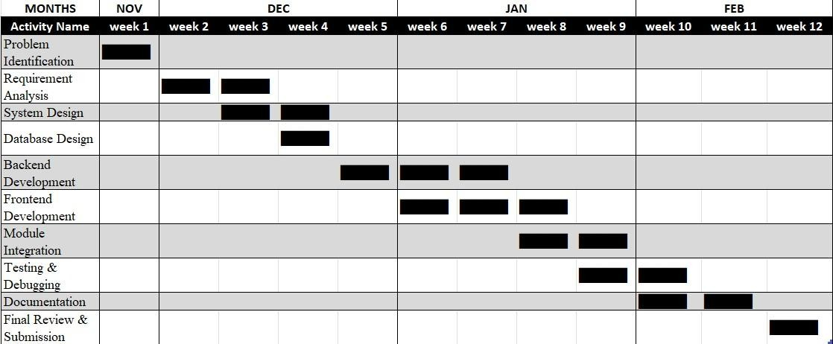
Figure 3.1 Gantt Chart

PERT Chart
PERT (Program Evaluation and Review Technique) is a project management tool used to analyze and represent the sequence of tasks in a project. Unlike the Gantt chart, which focuses on timelines, the PERT chart emphasizes task dependencies and the logical flow of activities.
In the SplitSync project, the PERT chart helps identify which tasks must be completed before others can begin. For example, requirement analysis must be completed before system design, and system design must be completed before implementation. Testing can only begin after development is completed.

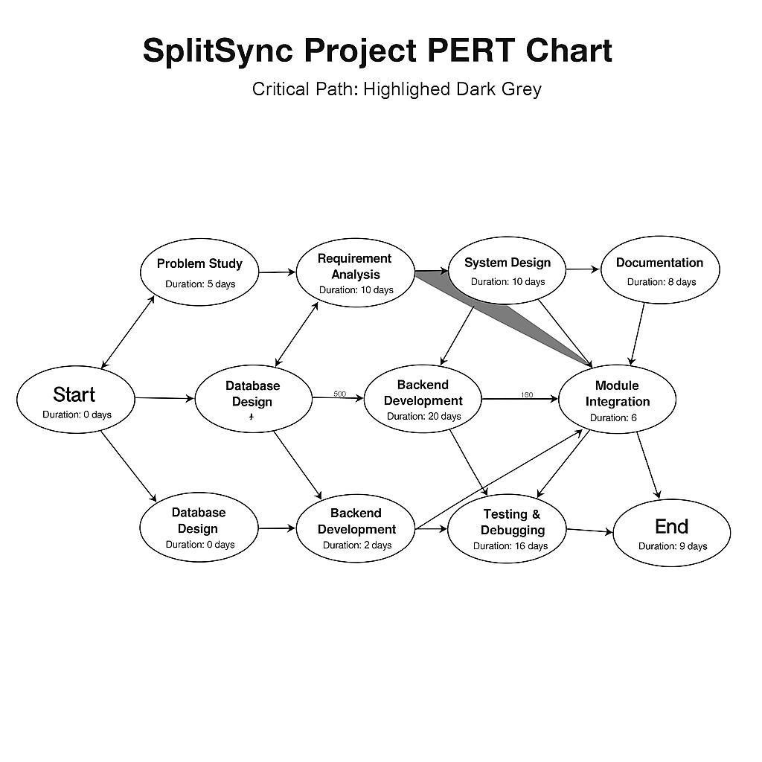
Figure 3.2 PERT Chart flow

3.4 Software and Hardware Requirements
Software and hardware requirements define the resources needed to develop, deploy, and use the proposed system efficiently. Identifying these requirements is an important part of requirement analysis, as it ensures that the system can be developed and executed without technical limitations. Since SplitSync is a web-based application, it is designed to operate with minimal hardware dependency while relying on reliable and widely used software technologies. This section describes the software and hardware requirements necessary for the successful development and operation of the SplitSync – Smart Bill Splitter & Expense Manager system.

3.4.1 Software Requirements
The SplitSync system requires a suitable operating system to support development and execution. The application can be developed and executed on commonly used operating systems such as Microsoft Windows, Linux, or macOS. These operating systems provide a stable environment and support the necessary development tools and frameworks required for web application development.
A modern web browser is required to access and use the application. Browsers such as Google Chrome, Mozilla Firefox, Microsoft Edge, or Safari are suitable, as they support modern web standards and ensure proper rendering of the user interface. The browser acts as the client interface through which users interact with the system.
Node.js is required as the primary backend runtime environment. It allows JavaScript code to be executed on the server side and supports non-blocking, event-driven architecture. This makes Node.js suitable for applications that require handling multiple user requests efficiently. Express.js is used as the backend framework on top of Node.js to manage routing, server logic, and API handling. Express simplifies backend development and improves code organization.
For database management, MySQL is used as the relational database management system. MySQL provides a structured and secure way to store user information, group details, expense records, and transaction history. It supports data integrity through relational constraints and allows efficient querying of large datasets. It provides features such as syntax highlighting, debugging, and extension support, which improve developer productivity. Git is used as a version control system to track changes in the project source code and manage different versions efficiently. GitHub may be used as a repository for storing code and enabling collaboration.Postman is used as an API testing tool to test backend endpoints and validate request-response behavior. It helps in verifying the correctness of server-side logic and ensures smooth communication between frontend and backend.
Sr. No. | Software Component | Description
1 | Operating System | Windows 10 / Linux / macOS
2 | Backend Runtime | Node.js
3 | Backend Framework | Express.js
4 | Frontend Technologies | HTML, CSS, JavaScript
5 | Database Management  System | MySQL
6 | Code Editor / IDE | Visual Studio Code
7 | Version Control System | Git
8 | API Testing Tool | Postman
9 | Web Browser | Google Chrome / Mozilla  Firefox
10 | Package Manager | Node Package Manager (npm)
Table 3.1 Software Component

3.4.2 Hardware Requirements
The hardware requirements for the SplitSync system are minimal because the application is web-based and does not require specialized hardware components. A standard computer or laptop is sufficient for both development and usage purposes.
The system requires a machine with at least a dual-core processor to support development activities such as running the server, database, and development tools simultaneously. A minimum of 4 GB RAM is required to ensure smooth operation of the development environment, although higher memory is recommended for better performance. Adequate storage space is required to store the operating system, development tools, project files, and database data.
An internet connection is required for accessing the application through a web browser, testing features, and downloading required libraries or packages. Since the system is web-based, users do not need high-end devices; any device capable of running a modern web browser can access the application.
The hardware requirements are intentionally kept minimal to ensure that the system is easily accessible and cost-effective. This makes SplitSync suitable for a wide range of users and environments, including academic institutions and small organizations.
Sr. No. | Hardware Component | Specification
1 | Processor | Dual-core or higher
2 | RAM | Minimum 4 GB (8 GB recommended)
3 | Storage | Minimum 20 GB free space
4 | Display | Standard monitor
5 | Input Devices | Keyboard and Mouse
6 | Internet Connection | Required for development and usage

Table 3.2 Hardware Component

3.5 Preliminary Product Description
The proposed system, SplitSync – Smart Bill Splitter & Expense Manager, is a webbased application designed to simplify and automate the management of shared expenses among groups of individuals. The system aims to address the common challenges faced in traditional expense-sharing methods by providing a centralized, structured, and transparent platform for recording, calculating, and settling group expenses. The preliminary product description outlines the overall functionality, behavior, and operational flow of the system at a high level, without focusing on detailed implementation aspects.
SplitSync is designed to support scenarios where multiple users are involved in shared financial activities. These scenarios include college group projects, hostel and rented accommodation living, group travel, office teams, family events, and other social or professional gatherings. In such situations, expenses are incurred by different members at different times and for different purposes. The system allows users to create groups corresponding to these activities and manage all related expenses within a single digital environment.
The application begins with a secure user authentication mechanism that ensures only authorized users can access the system. Once logged in, users are presented with a personalized dashboard that serves as the central interface for all operations. Through this dashboard, users can view their active groups, recent expenses, pending balances, and settlement summaries. The dashboard is designed to provide a clear and concise overview of financial status, enabling users to make informed decisions quickly. Group management is a key feature of the SplitSync system. Users can create new groups and add or remove members as required. Each group maintains its own independent expense records, ensuring that financial data does not overlap across different activities. This separation improves clarity and organization, especially for users who participate in multiple groups simultaneously. Group details such as group name, members, and creation date are stored securely in the system.
Expense management forms the core functionality of the system. Users can add expenses by entering essential details such as expense amount, date, description, category, and the member who paid the amount. The system allows users to specify which group members are involved in each expense. This flexibility is important because not all expenses are shared equally among all members in real-life situations. Once an expense is added, the system automatically calculates each member’s share based on the selected participants.
Automatic calculation and real-time balance updates are among the most important features of SplitSync. The system instantly updates individual balances and displays how much each user owes or is owed. These calculations are performed accurately and consistently, eliminating the need for manual computation. The system maintains uptodate records at all times, ensuring that users have access to the latest financial information.
Transparency is a fundamental design principle of the system. All group members can view expense details, calculations, and balances associated with the group. This open visibility helps build trust among users and prevents misunderstandings. Users can also view complete expense history, allowing them to review past transactions and verify calculations whenever required.
The system also supports settlement tracking, enabling users to mark payments as settled once money is transferred outside the system. This feature helps maintain accurate balance records and ensures that settled expenses are clearly distinguished from pending ones. By tracking settlement status, the system reduces confusion and ensures financial clarity within the group.
In addition to expense tracking, SplitSync provides summary views and reports that help users understand spending patterns. These summaries present aggregated information such as total group expenses, individual contributions, and outstanding balances. Such insights are useful for analyzing financial behavior and planning future activities more effectively.
From a design perspective, the system emphasizes usability and simplicity. The user interface is designed to be intuitive and easy to navigate, even for users with minimal technical knowledge. Clear labels, organized layouts, and consistent design elements are used to enhance user experience. Since the system is web-based, it can be accessed from any device with an internet connection and a modern web browser.
Security and data integrity are also considered in the preliminary design of the system. User credentials and financial data are stored securely, and access control mechanisms ensure that only authorized users can view or modify data. This protects sensitive information and maintains user privacy.
The SplitSync system is designed with scalability in mind. The modular architecture allows new features to be added in the future without affecting existing functionality. Possible future enhancements include payment gateway integration, mobile application support, advanced analytics, and notification systems. This flexibility ensures that the system remains relevant and adaptable to changing user needs.
In conclusion, the preliminary product description of SplitSync highlights its role as an efficient, transparent, and user-friendly solution for managing shared expenses. By automating calculations, maintaining structured records, and promoting transparency, the system addresses the limitations of traditional expense management methods. The application provides a strong foundation for further design and implementation, which are discussed in subsequent chapters of the project report.

CHAPTER 4: SYSTEM DESIGN

4.1 UML Diagrams

4.1.1 Use Case Diagram
A Use Case Diagram plays a vital role in the system design of the SplitSync – Smart Expense Splitting Web Application by visually representing how different users interact with the system. It identifies the functional requirements of the application by showing the various actions that users can perform, such as user registration, login, group creation, expense addition, expense splitting, settlement tracking, and report generation. By clearly defining the system boundary, the diagram distinguishes system functionalities from external entities, helping to establish a clear scope of the application.
The importance of the Use Case Diagram lies in its simplicity and clarity, making it easy to understand for both technical and non-technical stakeholders. It acts as a communication bridge between developers, project guides, and users by presenting system requirements in a visual format. This diagram helps identify missing or unclear requirements at an early stage, reducing the chances of errors during later phases of development.
Use Case Diagrams also serve as a foundation for further design activities such as sequence diagrams, class diagrams, and test case preparation. They ensure that the system remains user-centric and aligns with real-life usage scenarios. By focusing on user goals rather than internal implementation, the diagram helps in designing a system that meets practical needs effectively.
Additionally, Use Case Diagrams support relationships such as include, extend, and generalization. The include relationship is used where common functionality, such as authentication, is shared across multiple use cases. The extend relationship represents optional features like generating reports or exporting data. Generalization allows modeling of similar user roles if needed in future versions. These relationships enhance clarity and reduce redundancy.
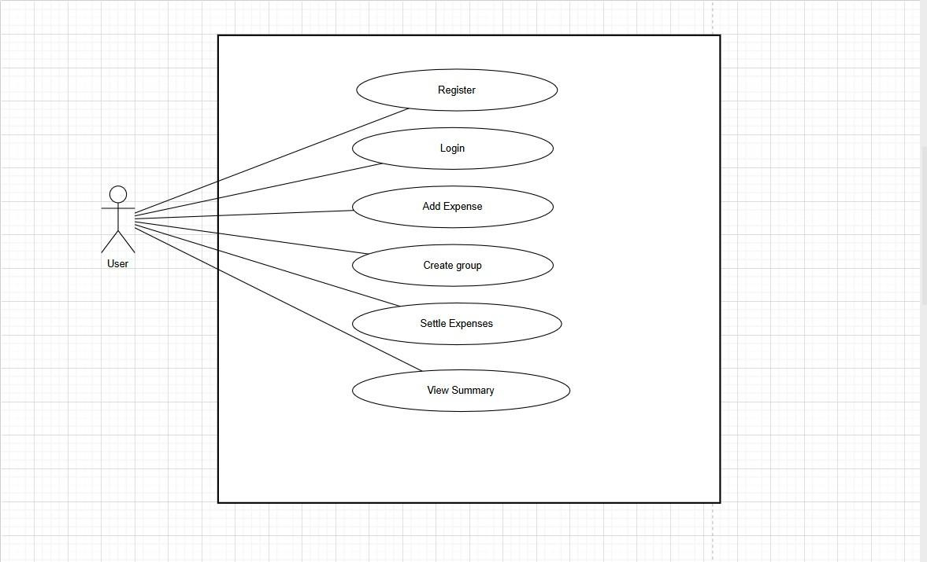

Figure 4.1 Use Case Diagram

In the Use Case Diagram of the SplitSync system, the primary actor is the User. The user initiates actions such as registering an account, logging into the system, creating or joining expense groups, adding expenses, viewing balances, settling payments, and generating reports. The system boundary encapsulates all functionalities related to expense management. This diagram provides a clear overview of how the user interacts with the system and how different features are logically connected, making it highly useful for documentation and explanation.

4.1.2 Sequence Diagram
A Sequence Diagram is an essential UML diagram used to represent the interaction between system components in a time-ordered sequence. In the context of the SplitSync application, the sequence diagram illustrates how messages flow between the user interface, backend server, and database during operations such as registration, login, expense addition, and balance calculation. It helps in understanding how a process starts, executes, and completes.
The importance of a Sequence Diagram lies in its ability to clearly explain the internal workflow of the system. It visually demonstrates how different components collaborate to perform a task. For example, when a user submits registration details, the frontend sends data to the backend, which validates the input and stores it in the database before returning a response. This clarity helps developers avoid logical errors during implementation.
Sequence Diagrams also support efficient coding and testing. Developers can map each interaction directly to code logic, while testers can design test cases based on message flow. This ensures that the system behaves as expected under different scenarios and improves overall reliability.
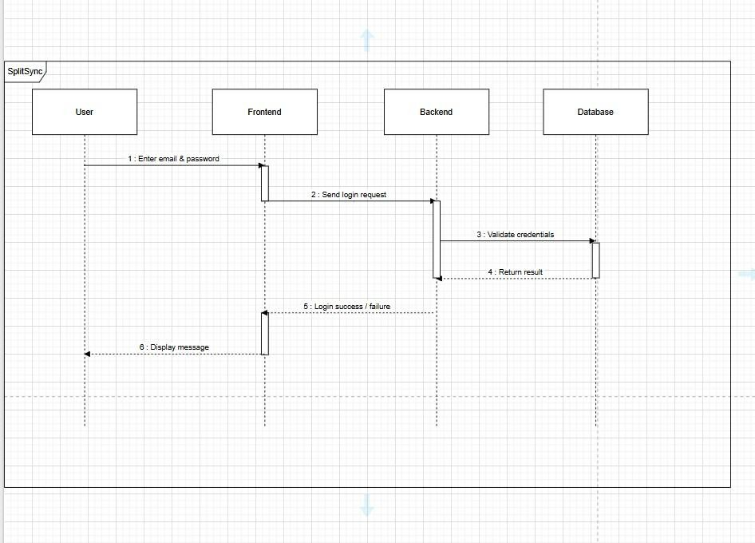

Figure 4.2 Sequence Diagram

In the Sequence Diagram of the SplitSync system, the interaction begins when the user submits an action such as registration or login through the web interface. The frontend forwards the request to the backend server. The backend processes the request, interacts with the database to store or retrieve data, and sends the response back to the frontend. The frontend then displays the result to the user. This diagram clearly represents the communication flow and timing between system components.

4.1.3 Activity Diagram
An Activity Diagram is used to model the workflow of activities within a system. In SplitSync, the activity diagram represents the step-by-step flow of operations involved in managing shared expenses. It shows how actions progress from user login to expense addition and settlement, including decision points and repeated activities.
The importance of an Activity Diagram lies in its ability to simplify complex workflows into an easily understandable visual format. It helps stakeholders understand the sequence of operations and decision-making logic within the system. By identifying alternative paths, such as valid or invalid login, the diagram highlights system behavior under different conditions.
The activity diagram for SplitSync begins with user login or registration. Once authenticated, the user can create or join a group, add expenses, and view calculated balances. Decision points determine whether expenses are settled or pending. The process continues until the user logs out. This diagram effectively illustrates the continuous and cyclic nature of expense tracking and management.
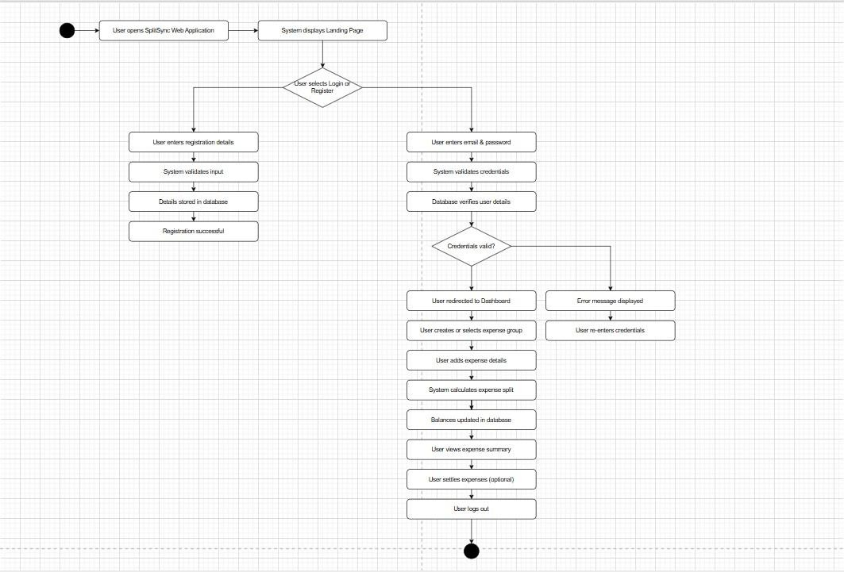

Figure 4.3 Activity Diagram

4.1.4 Class Diagram
A Class Diagram represents the static structure of the system by showing classes, their attributes, methods, and relationships. In the SplitSync application, the class diagram models entities such as User, Group, Expense, Settlement, and Report, along with their interactions.
The importance of the Class Diagram lies in translating system requirements into a structured object-oriented design. It helps developers understand data organization and responsibility distribution, reducing ambiguity during implementation.
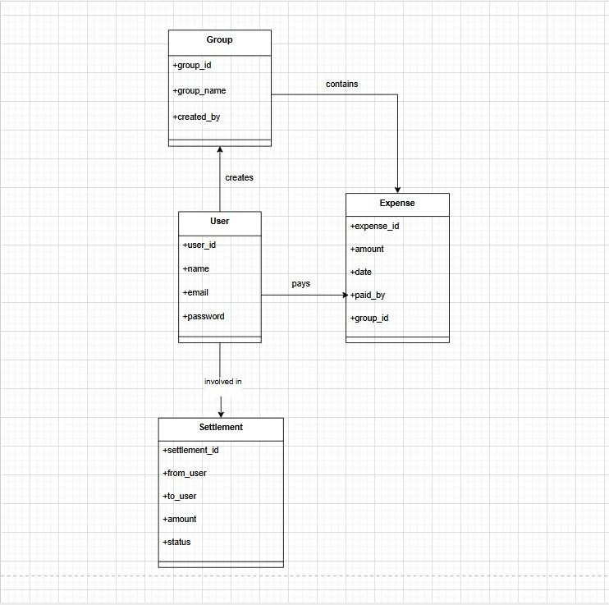
Figure 4.4 Class Diagram

Class Diagram Description – SplitSync System
- User Class: Stores user details such as userId, name, email, and password. It contains methods for registration and authentication.
- Group Class: Manages expense groups with attributes like groupId, groupName, and members.
- Expense Class: Stores expense details including amount, date, payer, and category.
- Settlement Class: Tracks pending and completed settlements.
- Report Class: Generates summaries and expense reports.
These classes interact to ensure accurate expense tracking and balance calculation.

4.1.5 State Machine Diagram
A State Machine Diagram represents the various states of a system and transitions triggered by events. In SplitSync, it models user states such as Logged Out, Logged In, Adding Expense, Viewing Balance, and Logged Out.
The diagram ensures that state-dependent behavior is correctly handled. It prevents invalid transitions and improves system reliability.
The system starts in the Logged Out state. After successful login, it transitions to Logged In. Users can then add expenses, view balances, or generate reports. Upon logout, the system returns to the Logged Out state.

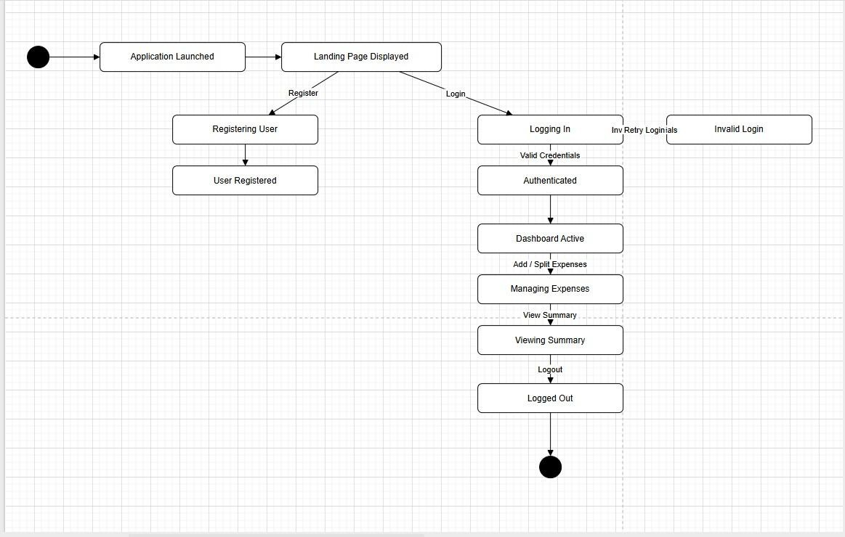

Figure 4.5 State Machine Diagram

4.1.6 Component Diagram
A Component Diagram shows the high-level organization of system components and their dependencies. In SplitSync, it represents the Frontend UI, Backend Server, Database, and optional services.
Component Diagram Description – SplitSync
- Frontend Component: Handles UI and user interaction.
- Backend Component: Processes business logic and validations.
- Database Component: Stores persistent data.
- Authentication Component: Manages login and registration. This modular structure ensures maintainability and scalability.
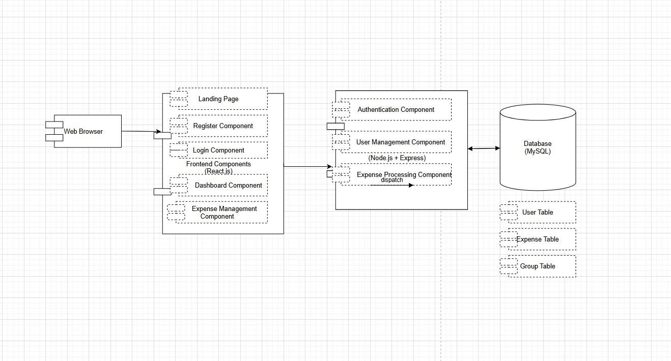

Figure 4.6 Component Diagram

4.2 MODULE DESIGN
The modular architecture used in the SplitSync system allows the application to be divided into multiple functional units that work together to provide the complete functionality of the expense management system. Each module is responsible for performing a specific task and communicating with other modules whenever necessary. Designing the system using modules improves software maintainability and scalability. If any feature of the system needs to be modified or updated, developers can work on a specific module without affecting the rest of the application. This reduces development complexity and improves system reliability.
Another advantage of modular design is that it allows different parts of the system to be tested independently. This ensures that errors can be identified quickly and corrected before the system is deployed.
The modules of the SplitSync system are designed in such a way that they support the entire workflow of the application, starting from user registration and login to expense management and balance settlement. Each module interacts with the database and other system components to perform its operations efficiently.
The following sections describe each module of the system in detail.
The main modules of the SplitSync system are as follows:
- User Registration Module
- User Authentication Module
- Dashboard Module
- Group Creation and Management Module
- Member Management Module
- Expense Management Module
- Expense Splitting Module
- Balance Calculation Module
- Expense History Module

4.2.1 USER REGISTRATION MODULE
The User Registration Module allows new users to create an account in the SplitSync system. This module is the starting point of the user journey because it establishes the identity of users within the application.
When a new user visits the application for the first time, they must complete the registration process to gain access to the system features. The registration interface provides a form that collects the user's personal details such as full name, email address, contact number, and password.
The system verifies that all required fields are filled before allowing the user to submit the form. Input validation is performed to ensure that the data entered by the user is correct and formatted properly. For example, the email address must follow the correct email format, and the phone number must contain valid digits.
After the user submits the form, the system checks whether the email address already exists in the database. If the email is already registered, the system displays a warning message and asks the user to use a different email address.
Once the validation process is completed successfully, the system stores the user information in the database. The password provided by the user is stored securely to prevent unauthorized access.
After successful registration, the system confirms the creation of the account and allows the user to proceed to the login page.
The registration module also plays an important role in maintaining a structured user database. Each registered user receives a unique identification number which helps the system track their activities within different groups and expenses.
This module ensures that the system maintains accurate records of all users and provides secure access to the platform.

Advantages of Registration Module
- Allows new users to join the system easily
- Maintains a structured database of users
- Ensures secure authentication of users
- Prevents duplicate user accounts

Interaction with Other Modules
The registration module interacts with:
- Authentication module for login verification
- Database module for storing user information
- Dashboard module for user navigation after login

4.2.2 USER AUTHENTICATION MODULE
The User Authentication Module ensures that only authorized users can access the SplitSync system. This module verifies the identity of users by checking their login credentials.
Once the user has registered successfully, they must log in to the system using their email address and password. The authentication module processes the login request and compares the entered credentials with the stored database records.
If the credentials match, the system grants access to the user and redirects them to the dashboard. If the credentials do not match, the system displays an error message indicating that the login attempt failed.
The authentication module also handles session management. When a user logs in successfully, a session is created to maintain the user’s login status while navigating through different pages of the application. This session remains active until the user logs out.
Security is an important aspect of this module. The system ensures that passwords are stored securely and not displayed in plain text. This protects the system from potential security threats.
The authentication module also prevents unauthorized users from accessing sensitive information such as expense records and financial balances.
This module plays a critical role in ensuring the overall security and privacy of the application.

Authentication Process
- User enters login credentials
- System sends request to server
- Server verifies credentials with database
- If credentials are correct, login is successful
- System creates user session
- User is redirected to dashboard

4.2.3 DASHBOARD MODULE
The Dashboard Module serves as the main interface of the SplitSync application. It acts as the central control panel where users can access different features of the system. After logging in successfully, users are directed to the dashboard where they can view an overview of their account activity. The dashboard provides information such as groups created by the user, expenses recorded in those groups, and the current balance status.
The dashboard provides quick navigation options that allow users to perform actions such as creating new groups, adding expenses, viewing group members, and checking transaction history.
A well-designed dashboard improves user experience by organizing important information in a clear and structured manner. It allows users to easily monitor their financial activity and manage expenses effectively.
The dashboard also displays summary information such as the total number of groups, recent expenses, and pending balances. This helps users understand their financial responsibilities within the system.
Another important feature of the dashboard is that it provides quick access to all system modules, making it easier for users to navigate the application.

Features of Dashboard
•Displays user groups
- Shows expense summaries
- Provides navigation to different modules
- Displays recent transactions
- Allows quick access to group management

4.2.4 GROUP CREATION AND MANAGEMENT MODULE
The Group Management Module allows users to create groups where multiple members can share expenses. This module is designed to simplify expense tracking among friends, roommates, or colleagues.
When a user creates a new group, they must provide a group name that represents the purpose of the group. For example, a group may represent a trip, a household expense group, or a college project team.
After creating the group, the user can add members who will participate in the expense sharing process. The system stores group information in the database and associates it with the user who created the group.
Each group functions independently within the system. Expenses recorded in one group do not affect other groups.
Users can manage multiple groups simultaneously. This allows them to track expenses for different activities without confusion.
The group management module also allows users to view group details, monitor expenses within the group, and track financial balances among members.
This module improves collaboration among users and makes it easier to manage shared expenses.

4.2.5 MEMBER MANAGEMENT MODULE
The Member Management Module manages the participants who are involved in group expenses. After creating a group, users must add members who will share expenses within the group.
Members can be added by entering their names or contact information. Once a member is added, the system records the member information and associates them with the specific group.
The system maintains a list of all group members and allows users to view or modify this list when necessary. For example, if a member leaves the group, the user can remove them from the group member list.
Proper member management is essential for accurate expense splitting because the system uses this information to determine how expenses should be distributed. This module ensures that only valid participants are included in the expense calculation process.

4.2.6 EXPENSE MANAGEMENT MODULE
The Expense Management Module allows users to record financial transactions within a group. This module ensures that all expenses are properly documented and shared among group members.
Users can add expenses by entering information such as the expense description, amount spent, and the person who paid for the expense.
Once the expense is added, the system stores the record in the database and makes it available for further processing by the expense splitting module.
Users can view a list of all expenses recorded in the group. This helps maintain transparency among group members and ensures that everyone is aware of the financial activities within the group.
The expense management module also allows users to edit or delete expense records if corrections are required.
This module ensures that the system maintains an accurate and organized record of all shared expenses.

4.2.7 EXPENSE SPLITTING MODULE
The Expense Splitting Module is responsible for dividing the total expense among group members. This module ensures that each participant pays their fair share of the expense.
The system calculates the expense share for each member based on the number of participants involved in the expense.
For example, if an expense of ₹1000 is shared among five members, the system automatically calculates that each member must contribute ₹200.
This module eliminates the need for manual calculations and ensures fairness in the expense distribution process.

4.2.8 BALANCE CALCULATION MODULE
The Balance Calculation Module calculates the net financial balance between group members. After expenses are split, the system determines how much each member owes or should receive.
The system continuously updates balances as new expenses are recorded. This allows users to easily track their financial obligations within the group.
For example, if one member pays more expenses than others, the system calculates how much the remaining members must pay to settle the balance.

4.2.9 EXPENSE HISTORY MODULE
The Expense History Module maintains a detailed record of all past expenses within the system. Users can review previously recorded transactions and track spending patterns.
The history includes information such as expense description, amount spent, date of transaction, and members involved.
This module improves transparency and accountability within the group. Members can verify expenses and resolve disputes if any discrepancies occur

4.3 Database Design

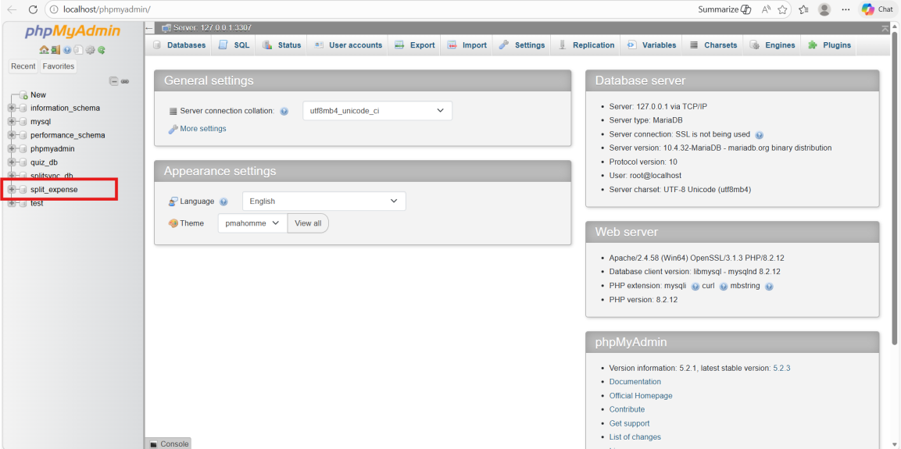

Screenshots 4.1 Database Page

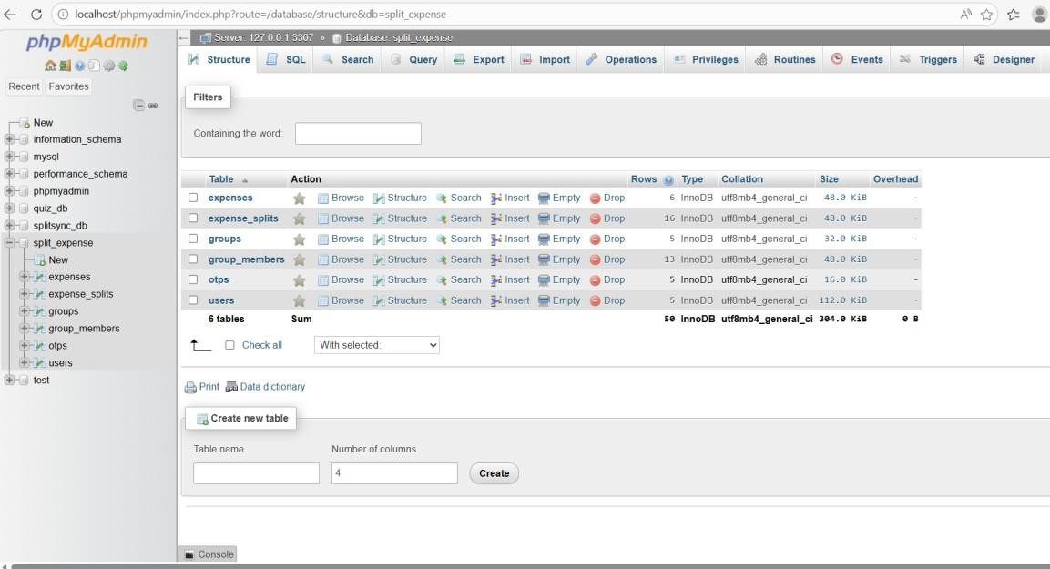
Screenshots 4.2 Tables

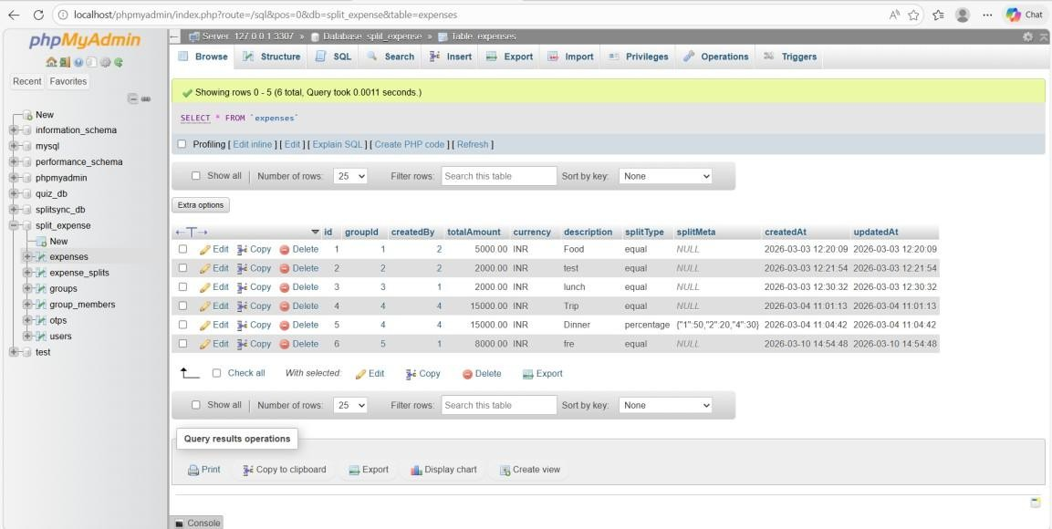

Screenshots 4.3 Expense Table

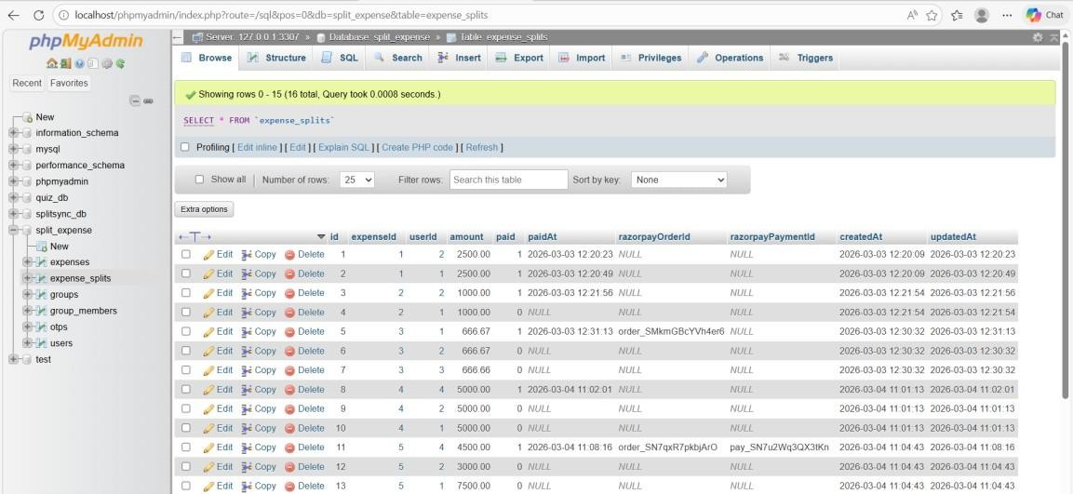

Screenshots 4.4 Expense Splits table

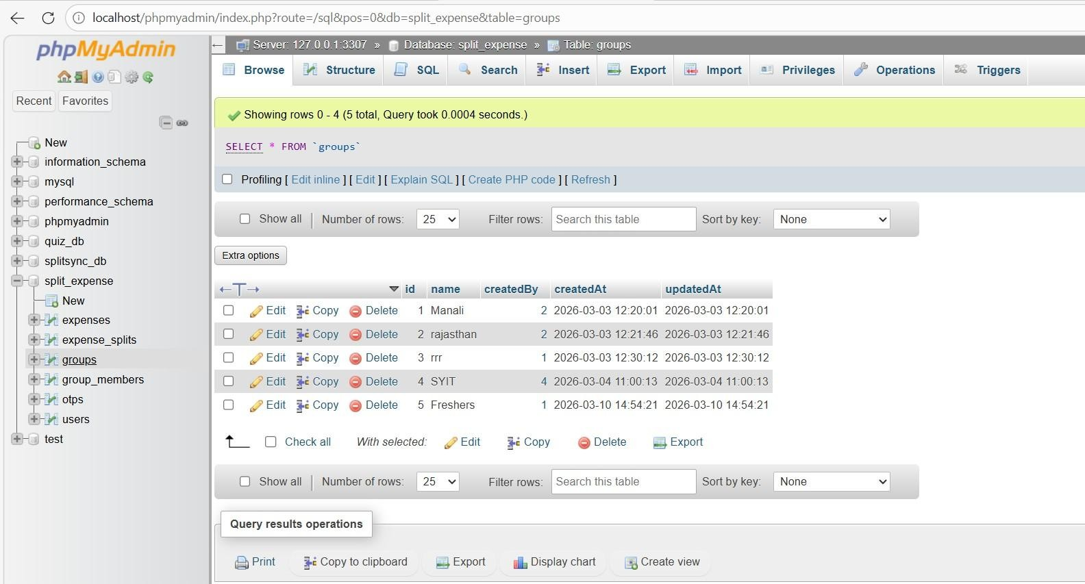

Screenshots 4.5 Groups Table

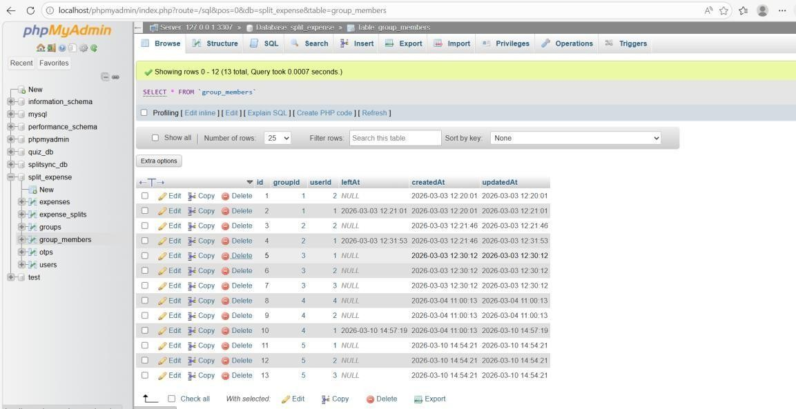

Screenshots 4.6 Group Members Table

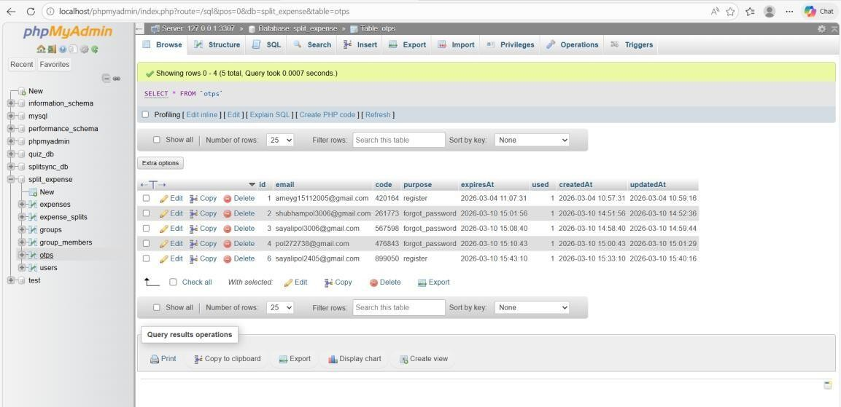

Screenshots 4.7 Otps Table

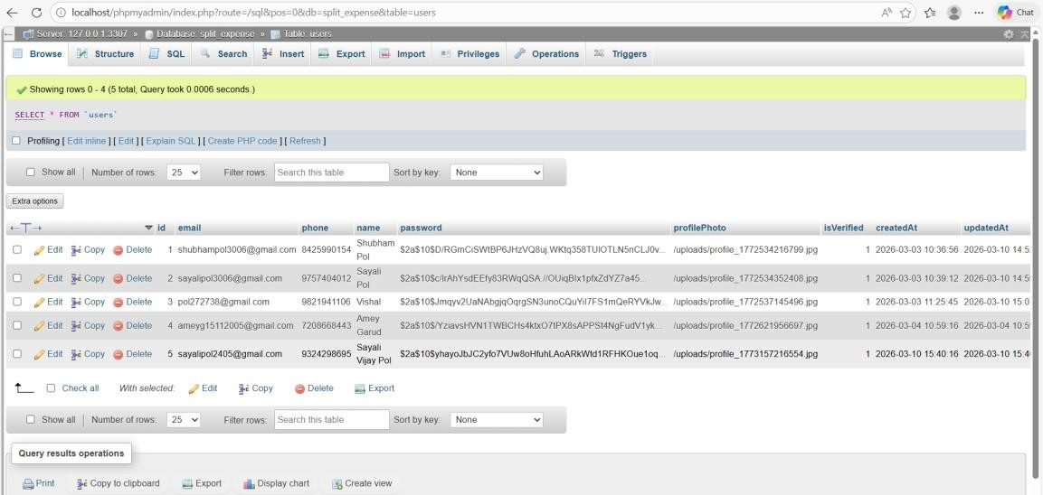

Screenshots 4.8 Users Table

4.3.1 Overview of Database Design
Database design is a crucial phase in the development of the SplitSync application, as it defines how data is stored, organized, and accessed throughout the system. A wellstructured database ensures that all application data remains consistent, accurate, and easily retrievable. In SplitSync, the database is designed to handle multiple users, expense groups, shared expenses, settlements, and reports efficiently.
The design focuses on separating data into logical entities and establishing relationships among them. This approach helps in minimizing redundancy, avoiding inconsistencies, and improving overall system performance. Proper database design also makes the application scalable, allowing new features such as analytics, notifications, or integrations to be added without major restructuring. Thus, the database design acts as a strong foundation for the entire SplitSync system.

4.3.2 Role of Database in SplitSync
The database plays a central role in the functioning of the SplitSync application. It acts as a permanent storage system that keeps track of all user-related and financial data. Every important operation—such as user registration, login authentication, group creation, expense entry, balance calculation, and settlement—is recorded in the database.
By storing complete transaction history, the database enables accurate tracking of expenses and balances among group members. It ensures transparency, allowing users to review past expenses and settlements at any time. The database also supports reporting features by maintaining historical data. Without a robust database, it would be impossible to manage shared expenses reliably and securely.

4.3.3 Database Environment and Platform
SplitSync uses MySQL as its relational database management system, integrated with a Node.js backend. MySQL is chosen due to its reliability, high performance, security features, and widespread industry usage. It supports structured query language (SQL), making it easy to perform complex data operations efficiently.
The Node.js backend serves as an intermediary between the frontend and the database. It handles all database connections and queries using secure APIs. This setup ensures fast data processing, smooth application performance, and proper handling of concurrent users. The selected environment is cost-effective, scalable, and well-suited for web-based applications like SplitSync.

4.3.4 Database Architecture
The database architecture of SplitSync follows a relational database model, where data is organized into tables consisting of rows and columns. Each table represents a specific real-world entity, and relationships between tables are established using keys. The architecture is designed using normalized tables to reduce redundancy and maintain data integrity. Relationships such as one-to-many and many-to-many are carefully implemented using foreign keys. This structured architecture allows efficient querying, easy maintenance, and reliable data management. It also ensures that the database can support future expansion without affecting existing functionality.

4.3.5 Entity Identification
Entity identification involves determining the main objects that need to be represented in the database. In SplitSync, the primary entities include User, Group, Expense, Settlement, and Report.
Each entity represents a key component of the application. The User entity stores personal and authentication details. The Group entity represents expense-sharing groups. The Expense entity records individual expenses. The Settlement entity tracks payments between users. The Report entity stores summarized expense data. Identifying these entities helps create a logical and efficient database structure aligned with application requirements.

4.3.6 Attribute Description
Attributes define the properties of each entity and describe the type of data stored in the database. For example, the User entity includes attributes such as userId, name, email, password, and createdAt. The Group entity includes groupId, groupName, createdBy, and createdDate.
Expense-related attributes include expenseAmount, category, date, and paidBy. Settlement attributes track who paid whom and how much. These attributes ensure that all relevant information is captured accurately. Proper attribute definition supports validation, querying, and reporting, making the database more reliable and meaningful.

4.3.7 Table Design Explanation
Each table in the SplitSync database corresponds to an identified entity. A primary key uniquely identifies each record, ensuring no duplicate entries. Foreign keys are used to establish relationships between tables and enforce referential integrity.
For example, the Expense table references the User and Group tables through foreign keys. This design ensures that expenses cannot exist without valid users and groups. Proper table design improves performance, avoids data anomalies, and supports efficient data manipulation operations.

4.3.8 Data Flow between Application and Database
In SplitSync, all data interactions occur through the backend server. The frontend communicates with the backend using secure APIs, and the backend processes these requests before interacting with the database.
This controlled data flow ensures that business logic, validation, and security checks are applied before any database operation. The backend handles CRUD operations and sends responses back to the frontend. This architecture prevents direct database access from the client side, enhancing security and system stability.

4.3.9 Normalization and Redundancy Control
Normalization is applied in the SplitSync database to organize data efficiently and reduce duplication. The database follows standard normalization rules, ensuring that each piece of data is stored only once.
This approach eliminates redundancy and reduces the risk of inconsistent data. For example, user details are stored in a single table and referenced wherever required. Normalization improves storage efficiency, data accuracy, and ease of maintenance.

4.3.10 Data Validation and Integrity Constraints
Data validation and integrity constraints are essential to maintaining database accuracy. Constraints such as NOT NULL, UNIQUE, CHECK, and FOREIGN KEY are applied to ensure valid data entry.
For instance, email addresses must be unique, expense amounts must be positive, and foreign keys must reference existing records. These constraints prevent invalid data from entering the system and help maintain trust in the stored information.

4.3.11 Security and Access Control
Security is a top priority in the SplitSync database design. Access to the database is restricted using authentication mechanisms and role-based access control. Only the backend server is permitted to interact with the database.
Sensitive data such as passwords is stored using encryption or hashing techniques. Secure database connections and query handling protect the system from unauthorized access and data breaches. These security measures ensure user privacy and data confidentiality.

4.3.12 Advantages of Using a Database
Using a database in SplitSync provides several benefits. It ensures reliable data storage, supports efficient data retrieval, and enables advanced analysis and reporting. The database also allows easy backup and recovery, ensuring data safety.
Additionally, a well-designed database supports scalability and future enhancements. As the number of users and transactions increases, the database can handle the load efficiently. Overall, the database plays a critical role in ensuring the success, reliability, and usability of the SplitSync application.

CHAPTER 5: IMPLEMENTATION AND TESTING

5.1 Overview of the Implementation
The implementation phase represents the stage where the theoretical design of the SplitSync – Smart Expense Splitting Web Application is transformed into a fully functional software system. During this phase, the modules designed in Chapter 4 are developed using appropriate programming languages, frameworks, and database technologies. The primary objective of the implementation phase is to convert the conceptual system architecture into a working web application that allows users to manage shared expenses efficiently.
The SplitSync system is developed as a modern web application using a client–server architecture. The system consists of three major layers: the presentation layer, the application layer, and the data layer. Each layer performs a specific role in the overall functioning of the system. The frontend layer is responsible for providing an interactive user interface through which users can interact with the system. The backend layer processes user requests, performs business logic, and manages communication with the database. The database layer stores all persistent information related to users, groups, expenses, and balances.
The application is developed using React.js for the frontend interface, Node.js and Express.js for the backend server, and MySQL as the relational database management system. This technology stack enables efficient data handling, responsive user interfaces, and scalable application development.
The implementation process followed a modular approach. Each module of the system was implemented independently based on the design defined in Chapter 4. These modules include the User Registration Module, User Authentication Module, Dashboard Module, Group Management Module, Member Management Module, Expense Management Module, Expense Splitting Module, and Balance Calculation Module. Developing the system in modular form improves code maintainability and allows developers to test and update individual components without affecting the entire system.
The frontend interface was developed using reusable React components to ensure a clean and organized user interface. Each major feature of the application, such as user registration, login, group management, and expense management, is implemented as a separate component. These components interact with the backend server through RESTful APIs to send and retrieve data.
The backend server developed using Express.js acts as the central controller of the application. It processes incoming requests from the frontend, validates user inputs, executes database queries, and returns appropriate responses. The backend also handles business logic such as splitting expenses among group members and calculating balances.
The MySQL database plays a crucial role in storing and managing system data. It stores records related to users, groups, group members, expenses, and balance information. Structured tables and relationships are used to maintain data integrity and ensure efficient data retrieval.
During implementation, special attention was given to important software engineering practices such as input validation, error handling, modular coding, and secure database interaction. These practices help improve system reliability and prevent potential errors or security issues.
The implementation phase also focused on building a user-friendly interface that allows users to easily navigate through the application. The interface provides clear options for creating groups, adding members, recording expenses, and viewing balances. This ensures that the system remains easy to use even for users with minimal technical knowledge.
After completing the development of all modules, the system was thoroughly tested to ensure correct functionality and smooth integration between different components. Testing was conducted at multiple levels, including unit testing, integration testing, and system testing.
The successful implementation of the SplitSync application demonstrates how modern web technologies can be used to build an efficient and reliable expense management system that simplifies financial collaboration among users.

5.2 Development Tools and Technology Stack
The development of the SplitSync application required the use of several modern software technologies and tools. These tools were carefully selected based on their performance, flexibility, scalability, and compatibility with web-based systems. The overall technology stack of the SplitSync system consists of frontend technologies, backend technologies, database systems, and development tools. Each technology plays a specific role in building a reliable and efficient application.

5.2.1 Frontend Technologies
React.js
React.js is used for developing the user interface of the SplitSync web application. React is a popular JavaScript library used for building interactive and dynamic user interfaces. It allows developers to create reusable components that simplify application development and improve code maintainability.
In the SplitSync system, React.js is used to build components such as the registration page, login page, dashboard interface, group management interface, and expense display pages. React’s component-based architecture allows each part of the interface to be developed and updated independently.
One of the major advantages of using React is the Virtual DOM mechanism. The Virtual DOM improves performance by updating only the necessary parts of the user interface instead of reloading the entire page. Key advantages of React.js include:
- Component-based architecture
- Fast rendering using Virtual DOM
- Reusable UI components
- Improved performance and scalability
- Easy integration with REST APIs
HTML5
HTML5 is used to structure the web pages of the SplitSync application. It defines the layout of the user interface elements such as forms, buttons, tables, and navigation components.
HTML5 provides semantic elements that help improve code readability and maintainability. These elements make the structure of the web pages clearer and more organized.
CSS3
CSS3 is used to style the user interface of the application. It controls the visual appearance of elements such as colors, fonts, spacing, and layout design.
CSS3 helps in creating an attractive and user-friendly interface. It also supports responsive design techniques that ensure the application works properly across different screen sizes.
JavaScript
JavaScript is used to implement client-side logic in the SplitSync application. It enables dynamic interaction between the user interface and the backend server.
JavaScript handles tasks such as:
- Form validation
- Button click handling
- API requests
- Dynamic content rendering
- State updates in React components

5.2.2 Backend Technologies
Node.js
Node.js is used as the server-side runtime environment for executing JavaScript code. It enables developers to build scalable backend applications that can handle multiple requests efficiently.
Node.js uses an event-driven architecture and non-blocking input/output operations, which improves the performance of web applications.
In the SplitSync system, Node.js is responsible for processing user requests, executing server-side logic, and communicating with the database.
Express.js
Express.js is a lightweight web application framework built on top of Node.js. It simplifies the development of server-side applications by providing tools for routing, middleware management, and request handling.
In the SplitSync application, Express.js is used to create RESTful APIs that allow communication between the frontend and backend systems.
Examples of API endpoints implemented in the system include:
- /register – registers a new user
- /login – authenticates a user
- /create-group – creates a new expense group
- /add-member – adds members to a group
- /add-expense – records an expense
- /get-expenses – retrieves group expenses
Express.js helps organize the backend code into structured routes and controllers, making the application easier to maintain.

5.2.3 Database Technology
MySQL Database
MySQL is used as the relational database management system for storing application data. It organizes data into structured tables and maintains relationships between different entities such as users, groups, expenses, and balances.
The database ensures that all financial records are stored securely and can be retrieved efficiently whenever needed.
Important tables used in the SplitSync database include:
- Users table
- Groups table
- Group Members table
- Expenses table
- Balance table
These tables are connected through primary keys and foreign keys to maintain data integrity.

5.2.4 Development and Testing Tools
Visual Studio Code (VS Code)
Visual Studio Code is used as the primary development environment for writing and managing source code. It provides features such as syntax highlighting, debugging tools, and extensions for React and Node.js development.
Postman
Postman is used for testing backend APIs independently. It allows developers to send HTTP requests and analyze responses to verify whether APIs are functioning correctly. Google Chrome
Google Chrome browser is used for running the application and debugging frontend components using developer tools.

5.3 System Architecture
The SplitSync – Smart Expense Splitting Web Application follows a structured threetier architecture that separates the system into different functional layers. This architecture improves system organization, maintainability, and scalability. Each layer performs a specific task and communicates with the other layers through well-defined interfaces.
The three main layers of the system architecture are:
- Presentation Layer (Frontend)
- Application Layer (Backend)
- Data Layer (Database)
This layered architecture ensures that user interface design, application logic, and data management remain independent of each other. Such separation makes it easier to maintain the system and update individual components without affecting the entire application.
The architecture also improves security because direct database access from the user interface is prevented. Instead, all communication between the user interface and database occurs through the backend server.

5.3.1 Presentation Layer (Frontend)
The Presentation Layer represents the user interface of the SplitSync application. It is responsible for displaying information to users and capturing user inputs.
The frontend of the system is developed using React.js .React enables the development of dynamic user interfaces using reusable components.
The presentation layer contains multiple UI components such as:
- Registration Page
- Login Page
- Dashboard Interface
- Group Management Page
- Member Management Page
- Expense Management Page
- Balance Display Page
- Download Reciept Page

Each component interacts with the backend server using HTTP requests. The frontend sends user inputs to the backend APIs and receives responses in JSON format. One of the major advantages of using React is that it updates only the necessary parts of the interface when data changes. This improves performance and provides a smooth user experience.
Responsibilities of the Presentation Layer include:
- Displaying user interfaces
- Collecting user inputs
- Sending API requests to the backend
- Rendering returned data dynamically
- Providing interactive user navigation

5.3.2 Application Layer (Backend)
The Application Layer is responsible for processing the core logic of the SplitSync system. It receives requests from the frontend, performs necessary operations, interacts with the database, and returns responses to the frontend.
The backend is implemented using Node.js with the Express.js framework. This environment allows efficient handling of multiple user requests simultaneously.
The backend performs several important operations such as:
- User registration and authentication
- Creating and managing groups
- Adding and removing group members
- Recording expenses
- Splitting expenses among members
- Calculating financial balances
- Retrieving data from the database

The backend server exposes several RESTful API endpoints that allow the frontend to communicate with the system.

Examples of backend APIs include:
- /register – Creates a new user account
- /login – Authenticates a user
- /create-group – Creates a new expense group
- /add-member – Adds a member to a group
- /add-expense – Records a new expense
- /calculate-balance – Calculates group balances
Express.js simplifies backend development by providing routing and middleware support.
The Application Layer also ensures that all data sent to the database is properly validated and sanitized.

5.3.3 Data Layer (Database)
The Data Layer manages the storage and retrieval of system data. It ensures that all user and financial information is stored securely and can be accessed whenever needed. The SplitSync system uses MySQL as its relational database management system. The database stores information in structured tables such as:
- Users
- Groups
- Group Members
- Expenses
- Balances

Each table contains specific attributes that represent real-world entities in the application.
Primary keys uniquely identify each record, while foreign keys establish relationships between tables.

For example:
- Each group is associated with a user who created it
- Each expense belongs to a specific group
- Each member belongs to a particular group
This relational structure ensures that data remains consistent and well organized.

5.3.4 Data Flow Architecture
The flow of data in the SplitSync system follows a structured sequence.
- The user interacts with the frontend interface.
- The frontend sends a request to the backend server.
- The backend validates the request.
- The backend interacts with the MySQL database.
- The database returns the requested data.
- The backend processes the data and sends a response.
- The frontend displays the updated information to the user.
This controlled flow of data improves system security and prevents unauthorized database access.

5.3.5 Advantages of the Architecture
The architecture adopted in SplitSync provides several advantages:
- Improved modularity
- Better maintainability
- Easy scalability
- Secure database access
- Faster application performance
- Clear separation of responsibilities
Because each layer performs a specific task, developers can easily maintain or upgrade the system without affecting other components.

5.4 Module-wise Implementation
The SplitSync application is implemented using a modular development approach. Each module of the system is responsible for performing a specific function within the application.
Dividing the system into modules improves code organization and allows developers to manage complex applications more efficiently.
The main modules implemented in the system include:
- User Registration Module
- User Authentication Module
- Dashboard Module
- Group Creation and Management Module
- Member Management Module
- Expense Management Module
- Expense Splitting Module
- Balance Calculation Module
Each module interacts with the backend server and database through APIs to perform its operations.

5.4.1 User Interface Design
The User Interface (UI) of the SplitSync application is designed to provide a clean and user-friendly experience for users. A well-designed interface ensures that users can easily navigate through the application and perform tasks without confusion.
The UI is developed using React.js components.
The design follows important UI principles such as:
- Simplicity
- Consistency
- Responsiveness
- Clear navigation
- Minimal user input complexity

The main interface pages implemented in the system include:
- Registration Page
- Login Page
- Dashboard Page
- Group Management Page
- Expense Management Page
- Balance Display Page
Each interface is designed using reusable components to ensure consistency across the application.

Registration Interface
The registration interface allows new users to create an account in the system. It contains input fields such as:
- Full name
- Email address
- Phone number
- Password
Client-side validation ensures that users enter valid data before the form is submitted.

Login Interface
The login interface allows registered users to access the system using their email and password. If the credentials match the database records, the user is redirected to the dashboard.

Dashboard Interface
The dashboard provides an overview of the user’s activity within the system. It displays the groups created by the user and provides options for managing expenses.

Group Interface
The group interface allows users to create new groups and manage existing groups.

Expense Interface
The expense interface allows users to add and view expenses recorded in a group.

5.4.2 Functional Modules

User Registration Module Implementation
The User Registration Module allows new users to create accounts within the system. The frontend registration form collects user information and sends it to the backend API.
The backend validates the data and inserts the new user record into the MySQL database.
Key implementation steps:
- User fills the registration form.
- React sends POST request to /register.
- Express backend validates data.
- User information is inserted into the database.
- Success message is returned to frontend.

User Authentication Module Implementation
The authentication module verifies user credentials during login.
When a user submits login information, the frontend sends the data to the backend API. The backend checks whether the email and password match the stored database record. If authentication is successful, the system allows access to the dashboard.

Dashboard Module Implementation
The dashboard module displays important information such as:
- List of groups created by the user
- Recent expenses
- Navigation options
The dashboard retrieves data from backend APIs and displays it dynamically using React components.

Group Management Module Implementation
The group management module allows users to create and manage expense groups.
Implementation steps:
- User enters group name.
- React sends request to /create-group.
- Backend stores group data in database.
- Group appears on dashboard.

Member Management Module Implementation
This module allows users to add members to groups.
Users can search for members using their email address. If the user exists, they are added to the selected group.

Expense Management Module Implementation This module allows users to record expenses in a group.
Users enter expense details such as:
- Expense description
- Amount
- Payer
The expense record is stored in the database for future calculations.

Expense Splitting Module Implementation
After an expense is added, the system automatically calculates each member’s share. The backend divides the expense amount by the number of group members and stores individual balances.

Balance Calculation Module Implementation
The balance calculation module continuously calculates how much each member owes or should receive.
This module updates balances whenever new expenses are added. Users can view their balances through the dashboard interface.

Tables have:
- users
- groups
- group_members
- expenses
- expense_splits
- otps

5.4.3 Database Integration
Database integration is a critical part of the SplitSync web application because it ensures that all data related to users, groups, expenses, and payments is stored and retrieved efficiently. The system uses a MySQL relational database to manage structured data.
The backend server developed using Node.js and Express.js communicates with the MySQL database to perform operations such as inserting new records, retrieving stored data, updating information, and deleting records when required.
Database integration allows the application to maintain persistent storage of all user activities including group creation, expense tracking, expense splitting, and payment settlements.

The database used in the SplitSync system is named split_expense, and it consists of six main tables:
- users
- groups
- group_members
- expenses
- expense_splits
- otps
Each table is designed to store specific information required for the functioning of the system.

Users Table Integration
The users table stores information about all registered users in the system. Every user must register before they can use the application. The users table includes fields such as:
id – Unique identifier for each user email – User’s registered email address phone – Contact number of the user name – Name of the user
password – Encrypted password stored securely
Passwords are stored in encrypted form using hashing algorithms to ensure security. During registration, the frontend sends user data to the backend server. The backend validates the input and inserts a new record into the users table.

Example record from the database:
id | email | phone | name | password
5 | sayalipol2405@gmail.com | 9324298695 | Sayali Vijay Pol | encrypted
This ensures that every user has a unique identity within the system.

Groups Table Integration
The groups table stores information about all expense groups created by users. A group represents a collection of people who are sharing expenses, such as trips, events, or shared living costs. Fields in the groups table include:
- id – Unique group identifier
- name – Name of the group
- createdBy – ID of the user who created the group
- createdAt – Date and time when the group was created
- updatedAt – Last updated timestamp

Example data:
id | name | createdBy | createdAt
1 | Manali | 2 | 2026-03-03
4 | SYIT | 4 | 2026-03-04
When a user creates a group from the frontend interface, the backend API stores the group information in this table.
This allows multiple groups to exist within the system.

Group Members Table Integration
The group_members table maintains the relationship between users and groups. This table stores the members who belong to a particular group.
Fields in the group_members table include:
- id – Unique identifier
- groupId – ID of the group
- userId – ID of the member user
- leftAt – Timestamp if the user leaves the group createdAt – Date when the member joined updatedAt – Last update time

Example record:
id | groupId | userId | createdAt
1 | 1 | 2 | 2026-03-03
This table ensures that each group can contain multiple members.
When a new member is added to a group through the frontend interface, the backend server inserts a new record into this table.

Expenses Table Integration
The expenses table stores all expense transactions recorded in the system.
Each expense belongs to a specific group and records details such as the payer, amount, and description.
Fields in the expenses table include:
- id – Expense identifier
- groupId – Group in which the expense occurred
- createdBy – User who added the expense
- totalAmount – Total expense amount
- currency – Currency used (INR)
- description – Description of the expense
- splitType – Type of split (equal or percentage)
- splitMeta – Metadata for percentage splits
- createdAt – Timestamp of expense creation

Example records from the database:
id | groupId | totalAmount | description | splitType
1 | 1 | 5000 | Food | equal
5 | 4 | 15000 | Dinner | percentage
This table acts as the main record of financial transactions in the system.
Whenever a user adds an expense from the frontend, the backend stores the details in this table.

Expense Splits Table Integration
The expense_splits table stores how each expense is divided among group members.
This table calculates the share of each user for a particular expense.
Fields include:
- id – Unique identifier
- expenseId – ID of the expense
- userId – Member responsible for paying the share
- amount – Amount owed by the member paid – Payment status (0 or 1) paidAt – Timestamp when payment was made

razorpayOrderId – Payment gateway order ID razorpayPaymentId – Payment transaction ID createdAt – Record creation timestamp

Example records:
id | expenseId | userId | amount | paid
1 | 1 | 2 | 2500 | 1
2 | 1 | 1 | 2500 | 1
This table ensures accurate tracking of payments between group members. It also supports payment integration using Razorpay.

OTP Table Integration
The otps table stores one-time passwords used for account verification and password recovery.
Fields include:
- id – Unique identifier
- email – Email address receiving the OTP
- code – OTP code generated by the system
- purpose – Purpose such as registration or password reset
- expiresAt – Expiration time of the OTP
- used – Status indicating whether OTP has been used • createdAt – Time when OTP was generated Example record:
id | email | code | purpose
2 | shubhampol3006@gmail.com | 261773 | forgot_password
OTP verification improves system security by ensuring that only authorized users can perform sensitive actions.

Database Relationships
The tables in the database are connected through relationships that maintain data integrity.
Important relationships include:
- A user can create multiple groups.
- A group can contain multiple members.
- A group can have multiple expenses.
- Each expense can have multiple expense_splits.
- OTPs are linked to users through email.
These relationships ensure that the system can accurately track financial activities and user participation in groups.

Benefits of Database Integration
The integration of MySQL database in the SplitSync system provides several advantages:
Efficient storage of large amounts of data
Fast retrieval of records
Data consistency and integrity
- Support for relational data structures
- Easy maintenance and scalability
Because of these benefits, MySQL serves as a reliable database system for the application.

5.4.4 Input / Output Handling
Input and Output handling is an essential component of the SplitSync web application. It ensures that data entered by users is properly validated, processed, and displayed in an organized manner.
The system accepts inputs from users through the web interface and processes them using backend APIs before storing the data in the database. The output generated by the system is displayed through the user interface in the form of dashboards, tables, notifications, and summaries.
Proper input/output handling improves system reliability and prevents invalid data from entering the system.

Input Handling
Input handling refers to the process of collecting and validating data entered by users through the application interface. The SplitSync system provides multiple forms where users enter information such as registration details, login credentials, group names, expense details, and payment information.
The input data is collected through HTML forms designed using React components. These forms include text fields, numeric inputs, dropdown selections, and buttons for submitting data.
When a user enters data into a form and submits it, the React frontend sends the information to the backend server using HTTP requests such as POST or GET requests. Before the data is sent to the backend, client-side validation is performed. This validation checks for errors such as:
- Empty fields
- Invalid email formats
- Incorrect phone numbers
- Password mismatch
- Negative expense amounts
After the frontend validation, the data is sent to the backend server where server-side validation takes place. This ensures that the input data is secure and prevents malicious inputs.

Examples of input forms in the system include:

User Registration Form
This form collects information required to create a new user account. Fields include:
Name
Email address
Phone number
• Password
After submission, the backend validates the data and stores it in the users table.

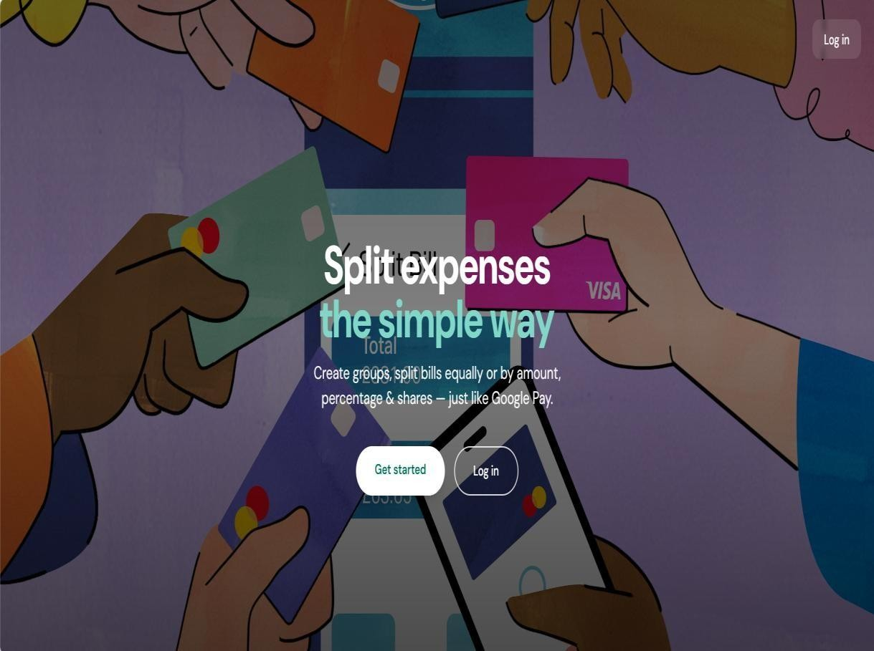

Screenshots 5.1 Home Page

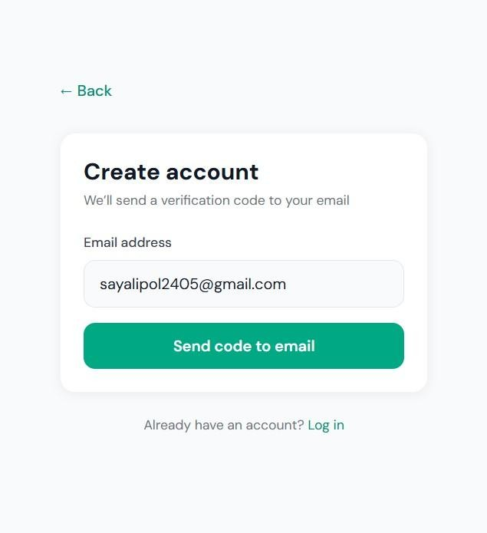

Screenshots 5.2 Registration Page

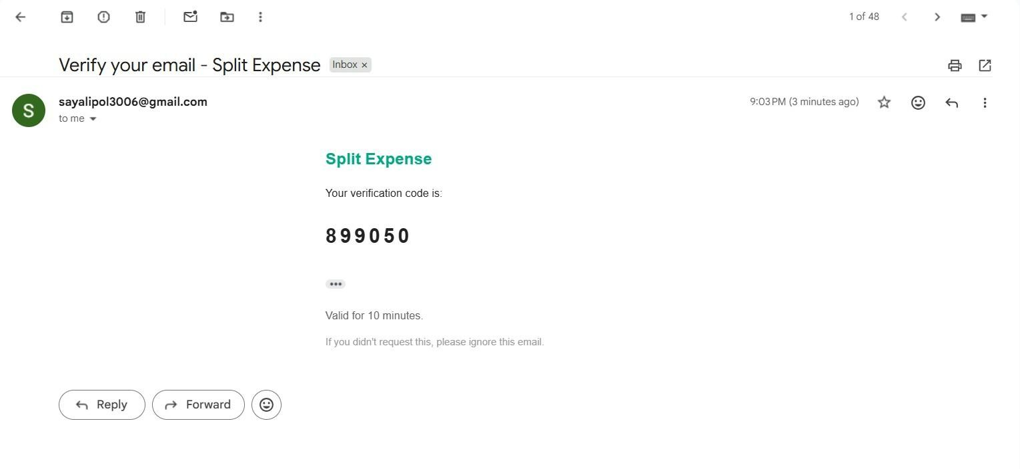

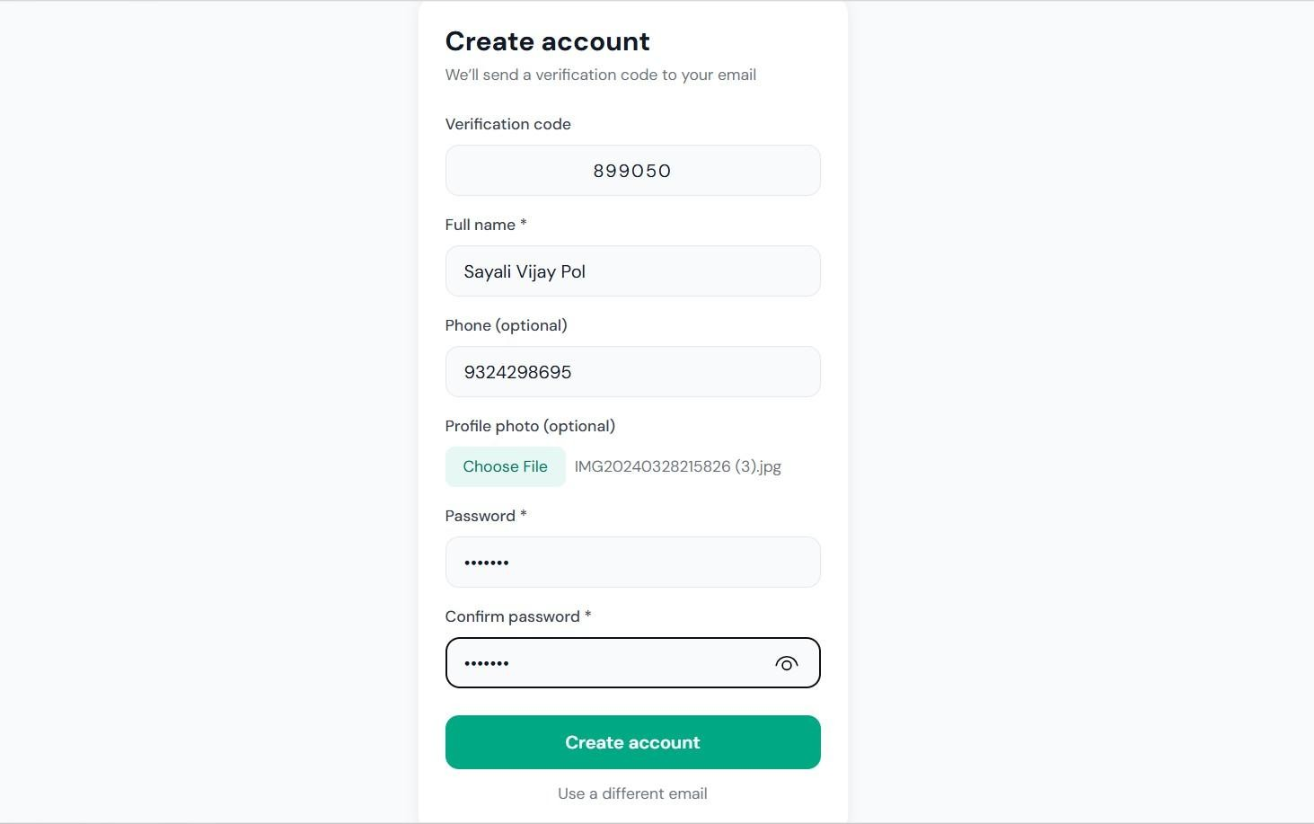
Screenshots 5.3 Registration Otp Verification

Login Form
The login form allows registered users to access the system.
Fields include:
- Email
- Password
The backend verifies the credentials using stored encrypted passwords.

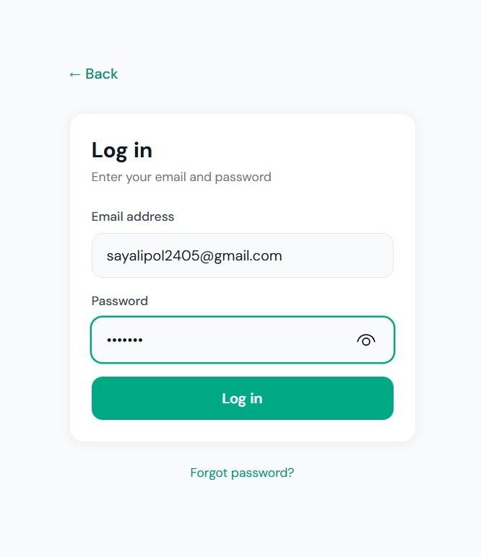
Screenshots 5.4 Login Form

Group Creation Form
This form allows users to create a new expense group. Field included:
• Group Name
After submission, the backend stores the group details in the groups table.

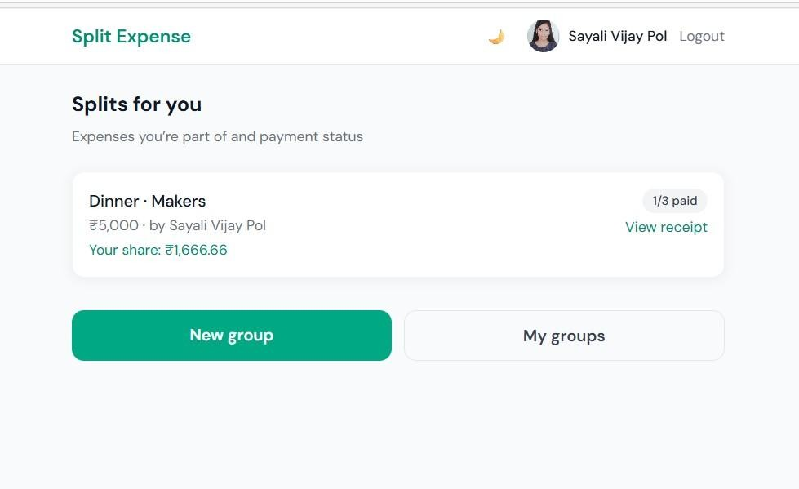

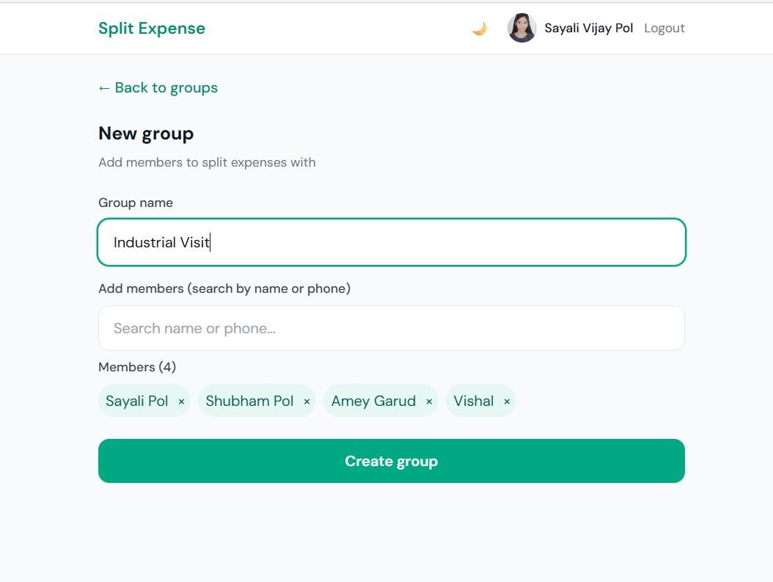
Screenshots 5.5 Group Creation Form

Expense Entry Form
Users enter expense information using the expense entry form.
Fields include:
- Expense description
- Amount
- Currency
- Split type (equal or percentage)
- Member shares
The backend stores this information in the expenses table and calculates individual shares stored in expense_splits.

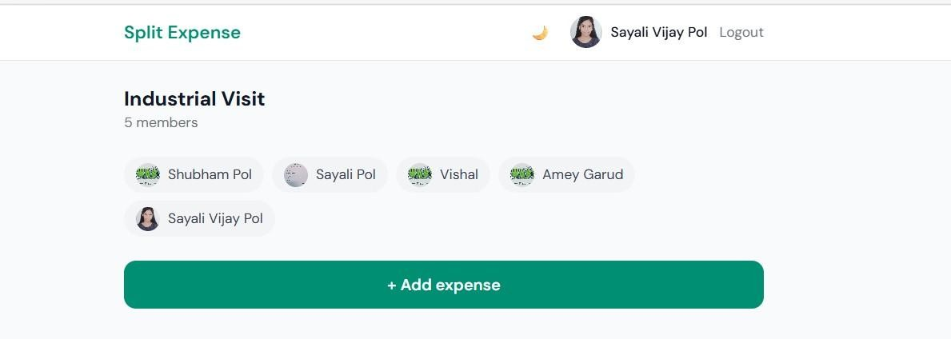

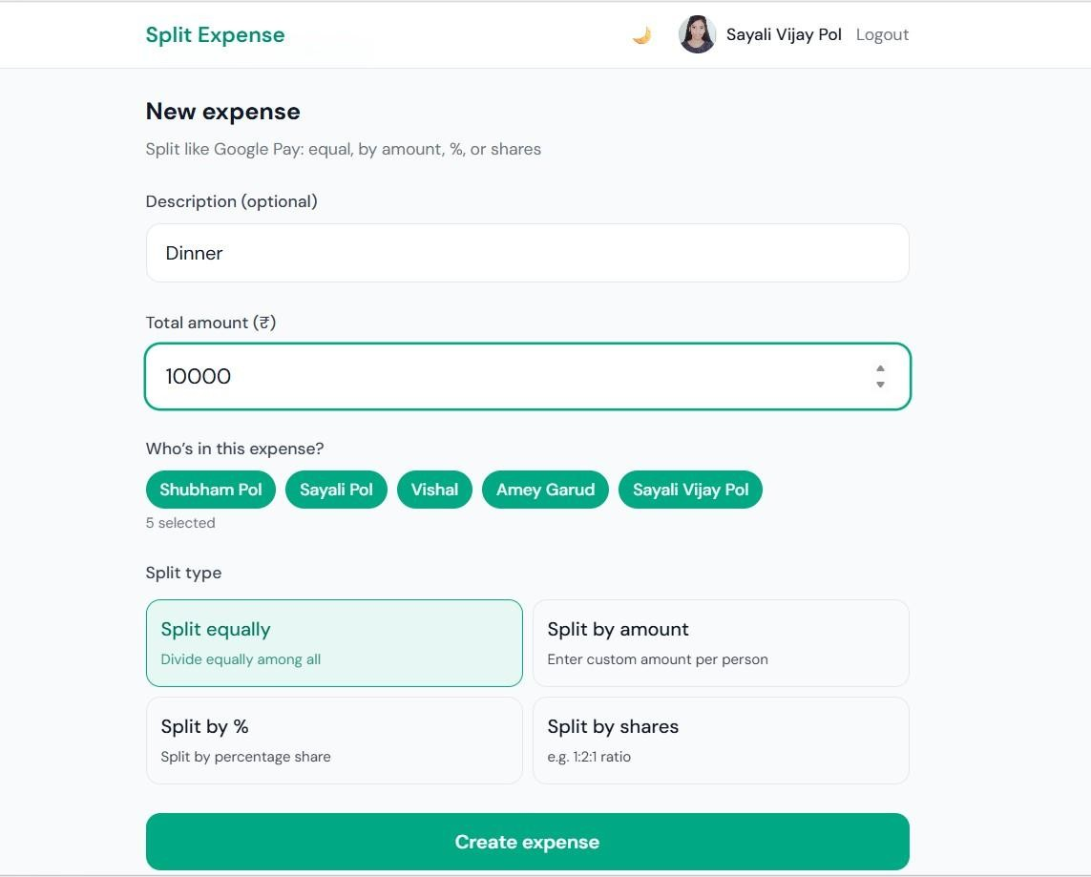

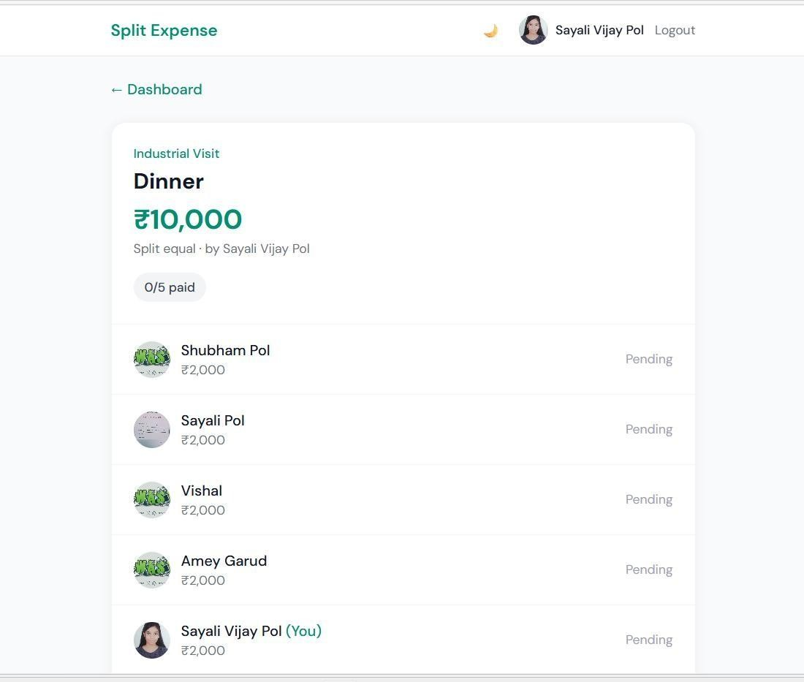
Screenshots 5.6 Expense Entry Form

Output Handling
Output handling refers to how processed data is displayed to users through the interface. The SplitSync system displays outputs such as:
- Dashboard summaries
- List of groups
- Expense history
- Member balances
- Payment confirmations
Outputs are retrieved from the database through backend APIs and displayed dynamically using React components.

Dashboard Output
The dashboard provides a summary of the user's activity in the system. It displays all groups the user belongs to and provides navigation options for managing expenses.

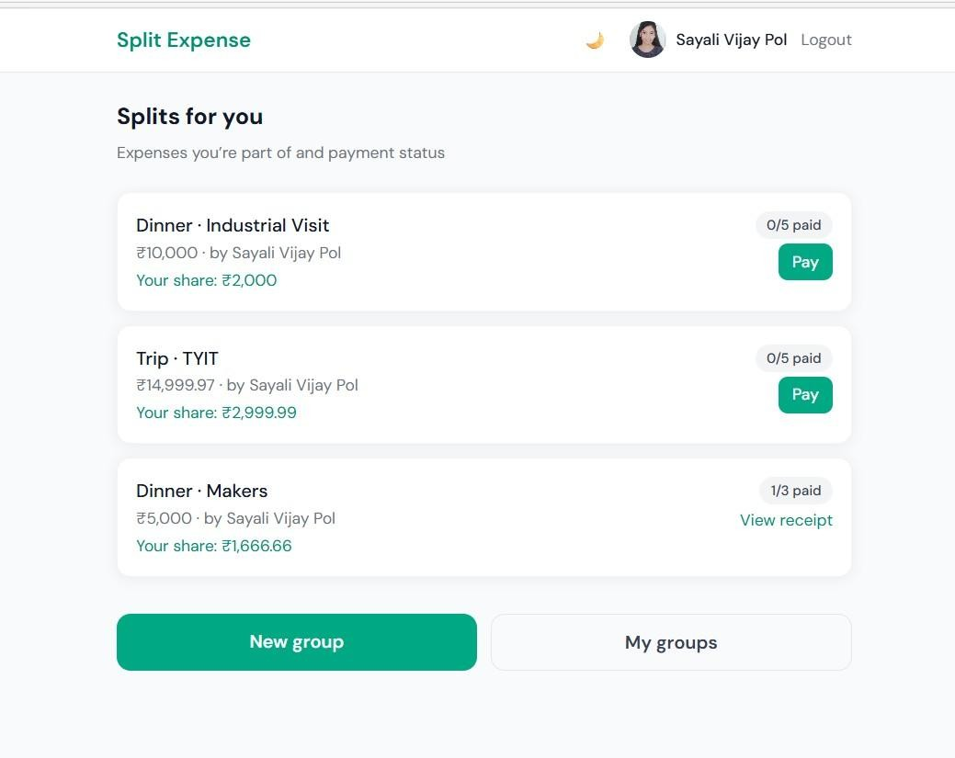
Screenshots 5.7 Dashboard Output

Group Members Output
When users open a group, the system displays a list of all group members.
Information displayed includes:
- Member names
- Member participation status
- Group activity

Expense List Output
The system displays all recorded expenses in a group along with details such as:
- Expense description
- Amount
- Person who paid
- Date of expense
This allows users to track all transactions within the group.

Balance Calculation Output
One of the main features of SplitSync is the automatic calculation of balances between members.
The system calculates who owes money and who should receive money based on recorded expenses.
Users can view these balances through the interface.
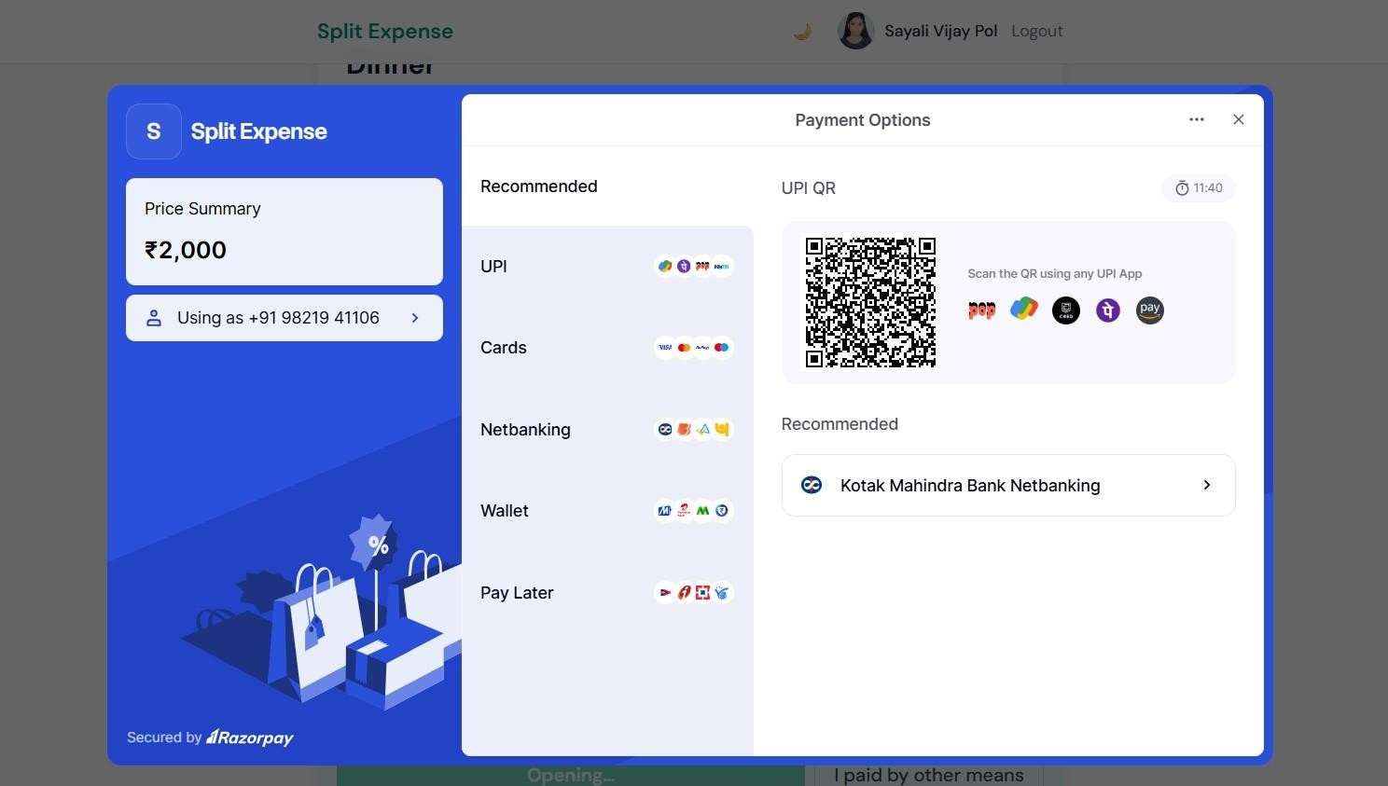

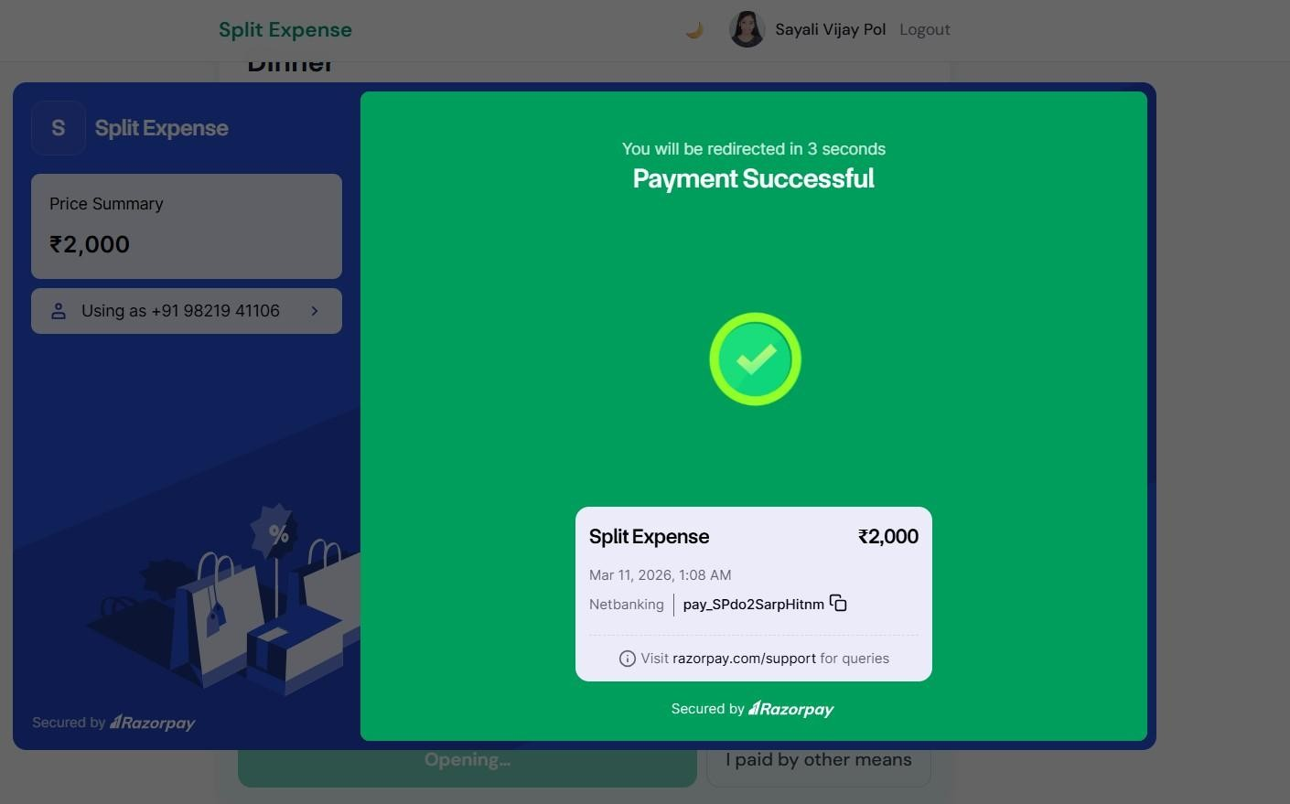
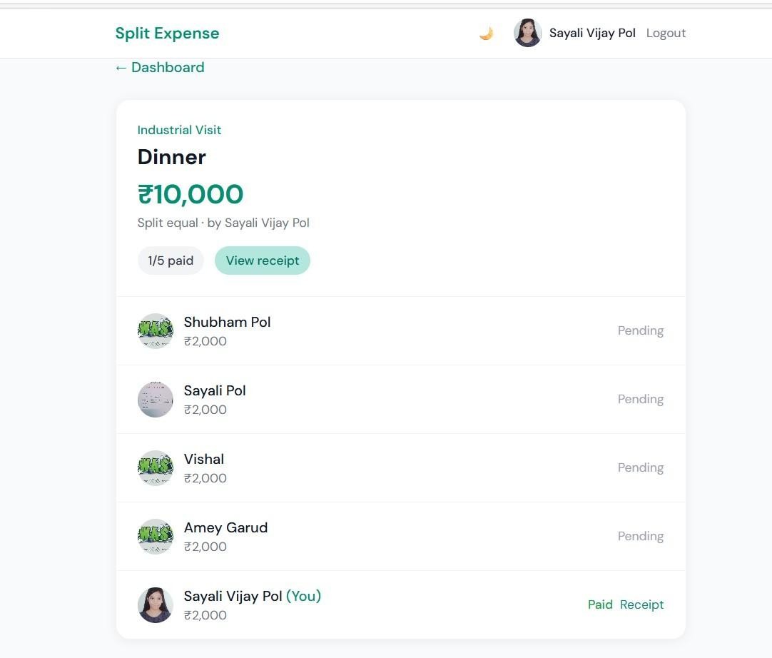

Screenshots 5.8 Balance Calculation Output

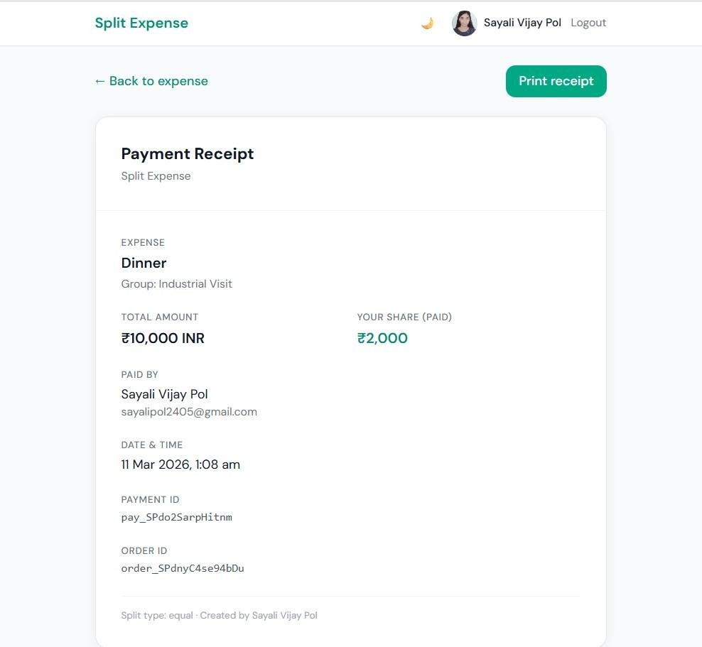
Screenshots 5.9 Split Bill

Benefits of Proper Input/Output Handling
The implementation of efficient input and output handling provides several advantages:
- Prevents invalid data entry
- Improves application security
- Enhances user experience
- Ensures accurate financial calculations
- Provides clear visualization of data
Because of these advantages, input and output handling plays a significant role in the reliability of the SplitSync application.

5.5 Challenges Faced and Solutions Implemented
During the development of the SplitSync application, several technical and design challenges were encountered. These challenges were addressed through various solutions and improvements during the development process.

Challenge 1: Designing the Expense Splitting Logic
One of the major challenges was implementing the expense splitting algorithm. The system needed to support multiple types of expense division such as equal splits and percentage-based splits.
Solution:
A flexible algorithm was developed that calculates individual shares based on the selected split type. For equal splits, the system divides the total expense amount equally among all members. For percentage splits, the system calculates shares based on predefined percentage values.
This approach ensured accurate and fair distribution of expenses among group members.

Challenge 2: Managing Database Relationships
Another challenge was designing the database structure to maintain relationships between users, groups, expenses, and members.
Solution:
A relational database schema was created using MySQL. Foreign key relationships were used to link tables such as groups, group_members, expenses, and expense_splits. This structure ensured data consistency and efficient retrieval of records.

Challenge 3: Ensuring Secure Authentication
User authentication is critical for protecting personal and financial information.
Solution:
Passwords were stored using encrypted hashing techniques to prevent unauthorized access. Additionally, OTP verification was implemented for account registration and password recovery.
This improved the overall security of the system.

Challenge 4: Handling Multiple User Requests
The system needed to handle multiple user interactions simultaneously without performance issues.
Solution:
Node.js was used for backend development because it supports asynchronous processing. This allows the server to handle multiple requests efficiently without blocking other operations.

Challenge 5: Payment Tracking and Settlement
Tracking whether users had paid their expense shares was another challenge.
Solution:
The expense_splits table was introduced to record individual payment status. Additional fields such as Razorpay order IDs and payment IDs were used to track payment transactions.

5.6 Testing Strategy and Methodology
Testing is a crucial phase in software development that ensures the system functions correctly and meets user requirements.
The SplitSync system was tested using multiple testing approaches to identify and correct errors before deployment.
The testing strategy involved the following stages:
- Unit Testing
- Integration Testing
- System Testing
- Test Case Evaluation
- Bug Tracking and Fixes
Each testing stage focused on verifying different aspects of the application to ensure reliable performance.

5.6.1 Unit Testing
Unit testing focuses on verifying the functionality of individual modules of the application.
Each module such as registration, login, group creation, and expense entry was tested independently.
Unit testing ensured that each module performed its intended function correctly without errors.
Examples of unit testing scenarios include:
- Testing the registration form validation
- Testing login authentication logic
- Testing expense calculation logic
- Testing group creation functionality
By testing individual components separately, developers were able to detect and fix errors early in the development process.

5.6.2 Integration Testing
Integration testing is performed to verify that different modules of the system work correctly when combined together. After individual modules are tested through unit testing, they are integrated to check whether the data flow between them works properly.
In the SplitSync system, several modules interact with each other, such as the user authentication module, group management module, and expense management module. Integration testing ensures that these modules communicate properly with the backend server and the database.
For example, when a user logs into the system and creates a group, the group must appear on the dashboard. Similarly, when an expense is added in a group, it should automatically update the balances of all members.
During integration testing, the following interactions were tested:
- Interaction between frontend forms and backend APIs
- Communication between backend server and MySQL database
- Data retrieval and display on the dashboard
- Expense calculations and balance updates
Integration testing confirmed that the system modules were properly connected and functioning together without errors.

5.6.3 System Testing
System testing evaluates the complete application as a whole to verify that it meets the functional and non-functional requirements defined during the system design phase.
In this stage, the entire SplitSync application was tested in a real working environment. The objective of system testing was to ensure that all features operate correctly and the system behaves as expected under normal conditions.
The system testing process involved verifying all major features of the application, including:
- User registration and login
- OTP verification process
- Group creation and member management
- Adding and viewing expenses
- Splitting expenses among group members
- Balance calculations and payment tracking
Different scenarios were tested to ensure that the system produces correct results even when multiple users interact with the application simultaneously.
System testing also ensured that the user interface is responsive, navigation is smooth, and all database operations are performed correctly.
The results of system testing confirmed that the application operates efficiently and meets the intended project objectives.

5.6.4 Test Cases with Expected and Actual Results
To verify the correct functionality of the SplitSync system, several test cases were created and executed. Each test case includes the test scenario, input data, expected result, and actual result observed during testing.

Table: Test Cases for SplitSync System
Test  Case ID | Test Scenario | Input | Expected Result | Actual Result | Status
TC01 | User Registration | Valid name, email, phone, password | User account created successfully | Account created | Pass
TC02 | User Registration with Existing Email | Existing email | System should show error | Error displayed | Pass
TC03 | User Login | Correct email and password | User logged in successfully | Login successful | Pass
TC04 | User Login with  Wrong Password | Wrong password | System shows authentication error | Error shown | Pass
TC05 | OTP Generation | Email entered | OTP sent to user email | OTP generated | Pass
TC06 | OTP Verification | Correct OTP | User verified successfully | Verification successful | Pass
TC07 | Create Group | Group name entered | Group created and stored in database | Group created | Pass
TC08 | Add Member to Group | Valid member email | Member added successfully | Member added | Pass
TC09 | Add Expense | Expense amount and description | Expense stored in database | Expense recorded | Pass
TC10 | Equal Expense  Split | Expense ₹5000 for 2 members | Each member share ₹2500 | Correct calculation | Pass
TC11 | Percentage Split | 50%, 30%, 20% split | Amount divided accordingly | Correct calculation | Pass
TC12 | View Expense History | Open group page | List of expenses displayed | Display successful | Pass
TC13 | View Group Members | Open group | Member list displayed | Members shown | Pass
TC14 | Balance  Calculation | Multiple expenses added | System calculates balances | Balance displayed | Pass
TC15 | Mark Expense as Paid | Payment completed | Payment status updated | Status updated | Pass
TC16 | Razorpay  Payment  Integration | Payment request | Payment processed successfully | Payment completed | Pass
TC17 | Invalid Expense  Amount | Negative amount | System should reject input | Validation error | Pass
TC18 | Empty Input Fields | Missing required fields | System displays validation message | Message shown | Pass
TC19 | Logout | User clicks logout | User redirected to login page | Logout successful | Pass
TC20 | Session Handling | Refresh page after login | User remains logged in | Session maintained | Pass

Table 5.1 Testing Table

5.6.5 Bug Tracking and Fixes
During the development and testing phases, several bugs and technical issues were identified. These bugs were carefully analyzed and resolved to improve system stability and performance.
Some common issues encountered during development included:
- Incorrect expense calculation when multiple users were added to a group
- Errors while retrieving group data from the database
- Login authentication failures due to incorrect password validation
- API response delays caused by inefficient queries
To resolve these issues, debugging tools and logging techniques were used to identify the root cause of each problem.
Solutions implemented included:
- Improving the expense splitting logic
- Optimizing SQL queries for faster data retrieval
- Implementing proper error handling in backend APIs
- Adding validation checks in frontend forms
Through continuous debugging and testing, the stability and performance of the system were significantly improved.

5.6.7 Tools Used for Testing
Various tools were used during the testing phase to ensure the reliability and correctness of the SplitSync system.

Browser Testing
The application was tested using different web browsers such as:
- Google Chrome
- Microsoft Edge
This ensured compatibility across different browsers.

Postman
Postman was used to test backend API endpoints. It allowed developers to send HTTP requests and verify responses from the server.
Using Postman helped in validating API functionality such as:
- User authentication APIs
- Group creation APIs
- Expense management APIs

phpMyAdmin
phpMyAdmin was used to monitor and manage the MySQL database during testing. It allowed developers to verify whether records were correctly inserted, updated, and deleted from database tables.

Console Debugging
Browser developer tools and Node.js console logs were used to detect runtime errors and debug application behavior.
These tools helped identify issues quickly and ensured the system worked correctly before final deployment.

CHAPTER 6: RESULTS

This chapter presents the results obtained after the successful development and testing of the SplitSync – Smart Expense Splitting Web Application. The purpose of this chapter is to evaluate the performance of the system and demonstrate how effectively the developed application satisfies the project objectives.
After completing the implementation and testing phases, the system was executed in a real working environment. Various functional operations such as user registration, login authentication, group creation, member management, expense tracking, and expense splitting were tested and verified. The results confirmed that the system performs all operations efficiently and provides accurate expense calculations.
The results of the project are presented in the form of test reports and user documentation. These results demonstrate that the system is capable of handling multiple users, managing shared expenses, and providing clear financial summaries for all group members.
The developed application successfully achieves the primary goal of simplifying group expense management by automating calculations and maintaining transparent records. The sections in this chapter include:
- Test Reports
- User Documentation

6.1 Test Reports
Testing was conducted to verify the correctness, reliability, and efficiency of the SplitSync system. The testing process involved executing different functionalities of the system and comparing the obtained results with the expected outcomes.
The system was tested under various scenarios including normal usage conditions and edge cases to ensure that it performs correctly in all situations. The testing results showed that the system operates smoothly and produces accurate outputs.
The major functionalities tested include:
- User registration and authentication
- OTP verification process
- Group creation and management
- Adding and managing group members
- Recording expenses
- Expense splitting calculations
- Payment status tracking
- Displaying balances between members
The successful execution of these functions confirmed that the system meets the functional requirements specified during the system design phase.

Registration and Authentication Results
The registration module was tested to verify whether new users could successfully create accounts in the system.
During testing, users entered their personal details including name, email, phone number, and password. The system validated the inputs and stored the user data securely in the database.
The login functionality was also tested to ensure that registered users could access the system using valid credentials.
The results confirmed that:
- The system correctly registers new users.
- Duplicate email registrations are prevented.
- Users can log in using valid credentials.
- Incorrect login attempts are rejected with appropriate error messages.

The group management functionality was tested to verify whether users could create and manage expense groups.
Users successfully created groups such as:
- Manali
- Rajasthan
- SYIT
- Freshers
- Makers
The groups were stored in the database and displayed correctly on the user dashboard. Members were successfully added to groups, and the system maintained accurate records in the group_members table.
The results confirmed that:
- Groups can be created successfully.
- Multiple members can be added to a group.
- Group data is stored and retrieved correctly from the database.

Expense Management Results
The expense management module was tested to verify whether users could record and manage expenses within a group.
Users added expenses such as:
- Food – ₹5000
- Lunch – ₹2000
- Trip – ₹15000
- Dinner – ₹15000
The system successfully recorded these expenses in the expenses table and displayed them within the group interface.
The system also recorded which user created the expense and the date of the transaction.
The results confirmed that:
- Expenses are stored correctly in the database.
- Expense history is displayed accurately.
- Users can track group expenses easily.

Expense Splitting Results
One of the most important features of the system is the automatic splitting of expenses among group members.
The system supports two types of expense splitting:
- Equal splitting
- Percentage-based splitting

For example:
Expense: ₹5000
Members: 2 Split Type: Equal Result:
User A share = ₹2500
User B share = ₹2500

For percentage splitting:
Expense: ₹15000
Member percentages: 50%, 20%, 30% Result:
User A share = ₹7500
User B share = ₹3000
User C share = ₹4500
The system successfully calculated these values and stored them in the expense_splits table.

Payment Tracking Results
The system also tracks whether users have paid their share of an expense.
Each member's payment status is recorded in the expense_splits table using the "paid" field.
The system also stores payment information such as:
- Razorpay Order ID
- Razorpay Payment ID
- Payment timestamp
Testing confirmed that the system correctly updates the payment status once the payment is completed.

System Performance Results
The overall performance of the SplitSync system was tested to ensure smooth operation.
The results showed that:
- The system responds quickly to user requests.
- Database operations are performed efficiently.
- Multiple users can interact with the system simultaneously.
- Expense calculations are performed accurately.
The system successfully handled all tested operations without major errors.

6.2 User Documentation
User documentation provides instructions that help users understand how to use the SplitSync application effectively. It serves as a guide for users who want to perform tasks such as creating accounts, managing groups, recording expenses, and tracking balances.
The user documentation explains the step-by-step process for using each feature of the system.

Step 1: User Registration
To begin using the system, a new user must first create an account.
Steps:
- Open the SplitSync application in the web browser.
- Navigate to the registration page.
- Enter the required information such as name, email, phone number, and password.
- Click the Register button.
- Enter the OTP sent to the registered email for verification. After successful verification, the user account is created.

Step 2: User Login
After registration, users can log into the system.
Steps:
- Open the login page.
- Enter the registered email and password.
- Click the Login button.
If the credentials are correct, the user is redirected to the dashboard.

Step 3: Creating a Group
Users can create a group to manage shared expenses.
Steps:
- Click the Create Group option.
- Enter the group name.
- Click Create.
The new group will appear on the user dashboard.

Step 4: Adding Members to a Group After creating a group, users can add members.
Steps:
- Open the group page.
- Enter the email address of the member.
- Click Add Member.
The member will be added to the group.

Step 5: Adding Expenses Users can add expenses for the group.
Steps:
- Open the group.
- Click Add Expense.
- Enter expense details such as amount, description, and split type.
- Click Submit.
The system will automatically split the expense among members.

Step 6: Viewing Expense Summary
Users can view the list of all expenses in the group. The system displays:
- Expense description
- Amount
- Payer
- Date
This allows users to track all financial activities within the group.

Step 7: Checking Balances
The system automatically calculates balances between group members.
Users can see:
- Who owes money
- Who should receive money
- Individual expense shares
This feature ensures transparency among group members.

CHAPTER 7: CONCLUSION

The development of the SplitSync – Smart Expense Splitting Web Application was aimed at solving the common problem of managing shared expenses among groups of people. When friends, family members, or colleagues share expenses during trips, events, or daily activities, it often becomes difficult to keep track of who paid and how much each person owes. Manual calculations can lead to confusion, errors, and misunderstandings.
The SplitSync system was designed and implemented to provide a digital platform that simplifies the management of group expenses. The application allows users to create groups, add members, record expenses, and automatically split the costs among participants. The system calculates individual balances and clearly displays who owes money and who should receive payments.
The project successfully integrates modern web technologies such as React.js for frontend development, Node.js with Express.js for backend functionality, and MySQL for database management. The system also incorporates features such as OTP verification, secure authentication, and payment tracking.
Throughout the development process, the system was designed using proper software engineering principles including system analysis, system design, database design, and modular implementation. Comprehensive testing was performed to ensure that all modules function correctly and produce accurate results.
The final implementation of the SplitSync application demonstrates that the system can effectively manage shared expenses and provide users with a clear and transparent view of their financial interactions within groups. The application reduces the need for manual calculations and helps maintain fairness and accuracy when dividing expenses. Overall, the project successfully meets its objectives and demonstrates how technology can simplify everyday financial management tasks.

7.1 Significance of the System
The SplitSync system provides several important benefits for users who frequently share expenses with others. Managing group expenses manually can be timeconsuming and prone to mistakes. By automating this process, the system provides a convenient and reliable solution.
One of the most significant advantages of the system is its ability to automatically calculate expense splits among group members. Users do not need to manually divide amounts or track payments, as the system performs these calculations instantly. Another important feature of the system is transparency. All members of a group can view the recorded expenses and understand how the total amount is divided. This helps prevent misunderstandings and ensures fairness among participants.
The system also improves record management. Instead of keeping handwritten notes or separate records, all expense information is stored in a centralized database. This allows users to easily access previous transactions and review financial activity within the group.
Security is another key aspect of the system. User authentication and OTP verification ensure that only authorized users can access their accounts. Passwords are securely stored in encrypted format, protecting user data.
The system is also scalable and flexible. Multiple groups can be created, and each group can contain several members and expenses. This makes the application useful for a wide range of scenarios such as:
- Group trips and vacations
- College project expenses
- Shared household expenses
- Event planning and cost sharing
- Business team expenses
By simplifying the process of expense tracking and settlement, the SplitSync system significantly improves the efficiency of managing shared finances.

7.2 Limitations of the System
Although the SplitSync application provides many useful features, there are certain limitations in the current version of the system.
One limitation is that the system is primarily designed for web-based usage and may not be fully optimized for mobile devices. While the application can be accessed through mobile browsers, a dedicated mobile application could provide a better user experience.
Another limitation is that the payment integration features are still basic. Although payment tracking is implemented, the system could be enhanced by integrating additional payment gateways and enabling direct settlement between users within the application.
The system currently relies on users manually entering expense information. If incorrect data is entered, it may affect the accuracy of the calculations. Additional validation and error-checking mechanisms could further improve data accuracy.
The application also requires a stable internet connection to function properly because it relies on server communication and database operations. Offline functionality is not currently supported.
In addition, the current version of the system does not include advanced financial analytics such as spending trends or expense categorization. These features could provide deeper insights into group spending behavior.
Despite these limitations, the system performs its core functions effectively and provides a strong foundation for further improvements.

7.3 Future Scope of the Project
The SplitSync system can be further enhanced by adding several advanced features and improvements in future versions. These enhancements can increase the usability, efficiency, and functionality of the application.
One potential improvement is the development of a mobile application for Android and iOS platforms. A mobile app would allow users to manage expenses more conveniently and receive real-time notifications about group activities.
Another future enhancement could involve integrating multiple payment gateways such as UPI, Google Pay, and Paytm. This would allow users to settle their balances directly within the application, eliminating the need for external payment methods. The system could also include real-time notifications to inform users when new expenses are added, payments are completed, or group members make updates. Notifications can improve communication among group members and keep everyone informed about financial activities.
Another possible enhancement is the addition of expense categorization and analytics. By analyzing spending patterns, the system could provide users with reports and insights into their financial behavior.
Artificial intelligence and machine learning techniques could also be incorporated in the future to provide smart recommendations for expense management.
Additional features such as multi-currency support, expense reminders, and automatic settlement suggestions could further enhance the functionality of the application.
By implementing these improvements, the SplitSync system can evolve into a comprehensive financial management tool capable of supporting a wide range of users and use cases.

CHAPTER 8 : REFERENCES / BIBLIOGRAPHY

Bushra Shaikh, Ayesha Khan, and Rehan Patel. (2025). A Study on the Advancement of Bill Splitting and Expense Management Applications. International
Journal of Computer Science and Financial Technology. https://scholar.google.com/scholar?q=A+Study+on+the+Advancement+of+Bill+Splitt
ing+and+Expense+Management+Applications

Arshi Khan, Bushra Shaikh, and Mehak Siddiqui. (2025). Group Expense Tracking, Analysis, and Settlement using a Web-based Application. International Journal of Advanced Research in Computer Science and Software Engineering. https://scholar.google.com/scholar?q=Group+Expense+Tracking+Analysis+and+Settl ement+using+a+Web-based+Application

Andres Fielbaum, Nicolas Jara, and Andres Munoz. (2022). Cost Sharing
Mechanisms for Ridepooling Systems: Stability and Efficiency Analysis.
Transportation Research Part B: Methodological. https://scholar.google.com/scholar?q=Cost+Sharing+Mechanisms+for+Ridepooling+
Systems+Fielbaum

Vasundhara Sharma, Rahul Mehta, and Nisha Patel. (2025). Splitwise – A Smart Bill Splitting and Expense Management System. International Journal of Innovative
Technology and Exploring Engineering. https://scholar.google.com/scholar?q=Splitwise+A+Smart+Bill+Splitting+and+Expen
se+Management+System

Khairkar, Raut, and Patil. (2025). Splitit: Group and Personal Finance Tracker. International Journal of Computer Applications and Financial Systems. https://scholar.google.com/scholar?q=Splitit+Group+and+Personal+Finance+Tracker

Crokidakis, N., and Sigaud, O. (2025). Statistical Physics Approach to Fair Bill Splitting in Social Groups. Physica A: Statistical Mechanics and its Applications. https://scholar.google.com/scholar?q=Statistical+Physics+Approach+to+Fair+Bill+Sp litting

Ahmed, S., Khan, M., and Hussain, T. (2022). Determining Exact Cost Allocation in Shared Mobility Services. Transportation Research Record: Journal of the
Transportation Research Board. https://scholar.google.com/scholar?q=Determining+Exact+Cost+Allocation+in+Share
d+Mobility+Services

Shaikh, Bushra, Khan, Arshi, and Patel, Sameer. (2025). Group Expense Tracking
Using Mobile and Web Technologies. International Journal of Computer Science and
Mobile Computing. https://scholar.google.com/scholar?q=Group+Expense+Tracking+Using+Mobile+and
+Web+Technologies

Jadhav, Rohit, Deshmukh, Ajay, and Patil, Sneha. (2025). SplitEase: A Web-Based Application for Efficient Expense Sharing. International Journal of Engineering
Research and Applications. https://scholar.google.com/scholar?q=SplitEase+A+WebBased+Application+for+Effi
cient+Expense+Sharing

Gawande, Pratik, Kulkarni, Neha, and Joshi, Rahul. (2025). Improving Group
Financial Transparency Through Smart Expense Management Systems. International Journal of Advanced Computer Science and Applications. https://scholar.google.com/scholar?q=Improving+Group+Financial+Transparency+Th
rough+Smart+Expense+Management+Systems

CHAPTER 9 – ANNEXURE

9.1 List of Tables

Table 3.1 Software Component ............................................................................................... 37
Table 3.2 Hardware Component .............................................................................................. 38
Table 5.1 Testing Table ............................................................................................................ 87

9.2 List of Figures

Figure 3.1 Gantt Chart ............................................................................................................. 35
Figure 3.2 PERT Chart flow .................................................................................................... 36
Figure 4.1 Use Case Diagram ................................................................................................. 42
Figure 4.2 Sequence Diagram ................................................................................................. 43
Figure 4.3 Activity Diagram.................................................................................................... 44
Figure 4.4 Class Diagram ........................................................................................................ 45
Figure 4.5 State Machine Diagram ......................................................................................... 46
Figure 4.6 Component Diagram .............................................................................................. 47

9.3 List of Screenshots

Screenshots 4.1 Database Page ............................................................................................... 52
Screenshots 4.2 Tables ............................................................................................................ 52
Screenshots 4.3 Expense Table ............................................................................................... 53
Screenshots 4.4 Expense Splits table ...................................................................................... 53
Screenshots 4.5 Groups Table ................................................................................................. 54
Screenshots 4.6 Group Members Table ................................................................................... 54
Screenshots 4.7 Otps Table ..................................................................................................... 55
Screenshots 4.8 Users Table .................................................................................................... 55
Screenshots 5.1 Home Page .................................................................................................... 73
Screenshots 5.2 Registration Page .......................................................................................... 74
Screenshots 5.3 Registration Otp Verification ........................................................................ 75
Screenshots 5.4 Login Form.................................................................................................... 76
Screenshots 5.5 Group Creation Form .................................................................................... 77
Screenshots 5.6 Expense Entry Form ...................................................................................... 79
Screenshots 5.7 Dashboard Output ......................................................................................... 80
Screenshots 5.8 Balance Calculation Output .......................................................................... 82
Screenshots 5.9 Split Bill ........................................................................................................ 83

