

**DR.LANAKPALLI BULLAYYA COLLEGE**

**VISAKHAPATNAM-530016**

# HEART DISEASE ANALYSIS

**LONG -TERM VIRTUAL INTERNSHIP PROGRAM 2024**

**DATA ANALYTICS**

**PROJECT PREPARED BY**

**Prashant kumar(T-leader)**

## 1. Heart diseases

Heart disease is perceived as the deadliest disease in the human life across the world. In particular, in this type of disease the heart is not capable in pushing the required quantity of blood to the remaining organs of the human body in order to accomplish the regular functionalities [6]. Some of the symptoms of heart disease include physical body weakness, improper breathing, swollen feet, etc. The techniques are essential to identify the complicated heart diseases which results in high risk in turn affect the human life [7]. Presently, diagnosis and treatment process are highly challenging due to inadequacy of physicians and diagnostic apparatus that affect the treatment of heart patients [8]. Early diagnosis of heart disease is significant to minimize the heart related issues and to protect it from serious risks [9]. The invasive techniques are implemented to diagnose heart diseases based on medical history, symptom analysis report by experts, and physical laboratory report. Moreover, it causes delay and imprecise diagnosis due to human intervention. It is time consuming, computationally intensive and expensive at the time of assessment [10]. Heart disease can be predicted based on various symptoms such as age, gender, pulse rate etc. Data analysis in healthcare assists in predicting diseases, improving diagnosis, analysing symptoms, providing appropriate medicines, improving the quality of care, minimizing cost, extending the life span and reduces the death rate of heart patients. ECG (Electro Cardio Gram) helps in screening irregular heart beat and stroke with the embedded sensors by resting it on a chest in order to track the patient’s heart beat. Heart disease prediction is being done with the detailed clinical data that could assist experts to make decision. Human life is highly dependent on proper functioning of blood vessels in the heart. The improper blood circulation causes heart inactiveness, kidney failure, imbalanced condition of brain, and even immediate death also. Some of the risk factors that can cause heart diseases are obesity, smoking, diabetes, blood pressure, cholesterol, lack of physical activities and unhealthy diet. Acute Myocardial Infarction (AMI) is the cardiovascular disease that happens due to interruption in the blood flow or circulation in the heart muscle, causes heart muscle to become necrotic (damage or die) [11]. The primary reason for this disease is the blockage means that the blood flow to the heart muscle become obstructed or reduced. If the blood flow is reduced or obstructed, the functioning of red blood cells that carries enough oxygen helps in sustaining consciousness and human life have a severe impact. Without oxygen supply for 6 to 8 minutes, heart muscle may get arrest that in turn resulted in patient’s death. The significant cause of the cardiovascular disease is ‘plaque’ means a hard substance formed in the coronary arteries which is made up of cholesterol (fat), causes the blood flow to be reduced or obstructed. Sometimes, it can be formed in the arteries known as atherosclerosis and 132 R. Indra Kumari et al. / Procedia Computer Science 173 (2020) 130–139 R. Indra Kumari et al./ Procedia Computer Science 00 (2020) 000–000 3 investigating the cause of it are determined as a chronic inflammation. The increase in the amount of white blood cells causes inflammation and other subsequent disorders such as stroke or reinfarction [12]. Generally, there are two stages of wound healing in terms of monocytes and macrophages, namely, inflammatory and reparative stages. However, the two stages are compulsory for proper wound healing and if the inflammation is continued too long, then it leads to heart failure. An unusual type of heart disease is the acute spasm or contraction in the coronary arteries. The spasms become visible in arteries suddenly with no symptom of atherosclerosis [13]. It blocks the blood flow that causes oxygen deprivation in the heart. Male genders are more likely to experience heart attack than females. Moreover, women can experience pain more than an hour and the duration to experience the pain of men is normally less than an hour.

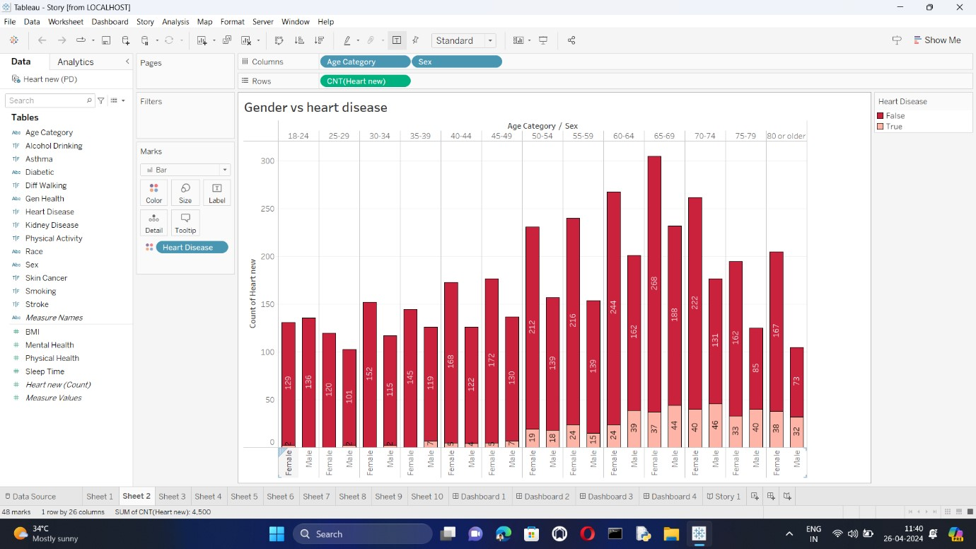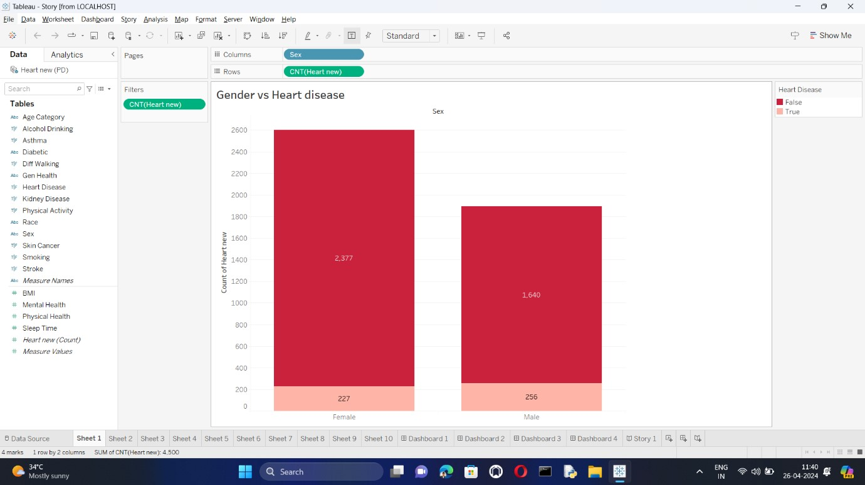

## 2.Diabatic vs Stroke

In the total population, stroke is the fifth most common cause of death and the leading neurological cause of long-term disability in the United States, accounting in 2011 for $34 billion in health care costs; the mean lifetime cost to care for a single patient with an ischemic stroke was estimated at $140,048 (1). In 2014, there were an estimated 795,000 strokes, approximately 610,000 being new or incident strokes and around 185,000 being recurrent strokes (1). Persons with diabetes have about twice the risk for stroke compared to those without diabetes, particularly for ischemic stroke. Yet, the aetiology of stroke in persons with diabetes is comparable to etiologist in nondiabetic populations. Multiple underlying pathophysiological processes in diabetes, however, lead to a high prevalence of small vessel and/or large vessel atherosclerosis in individuals with diabetes. This chapter describes the measurement and classification of stroke and stroke subtypes, and in persons with diabetes, the pathophysiology of stroke, the epidemiology of stroke, predictors of stroke risk, control of risk factors for stroke, and the disease course and prognosis after a stroke.

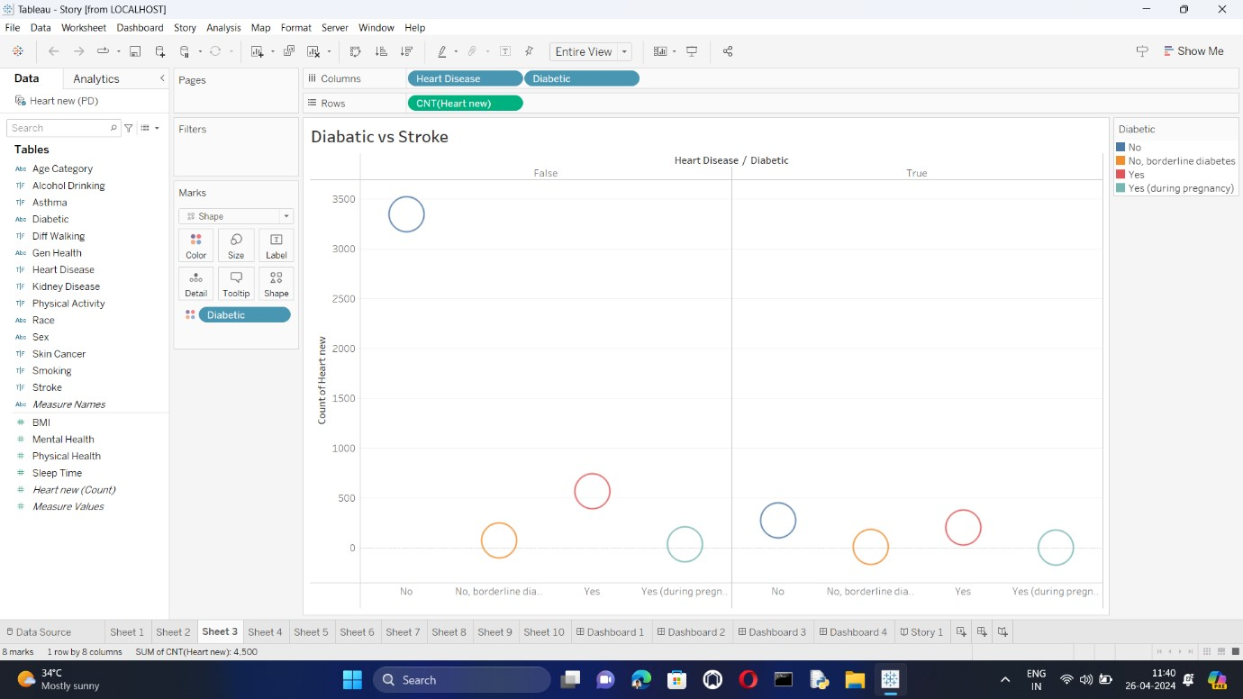

## 3.Impact of smoking and Alcohol on Heart Disease

Smoking and alcohol are two major risk factors for heart disease. They can damage your heart and blood vessels in a number of ways.

**Smoking**

* Damages the lining of your arteries, making them more likely to become clogged with plaque.
* Lowers your HDL ("good") cholesterol levels and raises your LDL ("bad") cholesterol levels.
* Increases your blood pressure and heart rate.
* Reduces the amount of oxygen in your blood.
* Can cause inflammation throughout your body.

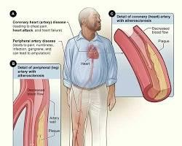

Smoking and heart disease

**Alcohol**

* Can damage your heart muscle, leading to a condition called cardiomyopathy.
* Can raise your blood pressure.
* Can contribute to obesity, which is another risk factor for heart disease.
* Can increase your risk of stroke.

**How much alcohol is too much?**

The amount of alcohol that is safe to drink varies depending on your individual health. However, the American Heart Association recommends that adults limit themselves to no more than one drink per day for women and two drinks per day for men.

If you are concerned about your risk of heart disease, it is important to talk to your doctor. They can help you create a plan to reduce your risk factors, such as quitting smoking and limiting your alcohol intake.

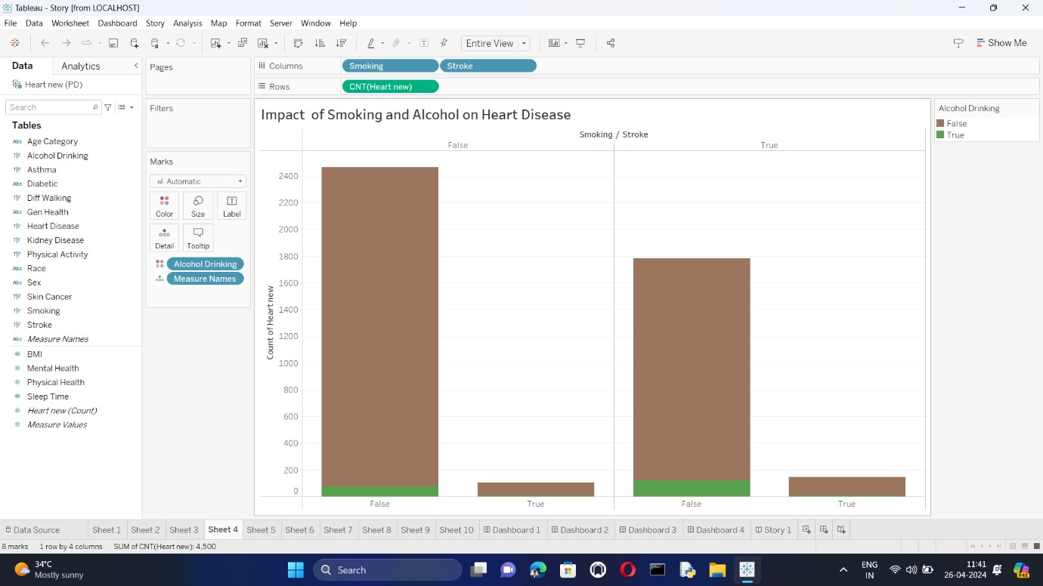

## 4.Stroke vs other Diseases

Here's a deeper analysis of stroke compared to asthma, kidney disease, and skin cancer:

**Similarities:**

* **Shared Risk factors:** All four diseases share some risk factors like high blood pressure, diabetes, and obesity. These factors contribute to inflammation and damage throughout the body.
* **Chronic vs. Acute:** Both stroke and kidney disease can be chronic conditions with episodes of worsening (stroke) or gradual decline (kidney disease). Asthma and some skin cancers are primarily chronic conditions with ongoing management.
* **Lifestyle Impact:** All these diseases can significantly impact your lifestyle, requiring medication adherence, dietary modifications, and potential activity limitations.

**Differences:**

* **Onset and Progression:** Stroke has a sudden onset, with symptoms appearing rapidly. Asthma and most skin cancers develop gradually over time. Kidney disease can be sudden (acute kidney injury) or gradual (chronic kidney disease).
* **Treatment Focus:** Stroke treatment focuses on immediate intervention to restore blood flow and minimize damage. Asthma and skin cancer treatments aim to manage symptoms and prevent progression. Some kidney disease cases may require dialysis or transplantation to replace kidney function.
* **Disability:** Stroke has a high risk of permanent disability depending on the severity and location of the brain damage. The other three diseases might cause varying degrees of disability depending on the specific case.
* **Mortality:** Stroke carries a high risk of mortality, particularly in the immediate aftermath. Early diagnosis and treatment are crucial. While some skin cancers can be life-threatening if neglected, early detection usually leads to good outcomes. Asthma and well-managed kidney disease generally don't significantly increase mortality risk.

**Public Health Impact:**

* Stroke is a leading cause of death and disability globally.
* Asthma is a prevalent chronic condition affecting millions, particularly children.
* Kidney disease is a growing public health concern with rising rates of diabetes and hypertension.
* Skin cancer, especially melanoma, is a significant public health issue requiring sun safety awareness.

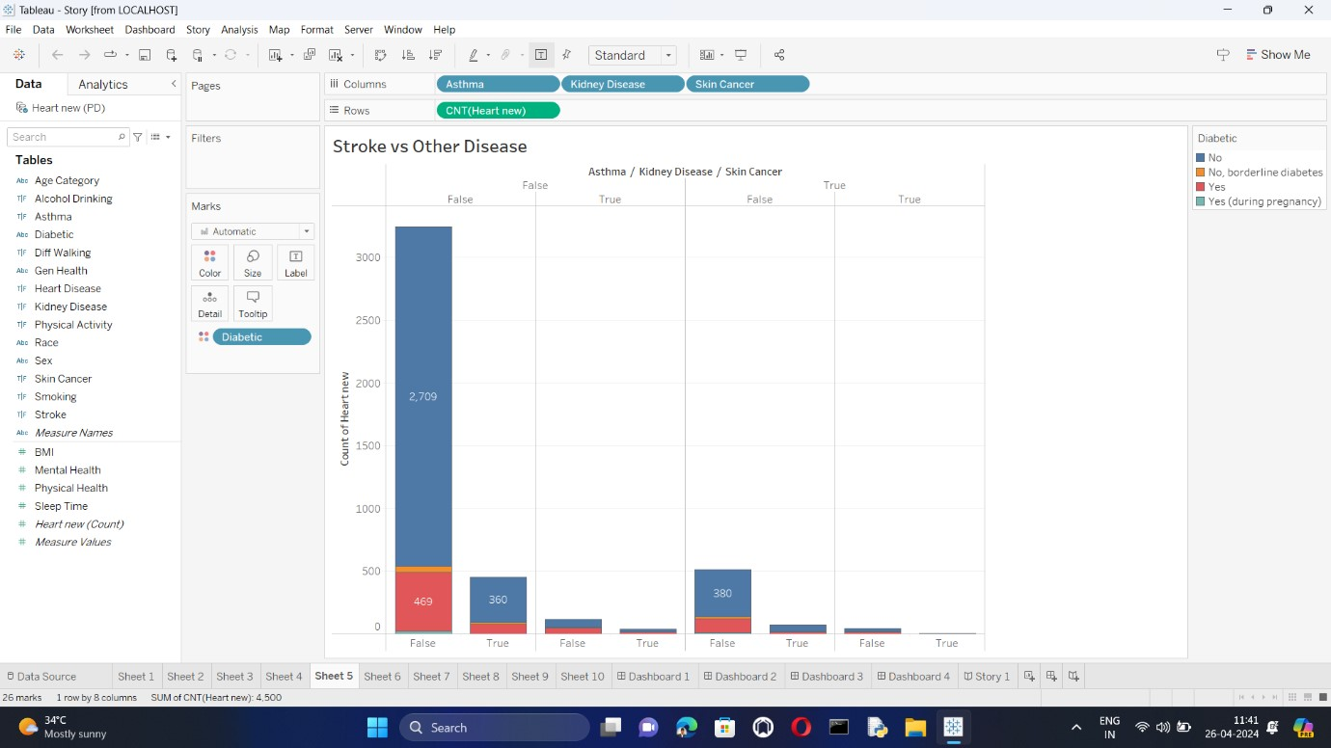

**Preventative Measures:**

* Stroke prevention focuses on managing risk factors through healthy lifestyle choices, medication, and blood pressure control.
* Asthma often involves identifying and avoiding triggers alongside medication adherence.
* Kidney disease prevention emphasizes controlling diabetes, maintaining healthy blood pressure, and avoiding nephrotoxins (substances toxic to the kidneys).
* Skin cancer prevention prioritizes sun protection using sunscreen, protective clothing, and limiting UV exposure. Regular skin checks are also important.

**Conclusion:**

Stroke, asthma, kidney disease, and skin cancer are all significant health concerns, but they differ significantly in their causes, symptoms, and long-term impacts. Understanding these differences is crucial for prevention, early detection, and effective management. If you have concerns about any of these diseases, consult a healthcare professional.

### 5.Race vs heart disease

Race and heart disease have a complex relationship. Here's a breakdown:

**Risk Factors:**

* **Underlying Conditions:** This increased risk is partly due to higher rates of underlying conditions like high blood pressure, diabetes, and obesity among minority populations.
* **Social Determinants of Health:** Social factors like access to quality healthcare, healthy food options, and safe neighborhoods can also play a role. These factors often differ by race and ethnicity, impacting overall health outcomes.

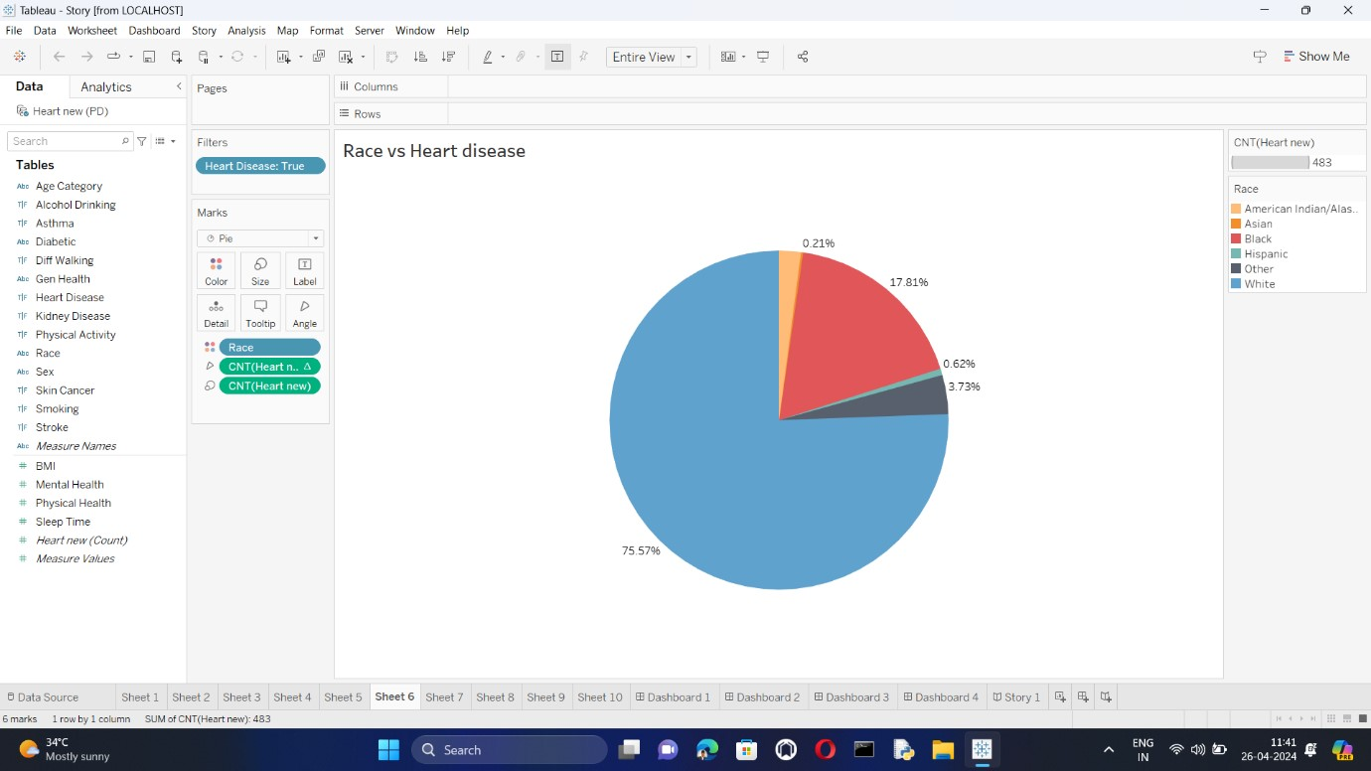

conclusion, race is a significant factor in heart disease risk, but it's just one piece of the puzzle. Addressing the underlying social and biological factors is key to achieving better cardiovascular health outcomes for all populations.

## 6.General health vs heart disease

General health refers to the overall well-being of your body, mind, and spirit. It encompasses physical health, mental health, and social health. When you're in good general health, you have the energy and stamina to do the things you want to do, you're able to cope with stress in a healthy way, and you have good relationships with others.

Heart disease, on the other hand, is a specific type of medical condition that affects your heart. It's the leading cause of death for both men and women in the United States. There are many different types of heart disease, but they all share one common feature: damage to the heart and blood vessels.

Here's a table summarizing the key differences between general health and heart disease:

|  |  |  |
| --- | --- | --- |
| **Feature** | **General Health** | **Heart Disease** |
| **Definition** | Overall well-being of body, mind, and spirit | A specific type of medical condition that affects the heart |
| **Examples** | Physical health, mental health, social health | Coronary artery disease, arrhythmia, heart failure |
| **Causes** | Varies depending on the aspect of health | Lifestyle factors, genetics, medical conditions |
| **Prevention** | Healthy lifestyle choices | Healthy lifestyle choices, medications, surgery |

In short, general health is a broad term that encompasses your overall physical, mental, and social well-being. Heart disease is a specific medical condition that affects your heart.

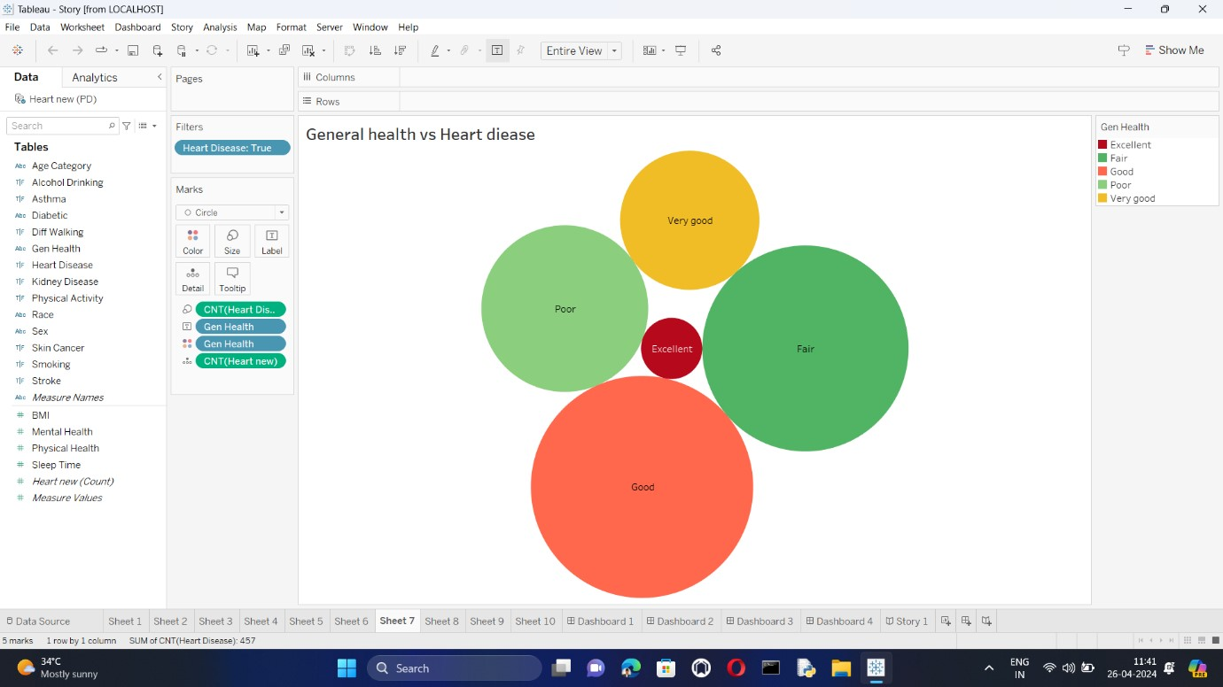

### 7.Physical activity vs Heart disease

Regular physical activity is one of the best things you can do for your heart health. It can help to:

* Reduce your risk of developing heart disease
* Manage your weight
* Lower your blood pressure
* Improve your cholesterol levels
* Control your blood sugar

**How physical activity helps your heart**

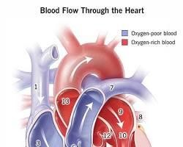

Heart with blood circulation

When you are active, your heart works harder to pump blood throughout your body. This strengthens your heart muscle and improves its ability to pump blood efficiently. Physical activity also helps to keep your blood vessels clear and flexible, which reduces your risk of heart disease.



### 8.Age vs BMI Diabetic

Here's an analysis of the relationship between age and BMI in diabetics:

**Positive Correlation:**

* **Increased risk with higher BMI:** Studies consistently show a positive correlation between BMI and type 2 diabetes (T2D), the most common form. A higher BMI indicates overweight or obesity, which puts strain on the body's insulin processing, increasing the risk of T2D [1].

**Age and BMI Interaction:**

* **Earlier onset with higher BMI:** There's evidence that individuals with a higher BMI tend to develop T2D at a younger age [2, 3]. This suggests a stronger influence of BMI on the age of T2D onset.
* **Shifting trends with age:** BMI may not keep rising with age throughout life. Studies suggest a peak in BMI around 50-60 years, potentially followed by a decline

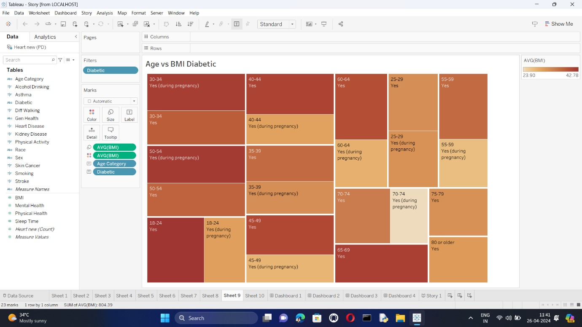

**Overall:**

* Both age and BMI are risk factors for diabetes, but they interact in complex ways.
* Higher BMI is associated with an increased risk of T2D and earlier disease onset.
* Age itself also increases the risk of T2D, but the impact of BMI might be stronger at younger ages.

**Further exploration:**

* More research is needed to understand the nuances of the age-BMI-diabetes relationship, particularly regarding factors like ethnicity and lifestyle.

If you'd like to delve deeper into specific aspects, like the mechanisms behind the BMI-diabetes link, feel free to ask!

### 9.People got stroke suffering from Heart disease and Diabetic

You're right. People with heart disease and diabetes are at an increased risk of stroke. Here's why:

* **High blood sugar:** Over time, high blood sugar from diabetes can damage blood vessels throughout the body, including those that supply blood to the brain. This damage can make it more likely for a blood clot to form or for a blood vessel to burst, either of which can cause a stroke.

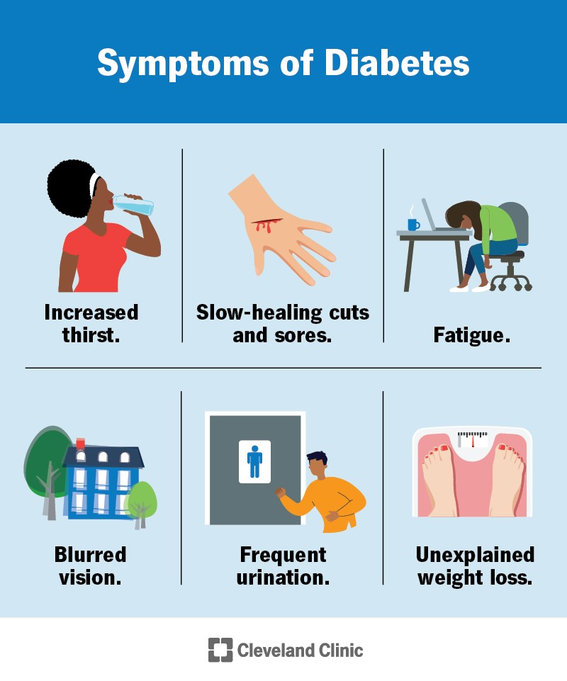

* **High blood pressure:** Both heart disease and diabetes can increase your blood pressure. High blood pressure puts extra strain on the blood vessels, making them more likely to weaken and burst.
* **High cholesterol:** High cholesterol can lead to the buildup of plaque in the arteries. This plaque can narrow the arteries, reducing blood flow to the brain and increase the risk of the stroke.

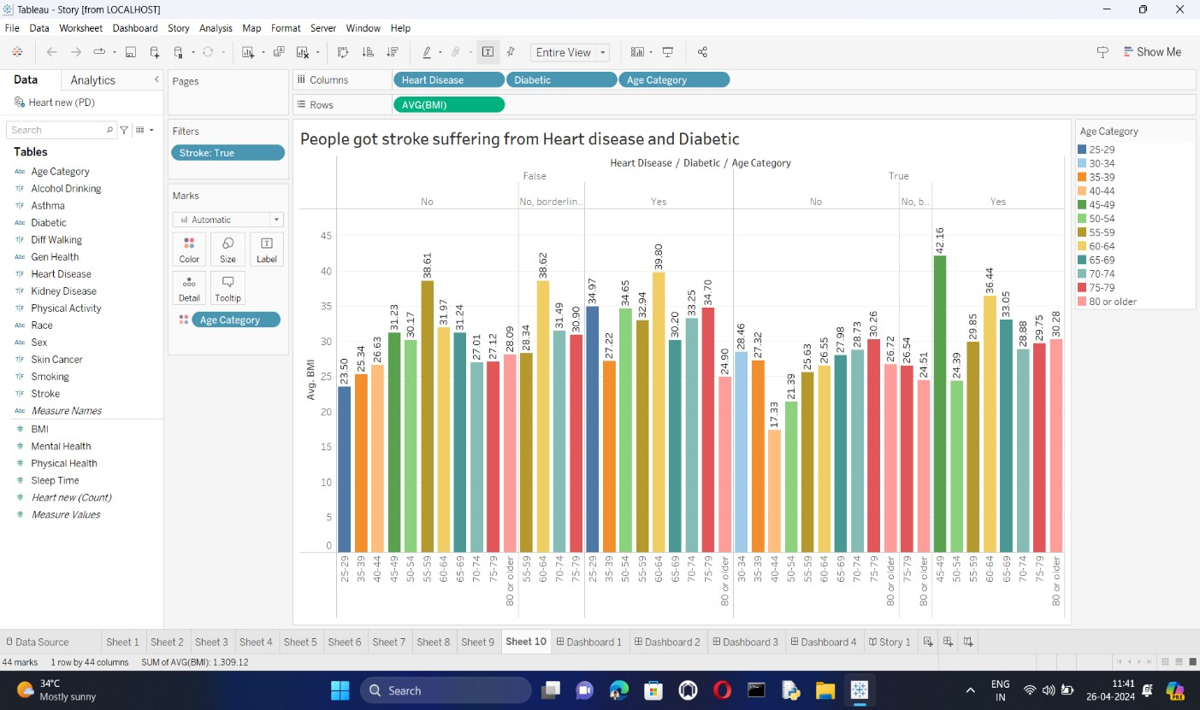

If you have heart disease or diabetes, it's important to work with your doctor to manage these conditions and reduce your risk of stroke. This may include lifestyle changes, such as eating a healthy diet, exercising regularly, and maintaining a healthy weight. You may also need to take medication to control your blood sugar, blood pressure, or cholesterol.