Monitor Log

Problem (Why we made this?)

If any apex class is throwing error and functionality is not working properly then we are not able to debug that time. To debug that code we need to create debug log on behalf of user and then we are able to perform action. To solve this problem we introduce Monitor Log.

Introduction

This feature is used to create logs in monitor log object and after that we are able to take back up of that records and able to delete. Mainly used for debug the apex classes and find where the apex code have errors.

Solution Implementation

Object Overview

Object Definition →
Object Name | Description
Monitor Log | Custom object

LWC Component →
Component Name | Description
sfdc-lwc-lightning-datatable | This Lwc is used to show Monitor Logs Records in related List with the help of recordid.

For more information refer Data Table document.

Apex Classes →
No | Apex Class Name | Description
1. | Monitor | This class is used to insert records in Monitor Log object from other apex classes. As well as used to insert deleted records which are stored in CSV files.
2. | MonitorLogGenerateFile | This class is used to create CSV files and delete logs records. As well as sending emails to users.
3. | MonitorLogHandler | This handler is used to start Scheduler based on specific criteria. As well as it will used to fire some validation based on certain criteria.

Apex Trigger →
No. | Apex Trigger | Description
1. | MonitorScheduler | This Trigger is used to start scheduler based on certain criteria and record Type.

Custom MetaData →
No. | Custom MetaData | Description
1. | Monitor | This Custom Meta data is used to define row and column of CSV as well as to whom we have to send email.

Method Description →
Class Name | Method | Description
Monitor | requestResponseLog(String request, String response,String statusCode,String apexClass,String recordId,String module,String userId,String message,String typeOfIntegration,String method,String requestURL,String remoteAddress,String headers,String dataSource,String externalSystemName) | This method is used to create records in Monitor Log if you are using Integration callouts.  Input Parameters are:  - String request --: Used to store http request in Monitor log.  - String response --: Used to store http response in Monitor log.  - String statusCode --: Used to store status code in Monitor log.  - String apexClass --: Used to store apex class name in Monitor Log.  - String recordId --: Used to store recordId in Monitor Log.  - String module --: Used to store module name on which we are working like Account, Sales order etc.  - String userId --: Used to store logged in user information.  - String message --: Used to store error or success message in Monitor Log.  - String typeOfIntegration--: Used to store Type of Integration Inboun or outbound in Monitor Log.  - String method--: Used to store method in Monitor Log.  - String requestURL--: Used to store request url in Monitor Log.  - String remoteAddress--: Used to store remote address in Monitor Log.  - String headers--: Used to store headers in Monitor Log.  - String dataSource--: Used to store data source in Monitor Log.  - String externalSystemName--: Used to store external System name in Monitor Log.
Monitor | log(String apexClass,String recordId,String module,String userId,String message,String method,String headers) | This method is used to create records in Monitor Log for normal classes which don’t have http callouts.  Input Parameters are:  - String apexClass --: Used to store apex class name in Monitor Log.  - String recordId --: Used to store recordId in Monitor Log.  - String module –: Used to store module name on which we are working like Account, Sales order etc.  - String userId --: Used to store logged in user information.  - String message --: Used to store error or success message in Monitor Log.  - String method: Used to store method in Monitor Log.  - String headers: Used to store headers in Monitor Log.
Monitor | exceptionHandler(Exception exObj,String recordId, String request,String response,String apexClass,String module) | This method is used to create records in Monitor Log if Exception occur  During execution of Apex class.  Input Parameters are:  - Exception exObj --: Used to store information of exception in error message Field.  - String recordId --: Used to store recordId in Monitor Log.  - String request --: Used to store http request in Monitor log.  - String response --: Used to store http response in Monitor log.  - String apexClass –: Used to store apex class name in Monitor Log.  - String module--: Used to store Module Name in Monitor Log.
Monitor | reloadRecords(String monitorId) | This method Used to reload records which are deleted from Monitor Log and stored in CSV file with respect to Scheduler record Type.  Input Parameter are :  - monitorId --: Used to Insert deleted records based on monitor recordId from CSV file.
Monitor | updateRecords(String monitorId,String trycatch) | This method is used to update monitor Logs Scheduler’s record based on insert operation and send email at the last.  Input Parameter are :  - String monitorId --: Used to Update record based on monitor Log Id.  - String trycatch --: Used to send email based on Try catch condition if try then Success email if Catch then Fail email will fire.
MonitorLogGenerateFile | execute(SchedulableContext sc) | This is Scheduler class which is used to delete records based on criteria  And create CSV files and store in Scheduler record type and at the end it will send success email with file Link as well as number of records that file Contains.  At the End it will Abort the running Job and process stops.
MonitorLogHandler | beforeInsert(List<Monitor_Log__c> m) | This methos is used to start Scheduler class based on certain condition and store job Id in record.  Input Parameter are :  - List<Monitor_Log__c> m : Monitor Logs record for performing some Logic.
MonitorLogHandler | afterInsert(List<Monitor_Log__c> n) | This methos is used to add some validation on Scheduler record type records based on certain Critria.  Input Parameter are :  - List<Monitor_Log__c> m : Monitor Logs record for performing some Logic.

Configuration→
- There is a one custom meta data named Monitor we have to Create Two records in that Custom meta data. First record for files Header and Row. Second record for email Id to fire email to certain user.

How to Use →
- Create new record against Scheduler record type.
- Enter Monitor Log Name, Except Module Log, Purging Schedule, Keep log for last X days,Concern check box true,as well as status checkbox true.
- Except Module if you don’t want to delete records of specific module so enter that module.
- Keep log for last X days is for to delete records before that X days Suppose you enter 10 then ten days before data will be deleted.
- Purging Schedule is nothing but Cron Job when you want to run your scheduler.
- If you want to Reload your data then Start your Reload picklist it will insert data whatever we deleted.
- Every Record of Monitor Log we are able to see in Data Table in related list of records.

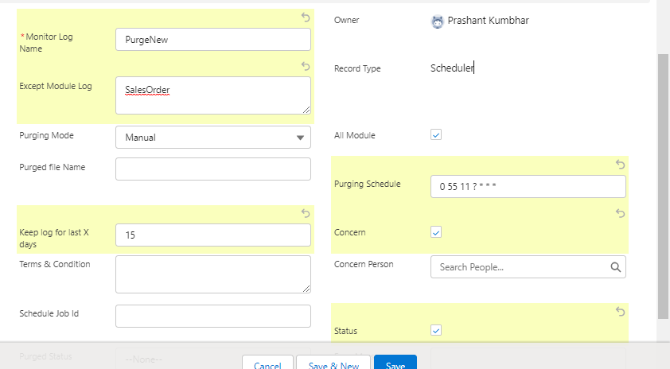

After Creating record it Looks Like –

