**Price Book Engine**

**Introduction**

This feature is used to create Price Book and price Book Entry from Price List object where data will come from Integration. It Will create Three types of Price Book Customer, Customer Group and Common.

**Solution Implementation**

**Object Definition 🡪**

|  |  |
| --- | --- |
| **Object Name** | **Description** |
| Price List | Custom object |
| Customer Group | Custom Object |

**Apex Classes 🡪**

|  |  |  |
| --- | --- | --- |
| **No** | **Apex Class Name** | **Description** |
| **1.** | Application | This class is used to Present all layers of Classes like Selector, Domain and Service. |
| **2.** | IPriceBookService | This is interface which is used in Service Class. |
| **3.** | IPriceBookServiceImp | This class is implementation class which used IPriceBookService. |
| **4.** | PriceBookService | This is Main class of Service Layer to call different-2  Classes based on Records. |
| **5.** | CreatePriceBookByCustomer | To create Customer Price Book and Price Book Entry. |
| **6.** | CreatePriceBookByCustomerGroup | Used to create Price Book and Price book Entry. |
| **7.** | CreatePriceBookByCustomerCommon | Used to create Common Price book and Price Book Entry. |
| **8.** | PriceListSelector | This class is used to query on Price List with various Parameter. |
| **9.** | PriceBookSelector | This class is used to query on Price Book with various Parameter. |
| **10.** | PriceListDomain | This is handler class of Trigger to help trigger to perform various actions. |
| **11.** | CreatePriceBookBatch | This Batch is used to create Price book and Price Book entry for the bulk of records. |
| **12.** | IPriceBookCreator | Interface of Service Class. |
| **13.** | PriceBookObjectCreator | With the Help of Custom setting it call the apex class. |
| **14.** | PriceBookEngineSelector | Selector class for Price Book Engine Meta Data. |

**Apex Trigger 🡪**

|  |  |  |
| --- | --- | --- |
| **No.** | **Apex Trigger** | **Description** |
| 1. | CreatePricebookandEntry | This trigger is used to call main service class after insert or update the records on Price List Object. |

**Custom Metadata 🡪**

|  |  |  |
| --- | --- | --- |
| **No.** | **Custom MetaData** | **Description** |
| **1.** | PriceBookEngine | This Custom Meta data is used to store field Mapping as well class name. |

**Method Description 🡪**

|  |  |  |
| --- | --- | --- |
| **Class Name** | **Method** | **Description** |
| CreatePriceBookByCustomer | createPricebook(Map<String,Price_List__c> mapOfCustomer, Map<String,Pricebook2> priceBookbyCustomer,List<Price_List__c> priceList,String ontrigger,String jsPriceBook,String jsPriceBookEntry,boolean discount) | This method is used to create records Price Book.  **Input Parameters are:**   * mapOfCustomer: get the Customer Map of Price List Object. * priceBookbyCustomer: get the value of Customer from Price Book Object. * priceList: Value of Price List Object. * ontrigger: to Check whether called from trigger or Not. * jsPriceBook: Field mapping of Price Book from Custom Meta Data. * jsPriceBookEntry: Field mapping of Price Book Entry from Custom Meta Data. * discount: to Check either discount or not. |
| CreatePriceBookByCustomer | createPricebookEntryByCustomer(List<Price_List__c> priceList,String ontrigger,String jsPriceBookEntry) | This method is used to create Price Book Entry.  **Input Parameters are:**   * priceList: List of Price List. * ontrigger: to Check for Updating the status * jsPriceBookEntry: Mapping of Price Book Entry from Custom Meta data. |
| CreatePriceBookByCustomerCommon | createPricebook(Map<String,Price_List__c> mapOfCustomerCommon, Map<String,Pricebook2> priceBookbyCommon,List<Price_List__c> priceList,String ontrigger,String jsPriceBook,String jsPriceBookEntry,boolean discount) | This method is Used Create Price Book For Common.  **Input Parameters are:**   * mapOfCustomerCommon: get the Common Map of Price List Object. * priceBookbyCommon: get the value of Common records from Price Book Object. * priceList: Value of Price List Object. * ontrigger: to Check whether called from trigger or Not. * jsPriceBook: Field mapping of Price Book from Custom Meta Data. * jsPriceBookEntry: Field mapping of Price Book Entry from Custom Meta Data * discount: to Check either discount or not. |
| CreatePriceBookByCustomerCommon | createPbEntryByCommon(List<Price_List__c> priceList,String ontrigger,String jsPriceBookEntry) | This method is Used Create Price Book Entry For Common.  **Input Parameter are:**   * priceList: List of Price List. * ontrigger: to Check for Updating the status * jsPriceBookEntry: Mapping of Price Book Entry from Custom Meta data |
| CreatePriceBookByCustomerGroup | createPricebook(Map<String,Price_List__c> mapOfCustomerGrp, Map<String,Pricebook2> priceBookbyCustomerGrp,List<Price_List__c> priceList,String ontrigger,String jsPriceBook,String jsPriceBookEntry,boolean discount) | This method is Used Create Price Book for Customer group  **Input Parameter are:**   * mapOfCustomerGrp: get the Customer Group Map of Price List Object. * priceBookbyCustomerGrp: get the value of Customer Group records from Price Book Object. * priceList: Value of Price List Object. * ontrigger: to Check whether called from trigger or Not. * jsPriceBook: Field mapping of Price Book from Custom Meta Data. * jsPriceBookEntry: Field mapping of Price Book Entry from Custom Meta Data * discount: to Check either discount or not. |
| CreatePriceBookByCustomerGroup | priceBookEntryByCustomerGroup(List<Price_List__c> priceList,String ontrigger,String jsPriceBookEntry) | This method is Used Create Price Book Entry for Customer Group.  **Input Parameter are**:  priceList: List of Price List.  ontrigger: To check for updating the status  jsPriceBookEntry: Mapping of Price Book Entry from Custom Meta data. |
| PriceBookService | createPriceBookAndEntries(List<Price_List__c> priceList,String ontrigger) | This method is Used Call Different Classes based on PriceList Data.  **Input Parameter are:**   * priceList: Get the Price List Records. |

**Configuration**🡪

* There is a one custom meta data named **PriceBookEngine** where field Mapping is stored and Class name is stored so we just need to fetch the data and compare in Code.
* Data stored in Json format and that format we will used for dynamic mapping.

Fields in Custom Meta Data:

* **Class Name** : to call different classes we need to store class name in Class name field.
* **Price Book JSON:** To configure Price book fields we need to insert both objects field here.
* **Price Entry JSON:** To enter Price book entry data field mapping we need to insert.

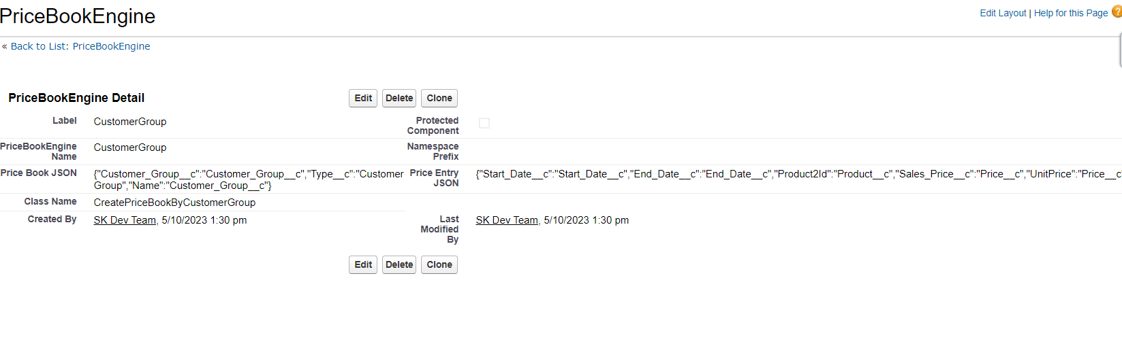

**How to Use 🡪**

* Create new record against Price list Object.
* If you want to process records from trigger then OnDemand check box put **false** and Latest Update Status to ‘**Open’** so it processes your records. It will work after insert or After Update.

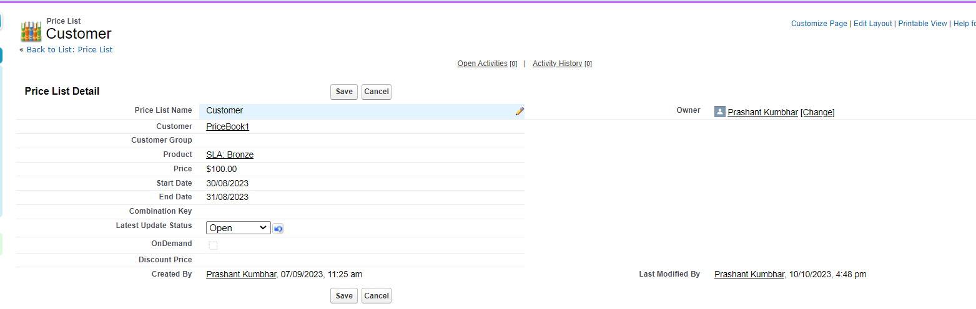

* If we want to Process records from Batch then we have Create Price Book Button If my On Demand Check box is true and Latest Update Status is True then this button will work and process our all records.

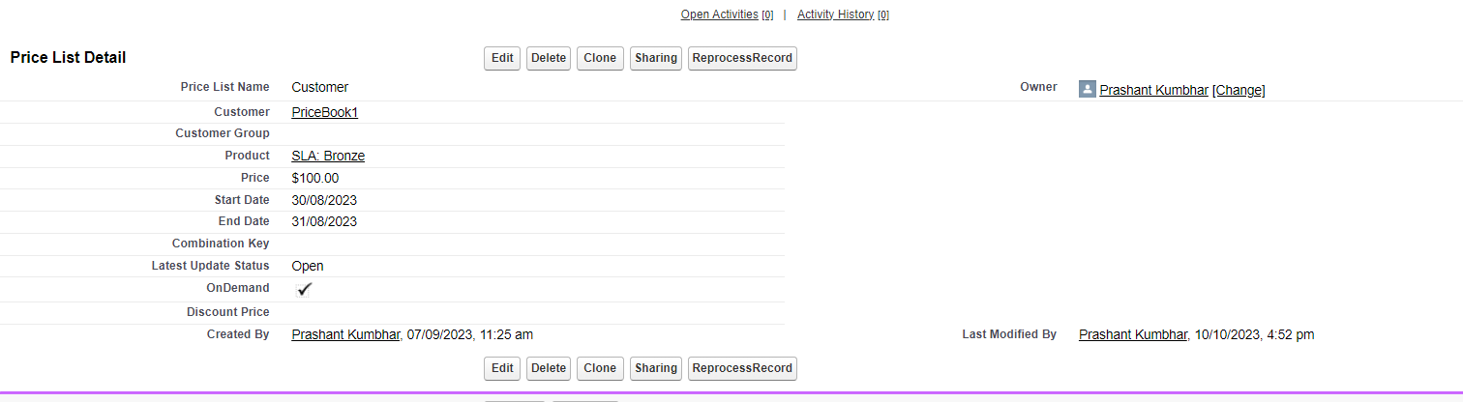

* We have two types of Price Book first one is normal Price and Second one is Discount. If Price is Present on Price List object then Price Book type is Price, if discount is present then Price Book type is Discount.