CANSAT

**Preliminary Design Review (PDR) –**

**Team Name**: SkyLinkers

**HimRakshak: An Autonomous Monitoring CanSAT for Border Security Forces**

**1. Introduction**

**1.1 Purpose of the Mission**

The purpose of the HimRakshak mission is to develop a rugged, lightweight CanSAT capable of supporting Indian border security forces in remote high-altitude environments. The CanSAT will assist in real-time environmental monitoring, location tracking, and detection of terrain-related hazards.

**1.2 Objectives**

* Monitor real-time temperature, pressure, and humidity.
* Detect motion anomalies indicating terrain shifts, such as snow slides or avalanches.
* Transmit GPS coordinates for real-time tracking of personnel and equipment.
* Enhance situational awareness and support rescue operations.

**1.3 Relevance of the CanSAT**

Deploying an autonomous, low-cost satellite prototype like HimRakshak can provide critical support in the Himalayas where traditional monitoring tools are limited by extreme weather, terrain, and logistics. It empowers field units with data-driven decision-making tools.

**1.4 Overview of Document**

This document outlines the mission requirements, system architecture, hardware specifications, risk analysis, testing strategies, budget considerations, and deployment roadmap for the HimRakshak CanSAT project.

**2. Mission Overview**

**2.1 Mission Requirements**

* Operational temperature range: -20°C to 50°C
* Real-time data transmission
* Secure and safe descent mechanism
* Weight under 300g

**2.2 Mission Objectives**

* Collect and transmit environmental and motion data.
* Ensure safe descent with minimal structural damage.
* Track CanSAT location via GPS.

**2.3 Operational Phases**

1. Pre-deployment setup and diagnostics
2. Aerial deployment (via Parachute)
3. Descent and data collection
4. Landing and data retrieval

**2.4 Key Innovations**

* Protective air-inflated balloon around the CanSAT for impact absorption
* Modular sensor integration
* Real-time data visualization platform

**3. System Design Overview**

**3.1 Structural Design**

A cylindrical 3D-printed chassis houses the core electronics. The design includes internal shock-absorbing padding and an external balloon shield.

**3.2 Satellite Body Design**

**3.2.1 Structural Overview**

The CanSAT is protected by a flexible air-inflated balloon that absorbs landing shocks and prevents tumbling during descent. This replaces conventional gyro-based stabilization, ensuring passive damping.

**3.2.2 Component Integration**

All sensors and the microcontroller are embedded in the chassis, with careful balance to maintain stability. The balloon is inflated pre-deployment and attached securely.

**3.3 Subsystems**

* **Power**: Rechargeable Li-ion battery
* **Control**: ESP32 microcontroller
* **Sensors**: MPU6050, BMP280, DHT11
* **Positioning**: GPS NEO-6M
* **Protection**: Air-inflated impact-absorbing balloon

**3.4 Detailed Component List**

|  |  |  |  |
| --- | --- | --- | --- |
| **S. No** | **Component** | **Weight** | **Purpose** |
| 1 | ESP-32 WROOM | 8g | Main microcontroller |
| 2 | MPU6050 | 3g | Motion detection |
| 3 | BMP280 | 3g | Atmospheric pressure and altitude |
| 4 | DHT11 | 3g | Temperature and humidity sensing |
| 5 | GPS Module (NEO 6M) | 20g | Location tracking |
| 6 | 3D Printed Chassis | 140g | Housing all components |
| 7 | Battery | 25g | Power supply |
| 8 | Wires & Connectors | 20g | Component connections |
| 9 | Air-inflated Balloon | 30g | Shock absorption and stabilization |

**3.5 CanSAT Working Block Diagram**

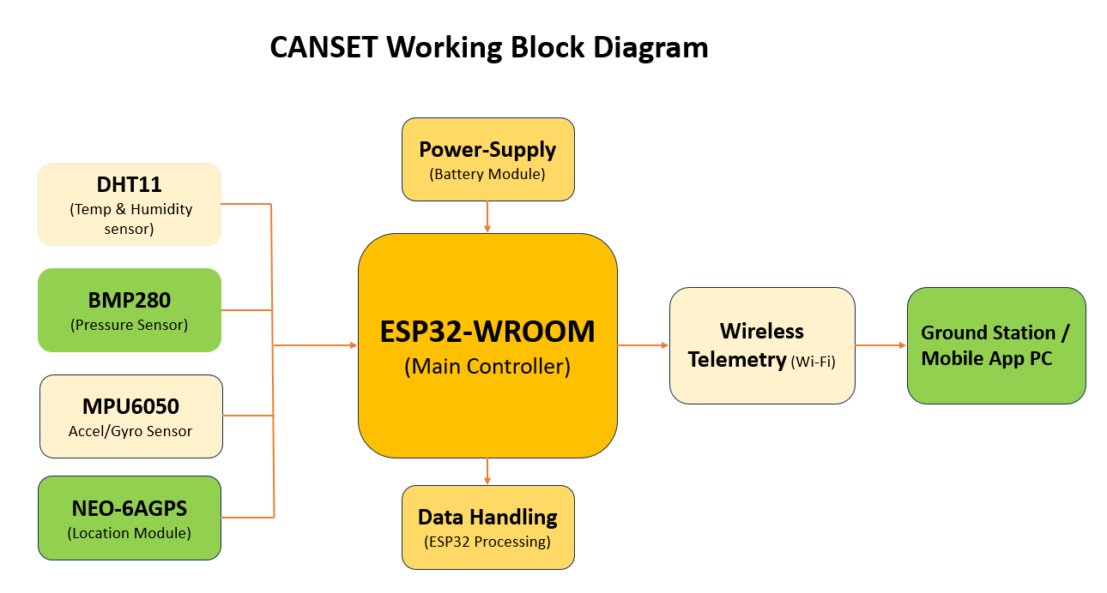

**3.6 CanSAT Working Flow Chart**

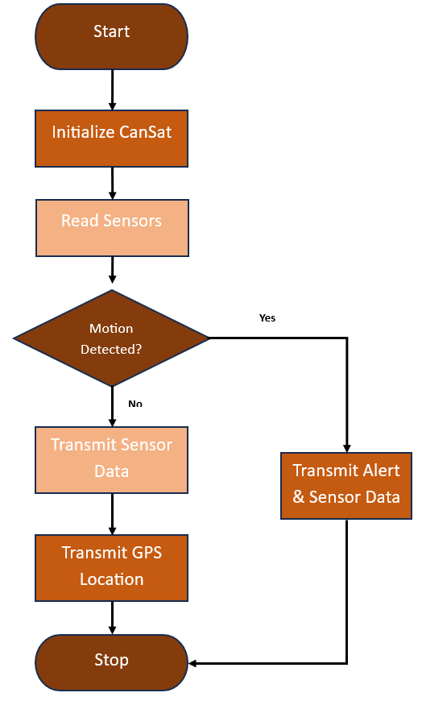

**3.6 CanSAT System Integration**

Sensors are wired to the ESP32, powered by the onboard battery. The balloon is mounted externally and partially encases the CanSAT for stabilization and impact safety.

**4. Mission Design**

**4.1 Deployment Phase**

The CanSAT is deployed using a high-altitude balloon or drone. The balloon shield is pre-inflated to serve both as a stabilizer and cushion.

**4.2 Descent Phase**

The inflated outer layer slows the descent while also damping oscillations, enhancing data collection stability.

**4.3 Landing and Recovery Phase**

Upon landing, the balloon absorbs the kinetic energy and minimizes internal impact. The GPS module helps locate the CanSAT.

**5. Technical Justifications**

**5.1 Balloon Stabilization System**

The balloon acts as both a stabilizer and shock absorber. It reduces tumbling during descent and protects internal components during impact. This method eliminates the need for complex active gyro systems.

**5.2 Parachute System**

An optional lightweight parachute can be attached if vertical descent speed reduction is critical beyond what the balloon can manage.

**6. Ground Station Design**

**6.1 Overview of Ground Station Role**

Receives, processes, and visualizes data in real-time.

**6.2 Ground Station Components**

* Laptop or Raspberry Pi
* USB receiver or LoRa module
* Visualization dashboard (Python/HTML)

**6.3 Communication Protocol**

* Wi-Fi for nearby monitoring
* LoRa for long-range telemetry (if needed)

**6.4 Testing and Verification**

Components and integration will be tested under:

* Temperature stress
* Simulated drop tests
* Data transmission range tests

**7. Risk Management**

**7.1 Risk Identification**

* Communication failure
* Sensor malfunction
* Harsh landing

**7.2 Risk Analysis**

Each subsystem is assessed for potential failure modes and impacts.

**7.3 Risk Mitigation**

**7.3.1 Technical Risk Mitigation**

* Use of redundant sensors (e.g., 2 temperature sensors)
* Balloon-based shock absorption

**7.3.2 Operational Risk Mitigation**

* Pre-flight tests
* Battery level checks

**7.3.3 Environmental Risk Mitigation**

* Casing tested against humidity and cold

**7.4 Risk Monitoring and Control**

Logs will be analyzed post-recovery to update risk matrices.

**12. Environmental and Ethical Impact**

**12.1 Environmental Impact**

Minimal environmental footprint due to biodegradable or reusable materials.

**12.2 Ethical Considerations**

Used solely for border protection and rescue; not for offensive purposes.

**13. Conclusion**

The HimRakshak CanSAT offers an innovative, low-cost solution for supporting Indian border forces. Its balloon-based shock protection, real-time monitoring, and compact design make it a reliable companion in harsh, high-altitude terrains.