NAME: PRASHANT UPPAR

SRN: 02FE22BCS069

ROLL NO:21

TEAM NO:08

CODE

#include <stdio.h>

#include <string.h>

#include <stdlib.h>

#include <limits.h>

int i = 0, j = 0, k = 0, a, b;

char location[50];

int adj[14][14];

// Function to print lines for formatting purpose

int user_signup()

{

FILE *fp=fopen("user_info.txt","r+");

if (fp == NULL)

{

printf("\n File is not found");

return 1;

}

char username[50],password[50];

printf("\n Enter the user name:-\t");

scanf("%s",username);

printf("\n Enter the password:-\t");

scanf("%s",password);

fprintf(fp,"%s %s",username,password);

printf("\n Your account is successfully created.......");

fclose(fp);

}

void print_line()

{

printf("\n\n-----------------------------------------------------------\n\n");

}

// Function to print pattern for the formatting purpose

void print_pattern()

{

printf("\n\n::::::::::::::::::::::::::::::::::::::::::::::::::::::::::\n\n");

}

// structure declaration for storing the cities name read through files

typedef struct cities

{

int city_id;

char city_name[50];

} CT;

CT c[1000];

// structure declaration for storing the venue halls name read through files

typedef struct venue

{

int venue_id;

char venue_hall[50];

int price;

} ve;

ve v[20];

// structure declaration for storing the events name read through files

typedef struct events

{

int Id;

char event_name[30];

} Et;

Et e[50];

//// structure declaration for storing the user information read through files

typedef struct user_info {

char username[50];

char password[50];

} User;

User users[10];

// structure declaration for storing the date of event booked and user id read through user

typedef struct venue_bookings

{

int date,user_id;

}month;

month m[25];

struct set

{

int key;

int data;

};

struct set *array;

// number of cells in the months

int capacity = 31;

// number of booking took place

int size = 0;

// hash function to calculate hashing address on given key given by the user

int hashFunction(int key)

{

return (key % capacity);

}

// Checking the user login credentials are present in the domain

int authenticate_user()

{

char username[50], password[50];

printf("\nEnter your username: ");

scanf("%s", username);

printf("Enter your password: ");

scanf("%s", password);

FILE *userFile = fopen("user_info.txt","r");

if (userFile == NULL)

{

printf("Error opening user_info.txt\n");

exit(1);

}

int validUser = 0;

while (fscanf(userFile, "%s %s", users[i].username, users[i].password) == 2)

{

if (strcmp(username, users[i].username) == 0 && strcmp(password, users[i].password) == 0) {

validUser = 1;

break;

}

}

fclose(userFile);

if (validUser)

{

printf("\nAuthentication successful. Proceeding to the program.\n");

return 1;

}

else

{

printf("\nInvalid username or password. Exiting program.\n");

return 0;

}

}

// Function to delete the event given to the manager

void delete_event(int event_id)

{

FILE *eventFile = fopen("event1.txt", "r");

if (eventFile == NULL)

{

printf("Error opening event1.txt\n");

exit(1);

}

FILE *tempFile = fopen("temp_event1.txt", "w");

if (tempFile == NULL) {

printf("Error opening temp_event1.txt\n");

exit(1);

}

while (fscanf(eventFile, "%d %s", &e[i].Id, e[i].event_name) == 2) {

if (e[i].Id != event_id) {

fprintf(tempFile, "%d %s\n", e[i].Id, e[i].event_name);

}

}

fclose(eventFile);

fclose(tempFile);

remove("event1.txt");

rename("temp_event1.txt", "event1.txt");

printf("\nEvent with ID %d has been deleted.\n", event_id);

}

// Function to delete venue hall based on given id

void delete_venue(int venue_id) {

FILE *venueFile = fopen("venues.txt", "r");

if (venueFile == NULL) {

printf("Error opening venues.txt\n");

exit(1);

}

FILE *tempFile = fopen("temp_venues.txt", "w");

if (tempFile == NULL) {

printf("Error opening temp_venues.txt\n");

exit(1);

}

while (fscanf(venueFile, "%d %s %d", &v[j].venue_id, v[j].venue_hall, &v[j].price) == 3) {

if (v[j].venue_id != venue_id) {

fprintf(tempFile, "%d %s %d\n", v[j].venue_id, v[j].venue_hall, v[j].price);

}

}

fclose(venueFile);

fclose(tempFile);

remove("venues.txt");

rename("temp_venues.txt", "venues.txt");

printf("\nVenue with ID %d has been deleted.\n", venue_id);

}

// functtion find prime used in hash function

int checkPrime(int n)

{

int i;

if (n == 1 || n == 0)

{

return 0;

}

for (i = 2; i < n / 2; i++)

{

if (n % i == 0)

{

return 0;

}

}

return 1;

}

// checking prime or not

int getPrime(int n)

{

if (n % 2 == 0)

{

n++;

}

while (!checkPrime(n))

{

n += 2;

}

return n;

}

void init_array()

{

capacity = getPrime(capacity);

array = (struct set *)malloc(capacity * sizeof(struct set));

for (int i = 0; i < capacity; i++)

{

array[i].key = 0;

array[i].data = 0;

}

}

void insert(int key, int data)

{

int index = hashFunction(key);

FILE *file = fopen("hash_table_data.txt", "a");

if (file == NULL)

{

printf("Error opening file.\n");

exit(1);

}

FILE *readFile = fopen("hash_table_data.txt", "r");

if (readFile != NULL)

{

int fileKey;

while (fscanf(readFile, "%d", &fileKey) != EOF)

{

if (fileKey == key)

{

printf("\n date (%d) already booked by others.\n", key);

fclose(readFile);

fclose(file);

return;

}

}

fclose(readFile);

}

fprintf(file, "%d %d\n", key, data);

fclose(file);

if (array[index].data == 0)

{

array[index].key = key;

array[index].data = data;

size++;

printf("\n date (%d) has been booked successfully \n", key);

}

else if (array[index].key == key)

{

array[index].data = data;

}

else

{

printf("\n collision occured date already booked \n");

}

}

// for the undo booking

void remove_element(int key)

{

int index = hashFunction(key);

if (array[index].data == 0)

{

printf("\n This date key does not exist \n");

}

else

{

array[index].key = 0;

array[index].data = 0;

size--;

printf("\n Key (%d) has been removed \n", key);

}

FILE *file = fopen("hash_table_data.txt", "r");

if (file == NULL)

{

printf("Error opening file.\n");

exit(1);

}

FILE *tempFile = fopen("temp_hash_table_data.txt", "w");

if (tempFile == NULL)

{

printf("Error opening temp file.\n");

exit(1);

}

int fileKey, fileData;

while (fscanf(file, "%d %d", &fileKey, &fileData) != EOF)

{

if (fileKey != key)

{

fprintf(tempFile, "%d %d\n", fileKey, fileData);

}

}

fclose(file);

fclose(tempFile);

remove("hash_table_data.txt");

rename("temp_hash_table_data.txt", "hash_table_data.txt");

}

// to display booking details

void display()

{

int i;

for (i = 0; i < capacity; i++)

{

if (array[i].data == 0)

{

printf("\n array[%d]: / ", i);

}

else

{

printf("\n date: %d feb[%d]: %d \t", array[i].key, i, array[i].data);

}

}

}

int size_of_hashtable()

{

return size;

}

// function to read number of rows in the files where adjacency matrix is stored

int calorder()

{

FILE *fp3 = fopen("adjacency_matrix.txt", "r");

char ch;

int row = 0;

if (fp3 == NULL)

{

printf("\n cannot open the file");

return 1;

}

while ((ch = fgetc(fp3)) != '\n')

{

if (ch == ',')

{

row++;

}

}

return row;

fclose(fp3);

}

// Load the adjacency matrix into adjcency matric from the file called adjacency matrix

void load_adjacency()

{

FILE *fp4;

fp4 = fopen("adjacency_matrix.txt", "r");

int n = calorder();

int temp;

char s;

for (i = 0; i < 14; i++)

{

for (j = 0; j < 14; j++)

{

fscanf(fp4, "%d%c", &temp, &s);

adj[i][j] = temp;

}

}

fclose(fp4);

}

// function calculate min distance between two areas where is it min than updated

int minDistance(int dist[], int sptSet[])

{

int min = INT_MAX, min_index;

for (int v = 0; v < k; v++)

{

if (sptSet[v] == 0 && dist[v] <= min)

{

min = dist[v];

min_index = v;

}

}

return min_index;

}

// printing the shortest path

void printSolution(int dist[], int n, int parent[])

{

printf("\n Node\tDistance\tPath\n");

for (int i = 0; i < k; i++)

{

printf("%d\t%d\t\t%d", i, dist[i], i);

int j = i;

while (parent[j] != -1)

{

printf(" <- %d", parent[j]);

j = parent[j];

}

printf("\n");

}

}

// Dijkstra's algorithm of finding shortest path

void dijkstra(int src, int dest)

{

int dist[k];

int parent[k];

int sptSet[k];

for (int i = 0; i < k; i++)

{

dist[i] = INT_MAX;

sptSet[i] = 0;

parent[i] = -1;

}

dist[src] = 0;

for (int count = 0; count < k - 1; count++)

{

int u = minDistance(dist, sptSet);

sptSet[u] = 1;

for (int v = 0; v < k; v++)

{

if (!sptSet[v] && adj[u][v] && dist[u] != INT_MAX &&

dist[u] + adj[u][v] < dist[v])

{

dist[v] = dist[u] + adj[u][v];

parent[v] = u;

}

}

}

printSolution(dist, k, parent);

printf("\n\n Shortest Path from %s to %s: %d\n", c[src].city_name, c[dest].city_name, dist[dest]);

}

// searching a city is is present in the considered domain

int searchCity(char pattern[])

{

int N;

for (N = 0; N < 16; N++)

;

int M = 3;

for (int i = 0; i <= N - M; i++)

{

int j;

for (j = 0; j < M; j++)

{

if (c[i].city_name[j] != pattern[j])

break;

}

if (j == M)

{

return i;

}

}

return -1;

}

void swap(ve *a, ve *b)

{

ve temp = *a;

*a = *b;

*b = temp;

}

// Quick sort partition function

int partition(ve arr[], int low, int high)

{

int pivot = arr[high].price;

int i = (low - 1);

for (int j = low; j <= high - 1; j++)

{

if (arr[j].price < pivot)

{

i++;

swap(&arr[i], &arr[j]);

}

}

swap(&arr[i + 1], &arr[high]);

return (i + 1);

}

// Quick sort main function

void quickSort(ve arr[], int low, int high)

{

if (low < high)

{

int pi = partition(arr, low, high);

quickSort(arr, low, pi - 1);

quickSort(arr, pi + 1, high);

}

}

int select_event()

{

printf("\n\n Enter the Id number of the event you want to choose: ");

scanf("%d", &a);

printf("\n Your events choice is successfully processed.......");

return a;

}

// Function to load and display events to the user

int load_events()

{

FILE *fp1;

fp1 = fopen("event1.txt", "r");

if (fp1 == NULL)

{

printf("\n File is not found");

return 1;

}

print_pattern();

printf("\n DISPLAYING EVENTS LIST >>>>>>>>>>>>>>>>>>> ");

print_line();

printf("\n -:The events at UK 27 are :-");

print_pattern();

printf("\n EVENT ID | EVENT NAME | PRICE");

printf("\n -------------------------------------------");

while (fscanf(fp1, "%d %s", &e[i].Id, e[i].event_name) == 2)

{

printf("\n %d.%s", e[i].Id, e[i].event_name);

i++;

}

fclose(fp1);

a = select_event();

return a;

}

// select the venue hall you want

int select_venue_hall()

{

printf("\n\n Enter the id of venue you want to book:-");

scanf("%d", &b);

printf("\n Your venue hall choice is successfully processed.... ");

return b;

}

// load and display venue halls to the user

int venue_halls()

{

FILE *fp1 = fopen("venues.txt", "r");

if (fp1 == NULL)

{

printf("\n File is not found");

return 1;

}

print_pattern();

printf("\n DISPLAYING VENUE HALLS LIST>>>>>>>>>>>>>>>>>>");

printf("\n\n\n -: The different venue hall at UK 27 are :-");

print_pattern();

printf("\n VENUE ID | VENUE HALL NAME | PRICE");

printf("\n ----------------------------------------------------");

while (fscanf(fp1, "%d %s %d", &v[j].venue_id, v[j].venue_hall, &v[j].price) == 3)

{

printf("\n %d.%s %d", v[j].venue_id, v[j].venue_hall, v[j].price);

j++;

}

fclose(fp1);

int r;

printf("\n\n Press 1 if u want to get display of venue hall in order of cost:-");

scanf("%d",&r);

if(r==1)

{

printf("\n\n PROCESSING DATA >>>>>>>>>>>>>>>>>>>");

printf("\n\n The venue hall in sorted order are :-%d", j);

printf("\n\n");

quickSort(v, 0, j - 1);

printf("\n VENUE ID | VENUE HALL NAME | PRICE");

printf("\n ----------------------------------------------------");

for (int h = 0; h < j; h++)

{

printf("\n %d.%s %d", v[h].venue_id, v[h].venue_hall, v[h].price);

}

}

b = select_venue_hall();

return 1;

}

// function to check user area

int domain_check()

{

char cityPattern[4];

printf("\n Enter the first 3 characters of the city name: ");

scanf("%s", cityPattern);

int cityIndex = searchCity(cityPattern);

if (cityIndex != -1)

{

printf("\n Area found: %s\n", c[cityIndex].city_name);

}

else

{

printf("\n City not found\n");

}

return 1;

}

// function to check user area

int travel_venue()

{

FILE *fp2 = fopen("cities.txt", "r");

if (fp2 == NULL)

{

printf("\n File is not found");

return 1;

}

printf("\n DISPLAYING AREAS OF THE BELAGAVI CITY>>>>>>>>>>>>>>>>>>");

printf("\n -:The the areas of belagavi under consideration of the shortest path:-");

printf("\n AREA ID | AREA NAME ");

printf("\n------------------------------------------------");

k = 0;

while (fscanf(fp2, "%d%s", &c[k].city_id, c[k].city_name) == 2)

{

printf("\n %d.%s", c[k].city_id, c[k].city_name);

k++;

}

fclose(fp2);

domain_check();

return 1;

}

// user booking perticular date for venue

void book_venue()

{

int choice, key, data, n;

int c = 0;

init_array();

do

{ print_pattern();

printf("\n1.Book the venue for the event"

"\n2.Undo your booking"

"\n3.Check number of booking took place in that month"

"\n4.Display booking details"

"\n\n Please enter your choice: ");

scanf("%d", &choice);

switch (choice)

{

case 1:

printf("\nEnter date of booking :-\t");

scanf("%d", &key);

printf("\n Enter user id number :-\t");

scanf("%d", &data);

insert(key, data);

break;

case 2:

printf("\n\n Enter the date of booking to be deleted-:");

scanf("%d", &key);

remove_element(key);

break;

case 3:

n = size_of_hashtable();

printf("\n Number of books are-:%d\n", n);

break;

case 4:

display();

break;

default: printf("Invalid Input\n");

break;

}

printf("\n\n Do you want to continue (press 1 for yes): ");

scanf("%d", &c);

} while (c == 1);

free(array);

}

void print_area()

{

FILE *fp=fopen("cities.txt","r");

if(fp==NULL);

{

printf("unable to read the file....");

}

int k=0;

printf("\n DISPLAYING AREAS OF THE BELAGAVI CITY>>>>>>>>>>>>>>>>>>");

printf("\n -:The the areas of belagavi under consideration of the shortest path:-");

printf("\n AREA ID | AREA NAME ");

printf("\n------------------------------------------------");

while (fscanf(fp, "%d%s", &c[k].city_id, c[k].city_name) == 2)

{

printf("\n %d.%s", c[k].city_id, c[k].city_name);

k++;

}

fclose(fp);

}

int user_program_advanced()

{

int choice, src, dest,login;

if (authenticate_user())

{

printf("\n 1.Choosing the events ");

printf("\n 2.venue hall list ");

printf("\n 3.travel to the venue ");

printf("\n 4.book the venue ");

printf("\n 5.Find Shortest Path");

printf("\n 6.exit");

while (1)

{

print_pattern();

printf("\n\n Enter your choice: ");

scanf("%d", &choice);

switch (choice)

{

case 1:

a = load_events();

break;

case 2:

venue_halls();

break;

case 3:

travel_venue();

break;

case 4: book_venue();

break;

case 5:load_adjacency();

printf("\n\n Enter source city id: ");

scanf("%d", &src);

printf("\n\n Enter destination city id: ");

scanf("%d", &dest);

print_area();

dijkstra(src, dest);

break;

case 6:

exit(1);

break;

default:

printf("\n\n Invalid choice. Please try again.\n");

break;

}

}

}

else

{

printf("\n INVALID USER NAME OR PASSWORD... !! TRY AGAIN");

return 1;

}

}

// User interface program

int user_program()

{

int choice, src, dest,login;

printf("\n1.SIGNUP TO THE SITE");

printf("\n2.LOGIN TO THE SITE");

printf("\nChoose your option:-");

scanf("%d",&login);

switch(login)

{

case 1: user_signup();

break;

case 2: user_program_advanced();

break;

default : printf("\n INVALID CHOICE");

exit(0);

}

}

// Add particular event:

int add_event()

{

FILE *fp1;

fp1 = fopen("event1.txt", "r+");

if (fp1 == NULL)

{

printf("\n File is not found");

return 1;

}

printf("\n DISPLAYING THE EVENTS LIST >>>>>>>>>>>>>>>>>>>>>");

printf("\n\n\n -:The events at UK 27 are :-");

print_pattern();

printf("\n EVENT ID | EVENT NAME ");

printf("\n --------------------------------------");

print_pattern();

while (fscanf(fp1, "%d %s", &e[i].Id, e[i].event_name) == 2)

{

printf("\n %d.%s", e[i].Id, e[i].event_name);

i++;

}

int id;

char event[50];

printf("\n\n Enter the next events id:");

scanf("%d",&id);

printf("\n Enter the event name:");

scanf("%s",event);

fprintf(fp1,"\n %d %s",id,event);

fclose(fp1);

printf("\n Events has been successfully added to the list....... ");

}

int add_venue_hall()

{

FILE *fp1 = fopen("venues.txt", "r+");

if (fp1 == NULL)

{

printf("\n File is not found");

return 1;

}

printf("\nDISPLAYING VENUE HALLS AT THE VENUE >>>>>>>>>>>>>>>>>>");

printf("\n\n\n -:The different venue hall at UK 27 are :-");

print_pattern();

printf("\n VENUE ID | VENUE HALL NAME | PRICE ");

printf("\n--------------------------------------------");

while (fscanf(fp1, "\n%d %s %d", &v[j].venue_id, v[j].venue_hall, &v[j].price) == 3)

{

printf("\n %d.%s %d", v[j].venue_id, v[j].venue_hall, v[j].price);

j++;

}

int id,price;

char venue_h[50];

printf("\n\n Enter the next events id:");

scanf("%d",&id);

printf("\n\n Enter the event name:");

scanf("%s",venue_h);

printf("\n\n Event hall price:");

scanf("%d",&price);

fprintf(fp1,"\n %d %s %d",id,venue_h,price);

fclose(fp1);

printf("\n venue hall has been successfully added to the list....... ");

}

int booking_data_display()

{

FILE *fp=fopen("hash_table_data.txt","r");

if (fp == NULL)

{

printf("\n File is not found");

return 1;

}

print_line();

printf("\n BOOKING DETAILS HERE >>>>>>>>>>>>> ");

printf("\n\n\n DATE\tUSER ID");

printf("\n---------------------------");

int i=0;

while(fscanf(fp,"%d %d",&m[i].date,&m[i].user_id)==2)

{

printf("\n %d\t%d",m[i].date,m[i].user_id);

i++;

}

}

int manager_login_info()

{

char user_name[50],password[50];

printf("\n Enter the user name:");

scanf("%s",user_name);

printf("\n Enter user password:");

scanf("%s",password);

if(strcmp(user_name,"professor@89")==0 && strcmp(password,"Raquel")==0)

{

printf("\n ACCESS GRANTED >>>>>>>>>>>>>>>>");

return 1;

}

else

{

return 0;

}

}

int display_events()

{

FILE *fp1;

fp1 = fopen("event1.txt", "r");

if (fp1 == NULL)

{

printf("\n File is not found");

return 1;

}

print_pattern();

printf("\n DISPLAYING EVENTS LIST >>>>>>>>>>>>>>>>>>> ");

print_line();

printf("\n -:The events at UK 27 are :-");

print_pattern();

printf("\n EVENT ID | EVENT NAME | PRICE");

printf("\n -------------------------------------------");

while (fscanf(fp1, "%d %s", &e[i].Id, e[i].event_name) == 2)

{

printf("\n %d.%s", e[i].Id, e[i].event_name);

i++;

}

fclose(fp1);

}

int display_venuehalls()

{

FILE *fp1 = fopen("venues.txt", "r");

if (fp1 == NULL)

{

printf("\n File is not found");

return 1;

}

print_pattern();

printf("\n DISPLAYING VENUE HALLS LIST>>>>>>>>>>>>>>>>>>");

printf("\n\n\n -: The different venue hall at UK 27 are :-");

print_pattern();

printf("\n VENUE ID | VENUE HALL NAME | PRICE");

printf("\n ----------------------------------------------------");

while (fscanf(fp1, "%d %s %d", &v[j].venue_id, v[j].venue_hall, &v[j].price) == 3)

{

printf("\n %d.%s %d", v[j].venue_id, v[j].venue_hall, v[j].price);

j++;

}

fclose(fp1);

}

void manager_program() {

int choice;

if(manager_login_info())

{

printf("\n1.DISPLAY EVENTS LIST");

printf("\n2. ADD EVENTS");

printf("\n3.DISPLAY VENUE HALLS LIST");

printf("\n4. ADD VENUE HALLS");

printf("\n5. DELETE EVENTS");

printf("\n6. DELETE VENUE HALLS");

printf("\n7. DISPLAY BOOKING RETAILS");

while (1)

{ print_pattern();

printf("\n\n Enter your choice: ");

scanf("%d", &choice);

switch (choice)

{

case 1:

display_events();

break;

case 2:

add_event();

break;

case 3: display_venuehalls();

break;

case 4:

add_venue_hall();

break;

case 5:

printf("\nEnter the event ID to delete: ");

scanf("%d", &a);

delete_event(a);

break;

case 6:

printf("\nEnter the venue ID to delete: ");

scanf("%d", &b);

delete_venue(b);

break;

case 7:

booking_data_display();

break;

case 8:printf("\n PROCESS COMPLETED THANK TOU FOR VISITING ....!!");

exit(0);

default:

printf("\nInvalid choice. Please try again.\n");

break;

}

}

}

else

{

printf("\n INVALID USER NAME OR PASSWORD TRY AGAIN");

}

}

void content_display()

{

printf("\n:::::::::::::::::: EVENT MANAGEMENT SYSTEM BY UK27 :::::::::::::::::::\n");

}

void user_choice()

{

int choice_control;

printf("\n GO TO INTERFACE >>>>>>>>>>\n\n ");

printf("\n1.USER INTERFACE ");

printf("\n2.MANAGER INTERFACE");

printf("\n\n Your choice: ");

scanf("%d",&choice_control);

while(1)

{

switch (choice_control)

{

case 1:

printf("\n OPENING THE USER INTERFACE>>>>>>>>>>>>>>>>>>>>>>> \n ");

user_program();

break;

case 2:

printf("\n OPENING THE MANAGER INTERFACE>>>>>>>>>>>>>>>>>>>>>\n");

manager_program();

break;

default: printf("\n Varify your entry........!!");

break;

}

}

}

int main()

{

content_display();

user_choice();

return 0;

}

PROGRAM OUTPUT

1) MANAGER INTERFACE

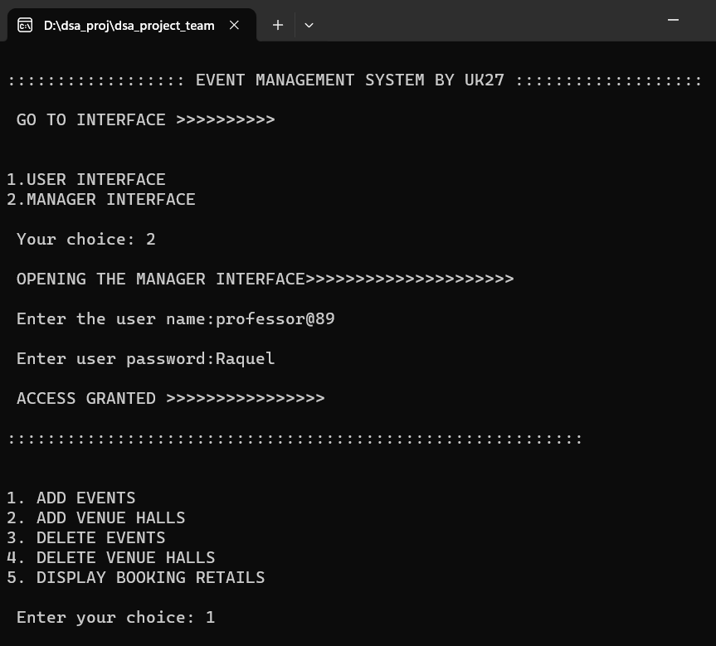

–––––––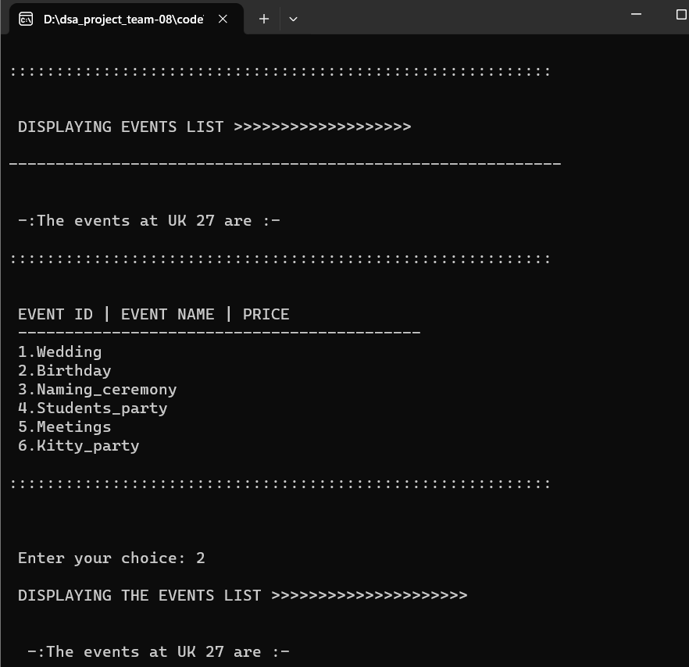

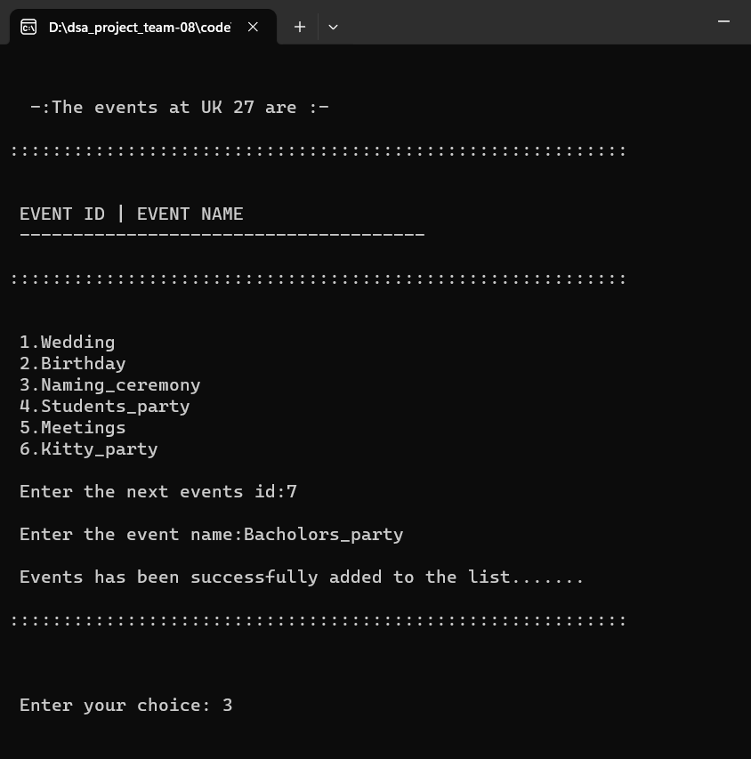

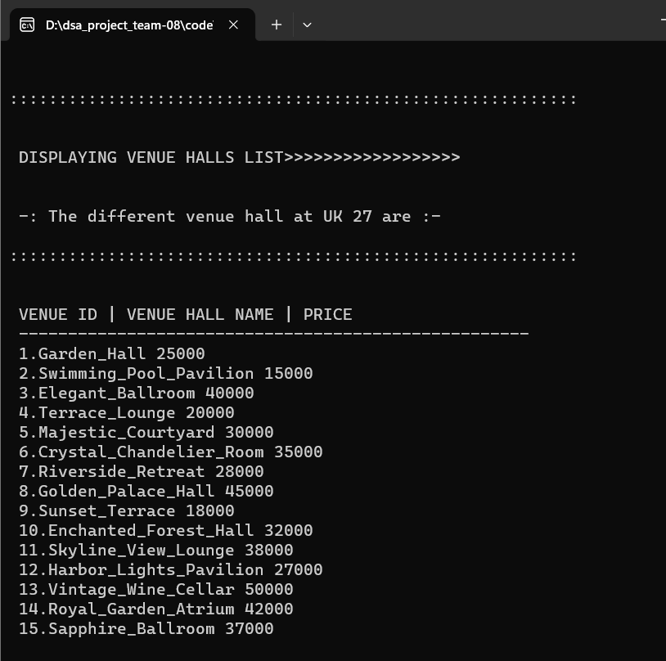

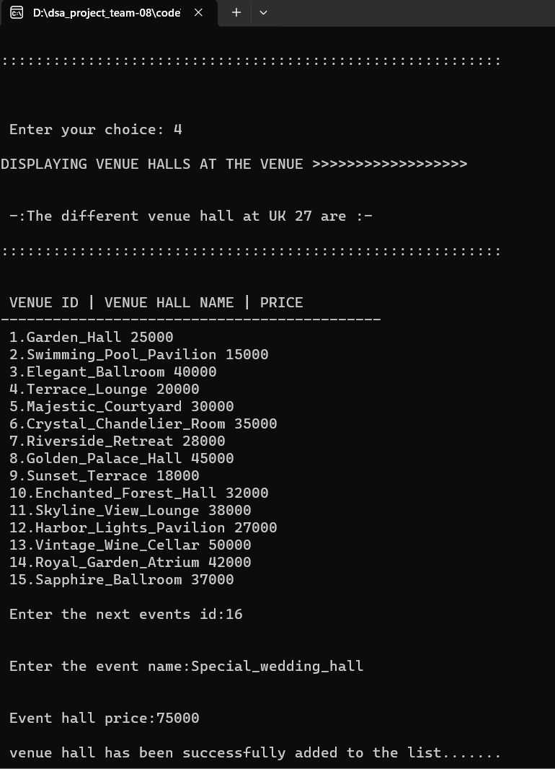

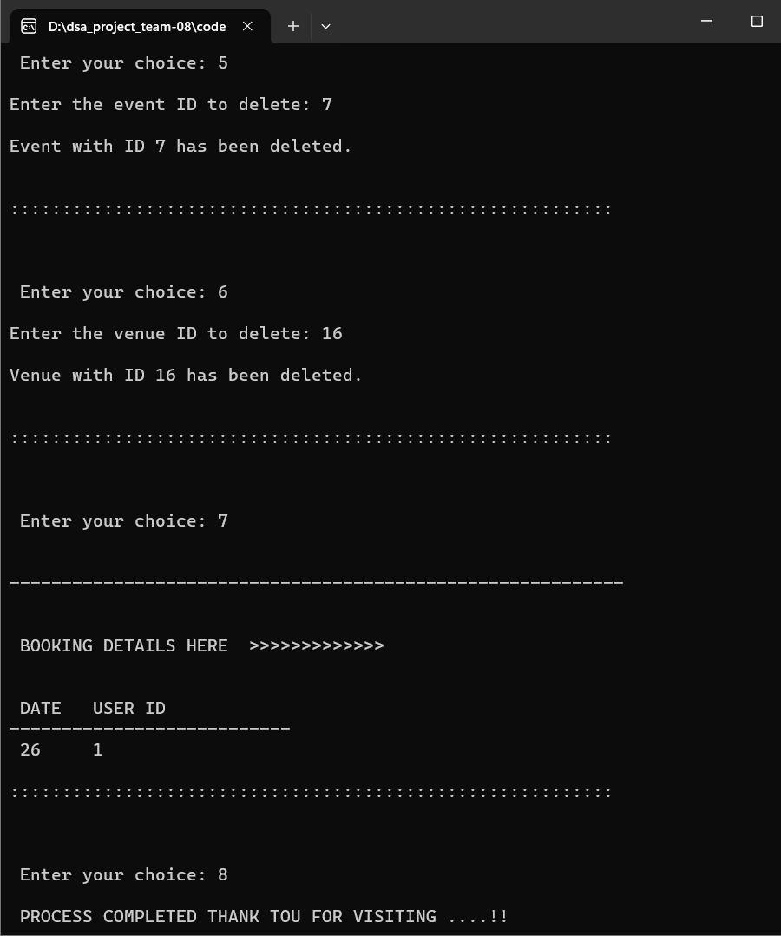

2)user interface

