**Industrial Training**

DATA SCIENCE AND MACHINE LEARNING USING PYTHON

TRAFFIC SING RECOGNITION SYSTEM



Industrial Training report Submitte towards partial fulfillment

of the degree of

**Bachelor of Technology**

Year 2022-23

Department of Information Technology

Guided By : Submitted By:

Prof. Aruna Patidar Prashant Vishvkarma

19100BTIT06591

**Shri Vaishnav Institute of Information Technology**



# **Certificate**

This is to certify that Mr Prashant Vishvkarma has satisfactorily completed the Industrial Training towards the partial fulfillment of the degree in Bachelor of Technology (Information Technology) Awarded by Shri Vaishnav Vidyapeeth Vishwavidyalya, Indore for the academic year 2022-23.

**Prof. Aruna Patidar Dr. Jigyasu Dubey**

**Training in charge Head, IT Department**

**Director, SVIIT**

**Internal External**

**Acknowledgements**

We are grateful to a number of persons for their advice and support during the time of complete our project work. First and foremost our thanks goes to Dr. Jigyasu Dubey Head of the Department of Information Technology and Prof. Aruna Patidar the mentor of ourproject for providing us valuable support and necessary help whenever required and also helping us explore new technologies by the help of their technical expertise. Her direction, supervision and constructive criticism were indeed the source of inspiration for us.

We would also like to express our sincere gratitude towards our Director Dr. Anand Rajavat for providing us valuable support.

We are really indebted to Prof. Souvik Ganguli, project coordinator for helping us in each aspect of our academics activities. We also owe our sincere thanks to all the faculty members of Information Technology Department who have always been helpful.

We forward our sincere thanks to all teaching and non-teaching staff of Information Technology department, SVVV Indore for providing necessary information and there kind co- operation.

We would like to thanks our parents and family members, our classmates and our friends for their motivation and there valuable suggestion during the project. Last, but not the least, we thank all those people, who have helped us directly or indirectly in accomplishing this work. It has been a privilege to study at SHRI VAISHNAV VIDYAPEETH VISHWAVIDYALAYA, INDORE.

**CONTENT**

|  |  |  |
| --- | --- | --- |
|  | Abstract | i |
|  | Acknowledgement | ii |
|  | **CHAPTER 1- Introduction** | **5 - 9** |
| 1.1 | Objectives of the industrial Training program | 5 |
| 1.2 | The Scope of the Industrial Training program | 6 |
| 1.3 | Duration | 7 |
| 1.4 | The importance of the industrial Training Program | 7 |
| 1.5 | Benefits derived from the Training | 8 |
| 1.6 | Objectives of the report | 9 |
|  | **CHAPTER 2- Training Description** | **10** |
| 2.1 | Training Description | 10 |
|  | **CHAPTER 3- Industrial Training** | **11 - 22** |
| 3.1 | Objectives | 11 |
| 3.2 | Analysis | 11 |
| 3.3 | Architecture and UML Diagram | 13 |
| 3.4 | Design and sample Code | 16 |
| 3.5 | Software and Tools Used | 18 |
| 3.6 | Highlights of training Exposure | 19 |
| 3.7 | Screenshots | 21 |
| 3.8 | Certificate Copy | 22 |
|  | **CHAPTER 4- Conclusions** | **23** |
| 4.1 | Conclusions | 23 |
|  | **CHAPTER 5- References** | **24** |
| 5.1 | References | 24 |

**CHAPTER 1- INTRODUCTION**



**1.1 Objectives of the industrial training program**

Learning Objectives/Internship Objectives

* + Internships are generally thought of to be reserved for college students looking to gain experience in a particular field. However, a wide array of people can benefit from Training Internships in order to receive real world experience and develop their skills.
  + An objective for this position should emphasize the skills you already possess in the area and your interest in learning more
  + Internships are utilized in a number of different career fields, including architecture, engineering, healthcare, economics, advertising and many more.
  + Some internships are used to allow individuals to perform scientific research while others are specifically designed to allow people to gain first-hand experience working.
  + Utilizing internships is a great way to build your resume and develop skills that can be emphasized in your resume for future jobs. When you are applying for a Training Internship, make sure to highlight any special skills or talents that can make you stand apart from the rest of the applicants so that you have an improved chance of landing the position.

**1.2 Scope of Industrial Training Program**

The Scope of Industrial Training is to expose students to real work of environment Experience and at the same time, to gain the knowledge through hands on observation and

Job execution. From the industrial training, the students will also develop skills in work ethics,

Communication, management and others. Moreover, this practical training program allows

Students to relate theoretical knowledge with its application in the manufacturing industry.

The objectives of industrial training are:

* To provide students the opportunity to test their interest in a particular career before permanent commitments are made.
* To develop skills in the application of theory to practical work situations.
* To develop skills and techniques directly applicable to their careers.
* Internships will increase a student's sense of responsibility and good work habits.
* To expose students to real work environment experience gain knowledge in writing report in technical works/projects.
* Internship students will have higher levels of academic performance.
* Internship programs will increase student earning potential upon graduation.
* To build the strength, teamwork spirit and self-confidence in students life.
* To enhance the ability to improve students creativity skills and sharing ideas.
* To build a good communication skill with group of workers and learn to learn proper behavior of corporate life in industrial sector.
* The student will be able instilled with good moral values such as responsibility, commitment and trustworthy during their training.
* Exploring career field based on your qualification
* Speculating different career choices
* Saving precious time and money

**1.3 Duration**

The duration of the industrial training of **Data Science** with **Machine Learning** is 1 month from 29-06-2022 to 28-07-2022 in which we studied about Machine Learning , Stock marketing, Cab prediction , Movie Recommendation learnt python.

**1.4** **The Importance of industrial Training Program**

The Importance of industrial training is to expose the students to real work in an industrial environment and at the same time to gain knowledge through hands-on experience and job execution. With the help of industrial training students will also develop their new skills in work integrity, project management, time management, communication and other useful skills. The **industrial training** program helps students in availing the required exposure of company or organization he would like to work upon as a professional and also provides technical skills required for a particular job. The students will learn how to deal problems related to work profile, how to deal with clientele, different kinds of software applications used by organization and also how a project can be managed which includes presentations and report writing.

While doing industrial training a student can be taught with all the required concepts of engineering subject that he is willing to take for his professional career. With the help of industrial mentor and academic guide a student can easily manage the problems that he met while during his industrial training. They face real time problems and solve themselves and find a logical solution to the problem related to their project they are working on.This industrial training provides them better opportunities at campus placement drives as they are asked questions based on their internships projects, and if they are provided with better exposure and proper technical guidance they will easily answer these questions and can create an impression on the interviewer from the industry and can have a job easily.

**The objective of industrial training are:**

* Industrial training provides opportunity to the students to test their interest in a particular career before joining any industry or organization.
* Industrial Training helps students to develop their skills in the application of theory to practical knowledge.
* +Industrial training helps to develop the skills and techniques which are directly relevant to their desired goals.
* Industrial Training also increases students’ responsibility and good work habits.
* Industrial Training helps to uncover the students in the real world of work environments to gain healthy knowledge in according to industrial point of view.
* Industrial training helps the student to build strength, self-confidence and teamwork spirit.

**1.5** **Benefits Derived From the Training**

Let’s look at some of the benefits which students can derive from an Industrial Training Program.

1. Industrial Training can make the students aware of the Industry Norms.
2. The students get to work in a real work environment which can help them in understanding how an organization works.
3. It also helps them in knowing the latest happenings in the industry.
4. It helps the students in understanding and using the latest technologies.
5. Industrial Training can fetch them job offers from good companies.
6. The students can get certifications and recommendations from the company after completion of their training program.
7. Industrial training is provided to the students so that they are capable to implementing the subjects practically.
8. It also helps the student in improving their knowledge.
9. It improves the versatility of the student and helps them in boosting their career.
10. It also boosts their confidence once they have the skills about the particular subject they have got training in.
11. They help you implementing the theory into realistic area.
12. Familiarize them with the environment of the companies.
13. They help the students to increase communication level as well as develop leadership qualities.
14. The students are provided training from the industry professionals who have assortment of knowledge in working in live-projects.

**1.6 Objectives of the Report**

Industrial Training Report is an important document to each of the students. It is a document with the activities that have been learned throughout the industrial training. The report helps student to understand the knowledge given to them throughout the industrial training. Another purpose of the industrial training report is to be used as a guideline and reference in their future working plans if they wish to continue working in the same course. Furthermore, this report is evidence that the student manage to complete their industrial training. In addition, the objective of this report is to document all activities that have been carried out during the period of industrial training. The report can be used as a reference by prospective employers during an interview. Provide guidance or as reference materials to students after completing their future studies. Students can train themselves to do some paperwork, this is because of the style of writing and the report is more or less the same for the completion of paperwork.

**CHAPTER 2- Training Description**

**2.1 Training Description**

**Ardent Computech Pvt. Ltd.**

IT learning and software Development Company established in 2002. The company started with the vision to bridge the gap between the academia and the industry. an ISO: 9001:2015 The sole objective is to provide high quality services at affordable cost. As part of our mission, they already shaped many careers and provided efficient and productive resources to the industry. The core strength of Ardent in the space of technical training and internships is live project centric approach. We encourage the learners to do global certifications post completion of the training or internship.

A training environment must be one which allows trainees to learn and practice the desired skills. Creating such an environment may include bringing together several components such as written and oral instruction and hand-on training. Through intentional employee training in a supportive training environment, employers can realize enhanced productivity, lessen the need for direct employee supervision and decrease the incidence of accidents on the job.

**CHAPTER 3- Industrial Training**



**3.1 Objective**

In this thesis I mainly focus on recognition of a wide set of traffic signs using thresholding and

thinning, Euclidean distance matching. Once a traffic sign is detected, three horizontal lines

(T, H, B) and three vertical lines (R, V, L) across the image are used to recognize the sign.

The number of crossings from a black pixel to a white pixel (peak) on each line is calculated.

**Research Questions**

• Classify the traffic sign.

• Develop a GUI where we can perform traffic sign detection, classification and measure

performance.

• Increase the accuracy of traffic sign classification.

**3.2 Analysis :**

These days’ recognition and detection of traffic signs is very important for drivers. For the safety of drivers, it is important to have advanced driver assistance system in every modern high-end car. These systems detect, recognize, and classify the traffic sign. But this is not so

easy due to various illumination problems. In the author proposed the recognition and detection of traffic signs by dividing it into two stages. Firstly, in the detection stage they localize signs from a whole image. In the classification stage the detected traffic sign is classified into one of the reference signs. In the detection module traffic sign is detected based on the colour, shape, and size. The classification module is done using a multi-layer perceptron neural network. By using neural networks, the classification has achieved a high rate with a good commutation-time.

Advanced driver assistance systems in modern high-end cars helps to save lives. Generally, accidents happen when the driver misses or misunderstands traffic sign. As the surveys tell most of the accidents occur when the driver is distracted. With the increase of driver’s attention

to the road signs many accidents can be averted. This happens when we try to detect the traffic sign correctly and help the driver in assisting it properly. For this in authors proposed a real

time system which integrates single view detection with region-based 3D tracking of traffic signs. By using this system, they are able track multiple traffic signs in 3D, from a single view.

Road signs or traffic signs are an important part of driver assistance system. These signs are designed to regulate the flow of vehicles. These signs give specific information to the drivers

regarding any warnings against unexpected road circumstances. Traffic sign information resources are useful for the drivers to take precautions in avoiding accidents. In authors proposed an approach for recognizing the broken area of traffic signs. It is based on recognition

system of traffic signs. In this paper they used SIFT matching to adjust the captured image to a standard position. After that histogram bin compared the pre-processed image with the reference

image and displayed the final output of the location, percent values of the broken area of the traffic signs. But with the help of this they can detect only broken are of the traffic sign. With the pre-processing they can achieve it more accurately.

Traffic signs information is very important for the safety of drivers. Much research has been

done to detect and classify the traffic signs. In authors dealt with the detection and classification of traffic signs especially in outdoor environments. In illumination conditions the detection of traffic signs is very difficult due to loss of the vision blocked by other objects and the position, orientation cannot be predicted in this situation. Generally, in artificial vision system the important factor to recognize traffic sign is how they detect them and identify their shape. For this work authors proposed a technique based on support vector machines for classifying. Many of the works show the partial solutions in detection and recognition of traffic signs with the other methods. But proposed solution results indicate that the system is robust in numerous conditions. In future they plan to reduce high number of false alarms by using other methods.

Advanced driver assistance system is an important feature in a robotic vehicle that drives automatically on roads. For the detection of traffic sign, in authors proposed an efficient novel approach, histogram-oriented gradient and support vector machine for the classification. The main purpose of detecting traffic signs is improving the safety of drivers on the roads. In the proposed solution authors used an algorithm which integrates top-down and bottom-up visual mechanism to recognize them and pay attention to the traffic signs. With this approach authors achieved high detection rate of 98% and false positive rate of 5% for each traffic sign. For the regulation of traffic, warning and guiding drivers and pedestrians on roads, traffic sign detection and recognition is very essential feature in advanced driver assistance system in highend

cars especially in European countries. In an automatic method for the detection and recognition of traffic sign in natural scenes is proposed which consists mainly three stages. In the first stage based on brightness and colour features authors detect road signs. In the second stage by using two shape classification criteria authors detect road signs. In the final stage by employing a fringe-adjusted joint transform correlation technique for the recognition of traffic sign. This method shows a new way to detect a traffic sign by integrating image features with the shape information. This paper developed a new methodology for classification of different shapes. This solution also offers a good false alarm rejection rate.

In this generation a vehicle with enormous features becomes an important research issue. In this work, for speed limit sign authors use two types of images, they are colour image and grey image. For colour images, authors can utilize colour information to differentiate specialized patterns. But there can be a misdetection by using speed limit sign because the image may appear rather differently when they try to display the same colour image under different lightning conditions. For speed limit signs detection, authors used both AdaBoost and circular Hough transform. With the help of support vector machine, a very high performance of recognition of speed-limit signs is achieved.

In this modern era the recognition and detection of traffic signs is an important test for an Advanced Driver Assistance System (ADAS). There are several distinguishing features that traffic signs possess for the detection and recognition – like contrast, shape, and colour. Authors in present a novel system for the real-time detection and recognition of traffic symbols. The important features to detect a traffic sign are based on size, colour, and contrast of the image. In this paper authors used traffic sign dataset provided by UK government, but it is different for every country in the detection and recognition of traffic signs. In they worked on the classification and accuracy by using maximally stable external regions and histogram of gradient.

**3.3 Architecture and UML diagram**

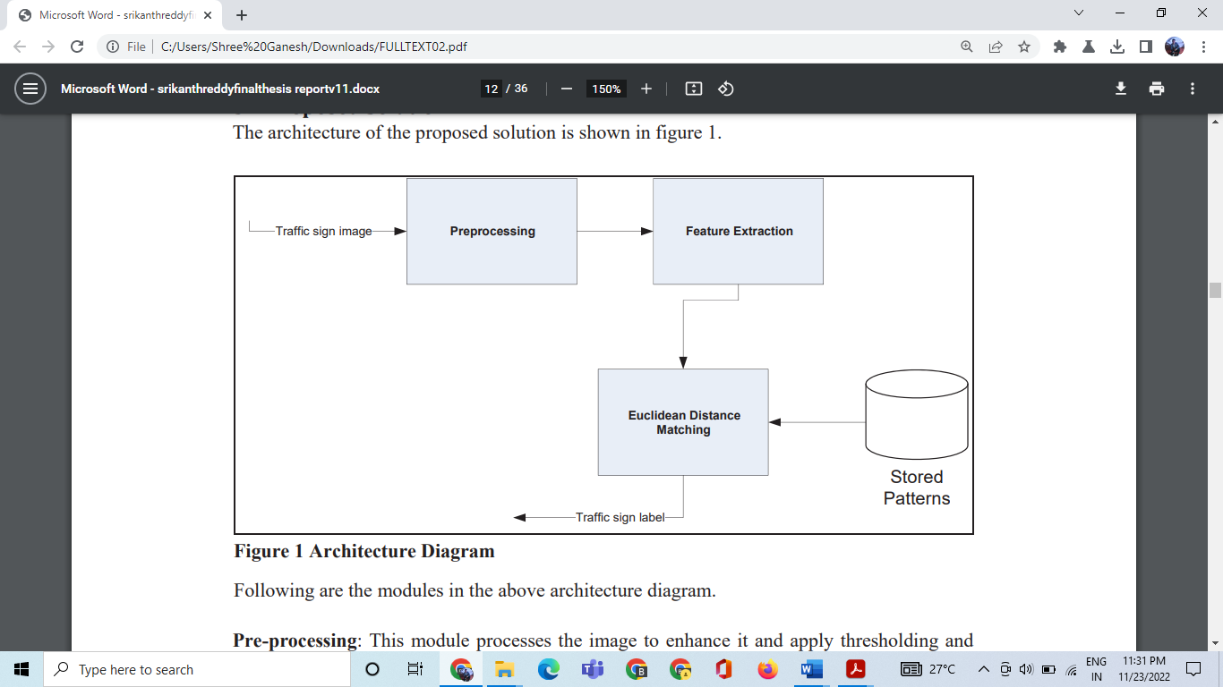

Fig 3.3.a. **Architecture Diagram**

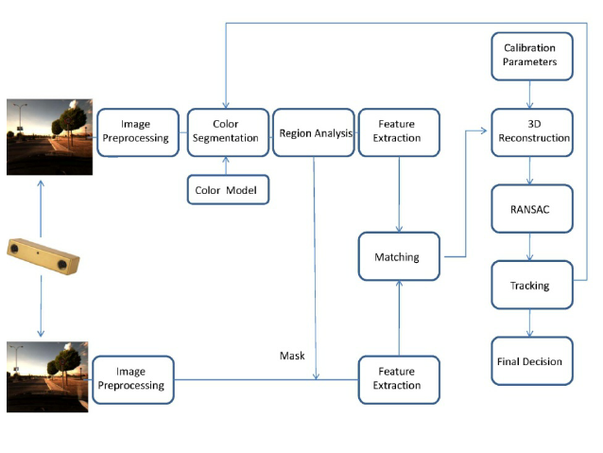

Fig3.3:b. Activity Diagram



Fig 3.3.c. UML diagram



Fig3.3.d Class diagram

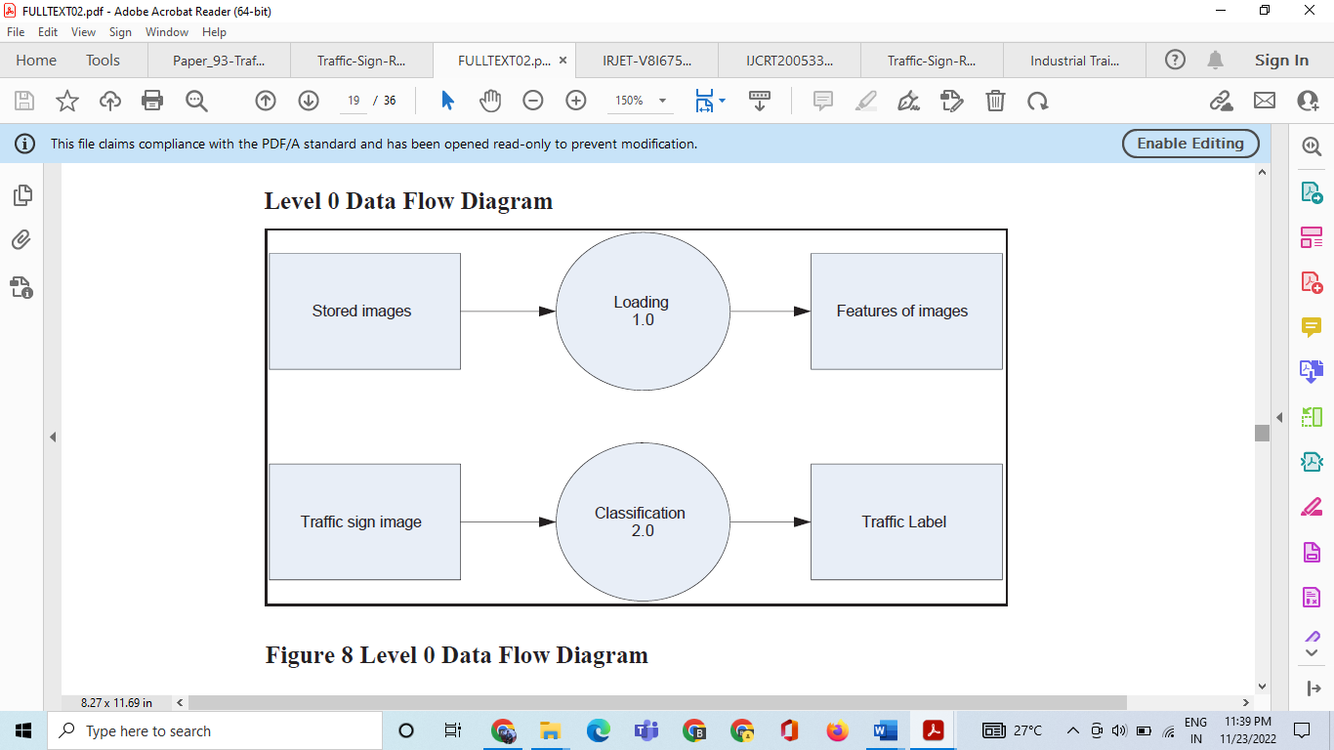

**Level 1 Data Flow Diagram**

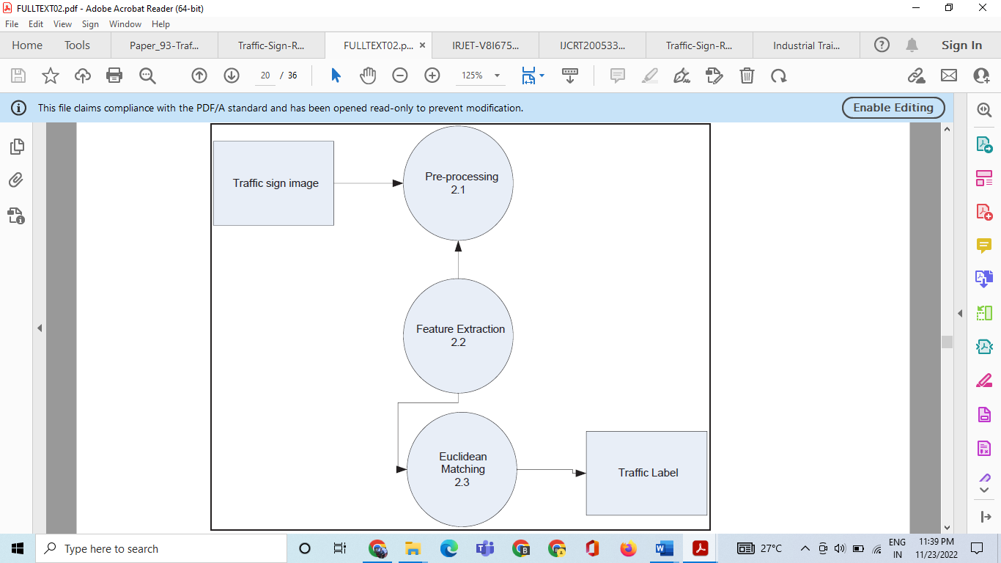

Fig3.3.e.DFD

**3.4 Design and sample code:**

**Code: (traffic_sign.py)** : To classify the images into their respective categories, we will build a CNN model ([*Convolutional Neural Network*](https://data-flair.training/blogs/convolutional-neural-networks-tutorial/)). CNN is best for image classification purposes code using python language .

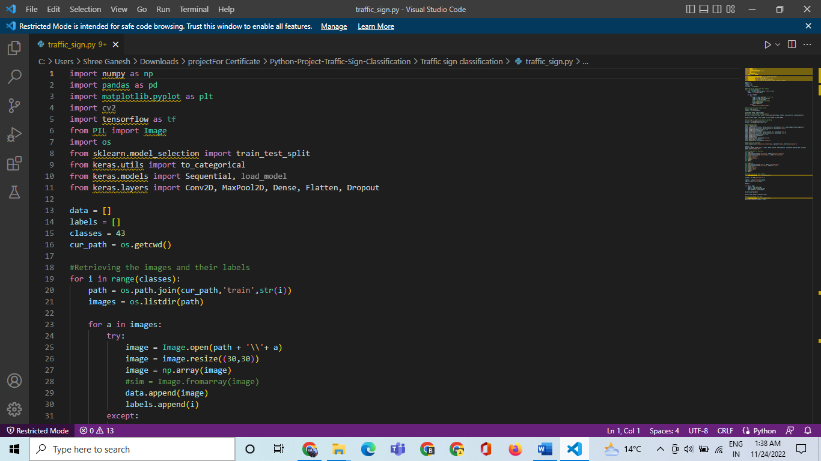

**Fig:-Sample Code (traffic_sign.py)**

**gui.py :**

Now we are going to build a graphical user interface for our traffic signs classifier with Tkinter. Tkinter is a GUI toolkit in the standard python library. Make a new file in the project folder and copy the below code. Save it as gui.py and you can run the code by typing python gui.py in the command line.

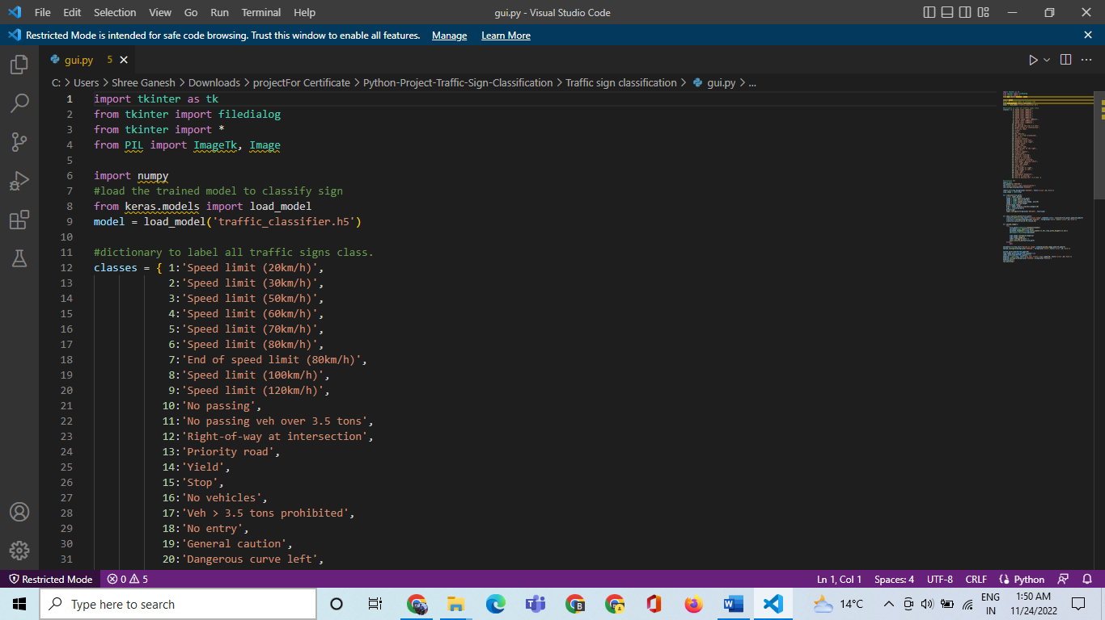

**Fig:-Sample Code (gui.py)**

**3.4 Software and Tools Used**

**3.4.1Software Specification**

1.Text Editor (VS-code/WebStorm)

**2.**Anaconda distribution package (PyCharm Editor)

**3.**Python libraries

**3.4.2. Software Requirements**

**Anaconda distribution:**

Anaconda is a free and open-source distribution of the Python programming languages for scientific computing (data science, machine learning applications, large-scale data processing, predictive analytics, etc.), that aims to simplify package management system and deployment. Package versions are managed by the package management system conda. The anaconda distribution includes data-science packages suitable for Windows, Linux and MacOS.3

**Python libraries:**

For the computation and analysis we need certain python libraries which are used to perform analytics. Packages such as SKlearn, Numpy, pandas, Matplotlib, Flask framework, etc are needed.

**SKlearn:** It features various classification, regression and clustering algorithms including support vector machines, random forests, gradient boosting, k-means and DBSCAN, and is designed to interoperate with the Python numerical and scientific libraries NumPy and SciPy.

**NumPy**: NumPy is a general-purpose array-processing package. It provides

a high-performance multidimensional array object, and tools for working withthese arrays. It is the fundamental package for scientific computing withPython. Pandas: Pandas is one of the most widely used python libraries in data science. It provides high-performance, easy to use structures and data analysis tools. Unlike NumPy library which provides objects for multi-dimensional arrays, Pandas provides in-memory 2d table object called Data frame.

**Flask**: It is a lightweight WSGI web application framework. It is designed to make getting started quick and easy, with the ability to scale up to complex applications. It began as a simple wrapper around Werkzeug.

**3.6 Highlights of Training Exposure (Area, Scope)**

Other than providing excellent quality education, different engineering institutes in India are trying to expose their students to industrial aspects and make them industry ready and for this, these institutes have arranged structured programs, projects, industrial training, visit to a industry, internships, R&D consultation, guest lectures, etc. with reputed industries. Even, the educational, as well as practical training programs of each of these engineering institutes, are regularly monitored by experts from industries and faculty members so that both the professional and technical skills meet the industrial skills and expectations as well.

Other than different research labs or industries, many engineering institutes in India have tie-up with more than thousands foreign industries or research labs all across the globe simply to fulfilling the criterion of industrial exposure of engineering students before completion of the course. Other aims of industrial exposure for education include the following.

* Partnering with different industries, students usually get placed in good job profiles in diversified industries
* Students get opportunities to work with industrial staff, understand their habits and approach towards problem solving
* To help students to gain experience by knowing the structure of any industries, its scope and job responsibility, its departmental functions and much more
* To help students in developing industrial skills such as Leadership, Team work, Conceptual skill, or Time Management by participating in different national or international level of project competitions.

**Scope**

"The main objective of the Training is to provide the students with practical, technological, as well as managerial experience trough personal contact in engineering and industrial organizations". Therefore training at universities or at the scientific research labs is generally not acceptable. It has to be completed at a company or a research and product development institute working on fundamental areas of Computer Engineering or Information Sciences – software development companies, – data processing centers, – hardware manufacturers – data communication companies using computer-based systems for their business-oriented purposes – organizations using computer automation in the manufacturing process – organizations using computer aided design and e-commerce technology

* The training must be supervised by a computer engineer (or a person holding a similar degree, subject to the approval of the advisor of the student)
* The training cannot comprise only of the learning of a system or application; it must also contain the development of a system or application. The applications can be on one of the following topics, as well as on other topics which will be found suitable by the Department. – System Analysis and Design – Software Design and Development – Database and Knowledge Base Applications – Microprocessor-Based System Design and Applications – Computer Network Applications – Computer-Aided Design and Manufacturing Applications

**3.7 Screen shot** of the result:

1. Open CMD in project folder Run CMD command python gui.py

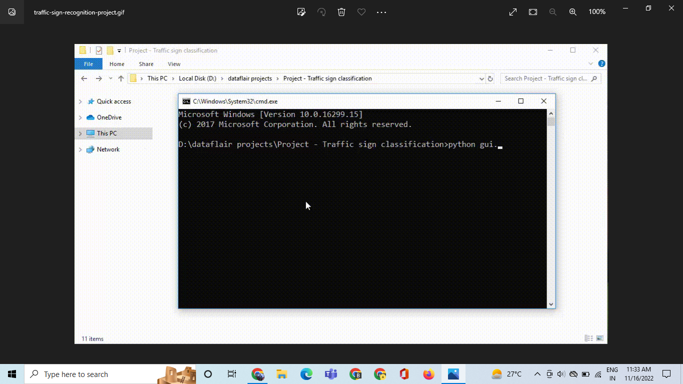

**Fig:-3.7.a. run gui.py**

2.Appear a GUI window and lick uload button and select a traffic sing pic .

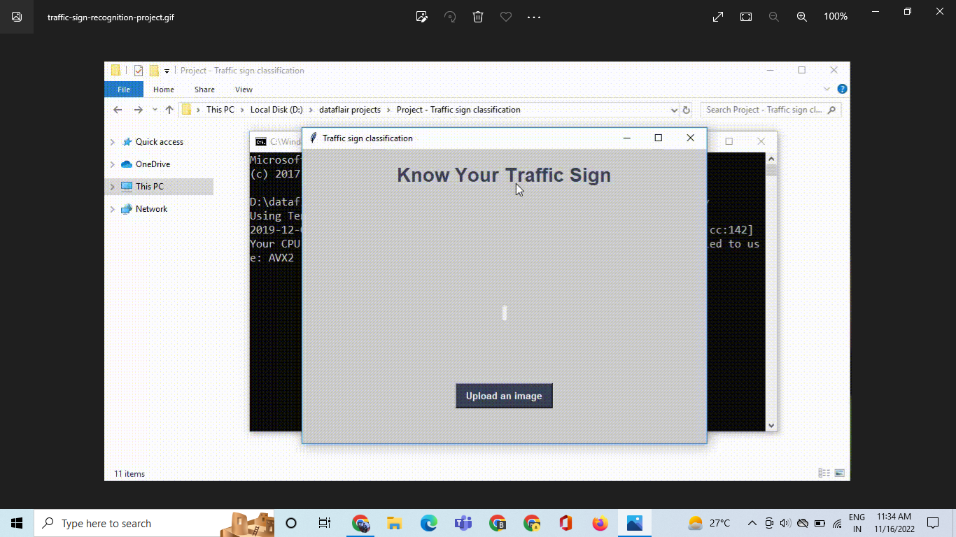

**Fig:-3.7.b. run gui.py**

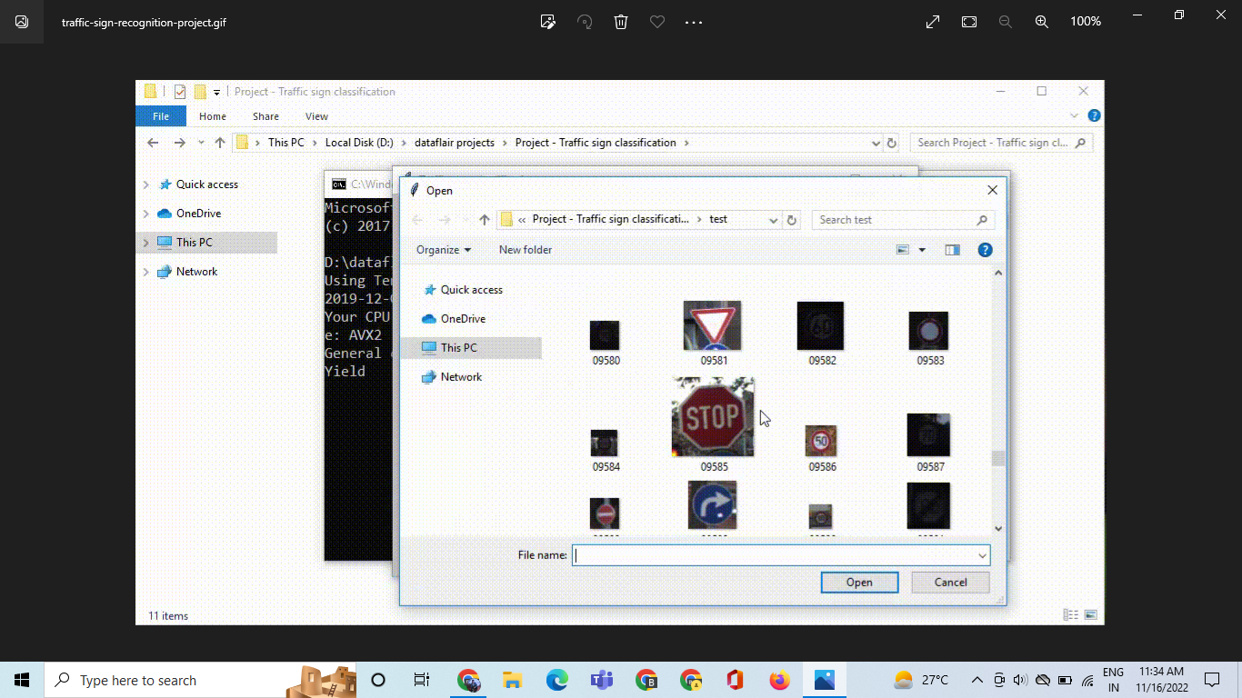

**Fig:-3.7.c. run gui.py**

1. Selected a sign and open so shows result

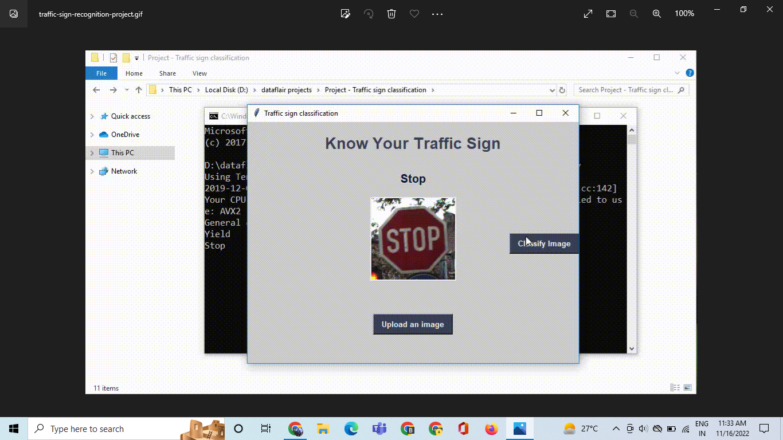

**Fig:-3.7.b Show Result**

**3.8 Certificate Copy:**

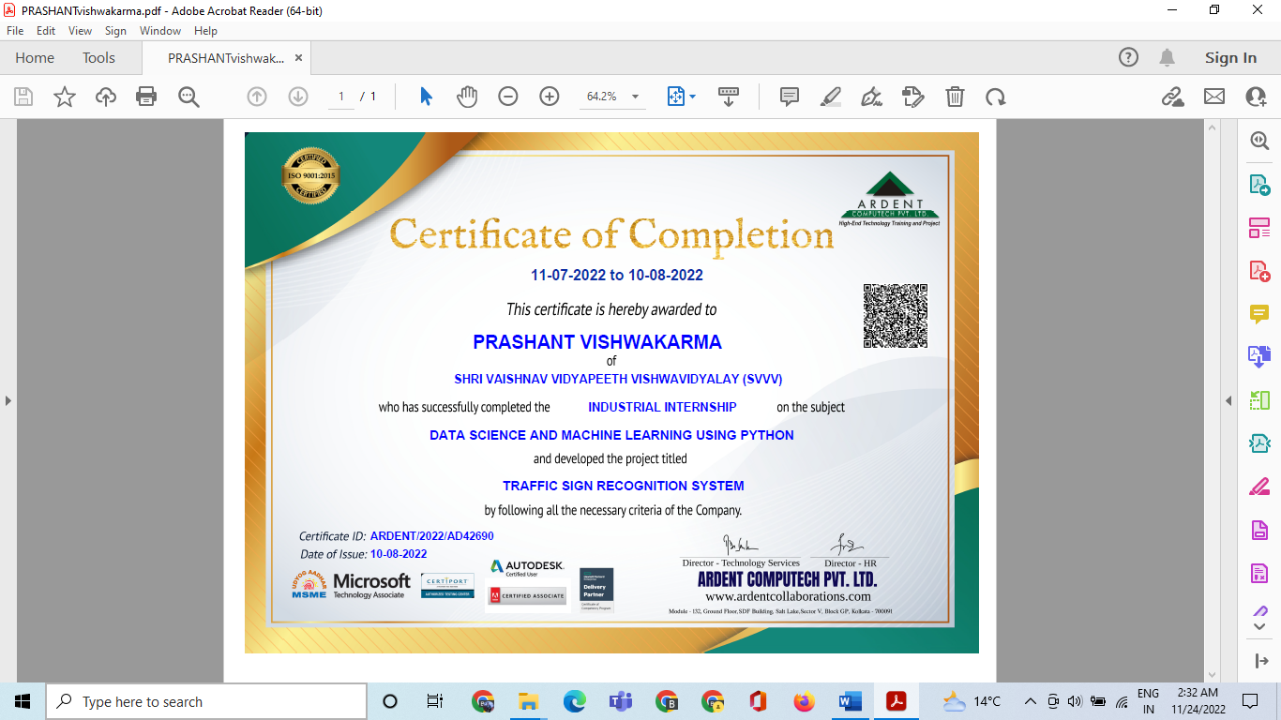

**CHAPTER 4- Conclusions**



**4.1 Conclusions**

In this project, we introduced a new method for recognition and tracking of traffic signs

dedicated for an automatic traffic assistance system. The proposed system is based on

intersection of traffic sign on a known grid pattern. It is simple and easy to implement with low

computational complexity. The proposed system was able to achieve more than 70% accuracy

and able to detect traffic sign between 30 to 40 milliseconds. In future, we can achieve more

accuracy by adding more no of images or by increasing the size of the database. We can have

more classes. In this thesis, generally we created our own DB file by taking the images from

German Traffic Sign (GTS), but in future we can apply this method directly to large datasets

like the German Traffic Sign (GTS) dataset and the Belgium Traffic Sign (BTS) dataset to

achieve faster time and greater accuracy.

**CHAPTER 5- References**



[1] A.Hechri and A. Mtibaa, "Automatic detection and recognition of road sign for driver assistance system," *2012 16th IEEE Mediterranean Electrotechnical Conference*, YasmineHammamet, 2012, pp. 888-891, doi: 10.1109/MELCON.2012.6196571.

[2] V. A. Prisacariu, R. Timofte, K. Zimmermann, I. Reid and L. V. Gool, "Integrating Object Detection with 3D Tracking Towards a Better Driver Assistance System," 2010 20th International Conference on Pattern Recognition, Istanbul, 2010, pp. 3344-3347, doi:

10.1109/ICPR.2010.816.

[3] L. Yang, K. Kwon, K. Moon, S. Lee and S. Kwon, "Broken traffic sign recognition based on local histogram matching," 2012 Computing, Communications and Applications Conference, Hong Kong, 2012, pp. 415-419, doi: 10.1109/ComComAp.2012.6154884.

[4] S. Lafuente-Arroyo, P. Gil-Jimenez, R. Maldonado-Bascon, F. Lopez-Ferreras and S. Maldonado-Bascon, "Traffic sign shape classification evaluation I: SVM using distance to borders," IEEE Proceedings. Intelligent Vehicles Symposium, 2005., Las Vegas, NV, USA, 2005, pp. 557-562, doi: 10.1109/IVS.2005.1505162

[5] Yuan Xie, Li-Feng Liu, Cui-Hua Li and Yan-Yun Qu, "Unifying visual saliency with HOG

feature learning for traffic sign detection," 2009 IEEE Intelligent Vehicles Symposium,

Xi'an, 2009, pp. 24-29, doi: 10.1109/IVS.2009.5164247.