1. First Click on Expense  
   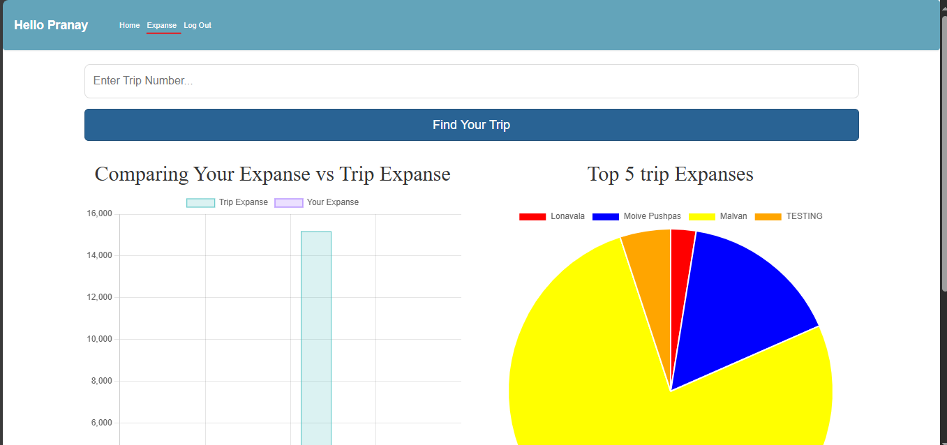
2. Click on create trip.  
     
   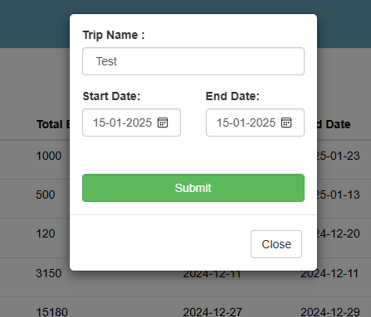
3. Fill in the details, then click on Submit.



1. After submission, a unique trip number (5-6 digits, e.g., 31154) will be generated.
2. Share this trip number with your trip members. They need to enter it in the Enter Trip Number input box and click on the Find Your Trip button

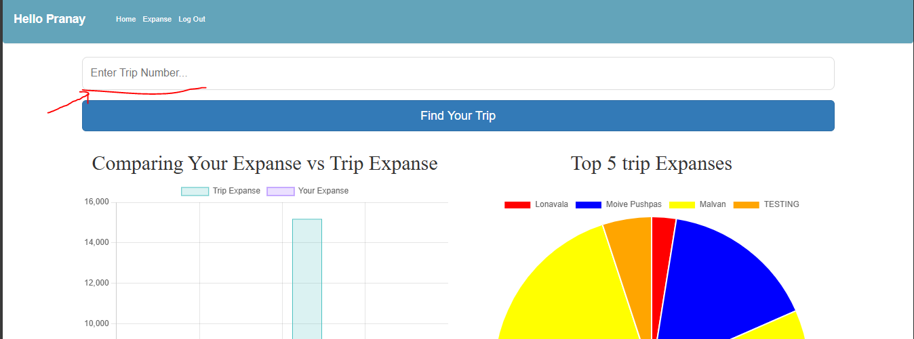

1. Then it look like this.

Once the trip is found, they should click on the Add Me button.

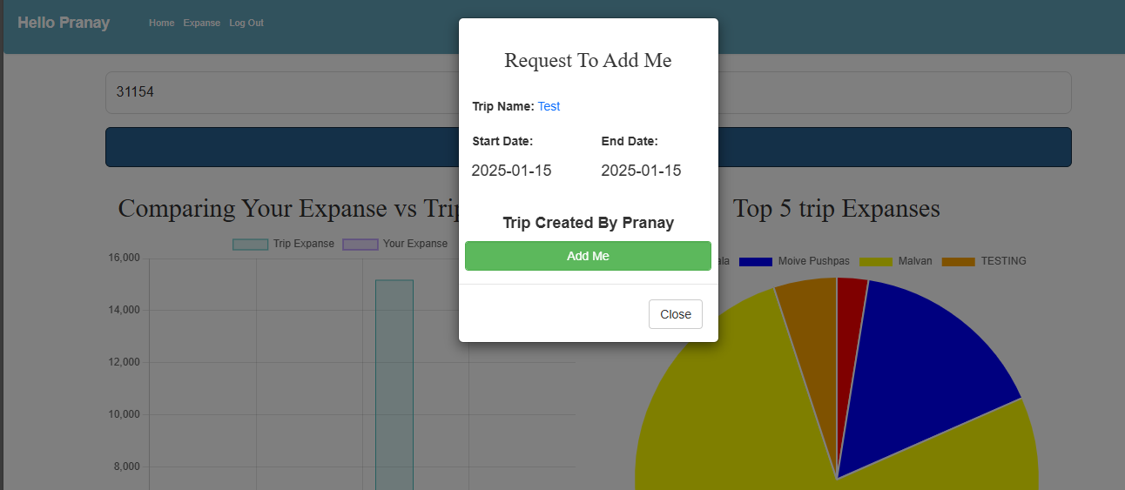

1. After this, go to the Expanse page. Now, click on the User button



1. In the User’s Request tab, you will see the pending requests. To add a user, simply click on the red button  
     
   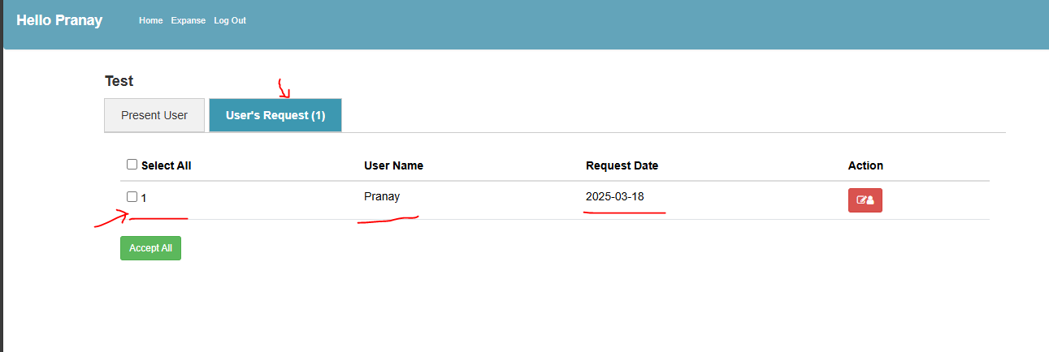
2. Once accepted, the user will be added to the Present Users list. Repeat this process to add all other trip members. 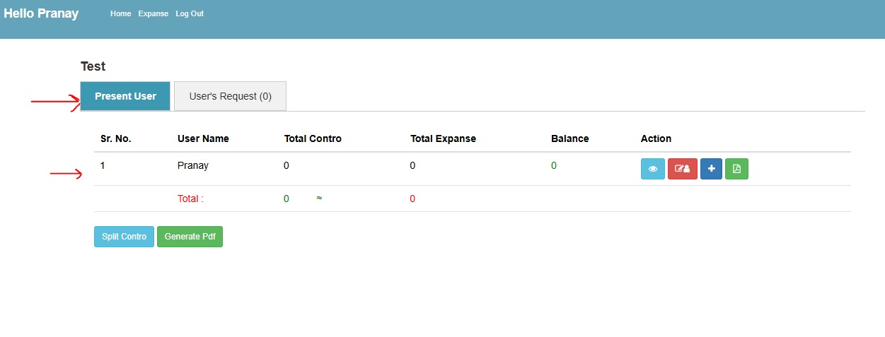

**Add Expanse:**

Click on expanse  


Then click on add expanse  
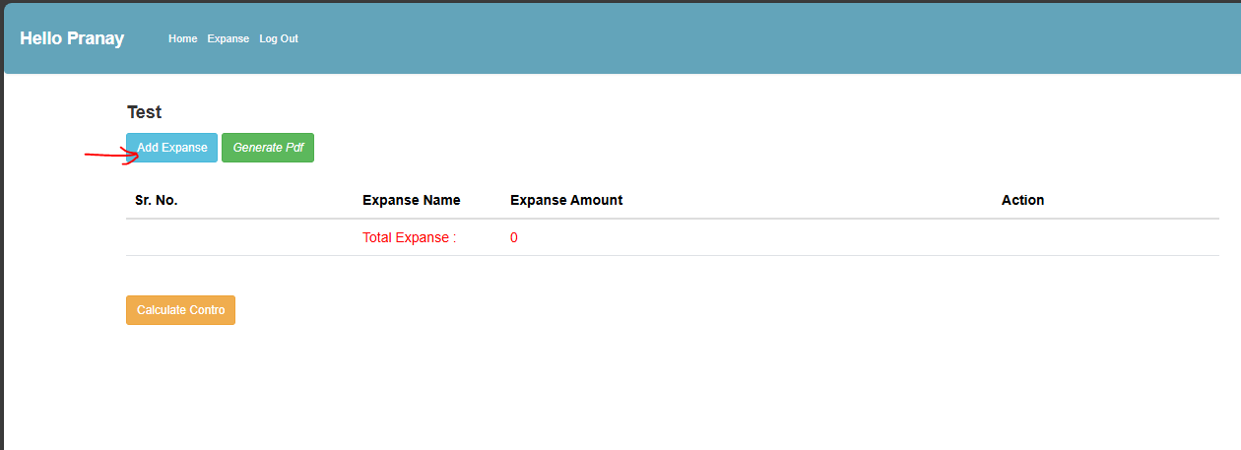

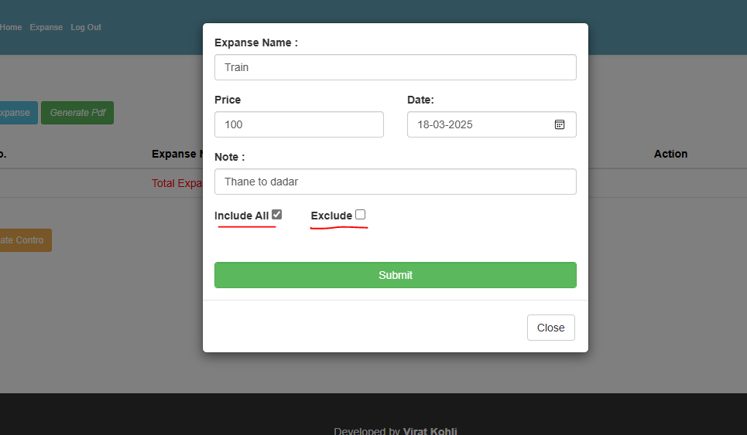  
  
· **Include All**: This will add all trip members.

· **Exclude**: Use this option to remove users you don’t want to include in a particular expense.

After submit:  
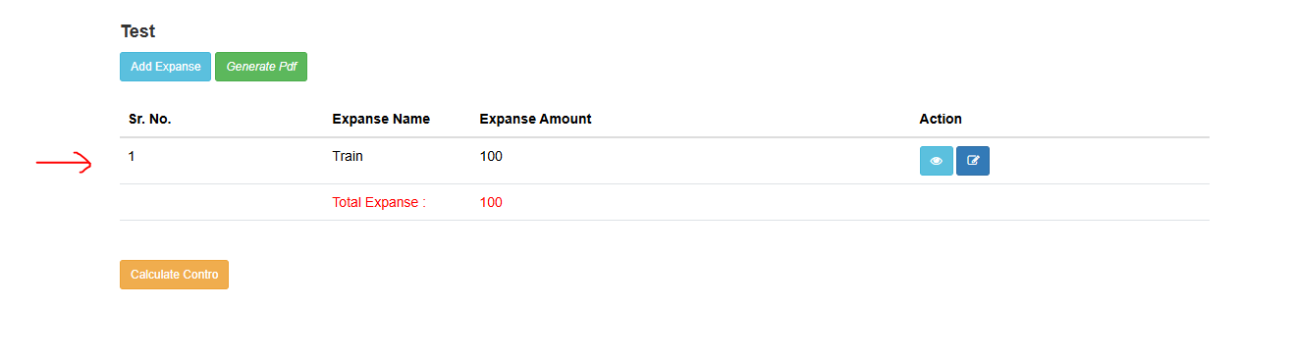  
Below is the "Calculate Contro" button. Once you click on it, all expenses will be calculated and divided among the users you added using the "Include All" and "Exclude" options.

After click it look like this.  
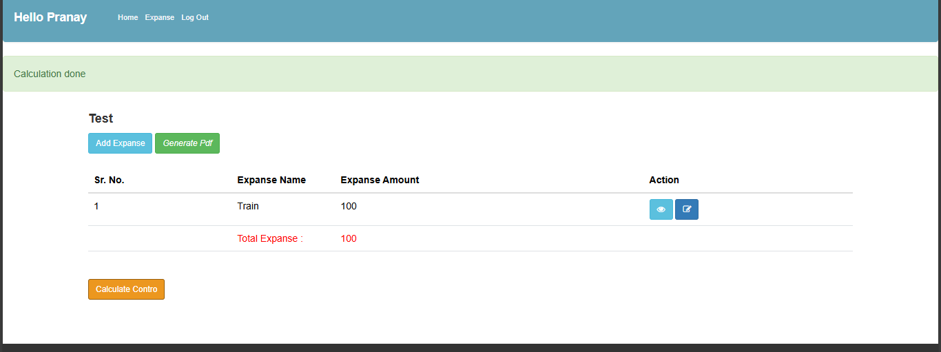  
Then in user section you can check :  
  
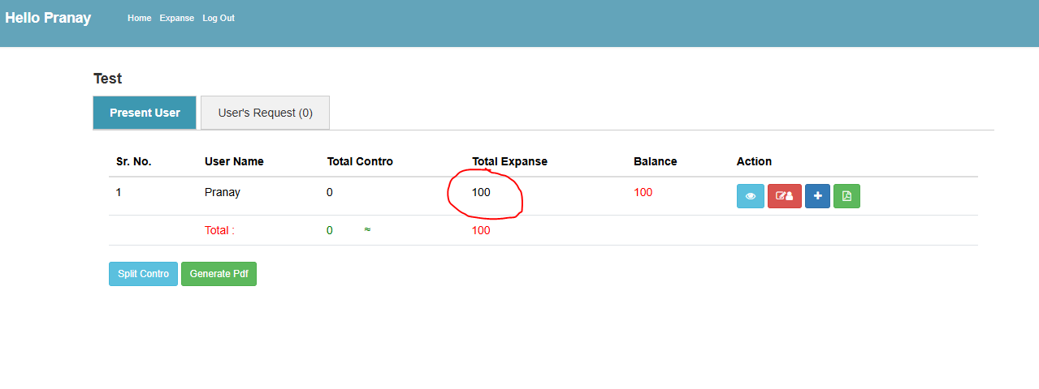

By click on this add button you can enter the amount which you have pay for the expanses.

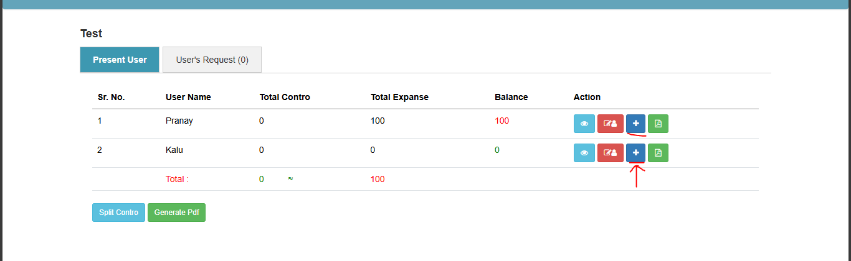

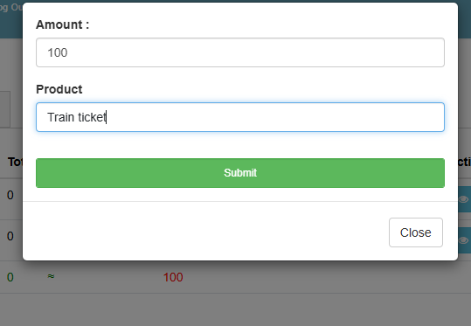

This PDF button will display the individual expenses of a particular member. 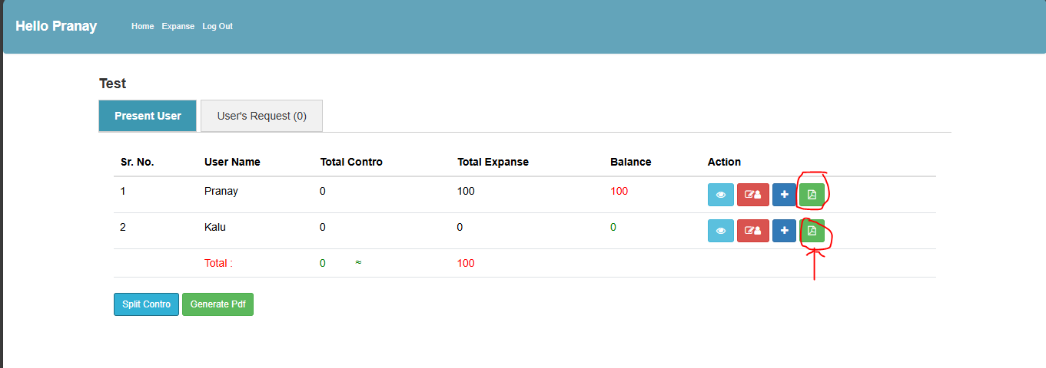

**Split Contro:**  
Buy using this you can add amount if someone give to you or give to someone else.

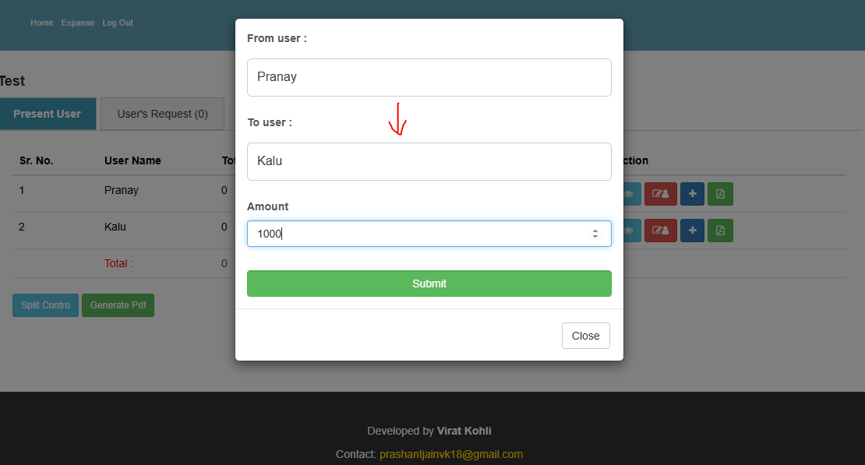

In the above scenario, Pranay gives ₹1000 to Kalu, which is later calculated properly.

**[Note: Only the user who created this trip or an admin of the trip can perform these actions. You can make anyone an admin of the trip.]**