App  
 Design

**Applications**In the future applications are going to be used more, more people today carry a phone, tablet or have access to the internet, and this would mean that more people would have access to new applications being made.   
 **Advantages and Disadvantages of creating an application**

|  |  |
| --- | --- |
| Advantages | Disadvantages |
| Today almost everybody has access to a phone or tablet to use, and this means that applications will be used more. | Time-because of the variety and range of new application available, this can cause it to take a lot of time to people to know about the application, meaning that profit will not come straight away, to overcome this advertising might be needed. |
| Trending-More people are beginning to use an application | Money-The application can cost a lot to develop and the profit will not come straight away. |

**Research on Applications**

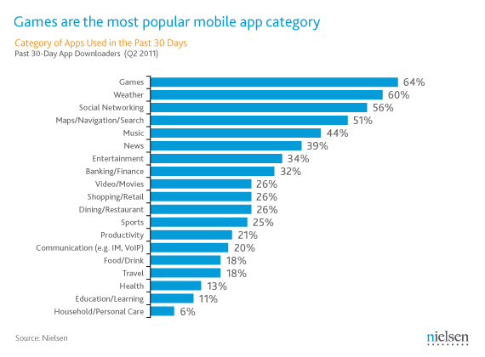

From the chart above it can be seen that the most used app category is gaming. This can be quite useful in app development as from this we can see that most people use games, meaning that this is one of the most profitable applications, however at the same time because technology is advancing more people are beginning to use functional apps which decrease the amount of work a person is doing. Examples of this include:   
- Spotify- Downloading music or buying it  
- Just Eat-Finds places to eat near by and some people substitute this to cooking  
-Translators-People don’t have to learn languages to their best

Because of this the data could be affected and more people will be using apps linked with health, productivity and food/drink, etc.

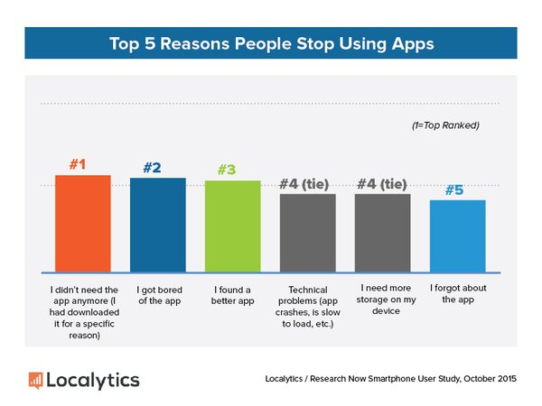  
  
From the Chart above it can be seen that people stop using apps main because that they needed the app for a specific reason or that app was quite boring. This can be quite useful in app development as it can show use what type of apps people would like and how this can be maintained so that people keep on using the app. The chart shows that the app needs to be interesting and entertaining for the user as well as having more than one usage. This will enable the user to use the app longer.

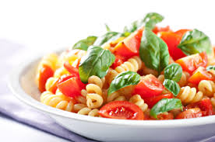**App Idea 1  
 Food and drink- Social media**

Our application idea is an app which can find recipe based on what type of ingredients you have using a barcode scanner. As well as this it would be able to search recipes manually with the users input which would allow the recipes which come from various site from the internet or from users which make an account and share recipes on this, will be refined to the users diet and tastes.  
Furthermore by having an account users would be able to find the recipes needed even if they are quite rare.  
Apart from this the user would be able to:  
-upload videos with recipe  
-comment on ideas and recipes  
-create a dietary plan   
-find recipes which apply to them- such as vegetarians, lactose intolerant, vegans, etc.  
-display calories in each recipe

Advantages  
- Allows people to find recipes to cook easily without having to go out to get the ingredients  
- Gives a wide range on recipe as well as allowing people to include their own recipes  
-Easy for people to use  
-User-friendly  
Disadvantages  
-Uses WI-FI connection, doesn’t work offline  
-Uses barcode scanning, and all ingredients may not have this, such as loosely packed food

Purpose of the App:   
The application will use a barcode scanner or a form to find out what ingredients a person has.  
Barcode scanner/Search -By scanning the barcode of the product or inserting in the product by inserting the name the user would be able to find recipes using those specific ingredients.  
  
The app will enable people to cook something with what they have in the kitchen, when in short notice or just as a quick meal.

How will this work?  
  
Scan for recipes- the user would be able to scan the barcode of each one of their ingredients or click/search for the ingredients in for those without a barcode and find recipes with the use of wifi.  
  
Search for recipes-searches the internet for possible recipes as well as giving videos and other suggestions  
  
Share-Users could login using email, facebook and other social media in order to share creations and other recipe ideas.  
  
Creating s dietary plan –give the use of a calendar allowing users to input the meals being eaten on those days  
  
Offline use-The user would download any recipes/recipe videos they like so they can be viewed offline (however search and scan would not be available)

Possible name ideas:   
- Need to eat!  
- Recipe fast  
-

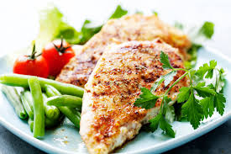 **#**

V

**Any dietary restrictions?**

**Your Ingredients:**

Meals at your convenience! --Company name-- helps you to find recipes which you can make with the ingredients at home, simply by typing or scanning the ingredients you have, we will supply you with many recipes with videos and comments for you to create and enjoy a healthy meal at breakfast lunch or dinner!

Scan for recipe

Company name --------

**Our Top Recipes**

Grilled Turkey Salad:  
   
Prep time: 1hr 30mins  
  
  
by – company name -

Home  
  
Scan/search  
  
Top Recipes  
  
Recipes  
  
Videos  
  
create my dietary plan

Login  
  
my home  
  
my uploads  
  
Favourites  
  
Friends  
  
Comments and reviews  
  
Share

-Company name-

Website

**E**

Grilled Turkey Salad  
Prep time: 1hr 30mins  
  
  
by – company name -

My Profile  
  
my uploads  
  
Favourites  
  
Friends  
  
Comments and reviews  
  
Share

Scan/search   
  
Top Recipes  
  
Recipes  
  
Videos  
  
Create my dietary plan

SCAN INGREDIENTS

LOGIN

**Your Ingredients:**

SUBMIT

**Any dietary restrictions?**

-Company name-

Phone/App Application

The mobile app will have the same kind of things as the website however to cut down storage there will be less on the app, it will have the scan and search as that is the main function of the app.  
  
The menu can be viewed by sliding to the right and for account information to the left this will cut down the amount of space being used on the one page.