**Dot Net Phase 1: Player and Team Project**

Phase-End Project Problem Statement



**Phase-End Project 1**

**Player and Team Requirements**

**Pre-Requisites:** Should have good knowledge of Classes, Interfaces, Generic Collections, and LINQ (Lambda expressions, Extension methods, and Anonymous Function)

**Application Environment:** Console Application using C#

**Case Study:**

FastPace Cricket Academy has decided to create a solution to maintain information about the teams’ players for one day game with the below functionalities:

* User will be able to add a player to the team with details Player Id, Name, and Age.
* User will be able to remove a player from the team by passing the player’s Id.
* User will be able to get player details by passing the player’s Id.
* User will be able to get player details by passing the player’s name.
* User will be able to get all player details.
* User will not be able to add more than 11 players to the team.

To fulfill the above requirements, follow the instructions given below:

1. Create a **Player** class with auto-implemented properties:

|  |  |  |
| --- | --- | --- |
| **Name** | **Type** | **Modifier** |
| PlayerId | int | Public |
| PlayerName | string | Public |
| PlayerAge | int | public |

1. Create an interface **ITeam** and declare functions as given below:

|  |  |  |
| --- | --- | --- |
| **Interface Members** | **Member** | **Description** |
| void Add(Player player); | Function | To implement functionality for adding a player to the Team by passing an object of type Player as a parameter |
| void Remove(int playerId); | Function | Implement functionality for removing the player from the Team by passing Player Id as a parameter |
| Player GetPlayerById(int playerId); | Function | To implement functionality to get player by passing Player Id as a parameter |
| Player GetPlayerByName(string playerName); | Function | To implement functionality to get player by Player Name as a parameter |
| List<Player> GetAllPlayers(); | Function | To implement functionality to get all players from the Team |

1. Create a derived class **OneDayTeam** to implement ITeam interface functionalities as given below:

|  |  |  |
| --- | --- | --- |
| **Class Members** | **Member** | **Description** |
| public static List<Player> oneDayTeam = new List<Player>(); | Global Field Member | Create a global variable of type List<Player> to collect objects of type Player |
| public OneDayTeam() | Constructor Function | Write a constructor to set the capacity property to 11 |
| public void Add(Player player) | Function | Implement functionality for adding a player to the Team by passing an object of the type Player as a parameter |
| public void Remove(int playerId) | Function | Implement functionality for removing the player from the Team by passing Player Id as a parameter |
| public Player GetPlayerById(int playerId) | Function | Implement functionality to get player by passing Player Id as a parameter. |
| public Player GetPlayerByName(string playerName) | Function | To implement functionality to get player by Player Name as a parameter. |
| public List<Player> GetAllPlayers() | Function | To implement functionality to get all players from Team. |

4. After writing all the above functions, write the code in the **Main** function inside the default class **Program:**

4.1 Create a menu to prompt the user to perform the required functionality as shown below:

"Enter 1:To Add Player 2:To Remove Player by Id 3.Get Player By Id 4.Get Player by Name 5.Get All Players:"

4.2 Write a switch-case construct to call the required function from **OneDayTeam** class per user choice

5. Please observe the given Console Output Window to meet all the above requirements:

a. To add player:

b. To remove a player by passing the Player Id:

c. To get player details by passing the Player Id:

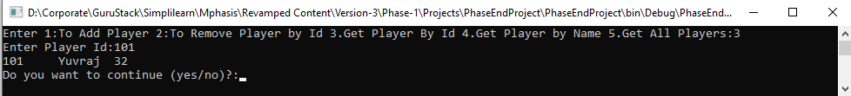

d. To get player details by passing the player’s name:

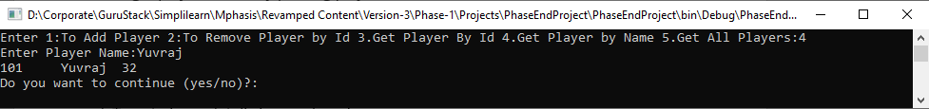

e. To get all player details currently present in the team:

f. Full output window with all inputs and outputs:

