**Assignment 17.1**

Write a program that accepts the job_id as argument and returns a custom counter and a system counter (total records input to the map tasks) associated with that job.

**Driver class**

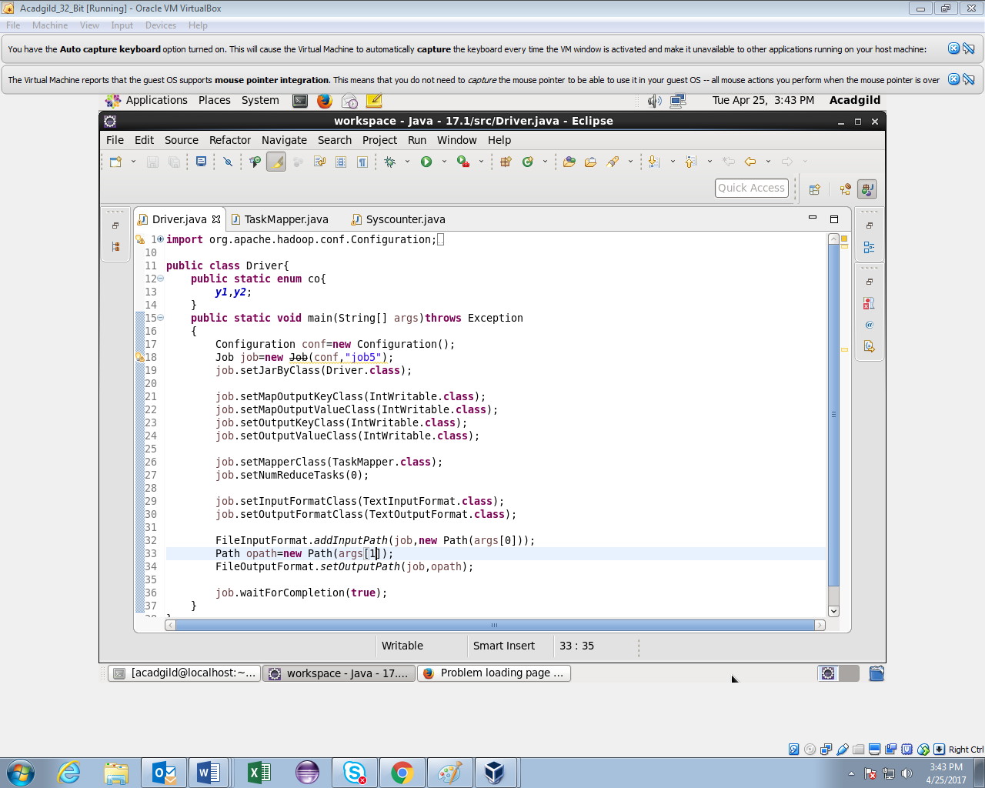

**Mapper class**

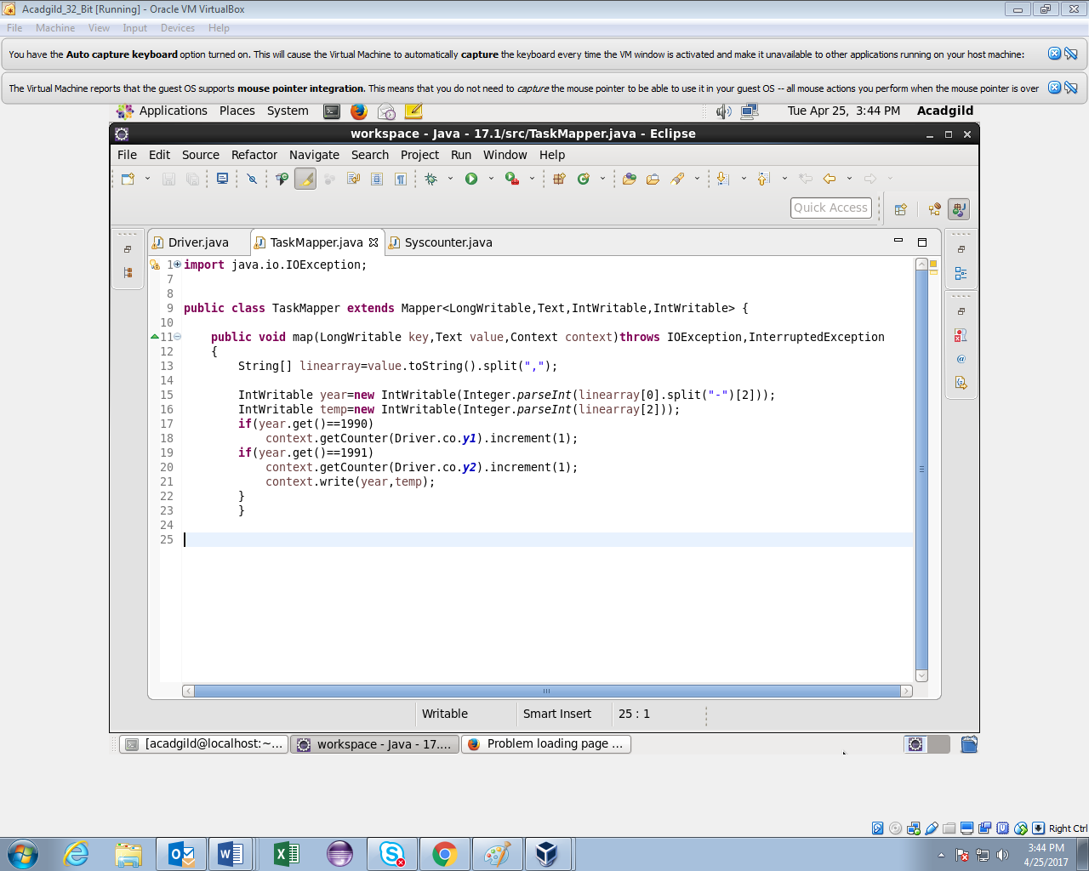

**Syscounter class**

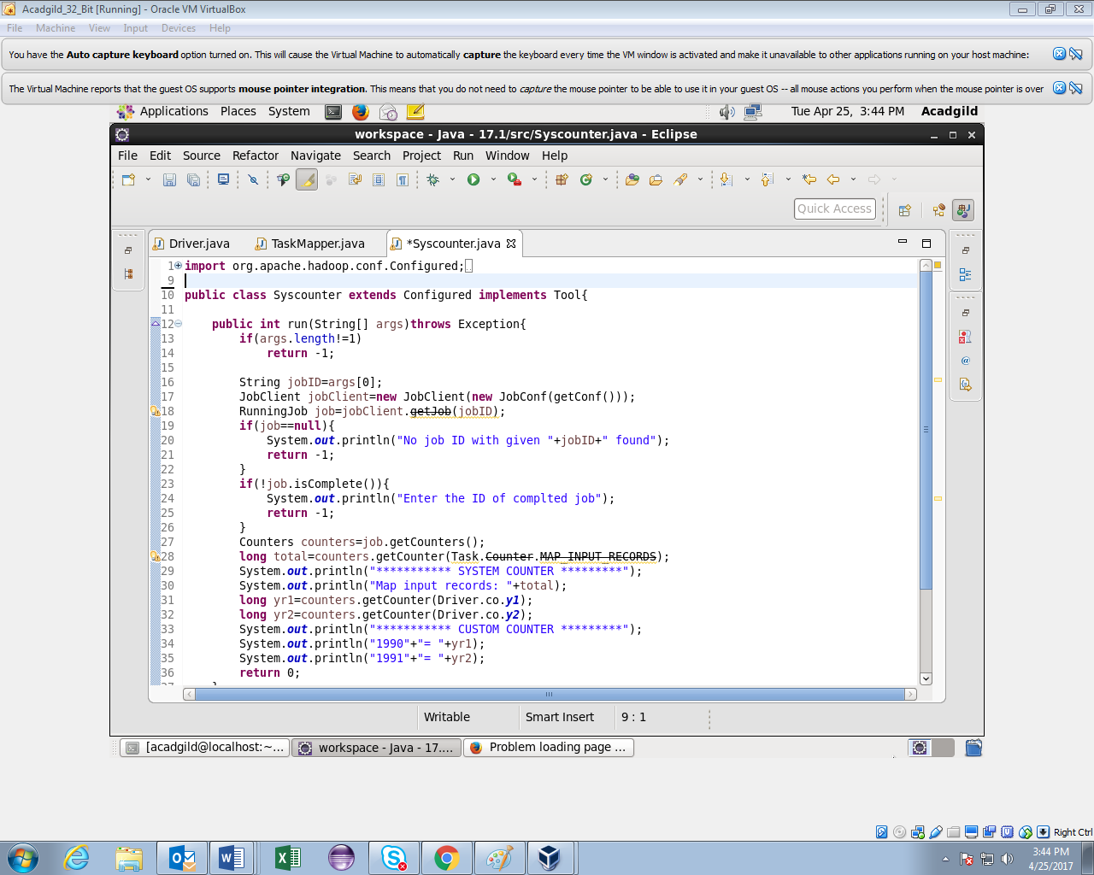

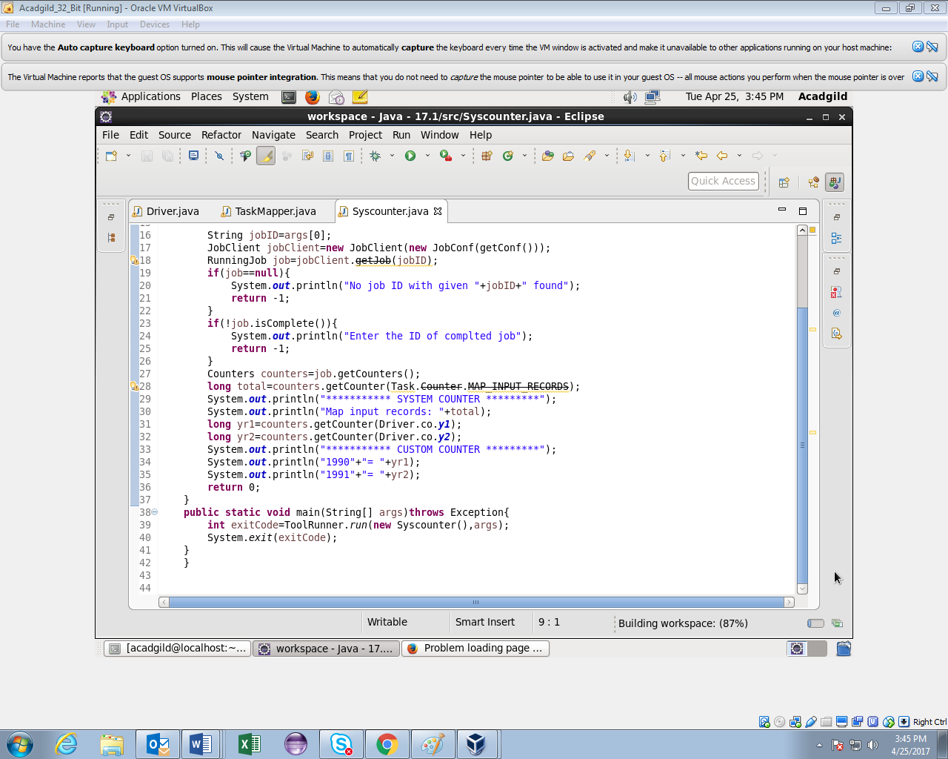

In the above class we accept job ID as input and display system counter and custom counter for the same job.

**Output**

