Assignment 9.3

1.Create two datasets employee and department of file type text where the columns are delimited by tab ( ‘\t’ ), and use these datasets to perform below Join operations : ● SELF JOIN ● INNER JOIN ● LEFT OUTER JOIN ● RIGHT OUTER JOIN ● FULL OUTER JOIN

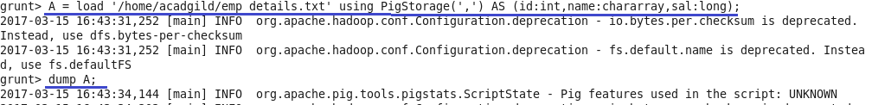

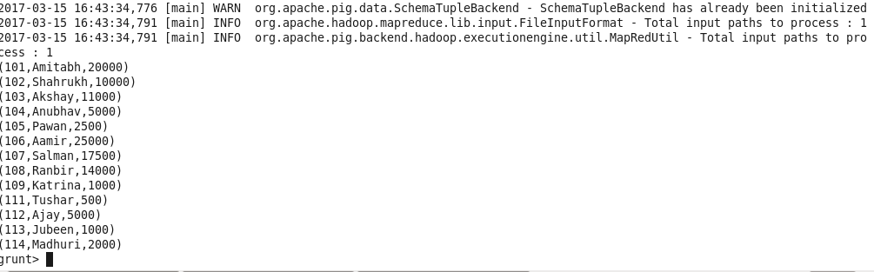

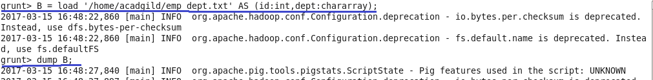

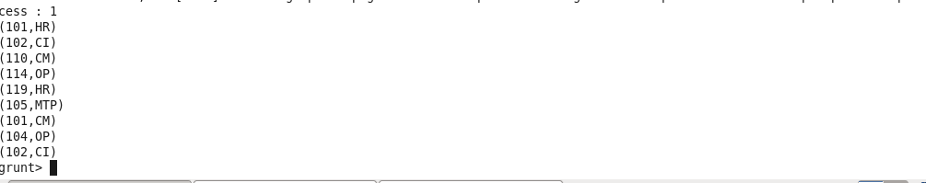

1.Inner Join



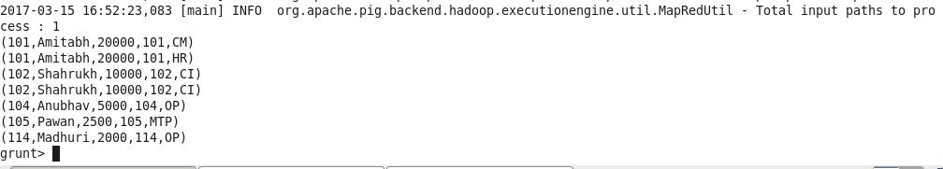

2.Self Join

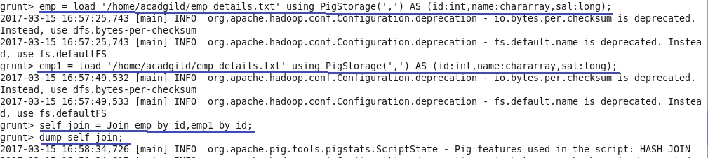

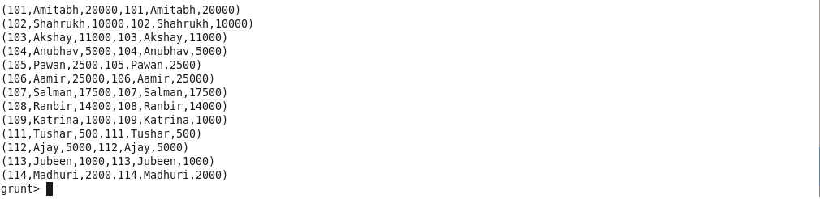

3.Left Outer Join

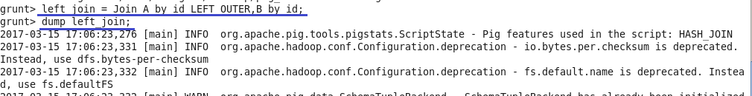

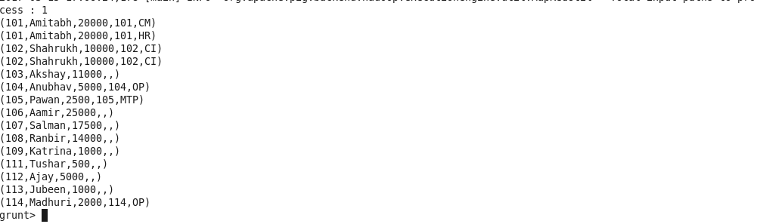

4.Right Outer Join

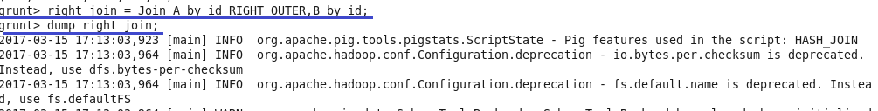

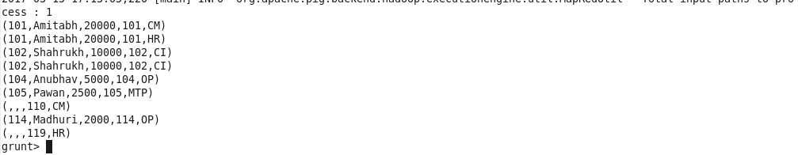

5.Full Outer Join

