1. What is the total amount of petrol in volume sold by every distributor?

SINCE WE WANT VOL SOLD BY EACH DISTRIBUTOR GROUP BY DISTR NAME AND SUM VOLUME OUT TO GET THE TOTAL AMT OF PETROL SOLD IN VOLUME

1. Which are the top 10 distributors ID's for selling petrol? Also display the amount of petrol sold in volume.

SINCE WE WANT VOL SOLD BY EACH DISTRIBUTOR ID, GROUP BY DISTR ID AND SUM VOLUME OUT TO GET THE TOTAL AMT OF PETROL SOLD IN VOLUME AND THEN SORT BY DESC THEN LIMIT BY 10 TO GET TOP 10;

1. List 10 years where consumption of petrol is more with the distributer id who sold it.

SINCE WE WANRT 10 YRS WHERE COMSMPTION IS MORE WITH THE DISTRID ,I GROUP BY ID YEAR THEN FOR EACH I WILL FIND VOLUME COMSUMED BY SUBTRACTING VOL IN – VOL OUT THEN ORDER BY IT DESC TO GET TOP 10 AND I WILL DISPLAY THE YEAR

1. Find the distributer name who sold petrol in least amount.

GROUP BY DISTR NAME AND SUM VOLUME OUT TO GET THE TOTAL AMT OF PETROL SOLD IN VOLUME AND LIMIT BY 1

PIG COMMANDS

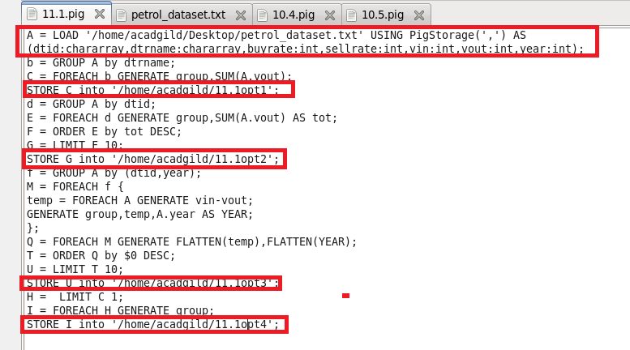

RUNNING PIG SCRIPT

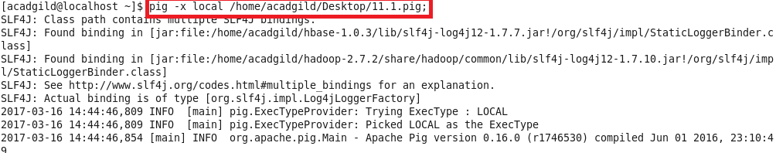

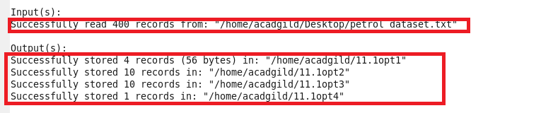

OTPT

