PROJECT EXPO

TEAM MEMBERS:
DHARSHANA S
ELAKIYAA K
MARIYAM SHAMNA M
PRASHEETHA S
Smart IoT-Based Shopping Trolley Using RFID
PROBLEM STATEMENT:
In supermarkets, customers spend significant time waiting at billing counters, as manual barcode scanning increases checkout time and leads to long queues, especially on weekends and during festive seasons. Customers cannot monitor their bill while shopping, making budgeting difficult, and often waste time searching for products due to the lack of in-store navigation. Existing trolleys lack automatic billing, item tracking, and theft prevention, with no way to verify that items in the trolley match the billed items before checkout, leaving them vulnerable to shoplifting. Store staff also lack real-time visibility into stock levels, causing stockouts, delayed restocking, and error-prone manual inventory audits. Additionally, dependency on billing counters raises operational costs due to extra staffing during peak hours, while the absence of digital payment options at the trolley adds to wait times. Elderly and differently-abled customers face further difficulty due to the lack of assistive features in manual scanning and heavy trolleys. Overall, the absence of a smart, integrated trolley system leads to inefficient checkout, poor inventory management, security risks, and a subpar shopping experience.

ABSTRACT:
The Smart IoT-Based Shopping Trolley is designed to automate the shopping experience using RFID technology and IoT. Every product carries an RFID tag. When a customer places an item in the trolley, the RFID reader detects the tag and automatically updates the product name, quantity, and price on an LCD display and cloud database. If an item is removed, the system automatically deducts it from the bill. The total bill is continuously displayed, allowing customers to track their expenses. At checkout, the final bill is sent to the billing server, eliminating the need for manual scanning. This system reduces billing time, minimizes human errors and improves the shopping experience.

OBJECTIVES:
- To eliminate the need for cashier-assisted billing by enabling a self-checkout process directly through the trolley.
- To reduce human error in billing caused by manual scanning, mismatched prices, or missed items.
- To provide personalized product recommendations and offers to customers based on items added to the trolley.
- To enable seamless digital/contactless payment options directly from the trolley, avoiding counter dependency.
- To assist store management with real-time inventory tracking by linking trolley data with stock levels.
- To reduce paper waste by offering digital bills/receipts instead of printed ones.
- To improve accessibility for elderly and differently-abled customers through an easy-to-use trolley interface.
- To enhance store security by preventing unbilled items from leaving the premises through automated verification.
- To collect and analyze customer shopping pattern data to help supermarkets optimize product placement and staffing.
- To build a low-cost, energy-efficient hardware model that can be easily adopted by small and medium-sized retail stores.
SCOPE OF THE PROJECT:
This project focuses on developing a smart trolley system integrated with RFID-based automatic billing, real-time bill tracking and in-store navigation assistance. The system is designed for deployment in supermarkets and retail stores to reduce checkout time, minimize manual errors, and enhance the overall shopping experience. It covers item detection and billing as products are placed in the trolley, a display unit for real-time cost updates, and a basic navigation aid to help customers locate product sections. The project can be extended in the future to include features like digital payment integration, personalized recommendations, and inventory management, making it scalable for both small retail stores and large supermarket chains. However, the current scope is limited to prototype-level implementation and may not cover full-scale deployment across multi-floor or extremely large retail spaces.

EXPECTED OUTCOMES:
Faster checkout with reduced billing queues.
Accurate, error-free billing.
Real-time bill tracking for better budgeting.
Theft prevention through automated item verification.
Easy product navigation within the store.
Lower staffing costs for supermarkets.
Improved overall shopping experience.
Working prototype proving RFID-based trolley feasibility.

LITERATURE SURVEY:
S.No | Author(s) / Year | Title | Technology Used | Key Findings | Limitation / Gap
1 | ANITS Project Report, 2019-20 | RFID Based Smart Trolley for Automatic Billing System | RFID, Arduino, LCD | Customers scan products, view finalized bill in trolley, pay via customer card; data sent to central PC Anits | No handling for products accidentally dropped into trolley; needs server maintenance Anits
2 | Kulkarni et al., 2023 | Smart Shopping Cart with Automated Billing Using Arduino | RFID tags + reader, Arduino | Automated billing within cart using RFID tags scanned as items added, reducing checkout queues Jetir | No theft-prevention or navigation feature
3 | Shahroz et al., IEEE Access, Vol. 8 | IoT Based Smart Shopping Trolley Using RFID | RFID sensors, Arduino, Bluetooth, mobile app | Efficiently managed shopping and billing, reducing waiting time and enhancing customer experience IRJMETS | No in-store navigation included
4 | Jaishree et al., 2021 | Smart Shopping Trolley Using IoT | Barcode scanner, LCD, Raspberry Pi | Reduced waiting time in queues during rush hours using barcode-based scanning IRJMETS | Barcode slower than RFID for bulk items
5 | Karpagam V. et al., 2017 | Smart Trolley with Smart Billing | RFID reader, LCD, ZigBee | Total cost of scanned products stored in microcontroller memory and displayed to customer IIETA | ZigBee has distance/range barrier IIETA
6 | Karthi et al., 2023 | IoT Based Smart Trolley System for Automated Billing | RFID + obstacle sensors | Trolley followed customers automatically while avoiding obstacles for secure shopping Jetir | High hardware complexity/cost

EXISTING SOLUTIONS ANALYSIS:
S.No | Existing Solution | Technology Used | Advantages | Disadvantages
1 | Traditional Barcode Billing (Manual Checkout) | Barcode scanner at counter | Low cost, widely used, simple to maintain | Long queues, time-consuming, requires staff, no real-time bill tracking for customer
2 | Self-Checkout Kiosks | Barcode/QR scanning by customer | Reduces cashier dependency, faster than manual counters | Still requires manual scanning of each item; prone to scanning errors/theft; limited kiosks cause queues
3 | RFID-Based Smart Trolleys (existing research) | RFID tags + RFID reader on trolley | Automatic item detection, faster billing, real-time bill display | No item-location/navigation feature; no verification for accidentally dropped items; needs infrastructure investment
4 | Amazon Go / Just Walk Out Technology | Computer vision, sensor fusion, deep learning | No checkout needed at all; fully automated; highly accurate | Very high implementation cost; requires extensive camera/sensor network; not feasible for small/medium retailers
5 | Mobile App-Based Scan & Go | Customer scans items via smartphone app | No extra hardware on trolley; flexible; customer-owned device used | Relies on customer honesty (self-scanning can be skipped); no automatic theft prevention; needs strong app adoption
6 | ZigBee-Based Smart Carts | ZigBee + RFID | Wireless communication between cart and billing system | Limited range/distance; signal interference in crowded stores
7 | IoT-Based Trolleys with Bluetooth/App Integration | RFID + Bluetooth + mobile app | Real-time billing sync with customer's phone; better UX | No standard theft-detection mechanism; dependent on stable Bluetooth connectivity

GAP ANALYSIS:
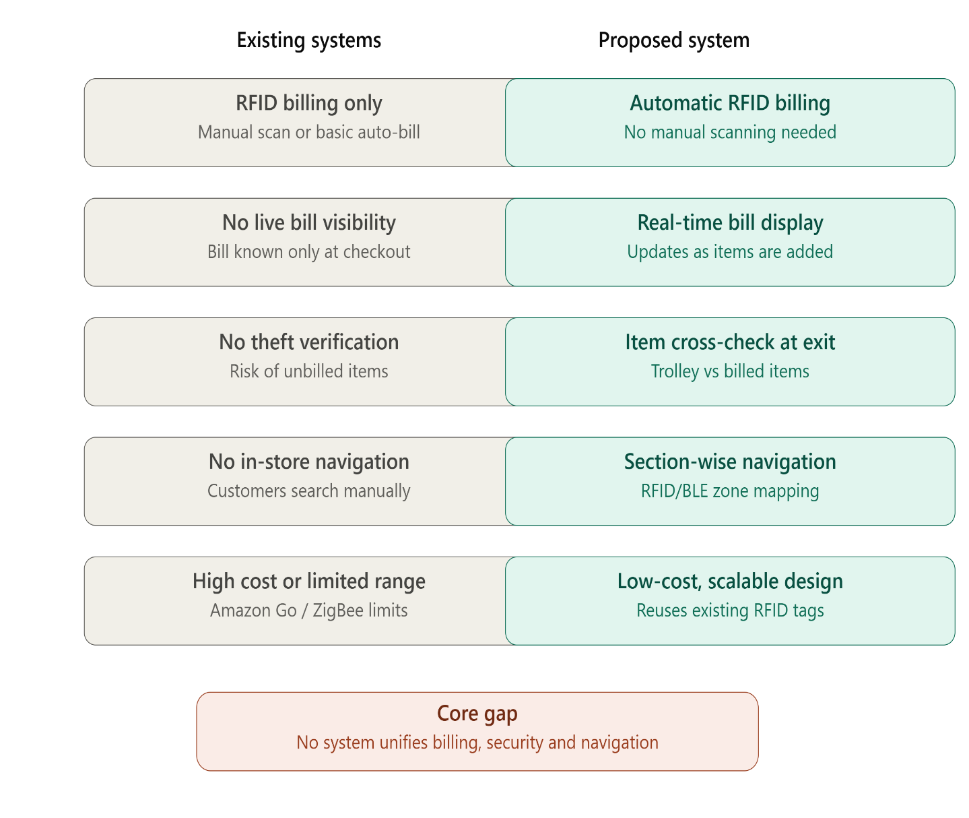
REFERENCES:
- M. Shahroz, M. F. Mushtaq, M. Ahmad, S. Ullah, A. Mehmood, and G. S. Choi, "IoT-Based Smart Shopping Trolley Using Radio Frequency Identification," IEEE Access, vol. 8, pp. 68426–68438, 2020.
- "Smart Shopping Trolley Using Arduino UNO," IEEE Conference Publication, 2024.
- R. Kulkarni, A. Kumavat, A. Jha, A. P. Singh, and A. Chincholkar, "Smart Shopping Cart with Automated Billing Using Arduino," 2023.
- S. Karthi, K. Sathiya Sri, A. Venimalathy, and T. Sindhu, "IOT Based Smart Trolley System for Automated Billing Using RFID," 2023.
- M. Jaishree, K. R. Lakshmi Prabha, S. Jeyaprabha, and K. Mohan, "Smart Shopping Trolley Using IOT," 2021 7th International Conference on Advanced Computing and Communication Systems.
- P. Chandrasekar and T. Sangeetha, "Smart Shopping Cart with Automatic Billing System through RFID and ZigBee," International Conference on Information Communication and Embedded Systems.
- V. Karpagam, S. Balapriya, G. Kalairubini, and A. Kalaivani, "Smart Trolley with Smart Billing," International Journal of Computer Systems, vol. 4, no. 3, pp. 55–58, 2017.
- A. Yewatkar, F. Inamdar, R. Singh, and A. A. Bandale, "Smart Cart with Automatic Billing, Product Information, Product Recommendation Using RFID & ZigBee," 2018.
- Kavitha T., Sasi Varun Kumar Reddy B., Surendra Goud E., and Ramya Sree G., "Smart Shopping Trolley with Auto Billing System Using RFID," Dept. of CSE, Srinivasa Ramanujan Institute of Technology, 2025.
- Priyanka Bhosale, "The RFID Based Smart Shopping Cart," International Journal of Engineering Research and General Science, vol. 3, no. 2, pp. 275–280, 2015.

