What is Docker?

Docker is a container management service. The keywords of Docker are **develop, ship** and **run** anywhere.

## Features of Docker

* Docker has the ability to reduce the size of development by providing a smaller footprint of the operating system via containers.
* With containers, it becomes easier for teams across different units, such as development, QA and Operations to work seamlessly across applications.
* You can deploy Docker containers anywhere, on any physical and virtual machines and even on the cloud.
* Since Docker containers are pretty lightweight, they are very easily scalable.

Docker VS vm

VM

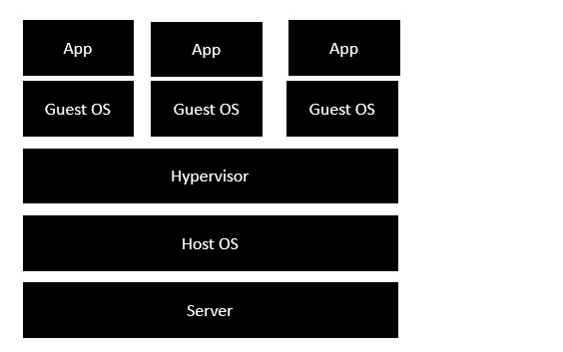

Docker

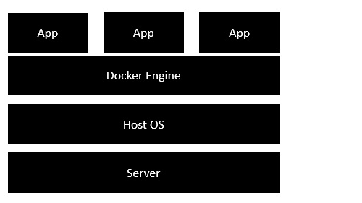

Docker Hub

Docker Hub is a registry service on the cloud that allows you to download Docker images that are built by other communities.

Components of Docker

There are four components that we will discuss in this Docker tutorial:

* Docker client and server
* Docker image
* Docker registry
* Docker container

### **Dockerfile:**

Dockerfile is a simple text file that consists of instructions to build Docker images.

List of Docker Commands for Creating a Dockerfile

Before we create our first Dockerfile, it is important to understand what makes up the file.

Dockerfile consists of specific [commands](https://www.simplilearn.com/tutorials/docker-tutorial/docker-commands) that guide you on how to build a specific Docker image.

The specific commands you can use in a dockerfile are:

FROM, PULL, RUN, and CMD

* FROM - Creates a layer from the ubuntu:18.04
* PULL - Adds files from your Docker repository
* RUN - Builds your container
* CMD - Specifies what command to run within the container

Mentioned below is an example of the dockerfile with the important commands

*FROM ubuntu:18.04*

*PULL. /file*

*RUN make /file*

*CMD python /file/file.py*