# Importing Relevant Libraries

In [1]:

**import numpy as np import pandas as pd**

**from pandas import** datetime

**import matplotlib.pyplot as plt**

**from pylab import** rcParams

**import seaborn as sb**

**from numpy.random import** randn

|  |  |  |
| --- | --- | --- |
| In | [2]: | %**matplotlib** inline  rcParams['figure.figsize']=5, 4 sb.set_style('whitegrid') |
|  |  |  |
| In | [3]: | address = 'C:/Users/Prashik/datasets/INTC.csv' |
|  | | df=pd.read_csv(address,index_col='Date', parse_dates = True)  df.head(n=3) |

Out[3]:

|  |  |  |  |  |  |  |
| --- | --- | --- | --- | --- | --- | --- |
|  | **Open** | **High** | **Low** | **Close** | **Adj Close** | **Volume** |
| **Date** |  |  |  |  |  |  |
| **2019-11-11** | 57.970001 | 58.500000 | 57.900002 | 58.349998 | 56.934311 | 11228900 |
| **2019-11-12** | 58.400002 | 58.799999 | 58.029999 | 58.200001 | 56.787952 | 11952500 |
| **2019-11-13** | 57.869999 | 57.970001 | 57.349998 | 57.889999 | 56.485474 | 15332700 |

In [4]:

df.tail(n=3)

Out[4]:

|  |  |  |  |  |  |  |
| --- | --- | --- | --- | --- | --- | --- |
|  | **Open** | **High** | **Low** | **Close** | **Adj Close** | **Volume** |
| **Date** |  |  |  |  |  |  |
| **2020-12-09** | 50.279999 | 50.840000 | 49.730000 | 50.070000 | 50.070000 | 34068400 |
| **2020-12-10** | 49.660000 | 50.720001 | 49.590000 | 50.259998 | 50.259998 | 33706000 |
| **2020-12-11** | 50.139999 | 50.139999 | 49.119999 | 49.730000 | 49.730000 | 29392900 |

# Time Series Analysis

In [5]:

df['Adj Close'].plot()

Out[5]: <matplotlib.axes._subplots.AxesSubplot at 0x8b59f70>

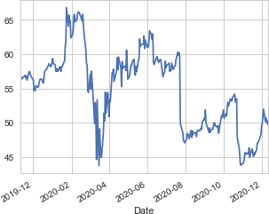

In [6]:

df2=df.sample(n=100, random_state=25,axis=0) plt.xlabel('Date')

plt.ylabel('Adj Close')

plt.title('Intel_Corp_stock') df2['Adj Close'].plot()

Out[6]: <matplotlib.axes._subplots.AxesSubplot at 0x8d39830>

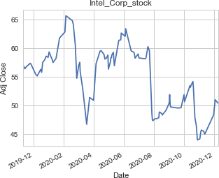

In [7]:

**from statsmodels.graphics.tsaplots import** plot_acf

**ImportError**Traceback (most recent call last)

**<ipython-input-7-5a20bf2855a9>** in <module>**()**

**----> 1 from** statsmodels**.**graphics**.**tsaplots **import** plot_acf

## C:\Users\KRISH KHULLAR\Anaconda2\lib\site-packages\statsmodels\graphics\tsapl ots.py in <module>()

4 **import** numpy **as** np 5

**----> 6 from** statsmodels**.**compat**.**pandas **import** sort_values

1. **from** statsmodels**.**graphics **import** utils
2. **from** statsmodels**.**tsa**.**stattools **import** acf**,** pacf

## C:\Users\KRISH KHULLAR\Anaconda2\lib\site-packages\statsmodels\compat\pandas. py in <module>()

1. **import** pandas**.**tseries**.**frequencies **as** frequencies
2. **except** ImportError**:**

**---> 56 from** pandas**.**core **import** datetools

57 frequencies **=** datetools

**ImportError**: cannot import name datetools

In [8]:

fig = plt.figure(figsize=(134,8)) ax1 = fig.add_subplot(211)

fig = sm.graphics.tsa.plot_acf(df['seasonal First Difference'].iloc[13:],lags= 40,ax=ax1)

In [ ]:

**NameError**Traceback (most recent call last)

**<ipython-input-8-41817eddad60>** in <module>**()**

1. fig **=** plt**.**figure**(**figsize**=(134,8))**
2. ax1 **=** fig**.**add_subplot**(211)**

**----> 3** fig **=** sm**.**graphics**.**tsa**.**plot_acf**(**df**['seasonal First Difference'].**iloc**[1 3:],**lags**=40,**ax**=**ax1**)**

**NameError**: name 'sm' is not defined

