DATA ANALYTICS PROJECT

SHOPPING TRENDS AND CUSTOMER PURCHASE ANALYSIS

A Data Analytics Project Using Python and Microsoft Excel
Submitted by

Prashitha K
B.E. Electronics and Communication Engineering

Project Area: Data Analytics

Dataset: Shopping Trends Dataset
2026

- INTRODUCTION
Data analytics helps organizations transform raw data into meaningful information that can support business understanding and decision-making. In the retail sector, customer purchase data can be analysed to understand product demand, category performance, customer characteristics, payment preferences, purchase frequency, subscription behaviour, and other shopping patterns.
This project focuses on analysing a Shopping Trends dataset containing 3,900 customer purchase records and 18 attributes. The dataset provides information about customers, products, purchase amounts, demographics, payment methods, discounts, ratings, and purchase frequency.
Python and Pandas were used for data preparation and analysis, while Matplotlib was used to create visualizations. Microsoft Excel was used to organize the analysed data and present the major findings through a dashboard.
The project demonstrates how raw shopping data can be cleaned, analysed, visualized, and converted into meaningful descriptive insights that can support retail business analysis.

2. PROBLEM STATEMENT
The aim of this project is to analyse shopping trends and customer purchase data to identify useful patterns related to products, categories, customer demographics, purchasing behavior, payment methods, discounts, subscriptions, and customer ratings.
The project seeks to convert raw customer purchase data into structured analytical results and business-oriented observations. The analysis focuses on understanding what products and categories contribute to purchase amounts, how purchasing behavior varies across customer groups, which payment methods are commonly used, and how subscription, discount, and purchase-frequency patterns appear in the dataset.

- OBJECTIVES
• To understand and prepare the Shopping Trends dataset for analysis.
• To calculate overall purchase and customer-related key performance indicators.
• To identify product categories with higher total and average purchase amounts.
• To identify individual products with higher total purchase amounts.
• To analyze customer purchasing behavior across different age groups and genders.
• To examine customer payment method preferences.
• To compare purchase behavior between subscribed and non-subscribed customers.
• To compare purchase records with and without discounts.
• To analyze customer purchase frequency patterns.
• To create clear visualizations and an Excel dashboard.
• To derive useful descriptive insights from the analyzed data.

4. DATASET DESCRIPTION
The project uses the Shopping Trends dataset, which contains 3,900 customer purchase records and 18 original columns. The dataset contains information related to customers, products, purchase amounts, shopping characteristics, and purchasing behavior.
The dataset includes customer demographics such as age and gender, product information such as item and category, purchase information such as purchase amount, and behavioural information such as subscription status, previous purchases, payment method, discount usage, and purchase frequency.
The main attributes used in the analysis are described in the table below.
Attribute | Description
Customer ID | Unique identifier for each customer
Age | Age of the customer
Gender | Gender of the customer
Item Purchased | Name of the purchased product
Category | Product category
Purchase Amount (USD) | Amount spent on the purchase
Location | Customer location
Size | Size associated with the purchased item
Colour | Colour of the purchased item
Season | Season associated with the purchase
Review Rating | Customer rating for the purchase
Subscription Status | Indicates whether the customer has a subscription
Payment Method | Method used for payment
Shipping Type | Shipping method selected
Discount Applied | Indicates whether a discount was applied
Promo Code Used | Indicates whether a promotional code was used
Previous Purchases | Number of previous purchases
Frequency of Purchases | Customer purchase frequency

- TOOLS AND TECHNOLOGIES
• Python — Used for data preparation, analysis, calculations, and visualization.
• Pandas — Used for data manipulation, grouping, aggregation, and exploratory data analysis.
• Matplotlib — Used to create analytical charts and visualizations.
• Google Colab — Used as the Python development environment for the analysis.
• Microsoft Excel — Used to organize analytical results and create the project dashboard.
• Google Sheets — Used to access and connect the dataset during the analysis workflow.

6. DATA CLEANING AND PREPARATION
Before performing the analysis, the dataset was inspected and prepared to improve consistency and reliability.
The following data preparation steps were performed:
- The Shopping Trends dataset was loaded into Python using Pandas.
- The number of rows, columns, and the overall structure of the dataset were checked.
- Important numerical columns such as Age, Purchase Amount (USD), Review Rating, and Previous Purchases were converted into appropriate numeric data types.
- The dataset was checked for missing values.
- Duplicate records were checked.
- Purchase frequency categories were standardized to make the analysis consistent.
- The “Bi-Weekly” category was standardized as “Fortnightly”.
- The “Every 3 Months” category was standardized as “Quarterly”.
- Age groups were created to support demographic analysis.
- The cleaned dataset was then used for exploratory data analysis, calculations, and visualization.
The cleaning checks resulted in 3,900 records with no missing values and no duplicate rows. The original 18 dataset columns were retained, while an additional Age Group field was created for analysis.

7. EXPLORATORY DATA ANALYSIS
The cleaned dataset was analyzed to identify patterns in customer purchases, product categories, payment methods, subscription status, discounts, demographics, and purchase frequency.
Descriptive statistics and grouped aggregations were used to calculate totals, averages, counts, and frequency distributions. These results were then visualized using charts to make the findings easier to understand.
The analysis focused on overall purchase performance, category performance, top products, customer demographics, payment preferences, subscription behavior, discount usage, and purchase frequency.

KPI | Result
Total Customers | 3,900
Total Purchase Amount | $233,081
Average Purchase Amount | $59.76
Average Review Rating | 3.75

9. CATEGORY ANALYSIS
The category-level analysis was performed by calculating the total purchase amount, average purchase amount, and number of records for each product category.
Clothing recorded the highest total purchase amount at $104,264, followed by Accessories at $74,200, Footwear at $36,093, and Outerwear at $18,524. Clothing also contains the largest number of records, so its higher total is partly associated with its larger record count.
Footwear recorded the highest average purchase amount at approximately $60.26, although the difference between category averages was relatively small.
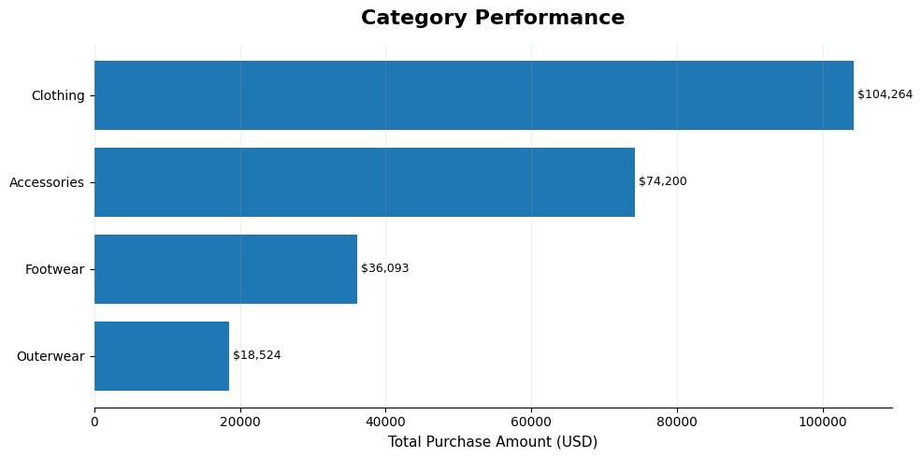

Figure 1: Category Performance by Total Purchase Amount

10. TOP 10 PRODUCTS BY TOTAL PURCHASE AMOUNT
The individual product analysis identified the products with the highest total purchase amounts in the dataset. Blouse recorded the highest total purchase amount among the analyzed products at $10,410, followed by Shirt at $10,332 and Dress at $10,320.
The remaining products in the top ten were Pants, Jewellery, Sunglasses, Belt, Scarf, Sweater, and Shorts. These results show the distribution of purchase amounts across individual product types in the dataset.
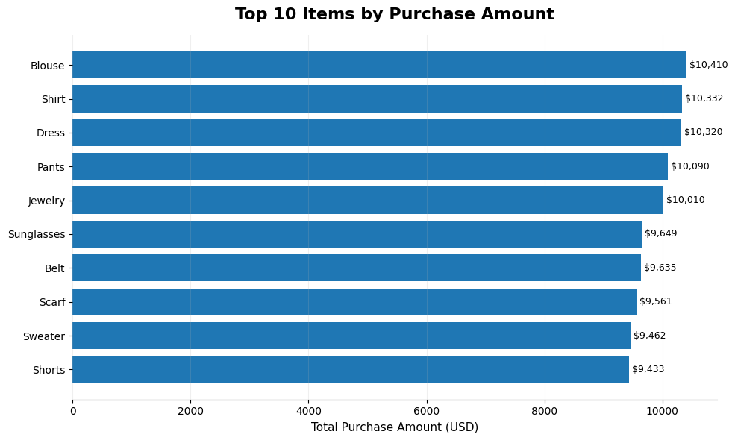
Figure 2: Top 10 Products by Total Purchase Amount
11. PAYMENT METHOD ANALYSIS
Payment method usage was analyzed using the number of customer records associated with each payment method.
PayPal was the most frequently used payment method with 677 records, followed by Credit Card with 671 and Cash with 670. Debit Card, Venmo, and Bank Transfer accounted for 636, 634, and 612 records respectively.
The distribution indicates that customers used multiple payment methods, with no single method accounting for an overwhelming majority of records.
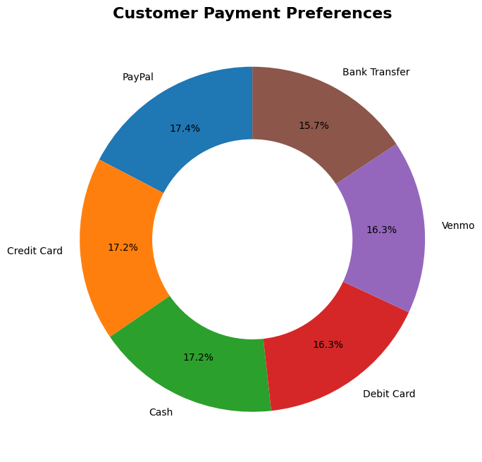
Figure 3: Customer Payment Method Preferences

12. SUBSCRIPTION ANALYSIS
Subscription status was analyzed by comparing total purchase amount, average purchase amount, and record count between subscribed and non-subscribed customers.
Non-subscribed customers accounted for 2,847 records and a total purchase amount of $170,436. Subscribed customers accounted for 1,053 records and a total purchase amount of $62,645.
The average purchase amounts were $59.87 for non-subscribed customers and $59.49 for subscribed customers. The averages are close, indicating only a small observed difference in average purchase amount between the two groups in this dataset.

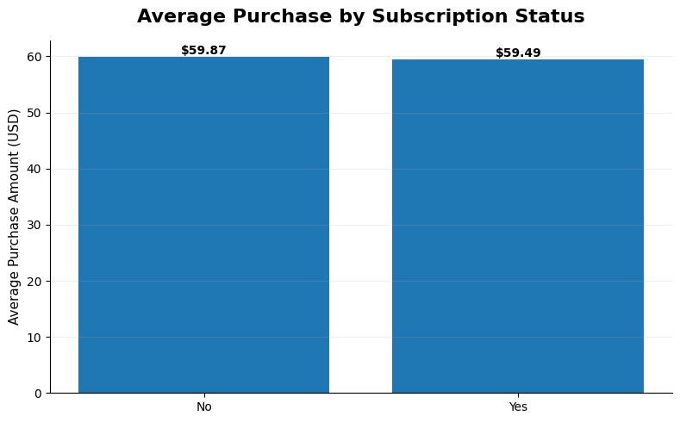
Figure 4: Average Purchase Amount by Subscription Status

13. DISCOUNT ANALYSIS
Purchase records were compared based on whether a discount was applied.
Records without a discount had an average purchase amount of approximately $60.13, while records with a discount had an average purchase amount of approximately $59.28. The total purchase amount was $133,670 for records without discounts and $99,411 for records with discounts.
These figures describe an observed difference in the dataset and should not be interpreted as proof that discounts caused lower purchase amounts.

14. AGE GROUP ANALYSIS
Customers were grouped into five age ranges to examine purchase behavior across different age groups.
The 56–70 age group had the highest total purchase amount at $65,256 and also had the largest number of records, with 1,105. The 18–25 age group recorded the highest average purchase amount at approximately $60.65.
The differences in average purchase amounts between the age groups were relatively small, while the total purchase amounts were influenced by the number of records in each group.
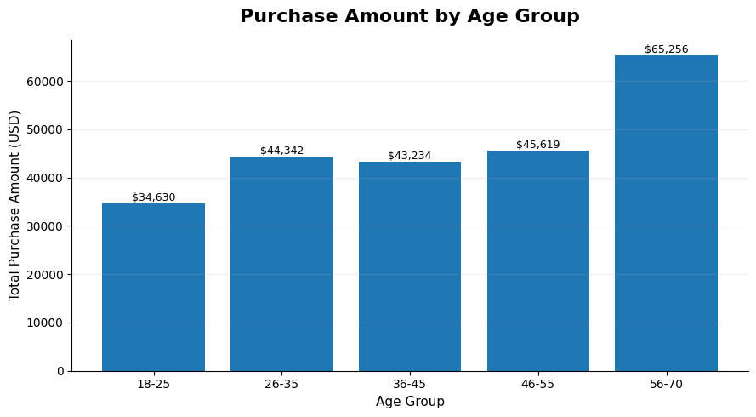
Figure 5: Total Purchase Amount by Age Group

15. GENDER ANALYSIS
Gender-based analysis was performed by comparing total purchase amount, average purchase amount, and number of records.
Male customers accounted for 2,652 records with a total purchase amount of $157,890, while female customers accounted for 1,248 records with a total purchase amount of $75,191.
The average purchase amounts were approximately $59.54 for male customers and $60.25 for female customers. The higher total purchase amount for male customers is associated with the larger number of male records in the dataset.
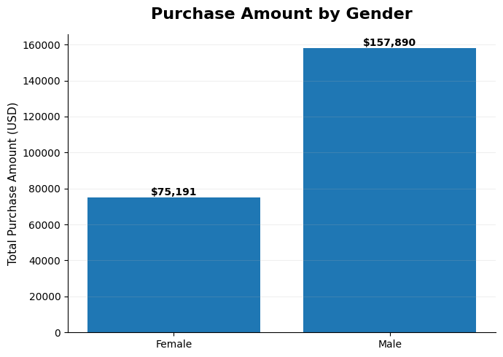
Figure 6: Purchase Amount by Gender

16. PURCHASE FREQUENCY ANALYSIS
Purchase frequency was analyzed to understand how frequently customers reported making purchases.
Quarterly purchases were the most common category with 1,147 records, followed by Fortnightly with 1,089 records. Annual, Monthly, and Weekly purchase frequencies accounted for 572, 553, and 539 records respectively.
The results indicate that Quarterly and Fortnightly were the two most frequently recorded purchase-frequency categories in the dataset.

- KEY RESULTS AND INSIGHTS
• The dataset contains 3,900 customer records and a total purchase amount of $233,081.
• Clothing recorded the highest total purchase amount at $104,264.
• Footwear recorded the highest average purchase amount at approximately $60.26.
• Blouse recorded the highest total purchase amount among individual products at $10,410.
• PayPal was the most frequently recorded payment method with 677 records.
• Non-subscribed customers represented a larger number of records than subscribed customers.
• The average purchase amounts for subscribed and non-subscribed customers were relatively close.
• Records without discounts had a slightly higher average purchase amount than records with discounts.
• The 56–70 age group had the highest total purchase amount, while the 18–25 group had the highest average purchase amount.
• Quarterly was the most frequently recorded purchase frequency.
• The observed differences describe patterns in the dataset and should not be interpreted as causal relationships.

18. BUSINESS INSIGHTS
The analysis provides several descriptive insights that can support retail-oriented decision-making.
- Product and Category Planning
The higher total purchase amount recorded for Clothing indicates that this category represents a substantial portion of the dataset. Businesses could monitor demand within major categories while considering both sales totals and the number of purchase records.
- Product-Level Monitoring
Blouse, Shirt, and Dress recorded the highest total purchase amounts among the analyzed products. These products can be monitored for demand and inventory planning.
- Payment Convenience
PayPal, Credit Card, and Cash were the most frequently recorded payment methods. Supporting multiple commonly used payment options can help accommodate different customer preferences.
- Customer Segmentation
Age-group analysis shows differences in record counts and average purchase amounts. Customer segmentation can therefore be considered when designing future retail analysis.
- Subscription Analysis
The average purchase amounts for subscribed and non-subscribed customers were similar in this dataset. Further analysis using additional customer behavior variables would be useful before drawing conclusions about subscription effectiveness.
- Discount Analysis
Discounted and non-discounted records showed different average purchase amounts. Additional information such as discount percentage, original price, campaign type, and transaction date would be required to evaluate promotional effectiveness more accurately.

20. PROJECT METHODOLOGY
The project followed a structured data analytics workflow.
- Dataset Collection — The Shopping Trends dataset was obtained and accessed through Google Sheets.
- Data Loading — The dataset was connected to Google Colab and loaded into Python.
- Data Inspection — The dataset structure, data types, missing values, and duplicate records were examined.
- Data Cleaning — Numerical fields were converted to appropriate types and purchase-frequency categories were standardized.
- Exploratory Analysis — Grouping and aggregation techniques were used to analyze categories, products, demographics, payment methods, subscriptions, discounts, and purchase frequency.
- Visualization — Matplotlib was used to create charts representing the major findings.
- Excel Dashboard — Analytical results were organized in Microsoft Excel and presented through a dashboard.
- Interpretation — The results were interpreted as descriptive patterns within the dataset.

21. LIMITATIONS
The project has several limitations that should be considered when interpreting the results.
• The dataset does not contain transaction dates, so time-series analysis and seasonal trends over time could not be performed.
• Customer IDs are unique in the dataset, limiting the ability to study repeated transactions for the same customer.
• The analysis is primarily descriptive and identifies patterns rather than proving causal relationships.
• The dataset does not provide detailed information about marketing campaigns, discount percentages, customer income, or reasons for purchase.
• The available customer and product attributes limit deeper customer segmentation.
• The dataset appears to be a structured/simulated shopping dataset, so the findings should not automatically be generalized to real-world retail populations.

22. FUTURE SCOPE
The project can be extended in several ways:
• Adding transaction dates would enable time-series and seasonal trend analysis.
• Power BI or Tableau could be used to develop more interactive dashboards.
• Customer segmentation techniques could be applied to identify different customer groups.
• Predictive models could be developed to forecast purchase behavior or customer demand.
• Detailed discount and campaign information could be analyzed to evaluate promotional effectiveness.
• Additional customer attributes could support more advanced behavioral analysis.
• Text-based customer reviews, if available, could be analyzed using natural language processing techniques.
23. CONCLUSION
This project analyzed the Shopping Trends dataset containing 3,900 customer purchase records and 18 original attributes. The data was prepared and analyzed using Python and Pandas, visualized using Matplotlib, and presented through a Microsoft Excel dashboard.
The analysis identified patterns across product categories, individual products, payment methods, customer demographics, subscription status, discount usage, and purchase frequency. Clothing recorded the highest total purchase amount, while Footwear recorded the highest average purchase amount. PayPal was the most frequently recorded payment method, and Quarterly was the most common purchase frequency.
The project demonstrates the complete data analytics workflow from data preparation and exploratory analysis to visualization, dashboard creation, and interpretation. The results provide descriptive insights into the dataset while recognizing the limitations of the available information.

24. PROJECT DELIVERABLES
Deliverable | Description
Dataset | Shopping Trends dataset
Python Notebook | Data loading, cleaning, analysis and visualization
Excel Workbook | Analysis sheets and dashboard
Project Report | Documentation of methodology, results and insights
README | Project overview and instructions
Requirements File | Python libraries required for the project
GitHub Repository | Online project repository containing project files

APPENDIX A — FINAL PROJECT KPI SUMMARY

KPI | Value
Total Customers | 3,900
Total Purchase Amount | $233,081
Average Purchase Amount | $59.76
Average Review Rating | 3.75
Highest Total Category | Clothing — $104,264
Highest Average Category | Footwear — $60.26
Top Individual Product | Blouse — $10,410
Most Used Payment Method | PayPal — 677
Largest Age Group by Records | 56–70 — 1,105
Highest Average Purchase Age Group | 18–25 — $60.65
Most Common Purchase Frequency | Quarterly — 1,147

