3 Tier Architecture
Due 26 June 2026 23:59•Multiple submissions allowed
Instructions
Create a 3 tier architecture where user is able to connect to load balancer where the load balancer load balances to 2 application servers. The application should also write to a database. Both application and database should not be reachable by the user, while access to port 443 and 80 is allowed. Architecture diagram is given below.

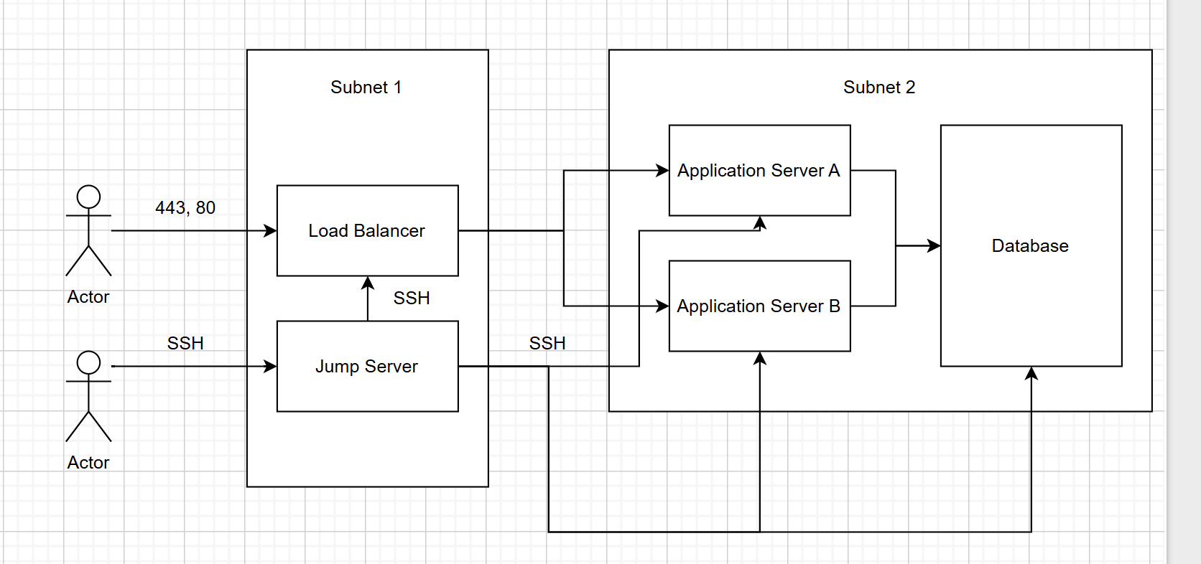

Database Backup
Due 26 June 2026 23:59•Multiple submissions allowed
Instructions
Create 2 servers where database is reachable from your PC only, while backup server is reachable from database only. Automate backup, where:-
- Database backup is created at a fixed time
- The backup is then pushed to backup server, data backup must be encrypted
- Decrypt the backup in backup server and push it to github
- Create dummy databases and scripts as required

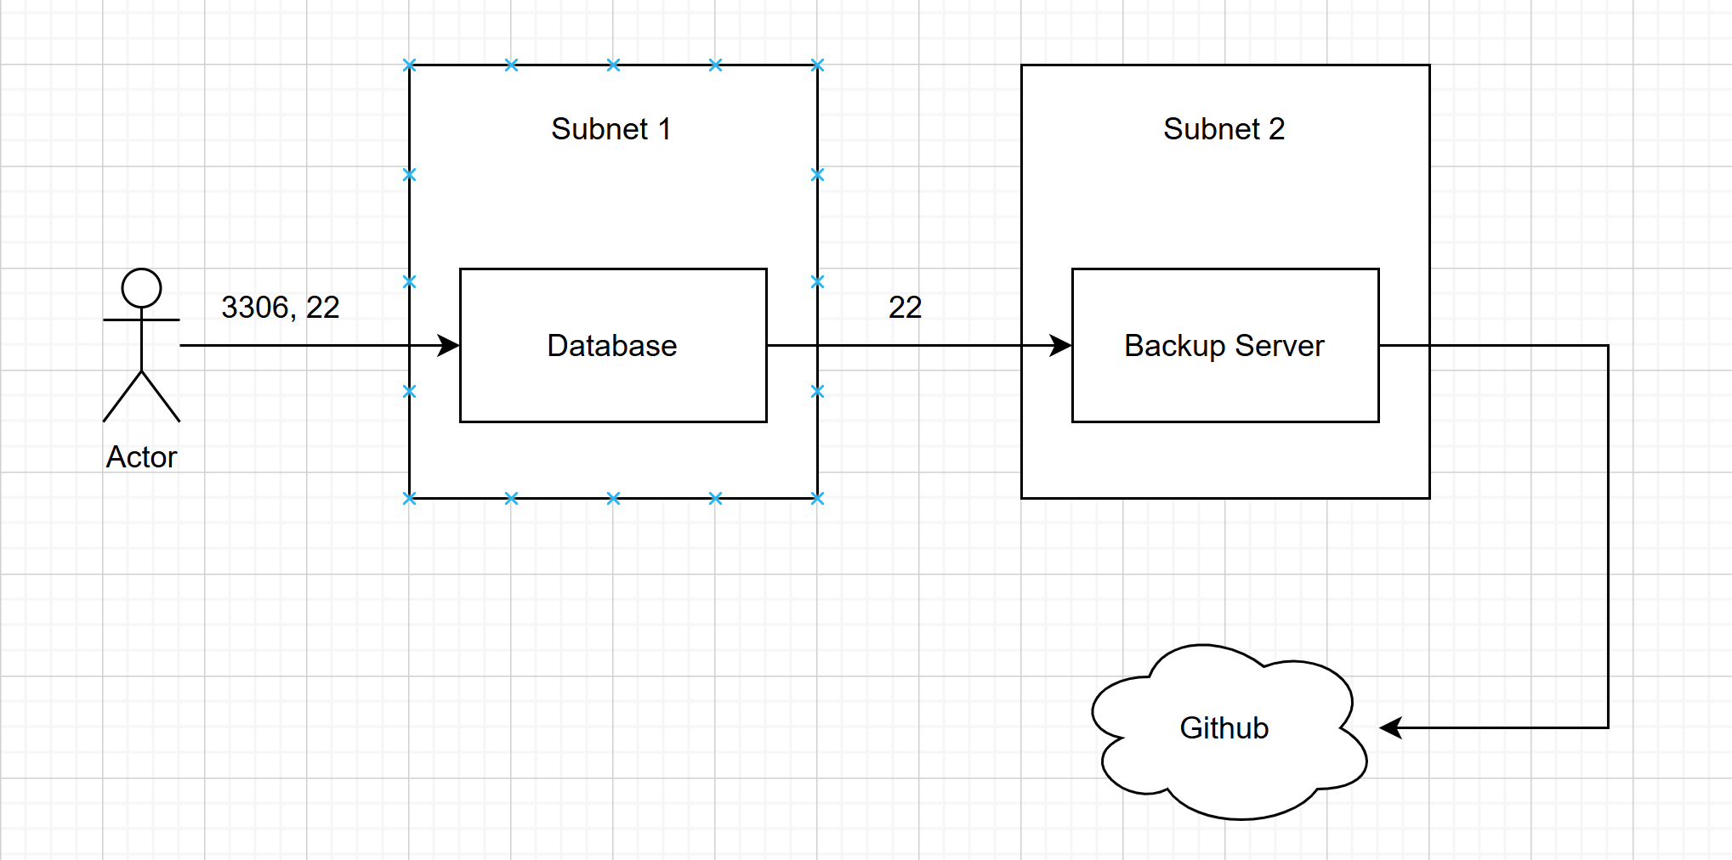

Assignment 2
Due 15 June 2026 23:59•Multiple submissions allowed
Instructions
Create 2 servers.
Network level requirement:
- You should be able to reach server A but not server B
- Server A should be able to reach server B
Requirement:
- When you upload a file, the file should be encrypted at server A
- Server A should then transfer the file to server B
- Server B should then decrypt the file and push to github
- Do not delete files in server B, but replace them if same name files are transferred from server A
- All files should be uploaded to the same github repository

