Project Description

The Uva Wellassa University website serves as an important online web resource for the university. By providing essential information and services to the students, faculty and administrative members and external stakeholders.

The objective of this project is to identify and address usability issues on the Uva Wellassa University website. The project's goal is to enhance the user experience overall by using user research techniques such as contextual Inquiry, video recordings by capturing real-time user interactions and Personas Development.

Its help to make the website is user-friendly, effective, and simple. and this project also involves examining the web interfaces and identify Usability issues based on contextual inquiry, Analyzing and provide ratings of the usability problems, then setting particular modifications into place in response to the difficulties with usability which are identified.

The ultimate goal of this project is to redesign the Uva Wellassa University website in order to make it simpler to use and accessible for all stakeholders. and making it more accessible and user-friendly for all stakeholders. We ensure that we cannot add new functionality to the selected project, only redesign existing aspects.

By the end of this project, the Uva Wellassa University website is expected to have improved navigation, consistent layouts, enhanced accessibility and user satisfaction. We ensure that this usability study will contribute to a more effective online website for Uva Wellassa University.

Alternatives Considered

Before identifying a project for our usability study, our team examined a number of university websites to determine which one was most suitable. The selection criteria include the complex structure of the website, the variety of interfaces, and the possibilities for identifying usability issues.

1. Horizon Campus Website (https://horizoncampus.edu.lk/)

The Horizon Campus website serves as the primary website for Horizon Campus, providing information about its academic programs, student services, and campus-related activities. in this website we identified some usability issues such as some pages have inconsistent layouts and limited interactive user features.

2. University of Colombo Website (https://cmb.ac.lk/)

The University of Colombo website that offering extensive information on the university’s academic programs, administration, and campus life. In this website the design is somewhat outdated and not fully responsive. and some pages are cluttered with too much information.

3. University of Moratuwa Website (https://uom.lk/)

The University of Moratuwa website provides detailed information about the university’s academic departments, student life, and administrative services. This website has well-structured and detailed content and clear organized navigation menus. But this website also has some usability issues like inconsistence in the visual design and layout and limited interaction between multimedia components.

After evaluating the alternatives, we selected the Uva Wellassa University website for our usability study. Using this selection, we can address major usability issues while making important modifications which will improve the university's web presence.

1. Expert User

Expert users are individuals who are highly experienced users who regularly access the Uva Wellassa University website for specific needs. This category involves faculty members, permanent staff members, researchers, and graduated students from the university who are familiar with the design and content of the website. These users have a deep understanding of the university's website. and they regularly use the website for to get educational materials, research papers, administrative activities, and internal communications. They are also comfortable with navigating the interfaces efficiently to find the information what they need.

2. Average User

Average users are individuals who have average level of familiarity with the Uva Wellassa University website. This category involves present students, staff members and occasional visitors. They use this website for accessing learning materials, checking messages and notifications and submitting assignments. Although they are usually comfortable on the website. But they may have trouble with browsing the utilized sections. So, they depend on information that is organized and clear with simple navigation.

3. New User

New users are people who are visiting the Uva Wellassa University website for the first time . This category involves new students, parents, new staff members, and external visitors. They access the website to get information about academic programs, admission procedures and to know the university events and campus facilities. New users want a simple user interface that provides easily accessible content, simple directions, and helpful guidance without navigation troubles.

|  |  |  |
| --- | --- | --- |
| Interfaces | Usability Issues | Description |
| Home Page  (figure 1) | Cluttered Layout  Inconsistent Navigation  Help and chat option  Similar colors visual hierarchy.  Small Font Size  The color contrast  Overlapping and clipping the sub menu bar options  Inconsistent tab order | The homepage has too much information displayed at once, so it’s difficult to navigate.  Navigation menus are confusing in this site. It’s difficult to access different sections.  There is no any help and chat option for users. If users need any clarifications or guidance, they cannot receive them.  Users can be disturbed by many other unwanted things and they get confused. Some items are visible in same colors  It is challenging for users with visual issues to read the text because of the small font size.  news items option in the home page not clearly visible. Color contrast is too low in this website.  The floating image’s grey line overlapping and clipping in the sub menu bar options.  In home page many active elements are no getting tab focus and inactive elements are getting tab focus. |
| Student Portal Login Page | Unresponsive Design  Complex Layout  Poor Error Handling  Lack of Help Options | The login page does not respond well on different devices or screen sizes, leading to lack of user experience  The login page is confusing for new users.  Error messages do not provide clear guidance on how to resolve login issues.  Users might be worried about their privacy whenever there are no options for multi-factor authentication. |
| Library Page  (figure 2) | Difficult Navigation  security issues  Limited search function  Outdated Information | Navigating the library catalog is difficult for new user  The library page is not protected. Users might be worried about their privacy  The search bar is not simple to use.  Some library information appears outdated |
| About UWE page | Too much information  Font style and font size  Inconsistent content flow | Too much detail that exceeds what is necessary or useful.  It is difficult to understand.  Content doesn’t follow a smooth order. |
| Contact us page  (figure 3) | Not clearly visible  Poor space management  Font size problem | It’s hard to see clearly.  Bad use of space and not properly use the space.  Font size is too small. |
| Research and innovation page | Color theme  Content structure  Font size | Inappropriate use of colors to headings and topics as well as some texts.  Organization and arrangement of content is difficult to understand to some users.  Font size is small and it can be difficult for some users. |
| Career Guidance Unit | Content is not well organized  Inconsistent use of language  Lack of visual hierarchy  Links and Buttons | Dense text blocks hinder information scanning. Consider visual aids.  The text on the page switches between English and Sinhala. This can be confusing for users who only speak one language.  Dense text lacks hierarchy. Bullet points, varied fonts, or sizes needed  The interactive elements like buttons and links are not clearly differentiated from non-interactive text. |
| International Collaboration Center | Poor Use of Space  Gallery Navigation  Limited calls to action | Excessive whitespace in layout hinders information density.  The gallery section on the right lack’s clear navigation controls, making it difficult for users to browse through images effectively.  Unclear instructions hinder user actions |
| Download | Poor Use of Whitespace  Poor Alignment | The content appears cluttered due to insufficient whitespace between different sections and elements.  It looks unorganized since the text and elements are not consistently aligned. |
| Admission Page | Complicated Navigation  Long Load Times  Unclear Instructions  Missing Contact Information  Poor mobile compatibility  Broken Links | Users find it difficult to find the entry page because the menu is chaotically organized.  Due to slow loading pages, the users of this webpage get frustrated and they leave the website.  Because the steps for the login process are not clearly stated, users may face problems in logging into this web page.  Users may have problems getting help due to lack of easily accessible contact information for enrollment queries.  The page is not optimized for mobile devices and will not display correctly on smartphones or tablets.  Links that lead to faulty pages prevent users from accessing the information they need. |
| Faculty Profile Page | No search functionality  Outdated Content  Poor Image Quality  Difficult Navigation  Inaccessible Design  Too Much Information  Lack of Social Media Links | No search bar makes it difficult for users to find specific faculty members.  Outdated or incorrect information may mislead users.  Low resolution photos of faculty members can create a bad impression.  Users have to click several pages to find a profile and they are reluctant to use it.  Profiles that do not follow accessibility guidelines (e.g., for screen readers) may exclude users with disabilities.  Presenting too much information at once makes it difficult to find key information about each faculty member.  Missing links to faculty members' professional social media (e.g., LinkedIn) can limit networking opportunities. |
| Academic program Page | Confused Structure  Lack of Program Details  No Comparison Option  Outdated Design  NO Virtual Tour  Limited Interactivity  No FAQ Section | Users have to struggle to find the programs they want because the programs are not clearly categorized.  Missing necessary information like course duration, fees or syllabus leaves users at a disadvantage.  Users may find it difficult to decide which one suits them best as there is no way to compare the programs.  An old-fashioned design makes users less trusting of the information  Lack of virtual tour option prevents prospective students from getting a feel of the campus.  A page that does not allow for interactive elements (such as videos or slides) may appear dull.  Without an FAQ section, users cannot find answers to common queries easily. |
| News & Event Page | Unclear distinction  Lack of filters  Not clear headlines  Navigation Problem | News articles and upcoming events are not clearly separated.  There no categories or filters to sort news by topic or department.  Headline are not highlight  News & event page id difficult finding the main navigation. |
| Career Service Page | Confusing Layout  Difficult to search functions  Lack of information  Missing contact information | Making it hard for users to find specific information.  Not have a search functions. Career fair, workshop or interview preparation information. |
| Alumni page | Limited contact  No Interaction Space  Navigation Issues | The page does not offer enough content to actively connect alumni with the university or each other.  There is no forum or dedicated space for alumni to interact and network.  The alumni page is hard to find from the main navigation menu. |

Contextual Inquiry

|  |  |  |
| --- | --- | --- |
| Background description of the user | Questions to be asked from the user | Tasks to be given to the user |
| Expert User:  Brithivi is a graduate of Uva Wellassa University with a strong background in DevOps engineering. He has 6 years of experience in developing infrastructure-related components, optimizing existing environments, and has strong scripting and coding skills. He frequently uses the university's website for alumni-related activities, accessing resources, and staying connected with the university community. | 1. How often do you visit the Uva Wellassa University website? 2. What are the primary tasks you typically complete on the website? 3. What specific features or sections of the website do you use most frequently? 4. How satisfied are you with the website's search functionality for finding specific information? 5. What do you think about the home page is it good or bad? 6. What do you think about security features in this website? 7. How do you feel about the design and layout of the website? 8. Have you encountered any technical issues while using the website? 9. Do you have any suggestions for improving the website? | 1. Find information about upcoming alumni events. 2. Download Application Form for Verification of Examination Marks 3. Locate the contact details for a particular faculty member. 4. Find and access a specific academic journal or research paper. |
| Average User :  Madhu is currently pursuing a Master of Information Technology degree at Uva Wellassa University. She is a dedicated and detail-oriented Software Quality Engineer with a bachelor's degree from Moratuwa University. She regularly uses the university website to access study materials, check announcements, and manage her coursework. | 1. How frequently do you use the Uva Wellassa University website for your studies? 2. Which sections of the website do you use the most? 3. Have you ever faced difficulties while navigating the website? If yes, please describe them. 4. Have you used the online library resources available through the website? 5. How satisfied are you with the contact us interface is that really helpful? 6. How satisfied are you with the VLE login page? 7. Do you find the website helpful for keeping up with university news and events? 8. What improvements would you like to see on the website? | 1. Log in to the student portal. 2. Search for and access a course syllabus. 3. Find the contact information for a faculty member. 4. Locate the syllabus and assignments for a specific course. |
| New User :  Koshi is a 20-year-old student who has just finished his A/L exams at  S. Thomas' College Bandarawela. He is currently exploring university options and is interested in pursuing a degree in Computer Science at Uva Wellassa University. He participates in extracurricular activities and is preparing his university applications. | 1. What information are you primarily looking for on the Uva Wellassa University website? 2. How did you find out about Uva Wellassa University? 3. How user-friendly do you find the website as a first-time visitor? 4. How do you feel about the design and layout of the website? 5. What do you think about career and guidance page because that is very important for your entry to the university? 6. How effective is the search feature in helping you find what you need? 7. What is your overall impression of the website's effectiveness in attracting prospective students? 8. Can you suggest any improvements to the website to make it more informative and engaging for new users? | 1. Explore the faculty section 2. Explore the "history" section: 3. Events and sports. 4. Search for Workshop on Higher Education Opportunities 5. Explore contact us |

5 usability issues in 5 individual interfaces based on the contextual inquiries.

|  |  |
| --- | --- |
| Interface name | Usability issue |
| Home Page | Cluttered Layout,  Inconsistent Navigation,  Information Overload and Poor Visual Hierarchy,  Floating Image Issues,  Poor search functionality option |
| Library Page | Security issues  Outdated information & Design  Difficult Navigation  Limited Search functionality  Lack of Accessibility features |
| Alumni Page | lack comprehensive information  Difficult Navigation  Inconsistent Layout  Poorly constructed links  Outdated Information |
| VLE Login Page  Contact US page | Lack of help options  Poor error handling  Layout design problems  Lack of consistency  Complicated Navigation  Poorly structed links  Poor design layout  Outdated information  Lack of personalization  Font size problems |

Based on the Uva Wellassa University website, contextual inquiry report, here are the usability issues identified and alongside ratings and justifications.

Information overloaded and cluttered layout Homepage

Rating : High

Reason : Users mentioned that the homepage has too much information displayed. And its difficult to navigate for the users. So, this homepage might discourage the users from exploring the website.

Outdated design and layout

Rating : High

Reason : The new user found this website’s design outdated and it has some layout problems. So, it might affect the first impression of the website. The modern layout and updated information must be needed for this website.

Poor search functionality :

Rating : High

Reason : Search option is must important for a website. Our search result must be gives the exact results. But this website’s search functionality gives complicated search results. Multiple users reported that the search function often fails to return relevant results.

Technical issues :

Rating : High

Reason : Technical problems are major issues that might affect the user experience and trustworthiness of the website, including website failures while downloading research papers academic resources.

Lack of security issues :

Rating : High

Reason : Security features are must important for a particular website. There is no multifactor authentication used in this website. And some interface sites are not protected.

Not affective contact us page

Rating : Medium

Reason : Contact us page contains outdated information. And some of the contact numbers are not working properly. There are lot of white spaces used in this website and its bit more complicated.

Lack of Help & support options

Rating : Medium

Reason : Lack of help options such as FAQs, important contact details or live chats are not included in the website. Users mentioned this in their interviews.

Lack of Updated news and events information

Rating : Medium

Reason : News and events sections are outdated in this website. Making it difficult for users to get important updates about the university.

Minor Visual Overlaps in Design Components

Rating : Low

Reason : This website has the distracting issue of the floating image’s grey line overlapping and clipping in the submenu bar options. This can be identified problems can be avoided.

Color scheme and font size problems

Rating : Low

Reason : Some users are mentioned there are some pages it has small font size and some interface has unappropriated color scheme quality. Adjusting the color scheme and font sizes for better visual distinction and readability can improve the user experience.

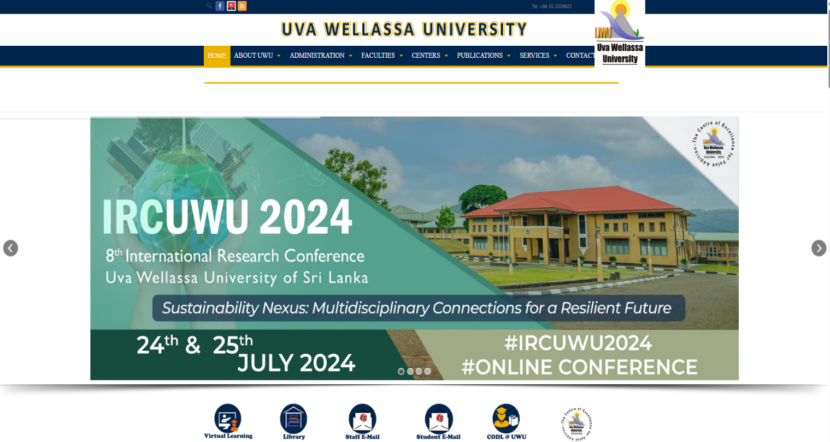

Figure – Home page

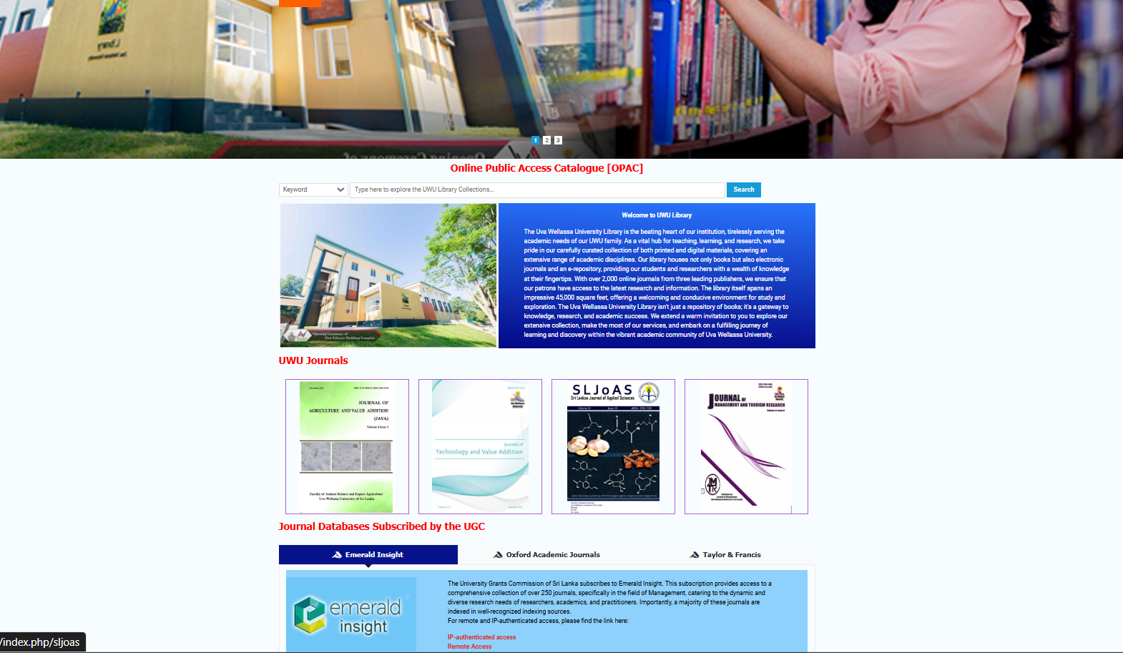

Figure – Library page

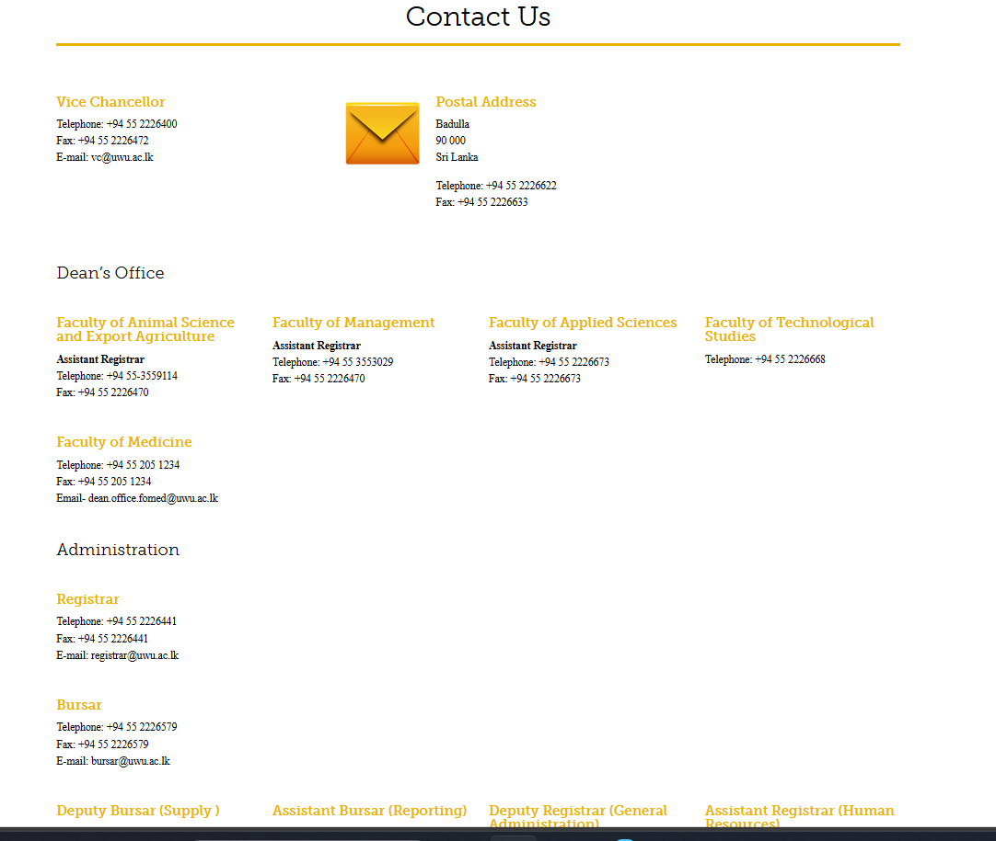

Figure – Contact Us Page

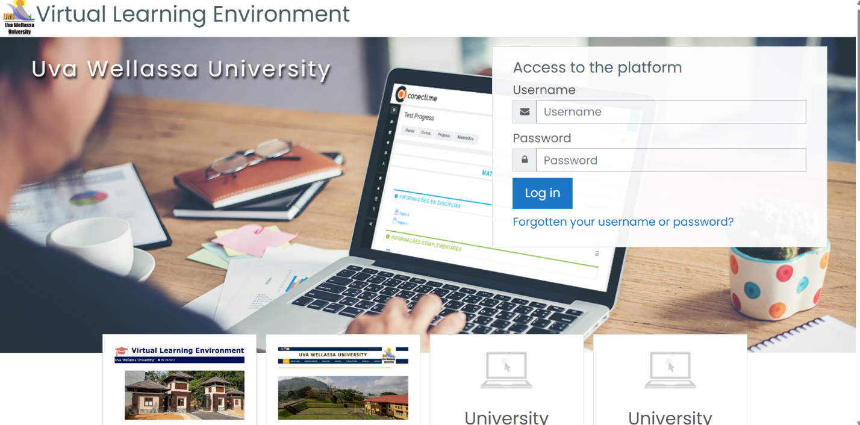

Figure - VLE login page

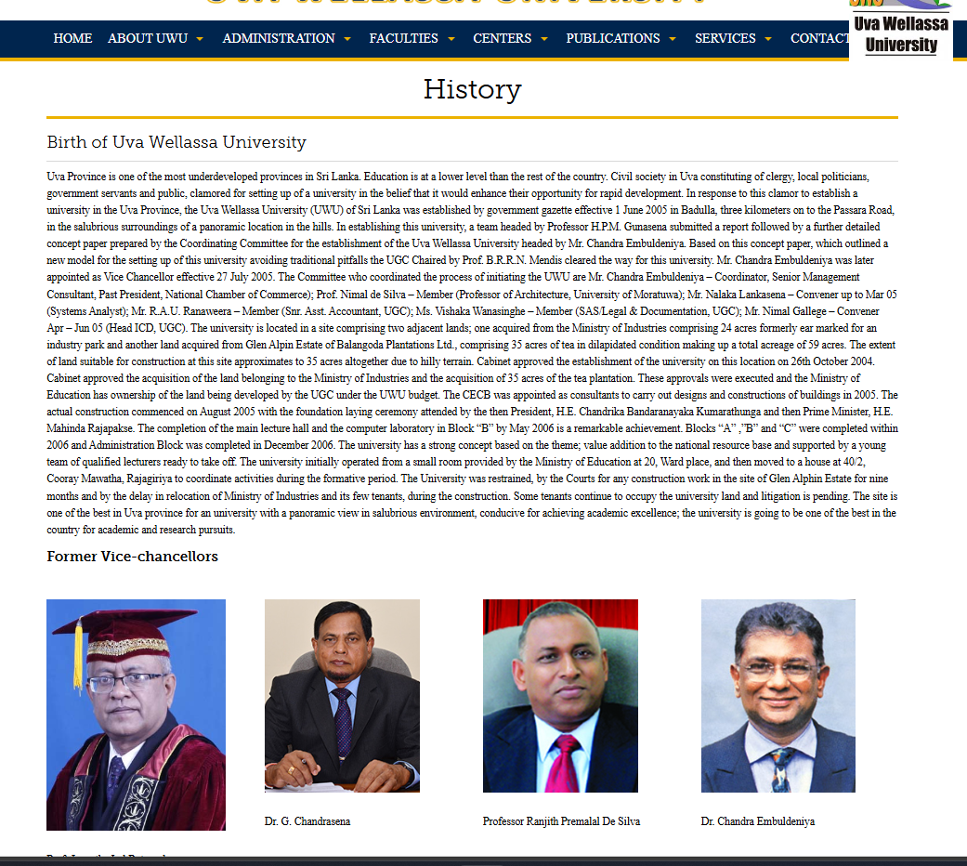

Figure – History page