Project-II Proposal on

**Public Transit Tracker**



Submitted to

**Department of Computer Science and Engineering Nepal Engineering College**

in Partial Fulfillment of the Requirements for the Degree of B.E. in Computer

Submitted By Pawan Shrestha (021-353)

Prashows Amatya (021-359)

Sananda Satyal (021-376)

Date: 2081/02/05

# Abstract

The "Public Transit Tracker" is an innovative Android application designed to improve the daily commuting experience by providing real-time tracking of public transit vehicles. This application leverages cutting-edge technologies, including C# and ASP.NET Core for backend services, Firebase for real-time data synchronization, and MAUI for cross-platform mobile development. Utilizing the Google Maps API, the app offers users an interactive map to view the current location of buses, receive precise estimated arrival times, and access detailed route information. Additionally, users can set notifications for bus arrivals and delays, save favorite routes, and engage with the system through real-time updates. Drivers benefit from features like location sharing, route management ensuring they stay on schedule and can communicate any delays. Administrators have a comprehensive dashboard to manage users and drivers, monitor the system's health. Emphasizing user participation and interaction, this app not only enhances the efficiency and reliability of public transportation but also fosters a community of informed and engaged commuters. Through its robust, scalable infrastructure, "Public Transit Tracker" aims to transform the public transit landscape by making it more predictable, efficient, and user-friendly.

#### [Keywords: Android application, public transit, real-time tracking, user interactive, Firebase, Google Maps API]

# Table of Contents

Abstract 1

Table of Contents 2

List of Figures 3

Chapter 1: Introduction 4

* 1. Background 4
  2. Problem Statement 4
  3. Objectives 4
  4. Aim 5
  5. Motivation 5
  6. Scope and Applications 5
  7. Feasibility Study 5
     1. Technical Feasibility 6
     2. Economic Feasibility 6
     3. Operational Feasibility 6
     4. Schedule Feasibility 6

Chapter 2: Literature Review 7

Chapter 3: System Design 9

* 1. Flowchart of the Public Transit Tracker 9
  2. Use Case of Public Transit Tracker 11
  3. System Requirements 11

Chapter 4: Expected Output 12

Chapter 5: Conclusion 13

References 14

# List of Figures

FIGURE 1: FLOWCHART OF PUBLIC TRANSIT SYSTEM 10

FIGURE 2:USE CASE OF PUBLIC TRANSIT TRACKER 11

# Chapter 1: Introduction

## Background

In today's urban environment, getting around using public transportation can sometimes feel like a puzzle. Our project “Public Transit Tracker” aims to simplify this daily travel. It aims to provide real time tracking and information of the public transportation. Navigating transit networks in cities can be tough, so we're creating an easy-to-use solution where one can use their phone to see detailed information about their ride and plan their travel. With our Public Transit Tracker app, travelers can access real-time tracking and detailed information about public transportation services directly from their smartphones. Whether you're taking a bus, van or any transport vehicle our user- friendly interface ensures that you can easily navigate, check estimated arrival times and plan your route with confidence. We understand the challenges travelers face in urban environments, and our goal is to create a solution that makes traveling smoother and more enjoyable for everyone.

## Problem Statement

Figuring out how to use public transportation can be tough. People often don't know when their bus or any public transport vehicle will arrive, where it's going, or how to get there efficiently. This leads to frustration and delays, and it can make public transit less reliable and time consuming. Additionally, many existing transit apps don’t work well on android phones. Our project aims to fix this by creating a user-friendly app for Android devices. It will give real-time updates and detailed information about public transit, making it easier for people to plan their journeys and rely on public transportation with confidence.

## Objectives

* Make an easy-to-use app for Android phones that helps people find buses for their desired destinations.
* Solve any technical problems to make sure the app works smoothly.
* Enable drivers to share their real time locations and manage routes.
* Make the app send a message to users when their vehicle is getting close.

## Aim

The main aim is to make it easier for people to use public transportation with our Public Transit Tracker android app. We want to help travelers get real-time tracking and detailed information about public transport so that travelling through public transportation is less time consuming and easy.

## Motivation

Our motivation comes from the daily challenges faced by travelers in navigating public transportation systems. We've witnessed the frustration of waiting for vehicles without knowing when they'll arrive or where they're headed. By addressing these issues, we aim to make the travel experience easy and make it more enjoyable for everyone.

## Scope and Applications

Our Public Transit Tracker Android app helps people easily find public transportation. It gives real-time updates on where this means of transport are, making it easier to plan trips and reduce waiting times. They also receive notifications when their transport is close, so they know when to leave. It's designed to be simple for everyone to use, helping make public transportation more accessible and reliable. Overall, our app aims to make traveling around cities smoother and more convenient for everyone.

## Feasibility Study

The feasibility study shows that the project is viable and has the potential to succeed. Here are the key factors:

### Technical Feasibility

The system can be developed using existing technologies and resources. Developing the Public Transit Tracker Android app doesn't require inventing anything new, we can use tools and programming languages that people already know how to use. In simple terms, we have everything we need to make this project work from a technical perspective.

### Economic Feasibility

The system is going to be developed as part of the project so there is no cost to spend for the proposed system. All the resources are already available which gives the indication of the system to be economically possible for development.

### Operational Feasibility

The proposed system is designed to be user-friendly and is expected to deliver public transportation data in real time. The current infrastructure can support the proposed system. The system will be supported by our team to handle any technical issues. Also, this project is economically possible for development. Thus, the proposed music suggestion system appears to be operationally feasible. It aligns with daily needs and utilizes existing resources effectively.

### Schedule Feasibility

The project is estimated to take 1 month from initial planning to final development. This includes time for requirement gathering, system design, development, and testing.

The project team members are allocated different tasks such as managing UI, handling database, and managing backend. Potential risks such as technical challenges or delay have been considered.

# Chapter 2: Literature Review

In metropolitan cities like Kathmandu, waiting for public transport can be quite a hassle and can lead to reduced productivity. To address this issue our project “Public Transits System” was proposed. The idea behind is, there is no such tracking system in CU. Moreover, some limitations arise with the present existing tracking systems in the universe-need hardware maintenance in the GSM/GPRS module that is expensive also, use conventional MySQL database that updates data within few seconds etc. Concerning these limitations, the developed system uses two smartphone applications for transmitting and receiving information using Firebase, an online server with real- time database updating data within few milliseconds that makes the system faster than others. The In-vehicle app receives latitude and longitude values from the satellite and transmits them to the firebase. Firebase updates the data continuously and transmits to the user app [1].

A system for tracking and knowing the location of inter-city buses in urban areas was developed in Ghana by the University of Ghana. GPS and GSM/GPRS system was used in the tracking system which sends SMS alerts about the vehicle location and provides real time tracking through web application [2]. Real-time information regarding buses is made available to passengers via the GPS and GSM-based Real-Time Bus Monitoring system, which aims to enhance public transportation. The system uses GPS and GSM technologies to track the location and estimated arrival time of buses and transmit this information to commuters’ mobile devices. This technology addresses the common problem of long waiting times at bus stops and the uncertainty of bus arrival times [3]. It is developed for Android users only. It can show updated estimated time arrival and the number of people inside the bus. This project uses two devices embedded inside the bus, which are GPS Tracker device and IoT people counter device. All devices will transmit the data into a cloud database which is Firebase. Real-Time Campus University Bus Tracking Mobile Application is developed as a platform for users to receive the data transmitted from database. Other than that, Student will know the time arrival of the bus and the current quantity of people inside the bus to lead them avoid wasted time knowing that they wait for the bus that pack of passenger. The students were also able to make complaint and feedback via the platform [4].

Our system takes inspiration from the popular application “Chalo – Live Bus tracking app” where you can simply enter their desired destination and then the app automatically searches for the bus nearby and predict the estimated arrival time of the bus. In ruler areas where availability of buses is scarce, people often wait for the bus for hours without knowing when the bus will arrive. Thus, through our application we aim to reduce this problem by providing real-time information on bus arrival times. Our application shares similarities with mobile apps like ‘Pathao’ and ‘Indrive.’ However, unlike those services, our app exclusively focuses on buses. Users can find the nearest available bus to their destination and receive real-time information on bus arrival times.

# Chapter 3: System Design

## Flowchart of the Public Transit Tracker

A flowchart diagram is a visual representation that illustrates the flow of data within the process or system. In the provided figure, we present a flowchart depicting the functionality of our proposed system. Upon opening this application, users are greeted with login/signup page. There users can sign up either as driver or users or admin. If the visitor is registered user, they can login and access the homepage. Admins are taken to the admin dashboard and are given power manage the account of both users and drivers.

After logging in, both the users and drivers are taken to their respective homepages. Within the homepage, both users and drivers can see their profile. In the homepage, drivers can set the routes for their buses. Meanwhile, users can search for routes to their desired destinations. When the routes set by the driver match the routes searched by the user, the users can access real-time information about the bus’s location and estimated arrival time. This allows them to plan their travel accordingly. In our application, users receive notifications when a vehicle is approaching their designated stop. Additionally, both users and drivers have access to an emergency call option in case any issues arise. For instance, users can inquire about delays if the bus takes longer than the estimated time to reach a stop. Furthermore, we provide a feedback tab for both users and drivers to share their thoughts and suggestions. Lastly, logging out from their accounts is an option available to all users, admin and drivers.

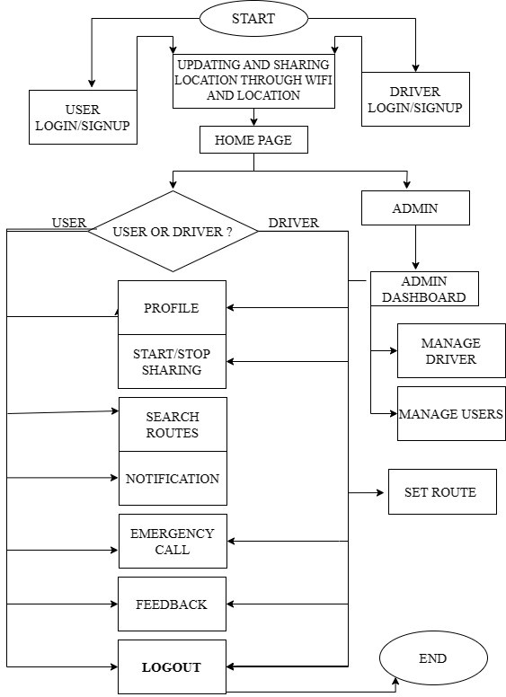

*Figure 1: Flowchart of Public Transit System*

## Use Case of Public Transit Tracker

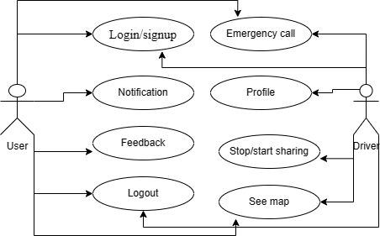

*Figure 2:Use case of Public Transit Tracker*

A user case diagram is a visual representation of interaction between users and system. It illustrates the various ways in which users interact with system to achieve specific goals or tasks. “Public transit system” is a mobile application that allows all it’s user to login/signup. Also, This application will send notification to the users and also allow users to send feedback regarding the application. Users and drivers both are allowed to make an emergency call in case any problem occurs. Drivers have their own profile page where they can update their status and allow them to share their location so that users can track the location. Drivers can stop or start sharing their location whenever they want. Both users and drivers can have access to the maps. Users can see maps so that they can know when their vehicle is arriving at their designated stop. They can also get to see the estimated arrival time of their vehicle to their designated stop. At last both, users and drivers are given access to logout of their profile. The proper use case diagram is shown above.

## System Requirements

Frontend-C# Maui framework .Backend Asp.Net core , Firebase , Google Maps Api

# Chapter 4: Expected Output

The expected output of the “Public Transit Tracker” project includes following points:

* + - The primary output of this application will be fully functional mobile applications available on the android platform.
    - Users would be able to login and register either as a driver or customer.
    - The system aims to provide real-time updates on the current location of the bus.
    - The system will display bus routes, including all stops along the way.
    - Passengers will see which stops are coming up and decide when to board.
    - Provide real-time updates on the current location of the vehicle.
    - Users will receive the notification estimated arrival time for the vehicle at their designated stop.
    - It will display public transport routes, including all stops along the way.

# Chapter 5: Conclusion

Our proposed bus tracking system aims to simplify travel for users, providing a seamless experience from one location to another. In urban areas, where time is at a premium, this system becomes an asset by offering real-time bus location updates. Additionally, it predicts bus arrival times at designated stops, allowing users to plan their journeys more efficiently. Our system prioritizes user convenience. With accurate information, passengers can effortlessly navigate their bus journeys. In bustling urban environments, every minute counts. By delivering real-time bus locations, our system empowers users to optimize their schedules. No more waiting at bus stops uncertainly— the system provides precise arrival predictions. Even in regions with limited bus availability, our solution remains effective. Users in rural areas face long wait times due to infrequent bus services. Our system alleviates this issue by offering real-time updates, ensuring that passengers know exactly when the next bus will arrive.

In summary, our bus tracking system revolutionizes public transportation, making it more efficient, reliable, and user centric.

# References

|  |  |
| --- | --- |
| [1] | M. S. e. a. Alamgir, "Chittagong university teachers' bus tracking system using smartphone application," *Bus tracking system,* vol. 4, no. 1, pp. 199-203, 2018. |
| [2] | R. V. Krishna, "IOT BASED BUS LOCATION TRACKING SYSTEM," *Bus*  *location tracking,* pp. 97-102, 2014. |
| [3] | K. Mundada, "Smart Bus Real-Time Tracking System Using GSM and GPS Module," *International Conference on ICT for Sustainable Development,* vol. 1, no. 1, pp. 509-518, 2023. |
| [4] | S. A. Sharif, "Real-Time campus university bus tracking mobile application,"  *Seventh ICT International Student Project Conference,* pp. 1-6, 2018. |